EE 638/738 Neural Data Analysis

Assignment 1

CHARITH SAI SATHVIK ALE
Cale2
Dr. Rachel June Smith

01/23/2024
Spring 2024

- Clear the workspace. Create a variable 𝐴 and assign it to the following matrix value:
𝐴 =[7,5 ;2,3;1,8]. Access the element 𝑖 = 2, and 𝑗 = 1 (where 𝑖 and 𝑗 denoted the row and column, respectively) and change it to a number twice its original value. Create a variable 𝐵 and assign to it a transpose of 𝐴. Verify that the fifth element of 𝐵 is counted column-wise is the same as the 𝑖 = 1, 𝑗 = 3 element using the function 𝑖𝑠𝑒𝑞𝑢𝑎𝑙().
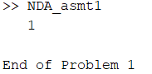

- Using the function 𝑙𝑖𝑛𝑠𝑝𝑎𝑐𝑒(), generate a row vector 𝑣1 with seven elements which uniformly cover the interval between 0 and 1. Now generate a vector 𝑣2 which also covers the interval between 0 and 1, but with a fixed discretization of 0.1. Use either the function 𝑙𝑒𝑛𝑔𝑡ℎ() or 𝑠𝑖𝑧𝑒() to determine how many elements the vector 𝑣2 has. What is the value of the third element of vector 𝑣2?
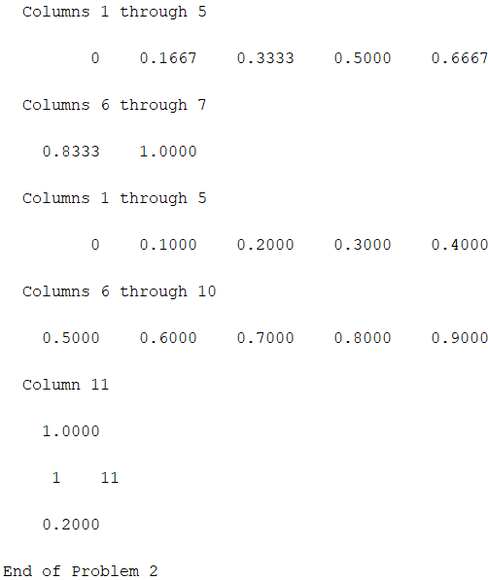

- Create a variable 𝐶 and assign it to a 5𝑥5 identity matrix using the function 𝑒𝑦𝑒(). Create a variable 𝐷 and assign to it a 5𝑥5 matrix of ones using the function 𝑜𝑛𝑒𝑠(). Create a third variable 𝐸 and assign to it the square of the matrix that is the sum of 𝐶 and 𝐷. Then create a fourth variable 𝐹 and assign to it the square of each element that is the sum of 𝐶 and 𝐷. (see the hint in the FOR loops slide in the notes!)
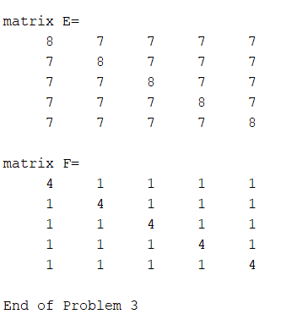

- Create a time vector 𝑡 that goes from 0 to 100 in increments of 5. Now create a vector 𝑞 whose length is that of 𝑡 and each element of 𝑞 is equal to 2 + 5 times the corresponding element of 𝑡 raised to the power of 1.7.
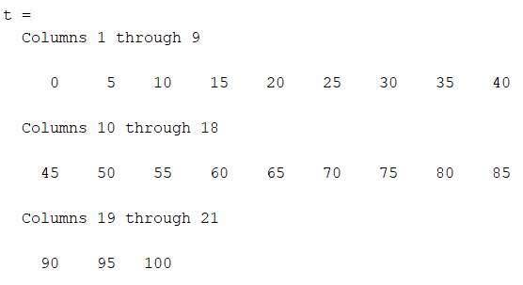

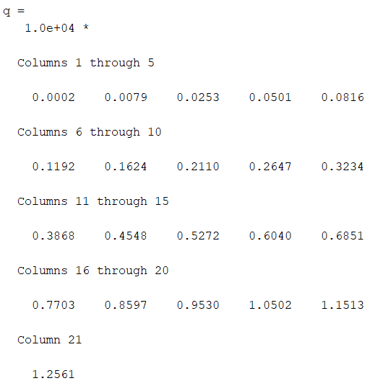

- Create a variable 𝑋 and assign to it the following matrix values:
𝑋= [ 1,2,3,4;4,5,6,7,8; 10,20,30,40; 50,60,70,80]. Find the row and column indices of the matrix 𝑋 whose values are greater than 20. Set all values
greater than 20 to the value 25. Set all elements of the second row equal to the value 17. Assign the value 2 to each of the last three entries in the second column (overwriting any changes you may have just made).

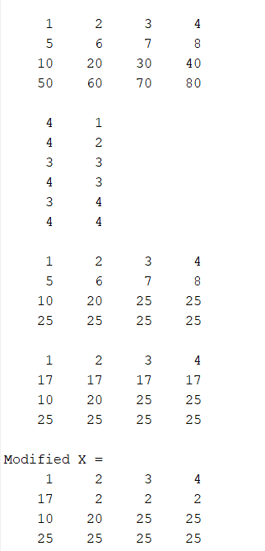

- Create a function named 𝑓𝑙𝑜𝑤𝑒𝑟 that has three inputs: 𝑝𝑒𝑡𝑎𝑙𝑠, 𝑠𝑡𝑒𝑚, and 𝑙𝑒𝑎𝑣𝑒𝑠 and two outputs: 𝑎𝑟𝑒𝑎 and 𝑏𝑖𝑔𝐼𝑛𝑑𝑖𝑐𝑎𝑡𝑜𝑟. Inside the function, calculate 𝑎𝑟𝑒𝑎 as the sum of 5 times the value assigned to 𝑝𝑒𝑡𝑎𝑙𝑠, 3 times the value assigned to 𝑙𝑒𝑎𝑣𝑒𝑠, and the value of 𝑠𝑡𝑒𝑚. Let 𝑏𝑖𝑔𝐼𝑛𝑑𝑖𝑐𝑎𝑡𝑜𝑟 equal 1 if the value of 𝑎𝑟𝑒𝑎 exceed a value of 15. (You can write the function in a new Editor page and then copy/paste the code in here).
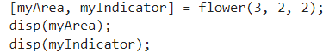
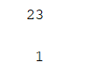

Load the EEG data clip into your workspace that we used in class (can be downloaded from Canvas under the Files tab) and let the variable be named 𝐸𝐸𝐺. The data is structured such that each row represents a channel, and each column is a different point in time.
7) Create a figure. Create two subplots in the figure, side-by-side (see 𝑠𝑢𝑏𝑝𝑙𝑜𝑡()). On the left
subplot, plot all values in the third channel of 𝐸𝐸𝐺. Title the left subplot “Left Subplot”, and
create x- and y-axis labels “X-axis” and “Y-axis”, respectively. For the right subplot, create a
vector 𝑟 that counts from 5 to 100 in increments of 5. Plot the first twenty elements of the 4th
channel of 𝐸𝐸𝐺 as a function of 𝑟. Title the subplot “Holla back”, and create x- and y-axis labels “Blaze” and “Dragons” for each respectively.
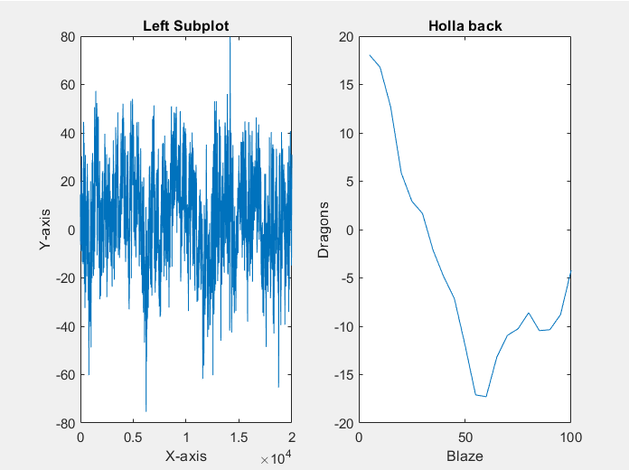

8) A. Create a new variable 𝐸𝐸𝐺_𝑟𝑒𝑝𝑚𝑎𝑡 and assign to it a matrix of NaNs with the same
dimensions as 𝐸𝐸𝐺. Calculate the mean of 𝐸𝐸𝐺 at each time point (mean down the column).
Use the function 𝑟𝑒𝑝𝑚𝑎𝑡() to subtract this vector from each row of 𝐸𝐸𝐺.
B. Create a new variable 𝐸𝐸𝐺_𝑓𝑜𝑟𝐿𝑜𝑜𝑝 and assign to it a matrix of NaNs with the same
dimensions as 𝐸𝐸𝐺. Again, calculate the mean of 𝐸𝐸𝐺 at each time point (mean down the
column). Design a FOR loop to subtract this vector from each row of the 𝐸𝐸𝐺.
C. Use the function 𝑖𝑠𝑒𝑞𝑢𝑎𝑙() to show that 𝐸𝐸𝐺_𝑟𝑒𝑝𝑚𝑎𝑡 is mathematically equivalent to
𝐸𝐸𝐺_𝑓𝑜𝑟𝐿𝑜𝑜𝑝.

9) Create a new variable 𝐸𝐸𝐺_3𝐷 and assign to it a matrix of NaNs with 5 rows, 100 columns, and 6“pages” (third dimension). Assign the values of the first and fourth pages of 𝐸𝐸𝐺_3𝐷 with the first 5 channels, from time points 1 to 100. Assign the values of the second and fifth pages of 𝐸𝐸𝐺_3𝐷 with channels 6 to 10, from time points 101 to 200. Assign the third and sixth pages of 𝐸𝐸𝐺_3𝐷 with a value of 23.

- Output the values of 𝐸𝐸𝐺_3𝐷(3, 42,:).
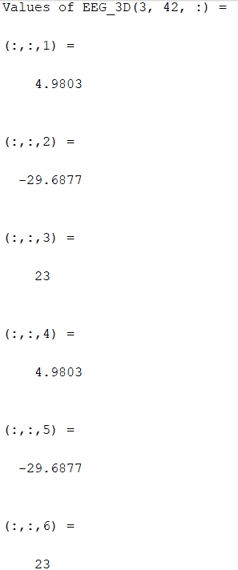

B. Create a variable 𝐸𝐸𝐺_𝑠𝑢𝑏𝑠𝑒𝑡 that includes the time points 601:650 from channel 7. Randomize the values in 𝐸𝐸𝐺_𝑠𝑢𝑏𝑠𝑒𝑡 by placing the values in new positions that are given by 𝑟𝑎𝑛𝑑𝑝𝑒𝑟𝑚(50). (Hint, you can do this in one line of code.)

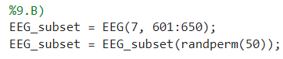

MATLAB Script
%Problem 1

A = [7,5;
2,3;
1,8];
A(2,1) = 2 * A(2,1);

B = A';
x = isequal(B(5),B(1,3));
disp(x);
disp('End of Problem 1');

%Problem 2
v1 = linspace(0,1,7);
disp(v1);
v2 = 0:0.1:1;
disp(v2);
x1 = size(v2);
disp(x1);
x2 = v2(3);
disp(x2);
disp('End of Problem 2');

%problem 3
C = eye(5);
disp(C);
D= ones(5);
disp(D);
E = (C + D)^2;
disp('matrix E=')
disp(E);
F = zeros(5);
new_matrix = C + D;
for i = 1:5
for j =1:5
F(i,j) = new_matrix(i,j)^2;
end
end

disp('matrix F=');
disp(F);
disp('End of Problem 3');

% Problem 4
t = 0:5:100;
q =zeros(size(t));
for i = 1: length(t)
q(i) = 2 +5 *(t(i)^(1.7));
end

disp('t ='); disp(t);
disp('q ='); disp(q);

%Problem 5
X = [1,2,3,4;
5,6,7,8 ;
10,20,30,40;
50,60,70,80];
disp(X);

[r_n,c_n] = find(X>20);
disp([r_n,c_n]);

X(X > 20) = 25;
disp(X);

X(2,:) = 17;
disp(X);

X(2,2:4) = 2;

disp('Modified X ='); disp(X);

%Problem 6
function [area, bigIndicator] = flower(petals, stem, leaves)
area = 5*petals + 3*leaves + stem;

if area > 15
bigIndicator = 1;
else
bigIndicator = 0;
end
end
[myArea, myIndicator] = flower(3, 2, 2);
disp(myArea);
disp(myIndicator);

%Problem 7
load('EEG_clip.mat', 'EEG');
figure;
% Left subplot
subplot(1, 2, 1);
plot(EEG(3, :));
title('Left Subplot');
xlabel('X-axis');
ylabel('Y-axis');

% Right subplot
subplot(1, 2, 2);
r = 5:5:100;
plot(r, EEG(4, 1:20));
title('Holla back');
xlabel('Blaze');
ylabel('Dragons');

%Problem 8
%8.A)
load('EEG_clip.mat', 'EEG');
EEG_repmat = nan(size(EEG));
Mean_repmat = mean(EEG, 1);

EEG_repmat = EEG - repmat(Mean_repmat, [size(EEG,1), 1]);

% 8.B)
load('EEG_clip.mat', 'EEG');
EEG_forLoop = nan(size(EEG));
Mean_forLoop = mean(EEG, 1);

% Subtract using a for loop
for row = 1:size(EEG,1)
EEG_forLoop(row,:) = EEG(row,:) - Mean_forLoop;
end

% 8.C)
load('EEG_clip.mat', 'EEG');
isEquivalent = isequal(EEG_repmat, EEG_forLoop);
disp(['Are EEG_repmat and EEG_forLoop identical? ', num2str(isEquivalent)]);

%Problem 9
%9.A)
load('EEG_clip.mat', 'EEG');
EEG_3D = nan(5, 100, 6);

% Pages 1 and 4: first 5 channels, time points 1–100
EEG_3D(:,:,1) = EEG(1:5, 1:100);
EEG_3D(:,:,4) = EEG(1:5, 1:100);

% Pages 2 and 5: channels 6–10, time points 101–200
EEG_3D(:,:,2) = EEG(6:10, 101:200);
EEG_3D(:,:,5) = EEG(6:10, 101:200);

% Pages 3 and 6: all elements set to 23
EEG_3D(:,:,3) = 23;
EEG_3D(:,:,6) = 23;

disp('Values of EEG_3D(3, 42, :) = ');
disp(EEG_3D(3, 42, :));

%9.B)
load('EEG_clip.mat', 'EEG');
EEG_subset = EEG(7, 601:650);
EEG_subset = EEG_subset(randperm(50));

