EE 638/738 Neural Data Analysis

Assignment 2

CHARITH SAI SATHVIK ALE
Cale2
Dr. Rachel June Smith

01/30/2025
Spring 2025

- Answer the following questions from the paper, “An efficient P300-based brain-computer interface for disabled subject” by Hoffmann et al. 2008 in Journal of Neuroscience Methods:
a. What is the neural signal these authors are using as a control signal? What two other methods are described as alternative brain signals that can be used as a control signal in the Introduction?
The control signal used is the P300 event-related potential. The two alternative signals for control in BCIs are slow cortical potential and motor-imagery.
b. Define the P300 signal.
The P300 is a positive deflection in the EEG that appears approximately 300ms after the presentation of rare or surprising, task-relevant stimuli.
c. What 6 images were used for the study?
The six images used in the study were a television, a telephone, a lamp, a door, a window, and a radio.
d. How many electrodes were used and what was the sampling rate for the recording?
The EEG was recorded using 32 electrodes placed according to the 10–20 system, with a sampling rate of 2048 Hz.
e. How many subjects participated in the study?
Nine subjects participated in the study, including five disabled and four able-bodied individuals.
f. What referencing scheme did the authors use?
The average signal from the two mastoid electrodes was used for referencing.
g. How long were the flashes of the images and how much time elapsed before the
presentation of the next image?
Each image flash lasted for 100ms, with a 300ms interval (inter-stimulus interval, ISI) before the presentation of the next image, making the total ISI 400ms.
h. What did the authors ask the subjects to do to make sure they were paying attention to the desired image?
Subjects were asked to silently count how many times the designated target image was flashed during the test runs.
i. How was session 2, 3, and 4 different from session 1 for the participant?
In sessions 2, 3, and 4, the target image was inferred from the EEG using a classifier, and the image identified by the classifier was then flashed five times to provide feedback to the participant. This differed from session 1 where such classification and feedback based on EEG data were not applied.

- The dataset can be found at the following link:
https://www.epfl.ch/labs/mmspg/research/page-58317-en-html/bci-2/bci_datasets/
Read the ReadMe.pdf
Subject 8’s data yielded the best classification accuracy, so we will use their data. Load the dataset from Subject 8, Session 4, the last run (eeg_200308290212_epochs.mat’).
3) First, let’s plot all the EEG channel data (first 32 channels) as a function of time (in seconds) on one figure. It should look like this:
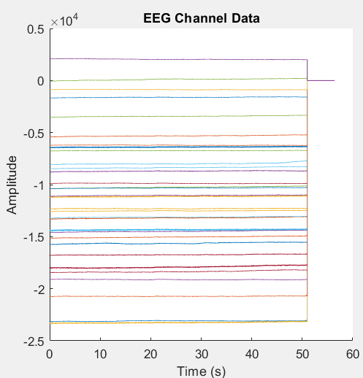
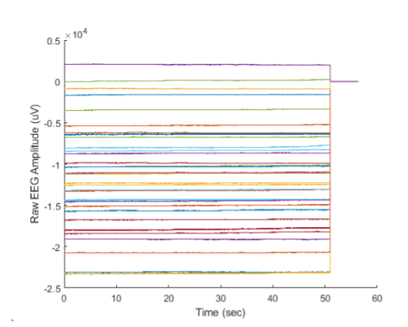

Remove the zeros from the end of the dataset and then subtract the mean from each channel.
Replot the signals all on the same axes as a function of time:
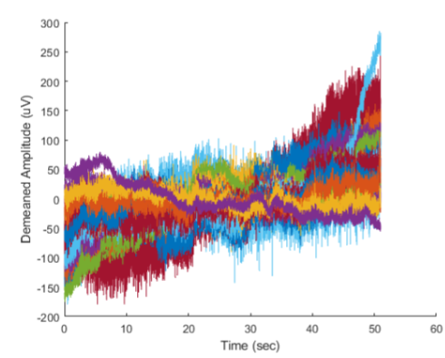

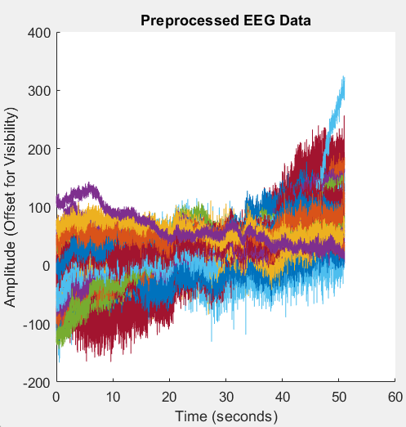

4) Write a function called extractAllTrials that returns all trials of the P300 experiment for one channel
of EEG.
Have the following inputs to the function:
a. ‘data’ = raw EEG data from the Hoffman dataset
b. ‘events’ = events matrix from Hoffman dataset, which includes the time of each stimulus
c. ‘electrode’ = index of the electrode you want to extract trials from
d. ‘timePreStim’ = the amount of time before the stimulus appears (a.k.a. start of the epoch), in
seconds
e. ‘timePostStim’ = the amount of time after the stimulus appears (a.k.a. the end of the epoch), in
seconds
The outputs should be:
f. ‘trials’ = a matrix of EEG where every row is one trial and every column is one point in time
g. ‘time’ = a vector of time points in the units of seconds; can use this to plot trials
Within the function, also perform the following pre-processing actions:
h. Remove zeros from the dataset
i. Remove the mean from each channel
*Hint*: You can use the function etime() to calculate the elapsed time between the times listed in the events matrix.
*Note*: You will need to skip the last event because there is not 0.6 seconds of data after the last stimulus.
5) The variable ‘stimuli’ included in the dataset describes which trials were associated with a particular image, indicated as values between 1 and 6, and ‘target’ describes which image the participant was focused on.
a. Plot all trials for channel Pz on the same figure for the time period -0.2 to 0.6 seconds (0.2 seconds before the stimulus to 0.6 seconds after the stimulus). Plot target trials with red lines and off-target trials with blue lines.
b. In a new figure, plot the average of the target and average of the off-target trials for channel Pz on the same figure. Plot the target average in red and the off-target average in blue.
We don’t see much evidence of the P300 signal yet!

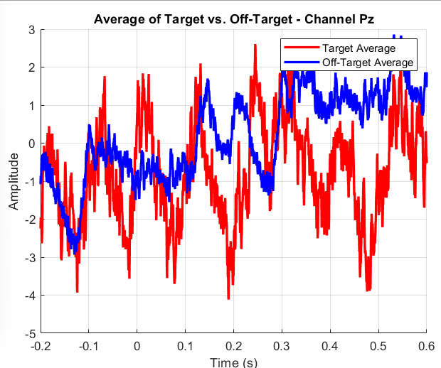
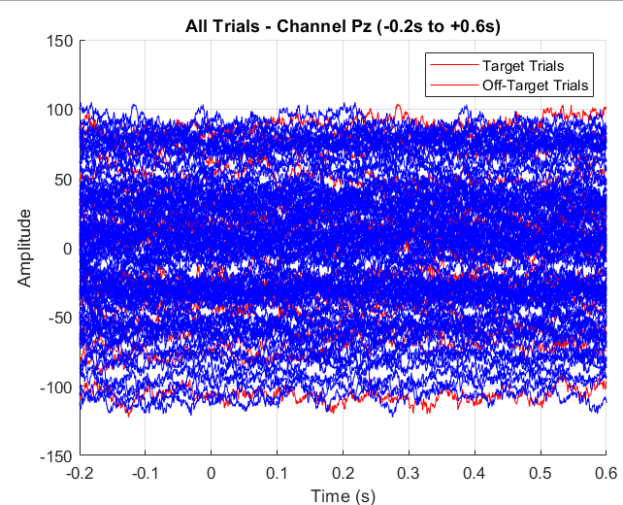

6) Re-referencing: We need to properly re-reference the data to see this ERP. In your extractAllTrials function, add a pre-processing step to re-reference the data to the average of the two mastoid electrodes.
Then, with your new and improved function,
a. Plot all trials for channel Pz on the same figure for the time period of -0.2 to 0.6 seconds. Plot target trials in red and off-target trials in blue.
b. In a new figure, plot the average of the target and average of the off-target trials for channel Pz
on the same figure. Plot the target average in red and the off-target average in blue.
With proper referencing, we can start to see evidence of the P300!
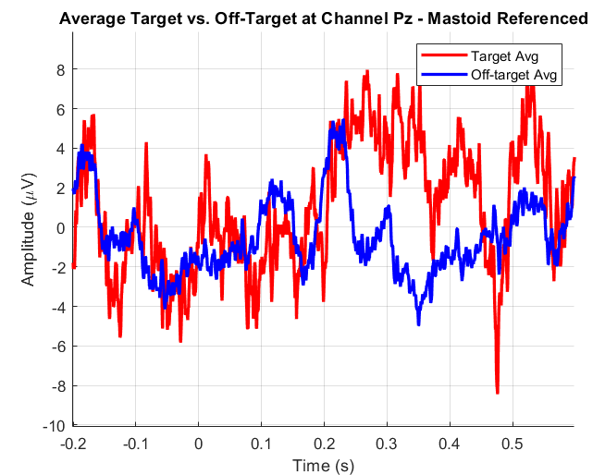
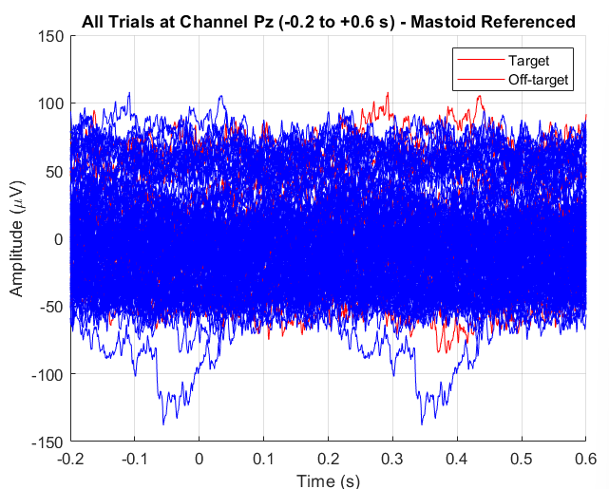

MATLAB SCRIPT
Q3-1)
d=load('C:\Users\DELL\OneDrive\Documents\MATLAB\subject8\session4\eeg_200308290212_epochs.mat');
data = d.data
events = d.events;
stimuli = d.stimuli;
target = d.target;
timePreStim = 0.2; % 200 ms before the stimulus
timePostStim = 0.6; % 600 ms after the stimulus
numElectrode = size(data, 1);
data = d.data(1:32, :); % Assuming the first 32 rows are EEG channels
samplingRate = 2048; % From your dataset description
numSamples = size(data, 2); % Number of samples in the EEG data
timeVector = (0:numSamples-1) / samplingRate; % Time vector in seconds
figure;
hold on;
for i = 1:32
plot(timeVector, data(i,:));
end
hold off;
xlabel('Time (s)');
ylabel('Amplitude(uV)');
title('EEG Channel Data');
legend(arrayfun(@(x) sprintf('Channel %d', x), 1:32, 'UniformOutput', false), 'Location', 'eastoutside');

Q3-2)
d = load("eeg_200308290212_epochs.mat");
EEG = d.data(1:32, :); % Assuming the first 32 rows are EEG channels
samplingRate = 2048; % Given sampling rate
lastNonZero = max(arrayfun(@(x) find(EEG(x, :) ~= 0, 1, 'last'), 1:32));
EEG = EEG(:, 1:lastNonZero);

EEG = bsxfun(@minus, EEG, mean(EEG, 2));
numSamples = size(EEG, 2);
timeVector = (0:numSamples-1) / samplingRate;
figure;
hold on;
colors = lines(32); % Generate 32 distinct colors
for i = 1:32
plot(timeVector, EEG(i, :) + 2*i, 'Color', colors(i, :)); % Offset each channel for visibility
end
hold off;
xlabel('Time (seconds)');
ylabel('Amplitude');
title('Preprocessed EEG Data');
legend(arrayfun(@(x) sprintf('Channel %d', x), 1:32, 'UniformOutput', false), 'Location', 'eastoutside');
Q4)
load('eeg_200308290212_epochs.mat');
% Defining parameters to extract trials
electrodeIdx = 13; % Channel 13 = Pz electrode list
timePreStim = 0.1;
timePostStim = 0.5;
[trials, timeVec] = extractAllTrials(data, events, electrodeIdx, timePreStim, timePostStim);

function [trials, time] = extractAllTrials(data, events, electrode, timePreStim, timePostStim)
Fs = 2048; %sampling rate
allZeroCols = all(data == 0, 1); % Removing columns that are entirely zero
data(:, allZeroCols) = [];
data = bsxfun(@minus, data, mean(data, 2)); % Subtracting the mean from each channel
nSamplesPre = round(timePreStim * Fs); % Number of samples in each epoch
nSamplesPost = round(timePostStim * Fs);
nEpochSamples = nSamplesPre + nSamplesPost + 1;
time = linspace(-timePreStim, timePostStim, nEpochSamples);
offsetFirstEvent_s = 0.4;
offsetFirstEvent_smp = round(offsetFirstEvent_s * Fs);

n_Events = size(events,1);
trials = [];
valid_Ec = 0;

for i_Ev = 1:n_Events
t_Sec = etime(events(i_Ev,:), events(1,:));
sample_Idx = offsetFirstEvent_smp + round(t_Sec * Fs);
start_Idx = sample_Idx - nSamplesPre; % Start and end indices for the epoch
end_Idx = sample_Idx + nSamplesPost;
valid_Ec = valid_Ec + 1;
epochData = data(electrode, start_Idx:end_Idx);
trials(valid_Ec,:) = epochData;
end
if valid_Ec == 0
trials = [];
end
end
Q5)
clear; clc; close all;
load('eeg_200308290212_epochs.mat');
Fs = 2048; % Sampling rate
channelOfInterest = 13; % Pz is channel #13 in Data
timePreStim = 0.2; % 0.2s before stimulus
timePostStim = 0.6; % 0.6s after stimulus
nSamplesPre = round(timePreStim * Fs);
nSamplesPost = round(timePostStim * Fs);
nEpochSamples = nSamplesPre + nSamplesPost + 1;
timeVec = linspace(-timePreStim, timePostStim, nEpochSamples);
allZeroCols = all(data == 0, 1);
data(:, allZeroCols) = [];
data = bsxfun(@minus, data, mean(data, 2));% Subtracting the mean from each channel (pre-processing)

offsetFirstEvent_s = 0.4; % Converting event times to sample indices
offsetFirstEvent_smp = round(offsetFirstEvent_s * Fs);

nEvents = size(events, 1);
validCount = 0; % Extracting trials for the chosen channel
trials = []; % will hold (numTrials x nEpochSamples)
trialLabels = []; % will record which stimulus (1..6) occurred on each trial
for iEv = 1:nEvents
% If 'events' is Nx6 date vectors, use etime to get seconds from first
tSec = etime(events(iEv,:), events(1,:));
sampleIndex = offsetFirstEvent_smp + round(tSec * Fs);

startIdx = sampleIndex - nSamplesPre;
endIdx = sampleIndex + nSamplesPost;

% Skip if the epoch extends out of bounds
if startIdx < 1 || endIdx > size(data,2)
continue;
end
validCount = validCount + 1;
trials(validCount,:) = data(channelOfInterest, startIdx:endIdx);
trialLabels(validCount,1) = stimuli(iEv);
end
% check: no. of valid trials
fprintf('Number of valid trials extracted: %d\n', validCount);
%Plotting target vs. off-target trials
figure('Name','Single-Trial Waveforms','Color','w');
hold on;
% Identifying which trials are target vs. off-target
isTargetTrial = (trialLabels == target);
plot(timeVec, trials(isTargetTrial,:)', 'r');
plot(timeVec, trials(~isTargetTrial,:)', 'b');
xlabel('Time (s)');
ylabel('Amplitude');
title('All Trials - Channel Pz (-0.2s to +0.6s)');
legend({'Target Trials','Off-Target Trials'});
grid on;

% Plotting the AVERAGE of target vs. off-target trials
figure('Name','Averaged Waveforms','Color','w');
hold on;
meanTarget = mean(trials(isTargetTrial,:),1);
meanOffTarget = mean(trials(~isTargetTrial,:),1);
plot(timeVec, meanTarget, 'r','LineWidth',2);
plot(timeVec, meanOffTarget, 'b','LineWidth',2);
xlabel('Time (s)');
ylabel('Amplitude');
title('Average of Target vs. Off-Target - Channel Pz');
legend({'Target Average','Off-Target Average'});
grid on;

Q6)
clear; clc; close all;
load('eeg_200308290212_epochs.mat'); % Contains data, events, stimuli, target, ...

% 3) Define parameters
channelPz = 13; % Pz is channel #13 in DATA
timePreStim = 0.2; % 0.2s before stimulus
timePostStim = 0.6; % 0.6s after stimulus

[trialsPz, timeVec, trialLabels] = extractAllTrials(data, events, stimuli, ...
channelPz, timePreStim, timePostStim);

isTarget = (trialLabels == target);

% Plotting all single trials
figure('Name','All Single-Trial Waveforms','Color','w'); hold on;
plot(timeVec, trialsPz(isTarget,:)', 'r');
plot(timeVec, trialsPz(~isTarget,:)', 'b');
xlabel('Time (s)'); ylabel('Amplitude (\muV)');
title('All Trials at Channel Pz (-0.2 to +0.6 s) - Mastoid Referenced');
legend({'Target','Off-target'});
grid on;

% Plotting the average target vs. off-target
avgTarget = mean(trialsPz(isTarget,:),1);
avgOffTarget = mean(trialsPz(~isTarget,:),1);

figure('Name','Averaged Waveforms','Color','w'); hold on;
plot(timeVec, avgTarget, 'r','LineWidth',2);
plot(timeVec, avgOffTarget, 'b','LineWidth',2);
xlabel('Time (s)'); ylabel('Amplitude (\muV)');
title('Average Target vs. Off-Target at Channel Pz - Mastoid Referenced');
legend({'Target Avg','Off-target Avg'});
grid on;

function [trials, time, trialLabels] = extractAllTrials(data, events, stimuli, ...
electrode, timePreStim, timePostStim)

Fs = 2048; % sampling rate
nSamplesPre = round(timePreStim * Fs);
nSamplesPost = round(timePostStim * Fs);
nEpochSamples = nSamplesPre + nSamplesPost + 1;
time = linspace(-timePreStim, timePostStim, nEpochSamples);

allZeroCols = all(data == 0, 1);
data(:, allZeroCols) = [];
ma1Index = 33; % MA1
ma2Index = 34; % MA2
if max([ma1Index, ma2Index]) > size(data,1)
error('Mastoid indices exceed channel dimensions. Check data channels.');
end
% Computing average of the two mastoid channels for each sample
mastoidAvg = (data(ma1Index,:) + data(ma2Index,:)) / 2;
% Subtract mastoidAvg from all channels
data = data - mastoidAvg;
data = bsxfun(@minus, data, mean(data, 2));
offsetFirstEvent_s = 0.4; % ~0.4s offset
offsetFirstEvent_smp = round(offsetFirstEvent_s * Fs);
nEvents = length(stimuli);
trials = [];
trialLabels = [];
validCount = 0;

for iEv = 1:nEvents
tSec = etime(events(iEv,:), events(1,:));
sampleIndex = offsetFirstEvent_smp + round(tSec * Fs);

startIdx = sampleIndex - nSamplesPre;
endIdx = sampleIndex + nSamplesPost;

% Skip if out of data range
if startIdx < 1 || endIdx > size(data,2)
continue;
end
validCount = validCount + 1;
trials(validCount,:) = data(electrode, startIdx:endIdx);
trialLabels(validCount,1) = stimuli(iEv); % which image was flashed
end
end

