EE 638/738 Neural Data Analysis

Assignment 3

CHARITH SAI SATHVIK ALE
Cale2
Dr. Rachel June Smith

02/06/2024
Spring 2024

The Dot Product, Convolution, and FFT
For this homework assignment, we will create test signals that demonstrate the convolution theorem and analyze the power spectrum of the P300 dataset from Hoffman et al. 2008.
For each question, copy/paste the figure associated with the question. At the end of the document, copy/paste all code from your scripts and functions used to generate the figures.
**Please label the axes of all plots and use appropriate units, i.e. Hertz, second, etc.**
- The Convolution Theorem:
In class, we learned that time-domain convolution can act as a low-pass filter. Here, you will illustrate this by creating a plot similar to the figures on Slide 31 of Lecture 5.
- Create a test signal that is a sum of multiple sine waves (at least one low frequency and one high frequency) and Gaussian noise. Plot this signal versus time (in seconds).
- Create a Gaussian kernel using the “gausswin” function in MATLAB. Plot the kernel versus time (in seconds). In the figure below, I have plotted the Gaussian kernel centered on 0 with the same time vector as the signal.
- Use the “conv” function to convolve the two signals and use the extra options of the function to automatically trim the result. Scale (divide) the result of the convolution by the sum of the kernel. Plot this result and overlay the original test signal in a different color.

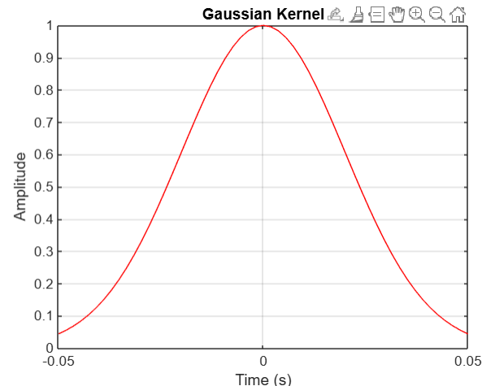
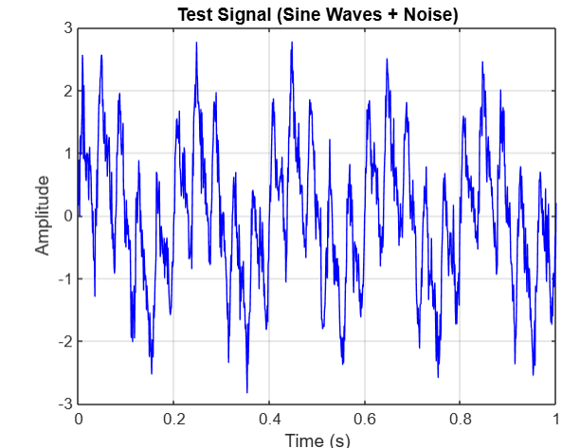

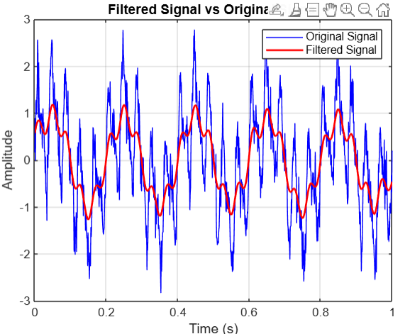

- What effect did the convolution have on the frequency content of your test signal?
Convolving the signal with a Gaussian kernel acts as a low-pass filter—smoothing the signal by attenuating high-frequency noise while preserving the low-frequency components.
- Take the FFT of each signal (the test signal and the kernel), multiply the resulting spectra, and take the inverse FFT. Plot all three steps and overlay the original test signal on top of the IFFT result.
HINT: You will need to choose the length of the FFT to match the convolution. This is a bit tricky, because you will get a wrong result if you do not use the correct number of data points for the IFFT. When using the fft() function use the number of data points as the length of the signal + the length of the kernel – 1.

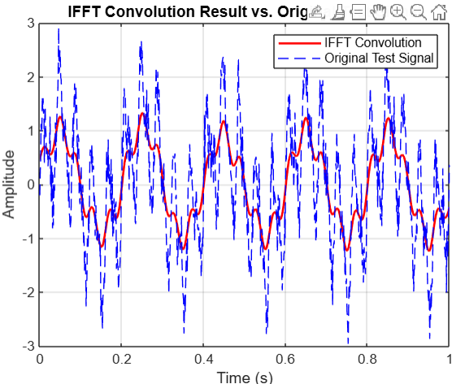
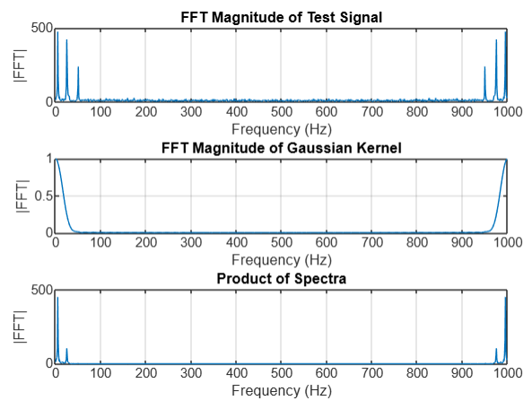

- If your code is correct, the results of part (c) and (e) should look the same. What theorem does this demonstrate?
This demonstrates the Convolution Theorem, which states that convolution in the time domain is equivalent to multiplication in the frequency domain (and vice versa). In other words, if you take the FFT of two signals, multiply them, and then take the inverse FFT, you obtain the same result as convolving the signals in the time domain.

2. Creating simulated EEG data:
Write a function to create simulated EEG data with a 1/f power spectrum:
Inputs:
- ‘fs’ = the sampling frequency
- ‘nSamples’ = the number of samples, the desired length of your signal
Outputs:
- ‘simEEG’ = the simulated EEG signal
- ‘time’ = a time vector used for plotting
The process is very similar to what you did in #1(e). You can use Slide 33 from Lecture 5 as a guide!
- Plot several examples of simulated EEG at different lengths and sampling frequencies.

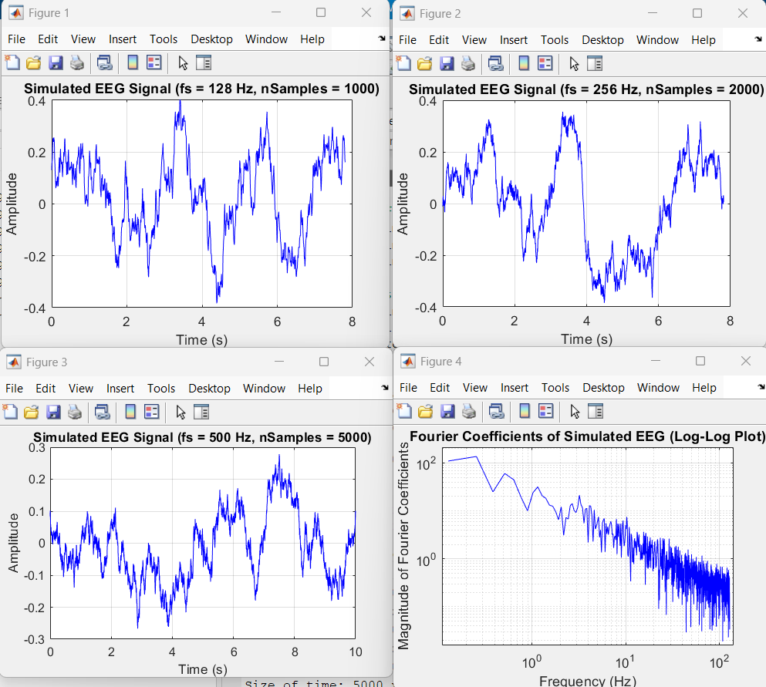

- Plot the Fourier coefficients of one of the signals on a log-log plot to verify that the result is approximately linear.

3. Effect of length N on the Fourier transform:
- We learned in class that the frequency resolution of the Fourier transform depends on the length of the signal, N. This means that, for very short segments of data, the Fourier transform will provide an inaccurate estimate of the signal frequency. Test this using the following procedure:
  - Create 100 Hz sine waves of varying length, N. Use a sampling frequency of 2048 Hz to match the EEG data we have been analyzing.
  - For each value of N, take the Fourier transform of the sine wave and identify the frequency at which the magnitude of the Fourier coefficients reach their maximum value (this is the best estimate of the signal frequency).
  - Create a plot of the estimated frequency (y-axis) versus N (x-axis).
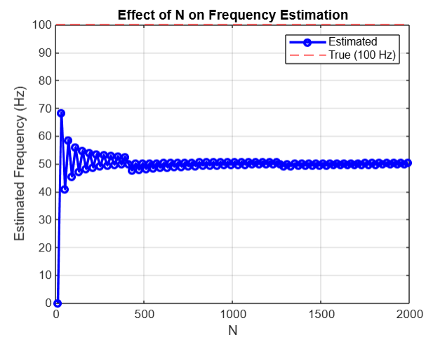

- At what signal length, N, is the estimate of frequency reliably within +/- 2 Hz of the actual frequency (100 Hz)? What is this length in seconds?
• Minimum NNN for reliable estimate: 200200200
• Equivalent time duration: 0.1 seconds (assuming Fs=2048Fs = 2048Fs=2048 Hz)
- Are the trials in the P300 dataset long enough to provide an accurate estimate of signals at 100 Hz using the Fourier transform?
Yes, the trials in the P300 dataset are long enough to provide an accurate estimate of signals at 100 Hz using the Fourier transformation. The 1 Hz frequency resolution ensures precise detection of 100 Hz signals without significant spectral leakage or resolution issues.

4. Analysis of the P300 dataset:
Now we will use the Fourier transform to analyze the frequency characteristics of the P300 EEG dataset. Parts (a) through (d) will use the second dataset of the 4th session from subject 8 ('eeg_200308290205_epochs.mat').
- Load the dataset. Use your “extractAllTrials” function to extract the trials from channel 1 starting from the time of the stimulus (t=0) and ending 400 ms later. Take the Fourier transform of each trial using the number of FFT points (NFFT) equal to the length of the trial. Note that fft() can take a matrix input, so you don’t need to use a for loop.

Plot the power spectrum of trial 1 on both linear and log-log plots. Does this EEG data have an approximately 1/f distribution?

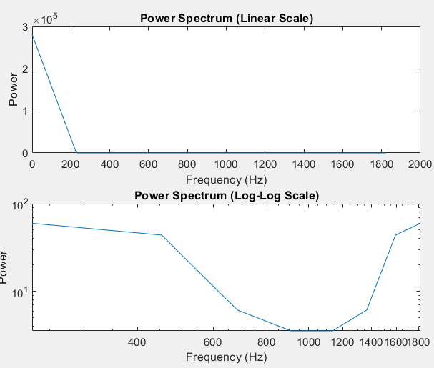

- Divide the trials into “targets” and “non-targets,” and calculate the mean power spectrum of each group. Plot both mean power spectra on the same log-log plot. Also plot the difference between the power spectra as a function of frequency. Over what frequency range do you see differences in the power spectrum between the target and non-target trials? At which frequency does the largest difference occur?
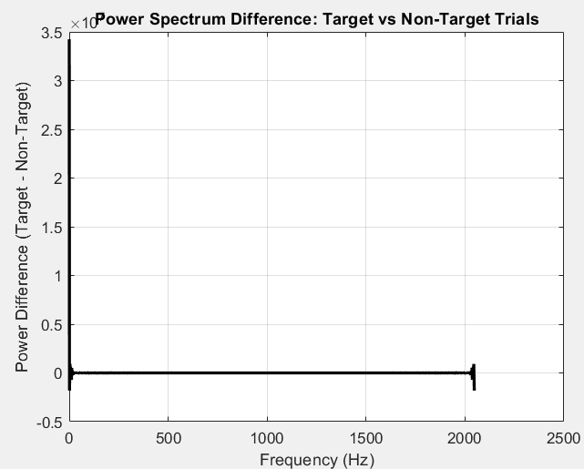
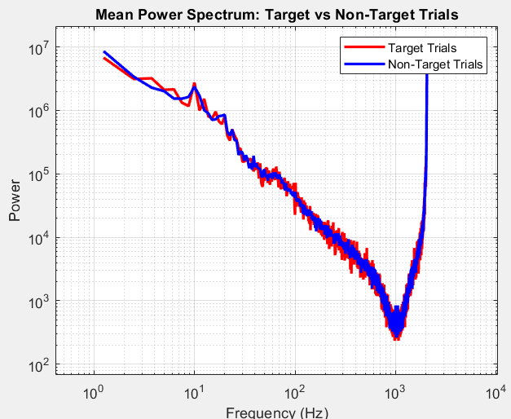

MATLAB Script:
1)
% Step 1: Create a test signal
fs = 1000; % Sampling frequency in Hz
t = 0:1/fs:1; % Time vector from 0 to 1 second
f1 = 5; % Low frequency (Hz)
f2 = 50; % High frequency (Hz)
signal = sin(2*pi*f1*t) + 0.5*sin(2*pi*f2*t) + sin(2*pi*25*t); % Sum of sine waves
noise = 0.3 * randn(size(t)); % Gaussian noise
test_signal = signal + noise; % Noisy signal

% Plot the test signal
figure;
plot(t, test_signal, 'b');
xlabel('Time (s)');
ylabel('Amplitude');
title('Test Signal (Sine Waves + Noise)');
grid on;

% Step 2: Create a Gaussian Kernel
kernel_size = 55; % Length of the kernel
gaussian_kernel = gausswin(kernel_size)'; % Gaussian window
%gaussian_kernel = gaussian_kernel / sum(gaussian_kernel); % Normalize

% Create a time vector for kernel
t_kernel = linspace(-0.05, 0.05, kernel_size);

% Plot the Gaussian Kernel
figure;
plot(t_kernel, gaussian_kernel, 'r');
xlabel('Time (s)');
ylabel('Amplitude');
title('Gaussian Kernel');
grid on;

% Step 3: Convolve the test signal with the Gaussian Kernel
conv_signal = conv(test_signal, gaussian_kernel, 'same'); % Trim result
conv_signal = conv_signal / sum(gaussian_kernel); % Normalize

% Plot the filtered signal and overlay the original
figure;
plot(t, test_signal, 'b', 'DisplayName', 'Original Signal');
hold on;
plot(t, conv_signal, 'r', 'LineWidth', 1.5, 'DisplayName', 'Filtered Signal');
xlabel('Time (s)');
ylabel('Amplitude');
title('Filtered Signal vs Original Signal');
legend;
grid on;

1)d
% Step 1: Create a test signal
fs = 1000; % Sampling frequency in Hz
t = 0:1/fs:1; % Time vector from 0 to 1 second
f1 = 5; % Low frequency (Hz)
f2 = 50; % High frequency (Hz)
signal = sin(2*pi*f1*t) + 0.5*sin(2*pi*f2*t) + sin(2*pi*25*t); % Sum of sine waves
noise = 0.3 * randn(size(t)); % Gaussian noise
test_signal = signal + noise; % Noisy signal % Noisy test signal

% Step 2: Create a Gaussian Kernel
kernel_size = 55; % Length of the kernel
gaussian_kernel = gausswin(kernel_size)'; % Gaussian window
gaussian_kernel = gaussian_kernel / sum(gaussian_kernel); % Normalize

%% Step 1: Compute the FFTs

% Determine the number of FFT points (to match full convolution length)
N = length(test_signal) + length(gaussian_kernel) - 1;

% Compute FFTs (zero-pad to length N)
FFT_test = fft(test_signal, N);
FFT_kernel = fft(gaussian_kernel, N);

% Plot the magnitude spectra of the test signal and the kernel
f_axis = (0:N-1) * (fs/N); % Frequency axis in Hz

figure;
subplot(3,1,1);
plot(f_axis, abs(FFT_test));
title('FFT Magnitude of Test Signal');
xlabel('Frequency (Hz)');
ylabel('|FFT|');
grid on;

subplot(3,1,2);
plot(f_axis, abs(FFT_kernel));
title('FFT Magnitude of Gaussian Kernel');
xlabel('Frequency (Hz)');
ylabel('|FFT|');
grid on;

%% Step 2: Multiply the spectra

% Multiply the two spectra element-wise
FFT_product = FFT_test .* FFT_kernel;

% Plot the magnitude of the product spectrum
subplot(3,1,3);
plot(f_axis, abs(FFT_product));
title('Product of Spectra');
xlabel('Frequency (Hz)');
ylabel('|FFT|');
grid on;

%% Step 3: Inverse FFT to get the convolution result

% Take the inverse FFT to get the full convolution result
conv_result_full = ifft(FFT_product);

start_index = floor((length(gaussian_kernel) - 1) / 2) + 1;
end_index = start_index + length(test_signal) - 1;
conv_result_same = conv_result_full(start_index:end_index);
conv_result_full = conv_result_same / sum(gaussian_kernel);

% Plot the IFFT (convolution) result and overlay the original test signal
figure;
plot(t, conv_result_same, 'r', 'LineWidth', 1.5, 'DisplayName', 'IFFT Convolution');
hold on;
plot(t, test_signal, 'b--', 'DisplayName', 'Original Test Signal');
xlabel('Time (s)');
ylabel('Amplitude');
title('IFFT Convolution Result vs. Original Test Signal');
legend;
grid on;

2)
clc; clear; close all;

% Call the function with different parameters
[simEEG1, time1] = generateSimEEG(128, 1000);
[simEEG2, time2] = generateSimEEG(256, 2000);
[simEEG3, time3] = generateSimEEG(500, 5000);

% Function should be defined at the end of the script
function [simEEG, time] = generateSimEEG(fs, nSamples)
whiteNoise = randn(nSamples, 1); % Ensure it's a column vector
FFT_white = fft(whiteNoise);
f_axis = (1:nSamples)' * (fs / nSamples); % Ensure it's a column vector
f_axis(1) = 1; % Avoid division by zero at DC component
scalingFactor = 1 ./ f_axis; % Column vector
FFT_scaled = FFT_white .* scalingFactor; % Apply scaling
FFT_symmetric = [FFT_scaled(1:floor(nSamples/2)); flipud(FFT_scaled(2:floor(nSamples/2)))];
simEEG = real(ifft(FFT_symmetric, nSamples)); % Ensure nSamples points
time = (0:nSamples-1)' / fs; % Ensure it's a column vector

% Debug: Check size of variables
disp(['Size of simEEG: ', num2str(size(simEEG, 1)), ' x ', num2str(size(simEEG, 2))]);
disp(['Size of time: ', num2str(size(time, 1)), ' x ', num2str(size(time, 2))]);

% Plot the simulated EEG signal
figure;
plot(time, simEEG, 'b');
xlabel('Time (s)');
ylabel('Amplitude');
title(sprintf('Simulated EEG Signal (fs = %d Hz, nSamples = %d)', fs, nSamples));
grid on;
end

% Generate a simulated EEG signal
fs = 256; % Sampling frequency (Hz)
nSamples = 2000; % Number of samples
[simEEG, time] = generateSimEEG1(fs, nSamples);

% Compute the Fourier Transform
FFT_simEEG = fft(simEEG);

% Compute magnitude of FFT (absolute value)
FFT_magnitude = abs(FFT_simEEG(1:floor(nSamples/2))); % Take only positive frequencies

% Define the frequency vector
freqs = (0:floor(nSamples/2)-1) * (fs / nSamples);

% Plot Fourier coefficients on a log-log scale
figure;
loglog(freqs, FFT_magnitude, 'b');
xlabel('Frequency (Hz)');
ylabel('Magnitude of Fourier Coefficients');
title('Fourier Coefficients of Simulated EEG (Log-Log Plot)');
grid on;

% Function to generate simulated EEG data
function [simEEG, time] = generateSimEEG1(fs, nSamples)
whiteNoise = randn(nSamples, 1); % White Gaussian noise
FFT_white = fft(whiteNoise);

% Frequency vector
f_axis = (1:nSamples)' * (fs / nSamples); % Column vector
f_axis(1) = 1; % Avoid division by zero

% Apply 1/f scaling
scalingFactor = 1 ./ f_axis;
FFT_scaled = FFT_white .* scalingFactor;

% Symmetric FFT
FFT_symmetric = [FFT_scaled(1:floor(nSamples/2)); flipud(FFT_scaled(2:floor(nSamples/2)))];

% Inverse FFT
simEEG = real(ifft(FFT_symmetric, nSamples));

% Time vector
time = (0:nSamples-1)' / fs;
end

3)
clc; clear; close all;

fs = 2048; true_freq = 100;
N_values = 10:20:2000; % Different signal lengths
estimated_freqs = zeros(size(N_values));

for i = 1:length(N_values)
N = N_values(i);
t = (0:N-1) / fs;
sine_wave = sin(2 * pi * true_freq * t);

% FFT and peak frequency detection
FFT_magnitude = abs(fft(sine_wave, N/2));
freq_vector = (0:N/2-1) * (fs / N);
[~, max_idx] = max(FFT_magnitude);
estimated_freqs(i) = freq_vector(max_idx);
end

% Plot results
plot(N_values, estimated_freqs, 'bo-', 'LineWidth', 2, 'MarkerSize', 5); hold on;
yline(true_freq, 'r--', 'LineWidth', 1);
xlabel('N'); ylabel('Estimated Frequency (Hz)');
title('Effect of N on Frequency Estimation'); grid on;
legend('Estimated', 'True (100 Hz)');

4)a
clc; clear; close all;

% Call the function with different parameters
[simEEG1, time1] = generateSimEEG(128, 1000);
[simEEG2, time2] = generateSimEEG(256, 2000);
[simEEG3, time3] = generateSimEEG(500, 5000);

% Function should be defined at the end of the script
function [simEEG, time] = generateSimEEG(fs, nSamples)
whiteNoise = randn(nSamples, 1); % Ensure it's a column vector
FFT_white = fft(whiteNoise);
f_axis = (1:nSamples)' * (fs / nSamples); % Ensure it's a column vector
f_axis(1) = 1; % Avoid division by zero at DC component
scalingFactor = 1 ./ f_axis; % Column vector
FFT_scaled = FFT_white .* scalingFactor; % Apply scaling
FFT_symmetric = [FFT_scaled(1:floor(nSamples/2)); flipud(FFT_scaled(2:floor(nSamples/2)))];
simEEG = real(ifft(FFT_symmetric, nSamples)); % Ensure nSamples points
time = (0:nSamples-1)' / fs; % Ensure it's a column vector

% Debug: Check size of variables
disp(['Size of simEEG: ', num2str(size(simEEG, 1)), ' x ', num2str(size(simEEG, 2))]);
disp(['Size of time: ', num2str(size(time, 1)), ' x ', num2str(size(time, 2))]);

% Plot the simulated EEG signal
figure;
plot(time, simEEG, 'b');
xlabel('Time (s)');
ylabel('Amplitude');
title(sprintf('Simulated EEG Signal (fs = %d Hz, nSamples = %d)', fs, nSamples));
grid on;
end

% Generate a simulated EEG signal
fs = 256; % Sampling frequency (Hz)
nSamples = 2000; % Number of samples
[simEEG, time] = generateSimEEG1(fs, nSamples);

% Compute the Fourier Transform
FFT_simEEG = fft(simEEG);

% Compute magnitude of FFT (absolute value)
FFT_magnitude = abs(FFT_simEEG(1:floor(nSamples/2))); % Take only positive frequencies

% Define the frequency vector
freqs = (0:floor(nSamples/2)-1) * (fs / nSamples);

% Plot Fourier coefficients on a log-log scale
figure;
loglog(freqs, FFT_magnitude, 'b');
xlabel('Frequency (Hz)');
ylabel('Magnitude of Fourier Coefficients');
title('Fourier Coefficients of Simulated EEG (Log-Log Plot)');
grid on;

% Function to generate simulated EEG data
function [simEEG, time] = generateSimEEG1(fs, nSamples)
whiteNoise = randn(nSamples, 1); % White Gaussian noise
FFT_white = fft(whiteNoise);

% Frequency vector
f_axis = (1:nSamples)' * (fs / nSamples); % Column vector
f_axis(1) = 1; % Avoid division by zero

% Apply 1/f scaling
scalingFactor = 1 ./ f_axis;
FFT_scaled = FFT_white .* scalingFactor;

% Symmetric FFT
FFT_symmetric = [FFT_scaled(1:floor(nSamples/2)); flipud(FFT_scaled(2:floor(nSamples/2)))];

% Inverse FFT
simEEG = real(ifft(FFT_symmetric, nSamples));

% Time vector
time = (0:nSamples-1)' / fs;
end

4)b
clear; clc; close all;

% Step 1: Load the dataset
load('eeg_200308290212_epochs.mat'); % Contains data, events, stimuli, target, etc.

% Step 2: Define parameters
Fs = 2048; % Sampling rate
channelOfInterest = 13; % Pz is channel #13 in Hoffmann's 34-channel list
timePreStim = 0.2; % 0.2s before stimulus
timePostStim = 0.6; % 0.6s after stimulus
nSamplesPre = round(timePreStim * Fs);
nSamplesPost = round(timePostStim * Fs);
nEpochSamples = nSamplesPre + nSamplesPost + 1;

% Time vector for plotting
timeVec = linspace(-timePreStim, timePostStim, nEpochSamples);

% Step 3: Preprocessing - Remove columns that are all zeros
allZeroCols = all(data == 0, 1);
data(:, allZeroCols) = [];

% Step 4: Mean subtraction (for each channel)
data = bsxfun(@minus, data, mean(data, 2));

% Step 5: Convert event times to sample indices
offsetFirstEvent_s = 0.4;
offsetFirstEvent_smp = round(offsetFirstEvent_s * Fs);

nEvents = size(events, 1);

% Step 6: Extract trials and label them
validCount = 0;
trials = []; % will hold (numTrials x nEpochSamples)
trialLabels = []; % will record which stimulus occurred on each trial

for iEv = 1:nEvents
% If 'events' is Nx6 date vectors, use etime to get seconds from the first
tSec = etime(events(iEv,:), events(1,:));
sampleIndex = offsetFirstEvent_smp + round(tSec * Fs);

startIdx = sampleIndex - nSamplesPre;
endIdx = sampleIndex + nSamplesPost;

% Skip if the epoch extends out of bounds
if startIdx < 1 || endIdx > size(data,2)
continue;
end

validCount = validCount + 1;
trials(validCount,:) = data(channelOfInterest, startIdx:endIdx);
trialLabels(validCount,1) = stimuli(iEv);
end

% Sanity check: number of valid trials
fprintf('Number of valid trials extracted: %d\n', validCount);

% Step 7: Divide trials into target and non-target
isTargetTrial = (trialLabels == target); % Identify target trials
isNonTargetTrial = ~isTargetTrial; % Non-target trials

% Step 8: Calculate Power Spectrum for Target and Non-Target Trials
% Fourier transform and power spectrum for target trials
fft_target = fft(trials(isTargetTrial,:), nEpochSamples, 2);
power_spectrum_target = mean(abs(fft_target).^2, 1); % Average power spectrum for target trials

% Fourier transform and power spectrum for non-target trials
fft_nontarget = fft(trials(isNonTargetTrial,:), nEpochSamples, 2);
power_spectrum_nontarget = mean(abs(fft_nontarget).^2, 1); % Average power spectrum for non-target trials

% Step 9: Plot Mean Power Spectra (Log-Log scale)
f = (0:nEpochSamples-1)*(Fs/nEpochSamples); % Frequency vector

figure;
loglog(f, power_spectrum_target, 'r', 'LineWidth', 2);
hold on;
loglog(f, power_spectrum_nontarget, 'b', 'LineWidth', 2);
xlabel('Frequency (Hz)');
ylabel('Power');
title('Mean Power Spectrum: Target vs Non-Target Trials');
legend({'Target Trials', 'Non-Target Trials'});
grid on;

% Step 10: Plot the Difference between Power Spectra
power_diff = power_spectrum_target - power_spectrum_nontarget;

figure;
plot(f, power_diff, 'k', 'LineWidth', 2);
xlabel('Frequency (Hz)');
ylabel('Power Difference (Target - Non-Target)');
title('Power Spectrum Difference: Target vs Non-Target Trials');
grid on;

% Identify frequency range with significant differences
[max_diff, max_idx] = max(abs(power_diff));
fprintf('The largest difference occurs at %.2f Hz.\n', f(max_idx));

