EE 638/738 Neural Data Analysis

Assignment 4

CHARITH SAI SATHVIK ALE
Cale2
Dr. Rachel June Smith

02/16/2025
Spring 2025



The Wavelet Convolution
For this homework assignment, we will create test signals that help us understand the wavelet convolution and visualize the frequency decomposition of EEG data from the P300 dataset from Hoffman et al. 2008.
For each question, copy/paste the figure associated with the question. At the end of the document, copy/paste all code from your scripts and functions used to generate the figures.
**Please label the axes of all plots and use appropriate units, i.e. Hertz, second, etc.**
- In this question, we will write basic code to do wavelet convolution and test it using a variety of signals.
  - Wavelet family. Create a family of 4-cycle (n=4) Morlet wavelets over the frequency range of 4:60 Hz. Make the wavelets all the same length and use a sampling frequency of 100 Hz. Plot the entire family of wavelets in a single figure versus time (in seconds). Be sure to use the complex Morlet wavelet equation on slide 18 of Lecture 6! $wavelet= Ae^{-\frac{t^{2}}{2s^{2}}}e^{i2πft}$ where $A=\frac{1}{{\left(s\sqrt{π}\right)}^{0.5}}$ and $s=\frac{n}{2πf}$.
Use a time vector from -0.5 to 0.5 seconds: t = -0.5:1/fs:0.5; where fs is sampling frequency.

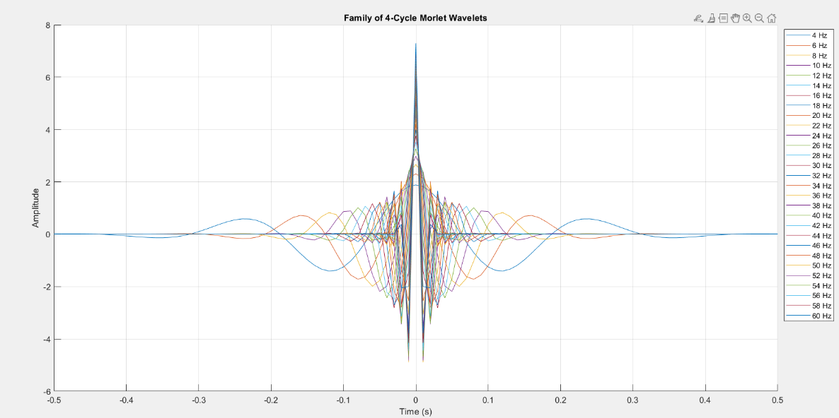
  - Complex wavelet convolution. Write code to perform wavelet convolution using the complex-valued wavelets you created in (a). Test your code by calculating the wavelet convolution of 5 perfect sine waves that are 10 seconds long, have a sampling frequency of 100 Hz, and have frequencies of 10 Hz, 20 Hz, 30 Hz, 40 Hz, and 50 Hz.
Plot the result of the wavelet convolution using the function imagesc. For example: imagesc(xAxis,yAxis,abs(waveletResult)) where xAxis will contain the time vector (in second), yAxis will contain the frequencies (in Hertz), and waveletResult will be a matrix where each row is the result of the convolution of the signal with one wavelet. Notice that the lowest frequencies are naturally at the top of the y-axis. To change this to have the lower frequencies on the bottom, use the command set(gca,’ydir’,’normal’);.
*Hints*: 1) Use a time vector for each sine wave from -5 to 5 seconds: t = -5:1/fs:5;
2) Be sure to use a real-valued sine wave to match EEG data: sineWave=sin(2*pi*f*t);
3) I used the jet colormap to display results. To use this, type colormap(jet); after the imagesc command.

The result of the wavelet convolution should look like this:

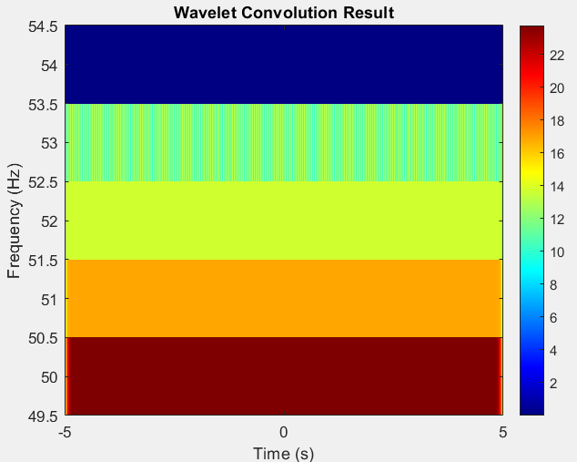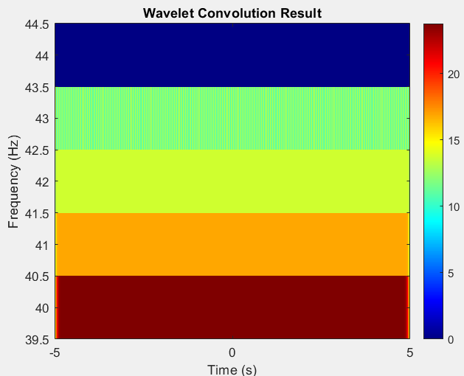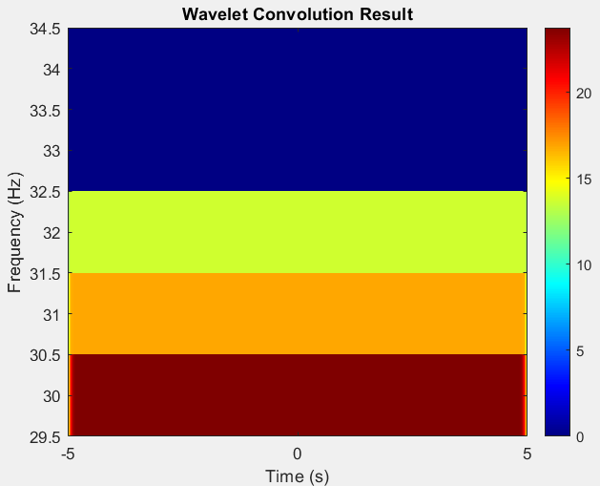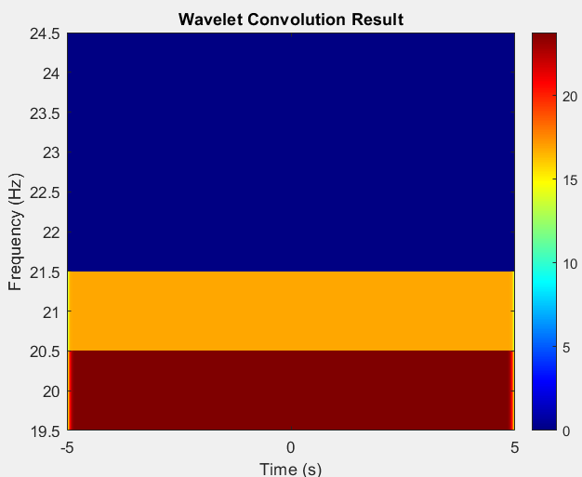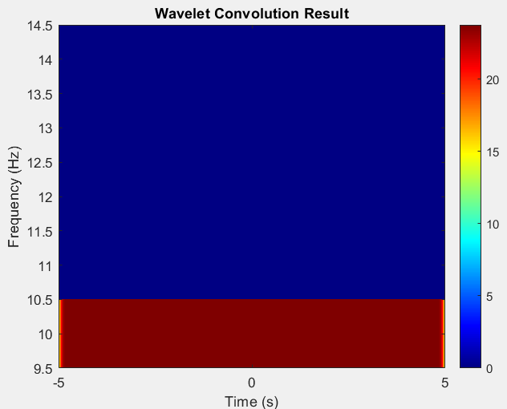

You should notice that you are not able to resolve all five frequencies with these parameters. Why not?
The wavelet duration is the same for all frequencies, ultimately leading to poor time resolution for higher frequencies. Higher frequency wavelets have narrower Gaussian windows, making them more sensitive to short time windows. Lower frequency wavelets have wider envelopes, causing frequency smearing. The sampling frequency (100 Hz) might limit precision at higher frequencies.
  - Frequency resolution. Now change the sampling rate from 100 Hz to 2048 Hz. Now change the sampling frequency to 2048 Hz to match the P300 EEG dataset. If our wavelet convolution code works with test signals that match the dataset, then we can be confident that it will work when we apply it to the real data.
Repeat part (b) at the higher sampling rate. You should now be able to resolve all 5 frequencies.
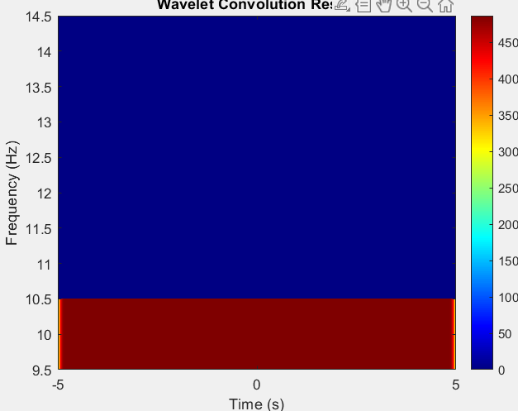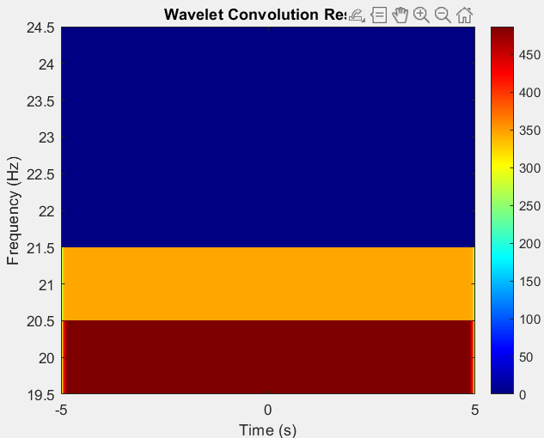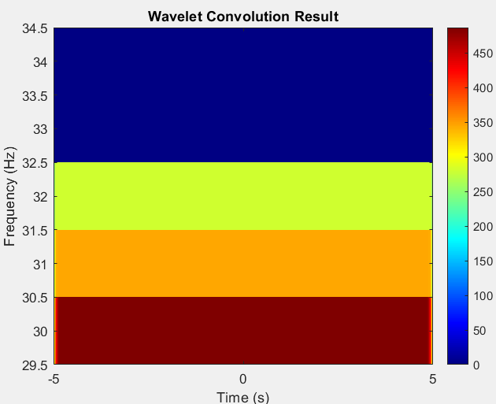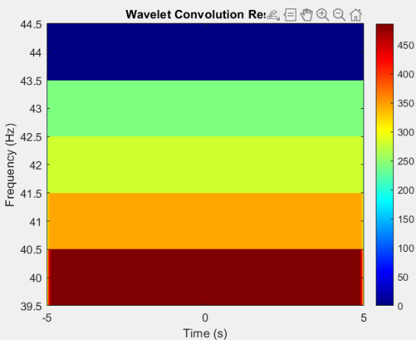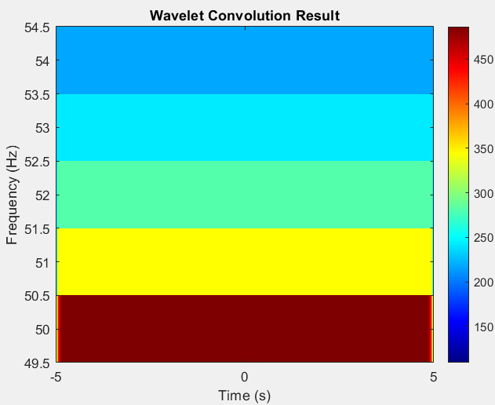

What is the theoretical maximum frequency you can resolve?
- While 1024 Hz is the theoretical maximum, the actual resolution depends on the wavelet's bandwidth and time resolution.
- The number of cycles (n) in the Morlet wavelet affects the balance between time and frequency resolution:
Lower cycles (e.g., 4 cycles) → Better time resolution but poor frequency resolution. Higher cycles (e.g., 8 cycles) → Better frequency resolution but poorer time resolution.
But what is the highest frequency you can resolve with these wavelet settings (fs=2048)? Let’s test it! Broaden the range of wavelet frequencies and sine waves you are using to see at what frequencies the sine waves are inadequately resolved. An approximate number (in Hertz) is fine. I tested sine waves from 200 to 1000 Hz in 100 Hz increments (sineFreqs = 200:100:1000;) with wavelets that ranged from 10 to 1000 Hz in 20 Hz increments (waveFreqs = 10:20:1000;) What is the highest frequency you can resolve before the signal is too distorted? The result should look like this:
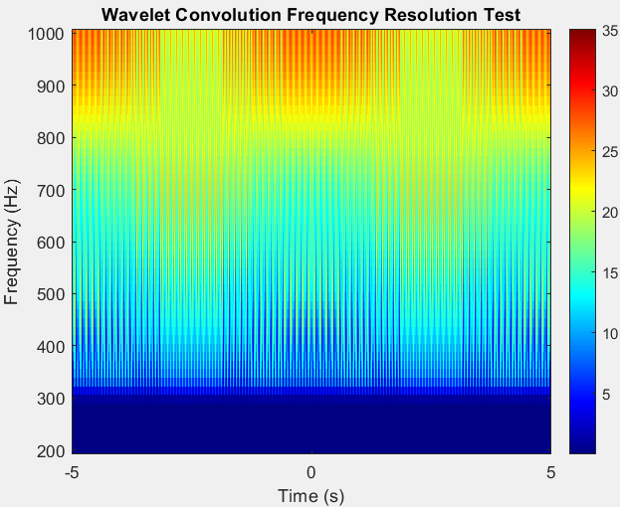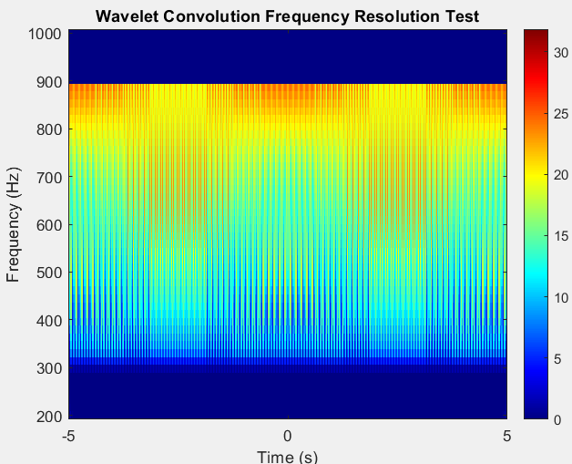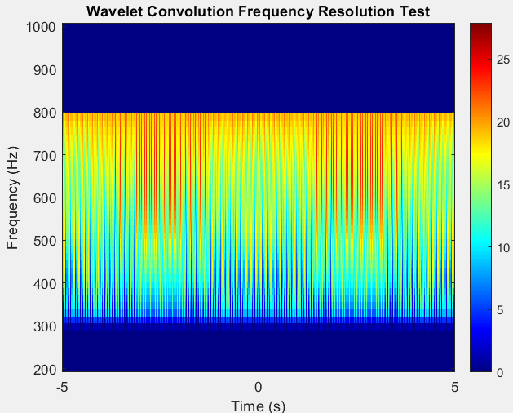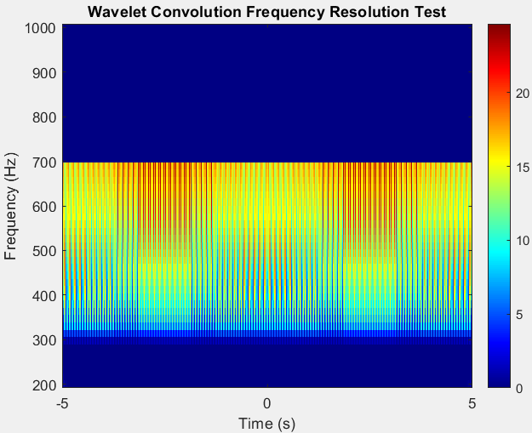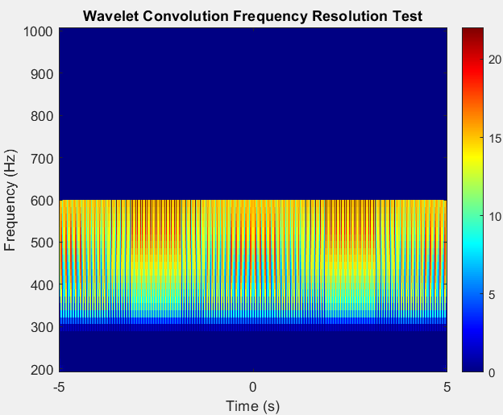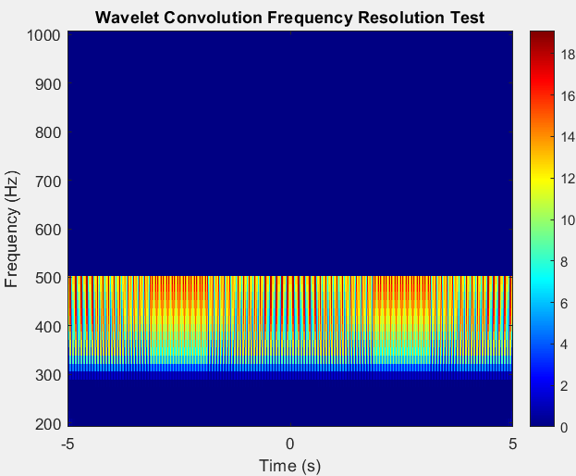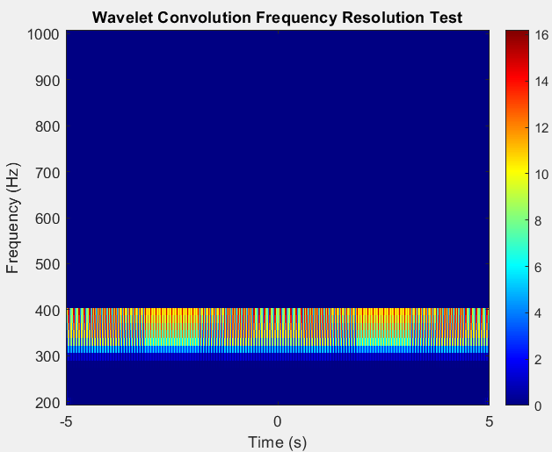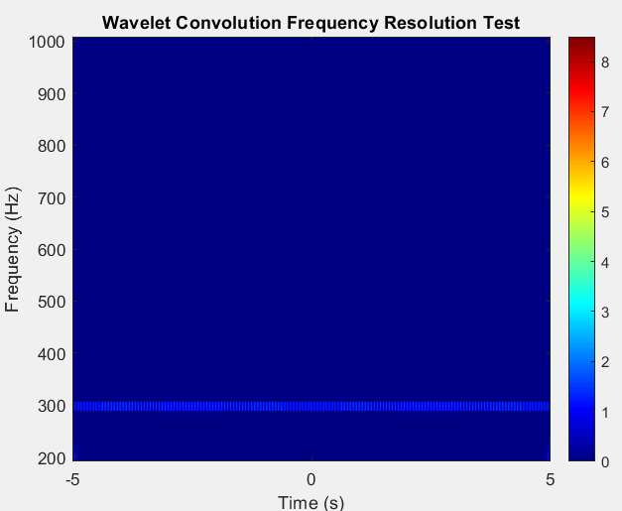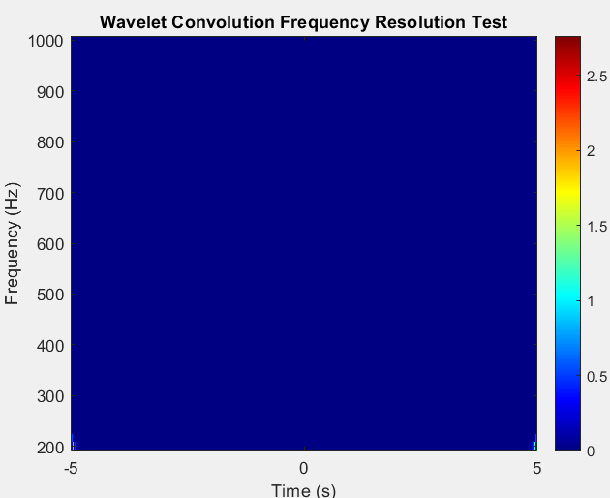

What is the effect of increasing the number of wavelet cycles to 8 (n=8)? What is the highest frequency you can resolve with these settings?
The result should look like this:

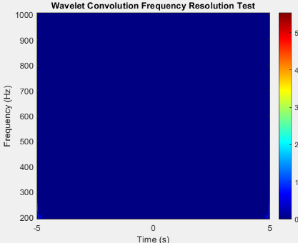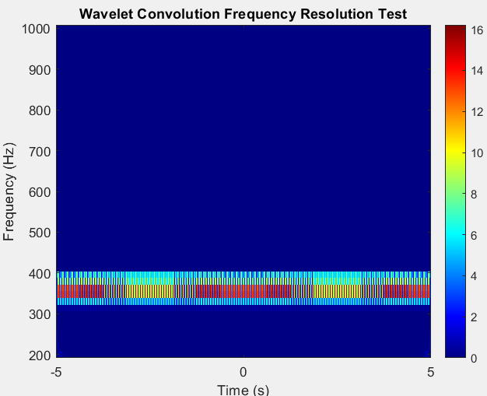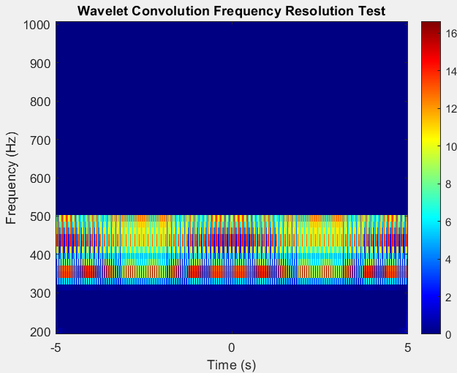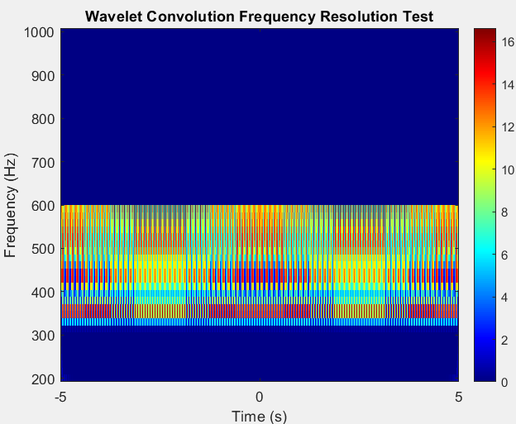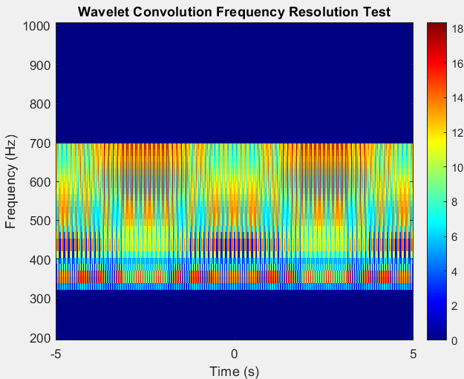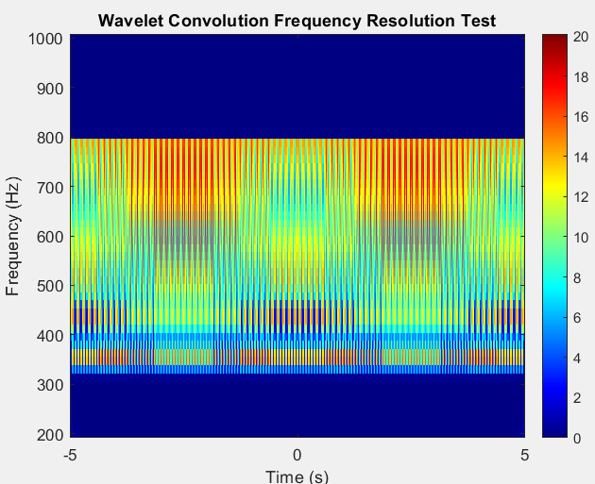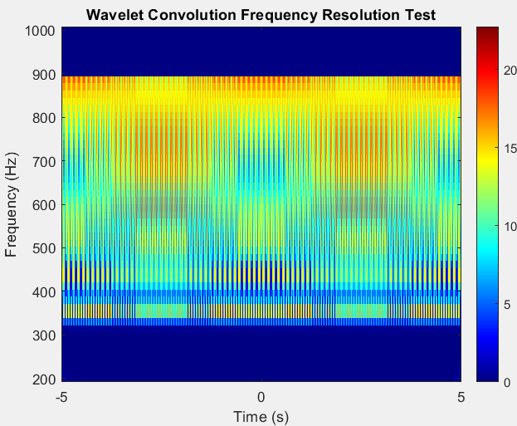

  - Temporal resolution. Now change your test signal to include an abrupt change in frequency from 10 Hz to 20 Hz and a sampling frequency of 100 Hz. For example, you could write:
>> testTime = (-5+1/fs):1/fs:5;
>> testSignal = nan(1,1000);
>> testSignal(1:500) = sin(2*pi*10*t(1:500));
>> testSignal(501:end) = sin(2*pi*20*t(501:end));
This is a “worst-case scenario” for studying the temporal resolution of the wavelet transform, since real data should not have this type of discontinuity.
Perform the wavelet convolution of this signal twice, once using n=3 and once using n=10, with wavelets over the range 4:60 Hz. For n=3 and n=10, plot the magnitude of the wavelet convolution result using imagesc. Also plot the magnitude of the wavelet convolution at 10 Hz versus time (this will be just one row of the wavelet convolution results).
The results should look like this:
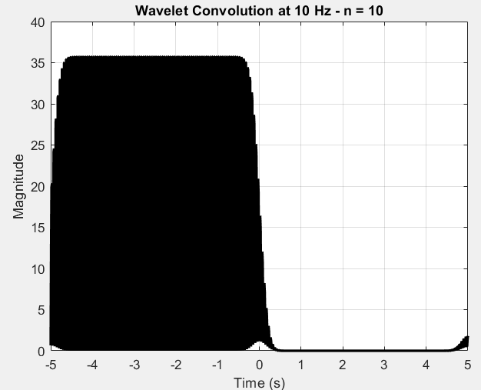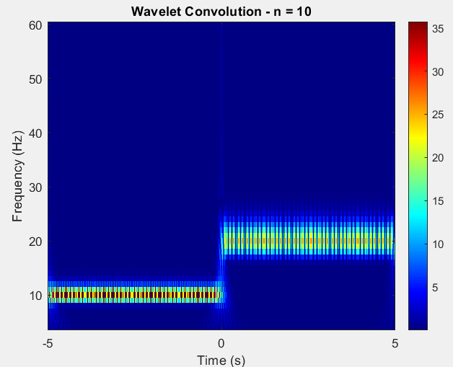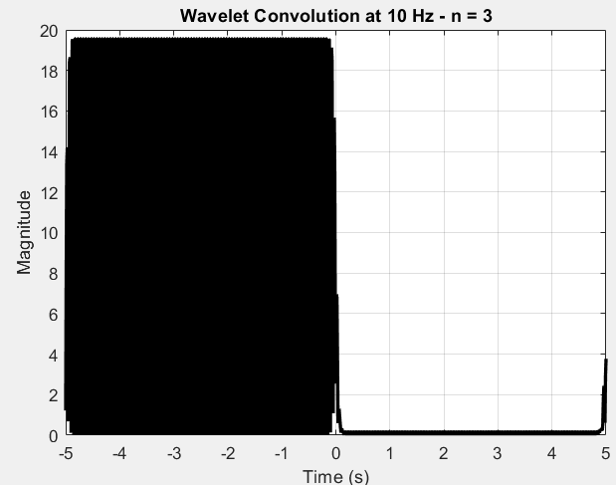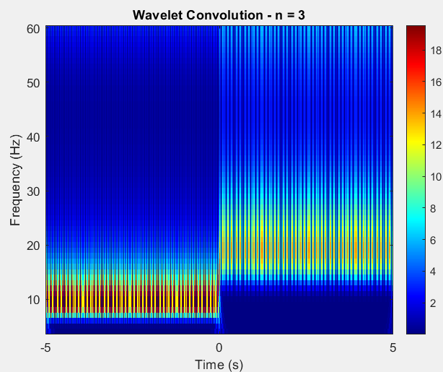

How much time does it take for the transition between 10 Hz and 20 Hz to occur, for both n=3 and n=10? The faster the transition occurs, the better the temporal precision is.
Based on your imagesc plots of the wavelet convolution results, which one (n=3 or n=10) has better frequency resolution?
- For better temporal resolution → Use n=3 (faster transition).
For better frequency resolution → Use n=10 (smoother separation of frequencies).

2. Wavelet convolution of the P300 dataset. Now that we have thoroughly tested out code on signals with known properties, we are ready to apply it to real data!
a. Load the dataset from subject 8, session 4, run 6 (eeg_200308290212_epochs.mat). Remember that the raw data has not been referenced and contains zeros at the end. We will analyze channel Cz (channel 32). First, pre-process the data:
- Extract channel 32 from data (e.g. Cz_data = data(32,:);)
- Find the zeros in Cz_data
- Remove the zeros from Cz_data as well as the referencing channels (mastoid channels 33 and 34)
- Re-reference Cz_data to the average of the mastoid channels
- De-mean the re-referenced data (subtract the mean)
Plot the pre-processed data versus time:

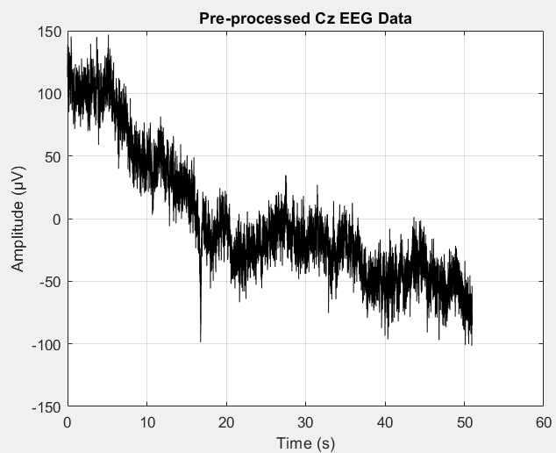
b. Use your code from Question 1 to do the wavelet convolution of the pre-processed data from channel Cz. Convolve the entire signal – do not extract the trials! Analyze frequencies from 4:60 Hz, and choose the wavelet settings to achieve good temporal resolution.
Plot the first 4 seconds of the magnitude of the wavelet convolution. This is the time-frequency decomposition of the EEG signal. You might need to adjust the color limits to see the variation in magnitude. To do this, use the function clim([0 5000]); or something similar. It should look something like this:
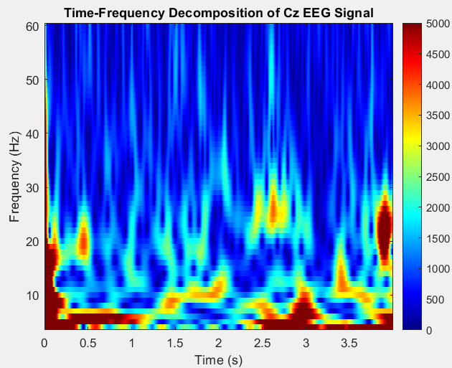
Note the dark red edge artifact at the beginning of the image. This is due to the wavelet sliding off the edge of the EEG signal, and this is the reason why we did not extract short trials of data before doing the wavelet convolution.

MATLAB CODE
1a)
clear; clc; close all;
% Define parameters
fs = 100; % Sampling frequency
t = -0.5:1/fs:0.5; % Time vector from -0.5 to 0.5 sec
n = 4; % Number of cycles
freqs = 4:2:60; % Frequency range from 4 Hz to 60 Hz with 2 Hz steps
% Initialize figure
figure;
hold on;
title('Family of 4-Cycle Morlet Wavelets');
xlabel('Time (s)');
ylabel('Amplitude');
grid on;
% Generate and plot Morlet wavelets
for f = freqs
s = n / (2 * pi * f); % Standard deviation of Gaussian envelope
A = 1 / ((s * sqrt(pi))^0.5); % Normalization factor
gauss_window = exp(-t.^2 / (2 * s^2));
wavelet = A * gauss_window .* exp(1i * 2 * pi * f * t); % Complex Morlet wavelet

plot(t, real(wavelet), 'DisplayName', sprintf('%d Hz', f)); % Plot real part
end
legend show;
hold off;

1b)
clear; clc; close all;
%% Step 1: Define Parameters
fs = 100; % Sampling frequency
t = -5:1/fs:5; % Time vector (-5 to 5 seconds)
n = 4; % Number of cycles
freqs = [10, 20, 30, 40, 50]; % Sine wave frequencies
%% Step 2: Generate Sine Waves
signals = zeros(length(freqs), length(t));
for i = 1:length(freqs)
signals(i, :) = sin(2 * pi * freqs(i) * t); % Real sine waves
end
%% Step 3: Create Morlet Wavelets
waveletResults = zeros(length(freqs), length(t)); % Store convolution results
for i = 1:length(freqs)
f = freqs(i);
s = n / (2 * pi * f); % Standard deviation of Gaussian
A = 1 / ((s * sqrt(pi))^0.5); % Normalization factor
gauss_window = exp(-t.^2 / (2 * s^2))
wavelet = A * gauss_window.* exp(1i * 2 * pi * f * t); % Complex wavelet
%% Step 4: Convolve Each Sine Wave with Corresponding Wavelet
convResult = conv(signals(i, :), wavelet, 'same'); % Convolution with same length
waveletResults(i, :) = abs(convResult); % Take absolute value (magnitude)
%% Step 5: Visualize the Wavelet Transform
figure;
imagesc(t, [f], abs(waveletResults)); % Plot result
set(gca, 'ydir', 'normal'); % Ensure low frequencies appear at the bottom
xlabel('Time (s)');
ylabel('Frequency (Hz)');
title('Wavelet Convolution Result');
colormap(jet);
colorbar;
end

1c)
% 1) Clear workspace and close all figures
clear; clc; close all;
% 2) Define parameters
fs = 2048; % Sampling rate
t = -5:1/fs:5; % Time vector
% 3) Define test sine waves from 200 Hz to 1000 Hz (in 100 Hz increments)
sineFreqs = 200:100:1000;
sineWaves = sin(2 * pi * sineFreqs' * t);

% 4) Define Morlet wavelet frequencies from 10 Hz to 1000 Hz (in 20 Hz increments)
waveFreqs = 10:20:1000;
n = 4; % 4-cycle Morlet wavelet
% 5) Perform wavelet convolution and store results
waveletResult = zeros(length(waveFreqs), length(t));
for i = 1:length(waveFreqs)
f = waveFreqs(i);
% Create Morlet wavelet
s = n / (2 * pi * f); % Wavelet standard deviation
A = 1 / ((s * sqrt(pi))^0.5); % Normalization factor
wavelet = A * exp(-t.^2 / (2 * s^2)) .* exp(1i * 2 * pi * f * t);
% Convolve wavelet with each sine wave and store absolute result
waveletConv = zeros(size(sineWaves));
for j = 1:length(sineFreqs)
waveletConv(j, :) = abs(conv(sineWaves(j, :), real(wavelet), 'same'));
end
% Store result for this wavelet frequency
waveletResult(i, :) = mean(waveletConv, 1);
% 6) Plot the time-frequency representation
figure;
imagesc(t, sineFreqs, abs(waveletResult));
set(gca, 'ydir', 'normal'); % Flip y-axis so lower frequencies are at the bottom
xlabel('Time (s)');
ylabel('Frequency (Hz)');
title('Wavelet Convolution Frequency Resolution Test');
colormap(jet);
colorbar;
end

p2

% 1) Clear workspace and close all figures
clear; clc; close all;
% 2) Define parameters
fs = 2048; % Sampling rate
t = -5:1/fs:5; % Time vector

% 3) Define test sine waves from 200 Hz to 1000 Hz (in 100 Hz increments)
sineFreqs = 200:100:1000;
sineWaves = sin(2 * pi * sineFreqs' * t);

% 4) Define Morlet wavelet frequencies from 10 Hz to 1000 Hz (in 20 Hz increments)
waveFreqs = 10:20:1000;
n = 8; % 4-cycle Morlet wavelet

% 5) Perform wavelet convolution and store results
waveletResult = zeros(length(waveFreqs), length(t));

for i = 1:length(waveFreqs)
f = waveFreqs(i);

% Create Morlet wavelet
s = n / (2 * pi * f); % Wavelet standard deviation
A = 1 / ((s * sqrt(pi))^0.5); % Normalization factor
wavelet = A * exp(-t.^2 / (2 * s^2)) .* exp(1i * 2 * pi * f * t);

% Convolve wavelet with each sine wave and store absolute result
waveletConv = zeros(size(sineWaves));
for j = 1:length(sineFreqs)
waveletConv(j, :) = abs(conv(sineWaves(j, :), real(wavelet), 'same'));
end

% Store result for this wavelet frequency
waveletResult(i, :) = mean(waveletConv, 1);
% 6) Plot the time-frequency representation
figure;
imagesc(t, sineFreqs, abs(waveletResult));
set(gca, 'ydir', 'normal'); % Flip y-axis so lower frequencies are at the bottom
xlabel('Time (s)');
ylabel('Frequency (Hz)');
title('Wavelet Convolution Frequency Resolution Test');
colormap(jet);
colorbar;
end

1d)
% 1) Clear workspace and close all figures
clear; clc; close all;
% 2) Define parameters
fs = 100; % Sampling rate (100 Hz)
t = -5:1/fs:5; % Time vector (-5 to 5 seconds)
% 3) Create a test signal with an abrupt frequency change (10 Hz -> 20 Hz)
testSignal = nan(1, length(t));
testSignal(1:floor(length(t)/2)) = sin(2 * pi * 10 * t(1:floor(length(t)/2))); % First half: 10 Hz
testSignal(floor(length(t)/2)+1:end) = sin(2 * pi * 20 * t(floor(length(t)/2)+1:end)); % Second half: 20 Hz
% 4) Define wavelet frequencies (4 Hz to 60 Hz)
waveFreqs = 4:60;
% 5) Function to perform wavelet convolution
performWaveletConvolution(testSignal, t, fs, waveFreqs, 3, 'n = 3'); % For n=3
performWaveletConvolution(testSignal, t, fs, waveFreqs, 10, 'n = 10'); % For n=10
% Function to compute wavelet convolution
function performWaveletConvolution(signal, t, fs, waveFreqs, n, titleStr)
waveletResult = zeros(length(waveFreqs), length(t));
for i = 1:length(waveFreqs)
f = waveFreqs(i);
% Create Morlet wavelet
s = n / (2 * pi * f); % Wavelet standard deviation
A = 1 / ((s * sqrt(pi))^0.5); % Normalization factor
wavelet = A * exp(-t.^2 / (2 * s^2)) .* exp(1i * 2 * pi * f * t);
% Convolve wavelet with signal
waveletConv = abs(conv(signal, real(wavelet), 'same'));
% Store result for this frequency
waveletResult(i, :) = waveletConv;
end
% 6) Plot time-frequency representation
figure;
imagesc(t, waveFreqs, waveletResult);
colormap(jet);
set(gca, 'ydir', 'normal'); % Flip y-axis for frequency order
xlabel('Time (s)');
ylabel('Frequency (Hz)');
title(['Wavelet Convolution - ' titleStr]);
colorbar;
% 7) Plot the magnitude of wavelet convolution at 10 Hz
figure;
plot(t, waveletResult(waveFreqs == 10, :), 'k', 'LineWidth', 2);
xlabel('Time (s)');
ylabel('Magnitude');
title(['Wavelet Convolution at 10 Hz - ' titleStr]);
grid on;
end

2a)
% 1) Clear workspace and close figures
clear; clc; close all;
% 2) Load EEG dataset
load('eeg_200308290212_epochs.mat'); % Load dataset
% 3) Extract Cz channel (Channel 32)
Cz_data = data(32, :);
% 4) Find zeros in Cz_data (unused parts of the EEG recording)
zero_indices = find(Cz_data == 0);
% 5) Remove zeros from Cz_data and mastoid channels (Ch. 33 & 34)
Cz_data(zero_indices) = [];
mastoid_33 = data(33, :);
mastoid_34 = data(34, :);
mastoid_33(zero_indices) = [];
mastoid_34(zero_indices) = [];
% 6) Re-reference Cz to the average of mastoid channels
Cz_reref = Cz_data - mean([mastoid_33; mastoid_34]);
% 7) De-mean the re-referenced data
Cz_reref = Cz_reref - mean(Cz_reref);
% 8) Create time vector (assuming known sampling frequency)
fs = 2048; % P300 EEG dataset uses 2048 Hz
time = (0:length(Cz_reref)-1) / fs;
% 9) Plot pre-processed EEG data
figure;
plot(time, Cz_reref, 'k');
xlabel('Time (s)');
ylabel('Amplitude (µV)');
title('Pre-processed Cz EEG Data');
grid on;

2b)
% 1) Clear workspace and close figures
clear; clc; close all;
% 2) Load EEG dataset and pre-process (as done in the previous step)
load('eeg_200308290212_epochs.mat'); % Load dataset
% 3) Extract Cz channel (Ch. 32) and mastoid channels (Ch. 33 & 34)
Cz_data = data(32, :);
mastoid_33 = data(33, :);
mastoid_34 = data(34, :);
% 4) Remove zero values (unused parts of EEG recording)
zero_indices = find(Cz_data == 0);
Cz_data(zero_indices) = [];
mastoid_33(zero_indices) = [];
mastoid_34(zero_indices) = [];
% 5) Re-reference Cz to the average of mastoid channels
Cz_reref = Cz_data - mean([mastoid_33; mastoid_34]);
% 6) De-mean the re-referenced data
Cz_reref = Cz_reref - mean(Cz_reref);
% 7) Define sampling frequency and time vector
fs = 2048; % EEG dataset sampling rate
time = (0:length(Cz_reref)-1) / fs; % Time vector
% 8) Define wavelet parameters
frequencies = 4:60; % Frequency range (4-60 Hz)
n_cycles = 6; % Choose n for good temporal resolution
time_wavelet = -0.5:1/fs:0.5; % Time vector for wavelets
% 9) Compute wavelets
wavelet_matrix = zeros(length(frequencies), length(Cz_reref)); % Initialize result
for fi = 1:length(frequencies)
f = frequencies(fi);
s = n_cycles / (2 * pi * f); % Standard deviation
A = 1 / ((s * sqrt(pi))^0.5); % Amplitude factor
wavelet = A * exp(-time_wavelet.^2 / (2 * s^2)) .* exp(1i * 2 * pi * f * time_wavelet); % Complex Morlet wavelet
% Convolution in frequency domain for efficiency
conv_result = conv(Cz_reref, wavelet, 'same'); % Same length as signal
wavelet_matrix(fi, :) = abs(conv_result); % Store magnitude of result
end
% 10) Plot time-frequency decomposition (first 4 seconds)
figure;
imagesc(time(1:fs*4), frequencies, wavelet_matrix(:, 1:fs*4)); % First 4 sec
xlabel('Time (s)');
ylabel('Frequency (Hz)');
title('Time-Frequency Decomposition of Cz EEG Signal');
set(gca, 'ydir', 'normal'); % Flip y-axis so low freq is at bottom
clim([0 5000]); % Adjust color limits
colormap(jet);
colorbar;

