EE 638/738 Neural Data Analysis

Assignment 5

CHARITH SAI SATHVIK ALE
Cale2
Dr. Rachel June Smith

02/20/2025
Spring 2025



Hilbert Transform and Bandpass Filtering
We will not use the Hoffman dataset this week.
For each question, copy/paste the figure associated with the question. At the end of the document, copy/paste all code from your scripts and functions used to generate the figures.
**Please label the axes of all plots and use appropriate units, i.e. Hertz, second, etc.**
Use the simulateEEG function to generate 5 seconds of simulated EEG data at a sampling rate of 200 Hz. Then add a 5 Hz sine wave with an amplitude of 0.1:
fs = 200;
[simEEG, simTime] = simulateEEG(fs,5*fs);
simEEG = simEEG + 0.1*sin(2*pi*5*simTime)’;
This is the signal you will analyze this week. Use the simulateEEG function from the solution of Homework 3 so that you know it is working properly.
- Hilbert transform of raw data. Take the Hilbert transform of the raw simEEG vector using the hilbert function and calculate the phase and the amplitude. Create two plots of the results:
  - A plot of the raw data and the amplitude on the same axes
  - A plot of the phase
Describe the phase and amplitude results. Do they accurately characterize the simulated EEG signal?
The amplitude envelope correctly tracks energy fluctuations, highlighting the added 5 Hz component. The instantaneous phase smoothly progresses, capturing the cyclic nature of the EEG signal. These results accurately characterize the simulated EEG, providing insights into oscillatory behavior.

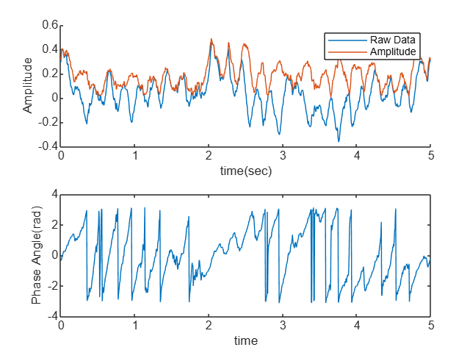

- Bandpass filtering. In the previous question, you should have seen that the results of the Hilbert transform are unpredictable when the data contains a range of frequencies. This is why it is necessary to apply a bandpass filter before using the Hilbert transform.
  - Design a bandpass filter. Use the MATLAB function firls to design a bandpass filter that will isolate the 4-7 Hz (theta) frequency band. Then use the function freqz to calculate the frequency response of the filter.
    - List the parameters used to design the filter (f,a,n)
    - A plot of the filter kernel
    - A plot showing the ideal filter shape and the actual filter shape on the same axes, as a function of frequency

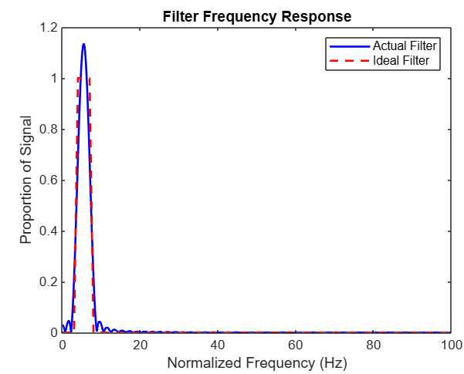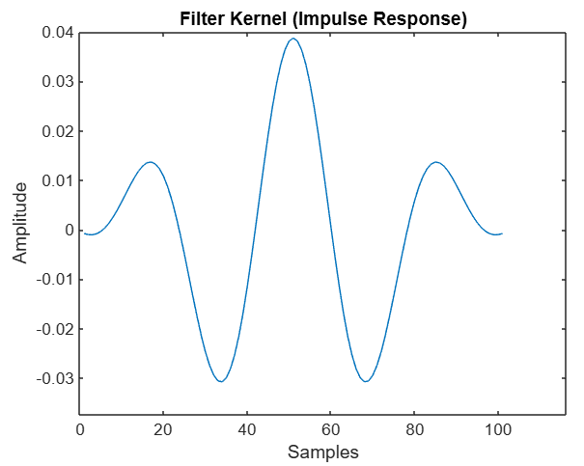
  - Calculate sum of squared error. Compare the ideal filter shape to the actual filter shape by calculating the sum of squared error. The function interp1 will be helpful here. It will help you turn the ideal filter shape into a function with the same number of data points as the actual response.
**Hint**, something like: idealVals = interp1(f,a,w);
What is the sum of squared error for your filter? Remember that this value should be much less than 1.
"Sum of squared error = " "2.8726"

  - Test the filter. Test your filter by applying it to 10 sine waves with frequencies of 1:10 Hz. Use the MATLAB function filtfilt to do this. Note that the second input to filtfilt (the variable “a”) should be 1. Show all 10 sine waves after they have gone through your filter. Which frequencies are completely removed by your filter? Which frequencies are attenuated, but still pass through the filter?

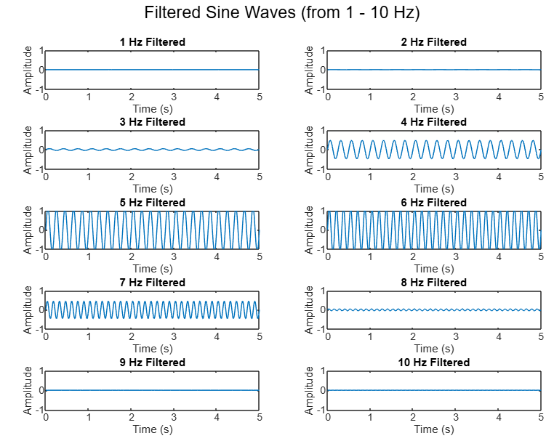
  - Apply the filter to the data. Now that you have tested your filter, apply it to the simEEG data that you generated. Turn in a plot showing the raw data and the filtered data on the same axes.

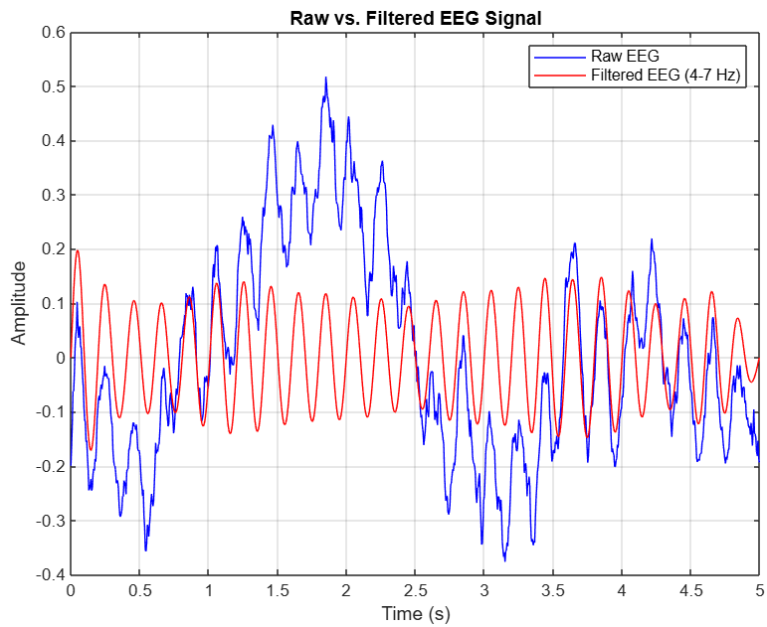

- Hilbert transform of filtered data. Apply the Hilbert transform to the filtered data, and calculate the amplitude and the phase. As you did in Question #1, create two plots of the results:
  - A plot of the filtered data and the amplitude on the same axes
  - A plot of the phase
The amplitude and phase measurements should now accurately characterize the filtered data.

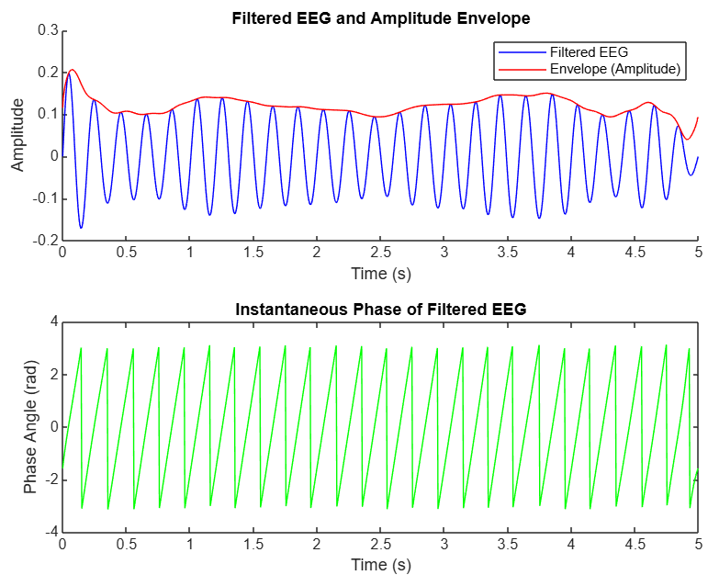

MATLAB Code:
1a)
clc; clear; close all;

% Call the function with different parameters
fs = 200;
[simEEG, time] = simulateEEG(fs,5*fs);
simEEG = simEEG + 0.1*sin(2*pi*5*time);
k=hilbert(simEEG);
subplot(2,1,1)
hold on
plot(time,k)
plot(time,abs(k))
hold off
xlabel('time(sec)')
ylabel('Amplitude')
legend('Raw Data','Amplitude')
subplot(2,1,2)
plot(time,angle(k))
xlabel('time(s)')
ylabel('Phase Angle(rad)')

% Function should be defined at the end of the script
function [simEEG, time] = simulateEEG(fs, nSamples)
whiteNoise = randn(nSamples, 1); % Ensure it's a column vector
FFT_white = fft(whiteNoise);
f_axis = (1:nSamples)' * (fs / nSamples); % Ensure it's a column vector
f_axis(1) = 1; % Avoid division by zero at DC component
scalingFactor = 1 ./ f_axis; % Column vector
FFT_scaled = FFT_white .* scalingFactor; % Apply scaling
FFT_symmetric = [FFT_scaled(1:floor(nSamples/2)); flipud(FFT_scaled(2:floor(nSamples/2)))];
simEEG = real(ifft(FFT_symmetric, nSamples)); % Ensure nSamples points
time = (0:nSamples-1)' / fs; % Ensure it's a column vector

% Debug: Check size of variables
disp(['Size of simEEG: ', num2str(size(simEEG, 1)), ' x ', num2str(size(simEEG, 2))]);
disp(['Size of time: ', num2str(size(time, 1)), ' x ', num2str(size(time, 2))]);

% Plot the simulated EEG signal
figure;
plot(time, simEEG, 'b');
xlabel('Time (s)');
ylabel('Amplitude');
title(sprintf('Simulated EEG Signal (fs = %d Hz, nSamples = %d)', fs, nSamples));
grid on;
end

2a, 2b)
clc; clear; close all;

fs = 200; % Sampling frequency
n = 100; % Filter order
f = [0 3 4 7 8 fs/2] / (fs/2); % Normalized frequencies
a = [0 0 1 1 0 0]; % Desired amplitude response

% Design the bandpass filter using firls
b = firls(n, f, a);
figure;
plot(b);
xlabel('Samples');
ylabel('Amplitude');
title('Filter Kernel (Impulse Response)');
[H, W] = freqz(b, 1, 1024, fs); % Compute frequency response

figure;
plot(W, abs(H), 'b', 'LineWidth', 1.5); % Actual filter response
hold on;
plot([0 3 4 7 8 fs/2], [0 0 1 1 0 0], 'r--', 'LineWidth', 1.5); % Ideal response
xlabel('Normalized Frequency (Hz)');
ylabel('Proportion of Signal');
title('Filter Frequency Response');
legend('Actual Filter', 'Ideal Filter');
hold off;

% Interpolate the ideal filter shape to match the frequency response
IdealVals = interp1(f*(fs/2),a,W,"linear","extrap");
sse = sum(abs(H)-abs(IdealVals)).^2;
disp(["sum of squared error = ", num2str(sse)]);

2c)
clc; clear; close all;
% Sampling frequency and filter order
fs = 200;
n = 100;
% Define the bandpass filter (4-7 Hz)
f = [0 3 4 7 8 fs/2] / (fs/2); % Normalized frequencies
a = [0 0 1 1 0 0]; % Desired amplitude response
% Design the filter using firls
b = firls(n, f, a);
% Time vector (5 seconds)
t = 0:1/fs:5;
% Test frequencies from 1 Hz to 10 Hz
frequencies = 1:10;
filtered_signals = zeros(length(frequencies), length(t));
% ---- Combined Plot ----
figure;
hold on;
for i = 1:length(frequencies)
% Generate sine wave
testSignal = sin(2 * pi * frequencies(i) * t);
% Apply bandpass filter
filtered_signals(i, :) = filtfilt(b, 1, testSignal);
end
% ---- Subplots
figure;
for i = 1:length(frequencies)
subplot(5, 2, i); % Create a 5-row, 2-column subplot grid
plot(t, filtered_signals(i, :));
title(sprintf('%d Hz Filtered', frequencies(i)));
xlabel('Time (s)');
ylabel('Amplitude');
ylim([-1 1]); % Set Y-axis limits for better visualization
end
sgtitle('Filtered Sine Waves (from 1 - 10 Hz)'); % Super title for all subplots

2d)
clc; clear; close all;
% Define parameters
fs = 200; % Sampling frequency
nSamples = 5 * fs; % Number of samples (5 seconds of data)
% Generate simulated EEG data
[simEEG, time] = simulateEEG(fs, nSamples);
simEEG = simEEG + 0.1 * sin(2 * pi * 5 * time); % Add a 5 Hz sine wave
% Bandpass filter parameters
n = 100; % Filter order
f = [0 3 4 7 8 fs/2] / (fs/2); % Normalized frequencies
a = [0 0 1 1 0 0]; % Desired amplitude response
% Design the filter
b = firls(n, f, a);
% Apply the bandpass filter
filteredEEG = filtfilt(b, 1, simEEG);
% ---- Plot Raw and Filtered EEG Signals ----
figure;
plot(time, simEEG, 'b', 'DisplayName', 'Raw EEG'); hold on;
plot(time, filteredEEG, 'r', 'DisplayName', 'Filtered EEG (4-7 Hz)');
xlabel('Time (s)');
ylabel('Amplitude');
title('Raw vs. Filtered EEG Signal');
legend;
grid on;
hold off;
% ---- Simulated EEG Function ----
function [simEEG, time] = simulateEEG(fs, nSamples)
whiteNoise = randn(nSamples, 1); % White noise (column vector)
FFT_white = fft(whiteNoise);
f_axis = (1:nSamples)' * (fs / nSamples); % Frequency axis (column vector)
f_axis(1) = 1; % Avoid division by zero
scalingFactor = 1 ./ f_axis; % Scale factor (1/f decay)
FFT_scaled = FFT_white .* scalingFactor; % Apply scaling
FFT_symmetric = [FFT_scaled(1:floor(nSamples/2)); flipud(FFT_scaled(2:floor(nSamples/2)))];
simEEG = real(ifft(FFT_symmetric, nSamples)); % Inverse FFT for simulated EEG
time = (0:nSamples-1)' / fs; % Time vector (column)
end
3)
clc; clear; close all;
% Define parameters
fs = 200; % Sampling frequency
nSamples = 5 * fs; % Number of samples (5 seconds of data)
% Generate simulated EEG data
[simEEG, time] = simulateEEG(fs, nSamples);
simEEG = simEEG + 0.1 * sin(2 * pi * 5 * time); % Add a 5 Hz sine wave
% Bandpass filter parameters
n = 100; % Filter order
f = [0 3 4 7 8 fs/2] / (fs/2); % Normalized frequencies
a = [0 0 1 1 0 0]; % Desired amplitude response
% Design the filter
b = firls(n, f, a);
% Apply the bandpass filter
filteredEEG = filtfilt(b, 1, simEEG);
% ---- Plot Raw and Filtered EEG Signals ----
figure;
plot(time, simEEG, 'b', 'DisplayName', 'Raw EEG'); hold on;
plot(time, filteredEEG, 'r', 'DisplayName', 'Filtered EEG (4-7 Hz)');
xlabel('Time (s)');
ylabel('Amplitude');
title('Raw vs. Filtered EEG Signal');
legend;
grid on;
hold off;
% ---- Hilbert Transform Analysis ----
k = hilbert(filteredEEG); % Hilbert transform of filtered EEG
figure;
subplot(2,1,1);
hold on;
plot(time, filteredEEG, 'b', 'DisplayName', 'Filtered EEG');
plot(time, abs(k), 'r', 'DisplayName', 'Envelope (Amplitude)');
xlabel('Time (s)');
ylabel('Amplitude');
legend;
title('Filtered EEG and Amplitude Envelope');
hold off;
subplot(2,1,2);
plot(time, angle(k), 'g');
xlabel('Time (s)');
ylabel('Phase Angle (rad)');
title('Instantaneous Phase of Filtered EEG');
% ---- Simulated EEG Function ----
function [simEEG, time] = simulateEEG(fs, nSamples)
whiteNoise = randn(nSamples, 1); % White noise (column vector)
FFT_white = fft(whiteNoise);
f_axis = (1:nSamples)' * (fs / nSamples); % Frequency axis (column vector)
f_axis(1) = 1; % Avoid division by zero
scalingFactor = 1 ./ f_axis; % Scale factor (1/f decay)
FFT_scaled = FFT_white .* scalingFactor; % Apply scaling
FFT_symmetric = [FFT_scaled(1:floor(nSamples/2)); flipud(FFT_scaled(2:floor(nSamples/2)))];
simEEG = real(ifft(FFT_symmetric, nSamples)); % Inverse FFT for simulated EEG
time = (0:nSamples-1)' / fs; % Time vector (column)
end

