EE 638/738 Neural Data Analysis

Assignment 6

CHARITH SAI SATHVIK ALE
Cale2
Dr. Rachel June Smith

03/01/2025
Spring 2025



Intertrial Phase Clustering
For this homework assignment, we will compute ITPC from randomly generated signals and from the P300 dataset from Hoffman et al. 2008.
For each question, copy/paste the figure associated with the question. At the end of the document, copy/paste all code from your scripts and functions used to generate the figures.
**Please label the axes of all plots and use appropriate units, i.e. Hertz, second, etc.**
To make sure you have the correct starting point for this homework, a function called p300_wavelet has been written for you and posted with this homework assignment. The function loads in the dataset associated with the 6th run of the 4th session for subject 8 (eeg_200308290212_epochs.mat). The function calculates the wavelet convolution for one channel at one frequency and returns the wavelet convolution for target and non-target trials as well as a time vector. The function must be saved in the same current directory as where the data is saved. You will use this function for Question 2.
- Significance level for intertrial phase clustering (ITPC). We will first apply the ITPC measure to randomly distributed vectors. This will help us validate our code and will allow us to calculate a significance level for ITPC based on the number of trials.
  - Write a small piece of code to calculate the ITPC of n=100 randomly generated phase vectors using a uniform distribution. See lecture 11, slide18 for an example of how to do this. Here, each vector in complex space represents the phase of an oscillation from one trial (so we have a total of 100 trials) at a single point in time. The MATLAB function rand will output a uniform distribution of values.

Now expand your code to do the ITPC calculation 1000 times, using a new set of random vectors for each iteration. Save the ITPC value for each iteration and plot a histogram of the results. You can use the MATLAB function histogram to do this. You should see that, over 1000 iterations, the mean value of ITPC is approximately 0.06 and that the highest values are around 0.25.
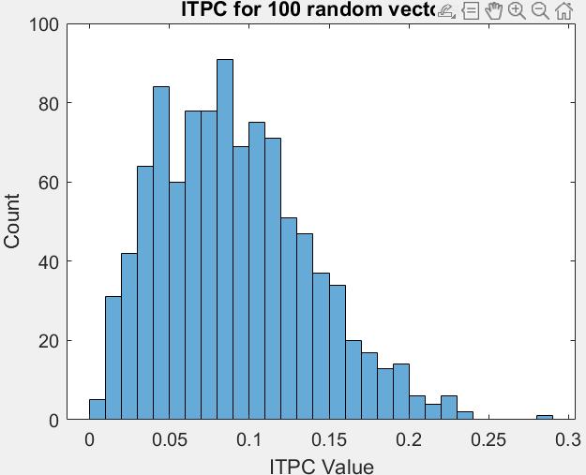
Mean ITPC Value: 0.088117
  - In Question 1A, we saw that even a random selection of phase vectors can produce seemingly significant values of ITPC. In this question, we will calculate the mean value of ITPC and a rough estimate of the 99% significance level as we vary the number of trials.

Modify your code from Question 1A to calculate the mean value of the ITPC for n=1 to n=200 trials. Use 1000 iterations of the ITPC calculation for each value of n. In addition to calculating the mean, calculate the threshold that separates the lowest 99% of values from the top 1%. If an ITPC value is above this threshold, we can be relatively confident that it is significant.

Hint: You might use the MATLAB function sort to sort the ITPC vector from the smallest to the largest value. Then you know that the last 1000*0.01 = 10 values represent the highest 1% of ITPC values. (Also see Figure 19.5 in the Cohen book.)
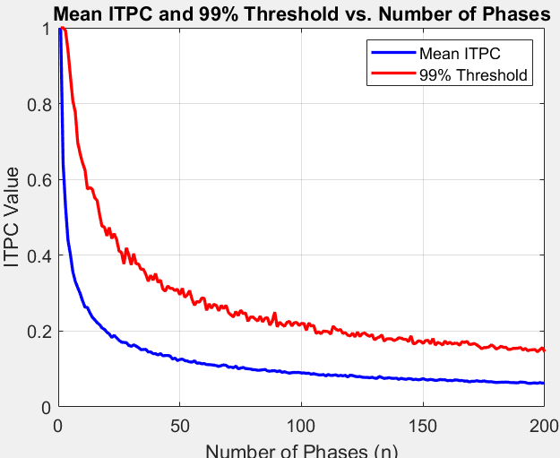
- ITPC for the P300 dataset. Now we will apply the ITPC measure to the P300 EEG dataset.
  - Let’s calculate the ITPC for one electrode at one frequency. Use the function p300_wavelet to calculate the wavelet convolution of channel 32 at 5 Hz. As outputs, the function will give you matrices of the wavelet convolution for both target and non-target trials. The time vector will go from -0.4 to 0.8 seconds after the stimulus.

Using the function imagesc, create raster plots of the phase angles for both target and non-target trial matrices. Each row will represent one trial, and the color represents phase.
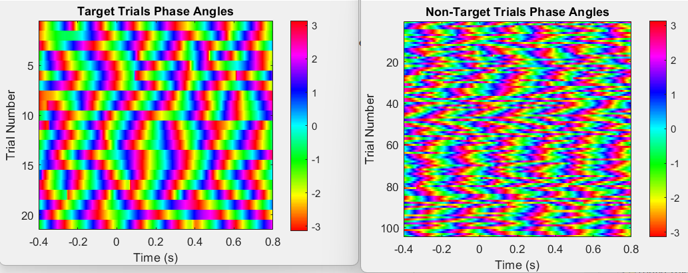
  - Now calculate the ITPC value as a function of time, for both target trials and non-target trials. You will use the target/non-target matrices you generated in Question 2A.

Note: Recall that the ITPC calculation requires that the magnitude of the complex vector be equal to 1. Thus, we must normalize the magnitude of the wavelet convolution such that each time point has a magnitude of 1 by dividing by the magnitude at each time point.
targetTrials_normed = targetTrials./abs(targetTrials);
nonTargetTrials_normed = nonTargetTrials./abs(nonTargetTrials);
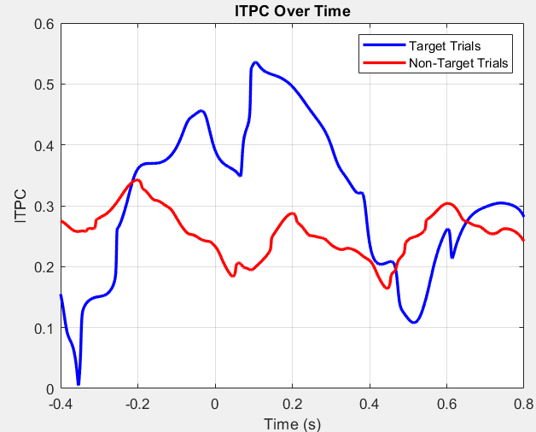
  - Based on your significance testing in Question 1B, what is the 99% significance threshold for the target trials? Does the ITPC value for target trials exceed this threshold?

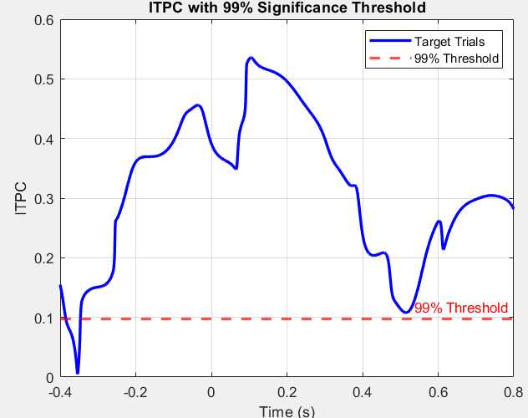
99% significance threshold for ITPC: 0.097157
Max ITPC for target trials: 0.53591
The ITPC for target trials exceeds the 99% significance threshold.99% significance threshold for
  - Based on your significance testing in Question 1B, what is the the 99% significance threshold for the non-target trials? Does the ITPC value for non-target trials exceed this threshold?
99% significance threshold for ITPC: 0.056097
Max ITPC for non-target trials: 0.53591
The ITPC for non-target trials exceeds the 99% significance threshold.

MATLAB Script:
1a)
n = 100; % Number of phase values per trial
num_t = 1000; % Number of trials
ITPC_values = zeros(num_t, 1); % Preallocate for speed
for j = 1:numTrials
p = rand(n,1)*2*pi - pi; % Generate random phase values between -pi and pi
pVec = exp(1i*p); % Create complex phase vector
ITPC_values(j) = abs(mean(pVec)); % Compute ITPC
end
mean_ITPC = mean(ITPC_values);
disp(['Mean ITPC Value: ', num2str(mean_ITPC)]);
% Plot histogram
histogram(ITPC_values, 'BinWidth', 0.01); % Adjust bin width if needed
title('ITPC for 100 random vectors');
xlabel('ITPC Value');
ylabel('Count');
set(gca, 'FontSize', 12); % Improve readability

1b)
num_t = 1000; % Number of trials for each value of n
n_values = 1:200; % Values of n from 1 to 200
mean_ITPC_val = zeros(length(n_values), 1); % Store mean ITPC for each n
th_ITPC_val = zeros(length(n_values), 1); % Store 99% threshold
for idx = 1:length(n_values)
n = n_values(idx); % Current value of n
ITPC_values = zeros(num_t, 1); % Store ITPC for each trial

for j = 1:num_t
p = rand(n,1) * 2 * pi - pi; % Generate random phase values between -pi and pi
pVec = exp(1i * p); % Create complex phase vector
ITPC_values(j) = abs(mean(pVec)); % Compute ITPC
end
% Compute mean ITPC for current n
mean_ITPC_val(idx) = mean(ITPC_values);

% Compute 99% threshold
sorted_ITPC = sort(ITPC_values); % Sort values in ascending order
th_ITPC_val(idx) = sorted_ITPC(round(numTrials * 0.99)); % Top 1% threshold
end
disp([ num2str(th_ITPC_val)]);
% Plot results
figure;
plot(n_values, mean_ITPC_val, 'b', 'LineWidth', 2);
hold on;
plot(n_values, th_ITPC_val, 'r', 'LineWidth', 2);
xlabel('Number of Phases (n)');
ylabel('ITPC Value');
legend('Mean ITPC', '99% Threshold');
title('Mean ITPC and 99% Threshold vs. Number of Phases');
grid on;
set(gca, 'FontSize', 12); % Improve readability
hold off;

2a,b)
% Define parameters
channel = 32; % Channel number
frequency = 5; % Frequency in Hz
% Call the p300_wavelet function
[targetTrials, nonTargetTrials, time] = p300_wavelet(channel, frequency);
% Extract phase angles from wavelet output
targetPhases = angle(targetTrials); % Phase angles for target trials
nonTargetPhases = angle(nonTargetTrials); % Phase angles for non-target trials
% Plot raster plot for target trials
figure;
imagesc(time, 1:size(targetPhases,1), targetPhases); % Time on x-axis, trials on y-axis
colormap(hsv); % Use HSV colormap for phase visualization
colorbar;
xlabel('Time (s)');
ylabel('Trial Number');
title('Target Trials Phase Angles');

% Plot raster plot for non-target trials
figure;
imagesc(time, 1:size(nonTargetPhases,1), nonTargetPhases);
colormap(hsv);
colorbar;
xlabel('Time (s)');
ylabel('Trial Number');
title('Non-Target Trials Phase Angles');

% Normalize the phase angles (divide by magnitude to get unit vectors)
targetTrials_normed = targetTrials ./ abs(targetTrials);
nonTargetTrials_normed = nonTargetTrials ./ abs(nonTargetTrials);

% Compute ITPC as the magnitude of the mean phase vector at each time point
ITPC_target = abs(mean(targetTrials_normed, 1)); % ITPC for target trials
ITPC_nonTarget = abs(mean(nonTargetTrials_normed, 1)); % ITPC for non-target trials

% Plot ITPC for target trials
figure;
plot(time, ITPC_target, 'b', 'LineWidth', 2);
hold on;
plot(time, ITPC_nonTarget, 'r', 'LineWidth', 2);
xlabel('Time (s)');
ylabel('ITPC');
title('ITPC Over Time');
legend('Target Trials', 'Non-Target Trials');
grid on;
hold off;

function [targetTrials, nonTargetTrials,time] = p300_wavelet(channel,frequency)
dataP300 = load('eeg_200308290211_epochs.mat');

fs = 2048; % sampling frequency

% Remove the zeros from the end of the dataset
datazeros = (sum(dataP300.data)==0);
lastDataPoint = find(diff(datazeros~=0));
data = dataP300.data(:,1:lastDataPoint);

% Remove mean from each channel
data = data - repmat(mean(data,2), 1, length(data));

% Re-reference the data
ref = 0.5*(data(33,:) + data(34,:));
data = data - repmat(ref,34,1);

% Build wavelet and perform wavelet convolution
nCycles = 4;
f = frequency;
s = nCycles/(2*pi*f);
A = 1/sqrt(s*sqrt(pi));
wTime = -0.5:1/fs:0.5;
wavelet = A*exp(1i*2*pi*f*wTime).*exp(-(wTime.^2)/(2*s^2));

wavelet_conv = conv(data(channel,:),wavelet,'same');

% Initialize matrix for trial data
timeBefore = 0.4;
timeAfter = 0.8;
ptsBefore = round(timeBefore*fs); % # of time points before stimulus
ptsAfter = round(timeAfter*fs); % # of time points after stimulus
time = (-ptsBefore:ptsAfter)/2048;

trials = zeros(length(dataP300.events), ptsBefore+ptsAfter+1);

% Extract trial data
for i=1:(length(dataP300.events)-1) %!!!!
elapsed = etime(dataP300.events(i,:), dataP300.events(1,:)); % elapsed time since trial 1
ind1 = round(elapsed*fs + 1 + 0.4*fs - ptsBefore);
ind2 = ind1 + ptsBefore + ptsAfter;
trials(i,:) = wavelet_conv(ind1:ind2);
end

%Perform wavelet convolution
targetBool = (dataP300.stimuli == dataP300.target);

targetTrials = trials(targetBool,:);
nonTargetTrials = trials(~targetBool,:);
nonTargetTrials = nonTargetTrials(1:end-1,:);

end
2c,d)
Note: round brackets() variables represent non target trials variables with same code instead of target trials .
% Define parameters.
numTrials = size(targetTrials(nontargetTrials), 1); % Number of trials in target trials
numIterations = 1000; % Number of random iterations
numTrialRange = 1:min(200, numTrials); % Limit max trials to numTrials

% Initialize ITPC storage
ITPC_simulated = zeros(length(numTrialRange), numIterations);

% Simulate ITPC for each trial count
for i = 1:length(numTrialRange)
n = numTrialRange(i); % Ensure n is within available trials

for j = 1:numIterations
% Randomly sample 'n' trials
randIndices = randperm(numTrials, min(n, numTrials));
randTrials = targetTrials_normed(nonTargetTrials_normed)(randIndices, :);

% Compute ITPC for the random sample
ITPC_simulated(i, j) = abs(mean(mean(randTrials, 1)));
end
end

% Sort ITPC values for significance threshold
sorted_ITPC = sort(ITPC_simulated(:));
threshold_99 = sorted_ITPC(round(0.99 * length(sorted_ITPC))); % 99th percentile threshold

% Display threshold value
disp(['99% significance threshold for ITPC: ', num2str(threshold_99)]);

% Check if actual ITPC exceeds threshold
significant_ITPC = ITPC_target(ITPC_nonTarget) > threshold_99;

% Plot ITPC with significance threshold
figure;
plot(time, ITPC_target(ITPC_nonTarget), 'b', 'LineWidth', 2);
hold on;
yline(threshold_99, '--r', '99% Threshold', 'LineWidth', 2);
xlabel('Time (s)');
ylabel('ITPC');
title('ITPC with 99% Significance Threshold');
legend('Target Trials(Non target trials)', '99% Threshold');
grid on;
hold off;
max_ITPC_target(max_ITPC_nonTarget) = max(ITPC_target(ITPC_nonTarget));
disp(['Max ITPC for target(non target) trials: ', num2str(max_ITPC_target(max_ITPC_nonTarget)]);

if max_ITPC_target(max_ITPC_nonTarget) > threshold_99
disp('The ITPC for target(non target) trials exceeds the 99% significance threshold.');
else
disp('The ITPC for target(non target) trials does NOT exceed the 99% significance threshold.');
end

