EE 638/738 Neural Data Analysis

Assignment 7

CHARITH SAI SATHVIK ALE
Cale2
Dr. Rachel June Smith

03/09/2025
Spring 2025



Surface Laplacian and Principal Components Analysis
For this homework assignment, we will answer theoretical questions about the surface Laplacian and perform PCA using the Hoffmann et al. 2008 dataset.
For each question, copy/paste the figure associated with the question. At the end of the document, copy/paste all code from your scripts and functions used to generate the figures.
**Please label the axes of all plots and use appropriate units, i.e. Hertz, second, etc.**
- The surface Laplacian:
  - Briefly describe the difference between the raw data and the surface Laplacian as shown below.
- The unprocessed raw EEG data measures voltage potentials across electrodes that represent brain activity near the electrodes and throughout distant areas.
- Through spatial filtering technology the surface Laplacian improves detection of nearby neural activities by minimizing distant signal influences. The second spatial derivative calculation of the voltage distribution increases spatial resolution while it aids in filtering volume conduction effects.
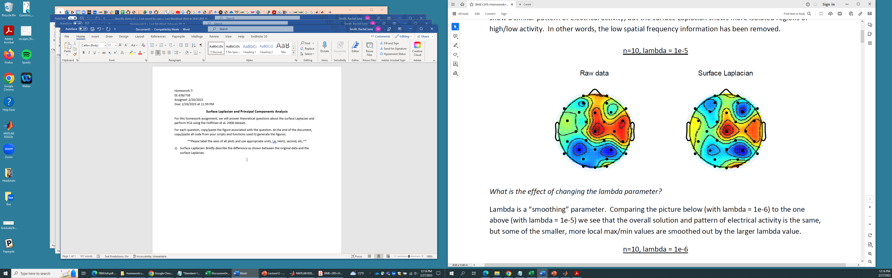
  - What is the effect of changing the lambda parameter? See that the value is different in the below picture than the one in (a).
- Supplied lambda value determines how smooth the estimated surface Laplacian will become.
- The estimated surface becomes smoother with increased lambda values yet this can result in losing precise spatial details.
- When lambda becomes lower the estimate detects high-frequency noise more strongly without losing detailed spatial information.
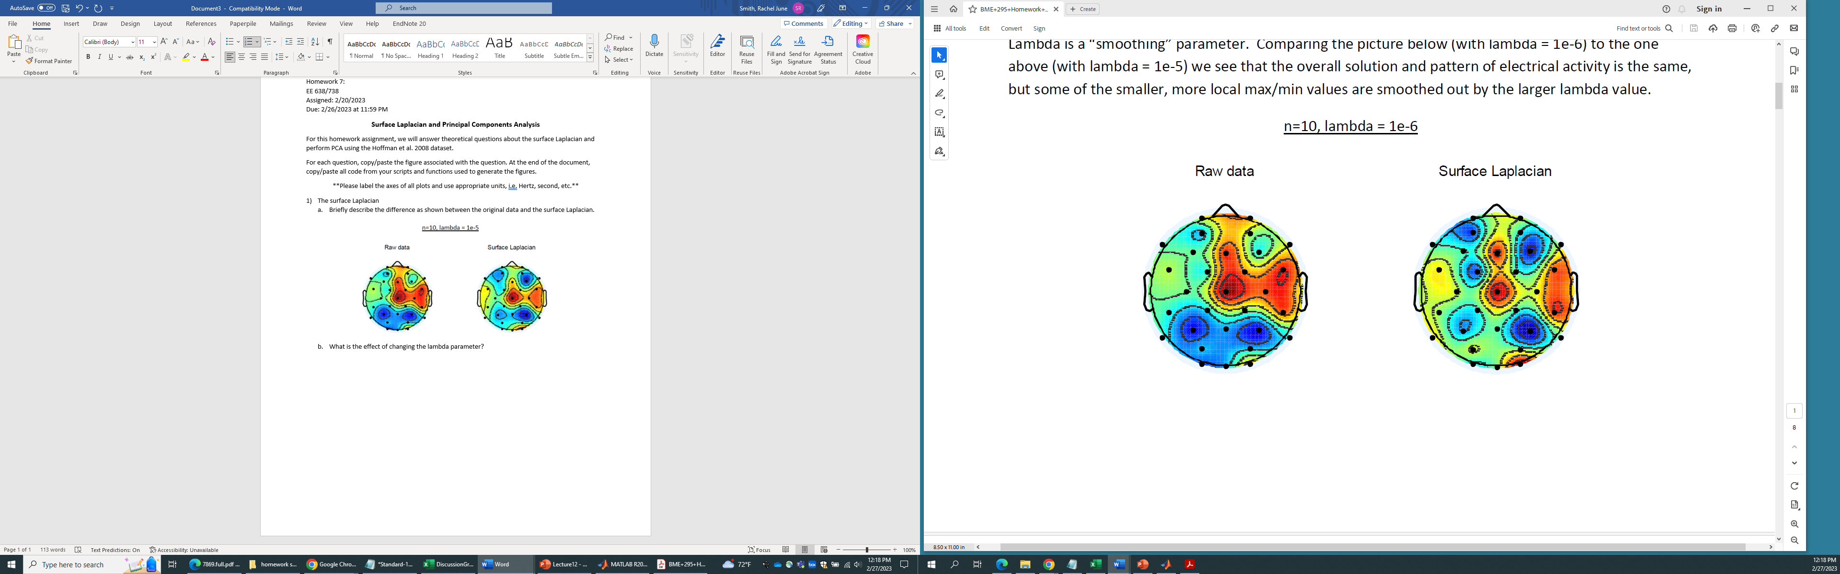

  - What is the effect of changing the m parameter?
- The value of m specifies which order of spherical splines serves to calculate the Laplacian.
- The m scale controls spatial detail sensitivity so it reveals better the smaller features within data.
- When m decreases it smooths the obtained results which reduces responsiveness to high-frequency variations in the scalp potentials.
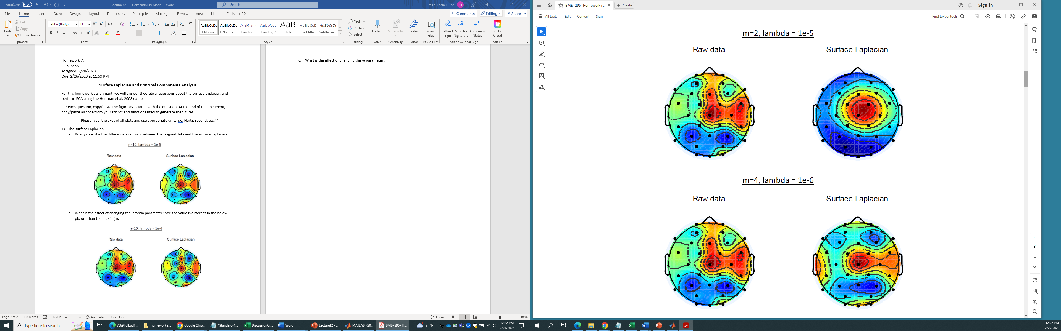
  - In theory, what is the effect of changing the Legendre polynomial, n?
- The Legendre polynomial order, n, influences the spatial scale of the Laplacian filter.
- The n value enables the detection of finer spatial elements yet produces possible noise artifacts.
- The spatial representation becomes smoother with lower n values because such values eliminate small details.

  - If we plotted the surface Laplacian for the target and non-target ERPs from the Hoffmann dataset, it is likely the results would not be good. What are 3 reasons why this might be the case?
- The accuracy of spatial derivatives from the Laplacian method becomes limited when there is a low number of electrodes in the Hoffmann dataset.
- Noise amplification becomes a problem when dataset SNR is low because the Laplacian processing intensifies instead of reducing noise levels.
- Volume conduction effects present a problem when deep source activity becomes a significant factor because the Laplacian fails to efficiently separate localized surface electrical changes.

- Principal Components Analysis:
  - We will use the 6th run of the 4th session from subject 8 for this analysis (eeg_200308290212_epochs.mat). Using your extractAllTrials function (with the pre-processing steps included), create an ERP matrix with the mean trial waveform from each channel from time 0 to 0.4 seconds for ALL trials. The dimensions of the final mean matrix should be 34 by 820.
Calculate the covariance matrix. $covariance={\left(n-1\right)}^{-1}\left(X-\overline{X}\right){\left(X-\overline{X}\right)}^{T}$ where T indicates transpose and $\left(X-\overline{X}\right)$ means to subtract the mean of each channel from its own time series.
Perform an eigendecomposition of the covariance matrix using the function eig. See the MATLAB help for how to use this function. Reorder the columns of the full matrix such that the last column is first, and the first column is last (notice this is not a transpose). This reorders the components to have the first principal component be the largest.
Extract the diagonal elements from the eigenvalue matrix using the function diag and plot the percentage of variance explained by each principal component from these extracted eigenvalues.
  - Using the topoplot function from EEGLAB (remember to add the eeglab folder to your path), plot the first 6 principal components. I have uploaded a channel locations file for you to use. It is called EE638-738.locs. You call the function like this:

>>topoplot(pc(:,i),’EE638-738.locs’);
Where pc is the full matrix from eig and i is the component you want to plot.
What do you notice about the first 3 components, which explain most of the variance in the EEG data?
When we look from principal component 1 to 3,we can see that there is increase in weights and high variance is resembled by redness in the topographical view.
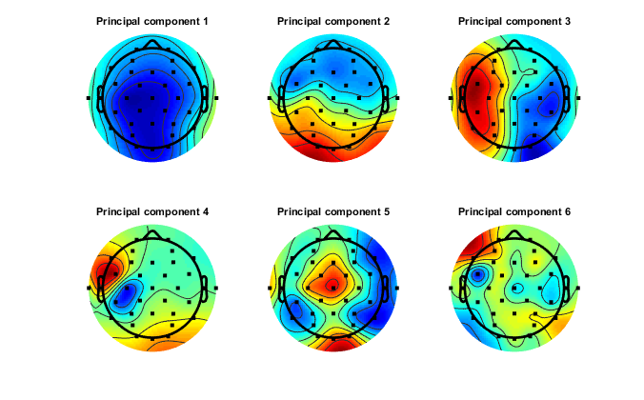
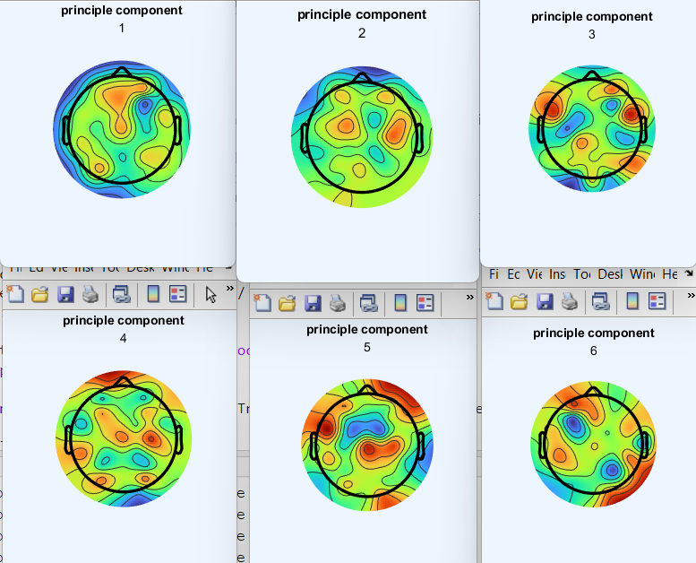
  - Now, we are going to plot the principal component time courses for target and non-target trials. Use your extractAllTrials function to get the mean trial waveform for all channels for both target and non-target trials from time 0 to 0.4 seconds. Both should be 34 x 820 in dimension.

Multiply the PC weightings by each channel in the time series to get the principal component time series. You will write something like: targetPCA_time = pc(:,i)’*targetERP.
Where pc is the full matrix from the eigendecomposition and targetERP is the 34x820 matrix of mean time series from all target trials.

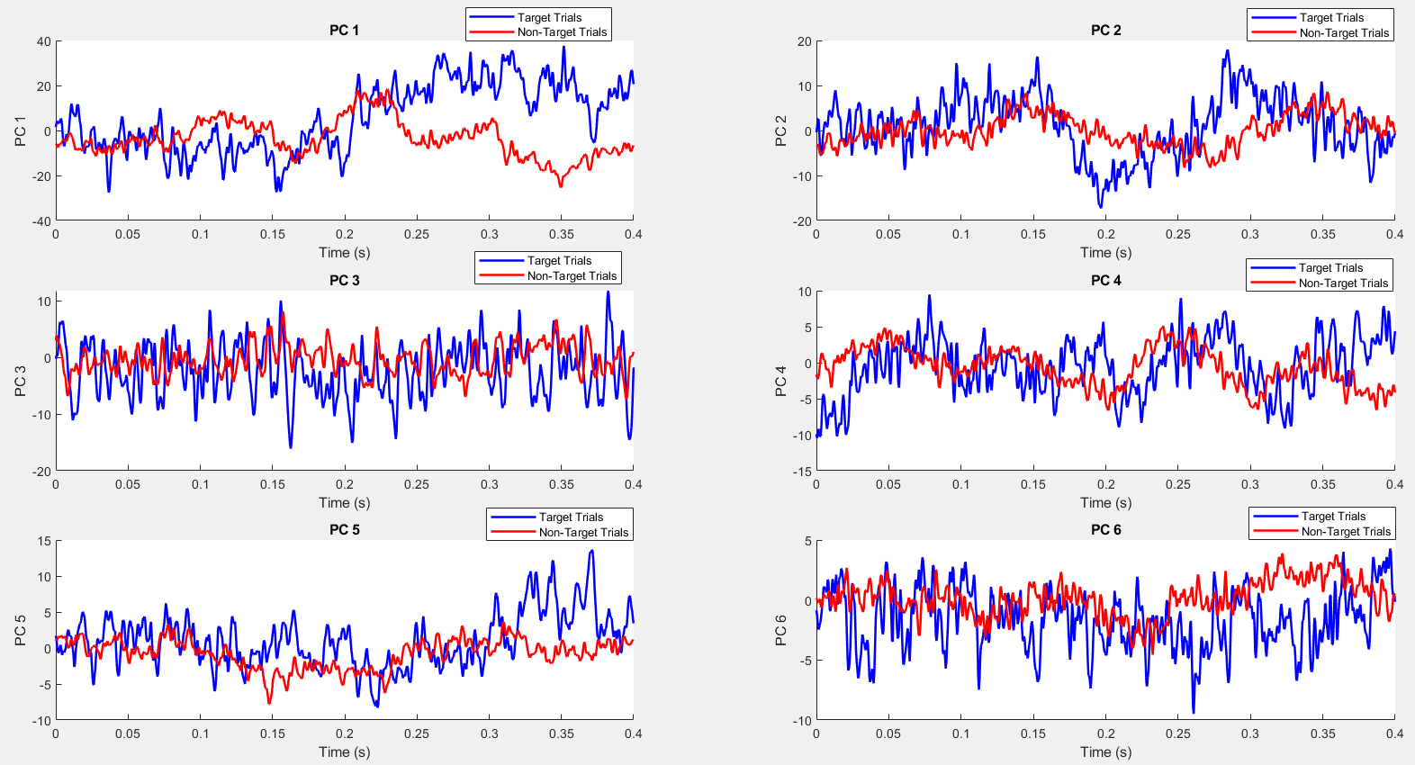

Yayyy! You’re done with homework assignments!!

MATLAB Script:
2a)
clear; clc; close all;
electrode = 1:34;
tPreStim = 0;
tPostStim = 0.4;
load('eeg_200308290212_epochs.mat');
[data, events] = extractAllTrials(data, events, electrode, tPreStim, tPostStim);
mean_matrix = mean(data, 1);
reshaped_data = reshape(data, size(data, 1), []);
mean_across_time = mean(reshaped_data, 2);
data_centered = reshaped_data - repmat(mean_across_time, 1, size(reshaped_data, 2));
covariance = (1/(size(data_centered, 2)-1)) * (data_centered * data_centered');
[eigenvecs, eigenvals] = eig(covariance);
[eigenvals_diag, sorted_indices] = sort(diag(eigenvals), 'descend');
eigenvecs_reordered = eigenvecs(:, sorted_indices);
explained_variance = eigenvals_diag / sum(eigenvals_diag) * 100;
figure;
plot(1:length(explained_variance), explained_variance, 'b.-');
xlabel('Eigenvalue Number');
ylabel('Percentage Variance Explained');
title('Percentage of Variance Explained by Principal Components');
xlim([1, 35]);
ylim([0, 100]);

function [trials, time] = extractAllTrials(data, events, electrode, timeBefore, timeAfter)
samplingfreq = 2048;
ptsBefore = round(timeBefore * samplingfreq);
ptsAfter = round(timeAfter * samplingfreq);
time = (-ptsBefore:ptsAfter) / samplingfreq;
num_trials = length(events) - 1;
trials = zeros(num_trials, length(electrode), ptsBefore + ptsAfter + 1);

% Debugging: Check the size of data before and after removing zero columns
disp('Size of data before removing zero columns:');
disp(size(data));

datazeros = (sum(data, 1) == 0);
lastDataPoint = find(diff(datazeros ~= 0));
data = data(:, 1:lastDataPoint);

disp('Size of data after removing zero columns:');
disp(size(data));

% Remove mean for each channel
data = data - mean(data, 2);

% Reference based on channels 33 and 34
ref = 0.5 * (data(33, :) + data(34, :));
data = data - repmat(ref, 34, 1);

% Extract trials
for i = 1:num_trials
elapsed = etime(events(i, :), events(1, :));
ind1 = round(elapsed * samplingfreq + 1 + 0.4 * samplingfreq - ptsBefore);
ind2 = ind1 + ptsBefore + ptsAfter;

% Debugging: Ensure indices don't exceed data bounds
if ind1 < 1
ind1 = 1; % Make sure ind1 is not below 1
end
if ind2 > size(data, 2)
ind2 = size(data, 2); % Make sure ind2 does not exceed data size
end

% Debugging: Check the size of the trial for the current iteration
disp(['Trial ', num2str(i), ' indices: ', num2str(ind1), ' to ', num2str(ind2)]);

trials(i, :, :) = data(electrode, ind1:ind2);
end
end

2b)
clear; clc; close all;
electrode = 1:34;
tPreStim = 0;
tPostStim = 0.4;
load('eeg_200308290212_epochs.mat');
[data, events] = extractAllTrials(data, events, electrode, tPreStim, tPostStim);
mean_matrix = mean(data, 1);
reshaped_data = reshape(data, size(data, 1), []);
mean_across_time = mean(reshaped_data, 2);
data_centered = reshaped_data - repmat(mean_across_time, 1, size(reshaped_data, 2));
covariance = (1/(size(data_centered, 2)-1)) * (data_centered * data_centered');
[eigenvecs, eigenvals] = eig(covariance);
[eigenvals_diag, sorted_indices] = sort(diag(eigenvals), 'descend');
eigenvecs_reordered = eigenvecs(:, sorted_indices);
explained_variance = eigenvals_diag / sum(eigenvals_diag) * 100;
for i=1:6
figure;
topoplot(eigenvecs(:,i),'EE638-738.locs');
title('principle component',i)
end
function [trials, time] = extractAllTrials(data, events, electrode, timeBefore,timeAfter)

samplingfreq = 2048;
ptsBefore = round(timeBefore * samplingfreq);
ptsAfter = round(timeAfter * samplingfreq);
time = (-ptsBefore:ptsAfter) / samplingfreq;
num_trials = length(events) - 1;
trials = zeros(num_trials, length(electrode), ptsBefore + ptsAfter + 1);
datazeros = (sum(data, 1) == 0);
lastDataPoint = find(diff(datazeros ~= 0));
data = data(:, 1:lastDataPoint);
data = data - mean(data, 2);
ref = 0.5 * (data(33, :) + data(34, :));
data = data-repmat(ref,34,1);
for i = 1:num_trials
elapsed = etime(events(i, :), events(1, :));
ind1 = round(elapsed * samplingfreq + 1 + 0.4 * samplingfreq - ptsBefore);
ind2 = ind1 + ptsBefore + ptsAfter;
trials(i, :, :) = data(electrode, ind1:ind2);
end
end

2c)
clear; clc; close all;
% Define your electrode and time window
electrode = 1:34; % 34 channels
timePreStim = 0; % 0 seconds before stimulus
timePostStim = 0.4; % 0.4 seconds after stimulus
load('eeg_200308290212_epochs.mat');

% Call the extractAllTrials function to get the target and non-target trials
[trials1, trials2, time] = extractAllTrials(data, events, electrode, timePreStim, timePostStim, stimuli);

% Compute the mean ERP for target and non-target trials
targetERP = mean(trials1, 1); % Mean ERP for target trials (size: 34 x 820)
nonTargetERP = mean(trials2, 1); % Mean ERP for non-target trials (size: 34 x 820)

% Reshape the data to 34 (channels) x 820 (time points) for PCA
reshaped_targetERP = reshape(targetERP, 34, []); % 34 x 820 matrix
reshaped_nonTargetERP = reshape(nonTargetERP, 34, []); % 34 x 820 matrix

% Perform PCA on the target ERP data (or use nonTargetERP if you want to apply PCA on non-target)
covariance_target = cov(reshaped_targetERP'); % Covariance matrix for target trials
[eigenvecs, eigenvals] = eig(covariance_target); % Eigen decomposition

% Sort eigenvalues and eigenvectors in descending order
[eigenvals_diag, sorted_indices] = sort(diag(eigenvals), 'descend');
eigenvecs_reordered = eigenvecs(:, sorted_indices);

% Multiply the PC weightings (eigenvectors) by the mean ERP for both target and non-target
% pc contains the eigenvectors (size: 34 x 34)
targetPCA_time = eigenvecs_reordered' * reshaped_targetERP; % Principal component time series for target trials
nonTargetPCA_time = eigenvecs_reordered' * reshaped_nonTargetERP; % Principal component time series for non-target trials

% Plot the principal component time courses for target trials
figure;
for i = 1:6 % Plot the first 6 principal components
subplot(3, 2, i); % Create a 3x2 grid of subplots
plot(time, targetPCA_time(i, :)); % Plot the i-th principal component time series
title(['Target Trial - PC ' num2str(i)]);
xlabel('Time (s)');
ylabel(['PC ' num2str(i)]);
end

% Plot the principal component time courses for non-target trials
figure;
for i = 1:6 % Plot the first 6 principal components
subplot(3, 2, i); % Create a 3x2 grid of subplots
plot(time, nonTargetPCA_time(i, :)); % Plot the i-th principal component time series
title(['Non-Target Trial - PC ' num2str(i)]);
xlabel('Time (s)');
ylabel(['PC ' num2str(i)]);
end

figure;
for i = 1:6 % Plot the first 6 principal components
subplot(3, 2, i); % Create a 3x2 grid of subplots
hold on; % Hold the plot to overlay both target and non-target
plot(time, targetPCA_time(i, :), 'b', 'LineWidth', 1.5); % Plot target trials (in blue)
plot(time, nonTargetPCA_time(i, :), 'r', 'LineWidth', 1.5); % Plot non-target trials (in red)
hold off;
title(['PC ' num2str(i)]);
xlabel('Time (s)');
ylabel(['PC ' num2str(i)]);
legend('Target Trials', 'Non-Target Trials'); % Add a legend
end
function [trials1, trials2, time] = extractAllTrials(data, events, electrode,timeBefore, timeAfter, stimuli)
samplingFreq = 2048;
ptsBefore = round(timeBefore * samplingFreq);
ptsAfter = round(timeAfter * samplingFreq);
time = (-ptsBefore:ptsAfter) / samplingFreq;
num_trials = length(events) - 1;
trials1 = zeros(num_trials, length(electrode), ptsBefore + ptsAfter + 1);
trials2 = zeros(num_trials, length(electrode), ptsBefore + ptsAfter + 1);
dataZeros = (sum(data, 1) == 0);
lastDataPoint = find(diff(dataZeros ~= 0), 1, 'last');
data = data(:, 1:lastDataPoint);
data = data - mean(data, 2);
ref = 0.5 * (data(33, :) + data(34, :));
data = data - repmat(ref, size(data, 1), 1);
k = 1; % Initialize counter for trials1
j = 1; % Initialize counter for trials2
for i = 1:num_trials
elapsed = etime(events(i, :), events(1, :));
ind1 = round(elapsed * samplingFreq + 1 + 0.4 * samplingFreq - ptsBefore);
ind2 = ind1 + ptsBefore + ptsAfter;
if stimuli(i) == 5
trials1(k, :, :) = data(electrode, ind1:ind2);
k = k + 1;
else
trials2(j, :, :) = data(electrode, ind1:ind2);
j = j + 1;
end
end
% Adjust the size of trials1 and trials2 based on actual counts
trials1 = trials1(1:k-1, :, :);
trials2 = trials2(1:j-1, :, :);
end

