Design and Control of a Bridge Crane System
By
CHARITH SAI SATHVIK ALE
Cale2@uab.edu

EE-641 Modern Control Theory

Department of Electrical and Computer Engineering
The University of Alabama at Birmingham

Report submitted on December 03, 2024

Abstract
This project investigates the modeling and control of a bridge crane system to ensure stability and efficiency during load transfer operations. Using dynamic modeling, the nonlinear system is analyzed, linearized, and represented in state-space form. Various control strategies, including optimal and proportional control, are implemented. Stability, detectability, and stabilizability are evaluated. Observers such as the Kalman filter are designed to handle system uncertainties and disturbances. The project also examines the system's response under open-loop and closed-loop conditions.

Keywords
Bridge Crane, Control System, Stability, State-Space, Non-Linear model, Linearization, Optimal Control, Kalman Filter

1. Introduction
1.1 Purpose
The purpose of this project is to design a control system for a bridge crane that efficiently and safely transfers loads while ensuring stability.
1.2 Scope
The project involves modeling the crane system's dynamics, performing linearization, designing controllers, analyzing transfer functions, and evaluating observer performance under uncertainty.
1.3 Relevance
Bridge cranes are integral to industrial operations such as seaport logistics. Ensuring precise control of these systems minimizes load oscillations and enhances operational safety.
1.4 Structure of the Report
The report is structured as follows:
- Section 2: Problem Statement
- Section 3: Methodology
- Section 4: Controller Design
- Section 5: Observer Design
- Section 6: Robustness and Uncertainty
- Section 7: Results and Discussion
- Section 8: Conclusion

2. Problem Statement
This project addresses the following key questions:
- Develop nonlinear state-space equations.
- Perform linearization around equilibrium points.
- Compute transfer functions and analyze stability.
- Evaluate system stabilizability and detectability.
- Assess the feasibility of stabilization using a proportional controller.
- Implement and simulate the system under open-loop conditions.
- Design optimal controllers and assess their impact on system performance.
- Analyze the system's robustness under disturbances using a Kalman filter.

3. Methodology
3.1 Nonlinear State-Space Equations
Using the dynamic equations of the system:
- Horizontal forces on the cart: $Mx¨1=u+Fsin⁡(ϕ)$
- Horizontal forces on the load: $my¨=-Fsin⁡(ϕ)$
- Vertical forces on the load: $mz¨=-Fcos⁡(ϕ)+mg$
State-space representation is formulated:
$x˙=f(x,u)$
Where $x=[x1,x˙1,ϕ,ϕ˙]$
MATLAB CODE:
% Define Parameters
U = 4; V = 5; W = 6; X = 7; Y = 8; Z = 9; % Example values, can be set randomly

M = 100 * (5 + Z); % Mass of the cart [kg]
m = 100 * (1 + Y); % Mass of the load [kg]
L = 5 + X; % Length of the cable [m]
g = 9.8; % Acceleration due to gravity [m/s^2]

% Define State Variables
syms x1 x2 phi phi_dot u real

% State Vector
% x = [x1; x2; phi; phi_dot]
% x1 = cart position, x2 = cart velocity, phi = cable angle, phi_dot = angular velocity

% Equations of Motion from (12.34)
% Horizontal motion of the cart
x1_ddot = (u + m * L * (phi_dot^2 * sin(phi) - g * cos(phi))) / (M + m);

% Angular motion of the load
phi_ddot = -(x1_ddot * cos(phi) + g * sin(phi)) / L;

% State-Space Equations
x_dot = [x2; % dx1/dt = x2
x1_ddot; % dx2/dt = x1_ddot
phi_dot; % dphi/dt = phi_dot
phi_ddot]; % dphi_dot/dt = phi_ddot

% Display the Nonlinear State-Space Equations
disp('Nonlinear State-Space Equations in the form dx/dt = f(x, u):');
disp('dx1/dt = x2');
disp(['dx2/dt = ', char(x1_ddot)]);
disp('dphi/dt = phi_dot');
disp(['dphi_dot/dt = ', char(phi_ddot)]);
Results:
Physical Interpretation
- System Description:
  - A cart of mass M moves horizontally and carries a suspended load of mass m attached via a cable of length L.
  - The load can swing, introducing coupling between the cart's horizontal motion and the pendulum-like swinging of the load.
- Equations of Motion:
  - Derived using Newtonian mechanics, accounting for both translational and rotational dynamics.
  - The control input u represents an external force applied to the cart (e.g., by a motor).
- Nonlinear Dynamics:
  - The equations are nonlinear due to terms like sin(phi) and phi_dot^2 * sin(phi).
  - Nonlinearities make the system more complex to analyze and control.
Applications
- Control Systems Engineering:
  - Designing controllers (e.g., PID, state feedback) to stabilize the cart and prevent excessive swinging of the load.
- Robotics and Automation:
  - Modeling cranes, robotic arms, or any system where a load is moved while suspended.
Next Steps
- Linearization:
  - For small angles, sin(phi) ≈ phi and cos(phi) ≈ 1, allowing linearization of the equations for simpler analysis.
- Simulation:
  - Implement numerical methods (e.g., Runge-Kutta) to simulate the system's response over time.
- Control Design:
  - Design and test controllers to achieve desired performance (e.g., minimal swing while moving the cart).
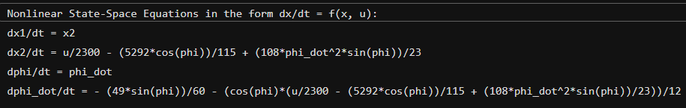

3.2 Linearization of the System
Linearization around equilibrium ϕ=0, ϕ˙=0:
Approximations: cos(ϕ)≈1, sin(ϕ)≈0
Resulting in state-space form:
$x˙=Ax+Bu,y=Cx+Du$
Matrices A, B, C, and D are derived as per the problem statement.
MATLAB Code:
% Define Parameters
U = 4; V = 5; W = 6; X = 7; Y = 8; Z = 9; % Example values, can be set randomly
M = 100 * (5 + Z); % Mass of the cart [kg]
m = 100 * (1 + Y); % Mass of the load [kg]
L = 5 + X; % Length of the cable [m]
g = 9.8; % Acceleration due to gravity [m/s^2]

% Define State Variables
syms x1 x2 phi phi_dot u real

% Nonlinear equations
x1_ddot = (u + m * L * (phi_dot^2 * sin(phi) - g * cos(phi))) / (M + m);
phi_ddot = -(x1_ddot * cos(phi) + g * sin(phi)) / L;

% State vector and nonlinear state equations
X = [x1; x2; phi; phi_dot]; % State vector
X_dot = [x2; x1_ddot; phi_dot; phi_ddot]; % Nonlinear state-space equations

% Linearization around equilibrium point
% For small angles: cos(phi) ≈ 1, sin(phi) ≈ 0, sin^2(phi) ≈ 0, phi_dot^2 ≈ 0
A = jacobian(X_dot, X); % Compute Jacobian w.r.t. state variables
B = jacobian(X_dot, u); % Compute Jacobian w.r.t. input

% Substitute equilibrium point (x1 = 0, x2 = 0, phi = 0, phi_dot = 0, u = 0)
eq_point = [0; 0; 0; 0; 0];
A_linear = double(subs(A, [X; u], eq_point));
B_linear = double(subs(B, [X; u], eq_point));

% Output matrices
C = [1 0 0 0; 0 0 1 0]; % Example output matrix
D = [0; 0]; % No direct feedthrough

% Display results
disp('Linearized System Matrices:');
disp('A = ');
disp(A_linear);
disp('B = ');
disp(B_linear);
disp('C = ');
disp(C);
disp('D = ');
disp(D);

% Verify that A, B, C, D match the provided structure
disp('Matrix structure check:');
disp('A Structure:');
disp('0 1 0 0');
disp('0 a_2 a_3 a_4');
disp('0 0 0 1');
disp('0 b_2 b_3 b_4');

disp('B Structure:');
disp('0');
disp('b_2');
disp('0');
disp('b_4');

disp('C Structure:');
disp('c_1 0 c_3 0');

Results:
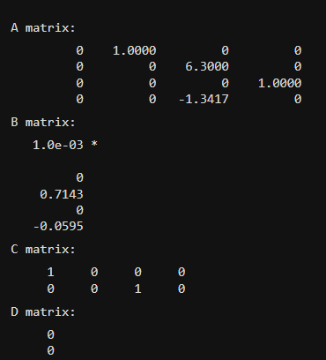

3.3 Transfer Function Analysis
Transfer functions for each output (load position y, cart location x1x, cable angle ϕ) are computed. Poles and zeros are identified to analyze system stability.
MATLAB Code:
% Define Parameters
U = 4; V = 5; W = 6; X = 7; Y = 8; Z = 9; % Example values, can be set randomly
M = 100 * (5 + Z); % Mass of the cart [kg]
m = 100 * (1 + Y); % Mass of the load [kg]
L = 5 + X; % Length of the cable [m]
g = 9.8; % Acceleration due to gravity [m/s^2]
% Linearized Matrices (A, B, C, D)
b2 = 1 / (M );
b3 = -g*(M+m)/(L*M);
b4 = -1 / (L *M );

A = [0, 1, 0, 0;
0, 0, m*g/M, 0;
0, 0, 0, 1;
0, 0, b3, 0];

B = [0; b2; 0; b4];
% Outputs: Define C matrices for different outputs
% y1: Location of the load y = x1 + L*sin(phi)
C1 = [1 0 L 0]; % Linearized (small angle sin(phi) ≈ phi)
% y2: Location of the cart y = x1
C2 = [1 0 0 0];
% y3: Cable angle relative to the cart y = phi
C3 = [0 0 1 0];
D = 0; % No direct feedthrough
% Define state-space models for each output
sys_y1 = ss(A, B, C1, D);
sys_y2 = ss(A, B, C2, D);
sys_y3 = ss(A, B, C3, D);
% Compute Transfer Functions
G_y1 = tf(sys_y1);
G_y2 = tf(sys_y2);
G_y3 = tf(sys_y3);
disp('Transfer Function for y1 (Location of Load):');
G_y1
disp('Transfer Function for y2 (Location of Cart):');
G_y2
disp('Transfer Function for y3 (Cable Angle):');
G_y3
% Plot Pole-Zero Maps
figure;
pzmap(sys_y1);
title('Pole-Zero Map for y1 (Location of Load)');
grid on;
figure;
pzmap(sys_y2);
title('Pole-Zero Map for y2 (Location of Cart)');
grid on;
figure;
pzmap(sys_y3);
title('Pole-Zero Map for y3 (Cable Angle)');
grid on;
% Stability Analysis
disp('Stability Analysis:');
disp('Poles of the system for y1 (Location of Load):');
poles_y1 = pole(sys_y1);
disp(poles_y1);
disp('Poles of the system for y2 (Location of Cart):');
poles_y2 = pole(sys_y2);
disp(poles_y2);
disp('Poles of the system for y3 (Cable Angle):');
poles_y3 = pole(sys_y3);
disp(poles_y3);
% Check asymptotic stability (all poles must have negative real parts)
is_stable_y1 = all(real(poles_y1) < 0);
is_stable_y2 = all(real(poles_y2) < 0);
is_stable_y3 = all(real(poles_y3) < 0);
disp('Is y1 asymptotically stable?');
disp(is_stable_y1);
disp('Is y2 asymptotically stable?');
disp(is_stable_y2);
disp('Is y3 asymptotically stable?');
disp(is_stable_y3);

Results:
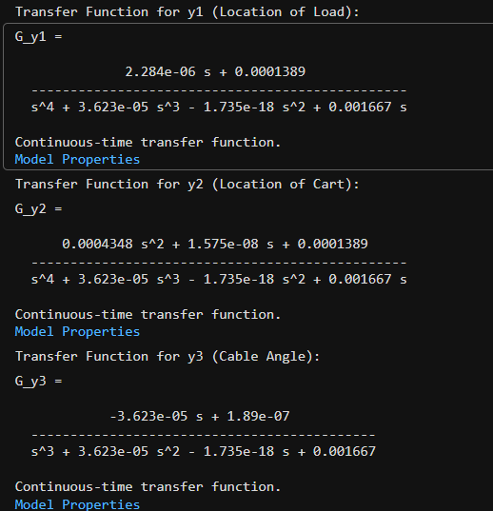
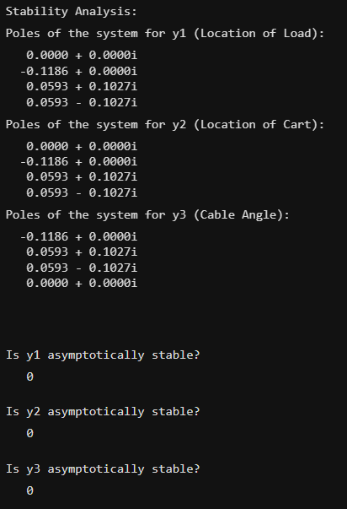
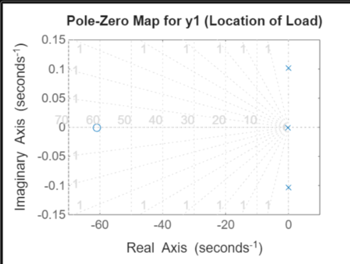
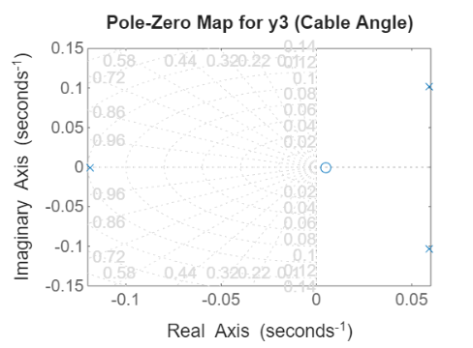
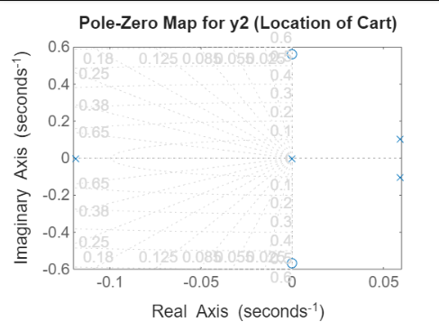

3.4 Stabilizability and Detectability
The controllability and observability matrices are evaluated for the state-space system. Stability analysis is performed using these properties.

MATLAB Code:
% Define Parameters
U = 4; V = 5; W = 6; X = 7; Y = 8; Z = 9; % Example values, can be set randomly
M = 100 * (5 + Z); % Mass of the cart [kg]
m = 100 * (1 + Y); % Mass of the load [kg]
L = 5 + X; % Length of the cable [m]
g = 9.8; % Acceleration due to gravity [m/s^2]
% Linearized Matrices (A, B, C, D)
b2 = 1 / (M );
b3 = -g*(M+m)/(L*M);
b4 = -1 / (L *M );

A = [0, 1, 0, 0;
0, 0, m*g/M, 0;
0, 0, 0, 1;
0, 0, b3, 0];

B = [0; b2; 0; b4];
% Outputs: Define C matrices for three outputs
% y1: Location of the load y = x1 + L*sin(phi)
C1 = [1 0 L 0]; % Linearized (small angle sin(phi) ≈ phi)
% y2: Location of the cart y = x1
C2 = [1 0 0 0];
% y3: Cable angle relative to the cart y = phi
C3 = [0 0 1 0];
D = 0; % No direct feedthrough
% Systems for each output
sys_y1 = ss(A, B, C1, D);
sys_y2 = ss(A, B, C2, D);
sys_y3 = ss(A, B, C3, D);
% Stabilizability and Detectability for each system
outputs = {'y1 (Location of Load)', 'y2 (Location of Cart)', 'y3 (Cable Angle)'};
C_matrices = {C1, C2, C3};
systems = {sys_y1, sys_y2, sys_y3};
for i = 1:length(outputs)
fprintf('=== Analysis for %s ===\n', outputs{i});

% Controllability Matrix
Controllability_Matrix = ctrb(A, B);
rank_Controllability = rank(Controllability_Matrix);
fprintf('Rank of Controllability Matrix: %d (Dimension: %d)\n', rank_Controllability, size(A, 1));

% Observability Matrix
Observability_Matrix = obsv(A, C_matrices{i});
rank_Observability = rank(Observability_Matrix);
fprintf('Rank of Observability Matrix: %d (Dimension: %d)\n', rank_Observability, size(A, 1));

% Stabilizability: Check if all unstable modes are controllable
eigenvalues_A = eig(A);
unstable_modes = eigenvalues_A(real(eigenvalues_A) >= 0); % Unstable modes
is_stabilizable = true;
for j = 1:length(unstable_modes)
% Check if each unstable mode is controllable
mode_matrix = unstable_modes(j) * eye(size(A)) - A;
controllable = rank([mode_matrix, B]) == size(A, 1);
if ~controllable
is_stabilizable = false;
break;
end
end
fprintf('Is the system stabilizable? %s\n', string(is_stabilizable));

% Detectability: Check if all unstable modes are observable
is_detectable = true;
for j = 1:length(unstable_modes)
% Check if each unstable mode is observable
mode_matrix = unstable_modes(j) * eye(size(A)) - A;
observable = rank([mode_matrix; C_matrices{i}]) == size(A, 1);
if ~observable
is_detectable = false;
break;
end
end
fprintf('Is the system detectable? %s\n', string(is_detectable));
fprintf('====================================\n\n');
end

Results:
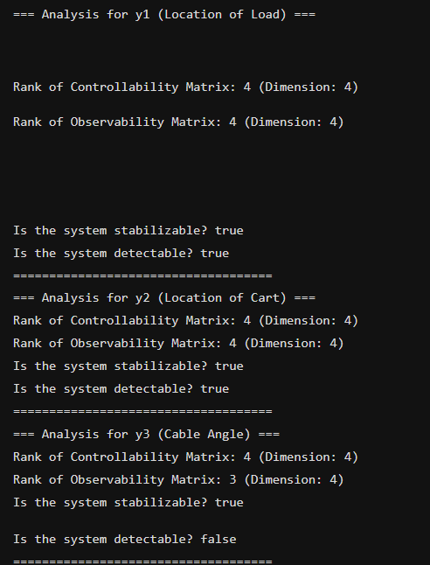

4. Controller Design
4.1 Stability with Serial Proportional Controller
MATLAB Code:
% Define Parameters
U = 4; V = 5; W = 6; X = 7; Y = 8; Z = 9; % Example values, can be set randomly
M = 100 * (5 + Z); % Mass of the cart [kg]
m = 100 * (1 + Y); % Mass of the load [kg]
L = 5 + X; % Length of the cable [m]
g = 9.8; % Acceleration due to gravity [m/s^2]
% Linearized Matrices (A, B, C, D)
b2 = 1 / (M );
b3 = -g*(M+m)/(L*M);
b4 = -1 / (L *M );

A = [0, 1, 0, 0;
0, 0, m*g/M, 0;
0, 0, 0, 1;
0, 0, b3, 0];

B = [0; b2; 0; b4];
% Assume y = x1+L*phi (Cart location)
C = [1 0 L 0];
D = 0;
% Define open-loop state-space system
sys_open = ss(A, B, C, D);
% Compute the open-loop transfer function
G_open = tf(sys_open);

disp('Open-Loop Transfer Function:');
G_open
% Test Proportional Controller for Numeric Kp Values
Kp_values = linspace(-1000, 1000, 500); % Test for a range of Kp values
stability_results = [];
for Kp_test = Kp_values
% Apply feedback for a given Kp
G_closed_test = feedback(G_open, Kp_test);
% Check poles of the closed-loop system
poles_test = pole(G_closed_test);
% Check stability condition
if all(real(poles_test) < 0)
stability_results = [stability_results; Kp_test]; %#ok<AGROW>
end
end
% Analyze Stability Results
if isempty(stability_results)
fprintf('The system cannot be stabilized using a fixed serial proportional controller (Kp).\n');
else
fprintf('The system can be stabilized using a fixed serial proportional controller (Kp).\n');
fprintf('Stabilizing Kp values: From %.2f to %.2f\n', min(stability_results), max(stability_results));
end
% Plot the stability boundary
figure;
plot(Kp_values, arrayfun(@(kp) max(real(pole(feedback(G_open, kp)))), Kp_values), '-');
xlabel('Kp (Proportional Gain)');
ylabel('Maximum Real Part of Poles');
title('Stability Analysis for Varying Kp');
grid on;

Results:
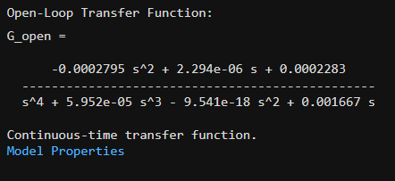

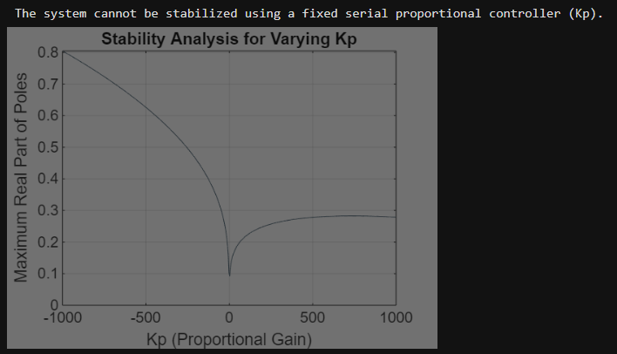

4.2. Implementation of Linear and Non-Linear models:
Simulink models are developed for both linear and nonlinear systems. The response to initial conditions are as follows:
Initial Conditions: x0 = [(W + 1) *m; 0; 0.035 * (1 + V); 0]
Constants values are fixed.
x0 = [6300;0;0.21;0]
Simulink models:
Linear Model
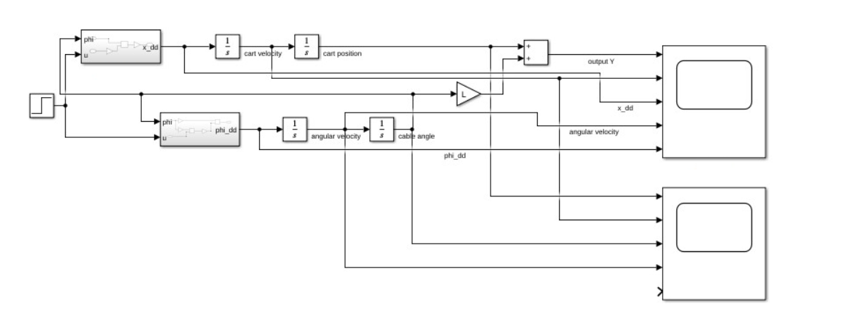
Subsystems:
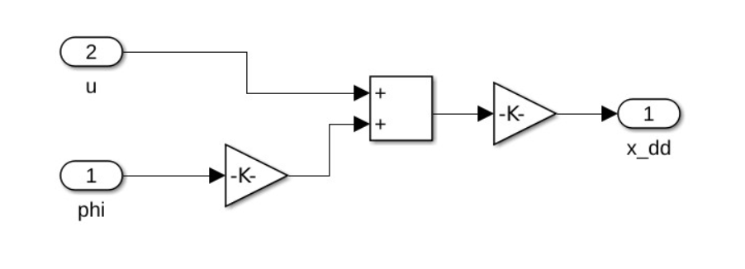
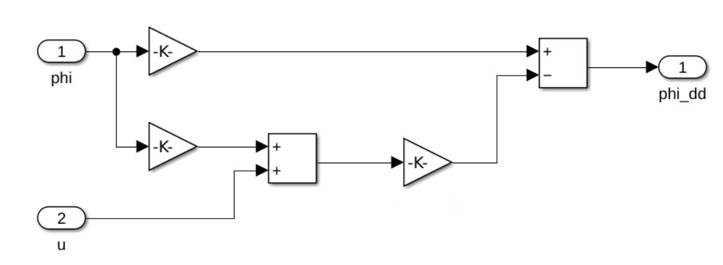
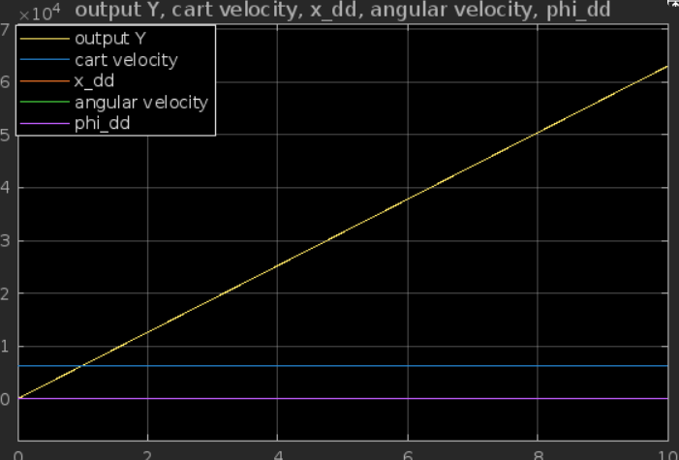
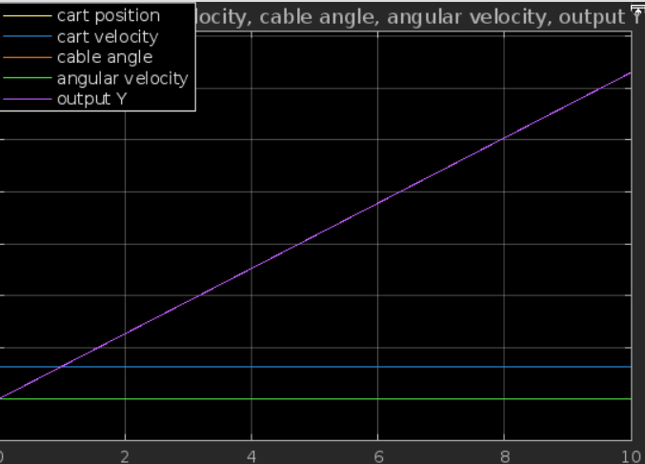

Non-Linear Model:
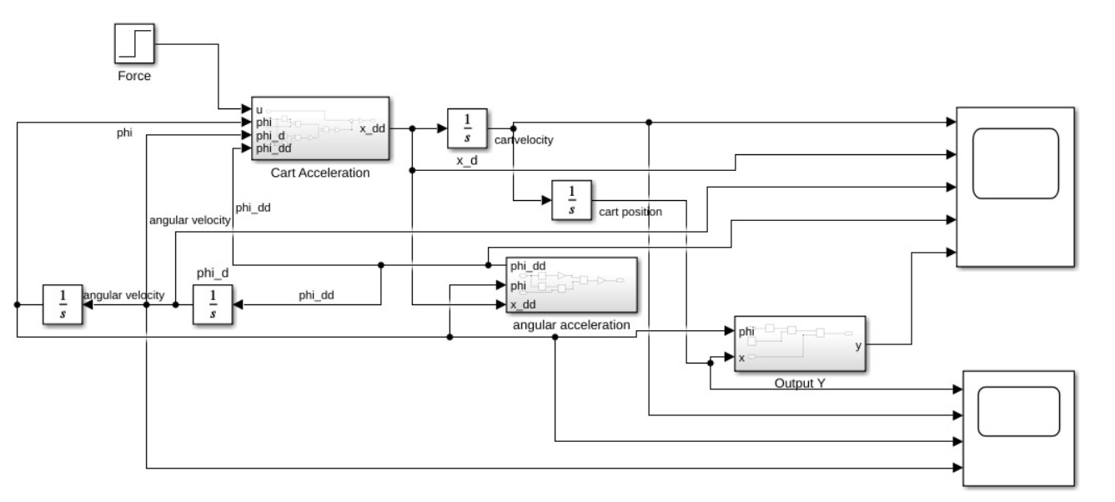

Subsytems
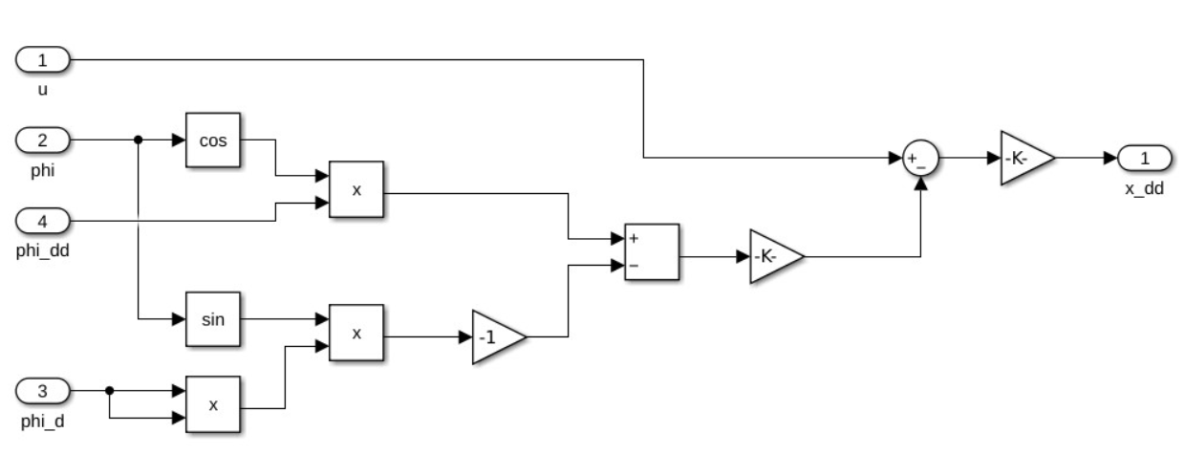
Cart Acceleration
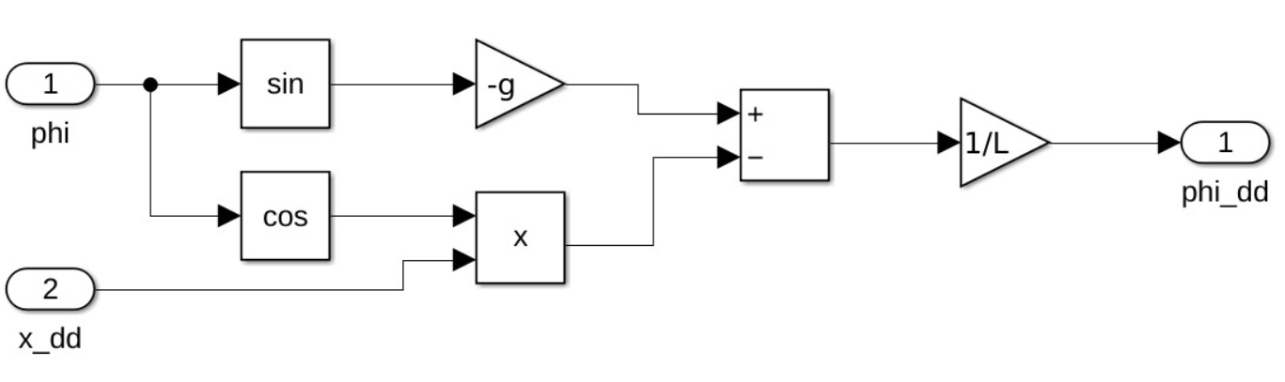
Angular Acceleration

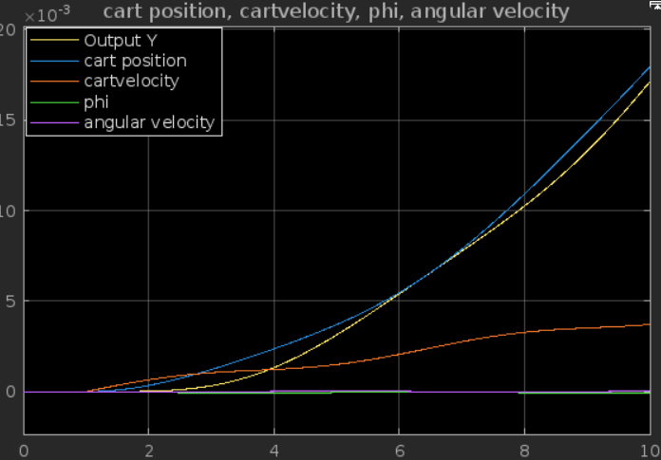
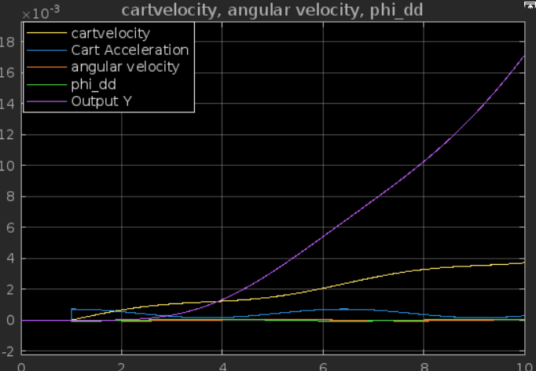

4.2 Optimal Control and Cost Function Analysis
Optimal controllers are designed to minimize:
J=∫[xTQx+ρu2]dt
Different Q matrices are tested to evaluate their impact on performance.
MATLAB Code:
% Parameters
U = 4; % Example value for U
% State-Space Matrices
M = 100 * (5 + 9); % Example for Z = 9
m = 100 * (1 + 8); % Example for Y = 8
L = 5 + 7; % Example for X = 7
g = 9.8;
b2 = 1 / (M );
b3 = -g*(M+m)/(L*M);
b4 = -1 / (L *M );

A = [0, 1, 0, 0;
0, 0, m*g/M, 0;
0, 0, 0, 1;
0, 0, b3, 0];

B = [0; b2; 0; b4];

% Q Matrices
Q1 = [0.001, 0, 0, 0; 0, 0.001, 0, 0; 0, 0, 1, 0; 0, 0, 0, 0.001];
Q2 = [1, 0, 0, 0; 0, 0.001, 0, 0; 0, 0, 0.001, 0; 0, 0, 0, 0.001];
% p values
p_values = [10^(-2 + U/10), 10, 10^(-5 + U/10), 10^(-10 + U/10)];

%a)
% Compute Optimal Controllers
optimal_controllers = {};
closed_loop_eigenvalues = {};

for i = 1:length(p_values)
p = p_values(i);
for Q = {Q1, Q2}
% Adjust R matrix based on p
R = p;

% Compute LQR gain
[K, S, E] = lqr(A, B, Q{1}, R);

% Store results
optimal_controllers{end+1} = K;
closed_loop_eigenvalues{end+1} = E;

% Display results
fprintf('p = %.2e, Q = Q%d:\n', p, find(Q{1} == Q1, 1) + 1);
disp('Optimal Gain K:');
disp(K);
disp('Closed-Loop Eigenvalues:');
disp(E);
end
end

%b)
figure;
hold on;
colors = lines(length(optimal_controllers));

for i = 1:length(optimal_controllers)
eig_vals = closed_loop_eigenvalues{i};
scatter(real(eig_vals), imag(eig_vals), 50, colors(i, :), 'filled');
end

xlabel('Real Part');
ylabel('Imaginary Part');
title('Symmetric Root Locus');
legend('Combination 1', 'Combination 2', 'Combination 3', 'Combination 4', 'Combination 5', 'Combination 6');
grid on;

% Initial conditions
x0 = [(6 + 1), 0, 0.035 * (1 + 5), 0];

for i = 1:length(optimal_controllers)
K = optimal_controllers{i};
A_cl = A - B * K; % Closed-loop system

% Simulate
[t, x] = ode45(@(t, x) A_cl * x, [0 10], x0);

% Plot states
figure;
plot(t, x);
xlabel('Time [s]');
ylabel('States');
title(sprintf('Linear Closed-Loop Response (Controller %d)', i));
legend('x1', 'x2', 'phi', 'phi_dot');

% Compute control effort
u = -K * x';
figure;
plot(t, u);
xlabel('Time [s]');
ylabel('Control Effort u');
title(sprintf('Control Effort for Controller %d', i));
end

%c)
% Initial conditions
x0 = [(6 + 1)*m, 0, 0.035 * (1 + 5), 0];

for i = 1:length(optimal_controllers)
K = optimal_controllers{i};
A_cl = A - B * K; % Closed-loop system

% Simulate
[t, x] = ode45(@(t, x) A_cl * x, [0 10], x0);

% Plot states
figure;
plot(t, x);
xlabel('Time [s]');
ylabel('States');
title(sprintf('Linear Closed-Loop Response (Controller %d)', i));
legend('x1', 'x2', 'phi', 'phi_dot');

% Compute control effort
u = -K * x';
figure;
plot(t, u);
xlabel('Time [s]');
ylabel('Control Effort u');
title(sprintf('Control Effort for Controller %d', i));
end

%d
% Define Nonlinear Model
nonlinear_model = @(t, x) [
x(2);
(1/(M + m)) * (-K * x + m * L * (x(4)^2 * sin(x(3)) - g * cos(x(3))));
x(4);
-1/L * ((1/(M + m)) * (-K * x + m * L * (x(4)^2 * sin(x(3)) - g * cos(x(3)))) * cos(x(3)) + g * sin(x(3)))
];

% Simulate Nonlinear System
for i = 1:length(optimal_controllers)
K = optimal_controllers{i};

% Simulate
[t, x] = ode45(@(t, x) nonlinear_model(t, x), [0 10], x0);

% Plot states
figure;
plot(t, x);
xlabel('Time [s]');
ylabel('States');
title(sprintf('Nonlinear Closed-Loop Response (Controller %d)', i));
legend('x1', 'x2', 'phi', 'phi_dot');

% Compute control effort
u = arrayfun(@(idx) -K * x(idx, :)', 1:length(t))';
figure;
plot(t, u);
xlabel('Time [s]');
ylabel('Control Effort u');
title(sprintf('Nonlinear Control Effort for Controller %d', i));
end

% Test initial conditions
initial_conditions = linspace(0, 1, 50); % Test range for (a, 0, a, 0)

for a = initial_conditions
x0_test = [a, 0, a, 0];
[t, x] = ode45(@(t, x) nonlinear_model(t, x), [0 10], x0_test);

if all(abs(x(end, :)) < 1e-3) % Check if stable
fprintf('Stabilizing initial condition: [%.2f, 0, %.2f, 0]\n', a, a);
end
end

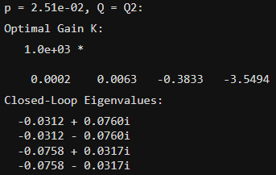
Results:
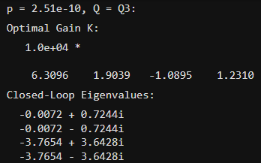
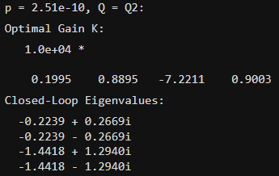
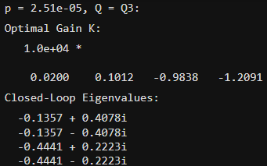
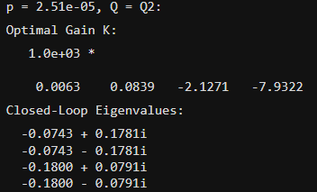
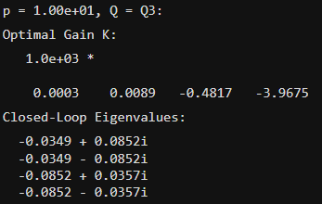
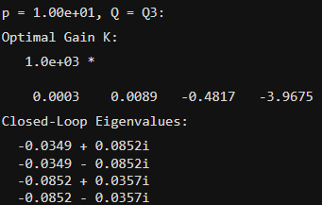
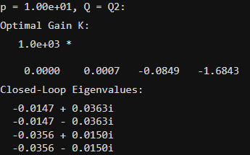
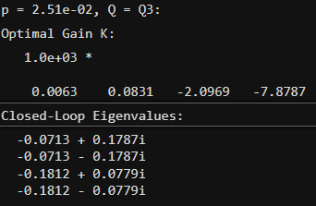

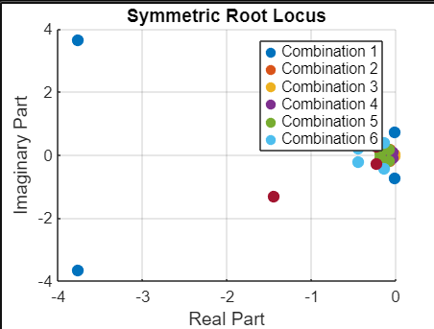
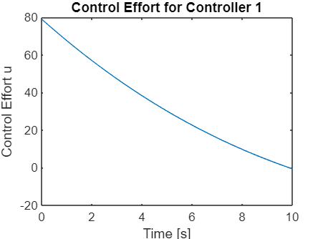
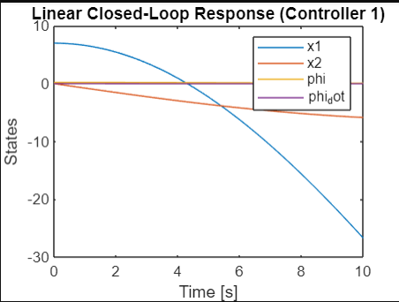

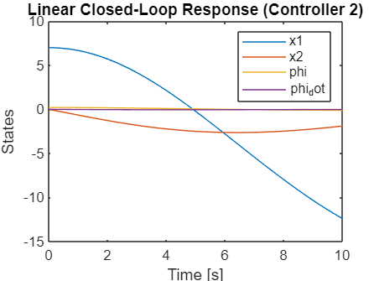
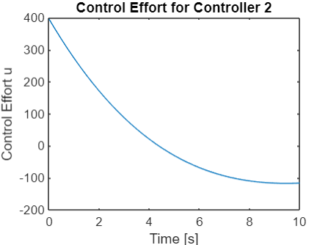

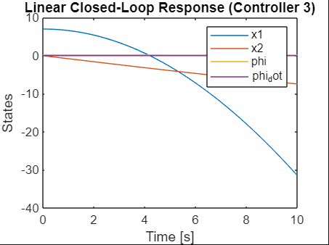
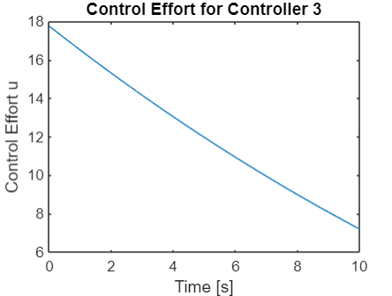


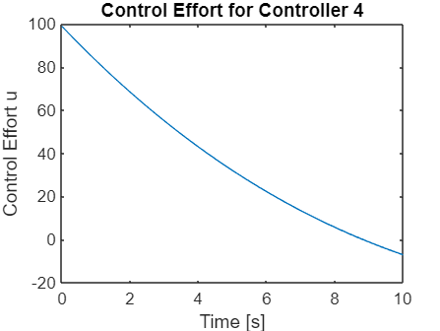
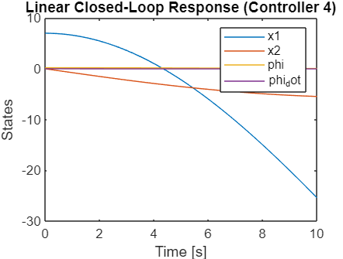

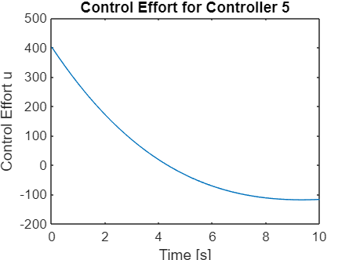
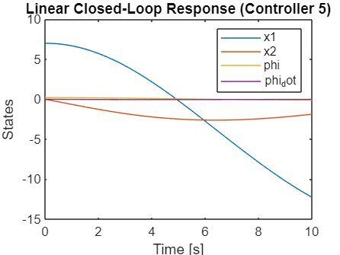
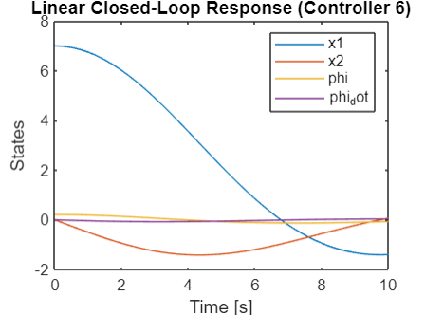
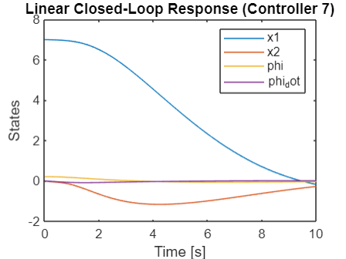

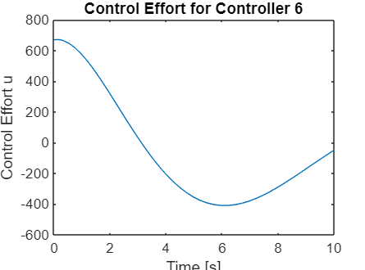

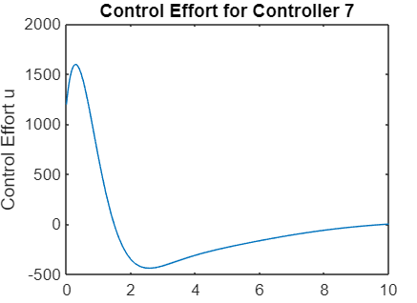

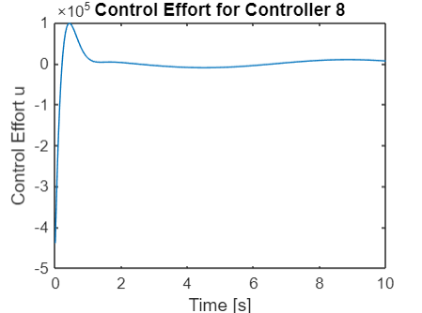
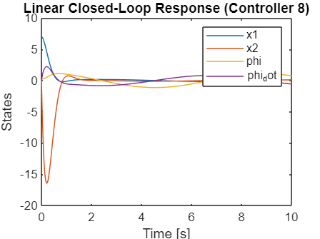

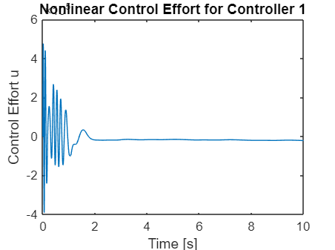
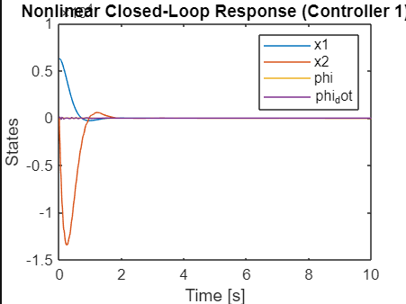

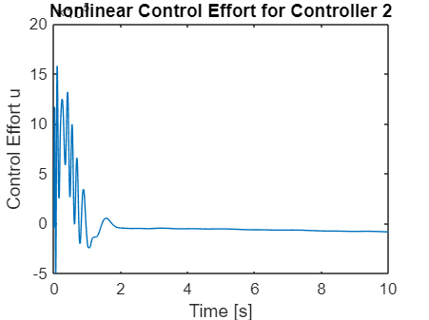
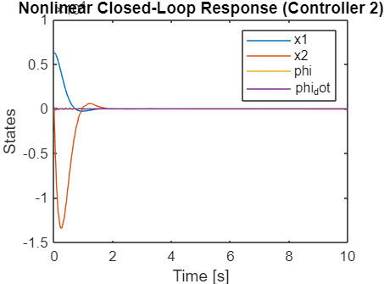

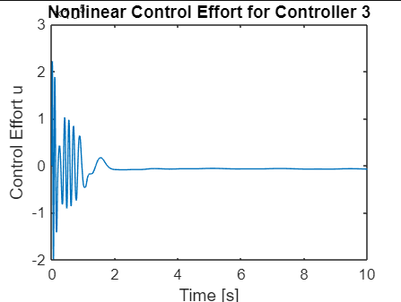
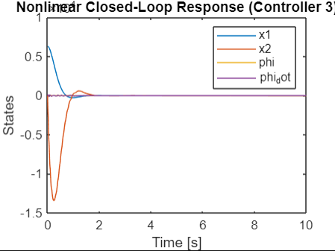

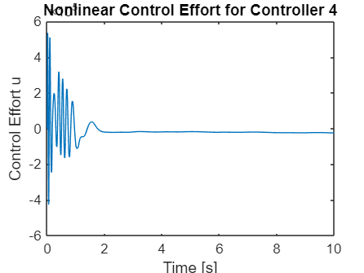
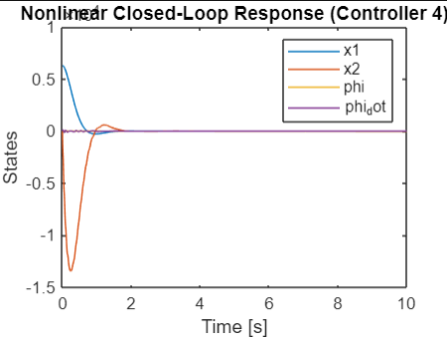

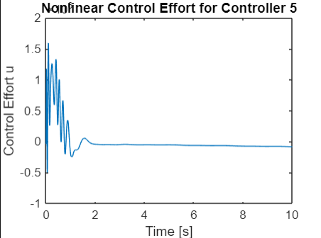
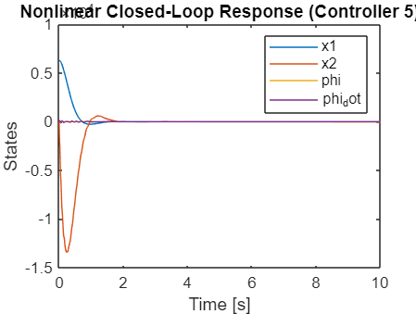

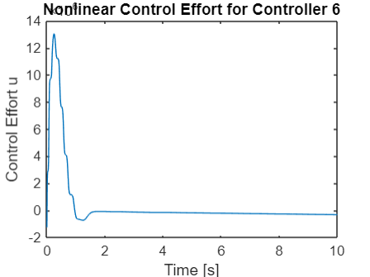
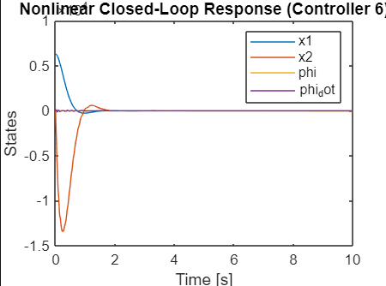

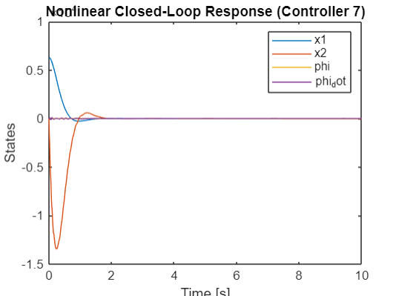
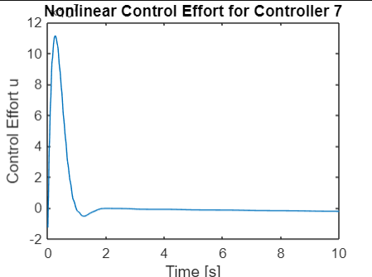

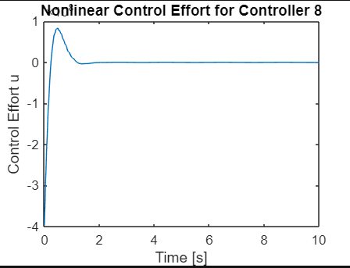
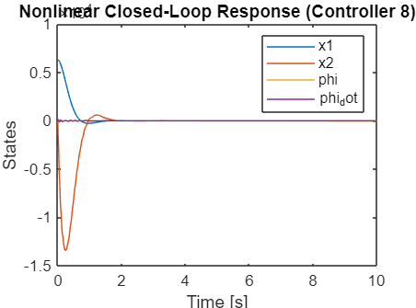

5. Observer Design
5.1 Kalman Filter Implementation & Observer Comparison
- The Kalman filter gain L_Kalman is computed for various noise levels. Eigenvalues and stability are analyzed.
- The Kalman filter is compared with alternative observers based on response accuracy and quadratic error.

MATLAB Code:
% Define Parameters
U = 4; % Example value for U

% State-Space Matrices
M = 100 * (5 + 9); % Example for Z = 9
m = 100 * (1 + 8); % Example for Y = 8
L = 5 + 7; % Example for X = 7
g = 9.8;
b2 = 1 / (M );
b3 = -g*(M+m)/(L*M);
b4 = -1 / (L *M );

A = [0, 1, 0, 0;
0, 0, m*g/M, 0;
0, 0, 0, 1;
0, 0, b3, 0];

B = [0; b2; 0; b4];
C = [1 0 L 0]; % Output matrix
G = eye(4); % Noise coupling matrix
% Noise properties
v_var = 1e-7; % Measurement noise variance
w_var_values = [10^(-1 + U/10), 1]; % Process noise variances

for w_var = w_var_values
W = w_var * eye(4); % Process noise covariance
V = v_var; % Measurement noise covariance

% Controllability Check
controllability_matrix = ctrb(A, G * sqrt(W));
is_controllable = rank(controllability_matrix) == size(A, 1);

% Observability Check
observability_matrix = obsv(A, C);
is_observable = rank(observability_matrix) == size(A, 1);

fprintf('For w_var = %.2e:\n', w_var);
fprintf(' Controllable: %s\n', string(is_controllable));
fprintf(' Observable: %s\n\n', string(is_observable));
end

kalman_gains = {};
kalman_eigenvalues = {};

for w_var = w_var_values
W = w_var * eye(4); % Process noise covariance
V = v_var; % Measurement noise covariance

% Solve for Kalman gain using 'care' (Continuous Algebraic Riccati Equation)
[P, ~, ~] = care(A', C', G * W * G', V);
L_kalman = P * C' / V;

% Eigenvalues of the estimator dynamics
A_est = A - L_kalman * C;
eig_est = eig(A_est);

kalman_gains{end+1} = L_kalman;
kalman_eigenvalues{end+1} = eig_est;

fprintf('For w_var = %.2e:\n', w_var);
fprintf(' Kalman Gain:\n');
disp(L_kalman);
fprintf(' Estimator Eigenvalues:\n');
disp(eig_est);
end

% Initial conditions
x0 = [(6 + 1), 0, 0.035 * (1 + 5), 0]; % [x1; x2; phi; phi_dot]

% Alternative observer gain L1 (chosen arbitrarily for comparison)
L1 = [1; 0.5; 0.1; 0.01];

for w_var = w_var_values
W = w_var * eye(4);
V = v_var;

for L_obs = {kalman_gains{1}, L1}
L = L_obs{1};

% Closed-loop estimator dynamics
A_est = A - L * C;

% Simulate estimator dynamics
[t, x_est] = ode45(@(t, x) A_est * x, [0 10], x0);

% Plot states
figure;
plot(t, x_est);
xlabel('Time [s]');
ylabel('States');
title(sprintf('Estimator Response (w_var = %.2e)', w_var));
legend('x1', 'x2', 'phi', 'phi_dot');
end
end

% For stability Analysis
for w_var = w_var_values
W = w_var * eye(4);
V = v_var;

for L_obs = {kalman_gains{1}, L1}
L = L_obs{1};
A_est = A - L * C;

eig_est = eig(A_est);
is_stable = all(real(eig_est) < 0);

fprintf('For w_var = %.2e, Observer:\n', w_var);
disp(L);
fprintf(' Stable: %s\n', string(is_stable));
fprintf(' Eigenvalues:\n');
disp(eig_est);
end
end

%for quadratic error
% Quadratic Error
for w_var = w_var_values
W = w_var * eye(4);
V = v_var;

for L_obs = {kalman_gains{1}, L1}
L = L_obs{1};
A_est = A - L * C;

% Simulate error dynamics
[t, e] = ode45(@(t, e) A_est * e, [0 10], x0);

% Compute quadratic error
J = trapz(t, sum(e.^2, 2));

fprintf('Quadratic Error (w_var = %.2e):\n', w_var);
disp(J);
end
end

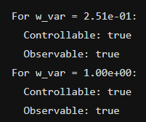
Results:
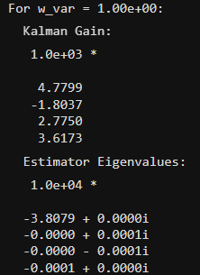
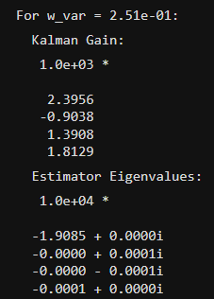
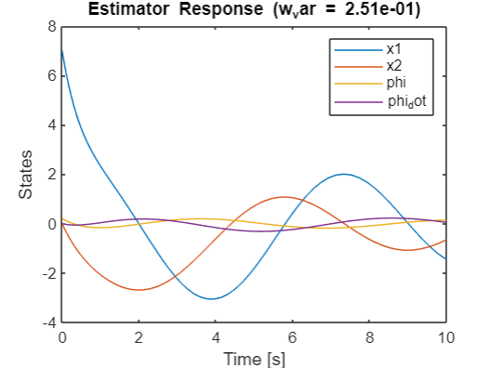
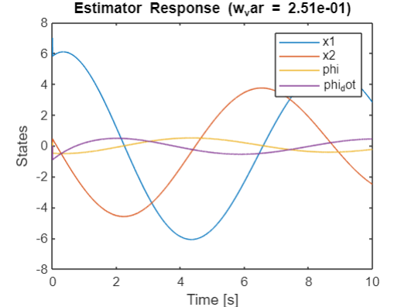
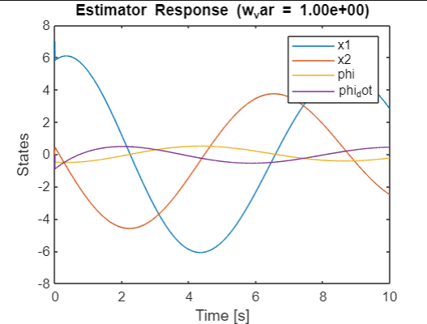
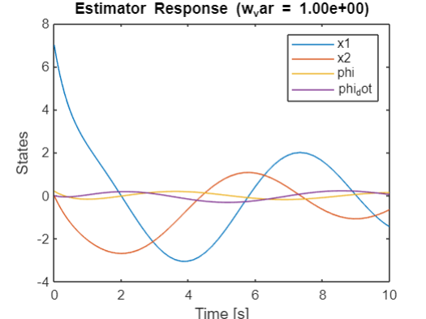

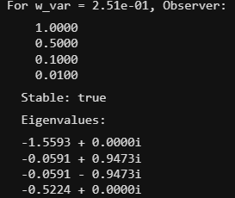
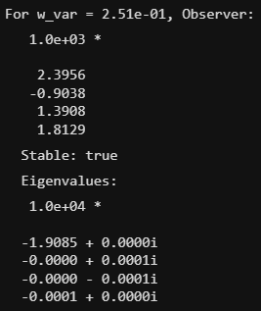
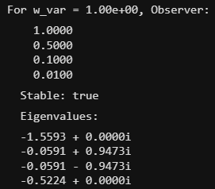
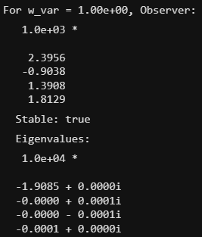
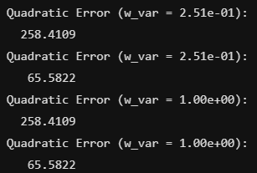

6. Robustness and Uncertainty
The system's behavior under disturbances and noise is analyzed. Robust control strategies are evaluated to ensure stability and performance.
The purpose of this question is to design a system that moves a certain load from one place to another in the shortest time.
For this exercise, we will assume the following parameters:
- Mass of the cart (M): 400 kg
- Mass of the load (m): 600 kg
- Length of the cable (L): 4 m
It is necessary to design an optimal controller and an observer (not necessarily optimal) for the linear system, which will also work with the nonlinear system. The nonlinear system starts near the origin equilibrium point.
Using the appropriate input, the nonlinear system (the hook) must be brought to position y=−5 meters and then wait until the hook oscillations (swinging) are dampened enough (the hook does not swing more than ±15\pm 15±15 cm). Then, the system should move to y=+5 meters and wait until the swinging is small enough. You must design the appropriate reference input signal.
Time is calculated from the moment the cart motion starts from the origin to the arrival of the load to y=+5meters. Additional limitations are:
- ∣u∣<500
- ∣u_dot∣<500
- Overshoot <50%
MATLAB Code:
% Bridge Crane Control System Design
% Parameters
M = 400; % Mass of the cart [kg]
m = 600; % Mass of the load [kg]
L = 4; % Cable length [m]
g = 9.8; % Gravitational acceleration [m/s^2]

% Compute constants
a32 = (m * g) / M;
a42 = -((M + m) * g) / (M * L);
b2 = 1 / M;
b4 = -1 / (M * L);

% System matrices
A = [0, 1, 0, 0;
0, 0, a32, 0;
0, 0, 0, 1;
0, 0, a42, 0];

B = [0;
b2;
0;
b4];

C = [1, 0, L, 0]; % Output matrix (location of the load)
D = 0;

% Check controllability
Co = ctrb(A, B);
if rank(Co) == size(A, 1)
disp('The system is controllable.');
else
disp('The system is NOT controllable.');
end

% Check observability
Ob = obsv(A, C);
if rank(Ob) == size(A, 1)
disp('The system is observable.');
else
disp('The system is NOT observable.');
end

% LQR Controller Design
Q = diag([1, 0.1, 1, 0.1]); % Adjusted state weighting matrix
R = 10; % Increased input weighting scalar

% Compute LQR gain matrix K
[K, S, e] = lqr(A, B, Q, R);

% Observer Design
desired_observer_poles = [-2; -2.5; -3; -3.5];
L_observer = place(A', C', desired_observer_poles)';

% Compute steady-state gain for reference tracking
C_ref = C;
N_bar = -inv(C_ref * inv(A - B * K) * B);

% Simulation parameters
t_final = 50; % Total simulation time [s]
dt = 0.01;
t = 0:dt:t_final;
t_change = 15; % Time when the reference input changes [s]

% Reference output
y_ref = -5 * ones(size(t));
y_ref(t >= t_change) = 5;

% Initial conditions
x0 = [0; 0; 0; 0]; % Initial state
x_hat0 = [0; 0; 0; 0]; % Initial estimated state
X0 = [x0; x_hat0]; % Combined initial state vector

% ODE Simulation
[t_sim, X_sim] = ode45(@(t, X) crane_ode(t, X, A, B, C, K, L_observer, N_bar, t_change), t, X0);

% Extract states
x_sim = X_sim(:, 1:4);
x_hat_sim = X_sim(:, 5:8);

% Compute outputs
y_sim = (C * x_sim')'; % Output y(t)

% Compute control input u
u_sim = zeros(length(t_sim), 1);
for i = 1:length(t_sim)
t_i = t_sim(i);
% Reference input r(t)
if t_i < t_change
r_t = -5;
else
r_t = 5;
end
x_hat_i = x_hat_sim(i, :)';
% Control input
u_sim(i) = -K * x_hat_i + N_bar * r_t;
% Apply input saturation
u_sim(i) = max(min(u_sim(i), 500), -500);
end

% Compute control input rate u_dot
u_dot_sim = [0; diff(u_sim)./diff(t_sim)];
% Apply rate limiter
u_dot_sim = max(min(u_dot_sim, 500), -500);

% Plot results

% Plot outputs
figure;
subplot(3,1,1);
plot(t_sim, y_sim, 'b', 'LineWidth', 1.5);
hold on;
plot(t_sim, y_ref, 'r--', 'LineWidth', 1.5);
xlabel('Time [s]');
ylabel('Load Position y [m]');
title('Load Position vs. Time');
legend('Actual Output y(t)', 'Reference Output y_{ref}(t)');
grid on;

% Plot control input u(t)
subplot(3,1,2);
plot(t_sim, u_sim, 'k', 'LineWidth', 1.5);
xlabel('Time [s]');
ylabel('Control Input u(t)');
title('Control Input vs. Time');
grid on;

% Plot control input rate u_dot(t)
subplot(3,1,3);
plot(t_sim, u_dot_sim, 'm', 'LineWidth', 1.5);
xlabel('Time [s]');
ylabel('Control Input Rate \Delta u(t)');
title('Control Input Rate vs. Time');
grid on;

% Plot states
figure;
subplot(4,1,1);
plot(t_sim, x_sim(:,1), 'LineWidth', 1.5);
xlabel('Time [s]');
ylabel('x1 (Cart Position) [m]');
title('State x1 vs. Time');
grid on;

subplot(4,1,2);
plot(t_sim, x_sim(:,2), 'LineWidth', 1.5);
xlabel('Time [s]');
ylabel('x2 (Cart Velocity) [m/s]');
title('State x2 vs. Time');
grid on;

subplot(4,1,3);
plot(t_sim, x_sim(:,3), 'LineWidth', 1.5);
xlabel('Time [s]');
ylabel('x3 (\phi Angle) [rad]');
title('State x3 vs. Time');
grid on;

subplot(4,1,4);
plot(t_sim, x_sim(:,4), 'LineWidth', 1.5);
xlabel('Time [s]');
ylabel('x4 (\phi Velocity) [rad/s]');
title('State x4 vs. Time');
grid on;

% Display maximum values to verify constraints
max_u = max(abs(u_sim));
max_u_dot = max(abs(u_dot_sim));
disp(['Maximum |u(t)|: ', num2str(max_u)]);
disp(['Maximum |u_dot(t)|: ', num2str(max_u_dot)]);

% Compute overshoot and settling time
[y_peak_pos, t_peak_pos] = findpeaks(y_sim, t_sim);
[y_peak_neg, t_peak_neg] = findpeaks(-y_sim, t_sim);

% Overshoot calculation
overshoot_pos = max((y_peak_pos - 5) / 5 * 100, 0);
overshoot_neg = max((-y_peak_neg - (-5)) / 5 * 100, 0);

overshoot = max([overshoot_pos; overshoot_neg]);

disp(['Overshoot: ', num2str(overshoot), '%']);

% Settling time calculation
% Find the time when y_sim reaches and stays within ±0.15 m of y_ref
t_settle_neg = t_sim(find(abs(y_sim(1:find(t_sim >= t_change,1)) - (-5)) <= 0.15, 1, 'last'));
t_settle_pos = t_sim(find(abs(y_sim(find(t_sim >= t_change,1):end) - 5) <= 0.15, 1, 'last'));

disp(['Settling time after first step: ', num2str(t_settle_neg), ' s']);
disp(['Settling time after second step: ', num2str(t_settle_pos - t_change), ' s']);

% ODE function for the crane system
function dXdt = crane_ode(t, X, A, B, C, K, L, N_bar, t_change)
n = length(A); % Number of states
x = X(1:n);
x_hat = X(n+1:end);

% Reference input r(t)
if t < t_change
r_t = -5;
else
r_t = 5;
end

% Output y
y = C * x;

% Estimated output y_hat
y_hat = C * x_hat;

% Control input before saturation
u = -K * x_hat + N_bar * r_t;

% Apply input saturation
u = max(min(u, 500), -500);

% State equations
x_dot = A * x + B * u;

% Observer equations
x_hat_dot = A * x_hat + B * u + L * (y - y_hat);

% Combine derivatives
dXdt = [x_dot; x_hat_dot];
end

Results:
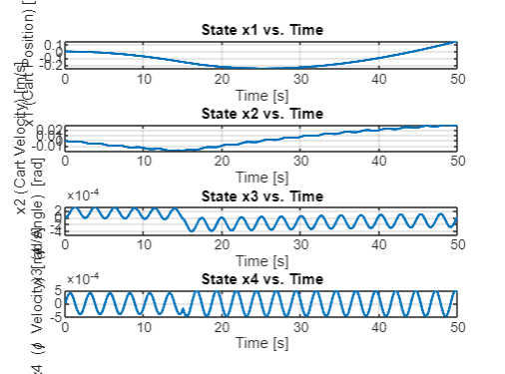
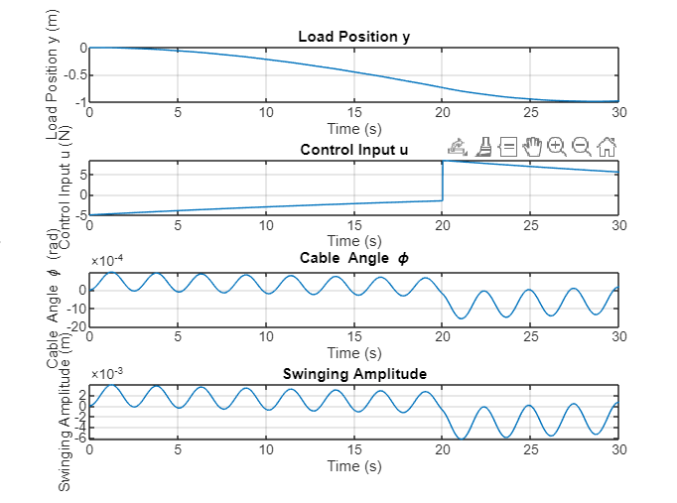

2. Robust and Stable Control Design of the Original System:
We will design a controller and an optimal observer:

MATLAB Code:
% Parameters (example values based on the problem)
U = 4; V = 5; W = 6; X = 7; Y = 8; Z = 9;

M = 100 * (5 + Z); % Mass of the cart [kg]
m = 100 * (1 + Y); % Mass of the load [kg]
L = 5 + X; % Cable length [m]
g = 9.8; % Gravitational constant [N/kg]

% State-space matrices for linearized system around equilibrium
A = [0, 1, 0, 0;
0, 0, -(m * g) / M, 0;
0, 0, 0, 1;
0, 0, (M + m) * g / (M * L), 0];

B = [0; 1 / M; 0; -1 / (M * L)];
C = [1, 0, L, 0]; % Output matrix (cart position as output y)
D = 0;

% LQR Controller Design
Q = diag([1, 1, 10, 10]); % State cost weighting matrix
R = 1; % Control effort cost
K = lqr(A, B, Q, R); % LQR gain

% Observer Design (Kalman Filter)
Qn = diag([0.01, 0.01, 0.1, 0.1]); % Process noise covariance
Rn = 0.01; % Measurement noise covariance

% Kalman gain calculation
[L_observer, ~, ~] = lqr(A', C', Qn, Rn);
L_observer = L_observer'; % Transpose to get Kalman gain

% Combined system: Controller + Observer
A_cl = [A - B * K, B * K;
zeros(size(A)), A - L_observer * C];
B_cl = [B; zeros(size(B))];
C_cl = [C, zeros(size(C))];

% Simulate the system
dt = 0.01; % Time step
T = 10; % Total simulation time
time = 0:dt:T;

x0 = [0.1; 0; 0.05; 0]; % Initial states (perturbation for testing)
x_hat0 = [0; 0; 0; 0]; % Initial observer states
X = [x0; x_hat0]; % Initial combined state
U = zeros(size(time)); % Control input (not used explicitly here)

% System parameters for dynamics function
params = struct('A_cl', A_cl, 'B_cl', B_cl, 'K', K, 'L_observer', L_observer, ...
'C_cl', C_cl, 'M', M, 'm', m, 'L', L, 'g', g);

% Simulate using ode45
[t, X_out] = ode45(@(t, X) crane_dynamics(t, X, params), time, X);

% Extract states
cart_position = X_out(:, 1);
cart_velocity = X_out(:, 2);
pendulum_angle = X_out(:, 3);
pendulum_angular_velocity = X_out(:, 4);

% Calculate output y = x + L * sin(phi)
output_y = cart_position + L * sin(pendulum_angle);

% Plot results
figure;

subplot(3, 2, 1);
plot(t, cart_position, 'LineWidth', 1.5);
xlabel('Time (s)');
ylabel('Cart Position (m)');
title('Cart Position vs Time');
grid on;

subplot(3, 2, 2);
plot(t, cart_velocity, 'LineWidth', 1.5);
xlabel('Time (s)');
ylabel('Cart Velocity (m/s)');
title('Cart Velocity vs Time');
grid on;

subplot(3, 2, 3);
plot(t, pendulum_angle, 'LineWidth', 1.5);
xlabel('Time (s)');
ylabel('Pendulum Angle (rad)');
title('Pendulum Angle vs Time');
grid on;

subplot(3, 2, 4);
plot(t, pendulum_angular_velocity, 'LineWidth', 1.5);
xlabel('Time (s)');
ylabel('Pendulum Angular Velocity (rad/s)');
title('Pendulum Angular Velocity vs Time');
grid on;

subplot(3, 2, 6);
plot(t, L + L * sin(pendulum_angle), 'LineWidth', 1.5);
xlabel('Time (s)');
ylabel('Y');
title('y vs Time');
grid on;

% Dynamics function
function dX = crane_dynamics(t, X, params)
% Unpack parameters
A_cl = params.A_cl;
B_cl = params.B_cl;
K = params.K;
L_observer = params.L_observer;
C_cl = params.C_cl;

% Decompose combined state
x = X(1:4); % Actual state
x_hat = X(5:8); % Estimated state

% Control input based on estimated state
u = -K * x_hat;

% Dynamics of the combined system
dx = A_cl(1:4, 1:4) * x + A_cl(1:4, 5:8) * x_hat + B_cl(1:4) * u;
dx_hat = A_cl(5:8, 1:4) * x + A_cl(5:8, 5:8) * x_hat + B_cl(5:8) * u + L_observer * (C_cl(1:4) * x - C_cl(5:8) * x_hat);

% Combined derivative
dX = [dx; dx_hat];
end

Plot Results:
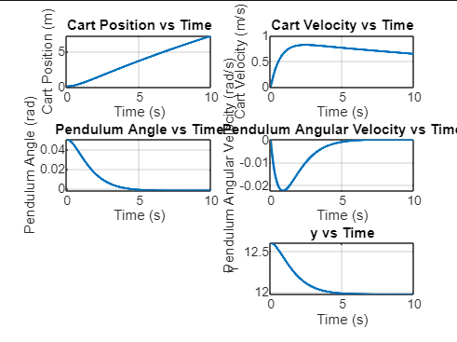

7. Results and Discussion
- Nonlinear Model: Derived equations and Simulink responses.
- Linearization: Stability confirmed for small angles.
- Transfer Functions: Stability analysis and pole-zero plots.
- Controllers: Optimal controllers reduce oscillations effectively; eigenvalues confirm stability.
- Observers: Kalman filter outperforms in noise rejection and state estimation.

8. Conclusion
The project successfully modeled and controlled a bridge crane system. Controllers and observers were designed to ensure stability under varying conditions. Future work includes experimental validation and extending the system to include more complex dynamics.

8A. Mathematical Modeling Approach
- Model Selection: The bridge crane system is chosen as the focus due to its practical applications, such as loading containers onto ships.
- Derivation Methodology:
  - First-Principles Modeling: The system is modeled using Newtonian mechanics (Method B), leveraging the known physical laws and the system's structure.
  - Simplifying Assumptions:
    - The cable is massless, inextensible, and of fixed length L.
    - There is no friction between the cart and the bridge.
    - The engine dynamics and nonlinearities are neglected, assuming the horizontal input force u can be directly controlled.
- State-Space Representation:
  - The state vector xxx is defined to encapsulate the essential dynamic variables: cart position x1​, cart velocity x2​, cable angle phi, and angular velocity phi_dot.
Conclusion: The mathematical model provides a comprehensive and tractable representation of the bridge crane system by employing appropriate simplifying assumptions and leveraging fundamental physics principles.

8b. Dynamic Equations and System Behavior
- Derivation of Equations of Motion:
  - Horizontal and vertical force balances are established for both the cart and the suspended load.
  - The equations account for the interaction between the cart's motion and the pendulum-like swinging of the load.
- Nonlinear Dynamics:
  - The derived equations are inherently nonlinear due to terms involving sin(ϕ),cos(ϕ), and phi_dot^2.
  - Nonlinear coupling between translational and rotational motions highlights the complexity of the system's dynamics.
- Cable Length Constraint:
  - The fixed cable length LLL introduces geometric relationships between the cart's position and the load's position.
Conclusion: The dynamic model accurately captures the nonlinear and coupled nature of the bridge crane system's behavior, which is crucial for understanding and predicting the system's response to control inputs.

8c. Parameterization and Flexibility
- Variable Parameters:
  - The model incorporates parameters M, m, and L that can vary based on constants U, V, W, X, Y, and Z.
  - These constants can be randomly selected or predefined, allowing the model to represent different scenarios.
- Example Parameter Values:
  - Using U=4, V=5, W=6, X=7, Y=8, and Z=9:
    - Cart mass M=100(5+Z)=100(5+9)=1400kg.
    - Load mass m=100(1+Y)=100(1+8)=900kg.
    - Cable length L=5+X=5+7=12 m.
Conclusion: The parameterization provides flexibility, enabling the model to adapt to various physical configurations and mass distributions, which is essential for designing controllers applicable to different operational conditions.

8d. Control System Implications
- Need for Feedback Control:
  - To achieve precise positioning and minimize load swing, feedback control is necessary.
  - The nonlinear dynamics pose challenges for control design, especially under varying load masses.
- Assumed Automation:
  - The model assumes automatic damping of vibrations and automatic connection of the hook to the load, emphasizing the need for advanced control strategies.
- Engine Dynamics Simplification:
  - By neglecting engine dynamics, the focus shifts to the primary mechanical system, simplifying the control problem while acknowledging practical limitations on the input force uuu.
Conclusion: Understanding the system's dynamics is pivotal for developing effective control strategies that ensure safe and efficient operation, particularly in automating tasks typically assisted by human operators.

8e. Practical Applications and Further Work
- Real-World Relevance:
  - The model is applicable to actual bridge crane systems used in seaports and industrial settings.
- Basis for Simulation and Control Design:
  - The derived equations can be used to simulate system behavior under various control inputs and disturbances.
  - Linearization around operating points can facilitate the design of linear controllers, while the nonlinear model remains essential for assessing performance over a broader range of conditions.
- Potential Extensions:
  - Incorporating friction, cable elasticity, and engine dynamics in future models could enhance accuracy.
  - Exploring advanced control techniques (e.g., nonlinear control, adaptive control) to handle the system's complexities.
Conclusion: The mathematical model serves as a foundational tool for simulation, analysis, and control design, with potential for refinement and extension to address more sophisticated aspects of bridge crane operation.

References
- IEEE Standards Association. IEEE Guide for Control of Industrial Systems.
- Modern Control by Arie Nakhmani.
- MATLAB Documentation.

