MOUNT KENYA UNIVERSITY
DEVELOPMENT LOGBOOK
Student details: Charity Karimi Musyoka
Admission no: BSCCS/2024/59249
Unit code: BIT3208
Project name : hospital system
Unit name: Advanced Web Design and Development
Selected technologies: PHP + MySQL, HTML, CSS, JavaScript, XAMPP
GitHub Link: https://github.com/charitykarimi/project1
Github repository link : https://github.com/charitykarimi/project1

Table of contents

WEEK 1: LOCAL ENVIRONMENT SETUP
Title: Installation and Testing of Local Development Environment

Fig 1: Installation of XAMPP
Successful installation of XAMPP development environment for Apache and MySQL services.
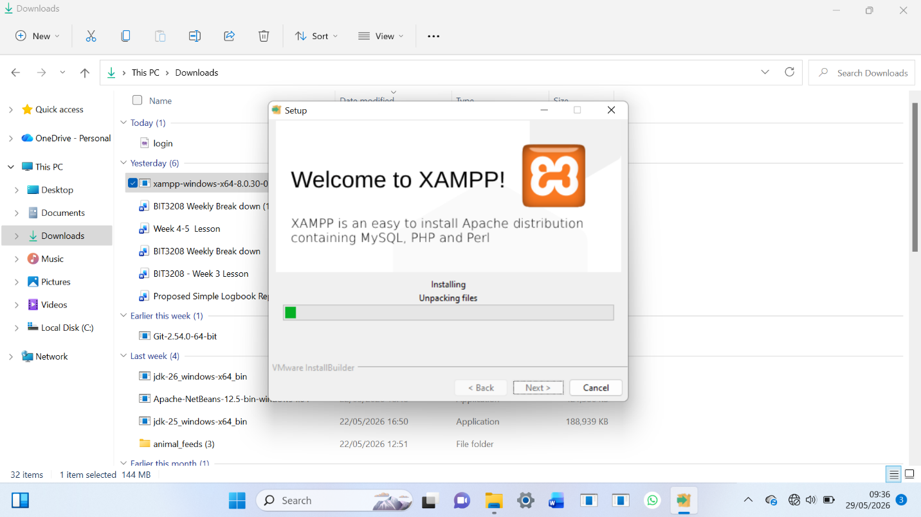

Explanation
Fig 1 shows the successful installation of XAMPP on the local computer. This environment was used to configure Apache and MySQL services for web application development. The installation confirmed that the machine was ready for PHP development and local database management.

Fig 2: Apache and MySQL Running
Apache and MySQL services running successfully in XAMPP Control Panel.
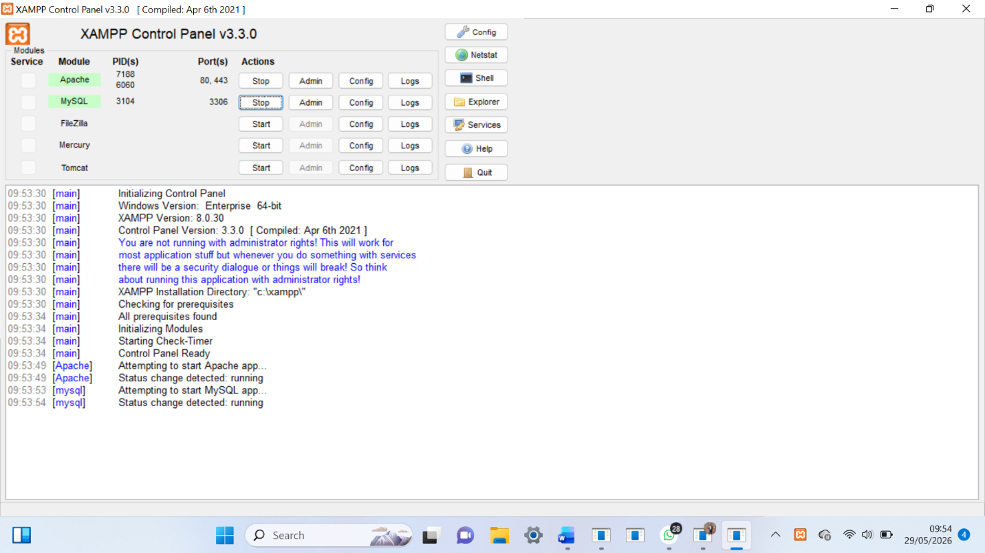
Explanation
Fig 2 demonstrates that Apache and MySQL services were started successfully from the XAMPP Control Panel. This confirmed that the web server and database server were properly configured and ready to support the Hospital Management System project.

Fig 3: Localhost Test Page
Browser successfully loading localhost test page.
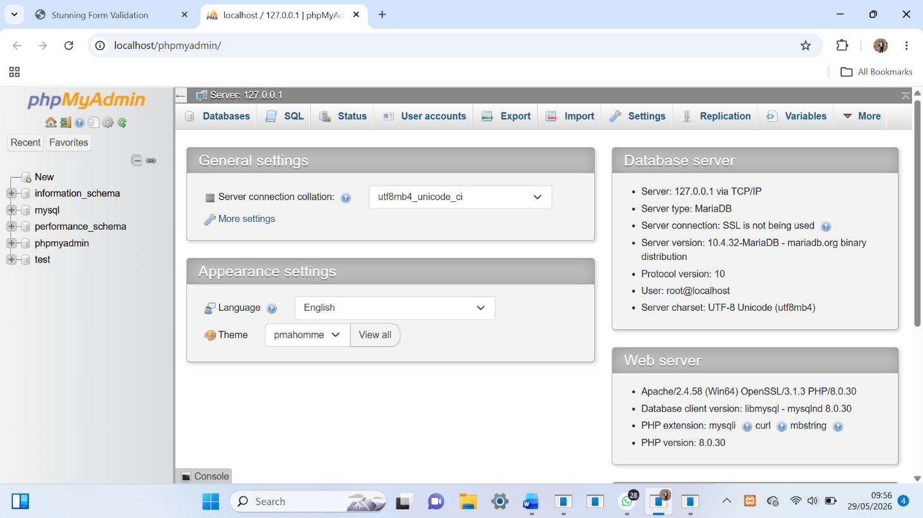

Explanation
Fig 3 shows the localhost page running successfully on the browser using Apache server. This verified that the local web server was functioning correctly and capable of hosting PHP web applications

WEEK 2: WIREFRAMES AND GUI DESIGN
Title: User Interface Planning and System Design

WEEK 3: JavaScript and PHP Basics
Title: Frontend interaction and Backend
Evidences:

Fig1: Javascript form validation preventing empty submissions
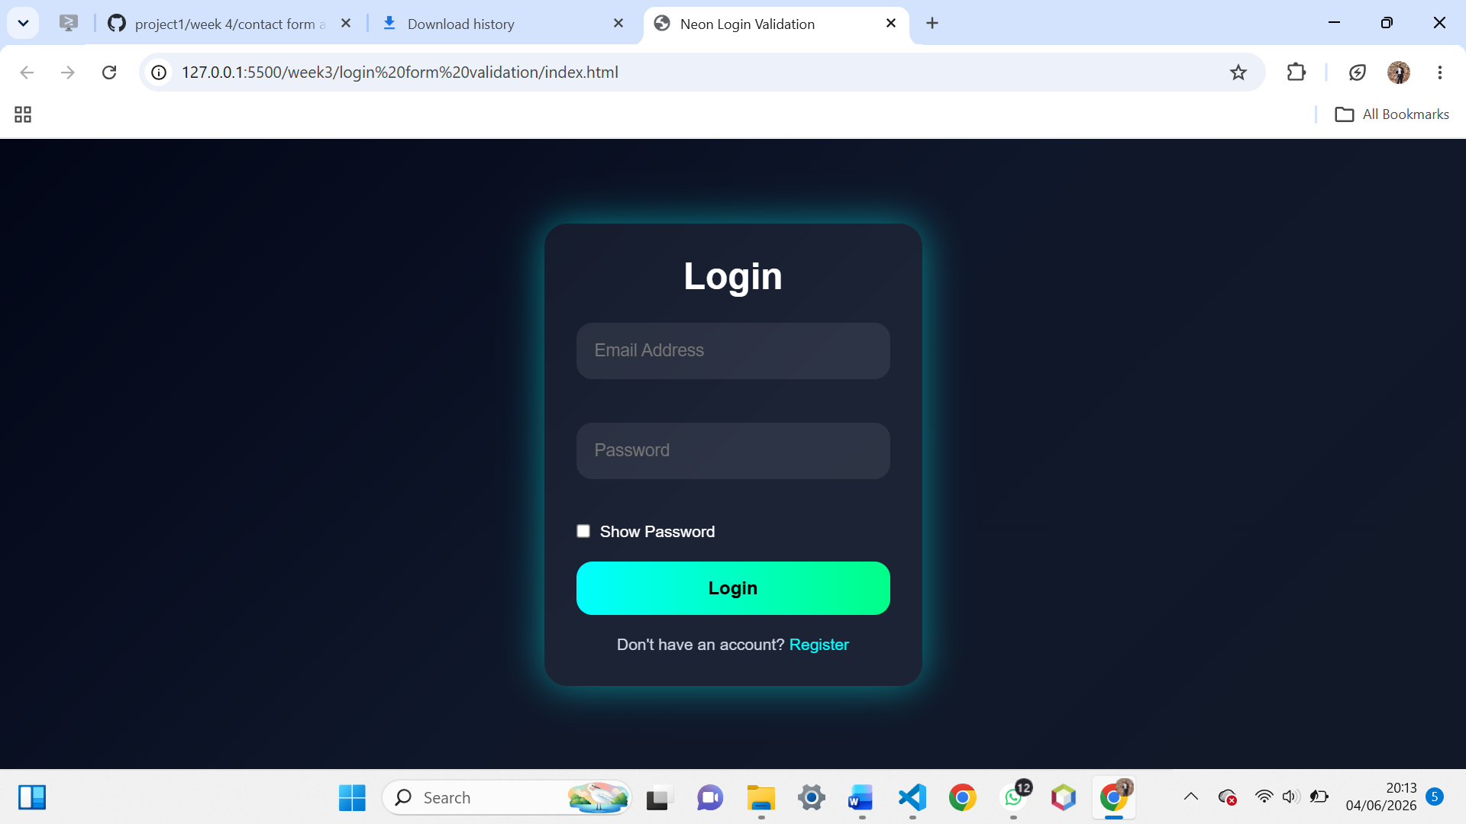

Fig2: Password strength checker with dynamic feedback
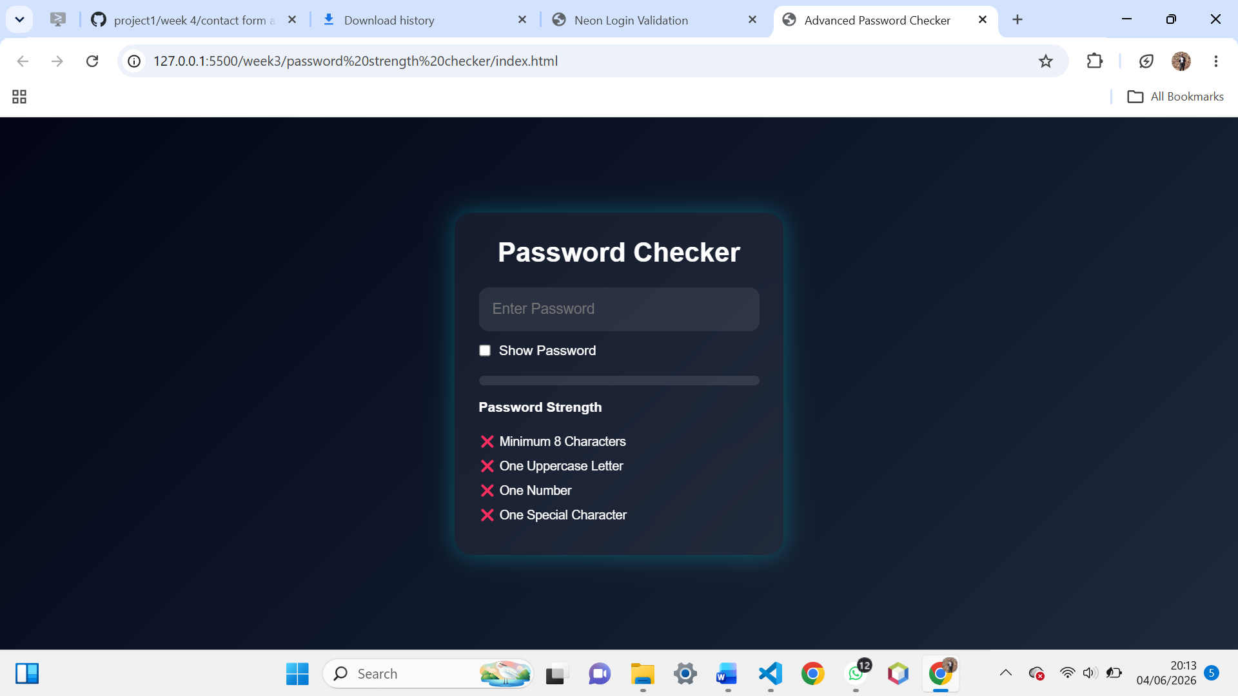
Fig3:Email validation script ensuring correct format
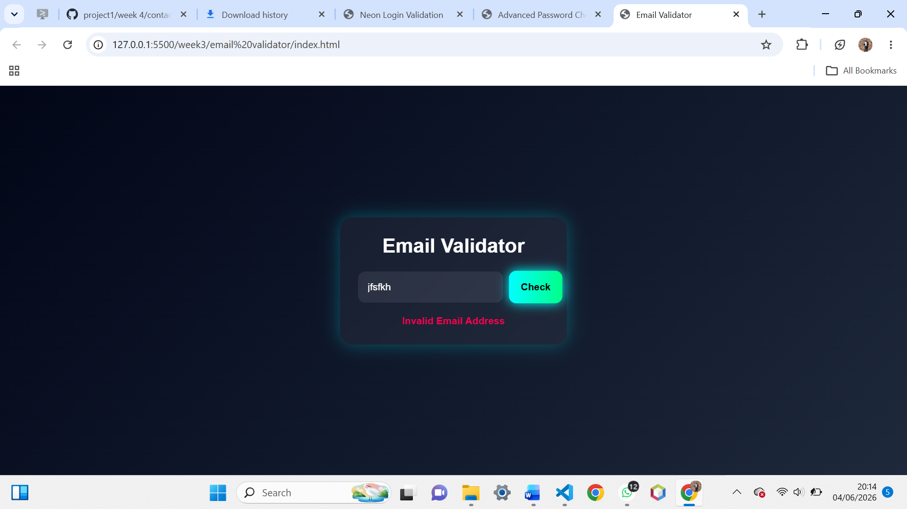

Fig4: login form validation with error message
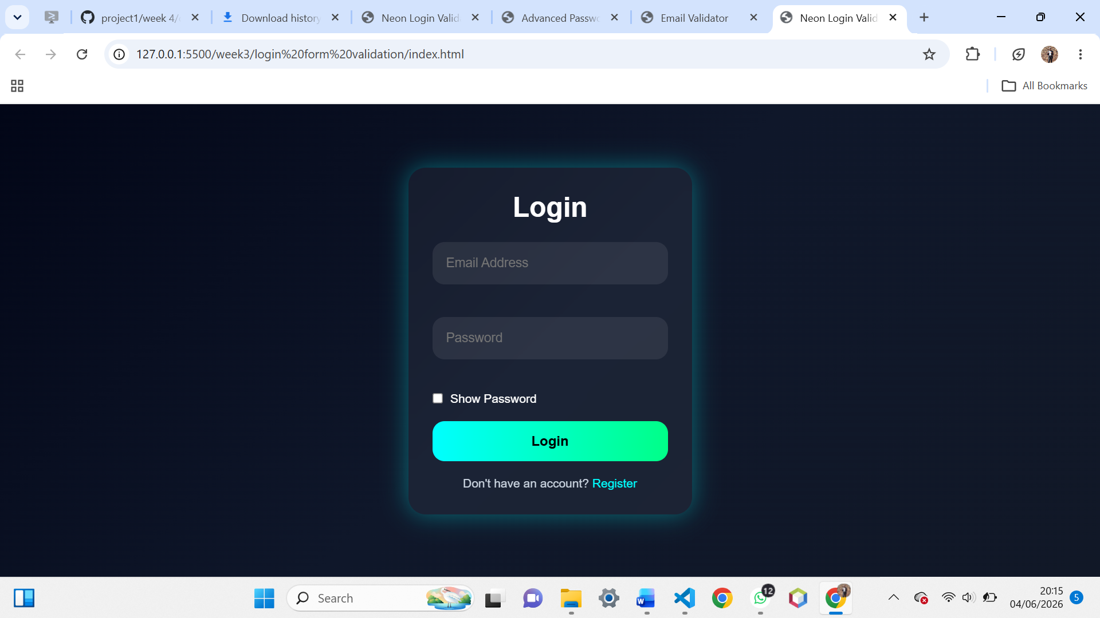
Fig5: Dynamic menu created with javascript
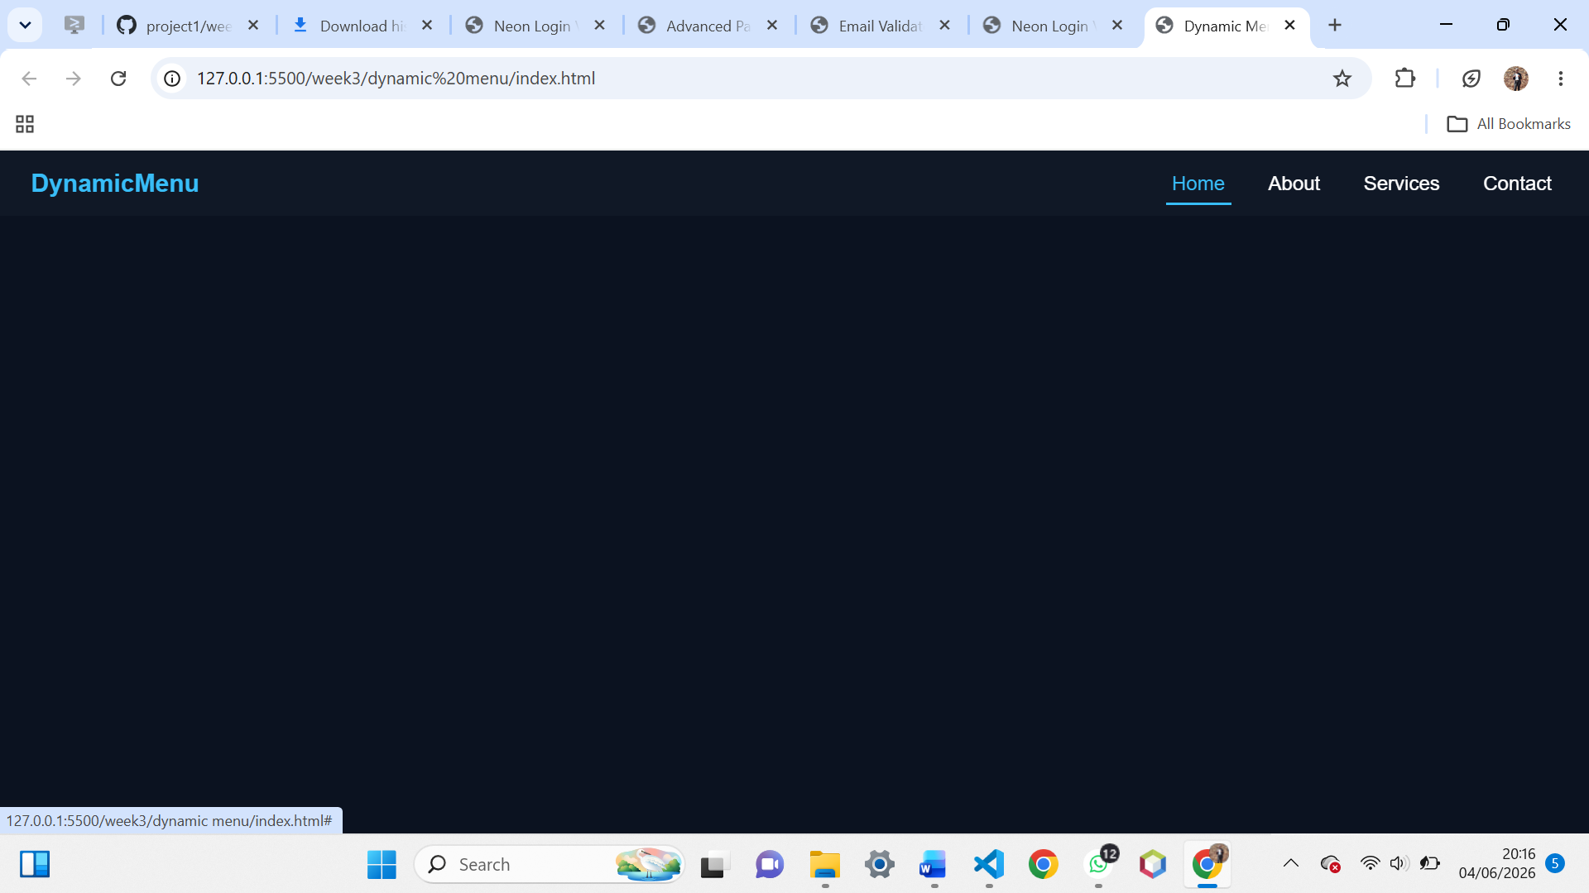

Fig6: live text preview system updating content in real time
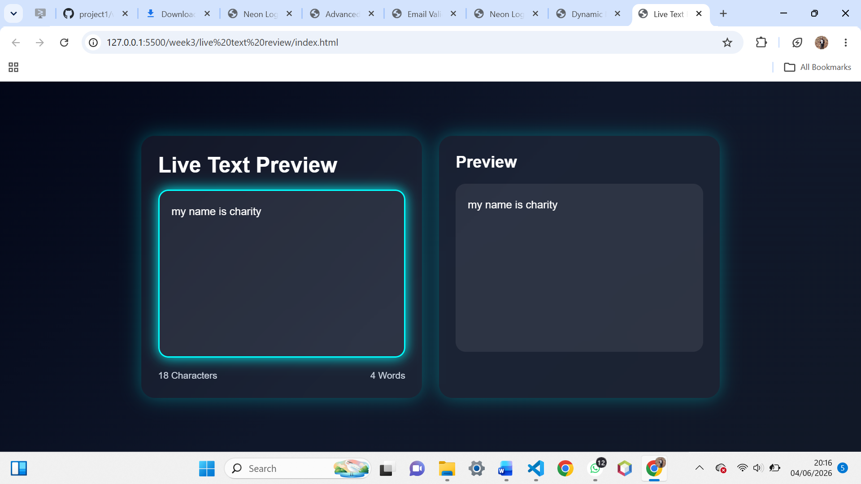
Fig7: index.php file displaying welcome message
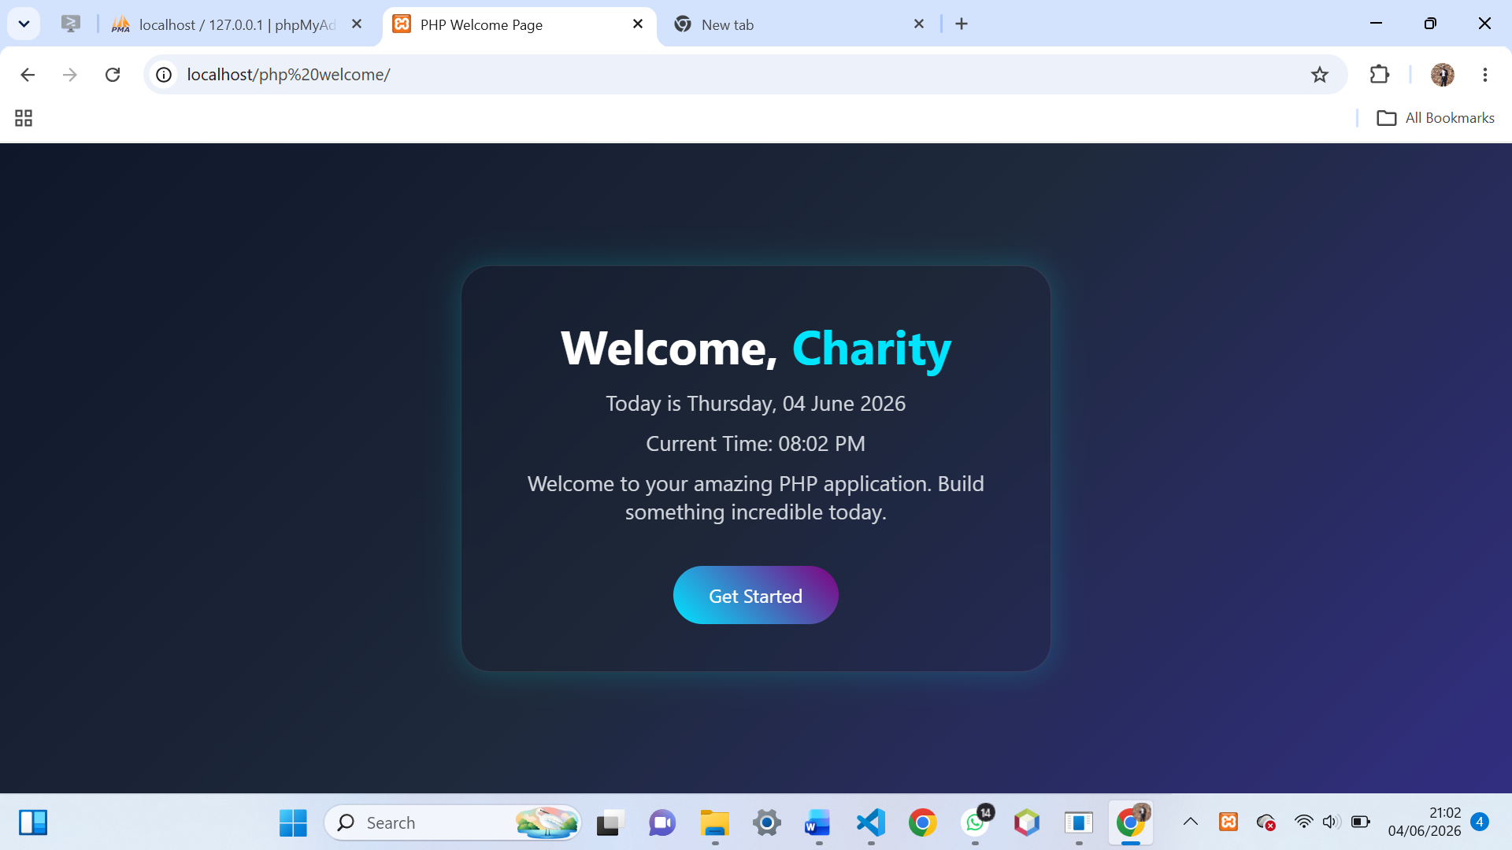

Fig8:interactive buttons responding to script
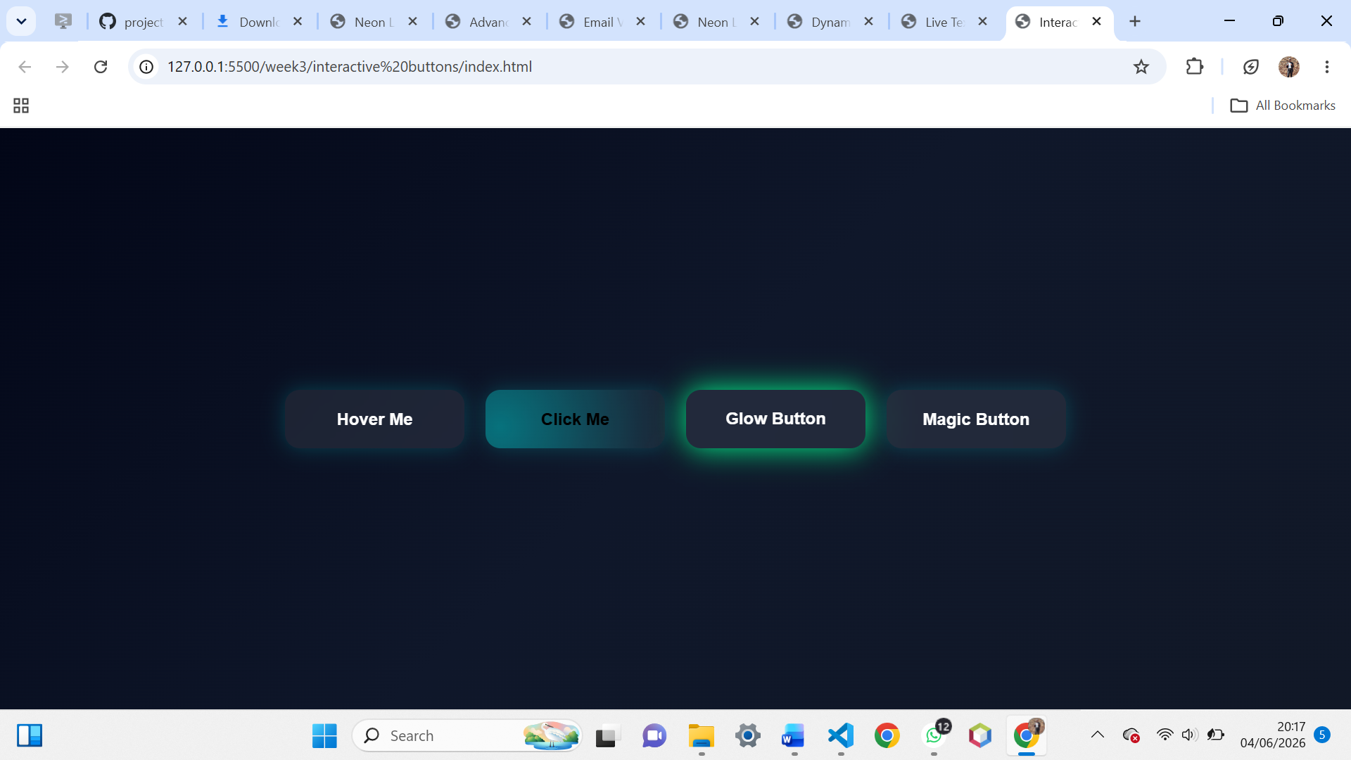
Fig9: simple form processor
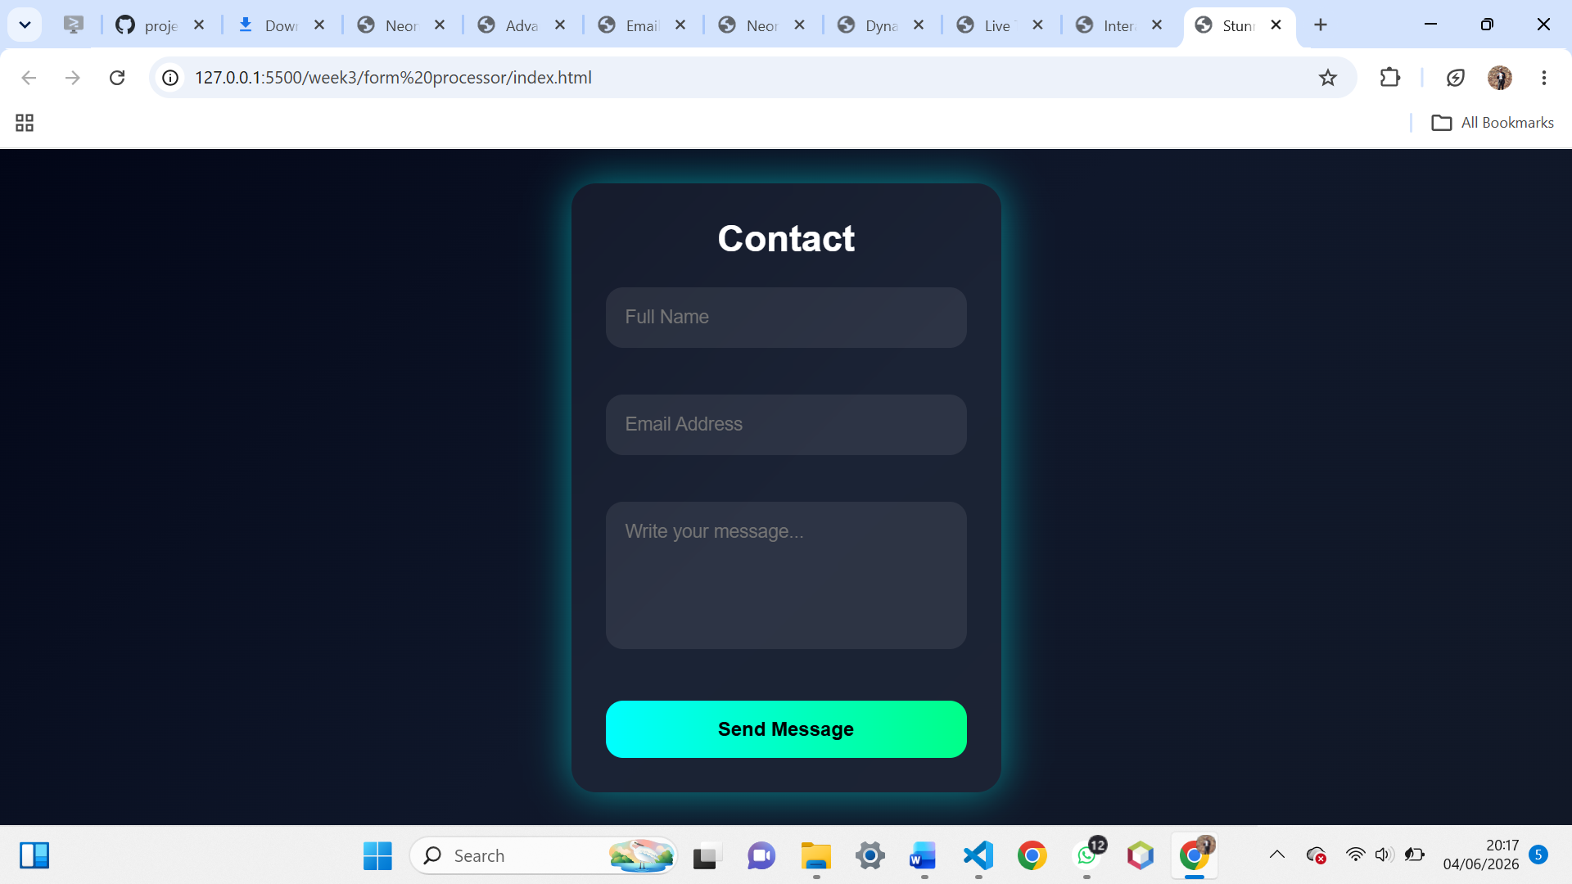
REFLECTION
This week I advanced from static pages to interactive systems. JavaScript tasks (Fig 1–7) improved user experience through validation, dynamic menus, and live previews. PHP basics (Fig 8–9) introduced server-side scripting and form handling, while Fig 10 confirmed successful database connectivity. These tasks demonstrated how frontend scripts and backend code integrate to build dynamic applications. The main challenge was debugging validation scripts and PHP syntax errors, which taught me careful attention to detail and improved my problem-solving skills

WEEK 4
Fig 1: Form submission system displaying dynamic welcome message
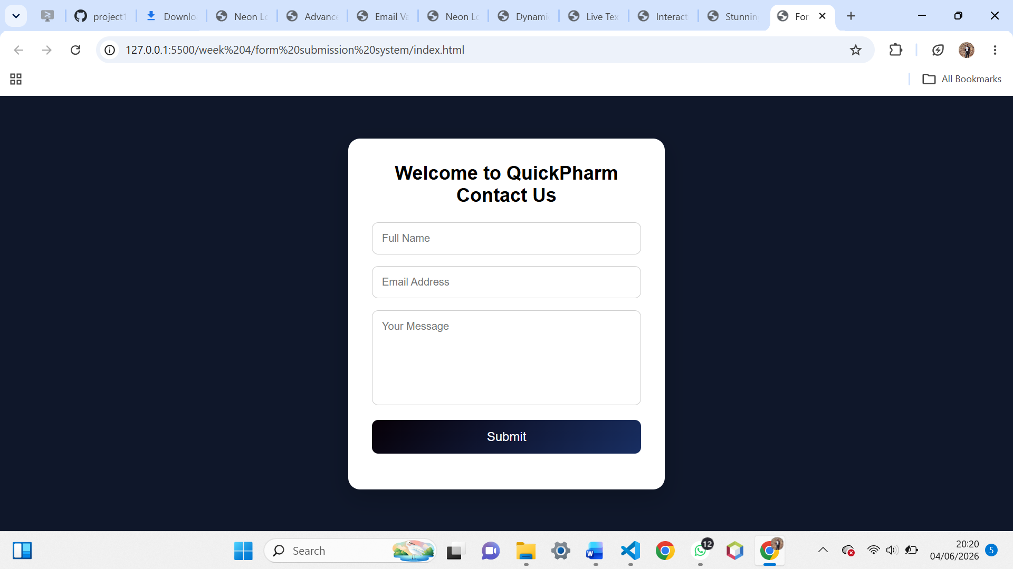
Fig 2: Homepage styled dynamically with PHP output

Fig 3: Simple PHP processing page handling user input

Fig 4: Registration form integrated with POST method
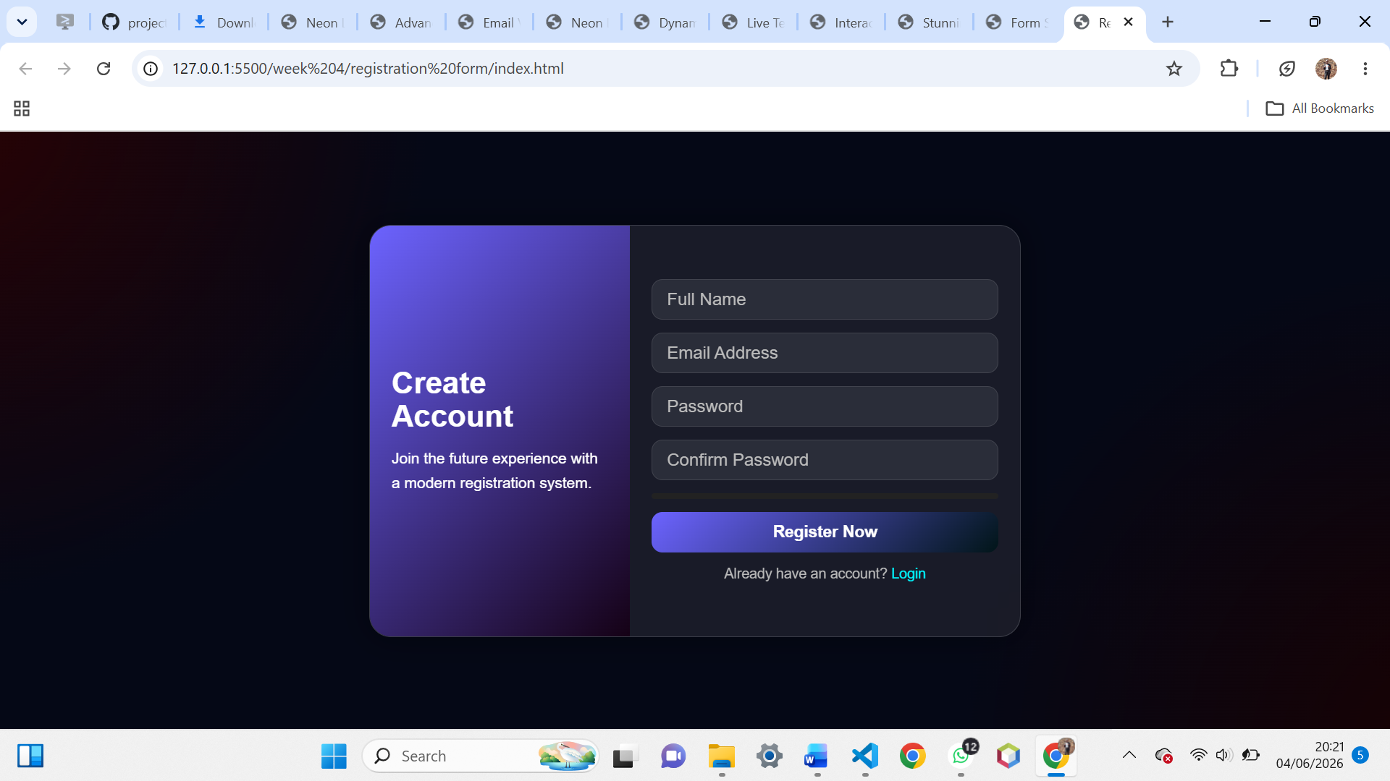
Fig 5: Login form with username/password validation
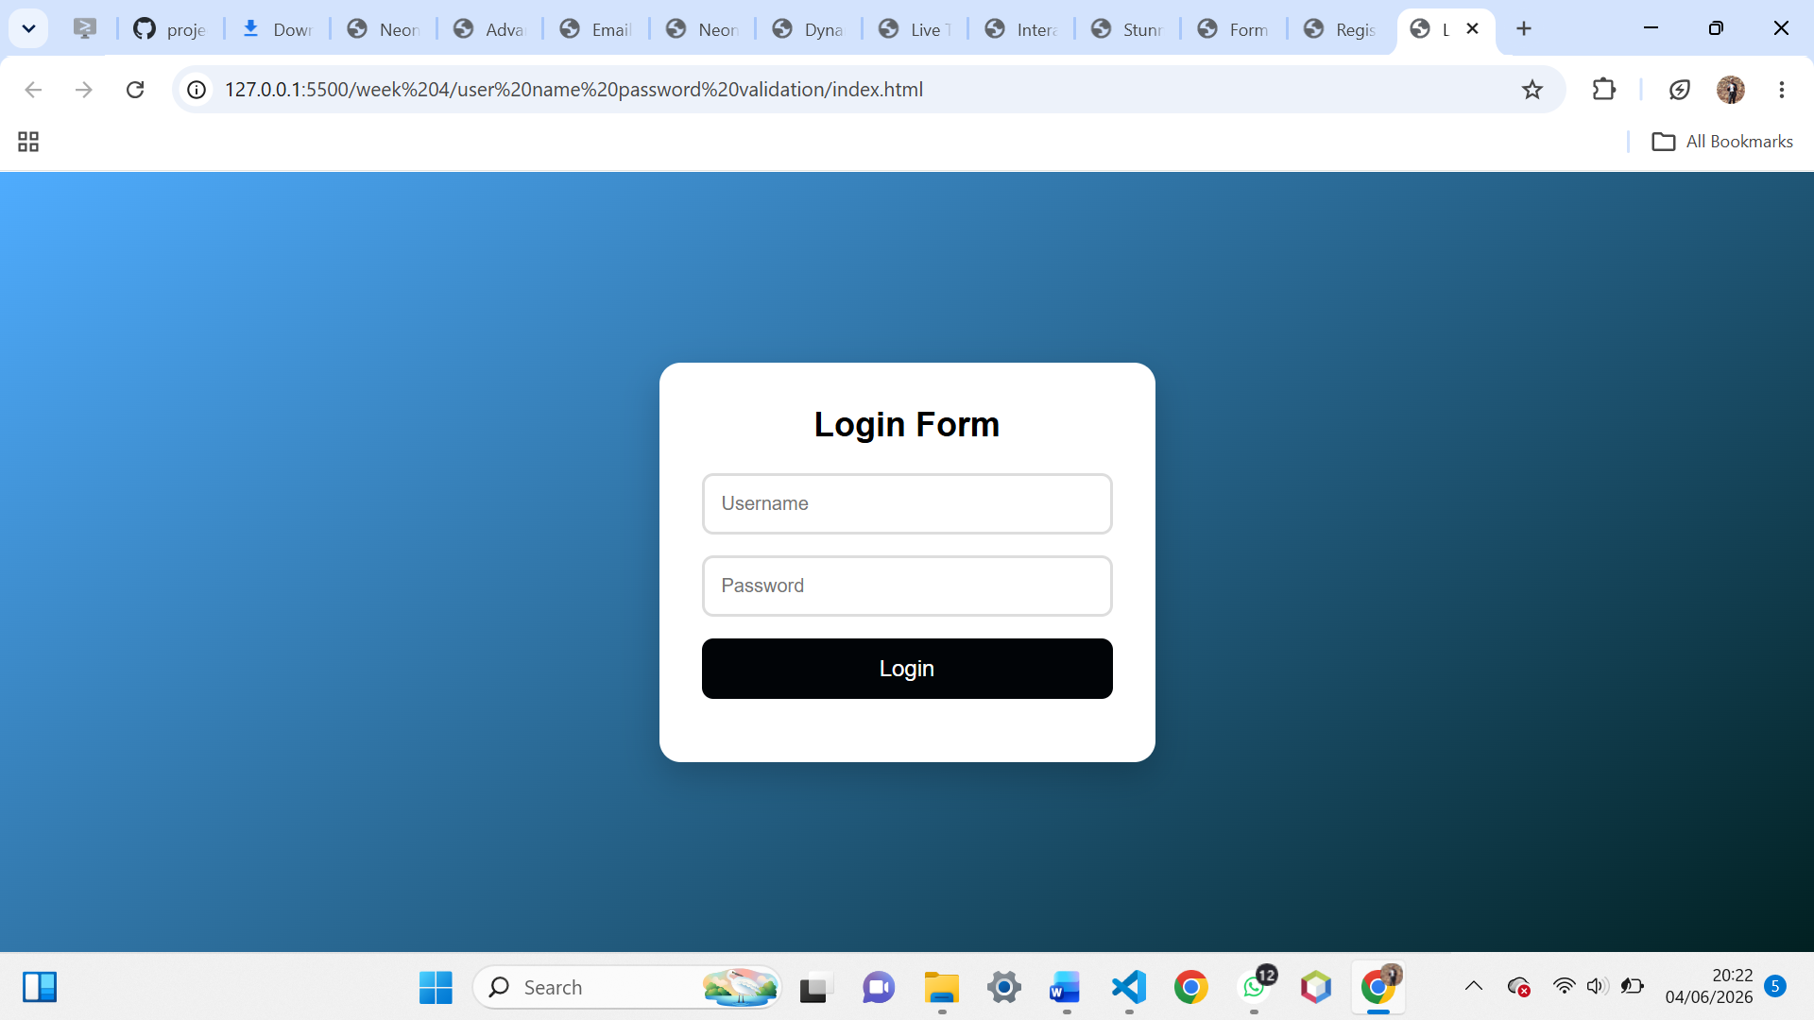

Fig 6: Contact form submission example
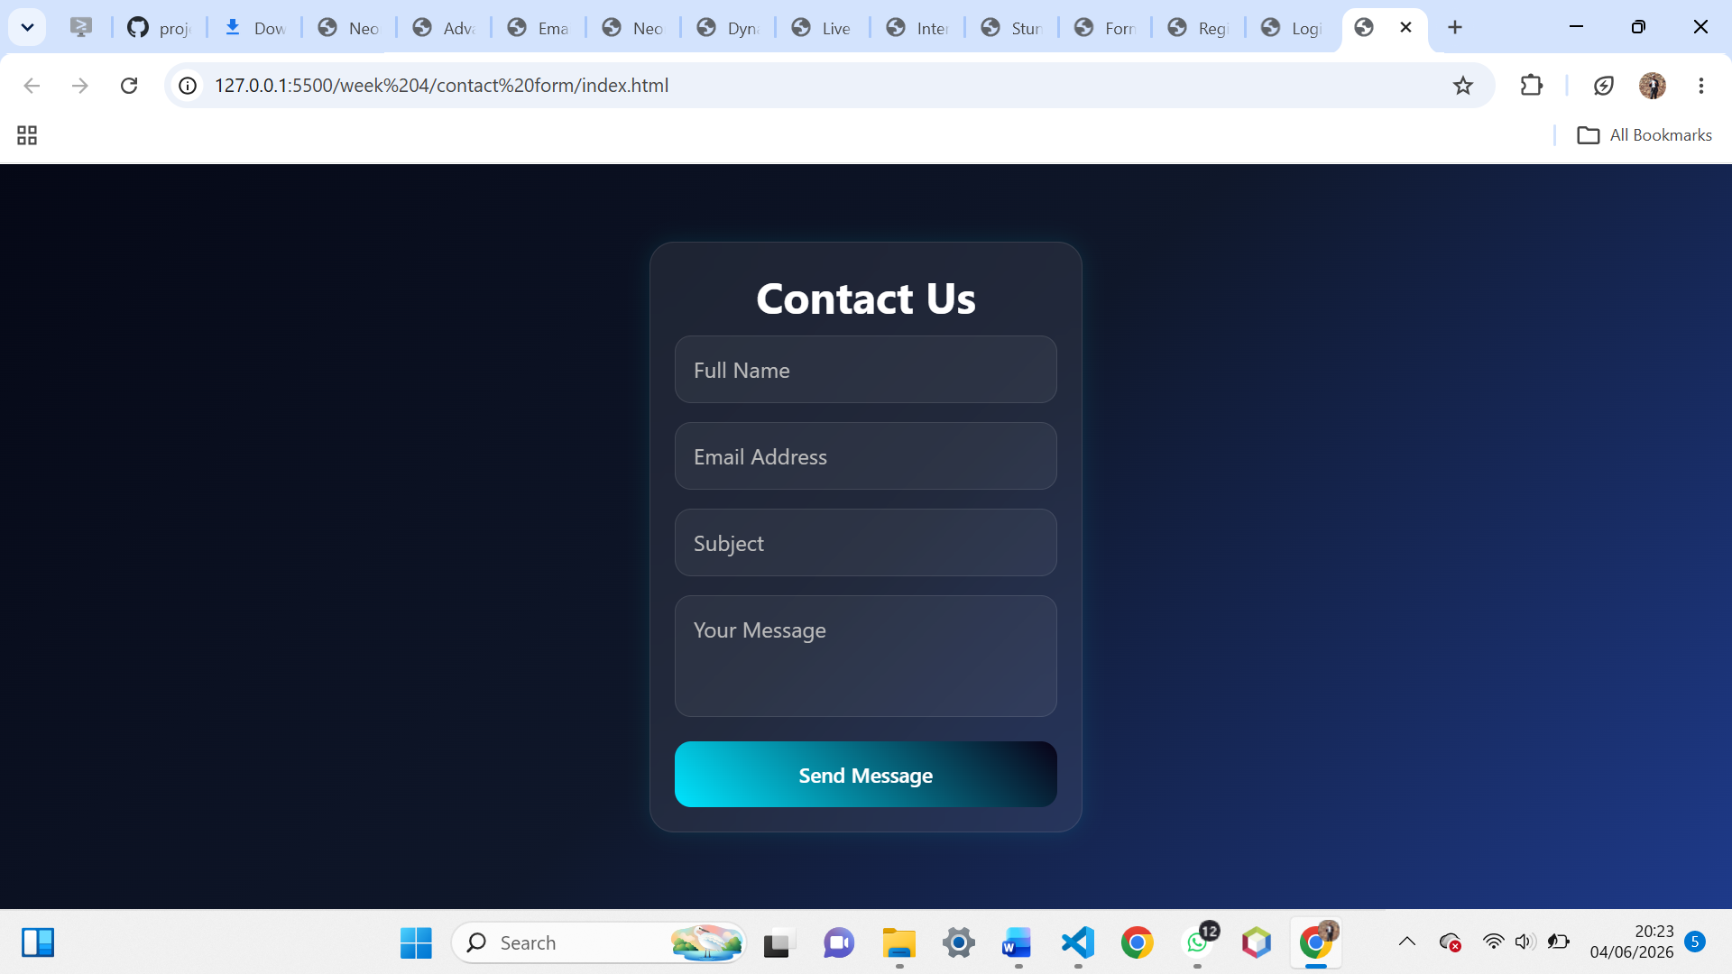
Fig 7: Basic login page with conditional access logic
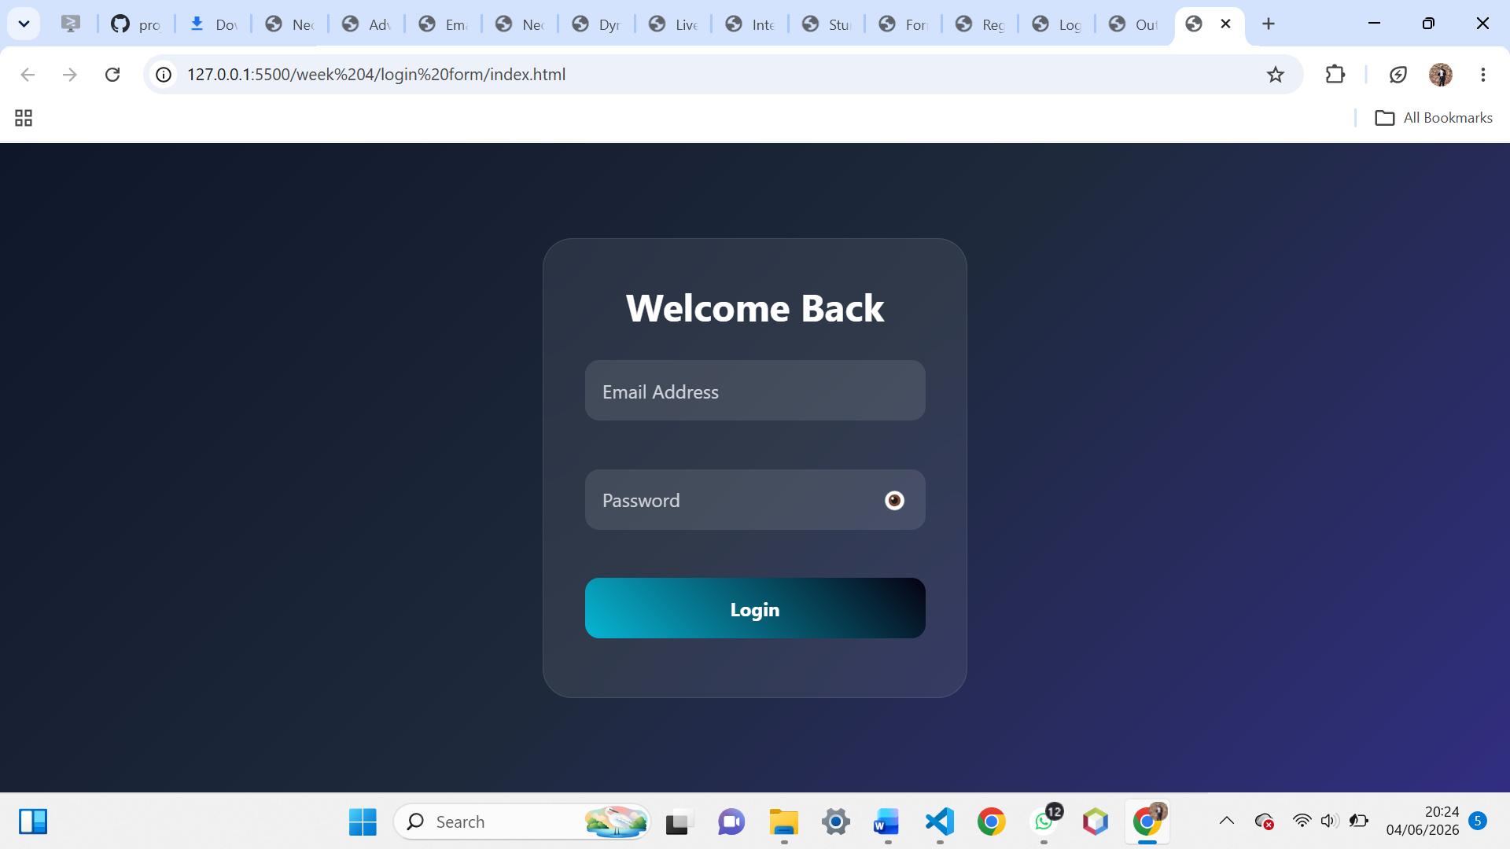

Fig 8: Username and password validation script ensuring secure login
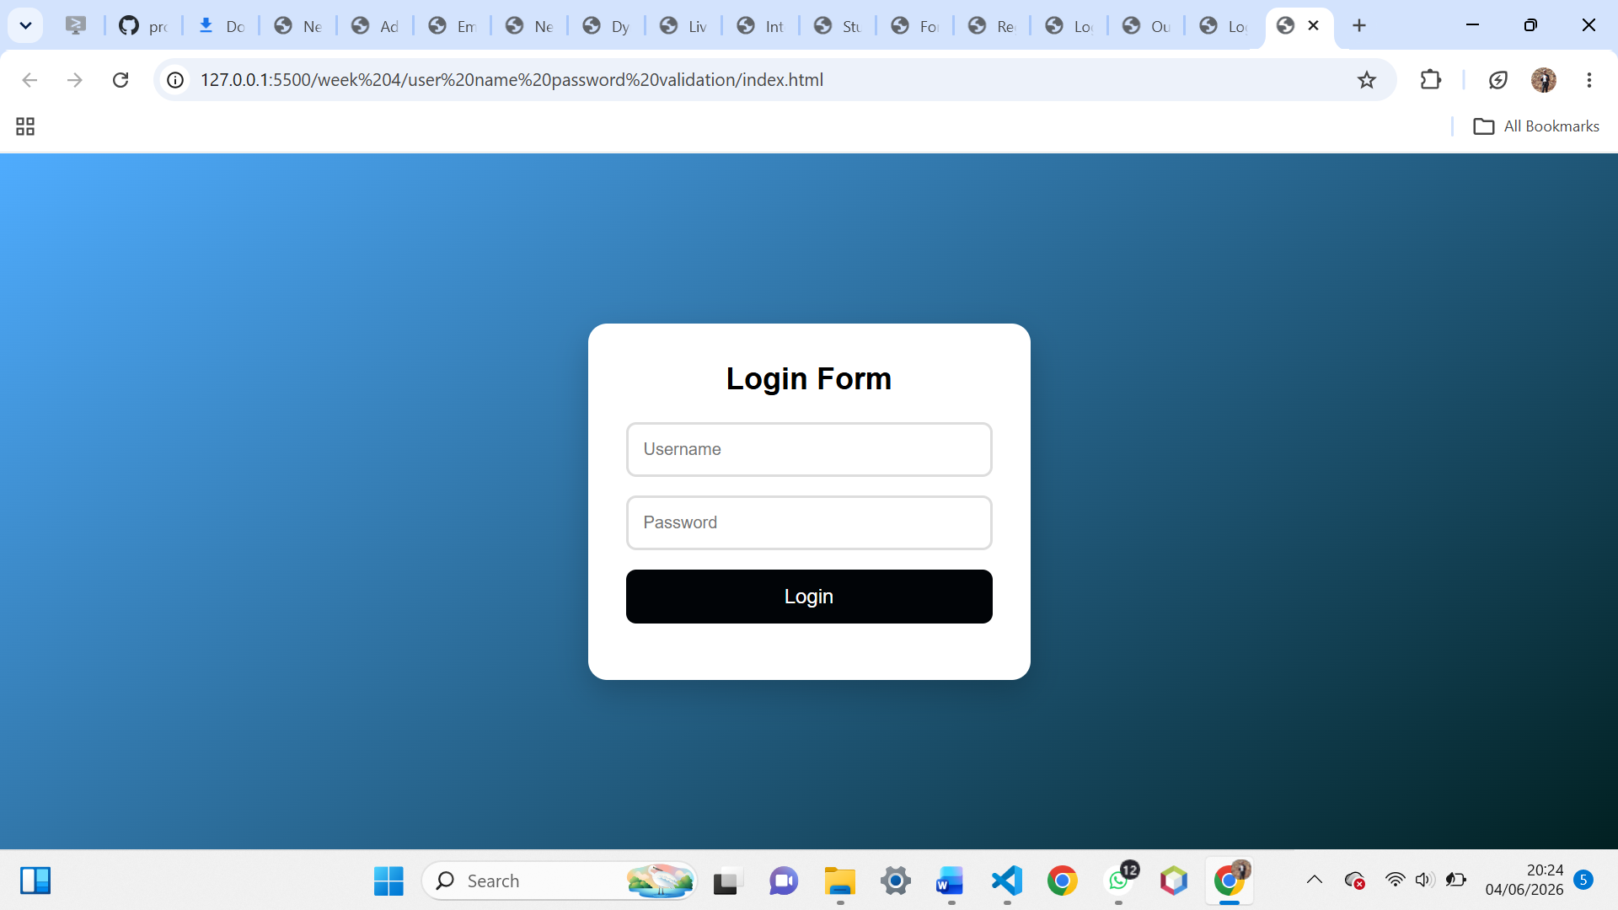
Fig 9: Session-based welcome page after successful login
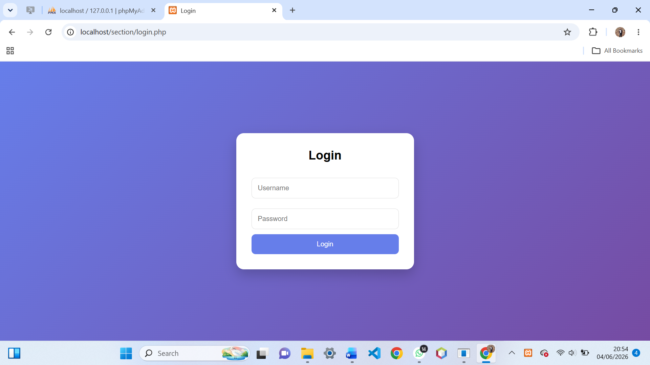

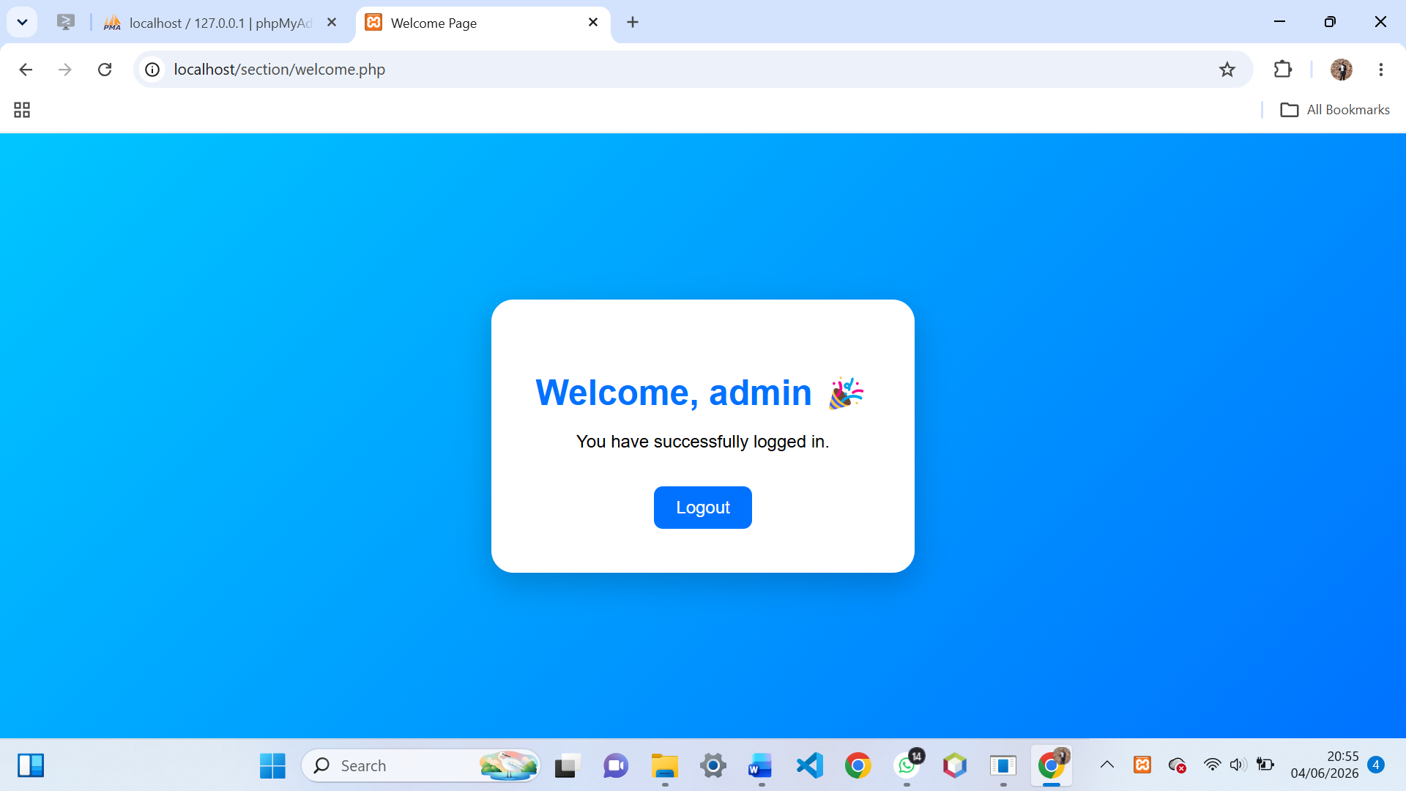
REFLECTION
This week I learned how server-side programming processes user requests. Fig 1–3 show PHP handling form submissions and generating dynamic content. Fig 4–6 demonstrate registration, login, and contact forms integrated with backend logic. Fig 7–8 confirm authentication with username/password validation, while Fig 9 shows session handling for personalized user experiences. Organizing files into a backend structure improved workflow. The main challenge was ensuring secure handling of form data, which taught me the importance of using POST methods and validating inputs before granting access

WEEK 5
Fig1: phpMyAdmin showing the database successfully created.
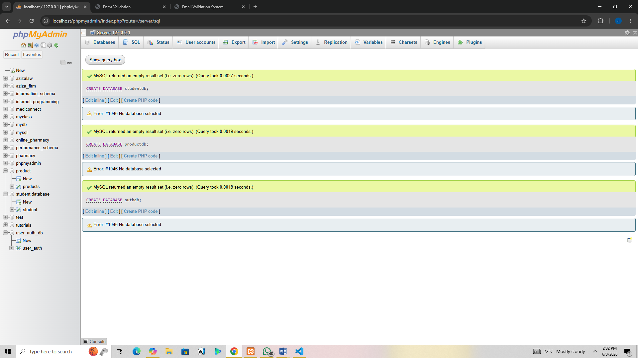
Fig 2: Table creation for users with ID, username, and password fields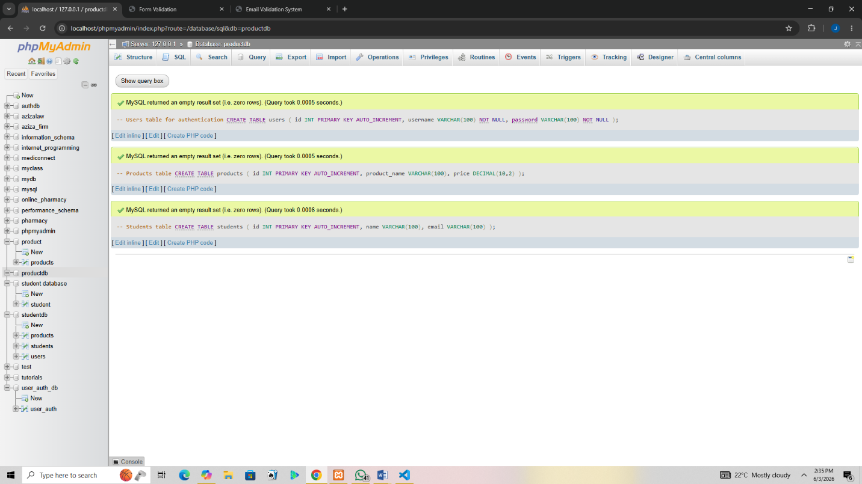

Fig 4: Insert query adding new student record
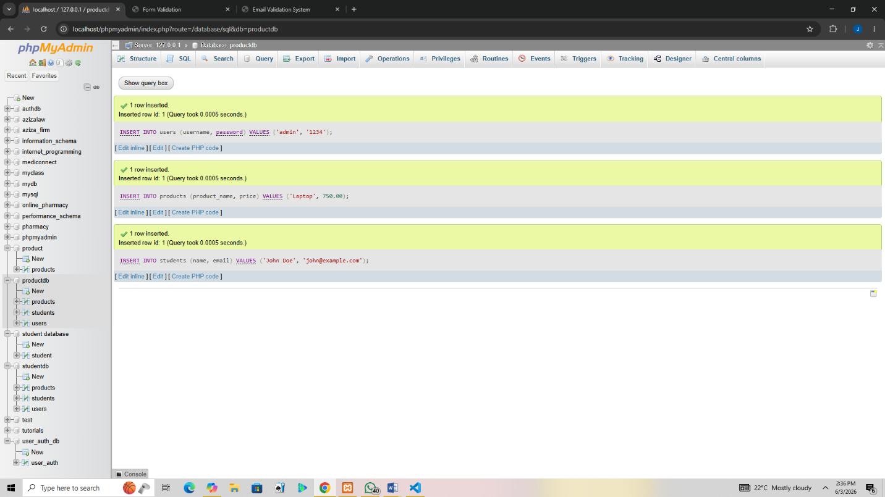
Fig 5: View records query displaying stored data
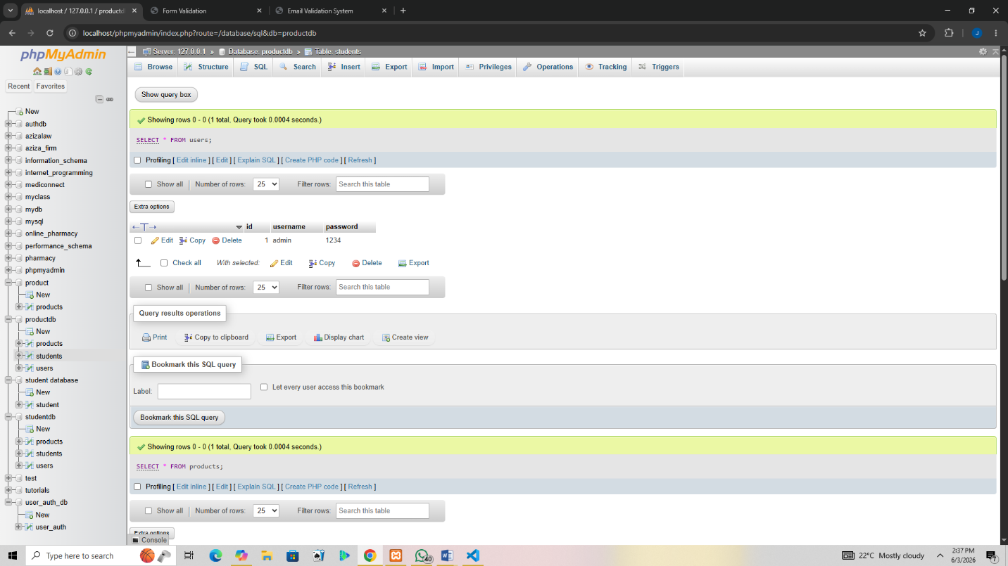
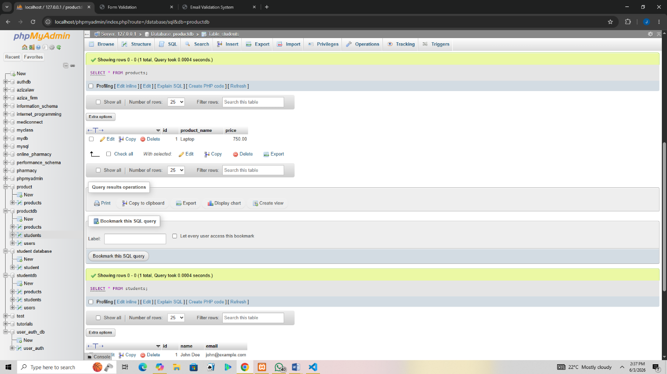

Fig 6: Edit query updating user information
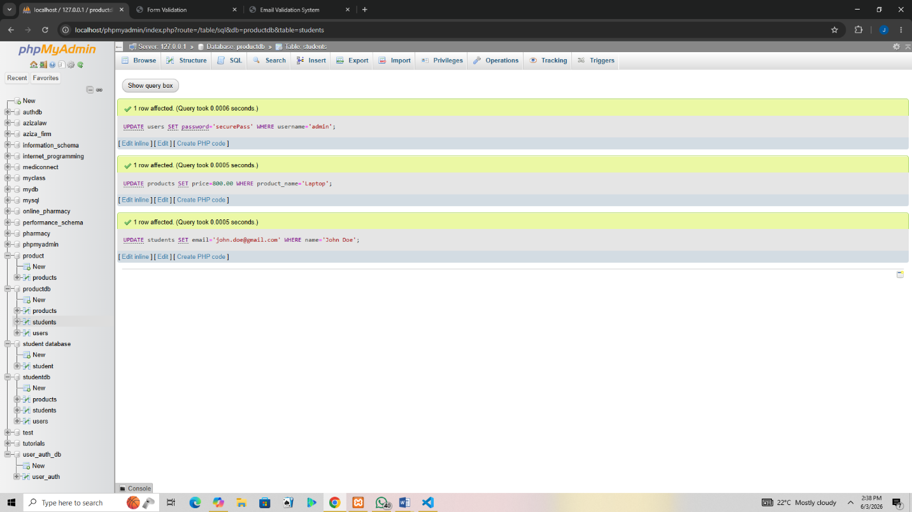

Fig 8: Delete query removing a record successfully(codes)
DELETE FROM users WHERE username='admin';
DELETE FROM products WHERE product_name='Laptop';
DELETE FROM students WHERE name='John Doe';

REFLEECTION
This week I learned how to build database-driven systems. Fig 1–3 show the creation of student, product, and authentication databases. Fig 4 demonstrates table setup for user credentials. CRUD operations (Fig 5–8) allowed me to add, view, edit, and delete records, proving full database functionality. These tasks taught me how backend systems manage persistent data and connect to frontend forms. The main challenge was ensuring queries executed correctly, which improved my understanding of SQL syntax and database integration with PHP.

