PROPOSED INFRASTRUCTURE SOLUTION
RFP Infrastructure Requirements, Compliance and Updated Technical Design
Digital Malawi Acceleration Project
Central Printing Facility
RFP No. MW-PPPC-546386-GO-RFB
Updated Technical Baseline - September 2026

1. Executive Summary
This document presents the updated infrastructure solution proposed to satisfy the infrastructure, high-availability, disaster-recovery, backup, cybersecurity, monitoring and facility requirements of the RFP. The design has been updated to separate application and database compute at the Primary site while retaining a consolidated recovery platform at the DR site.
The Primary site comprises four Hyper-V hosts: a two-node Application Cluster and a separate two-node Database Cluster. All four hosts access the same enterprise shared SAN through redundant storage paths. The DR site comprises a two-node consolidated Hyper-V cluster capable of hosting both application and database recovery workloads. Each host is proposed with 24 physical CPU cores and 256 GB RAM. Each site is proposed with not less than 20 TB usable shared SAN capacity.
The workload baseline includes approximately 15 production VMs plus development, training and test environments. The architecture also includes redundant core and edge switching, HA next-generation firewalls, Veeam-based backup and replication, encrypted backup repositories, immutable anti-ransomware storage, HSM capability, SIEM integration and SOC capability/integration.

2. RFP Basis and Design Principle
The RFP requires a secure, scalable, redundant, enterprise-grade hardware architecture for a mission-critical national identity personalization environment. It also requires clustering, automated failover, backup replication, disaster-recovery synchronization, point-in-time recovery and high-availability database clustering. These requirements appear in Section VII, Architectural Requirements (approximately pp. 139-141).
The RFP does not prescribe exact server CPU/RAM, SAN capacity in TB, server count, hypervisor product, SAN versus S2D, or backup repository capacity. Accordingly, the 24-core/256-GB host sizing, four-host Primary topology, two-host DR topology and >=20 TB usable SAN capacity per site are bidder-proposed technical sizing choices and must be validated against final application, database, retention and growth data.

3. Infrastructure Architecture
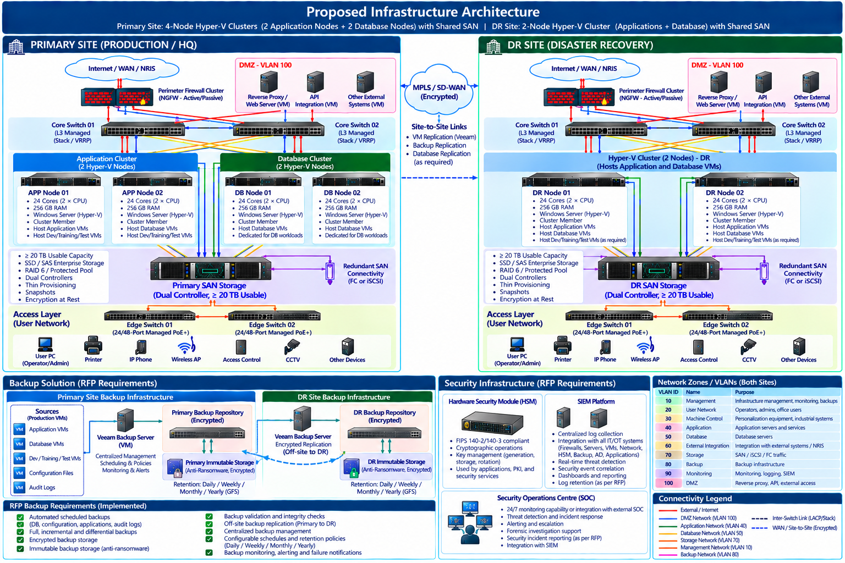
Figure 2 - Detailed Primary, DR, Backup and Security Architecture

3.1 Primary Site
Layer | Updated Proposed Design
Application Compute | 2-node Hyper-V/WSFC Application Cluster. Each node: 24 physical cores, 256 GB RAM. Hosts production application VMs and non-production VMs according to capacity and isolation policy.
Database Compute | Separate 2-node Hyper-V/WSFC Database Cluster. Each node: 24 physical cores, 256 GB RAM. Dedicated to database workloads and related database services.
Shared Storage | One enterprise dual-controller shared SAN accessible by both clusters through redundant FC or iSCSI paths. Proposed minimum capacity: >=20 TB usable.
Core Network | 2 redundant Layer-3 core switches with resilient uplinks to firewalls, hosts, storage and access layer.
Access Network | 2 redundant managed PoE+ edge/access switches, interconnected/stacked or equivalent resilient design.
Security Perimeter | HA next-generation firewall pair with DMZ and segmented internal security zones.
Backup | Veeam Backup Server, encrypted primary backup repository, immutable anti-ransomware storage and encrypted off-site replication.
Security Monitoring | HSM, SIEM integration and SOC capability/integration.

3.2 DR Site
Layer | Updated Proposed Design
Compute | 2-node consolidated Hyper-V/WSFC DR cluster. Each node: 24 physical cores, 256 GB RAM. Hosts recovered Application and Database VMs.
Shared Storage | Independent enterprise dual-controller SAN. Proposed minimum capacity: >=20 TB usable, same proposed usable capacity as Primary.
Core Network | 2 redundant Layer-3 core switches.
Access Network | 2 redundant managed PoE+ edge/access switches.
Security | Resilient NGFW architecture and the same logical security-zone model as Primary.
Backup | Encrypted DR backup repository plus immutable anti-ransomware storage. Receives encrypted off-site backup copies from Primary.
Recovery | VM, database and backup replication sized to meet agreed RPO/RTO and RFP synchronization targets.

4. Host and Workload Sizing
Site / Cluster | Nodes | Per-Node CPU | Per-Node RAM | Role
Primary - Application Cluster | 2 | 24 physical cores | 256 GB | Application, workflow, API/integration, reverse proxy, management, monitoring and approved non-production VMs.
Primary - Database Cluster | 2 | 24 physical cores | 256 GB | Production database VMs and database-related services.
DR - Consolidated Cluster | 2 | 24 physical cores | 256 GB | Recovery platform for both Application and Database workloads; non-production VMs as required.

Workload baseline: approximately 15 production VMs plus Development, Training and Test environments. Final placement must preserve sufficient failover headroom so that the surviving node of each two-node cluster can operate the critical workloads during a single-node outage. CPU, RAM, storage IOPS and network utilization must be validated during detailed sizing.

5. Storage Architecture
Requirement / Design Point | Proposed Response
Primary shared storage | >=20 TB usable enterprise SAN, dual controller, redundant FC/iSCSI connectivity, snapshots/thin provisioning as supported, encryption at rest.
DR shared storage | >=20 TB usable enterprise SAN with equivalent resilience and independent controllers/paths.
Primary cluster access | Both the 2-node Application Cluster and 2-node Database Cluster share the same Primary SAN, using separate LUNs/CSV ownership and access controls as appropriate.
DR cluster access | The consolidated 2-node DR cluster accesses the DR SAN.
Capacity basis | 20 TB is a proposed minimum usable figure, not an RFP-prescribed capacity. Raw capacity must additionally account for RAID/protection overhead, hot spares, metadata and vendor reserve.
Performance basis | Final disk/media tier, IOPS, latency, cache and connectivity must be sized against database/application vendor workload requirements.

6. Network and Security-Zone Architecture
Zone / Component | Purpose / Proposed Implementation
Management | Infrastructure administration, monitoring and controlled backup management.
User Network | Operators, administrators and office users.
Machine Control | Personalization equipment and industrial control systems.
Application | Application servers and services.
Database | Database servers; restricted access from authorized application/management services.
External Integration | NRIS and approved external-system integration.
Storage | SAN / iSCSI / FC-related connectivity as applicable.
Backup | Backup repository and backup/replication traffic.
Monitoring | Monitoring, logging and SIEM integration.
DMZ | Reverse proxy, API and externally exposed integration services.

The RFP explicitly calls for External Integration, DMZ, Application, Database, Machine Control and Management & Monitoring zones, together with VLAN segmentation, firewall isolation, secure remote administration and encrypted communications (Section VII, approximately pp. 141-142).

7. Backup and Recovery Solution
The RFP requires automated scheduled backups of databases, configuration files, application systems and audit logs; full, incremental and differential backup capability; encrypted backup storage; backup validation/integrity checks; off-site backup replication; immutable backup storage for anti-ransomware protection; centralized management; configurable retention; monitoring; and failure notification (Section VII, Software and Data Back-up and Recovery, approximately pp. 145-146).
RFP Backup Requirement | Proposed Implementation | Status
Automated scheduled backups | Veeam Backup & Replication policies for production and approved non-production workloads. | Covered
Database, configuration, application and audit-log backup | Protected through image-level and application/database-aware methods as appropriate. | Covered - final design
Full, incremental and differential capability | Veeam and/or database-native policy mapped to the exact workload requirement. | Covered - final design
Encrypted backup storage | Encrypted backup jobs/repositories and encrypted replication. | Covered
Backup validation/integrity checks | Scheduled verification and restore testing. | Covered
Off-site backup replication | Encrypted backup copy from Primary to DR/off-site repository. | Covered
Immutable backup storage | Immutable anti-ransomware storage included at Primary and DR in our proposed design. | Covered
Centralized management | Veeam Backup Server / management console. | Covered
Daily/weekly/monthly/yearly retention | Configurable Veeam retention/GFS policy. | Covered
Monitoring and failure notification | Veeam alerts integrated with monitoring/SIEM as required. | Covered

Important distinction: the RFP requires off-site backup storage and immutable backup capability, but does not prescribe backup repository capacity in TB and does not explicitly mandate one physical repository plus one immutable appliance at each site. Providing encrypted and immutable backup infrastructure at both Primary and DR is our proposed resilience enhancement.

8. Disaster Recovery Architecture
RFP DR Requirement | Proposed Response
Primary production environment | Four-node Primary design: 2 App + 2 DB nodes with shared SAN.
Secondary DR environment | Two-node consolidated DR Hyper-V cluster with independent SAN.
Backup replication infrastructure | Veeam encrypted backup copy/replication.
Off-site backup storage | DR backup repository serves as off-site copy relative to Primary.
DR synchronization | VM replication and/or database/application-native replication according to workload.
Hot/warm standby as applicable | DR cluster maintained ready for recovery according to final service tier.
Automated/manual failover procedures | WSFC local HA plus documented DR failover/failback runbooks.
RTO/RPO | Final values mapped to RFP and application tiers and demonstrated during testing.

The RFP performance section specifies automatic failover initiation of <=60 seconds, full service recovery of approximately 5-15 minutes depending on architecture, and Primary/DR synchronization near-real-time or <=5 minutes. These are acceptance targets that require end-to-end testing and sufficient WAN/application replication performance; they are not guaranteed solely by host hardware.

9. HSM, SIEM and SOC Requirements
RFP Security Requirement | How It Is Covered | Status
Hardware Security Module (HSM) | Dedicated HSM capability for cryptographic operations and key-management integration. Selected HSM must meet applicable FIPS 140-2/140-3 validation requirements stated by the RFP. | Additional product selection required
SIEM integration | Centralized security-log/event integration from firewalls, servers, Windows/AD, applications, databases, backup, network and other supported systems. | Covered - final product/integration
SOC capability or integration | 24/7 security monitoring capability or integration with an external/central SOC, including incident alerting, escalation, forensic support and reporting. | Covered - operational model to finalize

The RFP explicitly mentions HSMs for cryptographic operations, SIEM integration, and Security Operations Centre (SOC) capability or integration within its cybersecurity requirements (Section VII, approximately pp. 145 and 150-152).

10. Monitoring and Management
- Centralized infrastructure monitoring for Hyper-V hosts, VMs, databases, SAN, switches, firewalls and backup components.
- Real-time and historical performance monitoring with threshold-based alerts.
- Environmental monitoring for temperature, humidity, power and UPS status.
- Backup monitoring and failure notifications.
- Security-event forwarding to SIEM and SOC capability/integration.
- Capacity and SLA monitoring to support proactive scaling.

11. Facility and Physical Infrastructure
RFP Area | Proposed Coverage | Status
Power | UPS, generator integration, ATS, rack PDUs, grounding/earthing and electrical protection. | Additional item required
Environmental | HVAC/precision cooling, environmental monitoring and air filtration. | Additional item required
Racks and cabling | Racks/cabinets, structured copper/fiber cabling, patch panels, cable management and labeling. | Additional item required
Physical access | Biometric/smart-card access control and access logging. | Additional item required
CCTV/intrusion | CCTV/VMS/NVR retention, motion/door sensors and alarms. | Additional item required
Fire protection | Detection, smoke/heat alarms and clean-agent server-room suppression. | Additional item required

12. Infrastructure Compliance Matrix
RFP / Design Requirement | Proposed Coverage | Status
Secure/scalable/redundant enterprise hardware | 4-node Primary, 2-node DR, redundant SAN/network/security. | Covered
Active-passive/active-active clustering | WSFC Application, Database and DR clusters. | Covered
Automated failover | WSFC local HA; DR procedures/replication. | Covered - final testing
HA database clustering | Dedicated DB cluster infrastructure; DB-native HA to be finalized with vendor. | Application/vendor dependent
Load balancing for printing jobs | Infrastructure supports redundant services; application/vendor config required. | Application/vendor dependent
Network segmentation/firewall isolation | Redundant L3 core + VLAN zones + HA NGFW. | Covered
Redundant access switching | Two edge/access switches at each site. | Covered
Backup replication | Veeam backup copy/replication. | Covered
Off-site backup storage | DR backup repository. | Covered
Immutable backup | Primary and DR immutable storage in proposed design. | Covered
DR environment | 2-node consolidated DR cluster + independent >=20 TB usable SAN. | Covered
HSM | Included in updated security architecture; model/HA sizing to select. | Additional product selection required
SIEM | SIEM integration included. | Covered - final product/integration
SOC | SOC capability/integration included. | Covered - operational model to finalize
Environmental monitoring | Sensors/UPS monitoring integrated with monitoring platform. | Additional item required
Physical security/fire suppression | Included as facility requirements but products/sizing still to be added. | Additional item required

13. Preliminary Hardware and Software BOM
Component | Primary Site | DR Site | Key Proposed Specification / Note
Hyper-V Application Hosts | 2 | - | 24 physical cores, 256 GB RAM each; enterprise redundant PSU/NICs.
Hyper-V Database Hosts | 2 | - | 24 physical cores, 256 GB RAM each; dedicated DB cluster.
Hyper-V Consolidated DR Hosts | - | 2 | 24 physical cores, 256 GB RAM each; hosts App + DB recovery VMs.
Shared SAN | 1 | 1 | >=20 TB usable per site, dual controller, enterprise SSD/SAS or appropriate tier, redundant FC/iSCSI.
Core L3 Switches | 2 | 2 | Redundant/stack/MLAG/VRRP-equivalent design.
Edge/Access Switches | 2 | 2 | Redundant managed PoE+ access switches; 24/48 port subject to final port count.
NGFW | HA pair | HA/resilient pair | Security subscriptions/IPS/VPN; final sizing from throughput and sessions.
Backup Repository | 1 | 1 | Encrypted; capacity TBD from retention/change-rate sizing.
Immutable Backup Storage | 1 | 1 | Anti-ransomware immutable target; capacity TBD.
HSM | TBD | TBD / recovery design | FIPS 140-2/140-3 aligned as required; final quantity/HA/DR model to define.
SIEM | Integration / platform | Integration | Centralized security-event collection and monitoring.
SOC | Capability/integration | Capability/integration | 24/7 monitoring model to define.
Windows Server / Hyper-V | Licensed for 4 hosts | Licensed for 2 hosts | Edition/licensing sized to VM rights and cluster features.
Veeam Backup & Replication | Yes | Repository/replication target | Final licensing according to workload count and features.

14. Items to Finalize Before Tender Submission
- Confirm final VM inventory and allocate the 15 production VMs between Application and Database clusters.
- Confirm quantity and resource profile of Development, Training and Test VMs.
- Validate that 24 cores / 256 GB per node provides required single-node-failure headroom for each Primary cluster and the consolidated DR cluster.
- Perform SAN capacity and performance sizing: usable capacity, IOPS, latency, RAID/protection overhead, snapshots, growth and database requirements.
- Size Primary/DR backup repositories and immutable retention using source data, daily change rate, compression/deduplication assumptions and GFS policy.
- Calculate WAN bandwidth/latency required for <=5-minute synchronization target where applicable.
- Select HSM product, quantity, HA arrangement and DR/key-recovery design.
- Select SIEM product/integration approach and define SOC operating model.
- Finalize NGFW, switch, optics, NIC/HBA, rack, UPS, generator/ATS, HVAC and environmental-monitoring sizing.
- Add physical security, CCTV and clean-agent fire suppression products to the final facility BOM.
- Define FAT/SAT test cases for failover, DR, backup restore, performance, network redundancy and security monitoring.

15. Conclusion
The updated proposed architecture is aligned with the principal infrastructure requirements of the RFP and provides stronger workload separation at the Primary site through dedicated Application and Database clusters. The shared enterprise SAN design, redundant core and access networks, consolidated DR cluster, Veeam backup/replication, immutable backup protection, HSM, SIEM integration and SOC capability/integration provide a coherent enterprise architecture for the Central Printing Facility.
Final compliance should be declared after completion of detailed sizing, OEM/application compatibility confirmation, security-product selection, facility engineering and FAT/SAT acceptance criteria. The RFP-derived requirements and bidder-proposed design values should remain clearly distinguished in the final tender submission.

Appendix A - RFP Source Basis
Primary source: Final RFB as issued for the Digital Malawi Acceleration Project, Section VII - Purchaser's Requirements. Relevant areas include Architectural Requirements (software, hardware, network and DR architecture), Systems Administration and Management, Software and Data Back-up and Recovery, Cybersecurity Requirements, Business Continuity and DR Security Plans, Facility Infrastructure, Performance Requirements, Testing/Commissioning and Technical Documentation. Page references are approximate because pagination may vary between rendered and printed copies.

