Technical Proposal - System Architecture
Table of Contents
1. Introduction 4
1.1 Scope of supply 4
1.2 Integration and interoperability responsibility 4
2. Solution Overview 6
2.1 Architecture overview 6
2.2 End-to-end process flow 7
2.3 Card issuance lifecycle 9
3. Card Personalization System 11
3.1 Configuration and modular design 11
3.2 Laser marking capability 11
3.3 Marking resolution 12
3.4 Independent laser station operation 13
3.5 Throughput and duplex performance 13
3.6 Card recognition, alignment and in-line verification 14
3.7 Reject detection and in-job reproduction 14
3.8 Laser calibration and audit logging 15
3.9 Machine software, job and batch reporting 15
4. Polycarbonate Card 16
4.1 Construction and durability 16
4.2 Card body security features, front 16
4.3 Card body security features, back 17
4.4 Personalization security features 17
4.5 Digitally signed biometric QR code 18
4.6 Standards compliance and laboratory testing 18
4.7 Card samples 19
5. Mailing and Dispatch System 20
5.1 Configuration 20
5.2 Carrier letter printing and card affixing 21
5.3 Envelope insertion, sealing and address printing 21
5.4 Verification and card-to-recipient matching 21
5.5 Sorting, reject magazines and buffer modules 22
5.6 Throughput and capacity 22
5.7 Job data and dispatch records 22
6. Application Software 24
6.1 Software architecture 24
6.2 Card Personalization Management System 25
6.3 Card Layout Template Editor 26
6.4 Data Preparation Service 27
6.5 Signing Service 28
6.6 Printer Control Service 28
6.7 Laser Personalization Control Software 29
6.8 Quality Control Management 29
6.9 Mailing and Dispatch Management System 30
6.10 Stock Control and Card Accountability 30
6.11 Monitoring, Reporting and Analytics 32
6.12 Administration and Access Control 32
6.13 Presentation Layer 33
6.14 Software inventory and licensing 36
7. NRIS Integration 37
7.1 Integration architecture 37
7.2 Interfaces, protocols and middleware 38
7.3 Data mapping and transformation 39
7.4 Secure data exchange 40
7.5 Database connectivity 41
7.6 Real-time and batch processing 41
7.7 Card production request management 42
7.8 Citizen data retrieval 42
7.9 Personalization and quality assurance integration 43
7.10 Card lifecycle transactions 44
7.11 Production status feedback 44
7.12 Reprint and exception management 45
7.13 Reporting and analytics integration 45
7.14 Audit trail and end-to-end traceability 46
7.15 Disaster recovery integration 47
7.16 Integration testing 47
7.17 Integration deliverables 48
8. Dispatch and Delivery Tracking 50
8.1 Dispatch record generation 50
8.2 Dispatch batching and destination routing 50
8.3 Delivery status tracking and cardholder notification 51
8.4 Status feedback to NRIS 51
8.5 Undelivered, returned and re-dispatched items 51
8.6 Courier integration readiness 52
9. Infrastructure 54
9.1 Deployment architecture and platform 54
9.2 Network architecture and security zoning 59
9.3 High availability, failover and disaster recovery 63
9.4 Infrastructure scope of supply 64
9.5 Facility requirements 67
10. Security Architecture 69
10.1 Security model 69
10.2 Data protection and encryption 70
10.3 Identity and access management 71
10.4 PKI, HSM and digital signature architecture 72
10.5 Application and interface security 74
10.6 Logging and audit 76
10.7 Security monitoring and Security Operations Center 76
10.8 Standards compliance 79
11. Performance and Capacity 81
11.1 Production capacity 81
11.2 System response times 81
11.3 Concurrent users 82
11.4 Data volumes, growth and retention 83
11.5 Performance under peak and failover conditions 83
11.6 Performance validation 84
12. Operations, Administration and Support 86
12.1 System administration and configuration management 86
12.2 Operational monitoring, diagnostics and troubleshooting 87
12.3 Backup, recovery and restoration 87
12.4 Support model, service levels and performance indicators 88
12.5 Spare parts and consumables 90
13. Basis of Offer 92
13.1 Purchaser-provided items and services 92
13.2 Interfaces to systems outside the scope of supply 93
13.3 Matters for confirmation 94
Annex A. Abbreviations 95

Introduction

Scope of supply
The Information System supplied, installed, integrated and commissioned for the Card Production Facility at the National Registration Bureau, Lilongwe, and for its secondary environment at the Purchaser's disaster recovery data center, comprises:
Scope | Supplied
Equipment | Two automatic modular laser personalization systems; two automated mailing and dispatch systems
Materials | Two million chipless polycarbonate card bodies, serialized at manufacture
Software | Card Personalization Management System; Card Layout Template Editor; Data Preparation Service; Signing Service; Printer Control Service; Laser Personalization Control Software; Quality Control Management; Mailing and Dispatch Management System; Stock Control and Card Accountability; Monitoring, Reporting and Analytics; Administration and Access Control; Presentation Layer
Infrastructure | Compute, storage, database, network and security infrastructure at the primary site and the secondary environment, including the hardware security modules, the non-production environments and the Security Operations Center
Integration | Interfaces to the National Registration and Identification System; dispatch and delivery tracking, with readiness for courier or postal service interfaces; the Government public key infrastructure, for the digital signature on each card; NRB's Security Operations Center, to which security alerts and events are forwarded

Integration and interoperability responsibility
Pursuant to ITP 16.2(b), we confirm that, if awarded the Contract, we accept responsibility for the successful integration and interoperability of all components and proposed Information Technologies of the Information System, as required by the request for proposals document and as further specified in the Technical Requirements.
This responsibility covers:
- the personalization and mailing equipment, the interface between them, and their interfaces to the application software;
- the polycarbonate cards and their compatibility with the personalization equipment supplied;
- all application software, whether developed, configured or supplied under license;
- the compute, storage, database, network and security infrastructure, at the primary site and in the secondary environment;
- the hardware security modules and the interface to the Government public key infrastructure;
- the interfaces through which environmental, power and physical security events from the facility works reach the system's monitoring;
- the interfaces to the National Registration and Identification System;
- the interfaces to dispatch and delivery tracking services; and
- the forwarding of security alerts and events to NRB's Security Operations Center.
Responsibility is accepted as a single point of accountability to the Purchaser, irrespective of the number of manufacturers, subcontractors or joint venture members supplying individual components.

Solution Overview

Architecture overview
The Information System is a secure, modular, service-oriented platform organized in six logical layers, operating two independent personalization lines and two independent mailing lines at the Card Production Facility, with a secondary environment at the Purchaser's disaster recovery data center.
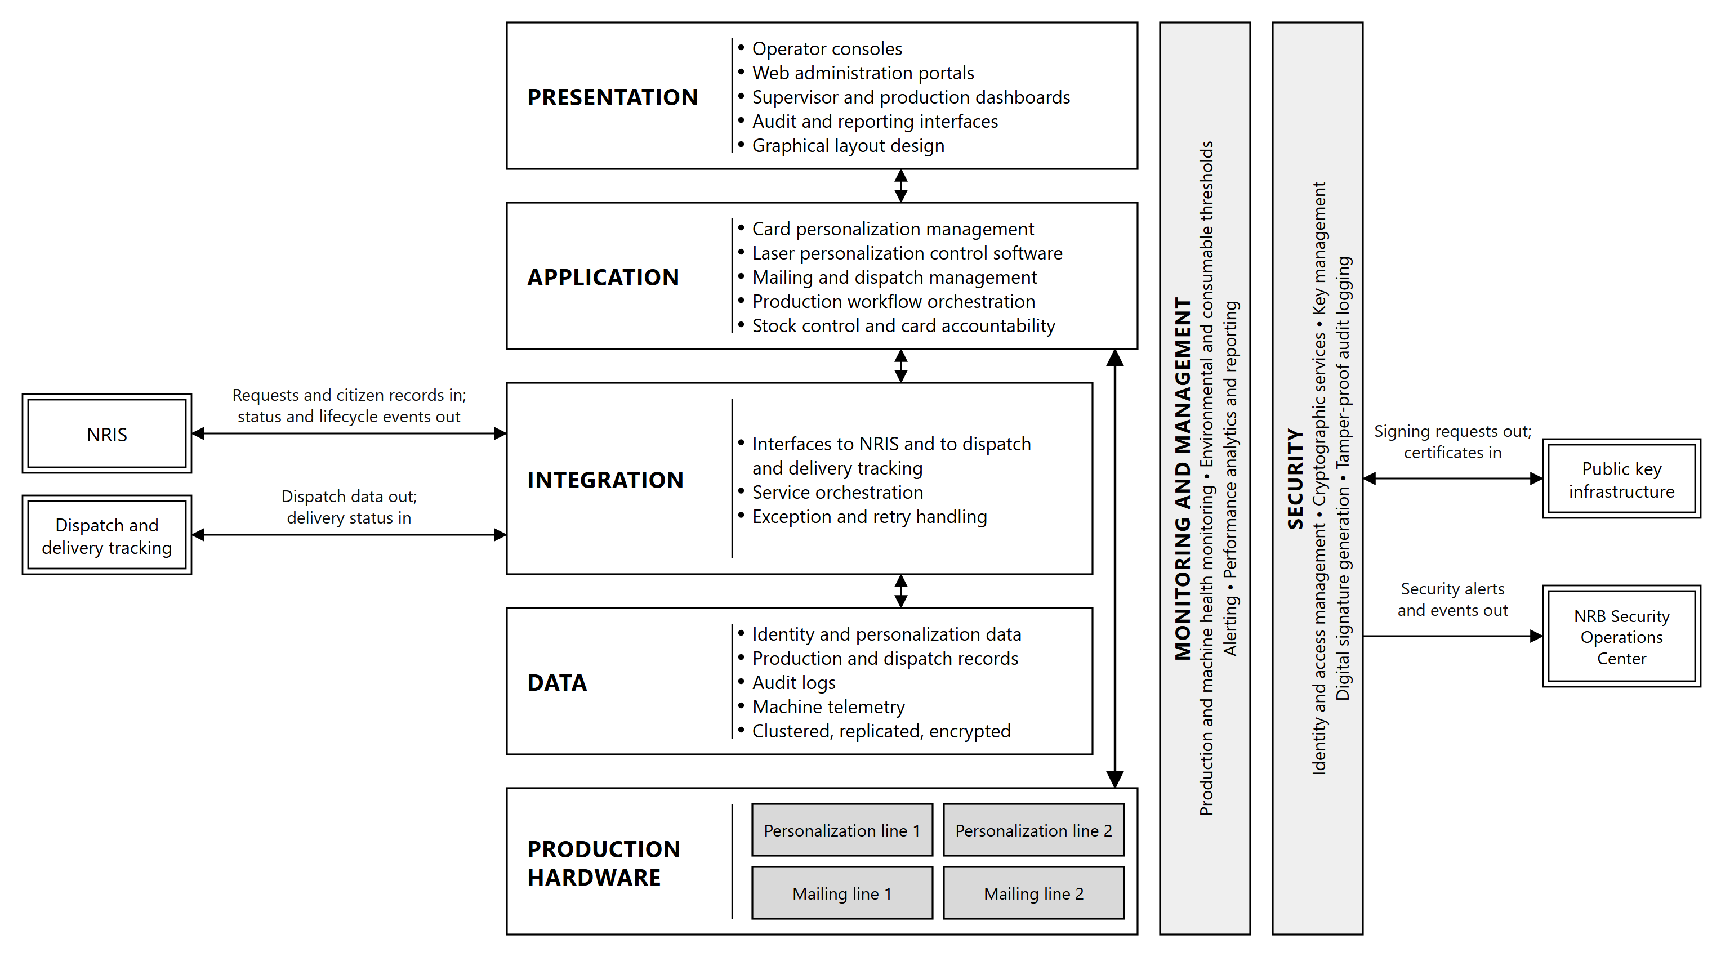
Figure 2.1: Architecture overview. Double borders are external systems; shaded boxes are hardware.
Layer | Function
Presentation | Operator consoles, web administration portals, supervisor and production dashboards, audit and reporting interfaces, graphical layout design
Application | Card personalization management, laser personalization control software supplied by the equipment manufacturer, mailing and dispatch management, production workflow orchestration, stock control and card accountability
Integration | Interfaces to NRIS, with database synchronization where the Purchaser approves it; dispatch and delivery tracking and courier systems; external verification systems, through the signed QR code verified against the Government public key infrastructure; audit systems, through the synchronized audit trail and the forwarding of security events; service orchestration, exception and retry handling
Data | Identity and personalization data, production and dispatch records, audit logs, machine telemetry (the status, fault and counter data reported by the equipment), held in a clustered, replicated and encrypted database platform
Security | Identity and access management, cryptographic services, key management, digital signature generation, tamper-proof audit logging
Monitoring and management | Production and machine health monitoring, environmental and consumable thresholds, alerting, performance analytics and reporting

Production hardware. Two automatic modular laser personalization systems and two automated mailing and dispatch systems. Each personalization line operates independently of the other, and each laser station within a line operates independently of the others, so that a station taken out of service does not interrupt production, and the loss of a whole line leaves production running on the other line.
External interfaces. The System exchanges data across the following external boundaries:
Interface | Direction | Content
NRIS | Inbound | Card production requests; approved citizen demographic, photograph, signature and biometric records
NRIS | Outbound | Production status events, quality outcomes, dispatch and delivery status, card lifecycle updates, audit records
Dispatch and delivery tracking | Outbound | Dispatch data and tracking references for each mail piece and each dispatch batch
Dispatch and delivery tracking | Inbound | Dispatch progress, and confirmation that cards have reached their destination
Public key infrastructure | Bidirectional | Certificate signing requests for the Document Signer key, and the Document Signer certificates issued against them for the biometric QR code applied to each card
NRB Security Operations Center | Outbound | Security alerts, and the security events behind them
Alert notification | Outbound | Alert emails and SMS messages to the NRB staff designated for each type of alert

End-to-end process flow
Card production runs as a single controlled sequence from the retrieval of a card production request to the confirmation of delivery, with rejected cards reproduced within the same job, and a status event returned to NRIS at each defined point.
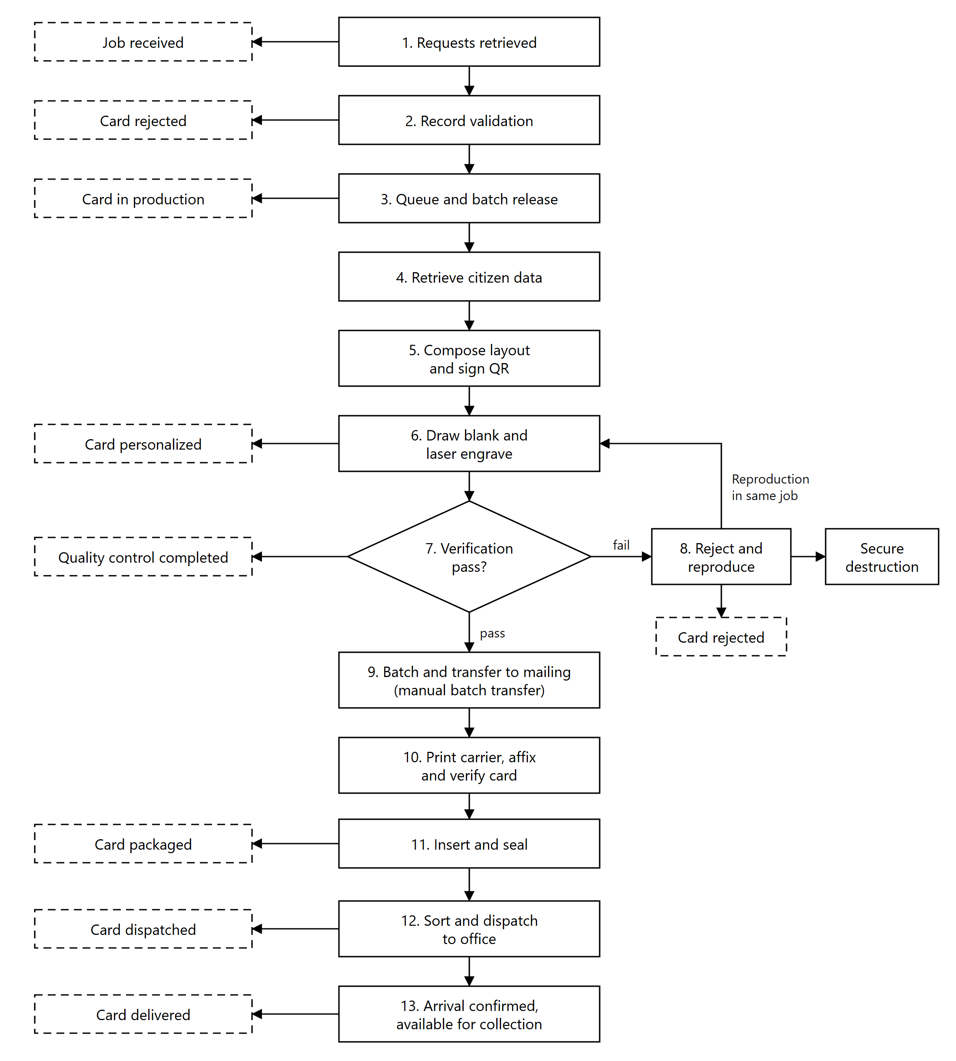
Figure 2.2: End-to-end process flow. Dashed boxes show the status events reported to NRIS.
Stage | Process | Status returned to NRIS
1 | Card production requests, with the demographic data of each record, are retrieved from NRIS, originating from registration centers, remote sites and mobile registration equipment | Job received
2 | Each record is validated for completeness and data quality. Records that fail validation are reported back to NRIS with a reason and are not released to production | Card rejected
3 | Validated records are queued, assigned to a production batch and released as a personalization job | Card in production
4 | The photograph, signature and biometric records of the citizens in the batch are retrieved from NRIS over an encrypted, mutually authenticated connection, and each photograph is checked against the ICAO specifications | None
5 | The card layout is composed from the approved template. Variable data, the greyscale portrait, the secondary image, micro-text, the changing laser image and the biometric QR code are generated, and the QR payload is digitally signed | None
6 | A blank card is drawn from controlled stock and issued to the job against its serial number, checked against the card reference, and personalized by laser engraving on both faces | Card personalized
7 | Each card is verified in line for print quality, engraving quality and correct machine-readable content, against the source record | Quality control completed
8 | Cards failing verification are rejected automatically and reported to the operator on screen. Reproduction takes place within the same job, and the rejected card is held for secure destruction | Card rejected
9 | Accepted cards are batched and transferred to a mailing line, where each card is identified by reading the machine-readable identifier engraved on it | None
10 | The personalized carrier letter is printed with the destination address and the dispatch reference, and the card is affixed. The machine reads the card and its carrier together and confirms they match, so that each card reaches the correct recipient | None
11 | The carrier is folded and inserted into a window envelope, and the envelope is sealed | Card packaged
12 | Mail pieces are sorted by destination and released for dispatch to the registration office that ordered them | Card dispatched
13 | Arrival at the destination office is confirmed and the card is available for collection | Card delivered

Every stage writes to a tamper-proof audit record keyed to the National Identity Number and, from the moment a blank is drawn, to the card serial number, so that any card can be traced from the originating NRIS record through personalization, verification, mailing and dispatch to delivery.

Card issuance lifecycle
The System integrates with NRIS to manage the full card lifecycle, driven by events arising in the National Identity System and the civil registration systems it integrates.
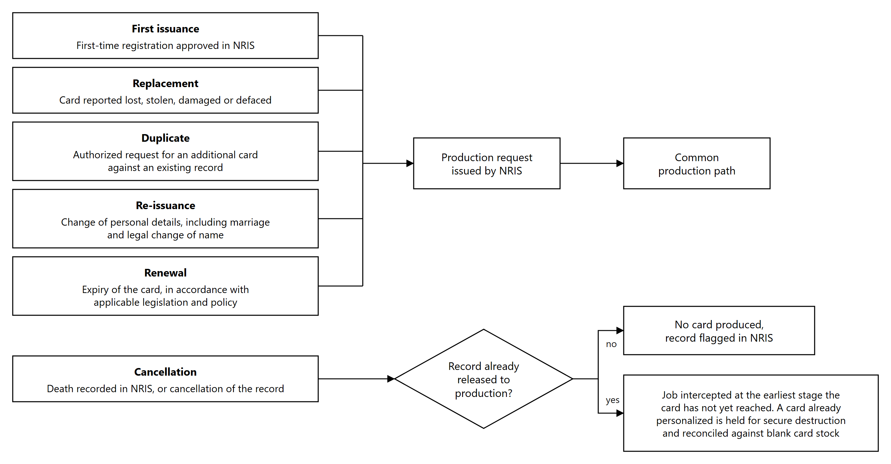
Figure 2.3: Card issuance lifecycle
Operation | Trigger | Production treatment
First issuance | First-time registration approved in NRIS | New card produced against a newly issued National Identity Number
Replacement | Card reported lost, stolen, damaged or defaced | New card produced against the existing National Identity Number, and the superseded card is flagged in NRIS
Duplicate | Authorized request for an additional card against an existing record | New card produced against the existing National Identity Number
Re-issuance | Change of personal details, including marriage and legal change of name | New card produced carrying the amended details, and the superseded card is flagged in NRIS
Renewal | Expiry of the card, in accordance with applicable legislation and policy | New card produced
Cancellation | Death recorded in NRIS, or cancellation of the record | No card produced. The record is flagged in NRIS and any card in production is withdrawn from the job

Replacement, duplicate, re-issuance and renewal are processed on the same production path as first issuance and are distinguished by the request type carried on the NRIS record. Card serial numbers are unique to each physical card, so a replaced or re-issued card is traceable independently of the National Identity Number it carries.
Where a cancellation is received for a record already released to production, the job is intercepted at the earliest stage the card has not yet reached. Cards already personalized against a canceled record are held for secure destruction and reconciled against the blank card stock issued.

Card Personalization System

Configuration and modular design
Two automatic modular laser personalization systems are supplied, installed and commissioned. Each system is a complete production line capable of personalizing a card from blank body to verified output without reference to the other, so that the two lines can run the same job in parallel, run different jobs concurrently, or run singly while the other is under maintenance.
Each line comprises:
Component | Function
Card feeder | Draws blank card bodies from controlled stock into the transport path, with a 600 card capacity for continuous production
Card transport system | Moves cards between stations under positional control
Laser engraving units | Perform all marking on both faces of the card
Verification cameras and scanners | Read and check the personalized card in line
Card reject module | Diverts cards failing verification out of the production path
Cooling system | Maintains laser operating temperature under continuous industrial duty
Air compressor system | Supplies the pneumatic transport and handling functions
Card stacker | Receives verified cards on completion, with a 600 card capacity
Industrial control PC | Runs the machine software and drives the laser stations
Emergency stop buttons | Positioned around the machine, so that the operator can reach one from every point at the line

The marking subsystem is fully integrated into the machine rather than assembled from separate units. It comprises the dedicated laser marking unit, the power supply and control PC for laser and greyscale personalization, and the integrated cooling system, all operating under synchronized workflow control as a single system.
Marking uses fiber laser technology with greyscale printing, applied to 100% polycarbonate cards. Laser engraving carbonizes material within the card body itself rather than depositing anything on the surface, so the personalized data cannot be removed or altered without leaving visible damage to the card.
Modularity. The machine is built as a modular platform so that capability can be added after commissioning without replacing the line. Modules are added and reconfigured on site rather than by returning the machine to the factory. Laser stations can be added to raise throughput, and additional processing modules can be introduced into the transport path. This includes provision for card encoding should the Purchaser choose to move to chip-based cards in a future issuance program.

Laser marking capability
Each card is personalized on both faces by laser engraving. The following elements are produced:
Element | Description
Laser engraved text | Variable cardholder data engraved within the card body
Greyscale photograph | The cardholder portrait, rendered in greyscale
Secondary image | A second rendering of the portrait in its own zone of the layout, so that substitution of the main portrait is evident
Micro lettering | Text too small to be read without magnification, positioned in defined zones of the layout
Changing Laser Image (CLI) | Two engravings applied through a lenticular structure at differing angles, so that separate images appear as the card is tilted
QR code | Carrying both alphanumeric values, digitally signed as described in Section 4.5
Card identifier | Machine-readable rendering of the card serial number, read on the mailing line
Tactile laser printing | Raised relief that can be verified by touch as well as by sight
Multilingual data | Card text in English and Chichewa, as the approved layout requires

These features are produced as stacked layers: each is engraved at a controlled depth within the fused polycarbonate body rather than on a single plane. Because the layers sit at different depths inside a card that cannot be delaminated, an attempt to alter any one of them disturbs the others and leaves visible damage. The security of the personalization therefore derives from the construction of the card as much as from the individual features.
Greyscale is achieved by varying the energy density delivered at each addressed point. The degree of carbonization determines the grey level, which is what allows a continuous-tone portrait to be produced by a monochrome process.

Marking resolution
Element | Resolution
Photograph | 600 dpi or higher, in greyscale
Micro text | 600 dpi or higher, at a line width and height of 0.33 mm

Resolution in laser personalization is governed by three factors: the focused spot size of the laser, the positional accuracy of the beam deflection system, and the precision of pulse control that sets the energy delivered at each point. Micro text at 0.33 mm line width requires a spot size substantially below that dimension, together with positional repeatability sufficient to place successive characters without drift across the marking field.
Both resolutions are measured on produced cards at factory acceptance testing, as set out in the Testing and Quality Assurance Sub-Plan of the Preliminary Project Plan.

Independent laser station operation
Each integrated laser station personalizes a complete card on its own. A station receives the full card layout and the full data record for the card it is processing, and completes all marking for that card without depending on any other station.
This has three consequences for production:
Any station can be taken out of service without stopping the line. A station may be switched on, switched off, or removed for maintenance while the line continues to run. The production workflow routes cards only to stations that are available.
Production continues without interruption or loss of quality. While a station is out of service, cards continue to be fed, marked, verified and stacked, and no job is stopped or rerun. All stations are calibrated to identical marking quality, as described in Section 3.8, so a card is the same whichever station marked it. There is no single station whose loss halts the line.
Maintenance can be scheduled without a production window. Because stations are independent, routine maintenance on one station proceeds while the remainder of the line is producing cards.
The same principle applies at the level of the two machines. Each line operates independently of the other, so the loss of a complete line does not stop production, which continues on the other line.
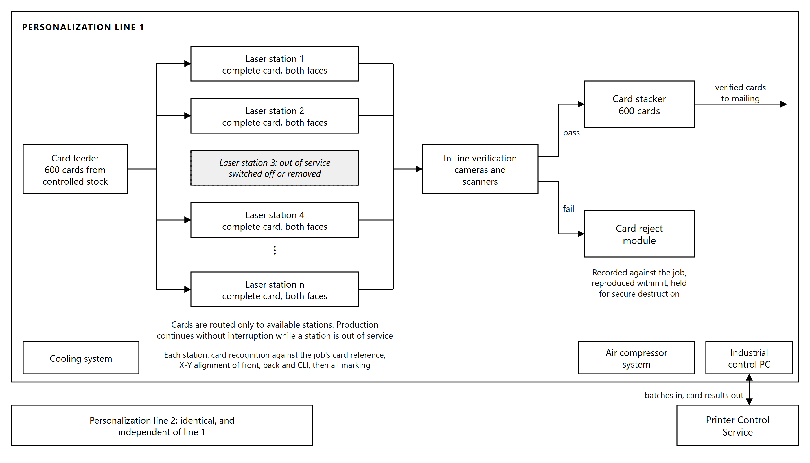
Figure 3.1: Personalization line. Each laser station marks a complete card on both faces; a station out of service is bypassed and production continues without interruption.

Throughput and duplex performance
Measure | Performance
Rated speed, per machine | Up to 2,000 cards per hour, as stated in the manufacturer's datasheet
Combined output, two machines | Not less than 2,000 cards per hour, duplex
Output per machine | Not less than 1,000 cards per hour
Operating window | Two shifts of seven hours, fourteen hours per day
Daily output | 28,000 cards
Batch size | 500 to 1,000 cards per batch
Sustained operation | Continuous 24/7 capability during peak issuance periods, without degradation over sustained production cycles of at least 8 to 12 hours

Both faces of the card are personalized within a single pass of the transport path, and the rates above are for duplex personalization. The rated speed is the manufacturer's maximum. The contractual rates, not less than 1,000 cards per hour per machine and 2,000 combined, are the nominal capacity against which throughput is measured at factory acceptance, in the acceptance tests and in the service level reporting.
The daily figure. Two shifts of seven hours give a fourteen hour operating window, in which the two lines together produce the 28,000 cards per day required. The machines are rated for continuous duty, so the window can be extended during peak issuance without exceeding that rating.

Card recognition, alignment and in-line verification
Card recognition. Before marking begins, the system identifies the blank card body presented at the station and checks it against the card reference held for the job. A card body that does not match the expected reference is rejected before any data is applied to it, so that personalization cannot begin on the wrong stock.
Alignment. The system performs X-Y alignment independently for the card front, the card back and the CLI feature. Front and back each register to the pre-printed card body, and the CLI registers to the lenticular structure within the card.
In-line verification. Each personalized card is verified within the production path, before it leaves the machine. Verification covers the engraved data against the source record, the quality of the engraving, and the optical data: text is read by optical character recognition and verification, and the machine-readable codes are read and validated, on the front and the back of the card. Verification is performed on every card, not on a sample.

Reject detection and in-job reproduction
Cards failing verification are rejected automatically and diverted out of the production path.
Each rejection is recorded against the production job, identifying the card, the point of failure and the reason. The operator is notified by an on-screen message at the machine, so that a rising reject rate is visible while the job is running rather than discovered at the end of it.
Reproduction of a rejected card takes place within the same production job, either automatically or on operator instruction. Because the replacement card is produced within the job that generated the rejection, the job completes with the full quantity of good cards and no separate re-run is required.
Rejection and reproduction proceed without stopping the production flow. Rejected cards are retained under control for secure destruction and are reconciled against the blank card stock issued to the job, so that every blank drawn from stock is accounted for as either a good card, a rejected card held for destruction, or a card still in production.

Laser calibration and audit logging
Each machine includes a laser calibration tool capable of adjusting an individual laser station or all stations simultaneously.
All stations are calibrated to a common reference, so that marking quality is consistent, uniform and identical across the production line, and cards marked by different stations in the same job are indistinguishable.
Calibration is automated and operator-assisted, and every calibration generates a log for audit purposes recording what was adjusted, when, and by whom.

Machine software, job and batch reporting
The machine software provides a graphical operator interface at each line, together with diagnostic and setup software for maintenance and fault isolation. The machine connects to the production network over Ethernet.
Record status retrieval. The interface allows staff to retrieve the status of each individual record in a job, so that the position of any card can be established while the job is running. This status is written to the production database by the Printer Control Service described in Section 6.6, and from there is published to NRIS.
Job and batch output files. On completion of each job or batch, the machine generates output files in audit, XML or flat-file format recording the outcome of every record processed. These files are the machine-level record of what was produced, and they are the source from which production status is reported and reconciled.

Polycarbonate Card
Two million polycarbonate cards are supplied. The cards are delivered as blank card bodies carrying the full static security construction described in Sections 4.2 and 4.3, and are personalized at the Card Production Facility on the systems described in Section 3. The cards are chipless, and each card body is serialized at manufacture, under a numbering scheme, format and range proposed by the Supplier and approved by the Purchaser. They are delivered in shipments of not less than 500,000 cards, and all two million are on site before commissioning begins.

Construction and durability
Property | Specification
Material | 100% polycarbonate
Construction | Six or more layers, fully fused
Adhesives | None
Service life | Minimum ten years

The card is built from polycarbonate layers fused into a single monolithic body under heat and pressure. Because fusion forms a continuous material rather than a bonded stack, there is no interface at which the card can be opened, and no adhesive layer to fail with age or heat.
Features printed on inner layers before fusion are sealed within the body and cannot be reached without leaving visible damage to the card. With no adhesive interface, the card is not exposed to delamination, the common failure mode of laminated cards over a ten-year life.

Card body security features, front
Feature | Description
Guilloche background | Fine interlaced line patterns, reproducible only by the original design data
Rainbow (IRIS) printing | Continuous color transition across the background with no visible boundary between colors
Optically Variable Magnetic Ink (OVMI) | Malawi flag motif, changing appearance with viewing angle
Changing Laser Image (CLI) | Photograph and card number, applied during personalization
Micro-text | Including micro-text within the portrait box
Relief tactile text | Raised text verifiable by touch, including tactile micro-text
Deliberate error elements | Intentional variations within the micro-text and relief text, known to the issuing authority
Invisible UV printing | National emblem, visible only under ultraviolet light
Numismatic background pattern | Fine engraved-style patterning of the type used in banknote printing
Photonic crystal pattern elements | Structural color effects that shift with viewing angle
Thermochromic ink | Changes color when warmed by a finger, verifiable without any equipment

The features are distributed across three levels of inspection. Some can be checked by any holder without equipment, such as the OVMI, the rainbow printing, the tactile relief and the thermochromic ink. Some require simple equipment, such as the UV printing and the micro-text. The deliberate error elements are known only to the issuing authority and are used in forensic examination, where a counterfeit that reproduces the visible design correctly will reproduce the intended text rather than the deliberate error.

Card body security features, back
Feature | Description
Rainbow color transition effect | Continuous color transition across the reverse
Optically Variable Magnetic Ink (OVMI) | Malawi map or rising red half-sun symbol
Invisible UV printing | Malawi map or rising red half-sun symbol, under ultraviolet light
Guilloche security structures | Interlaced line patterning
Micro-text | Too small to be read without magnification
Deliberate error elements | Intentional variations for forensic verification

Personalization security features
Applied at the Card Production Facility by laser engraving, within the card body:
Feature | Specification
Portrait | High resolution, 600 dpi or higher, greyscale, with photograph size and image to ICAO specifications
Stacked-layer greyscale personalization | Elements engraved at differing depths within the fused body
Secondary image | Second rendering of the portrait in its own zone of the layout, so that substitution of the main portrait is evident
CLI elements | Photograph and number, visible alternately as the card is tilted
Micro-lettering | Above 600 dpi
QR code | Carrying both alphanumeric values, described in Section 4.5
Card identifier | Machine-readable rendering of the card serial number, read on the mailing line
Multilingual data | Card text in English and Chichewa, as the approved layout requires
Tactile laser printing | Raised relief, verifiable by touch

Digitally signed biometric QR code
Each card carries a QR code containing the cardholder's biographical data together with facial and fingerprint biometric information. The contents are digitally signed, and are readable only by verification software holding the keys issued for the purpose.
Purpose. The signature allows an authorized verification application to establish two things offline, with no connection to NRIS and no database lookup: that the data originated from the authorized issuing system, and that not a single character has been altered since it was signed.
How the signature is applied. During personalization, the system assembles the QR payload from the citizen record retrieved from NRIS and submits it to the hardware security modules for signing. The signing key is generated inside the module and never leaves it. The resulting signature is encoded into the QR code alongside the payload and engraved into the card. The signing architecture, key custody and certificate lifecycle are described in Section 10.4.
How the contents are read and verified. Reading the code requires a device with standard scanning capability, running verification software that holds the keys issued for the purpose. That application checks the signature using the public key carried in the signer's certificate, and checks that certificate against the certificate authority it already trusts. Both checks are computed on the device, so verification works in the field without connectivity.
Because the card is chipless, the signed QR code is its only cryptographically verifiable feature.

Standards compliance and laboratory testing
Cards comply with:
Standard | Scope
ISO/IEC 7810 | Physical characteristics and dimensions
ISO/IEC 10373-1 | Test methods
ISO/IEC 24789-1 and 24789-2 | Card service life and durability

Not fewer than two laboratory test reports are provided, from an independent international laboratory holding ISO/IEC 17025 accreditation with a scope covering these standards, dated within the last three years, and covering:
# | Test
i | Card usage and aging simulation, minimum ten years service life
ii | Card dimensions
iii | Card bending stiffness
iv | Card resistance to chemicals, except salt mist
v | Card resistance to chemicals, salt mist
vi | Card dimensional stability and warpage, temperature and humidity
vii | Card ultraviolet light exposure
viii | Card dynamic bending stress, up to 1,000 cycles
ix | Card dynamic torsional stress, up to 1,000 cycles
x | Card peel strength
xi | Card adhesion, blocking
xii | Card opacity
xiii | Card warpage
xiv | Card resistance to heat

Testing is arranged and provided by the Supplier.

Card samples
Sample card images are provided showing the exact layout, design and security features:
- Blank card, front
- Blank card, back
- Personalized card, front
- Personalized card, back
Not fewer than two physical sample cards, blank or from previous national identity programs, are included in the bid submission, so that the card construction and the types of security feature described above can be examined directly.
Physical samples are provided again during production testing, so that the cards produced on the installed line can be compared against the approved design before volume production begins.
Five thousand specimen cards to the approved design are supplied, in addition to the two million, for testing the laser personalization systems.

Mailing and Dispatch System

Configuration
Two automated mailing and dispatch systems are supplied, installed and commissioned. Each system performs the complete sequence from card reading to sealed, addressed mail piece in a single integrated line: card reading, card transport, carrier letter printing, card affixing, verification, folding, envelope insertion, sealing and sorting.
Each line comprises:
Component | Function
Card input hopper | Holds personalized cards for continuous production
Card reading station | Reads the machine-readable identifier engraved on each card
Fully integrated card transport modules | Move cards from hopper to affixing station under positional control
Carrier printing station | Prints the personalized carrier letter, including the destination address and the dispatch reference
Card affixing station | Attaches one to four cards to the carrier
Verification station | Reads the card and its carrier together after affixing and confirms that they match
Folding station | Folds the carrier to suit the envelope
Inserting module | Conveys the folded document into the envelope
Sealing station | Seals the envelope. The address and dispatch reference printed on the carrier show through the envelope window
Buffer modules | Absorb short interruptions without stopping the line
Reject magazines | Separate reject hoppers receive the cards and the carriers diverted out of the production path
Dispatch sorting | Groups completed mail pieces by destination for dispatch

Personalized cards are transferred to the mailing line in batches. Each card is identified at the reading station from the machine-readable identifier engraved on it, which the line matches against the job data supplied for the batch. The line therefore establishes what each card is from the card itself rather than from the order in which cards were loaded.
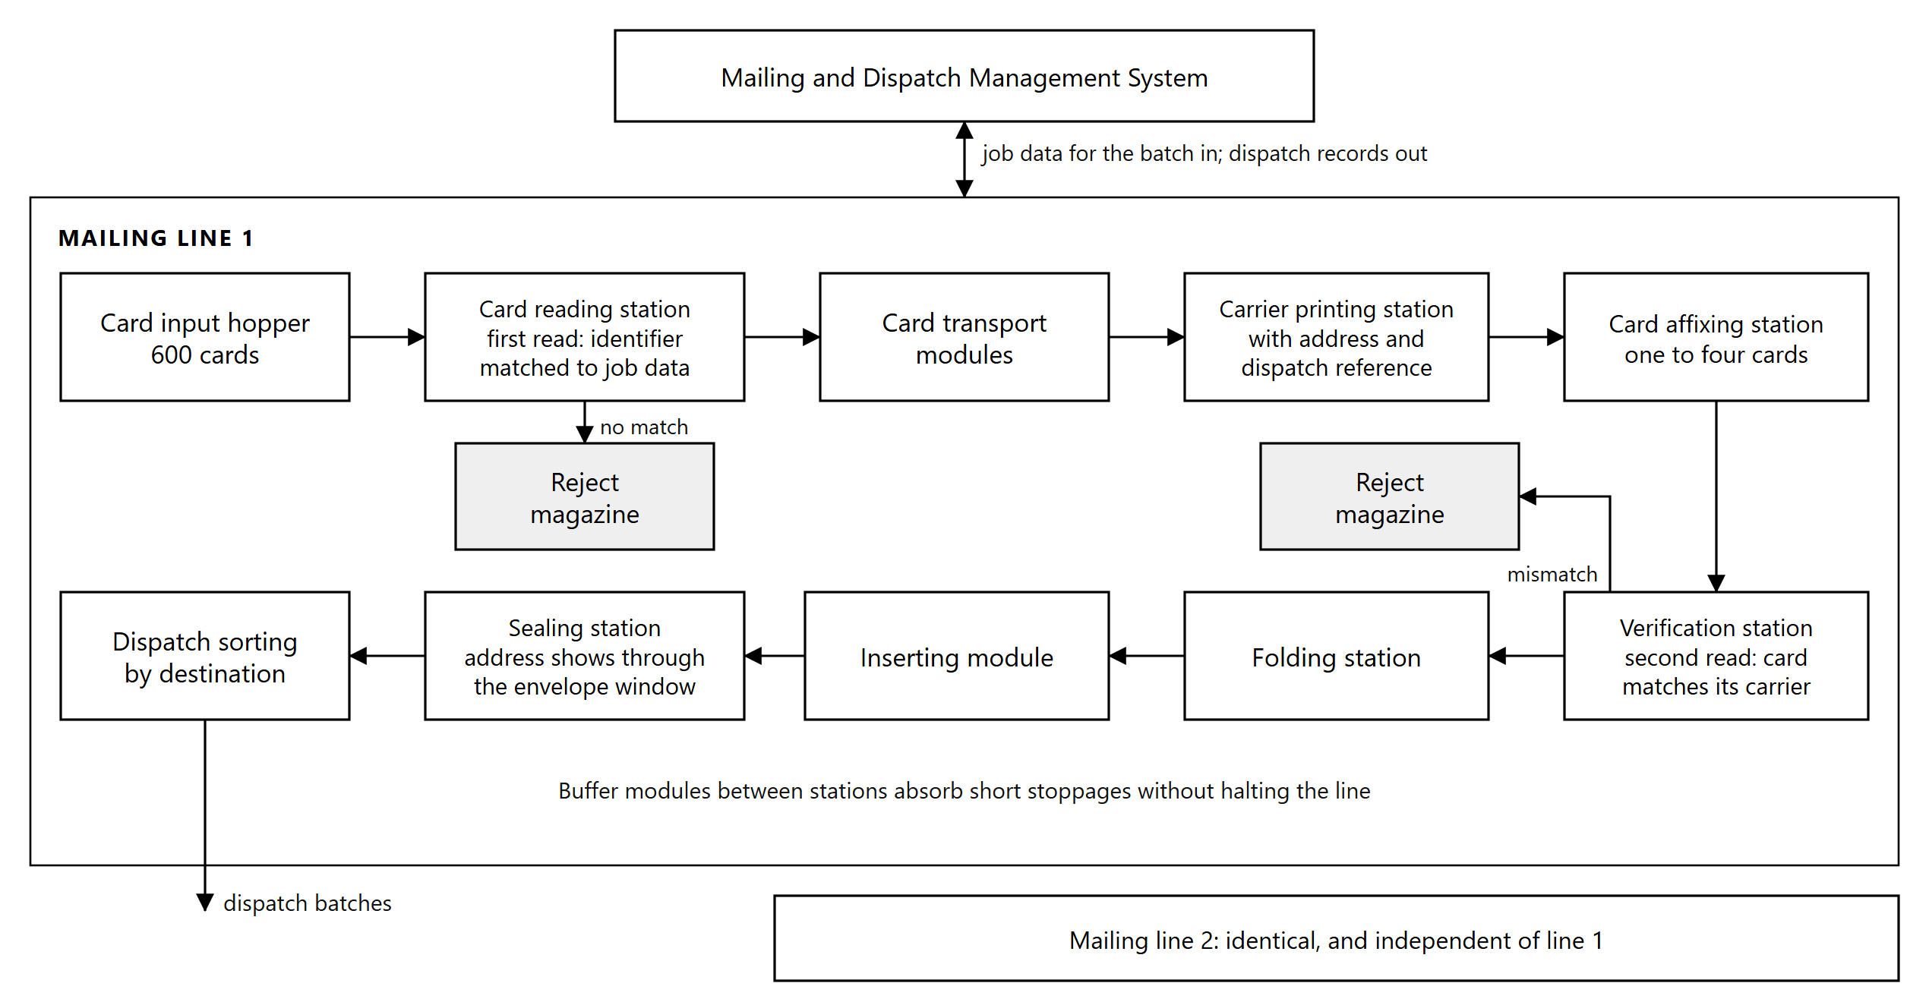
Figure 5.1: Mailing line. Each card is read against the job data before its carrier is printed, and read again with its carrier after affixing, before the mail piece is folded and inserted.

Carrier letter printing and card affixing
The carrier letter is printed at the line, personalized to the recipient, immediately before the card is attached. Printing and affixing in the same pass is what allows the carrier to be matched to the card by data rather than by sequence.
One to four cards per carrier. The system attaches between one and four cards to a single carrier letter.
The carrier accommodates A4 and US letter formats at paper weights up to 100 gsm, folded in C, V or Z configurations according to the envelope in use.

Envelope insertion, sealing and address printing
After the card is affixed and the match verified, the machine conveys the document automatically through the inserting module into the envelope. No manual handling occurs between affixing and insertion.
The envelope is then sealed. The destination address and the dispatch reference are printed on the carrier letter and show through the envelope window, together with the courier tracking number where a courier service is used. The destination is held on the production record retrieved from NRIS, so the address on the mail piece derives from the same source record as the data personalized onto the card it contains.

Verification and card-to-recipient matching
Verification reads 1D, 2D and QR codes.
Matching is by identifier, not by content. Each card carries a machine-readable identifier derived from its card serial number. The line reads that identifier and matches it against the job data supplied for the batch, which pairs each identifier with the carrier content and the destination prepared for it. Matching therefore requires no access to the contents of the digitally signed QR code, and does not depend on the order in which cards were loaded.
Every card is read twice, and each reading is checked against the record the mail piece was built from: once at the reading station, before its carrier is printed, and again with its carrier after affixing. The second reading is the control that matters: it confirms that the card physically attached to the carrier is the card the carrier and the address were prepared for. Nothing separates the card from its carrier after that point.
This detects the failure modes that arise inside the machine after correct data has been supplied. A mis-feed, a double-feed or a card out of sequence produces a mail piece whose contents do not match its address, and no upstream system can see that, because upstream the pairing was correct. Reading the card and its carrier together after affixing is the point at which such a fault is caught.
Cards and carriers failing verification are diverted to the reject magazine rather than inserted.

Sorting, reject magazines and buffer modules
Buffer modules hold work in progress between stations so that a brief stoppage at one station does not halt those upstream and downstream of it. This is what allows the line to run continuously under sustained load rather than stopping and restarting with each minor interruption.
Reject magazines receive the cards and carriers diverted out of the production path. Rejected items are held under control and recorded against the job, so that every card issued to the mailing line is accounted for as either a completed mail piece or a recorded reject.
Sorting is by sequence. The Mailing and Dispatch Management System orders each batch by destination, so completed mail pieces leave the line grouped by destination for dispatch.

Throughput and capacity
Measure | Performance
Combined output, two machines | Not less than 2,000 completed mailers per hour, measured on single-card mailers
Output per machine | Not less than 1,000 completed mailers per hour
Operating window | Two shifts of seven hours, fourteen hours per day
Daily output | 28,000 envelopes
Card input hopper | 600 cards per line, for continuous production

Two shifts of seven hours give a fourteen hour operating window, in which the two lines together produce the 28,000 envelopes per day required.
The mailing capacity is matched to the personalization capacity described in Section 3, both lines being rated at the same hourly figure and running in the same window. Cards therefore do not accumulate ahead of the mailing line while personalization is running, and the buffer modules absorb the short interruptions that would otherwise create a backlog under peak load.

Job data and dispatch records
The mailing system receives job data over a live interface from the Mailing and Dispatch Management System described in Section 6.9. This interface is the direct linkage between the mailing line and the identity data held upstream. Carrier content, destination data and the pairing of each card identifier to its recipient are supplied to the line as data. No information is re-keyed at the machine.
A dispatch record is generated for every mail piece, identifying the card, the cardholder, the destination, the dispatch batch and the tracking reference where one applies. These records are the source from which dispatch and delivery status is reported back to NRIS, and they are available for export.
Once mail pieces are sorted and packed they are grouped by destination and released for dispatch. The status reported to NRIS is what allows the cardholder to be notified that the card is available for collection, drawn from the record this system produced rather than from a separate count.

Application Software

Software architecture
The application software is built as a set of discrete services, each with a single responsibility and a defined interface, rather than as a single monolithic application. Services communicate through published interfaces and share state through the database, so that a service can be scaled, restarted or replaced without affecting the others.
Architectural principles
Principle | Effect
Single responsibility | Each service performs one function, so a fault is contained within the function where it occurs
Defined interfaces | Services are replaceable. The interface to the equipment manufacturer's software is one contract among several, not an embedded dependency
Separation of design time from run time | Card layout is defined once, under approval. The production path binds data into it and cannot alter it
Stateless services where possible | Production state lives in the database, so a service restart does not lose work in progress
Clustering and failover | Services run on a clustered platform with automated failover, backed by high-availability database clustering, replication to the secondary environment and point-in-time recovery, as described in Section 9.3. Printing jobs are balanced across the production lines, as described in Section 6.2

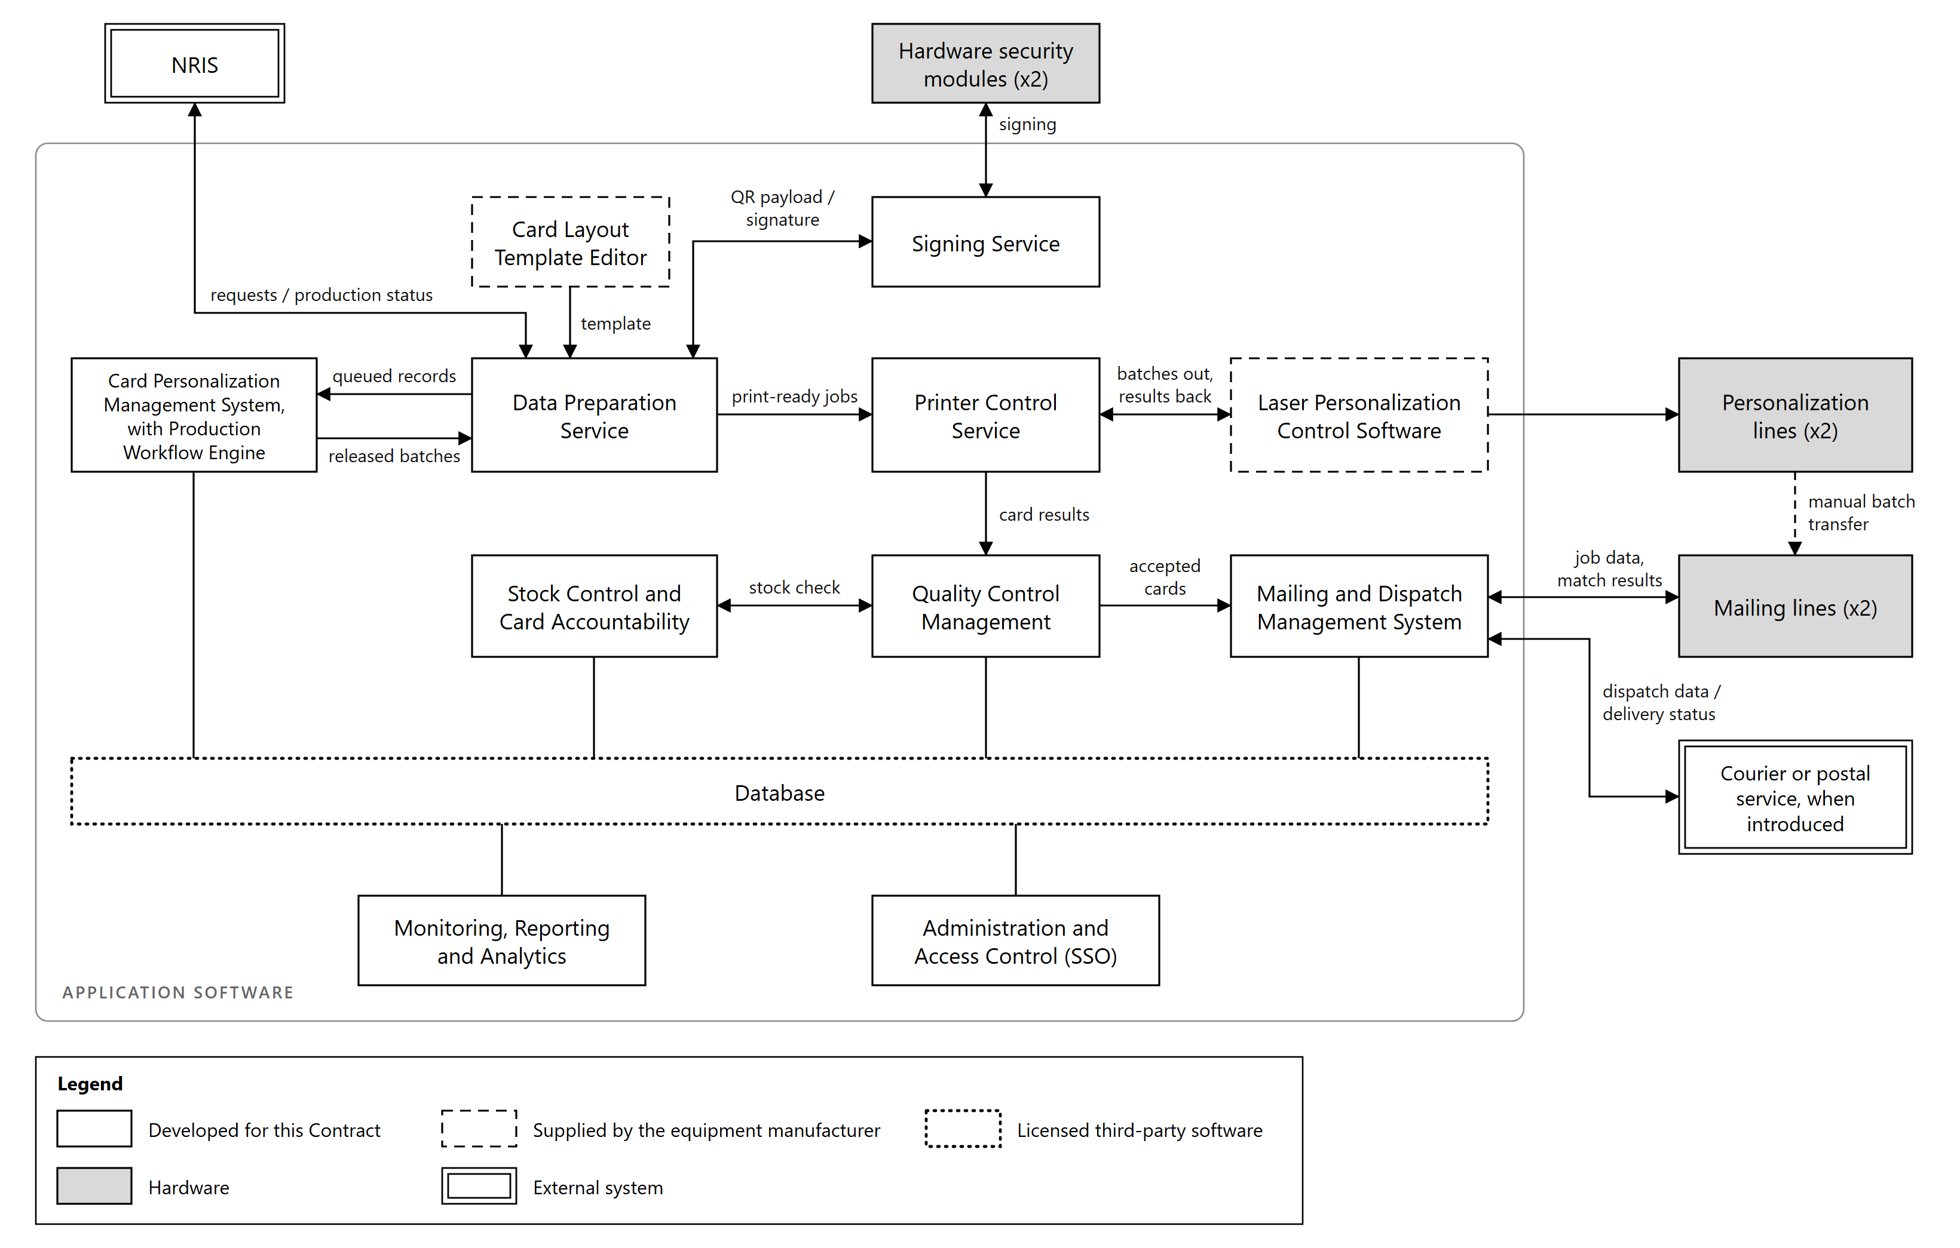
Figure 6.1: Application component architecture. Border style shows ownership; shaded boxes are hardware.
How the services relate. The Data Preparation Service polls NRIS for citizen records released for production and adds to the print queue those not already held in the database, so that a repeated scan cannot queue the same request twice. The Card Personalization Management System validates the queued records, assembles them into batches and releases the batches for production. The Data Preparation Service binds each record into the approved card template and calls the Signing Service to sign the QR payload, producing a print-ready job. An operator selects work from the queue and assigns it to a production line. The Printer Control Service submits the job to the equipment manufacturer's personalization control software and receives success and failure results back, writing them to the database where they surface in the operator interface. Quality Control Management evaluates verification results and reports production outcomes. Completed cards pass to the Mailing and Dispatch Management System. Throughout, the Card Personalization Management System, through its Production Workflow Engine, holds the state of every job and drives its progression across both production lines and both mailing lines, and Stock Control accounts for every blank card issued. Production status is published back to NRIS through the same interface that retrieved the records.
Presentation. Users reach these services through the consoles, portals and dashboards described in Section 6.13.

Card Personalization Management System
The Card Personalization Management System decides what is produced. It is the system of record for a card from the moment a record enters the print queue until the card is dispatched.
Function | Description
Card issuance workflow management | Validates each queued record for completeness and data quality, and holds records that fail with a reason recorded against them and reported to NRIS
Batch processing | Groups validated records into production batches of a configurable size, 500 to 1,000 cards in normal operation
Job scheduling | Releases batches to production in the required order, with priority applied according to rules configured by NRB
Print queue management | Tracks the position of every record in the print queue, from receipt to production
Card lifecycle management | Maintains the state of each card across first issuance, replacement, duplicate, re-issuance, renewal and cancellation
Reprint and reissue handling | Manages reproduction of rejected cards within the originating job, and reissue requests arising after dispatch

Production Workflow Engine. The system holds the state of every job and every card within it, and drives progression through the production sequence:
Function | Description
Workflow orchestration | Sequences the handoffs between services so that a job progresses from preparation through personalization and verification to dispatch without manual coordination at each step
Exception handling | Applies defined handling to conditions such as an unreachable interface, a failed submission or an incomplete record, holding the affected work rather than failing the batch
Queue prioritization | Determines the order in which queued work is consumed when capacity is constrained
Parallel processing | Runs work concurrently across both production lines and both mailing lines
Production balancing | Distributes batches across the available machines, and directs queued batches away from a machine that becomes unavailable

Operator-directed assignment with automated balancing. An operator selects work and nominates the production line through the Printer Controller Admin console. Within a line, the machine's own control software routes cards to the available laser stations, as described in Section 3.4, so a station taken out of service mid-batch does not stop production. Where an operator does not nominate a line, work is allocated on available capacity.
Production status written by the Printer Control Service surfaces in this system's interface, so a supervisor sees the live state of every batch and every card within it from one place.

Card Layout Template Editor
The card layout is defined once, at design time, using the graphical template editor supplied with the equipment manufacturer's personalization software. The editor produces a template in the job file format used by the laser marking subsystem, which fixes the position of every element on the card.
Element type | Configured in the template
Text fields | Position, font, size and orientation for each variable field
Images | Portrait box and signature field, with their dimensions and placement
CLI window | The region marked at two deflection angles through the lenticular structure
Micro-text zones | Position and content of micro-lettering, including within the portrait box
QR zone | Position and dimensions of the QR symbol
Card identifier zone | Position and format of the machine-readable rendering of the card serial number
MRZ zone | Position and format of the machine-readable zone
Tactile regions | Areas receiving raised relief marking

The editor works in marking geometry: vectors, raster areas, text and generated symbols placed at coordinates. Security features are expressed in the same terms. Micro-text is text at a very small size; the changing laser image is a marking strategy applied to a defined region rather than a distinct object type; the QR and MRZ are generated symbols placed in their zones.
The template is a controlled artifact. It is versioned, and a change to it passes through approval before production uses it. Each card record carries the version of the template that produced the card, so any card can be traced to the layout in force when it was made.
The production path cannot alter the template. Services downstream bind values into elements the template already defines, and have no means of moving, resizing or removing them. A fault or compromise in the production path therefore cannot relocate the portrait, shrink the micro-text or move the QR code outside its zone.
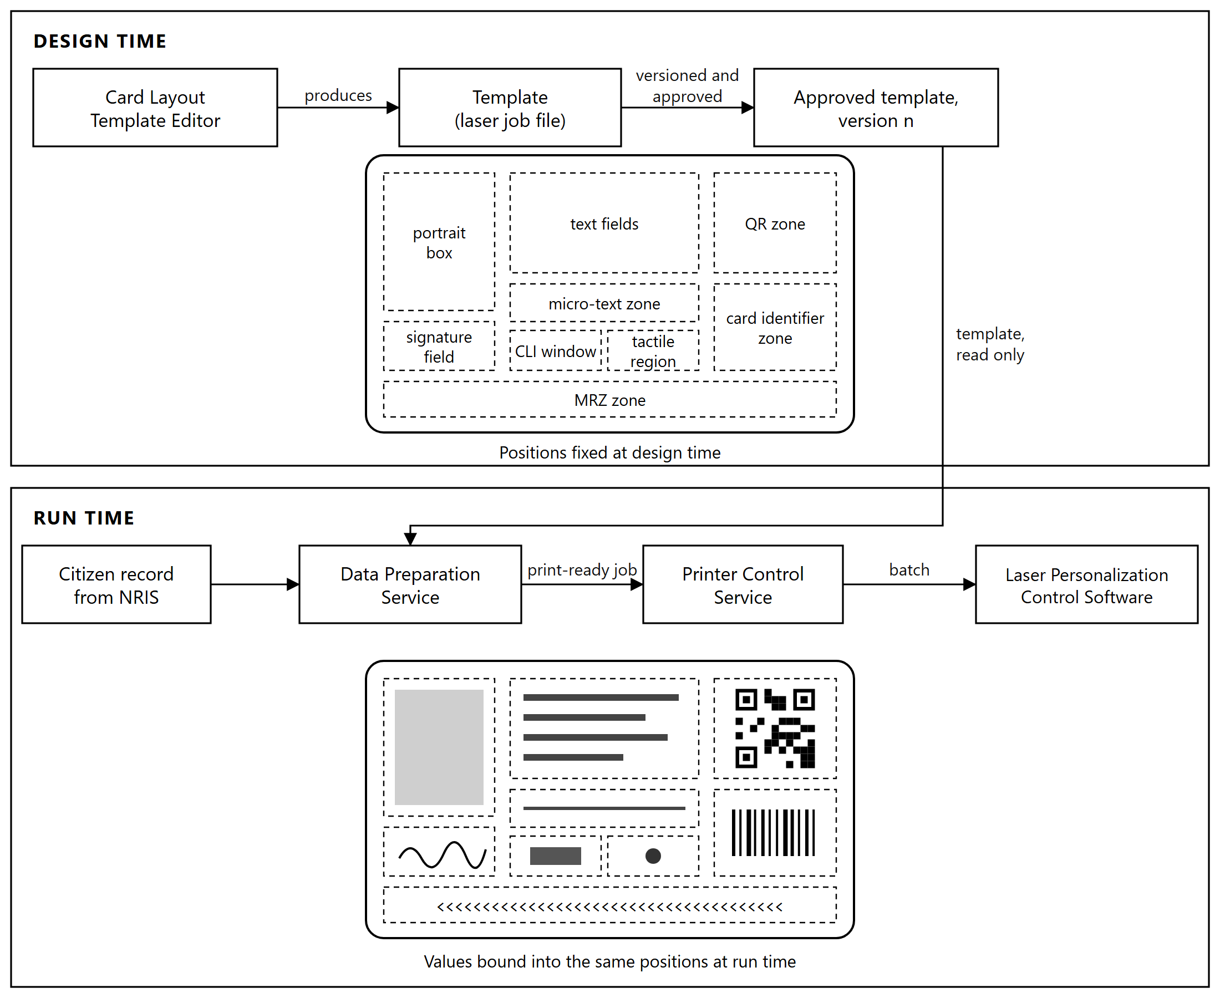
Figure 6.2: Design time and run time. The template fixes the position of every element; the production path binds values into those positions and cannot alter them.

Data Preparation Service
The Data Preparation Service turns an approved citizen record into a print-ready job.
Ingestion. The service holds the interface to NRIS. It polls for citizen records released for production, with the demographic data of each, and checks every record against the database before adding it to the print queue. A request already held is not queued a second time, so a repeated scan cannot put the same request into production twice. The photograph, signature and biometric data are retrieved for the records of a batch when the batch is prepared, as described in Section 7.8.
Preparation. For each record the service binds the retrieved values into the elements defined by the approved template: name, date of birth, National Identity Number and other variable fields, the portrait, the signature image, and the data encoded into the QR symbol, assembled and, where the Purchaser's QR specification requires it, encrypted, in the format that specification defines. It calls the Signing Service to sign the QR payload, and incorporates the returned signature into the job.
Output. The result is a batch of cards in the format the personalization equipment expects, each card complete with its data and its signature, ready for submission with no further processing.
Queue services. The same service exposes the prepared queue to the Printer Controller Admin console, so that an operator can list work awaiting production, select what to print, and assign it to a production line.
Status publication. The interface to NRIS carries production status in the return direction. The other services write outcomes to the database as work progresses, and this service publishes them to NRIS at each defined point. NRIS is therefore updated across a single interface rather than by several components independently, which is what allows the status held there to be reconciled against the production record as one set.

Signing Service
The Signing Service applies the digital signature carried in the QR code on every card.
It receives a prepared QR payload from the Data Preparation Service, submits it to the hardware security modules for signing, and returns the signature. The signing key is generated inside the module and cannot be extracted from it, so the service holds no key material of its own.
Isolating signing in a single service has three consequences:
One enforcement point. No card can be produced without a signature, because the only path to a print-ready job passes through this service.
One audited interface. Every signing operation is logged with the record it applied to and the certificate that signed it, so the complete set of cards signed under any certificate can be established.
Contained key access. Only this service holds credentials to the hardware security modules. No other component can request a signature, and a compromise elsewhere in the production path does not yield the ability to sign.
Key custody, the certificate lifecycle and the signing architecture are described in Section 10.4.

Printer Control Service
The Printer Control Service is the boundary between the Information System and the personalization equipment. It works in both directions.
Outbound. It submits prepared batches to the equipment manufacturer's personalization control software through its application programming interface, addressed to the production line the operator selected.
Inbound. It receives the result of each card from that software, success or failure, and writes the outcome to the database against the card record. This is the path by which production status reaches the Card Personalization Management System interface, and from the database it is published to NRIS.
Printer Controller Admin console. The operator console for this service lists the prepared queue retrieved from the Data Preparation Service, allows an operator to select work for production, and assigns it to a nominated production line. The console also presents the live state of each line and the progress of work in production on it.
Because the interface to the personalization equipment's software is confined to this one service, the rest of the application software is independent of that equipment. A change of personalization equipment affects this service and nothing above it.

Laser Personalization Control Software
Personalization control software supplied by the equipment manufacturer forms part of the Information System. It receives prepared batches through its interface and performs all marking control:
Function | Description
Laser engraving control | Drives the laser stations and sequences marking across both faces of the card
Greyscale personalization control | Modulates energy density to render the continuous-tone portrait
CLI generation | Marks the changing laser image at its two deflection angles through the lenticular structure
QR generation | Renders the QR symbol from the signed payload supplied in the job
Microtext generation | Marks micro-lettering at the positions the template defines
Tactile laser printing control | Controls the passes producing raised relief
Calibration management | Adjusts laser stations individually or together to hold marking quality consistent across the line

The division of work is that the Information System supplies data and the manufacturer's software marks the card. The Data Preparation Service produces the signed QR payload; this software renders it into a symbol and engraves it. The same applies to text, portrait and micro-text: content and position come from the prepared job, and marking is performed here.
Results for each card, success or failure, are returned to the Printer Control Service.

Quality Control Management
Quality Control Management evaluates the verification performed on the production line and decides the outcome for each card.
Data verification. The QR code read from the card is compared, byte for byte, with the payload prepared and signed for that card, and the engraved text, read by optical character recognition, is compared with the source record. A card fails if either comparison fails. Neither check requires the QR contents to be decrypted. In addition, quality assurance staff visually compare a sample of cards from each batch with the source record.
Stock check. Each card is checked against the blank card stock issued to the job. A card that cannot be matched with the controlled stock is rejected. This prevents a blank that never passed through Stock Control from entering production, and makes card accountability a condition of acceptance rather than a reconciliation performed afterwards.
Engraving quality verification. Print and engraving quality and the legibility of machine-readable elements are assessed against the acceptance thresholds.
Outcome management. Accepted cards are released for mailing. Rejected cards are recorded against the job with a reason, routed for reproduction within the same job, and held for secure destruction. Production outcomes are reported to NRIS.
Trending. Rejection reasons are recorded and analyzed so that a rising reject rate is attributable to a cause, whether a laser station drifting out of calibration, a card stock batch, or a data condition arising upstream.

Mailing and Dispatch Management System
The Mailing and Dispatch Management System covers everything between a verified card and confirmed delivery.
Batch handover. Verified cards are transferred by hand from the personalization output to a mailing line. The mailing line identifies each card by reading its machine-readable code, so the system establishes what is in the batch from the cards themselves rather than from the order in which they were loaded.
Function | Description
Card-to-envelope matching | Supplies the mailing line with each card identifier paired to the carrier content and destination prepared for that cardholder, and records the match confirmed at the line
Carrier letter generation | Produces the personalized carrier content for printing at the line
Envelope insertion workflows | Sequences the folding, insertion and sealing operations
Mailing label creation | Produces the label for each dispatch batch, carrying its dispatch reference, destination office and contents list
Dispatch data generation | Generates the dispatch reference and dispatch data for each mail piece and each batch, and passes them to the tracking interface
Courier integration | Exchanges dispatch data, tracking references and delivery status with the tracking service of a courier or postal operator, as described in Section 8.6
Dispatch tracking | Maintains the status of each mail piece from packaging through dispatch to delivery
Reject handling workflows | Records mail pieces diverted at the line, removes them from the dispatch batch and queues them for rework

Status reaches NRIS at each defined point: card packaged, card dispatched and card delivered. Delivery status is written against the card record and reported to NRIS, which is what allows the cardholder to be notified from the production record rather than from a separate count, and what closes the loop between a record released for production and the citizen who received the card.

Stock Control and Card Accountability
Stock Control accounts for every blank card the Facility receives, from delivery to either a personalized card or a certified destruction.
Blank cards are serialized. Every blank carries a unique serial number applied by the card manufacturer, under a numbering scheme, format and range proposed by the Supplier and approved by the Purchaser during design. Stock is held against that serial number rather than against a batch quantity. Traceability is therefore per card across the whole lifecycle, from the supplier delivery that brought the blank into the Facility to the issued card or the destruction record that closed it out. A count-based inventory can show that the numbers balance; only a serialized one can say which particular blank is unaccounted for.
Function | Description
Receipt | Books blank card deliveries into secure storage against the delivery batch, the manufacturer's identifiers and the serial number of every blank received
Issue | Records blanks issued from secure storage to a production job and to a named operator
Reconciliation | Balances blanks issued against cards personalized, cards rejected and cards remaining, for every job and every shift
Destruction | Records rejected and defective cards through secure destruction, with the destruction certificate closing them out of the reconciliation
Consumables tracking | Monitors carrier stock, envelopes and other consumables against usage
Low-stock alerting | Raises alerts against defined thresholds in time to reorder before production is affected
Inventory reporting | Produces real-time stock positions and historical consumption
Blank lifecycle reporting | Publishes the lifecycle state of each serialized blank to NRIS through the single NRIS interface, so that the register holds the same card-level position as the Facility, as described in Section 7.14

The reconciliation is the control that matters. Every blank issued to a job resolves to one of three states: a good card produced, a rejected card destroyed under record, or a blank returned to store. An unexplained difference is visible at the end of the shift that produced it, not at an annual audit.
Quality Control Management checks each card against this record during verification, so a card that cannot be traced to issued stock is rejected before it reaches mailing.
Secure destruction of rejected and defective cards. A rejected card carries a citizen's portrait, signature and personal data, and it carries the card body security features. It is a partial identity document, and until it is destroyed it is an asset an attacker would want. Rejected and defective cards are therefore held in the secure store, not in the production area, and are destroyed in controlled batches rather than individually at the line.
Step | Control
Quarantine | Rejected cards are booked back into secure storage against their serial number and held apart from usable stock
Dual custody | Destruction is performed by two authorized people together and witnessed, so that no individual can remove a card from the batch between quarantine and destruction
Destruction | Cross-cut shredding to a particle size at which no personal data element and no security feature can be reconstructed, to the media destruction standard recorded in the approved Standard Operating Procedure
Certificate | Each destruction batch produces a certificate listing every serial number destroyed, signed by both custodians
Reconciliation | The certificate closes those serial numbers out of the stock reconciliation, so a destroyed card cannot remain open in the ledger

The destruction takes place in the secure destruction area provided under the facility works. What makes the control meaningful is the closure of the loop: a blank is issued, and it resolves to a personalized card, a serial number on a signed destruction certificate, or a blank returned to store. There is no other outcome, and an unresolved serial number is visible at the end of the shift.

Monitoring, Reporting and Analytics
Function | Description
Centralized monitoring dashboards | Present the state of the whole facility on one view
Real-time production monitoring | Cards produced against target, batch progress, throughput by line, reject rate against threshold
Machine health monitoring | Station status, error counts, consumable levels and service intervals for each machine
Environmental and consumable thresholds | Temperature, humidity and stock levels against defined limits
Alerting and notification | Raises alerts on system failure, performance degradation and consumable thresholds, delivered to operators in real time on the dashboards and consoles, and by email and SMS to the NRB staff designated for each type of alert, through the System's own mail relay and a bulk SMS service
Performance analytics | Throughput trends, capacity utilization, bottleneck identification and forecasting
SLA monitoring and reporting | Uptime, throughput and rejection rate measured against the agreed service levels
Predictive maintenance analytics | Identifies components trending toward failure from error rates and cycle counts, so that maintenance is scheduled before a station fails

Reporting covers daily, weekly and monthly production volumes, card issuance statistics, rejection rates by cause, personalization throughput, mailing performance and SLA compliance. Reports are available to authorized users on demand and are reconcilable against the system logs they derive from.

Administration and Access Control
Single sign-on. Users authenticate once through the single sign-on service, which issues the credentials used by both the web interfaces and the service interfaces. Authentication is not implemented separately by each application, so an account disabled centrally is disabled everywhere at once.
Function | Description
Centralized user management | Provisioning, modification and deactivation of accounts from one console
Role-based access control | Permissions granted by role, covering operators, supervisors, system administrators, security administrators, quality assurance staff, auditors and management
Multi-factor authentication | Required for administrators, operators and all privileged users
Privileged access management | Elevated access granted for defined purposes and periods rather than held permanently
Session management | Session timeout, concurrent session limits, login attempt restrictions and account lockout
Password policy | Minimum length, reuse prevention and screening against known compromised passwords, in line with NIST Special Publication 800-63B, for every user, administrator and break-glass account
Separation of duties | Roles constructed so that no single user can both perform and approve a controlled action
Time-bound access | Access granted for a defined period and withdrawn automatically on expiry
User activity logging | Every interaction recorded against the user who performed it
Audit trails | Time-stamped, tamper-proof records of system access, data access, administrative actions and security events, searchable and exportable

Audit records cannot be altered by any user, including administrators. The record of who released a batch, who ran it, who calibrated a station during it and when each occurred is available for the retention period and is exportable for external audit.

Presentation Layer
Users work with the Information System through graphical interfaces, each built around the work of one role. The consoles, portals and dashboards are web applications, served by the application services and used from the workstations listed in Section 9.1, so a change to an interface is deployed once on the server rather than on each workstation. Two interfaces run locally: the Card Layout Template Editor, installed on the design workstation in the controlled design area, and the machine software, which provides the operator interface on the control computer of each line.
Interface | Used by | Presents
Printer Controller Admin console | Operators and supervisors | The prepared queue, the selection of work and its assignment to a line, and the live state of each line, as described in Section 6.6
Supervisor dashboard | Supervisors | The Card Personalization Management System's view of every batch and every card within it, records held at validation with their reasons, exceptions awaiting a decision, and the shift reconciliation, as described in Section 6.2
Quality control console | Quality assurance staff | Rejected cards with their reasons, their reproduction within the job, and reject trends, as described in Section 6.8
Mailing and dispatch console | Operators | The handover from personalization, card-to-envelope matching, diverted mail pieces and dispatch batches, as described in Section 6.9
Stock control console | Operators assigned to stock control | Receipt, issue, return and destruction of serialized blanks, and the reconciliation by job and shift, as described in Section 6.10
Production monitoring dashboard | Supervisors, system administrators and management | The whole facility on one view: lines, stations, throughput, environment and consumables, as described in Section 6.11
Reporting and analytics dashboards | Supervisors, quality assurance staff and management | Production, issuance, rejection, mailing and service level reporting, and performance analytics, as described in Section 6.11
Audit interface | Auditors and security administrators | Audit trails, searchable and exportable, as described in Section 6.12
Administration portal | System administrators and security administrators | User and role management, configuration and reference data, as described in Section 6.12 and Section 12.1
Card Layout Template Editor | Template designers and approvers | Card templates, their versions and their approval, as described in Section 6.3
Machine operator interface | Operators at the line | Station status, faults, calibration and the status of each record in the job, as described in Section 3.9

Role-based views. An interface shows only the functions and data the user's role grants. An operator's console carries no administration functions, and the audit interface reads the record without being able to change it. Where a controlled action can be taken is set by the workstation as well as by the role: the context-aware access control described in Section 10.3 ties such actions to the workstations provided for them, so work is released to a line only from the production supervision workstations and a template is changed only from the design workstation, whoever is signed in.
Secure authentication. The web interfaces authenticate through the single sign-on service described in Section 6.12, with multi-factor authentication for operators, administrators and all privileged users, and are served over TLS 1.2 or higher only. A session left unattended locks at the timeout set for its role and is resumed only by signing in again.
Multilingual support. Interface text is held in language resource files, separate from the application code, and the interface language is selected per user. The interfaces are delivered in English, and a further language is added by supplying its resource file, with no change to the application. Data is held and displayed in Unicode throughout, so a name appears on screen and in reports exactly as NRIS holds it, whatever characters it contains.
Real-time operational visibility. Status changes are pushed to every interface displaying them as they are recorded, rather than collected when a page is refreshed, so the dashboard a supervisor is watching changes when the line does. Standard queries respond within 2 seconds, as set out in Section 11.2.
Operator workflow interfaces. Each console is laid out as the sequence of the task it supports, and at each step offers only the actions valid in the current state of the work. A batch cannot start production before blanks are issued to it, and cannot be closed until every blank issued to it is accounted for.
Workflow | Console | Sequence
Batch production | Printer Controller Admin console | Select prepared work, confirm the blanks issued to it, assign a line, follow progress, close the batch
Reject review | Quality control console | Review each rejected card and its reason, follow its reproduction within the job, hand it over for quarantine
Mailing | Mailing and dispatch console | Record the handover from personalization, follow matching at the line, resolve diverted mail pieces, close the dispatch batch
Stock movement | Stock control console | Book receipts, issue blanks to a job and an operator, book returned blanks and rejected cards back into store, record destruction
Template change | Card Layout Template Editor | Edit the template, submit it for approval, release the approved version to production

A step that needs a second person is completed at the same console. Where separation of duties requires approval, as for releasing a template or recording a destruction batch, the second person authenticates at the console where the step is taken, and the approval is recorded against that person rather than against the session already open.
Error handling and notification interfaces. A condition is shown to the person who can act on it, in the interface that person is using, with what is needed to act on it:
Condition | Shown in | Detail given
Card rejected at the line | Machine operator interface and quality control console | The card, the reason and the reproduction status, as described in Section 3.7
Station or machine fault | Machine operator interface, Printer Controller Admin console and production monitoring dashboard | The station, the error code and its interpretation, as described in Section 12.2
Record held at validation | Supervisor dashboard | The record and the reason, as reported to NRIS
Failed exchange with NRIS | Supervisor dashboard and administration portal | The work held and its retry state, as described in Section 7.12
Mail piece diverted at the line | Mailing and dispatch console | The mail piece, the reason and its rework status
Unreconciled blank | Stock control console and supervisor dashboard | The job, the shift and the serial numbers not accounted for
Threshold breach | Production monitoring dashboard, with email and SMS | The measure, its threshold and its trend, as described in Section 6.11

Every notification carries its severity, its time and the object it concerns. Acknowledgment is recorded against the user who gave it, and a notification not acknowledged within the time set for its severity escalates under the rules described in Section 12.2.

Software inventory and licensing
Every software title forming part of the Information System is inventoried and classified as system, general purpose or application software; as standard or custom software; and as proprietary or open source. License terms are supplied for each title.
The inventory covers software developed for this Contract, standard software supplied under license, the personalization and mailing control software supplied by the equipment manufacturer, including the card layout template editor, database and operating system software, and the monitoring and security components.
Licensing is provided for three years from Operational Acceptance, covering the license entitlement itself together with support and updating subscription for the same period. Entitlements are mapped to the functional components they serve, so that the licensing position for any part of the system can be established directly. The itemized licenses, with their metrics, quantities and that mapping, form the Licensing Bill of Materials submitted with the Preliminary Project Plan.
Where any component is open source software, it is identified as such and the applicable licenses are supplied.

NRIS Integration

Integration architecture
The Personalization and Mailing System integrates with NRIS across a single controlled boundary. All data crossing that boundary passes through one interface, and no component of the production system holds a connection to NRIS of its own.
The counterpart system. NRB operates four registration systems: the Electronic Birth Registration System, the National Identity System, the Electronic Marriage Registration System and the Electronic Death Registration System. The National Identity System is the central repository and integration hub connecting the civil registration systems, and it generates and manages the National Identity Number carried across all of them.
Integration is therefore directed at the hub rather than at the registration systems individually. A civil event registered in its own system reaches the hub, and the hub releases the card production request that reaches the personalization system. Card production consumes one consolidated identity record rather than reconciling four sources, and the National Identity Number is the key that ties every produced card back to the citizen record it came from.
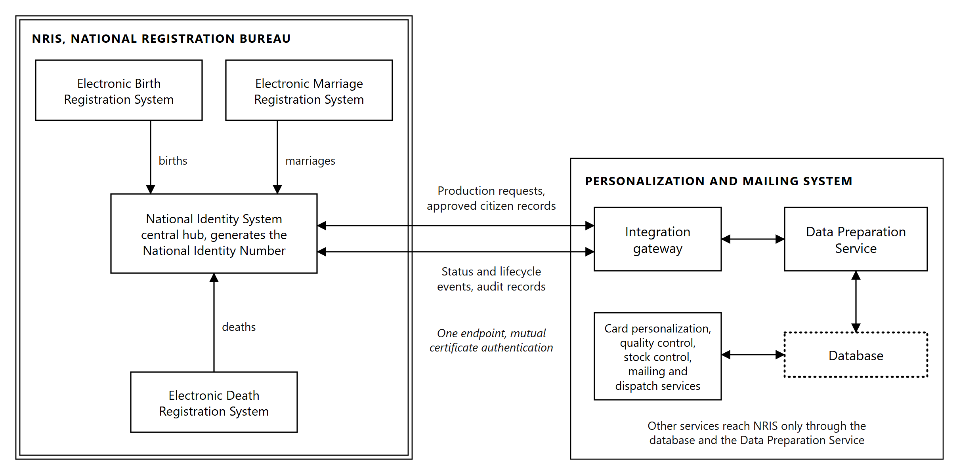
Figure 7.1: Integration with NRIS. Civil registration events reach the National Identity System hub, and production exchanges with the hub through a single endpoint. The double border is the Purchaser's estate.
What crosses the boundary.
Function supported | What is exchanged
Automated card production requests | Requests released by NRIS and retrieved by the production system
Secure transfer of citizen demographic and biometric data | Approved citizen records, biographical data, photograph, signature image and biometric data
Card personalization and issuance | Personalization data generated from the retrieved record, and issuance confirmation returned
Quality assurance and production monitoring | Verification outcomes, reject reasons and production quality data returned
Mail processing and dispatch | Address data drawn from the citizen record, and packaging and dispatch events returned
Status tracking and reporting | Production, dispatch and delivery status at each defined point
Reprint and replacement card management | Reprint and replacement requests inbound, and their outcomes returned
Audit and traceability | Transaction records establishing traceability from the NRIS record through to dispatch

A single integration gateway. The production system presents one endpoint to NRIS. The interface is held by the Data Preparation Service described in Section 6.4. Other services reach NRIS through the shared database and that service rather than by connections of their own.
This has three consequences:
One surface to secure. Encryption, certificate handling, authentication and key management are configured and audited at one point rather than in every service that has something to exchange with NRIS. The attack surface presented to the Purchaser's network is one interface, not several.
One record of what was exchanged. Every transaction crossing the boundary is logged at the same point. Traceability from the NRIS record through personalization and mailing to dispatch is read from a single sequence rather than assembled by correlating logs from several components after the fact.
One interface to test and to change. Interface testing, system integration testing and user acceptance testing address a single contract. A change on the NRIS side is absorbed within one service rather than in every component that holds a connection.
Integration patterns. The interface supports REST APIs, SOAP web services, secure file transfer, message queues and middleware integration, and database integration services. Which of these carries each exchange is settled against the interfaces NRIS exposes, and is described in Section 7.2.

Interfaces, protocols and middleware
The interfaces between NRIS and the Personalization and Mailing System are specified and designed as part of the supply, and the production side of each is developed, tested and deployed with it. NRB developers build the NRIS side of each interface, working to the same Interface Control Documents and in coordination with the Supplier. The integration supports the following transports:
Transport | Use
REST APIs | Request and response exchanges where a reply is needed within the call
SOAP web services | Exchanges where NRIS exposes a SOAP contract
Secure file transfer | Scheduled bulk exchanges and historical synchronization
Message queues and middleware | Asynchronous exchanges where the two systems must not be coupled to each other's availability
Database integration services | Direct database exchanges where the Purchaser approves them, described in Section 7.5

Message formats. Payloads are carried as JSON or XML, and file exchanges as a defined delimited or fixed-width flat file. The format for each exchange is fixed in its Interface Control Document together with the schema that validates it, so that a message is rejected at the boundary when it does not conform rather than being part-processed inside the production system.
How the transport for each exchange is settled. The choice is made against the interfaces NRIS already exposes, not imposed on it. Where NRIS presents a working interface, that interface is consumed as it stands. Where none exists for a required exchange, one is specified, agreed with the Purchaser and documented before development begins.
The governing principle is that the production system adapts to NRIS. Card production is the new system in this relationship, and a national identity register in live operation is not a safe place to absorb change driven by a downstream consumer.
The present position. NRIS integrates with the existing card printers through a middleware application connected directly to the database. For the new system, the Purchaser develops and provides the NRIS application programming interface, and the integration is designed to it, with the database connectivity described in Section 7.5 available where the Purchaser approves it.
Interface Control Documents. Every interface is documented in an Interface Control Document before it is built, covering the transport, the operation, the request and response structures, the field-level data definition, the error conditions and the expected behavior on each. The Interface Control Documents are a named deliverable, listed in Section 7.17, and they are the reference against which interface testing is performed.
Middleware and orchestration. Middleware components are configured where an exchange requires routing, translation or decoupling rather than a direct call:
Function | Effect
Service orchestration workflows | Sequences multi-step exchanges so that a single business event resolves the calls it requires, in order
Message routing | Directs each message to its destination by content and type rather than by fixed endpoint
Exception handling | Applies defined handling to a failed exchange rather than discarding it, holding the affected work and raising it for attention
Retry mechanisms | Repeats a failed exchange on a defined schedule, with a limit, so that a brief interruption on either side does not require manual recovery

Retry with a limit is what distinguishes a recoverable interruption from a fault. An exchange that succeeds on retry is recorded and continues. One that exhausts its retries is raised as an exception under Section 7.12 rather than retried indefinitely, so that a persistent fault becomes visible instead of consuming capacity silently.

Data mapping and transformation
Analysis before mapping. NRIS data structures are analyzed before any mapping is written. The analysis establishes, for each field the personalization system requires, where it is held in NRIS, its type and length, its permitted values, whether it is mandatory, and how it behaves when absent. Mapping written without that analysis produces a system that works on the sample data it was built against and fails on the population.
Field mapping. Each NRIS field is mapped to its counterpart in the personalization system, and the mapping is recorded field by field in the Data Mapping and Transformation Document listed in Section 7.17. The data elements carried are:
Group | Elements
Demographic data | National ID Number, names, date of birth, gender, nationality, address information, district, Traditional Authority, card serial number, which the production system returns to NRIS
Biometric data | Facial image, fingerprint references, signature image
Card data | Card issue date, card expiry date, card type, card status

Transformation rules. Where the representation in NRIS differs from what personalization requires, a transformation rule is defined and applied in one place. Date formats, name ordering and casing, character handling in names, image format and resolution conversion for the portrait and signature, and address composition into the lines printed on the carrier are each governed by a stated rule rather than by handling written into individual services.
Validation and cleansing. Every record is validated before it is queued for production. Validation covers presence of mandatory fields, conformance to the defined types and lengths, and consistency between related fields. Records that fail are held with the reason recorded and reported to NRIS, and are not released to production.
Validating at the boundary rather than at the machine is what keeps a data fault cheap. A record rejected before it enters the queue costs nothing. The same record discovered at the personalization line has already consumed a blank card from controlled stock.

Secure data exchange
Citizen demographic and biometric data crosses the boundary on every production run, so the exchange is secured at transport, message and identity level rather than at any one of them alone.
Control | Implementation
TLS-secured communications | All exchanges run over TLS. Plain-text transport is not offered or accepted on any interface
End-to-end encryption | Payloads carrying biometric or personal data are encrypted end to end between the NRIS interface and the integration gateway, with no intermediate point at which they are decrypted. Where the NRIS interface supports message-level encryption, payloads are also encrypted for the receiving system
Digital certificates | Both systems present certificates. The production system authenticates NRIS and is authenticated by it
PKI-based authentication | Machine identity is established by certificate rather than by a shared secret held in configuration
Data integrity validation | Each exchange carries an integrity check, so alteration in transit is detected rather than assumed absent
Secure key management | Private keys used for interface authentication are held in protected storage with controlled access and a defined rotation schedule

Mutual authentication is the control that matters here. One-sided authentication proves to the production system that it is talking to NRIS, and proves nothing to NRIS about what is asking it for citizens' biometric records. Both directions are authenticated by certificate.
The key material used for interface authentication is separate from the signing key used for the biometric QR code on the card. They serve different purposes, are held separately and are managed under different lifecycles. The card signing architecture is described in Section 10.4.

Database connectivity
Database connectivity to NRIS is provided where the Purchaser approves it. Interface-based exchange is preferred over direct database access, because an interface is a stable contract while a database schema is an internal detail of NRIS that may change without notice to the systems reading it.
Provision | Description
Secure connectivity | Connections to NRIS databases run over encrypted channels, from defined hosts, under named service accounts
Read-only interfaces | Retrieval of citizen and card data uses read-only access, so that no production process can alter an NRIS record by that route
Transactional interfaces | Where the Purchaser approves write access for a defined purpose, exchanges are transactional, so that a partial update cannot be left committed
Data synchronization | Reference data held on both sides is synchronized on a defined schedule, with differences reported rather than silently reconciled
Performance optimization | Queries are written and indexed against the access patterns card production generates, and reviewed with the Purchaser before deployment

Read-only by default is deliberate. Card production consumes identity data and produces card data. It has no reason to modify a citizen record, and an architecture that cannot do so is easier to assure than one that merely does not.

Real-time and batch processing
The integration carries both real-time and batch exchanges, matched to what each carries rather than applied uniformly.
Mode | Exchanges
Real time | Card production requests, card status updates, production alerts
Batch | Daily card production batches, bulk reprints, historical data synchronization

Why the split falls where it does. A status update is worth nothing late. Its purpose is to let NRIS answer where a citizen's card has reached, and a delayed answer is a wrong answer. A production alert is worth nothing late for the same reason. Daily production batches and historical synchronization move volume rather than answer questions, and are scheduled so that the volume runs when it does not compete with production traffic.
Both modes write to the same records and the same audit trail, so a card that entered production in a batch and reported status in real time has one history, not two.

Card production request management
The system receives card production requests from NRIS and processes each automatically:
Step | Action
Validate records | Each request is validated against the rules described in Section 7.3. Failures are held with a reason and reported to NRIS
Queue records for production | Validated records are placed in the print queue, checked against the queue and the production database before being added
Assign production batches | Queued records are assembled into production batches of a configurable size, 500 to 1,000 cards in normal operation
Generate production jobs | Each batch is prepared into a print-ready job and released to a production line

How requests reach the system. The production system retrieves requests released by NRIS rather than waiting to be called. Each retrieved request is checked against the database before it is queued, and a request already held is not queued a second time.
This matters for a national program. A retrieval that repeats after an interruption, a restart or a network fault cannot place the same request into production twice, because the check is on the request rather than on the delivery. A system that depends on each request arriving exactly once has no defense when it arrives twice, and a second card produced from the same request is an error in the register rather than merely a wasted blank.
Retrieval also means production continues to accept work without requiring NRIS to hold a connection to the Card Production Facility, and resumes on its own after an interruption rather than requiring the queue to be replayed by hand.

Citizen data retrieval
For each record released for production, the personalization system retrieves from NRIS:
Element | Use
Approved citizen records | The record authorizing production. Approval is determined in NRIS before release
Biographical information | Variable data engraved on the card, and the data used to compose the carrier letter and the address printed on it
Photograph | The greyscale portrait and the secondary image engraved into the card body. The source image is checked against the ICAO specifications for size and resolution when it is retrieved, and a record whose image does not conform is held with its reason and reported to NRIS
Signature image | The signature field engraved on the card
Card issuance information | Card type, issue date, expiry date and card status, which determine the layout applied and the lifecycle state recorded

Retrieval runs over the secured exchange described in Section 7.4. Biographical information is retrieved with each request, and the photograph, signature and biometric data for the records in the batch being prepared. All of it is held only for as long as production requires it, so the Card Production Facility does not accumulate a second copy of the national register.

Personalization and quality assurance integration
Personalization. From the retrieved record the system generates the personalization data, applies the approved card layout, and produces the print-ready job that drives marking:
Function | Where it is performed
Generate card personalization data | Data Preparation Service, binding retrieved values into the approved template
Produce card layouts | The approved template fixes every element position, as described in Section 6.3
Print visual information | Laser marking of variable text, portrait and signature within the card body
Laser engrave card information | Laser engraving of all personalization elements within the card body
Encode machine-readable data | The digitally signed biometric QR code described in Section 4.5

The cards supplied are chipless, so chip encoding does not arise. The machine-readable elements carried on the card include the QR code, verified in line, and the card identifier, which the mailing line reads to match each card to its mail piece.
Quality assurance. Verification results are integrated with NRIS so that the production outcome for every card is recorded against its citizen record:
Function | Description
Verify printed information | Engraved data, read by optical character recognition, is checked against the source record for every card
Verify laser engraving | Engraving quality is assessed against the acceptance thresholds
Verify machine-readable elements | The QR code read from the card is compared, byte for byte, with the payload prepared and signed for that card, and the card identifier is read and matched to the record
Reject defective cards | Cards failing any check are diverted from the production path and recorded against the job with a reason
Update NRIS on production outcomes | Each outcome, accepted or rejected, is reported with its reason

Reporting rejections with their reasons, rather than reporting only successes, is what allows NRIS to distinguish a card that is late from a card that will not arrive. A citizen whose card was rejected and is being reproduced has a different answer waiting at the registration office than a citizen whose card is already in the post.

Card lifecycle transactions
The integration manages the full card lifecycle against NRIS. Each transaction type is distinguished by the type carried on the NRIS record and produces a defined outcome:
Transaction | Outcome
New card issuance | A card is produced against a newly issued National Identity Number
Replacement card | A card is produced against the existing National Identity Number, and the superseded card is flagged in NRIS
Duplicate card | A further card is produced against the existing record, the two distinguished by card serial number
Lost card | The lost card is flagged in NRIS and a replacement is produced
Damaged card | The damaged card is flagged in NRIS and a replacement is produced
Card cancellation | No card is produced. The record is flagged in NRIS and any card already in production is withdrawn from the job

Re-issuance on a change of personal details and renewal on expiry, described in Section 2.3, follow the same path against the existing National Identity Number.
Every card carries a card serial number unique to the physical card, distinct from the National Identity Number it bears. This is what makes the lifecycle tractable. A citizen who has held four cards has one National Identity Number and four serial numbers, and the status of each card is recorded independently. Without it, a replacement cannot be distinguished from the card it replaced.
Cancellation while a card is in production. A cancellation arriving after a job has been released withdraws that card from the job. The blank is accounted for under Section 6.10 as a card withdrawn rather than produced, so cancellation does not open a gap in the reconciliation.

Production status feedback
The personalization system updates NRIS automatically at each defined point. No status event depends on an operator remembering to report it:
Event | Raised when
Job received | A production request has been retrieved from NRIS
Card in production | The record has been assigned to a batch and released to a production line
Card personalized | Marking of the card is complete
Quality control completed | In-line verification has been evaluated and the outcome decided
Card rejected | The record failed validation and was not released to production, or the card failed verification and has been diverted for reproduction and secure destruction
Card packaged | The card has been affixed to its carrier and verified, and the mail piece inserted and sealed
Card dispatched | The mail piece has been released for dispatch to its destination
Card delivered | Arrival at the destination has been confirmed and the card is available for collection

Events are written as they occur and published over the interface described in Section 7.1. Each carries the National Identity Number, the card serial number, the job and the time of the event, so a status update is attributable to a specific physical card rather than to a batch.
Mailing and dispatch integration, and the dispatch and delivery tracking that produces the last two events, are described in Section 8.

Reprint and exception management
Reprint. A reprint request arriving from NRIS is treated as a production request carrying a reprint type. It is validated, queued and produced on the same path as any other card, and raises the same status events. Cards reproduced after rejection inside a job are handled within that job under Section 3.7 and do not return to NRIS as new requests, because the original request has not yet been satisfied.
The distinction matters for reconciliation. A card reproduced inside its job resolves the original request. A reprint requested after dispatch is a new request against the same citizen record, and produces a card with a new serial number.
Exception management. An exception is any condition that prevents an exchange or a card from completing as expected. Each is handled by a defined path rather than by discarding the work:
Condition | Handling
Interface unreachable | The exchange is retried on schedule under Section 7.2. Work in progress is held rather than failed
Retries exhausted | The exchange is raised as an exception for attention, with the affected records identified
Record fails validation | The record is held with its reason and reported to NRIS. It is not released to production
Record incomplete on retrieval | The record is held pending retrieval of the missing elements rather than produced with gaps
Card withdrawn after release | The card is removed from the job and accounted for in the stock reconciliation
Duplicate request detected | The request is not queued a second time, and the condition is recorded

Every exception is recorded against the record it affects, and is visible in the operator interface and in the reporting described in Section 7.13. An exception handled silently becomes a defect in the register, discovered by the citizen at a service counter rather than by the Facility that caused it.

Reporting and analytics integration
Production data is made available to NRIS reporting for:
Report | Content
Daily production volumes | Cards produced per day, per line and per shift
Card issuance statistics | Volumes by transaction type across first issuance, replacement, duplicate and cancellation
Rejection rates | Rejections as a proportion of production, with reasons, by line and by station
Personalization throughput | Achieved rate against the contractual rate in Section 3.5, per machine and combined
Mailing performance | Mail pieces completed, rejects at the mailing line, and dispatch volumes
SLA compliance | Performance against the agreed service levels

Reporting draws on the same production records that drive status feedback, so a figure reported to NRIS reconciles to the card-level data behind it. Reporting built on a separate extract diverges from the operational record in a way that is not visible until the two are compared.
Rejection rates are reported with their reasons rather than as a single figure. A rate is a symptom. The reason distinguishes a laser station drifting out of calibration from a card stock batch or a data condition arising upstream, and only the reason indicates what to do about it.

Audit trail and end-to-end traceability
All transactions are traceable from NRIS through card production and mailing.
Log | Content
Transaction logging | Every exchange crossing the boundary, with its direction, payload reference, outcome and time
Security logging | Authentication events, certificate validation outcomes, and access grants and denials on the interface
User activity tracking | Operator and administrator actions, identifying who performed each action and when
Audit trail synchronization | Production audit records aligned with the NRIS audit trail so that the two reconcile
Blank card stock | The lifecycle state of every serialized blank, published from the Stock Control function described in Section 6.10

Blank card traceability reaches NRIS. Blank cards are serialized by the manufacturer, and the interface carries each blank's state to NRIS from supplier delivery through issue to a production job, to either the personalized card it became or the record of its destruction. The register therefore holds the same card-level stock position as the Facility, and a blank that is unaccounted for is visible to the Purchaser rather than only in a local reconciliation.
The traceability chain. Every record is keyed to the National Identity Number and the card serial number, and every stage writes against that key. A single card is therefore traceable from the request retrieved from NRIS, through validation, preparation, signing, marking, verification, packaging and dispatch, to delivery confirmation, without correlating records across systems by inference.
Synchronization between the two audit trails is what makes the chain complete rather than merely local. A production audit trail that cannot be aligned with the NRIS trail establishes what happened inside the Card Production Facility and nothing about what was asked of it.
Time is synchronized across all components against a common source, so that events ordered by their recorded time are ordered as they occurred.

Disaster recovery integration
Integration is designed to continue across a failover on either side.
Provision | Description
Integration with NRIS disaster recovery mechanisms | Interfaces are configured against the NRIS recovery endpoints as well as the primary, so a failover on the NRIS side does not require reconfiguration at the Card Production Facility
Failover support | Interface components run on the clustered infrastructure described in Section 9.3, so the loss of a node does not interrupt exchange
Continuity of card production | Work already retrieved and held in the production database continues to be produced while the NRIS interface is unavailable

Why production continues through an interface outage. Records retrieved and queued are held in the production database with everything required to produce them. A loss of the NRIS interface stops new work entering and stops status leaving. It does not stop the cards already prepared from being produced, verified, packaged and dispatched.
Status events raised while the interface is unavailable are held and published when it returns, in the order they occurred. Nothing is discarded because it could not be sent at the moment it arose, and the traceability chain in Section 7.14 closes without gaps once the interface recovers.

Integration testing
Integration is tested at five levels before Operational Acceptance. Each level is performed against the Interface Control Documents described in Section 7.2, and produces a report listed in Section 7.17.
Interface testing.
Test | Coverage
API testing | Every operation on every interface, against its documented request and response structure
Data validation testing | Field-level conformance to type, length and permitted values, including boundary values and absent optional fields
Error handling testing | Each documented error condition, confirming the system produces the defined behavior rather than an undefined one

System integration testing. End-to-end data flow from the retrieval of a request through to delivery confirmation, process orchestration across the full production sequence, and exception handling exercised by inducing the conditions listed in Section 7.12 rather than by inspection.
Performance testing. Throughput against the required production rate, batch processing capacity at the daily volume, and concurrent transaction processing at the expected load. Performance is verified at the volumes the system is contracted to sustain, not at a reduced scale.
Security testing.
Test | Coverage
Vulnerability assessment | The integration components and the hosts they run on
Penetration testing | The exposed interface surface, performed against the deployed configuration
Authentication testing | Certificate validation, rejection of invalid and expired certificates, and refusal of unauthenticated requests
Encryption validation | Confirmation that data in transit is encrypted as specified, and that weak protocol versions and cipher suites are refused

User acceptance testing. NRIS stakeholders are supported in validating business workflows, functional requirements and reporting requirements against the live integration. Support covers test data preparation, scenario walkthroughs, defect triage and retesting.
Exception handling and error conditions are tested by inducing them. A path that has never failed under test is an untested path, and interface faults in production arise from the conditions that were never exercised.

Integration deliverables
We will provide the following integration deliverables:
# | Deliverable
1 | Integration Strategy and Methodology
2 | Detailed Integration Architecture
3 | Interface Control Documents
4 | API Specifications
5 | Data Mapping and Transformation Documents
6 | Security Design Documentation
7 | Test Plans and Test Scripts
8 | Integration Test Reports
9 | Performance Test Reports
10 | Security Test Reports
11 | As-Built Integration Documentation
12 | Operations and Maintenance Manuals
13 | Knowledge Transfer and Training Materials

Deliverables are issued in editable format and as PDF. As-Built Integration Documentation reflects the integration as deployed at handover rather than as designed, and is reissued if the integration changes during the warranty period.

Dispatch and Delivery Tracking

Dispatch record generation
A dispatch record is created for every mail piece at the point the mailing line releases it. The record is the unit of accountability from that point onward, and every later status refers to it.
Field | Content
Card serial number | Identifies the physical card in the envelope
National Identity Number | Identifies the cardholder the card was produced for
Card identifier read at the line | The value read from the card with its carrier after affixing, which is what proves the pairing
Destination | The registration office the mail piece is addressed to
Dispatch batch | The batch the mail piece was grouped into for handover
Tracking reference | The reference generated for the mail piece, used where a courier or postal operator applies one
Time of release | When the mail piece completed verification and was released

The record is written from what the machine read, not from what the job intended. A mail piece released after the verification station confirmed the card against its carrier carries a record of that confirmation, and a mail piece diverted to the reject magazine does not produce a dispatch record at all. The dispatch set is therefore a record of what physically exists, which is what allows it to be reconciled against the production job and against blank card stock.
Dispatch records are available for export in structured form, and are retained under the retention policy described in Section 11.4.

Dispatch batching and destination routing
Grouping. Completed mail pieces are grouped into dispatch batches by destination. A batch is the unit handed over for transport, and it carries its own identity, its destination, its contents list and its handover time.
Routing. The destination for each mail piece is the registration office that ordered the card. It is carried on the production record retrieved from NRIS and printed on the carrier letter, where it shows through the envelope window, so routing is determined by data rather than by sorting after the fact.
Batch tracking. Each batch is tracked as a unit in addition to the individual mail pieces within it. Tracking at both levels is what allows a query about a single citizen and a query about a consignment to be answered from the same records:
Level | Answers
Mail piece | Where is the card for this National Identity Number
Dispatch batch | What was sent to this office, when, and how many pieces it contained

Handover. A batch is closed at handover. The closing record states the batch, its destination, its piece count, the time and the party that accepted it. A mail piece cannot be added to a batch after it closes, so the contents list and the handover record cannot diverge.

Delivery status tracking and cardholder notification
Status is maintained for every mail piece from release through to the point the card is available for collection.
Status | Set when
Packaged | The mail piece has been verified and released by the mailing line
Dispatched | The batch containing it has been handed over for transport
Delivered | Arrival at the destination office has been confirmed
Available for collection | The office has confirmed the card is ready for the cardholder

Notification. NRB operates a document tracking system within NRIS which moves a card through printing, dispatching and ready for collection, and sends the cardholder an SMS once the card is ready. The status this system reports is what advances that tracker. Notification therefore derives from the production and dispatch record rather than from a separate count kept alongside it, and a citizen is told the card is ready because the system that produced and dispatched it said so.
Why status is set from events rather than assumed. A status that advances on a timer, or on the expected arrival of a batch, reports progress that may not have happened. Each status above is set by a specific event, and a mail piece whose event has not occurred holds its previous status and is visible as outstanding rather than silently progressing.

Status feedback to NRIS
Dispatch and delivery status is fed back into NRIS over the interface described in Section 7.1. The events raised are those listed in Section 7.11: card packaged, card dispatched and card delivered.
Event | Carries
Card packaged | Card serial number, National Identity Number, job, time
Card dispatched | The above, plus the dispatch batch and its destination
Card delivered | The above, plus confirmation time

Each event is attributable to a single physical card. A status update that referred only to a batch would be unable to answer a question about one citizen, which is the question the tracker and the SMS notification exist to answer.
Events raised while the NRIS interface is unavailable are held and published in the order they occurred when it returns, under Section 7.15, so an interruption in the interface delays the notification rather than losing it.

Undelivered, returned and re-dispatched items
Not every mail piece reaches its destination, and the cases are handled distinctly because they have different causes and different resolutions.
Case | Handling
Rejected at the mailing line | No dispatch record is created. The card is recorded against the job as a reject, held under control, and reproduced within the job or returned to stock reconciliation
Batch not received at destination | The batch remains open against its handover record, and the mail pieces within it hold the dispatched status. The discrepancy is visible as a batch whose delivery was never confirmed
Individual piece missing from a received batch | The piece is recorded as missing against the batch it was dispatched in, and the card is flagged in NRIS as not delivered
Returned undelivered | The return is recorded against the dispatch record, the card status is updated in NRIS, and the card is held under control pending instruction
Uncollected after notification | The status remains available for collection. Handling of uncollected cards is an operational decision of the Purchaser, and the system reports the position rather than acting on it
Re-dispatch | A returned card that is re-dispatched produces a new dispatch record referencing the original, so both movements are visible and the card's history is not overwritten

Cards returned under control. A card that comes back is still a personalized identity document. It is recorded, held in secure storage under Section 6.10, and either re-dispatched or passed to secure destruction with a destruction record. It is not returned to blank stock, because it is no longer blank, and it is not left unaccounted, because it was issued from controlled stock.
A re-dispatch is a movement of an existing card. It is distinct from a reprint under Section 7.12, which produces a new card with a new serial number.

Courier integration readiness
No courier or postal operator is currently designated for card delivery. The Supplier is responsible for engaging with the courier or postal operator through which cards are delivered, to agree with it on the exchange of dispatch data, tracking references and delivery status, and to connect the system to the operator's tracking service, through its application programming interface or, where it offers none, by secure file transfer. The system is built so that an operator can be introduced without change to the dispatch record structure.
Capability | Provision
Tracking reference generation | A tracking reference is generated for every mail piece and every dispatch batch, in a format that can be replaced by an operator's own reference without changing the dispatch record structure
Dispatch data export | Dispatch and batch data is produced in structured form for transmission to an operator
Status ingestion | Delivery status received from an external party is written against the dispatch record by the same path that records internal confirmation
Interface | Integration with an operator's application programming interface is provided as a configured interface, in the same pattern as the interfaces described in Section 7.2
Address validation | Destination data is validated against the record it came from before the address is printed on the carrier

Why this is built now rather than later. The point at which a courier is introduced is the point at which the delivery model changes, and a system that assumed a single delivery path would need its dispatch records restructured to accommodate one. Generating a tracking reference and holding delivery status as an event from the outset means the operator becomes a source of those events rather than a change to what the system records.
Physical delivery of cards, from the Card Production Facility to registration offices or to cardholders' addresses, is outside the scope of supply and remains the responsibility of NRB, which today uses its own fleet. The operator's own systems are also outside the scope of supply, and both are listed in Section 13.2. The interface specification and address data standard are the operator's, and the system's data exchange and address validation are configured to them.

Infrastructure

Deployment architecture and platform
The infrastructure supporting the Information System is supplied, installed and configured as part of the scope. It is sized for a national identity production facility rather than for the average load, because the consequence of undersizing is a queue of citizens rather than a slow report.
Sizing basis. Quantities below are derived from the performance requirements the System is contracted to meet, rather than chosen and then justified:
Driver | Requirement | Consequence
Record scale | 10 to 50 million identity records | Storage capacity for production data
Retention and growth | 10 to 15 years, 15 percent annual growth | Capacity expansion without platform replacement
Audit and log volume | Millions of entries per day, retained 5 to 10 years | Storage, typically exceeding the production data
Availability | Not less than 99 percent | The workload must survive the loss of a host
Failover | Automatic within 60 seconds | Clustered hosts rather than a manual rebuild
Concurrent users | Up to 100 without degradation | Application server capacity, load balanced across two application servers
Production rate | 2,000 cards per hour, with portrait and signature handling | Processing and network capacity between services and lines

Storage derivation. The portrait, signature and biometric data are held only while a card is in production, as described in Section 7.8, so what is retained for each card is its production and dispatch record: identifiers, card serial number, status history and dispatch details. Allowing 5 kilobytes per card including index overhead, the upper record scale of 50 million gives approximately 0.25 terabytes, and the data of cards in production at any time adds little to that. Audit and log data at several million entries per day, retained for ten years and compressed as required, gives approximately 4 terabytes. Machine telemetry, reporting and working space add approximately 1 terabyte, for approximately 5 terabytes derived.
The platform provides not less than 20 terabytes usable after RAID at Operational Acceptance, more than three times the derived figure, so that several years of the 15 percent annual growth are absorbed within the initial provision. Raw capacity is provisioned above that, because part of it holds the parity that protects the data on the storage array against drive failure. Growth beyond the initial provision is met by adding drives or drive enclosures to the array rather than by replacing the platform, which is how the 15 percent annual growth is absorbed across a ten to fifteen year retention period.
Storage array. The virtual machines and their data are held on a dual-controller enterprise storage array shared by the four virtualization hosts of the primary site. The platform is Windows Server with Hyper-V, and the hosts form two failover clusters over the shared storage, an application cluster and a database cluster of two hosts each. The array has two controllers with non-disruptive failover between them, redundant power, and solid-state drives in a protected pool, RAID 6 or the manufacturer's equivalent, which keeps the data available through the failure of any two drives. Data on the array is encrypted at rest. Snapshots on the array are operational aids, such as a rollback point before a change, and are not backups. Backups are written to the separate immutable backup storage, under the regime described in Section 12.3.
The failure of a controller, a power supply, a path to a host or a drive leaves the data and every service available. Because the hosts hold no production data of their own, a host can also be lost or taken out for patching without reducing the protection of the data. The array is nonetheless one chassis, and its total loss would stop every service at the primary site. That case is covered by the secondary environment described in Section 9.3, which carries the data and the application services until the array is restored.
Host derivation. The primary site runs four virtualization hosts in two clusters, each host with two processors of 24 cores and 256 GB of memory. The application cluster of two hosts carries the integration, application, machine control, management, directory, security and backup virtual machines and the non-production environments, and each of its hosts is sized to run every production virtual machine of the cluster on its own. The database cluster of two hosts carries the two database nodes, one on each host, so that the database has processor, memory and storage paths of its own and never contends with the application workload. When a host in either cluster is lost, or taken out for patching, the other host of that cluster carries its workload at full performance, and the non-production environments are the first workloads stopped to make room for it.
Primary site deployment.
Element | Quantity | Role
Application hosts | 2 | Two processors of 24 cores and 256 GB of memory each. Application cluster with automated failover over the storage array, carrying the integration, application, machine control, management, directory, security and backup virtual machines and the non-production environments, each sized to run every production virtual machine of the cluster alone
Database hosts | 2 | Two processors of 24 cores and 256 GB of memory each. Database cluster over the storage array, one database node on each host
Storage array | 1 | Holds the virtual machines and their data, not less than 20 TB usable after RAID, with dual controllers, redundant power and solid-state drives in a protected pool
Backup repository | 1 | Encrypted, managed by Veeam Backup & Replication, holding the restore points used for routine restoration
Immutable backup storage | 1 | Not less than 40 TB usable, encrypted, covering retention cycles, with copies that no administrator can alter or delete before their retention ends
Core switches | 2 | Layer 3, redundant pair carrying the zone VLANs, including the Storage Zone
Edge switches | 3 | Managed and non-PoE, in one stack, connecting the operator and administrative workstations in the User Network, the personalization and mailing lines in the Machine Control Zone, and the management interfaces in the Management Network, to the core pair
Next generation firewalls | 2 | High availability pair, providing zone policy and intrusion detection and prevention
Hardware security module | 1 | Holds the Document Signer key, replicated to a second module at the secondary site, as described in Section 10.4
Operator and administrative workstations | 10 | Client devices for the consoles described below

The storage network is specified, not assumed. Every read and write of every virtual machine passes between the hosts and the storage array, so the storage network carries the production workload rather than only management traffic. Each host reaches both controllers over two independent paths, one through each core switch, with multipath across them, so that the loss of a path, a switch or a controller leaves every host with a route to the data. The paths, and the core switch ports that carry them, are provisioned accordingly. Under-specifying them is the common way such a deployment performs poorly while appearing correctly built.
Platform integrity. Secure boot is enabled on the virtualization hosts, on every virtual machine, on the backup repositories and the immutable backup storage, and on the operator and administrative workstations, so that firmware, boot loader and operating system kernel are verified against trusted signatures before the platform loads, and the network, storage and security devices load only firmware images signed by their manufacturer. The hardened configuration baselines applied on top of it are described in Section 12.1. The control matters here because an attacker who can place code below the operating system is beneath every control the operating system provides, including the audit trail that would otherwise record the intrusion.
Workstations. The equipment manufacturer supplies the industrial control personal computers that form part of each personalization and mailing line. The workstations below are the client devices for the software described in Section 6:
Purpose | Quantity
Production supervision, Printer Controller Admin console | 2
Quality control review | 2
Mailing and dispatch operation | 2
Stock control and secure storage | 1
Card layout design, in the controlled design area | 1
System administration | 2

Virtual machine inventory. The services described in Section 6 are deployed as follows, each within the network zone appropriate to its function:
Virtual machine | Services | Zone | Instances
Integration gateway | The NRIS interface of the Data Preparation Service, described in Section 7.1 | External Integration Zone | 1
Application server | Card Personalization Management, Data Preparation, Quality Control Management, Stock Control and Card Accountability, Mailing and Dispatch Management System, and Monitoring, Reporting and Analytics | Application Zone | 2
Signing Service | Signing Service, the sole client of the hardware security modules | Application Zone | 1
Database | Clustered database, two nodes, one on each database host | Database Zone | 2
Printer control | Printer Control Service and the interface to the manufacturer's personalization control software, for both personalization lines | Machine Control Zone | 1
Management | Administration and Access Control, administrative access host, and the mail relay that sends alert emails | Management and Monitoring Zone | 1
Directory | Domain controllers: the directory, authentication and name resolution for the estate, and its common time source. The two run on different application hosts and replicate to each other, and a third runs at the secondary site | Management and Monitoring Zone | 2
Security monitoring | Security information and event management, log aggregation, endpoint management | Management and Monitoring Zone | 1
Backup server | Veeam Backup & Replication: backup scheduling, cataloging, replication to the secondary site and restoration | Backup Zone | 1

Both application servers are active. Application and administrative traffic is load balanced across the two application server instances, which the cluster keeps on different application hosts. Each instance is sized to carry the whole load, so that when one is lost the other takes its traffic at once, while the cluster restarts the lost instance on the surviving host.
The database runs on hosts of its own. The two database nodes run on the two hosts of the database cluster, one on each, so that the database never contends with the application workload for processor, memory or storage paths, and no single host failure affects both nodes.
The DMZ is provisioned and carries no service at go-live. The zone is configured with its policy and addressing in place, so that any externally exposed service the Purchaser later introduces has a prepared place to go. The System as offered exposes no service outside the production network.
The Signing Service is deployed alone. It is the only component holding credentials to the hardware security modules, and Section 10.1 rests on that being true. It runs in a virtual machine of its own, because sharing an operating system with other services would leave the claim depending on operating system separation alone.
Printer control serves both lines. One instance addresses both personalization lines. The lines remain independent of each other, because each runs the manufacturer's control software on its own industrial control PC. If its host is lost, the instance is restarted on the other application host.
Time synchronization. The domain controllers provide the common time source for the estate, themselves synchronized to external reference time sources through the firewalls, so that time does not depend on any NRB service. Section 10.6 depends on events ordered by their recorded time being ordered as they occurred, and that holds only where every component takes its time from one place.
Secondary site. The secondary environment is deployed into the Purchaser's existing disaster recovery data center, on equipment supplied under this Contract. It uses none of the Purchaser's data center equipment: the Purchaser provides the space, power, cooling and the Government Wide Area Network connection.
Element | Quantity | Role
Virtualization host | 1 | Standalone, with the same processors and memory as the primary hosts, and internal storage of not less than 20 TB usable after RAID. It runs 7 virtual machines: the secondary copy of the database, kept current by database replication; a domain controller, kept current by directory replication; and standby copies, one of each, of the integration gateway, application server, management, security monitoring and backup server virtual machines, kept current by virtual machine replication
Backup repository | 1 | Encrypted, receiving the backup copies replicated from the primary site
Immutable backup storage | 1 | The offsite copy of the backups, not less than 40 TB usable, encrypted
Next generation firewall | 1 | Standalone, providing zone policy and intrusion prevention for the secondary environment
Core switch | 1 | Layer 3, standalone, carrying the secondary environment's network. No separate edge switches are needed at this site
Hardware security module | 1 | Replicated from the module at the primary site, as described in Section 10.4

The secondary site carries no personalization or mailing equipment and no machine control instances, because there is no equipment there to control. A single host is sufficient because high availability is required of the production system rather than of its standby: the standby is needed when the primary storage or the primary site is lost, and its own loss does not affect production. For the same reason its virtual machines are held on the host's internal storage rather than on a storage array. A shared array earns its place by letting clustered hosts reach the same disks, and a single standby host has no other host to share them with.
Non-production environments. Three environments are provided in addition to production:
Environment | Purpose
Development | Configuration and interface development
Training | Operator and administrator training, isolated from production
User acceptance testing | Purchaser validation of workflows, functions and reporting

These run on two virtual machines on the hosts of the application cluster: one for development, and one shared by training and user acceptance testing, which run the same released version. With them, the primary site runs 14 virtual machines: the 12 production virtual machines in the inventory above and these 2. They sit on a segment of their own within the Application Zone, which the firewall pair separates from every production service, as described in Section 9.2. Running them on the production platform keeps them on the same software and versions as production and under the same physical controls, without further hardware. They are the first workloads stopped when a host is lost, so that production keeps its full capacity.
Personal data is masked in every non-production environment, so that training and testing do not create further copies of citizen records.
Database platform. The data layer uses an enterprise-grade database platform providing:
Capability | Purpose
High-volume transactional processing | Sustains the transaction rates described in Section 11.4 under production load
ACID compliance | A production transaction either completes or does not, so a card cannot be half recorded
Clustering and high availability | The database survives the loss of a node without losing committed work
Replication | Maintains the secondary copy described in Section 9.3
Encryption at rest | Protects identity and personalization data on disk, under Section 10.2
Backup and recovery | Supports the backup and restoration regime in Section 12.3
Point-in-time recovery | Allows recovery to a chosen moment rather than only to the last full backup

The data layer holds identity data, personalization data, production logs, audit logs, machine telemetry, and mailing and dispatch data. These are held in one platform under one backup and retention regime, so that a card can be traced across all of them without correlating separate stores.
Final component specifications, including the drive configuration of the storage array and of the secondary host, the resulting raw capacity, and the capacity of the backup repositories, are confirmed during detailed design against the approved data volumes, the backup retention policy and the layout of the allocated room.

Network architecture and security zoning
The network is divided into ten segregated zones, each a separate VLAN. Traffic between zones passes through firewall policy, and no zone is reachable from another by default.
VLAN | Zone | Contents
10 | Management Network | The management interfaces of the hosts, the storage array, the switches, the firewalls, the hardware security module and the backup storage, reached from the administrative access host
20 | User Network | The operator and administrative workstations, connected through the edge switch stack
30 | Machine Control Zone | The personalization and mailing lines and their control systems, connected through the edge switch stack
40 | Application Zone | The application services described in Section 6, including the Signing Service, and, on segments of their own, the hardware security module and the non-production environments
50 | Database Zone | The database nodes
60 | External Integration Zone | The interface to NRIS and to external services
70 | Storage Zone | The traffic between the virtualization hosts and the storage array, and nothing else
80 | Backup Zone | The backup server, the backup repository, the immutable backup storage and the backup traffic
90 | Management and Monitoring Zone | Administration, the directory, monitoring and logging, and the security services: security information and event management, endpoint management and privileged access management
100 | DMZ | Reserved for a reverse proxy, application programming interfaces and other approved external-access services. No service is deployed there at go-live

The External Integration, Application, Database and Machine Control Zones are the production zones. The User Network holds the people who use the System. The Management Network, the Storage Zone and the Backup Zone carry the infrastructure, the Management and Monitoring Zone is the management and security zone, and the DMZ is reserved for externally exposed services.
Traffic between zones is routed only through the firewall pair, which applies the zone policy and intrusion prevention, and the Storage Zone is not routed at all. Communications are encrypted in transit as described in Section 10.2, and replication and backup copies between the primary and secondary sites cross the Government Wide Area Network inside an encrypted tunnel between the firewalls at each site.
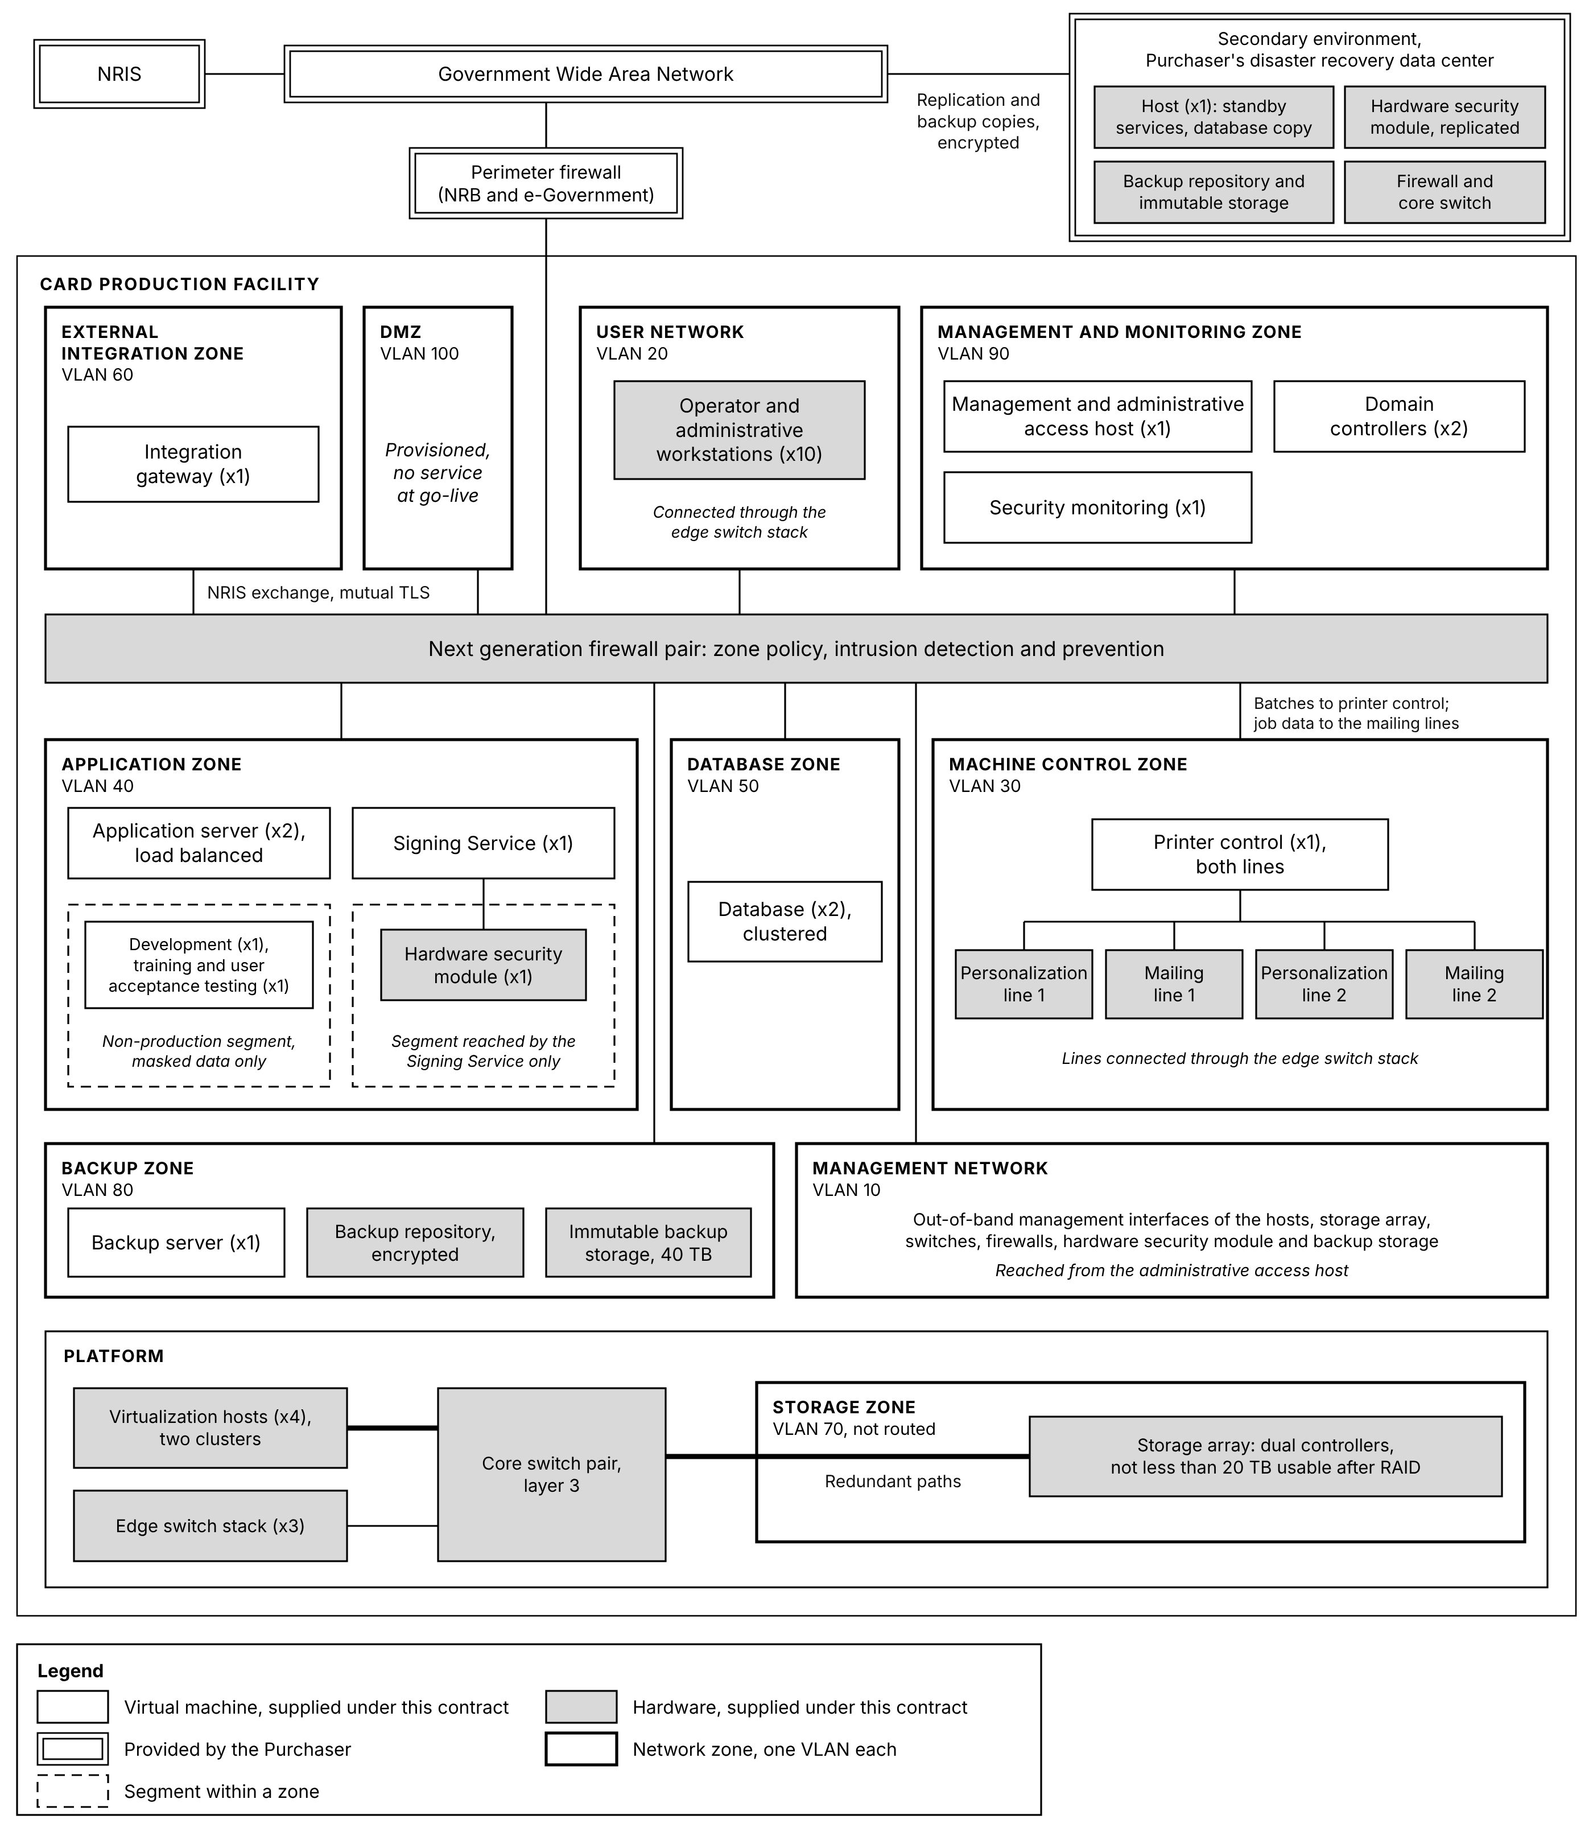
Figure 9.1: Network zones. Ten zones, each a VLAN, with every routed path between them passing through the firewall pair. Double borders are provided by the Purchaser; shaded boxes are hardware.
Why the Machine Control Zone is separated. The personalization and mailing lines run industrial control systems with their own lifecycle, patched to the equipment manufacturer's schedule rather than to the operating system vendor's. Placing them in their own zone means that constraint does not set the patching posture of the rest of the estate, and that a compromise elsewhere does not reach the equipment that produces identity documents. The lines connect to the edge switch stack on ports assigned to the Machine Control Zone, which reach the other zones only through the firewall pair. Personalization line 1 and mailing line 1 connect to one switch of the stack and the lines numbered 2 to another, so the loss of a switch takes one pair of lines out of production rather than all four.
Why the Database Zone is separated from the Application Zone. The application services are the components that talk to other systems and therefore the components most exposed. Requiring traffic to the database to cross a policy boundary means that reaching an application service does not by itself yield the identity data behind it.
The Storage Zone is carried separately. Traffic between the virtualization hosts and the storage array is placed in a zone of its own, which is not routed, so that storage traffic and application traffic do not compete, and so that the storage array is not reachable from the service zones.
Backup traffic has a zone of its own. Backups move large volumes of data, and the copies they make are what recovery from an attack depends on. The Backup Zone keeps that traffic off the production zones, and the backup server reaches the systems it protects only through firewall rules that permit backup traffic and nothing else, as described in Section 12.3.
Workstations, administration and the signing modules. The workstations listed in Section 9.1 sit in the User Network, connected through the stack of three edge switches, and reach the application services only through firewall policy. Administration of any zone passes through the administrative access host in the Management and Monitoring Zone, so no workstation holds a direct administrative path to a server in normal operation. The out-of-band management interfaces of the hosts, the storage array and the network and security devices sit in the Management Network, reached from the system administration workstations under a recorded break-glass procedure when the administrative access host is itself unavailable. The hardware security module at the primary site sits on a segment of the Application Zone that only the Signing Service can reach, and the module at the secondary site on the corresponding segment there, reachable from the Signing Service only through the encrypted tunnel between the sites. The boundary described in Section 10.1 is therefore enforced by the network as well as by the credentials.
Facility systems. The physical access control, intrusion detection, environmental sensors and uninterruptible power supplies installed under the facility works run on a network of their own, outside the zones above. Their events and readings reach the monitoring described in Section 12.2 and security information and event management through the firewall pair, on rules that permit only that exchange with the Management and Monitoring Zone, so that no facility device has a path into a production zone.
The non-production segment. The development, training and user acceptance testing environments sit on a segment of their own within the Application Zone, which the firewall pair separates from every production service, and hold masked data only. A fault induced in training, or an untested change in development, cannot reach production.
Wide area connectivity. Connectivity between the Card Production Facility, NRIS, the secondary environment and the other NRB services the System exchanges with is carried on the Malawi Government Wide Area Network, which the Purchaser provisions. The bandwidth, latency, availability and firewall openings each link requires, and the internet access that security subscriptions and software updates need, are specified during design from the NRIS exchange and the replication and backup volumes, for the Purchaser to provision against. NRB's perimeter firewall and the wide area service are administered jointly by NRB and e-Government and sit outside the scope of supply.
Remote administration. Remote administration follows the same path as administration on site. A remote session arrives through the access NRB and e-Government arrange and is subject to their controls, is encrypted to the firewall pair, is authenticated with multi-factor authentication, and reaches only the administrative access host, from which privileged access is issued for a session and a purpose under Section 10.3. No function of the System depends on remote access being available.

High availability, failover and disaster recovery
High availability within the facility. Application services are clustered across the two hosts of the application cluster, the two database nodes run on the two hosts of the database cluster, every host reaches the storage array through both of its controllers, and printing jobs are distributed across available lines by the Card Personalization Management System described in Section 6.2. The failure of a line, an edge switch, a host, a database node, a storage controller, a core switch or a firewall reduces throughput, or pauses it for the failover window, rather than stopping production. Nor does the failure of the hardware security module at the primary site: the Signing Service then signs through the replicated module at the secondary site, over the encrypted connection between the sites, until the module is replaced. The loss of the storage array as a whole is the exception, and is covered by the secondary environment.
Measure | Target
Failover initiation | Automatic, within 60 seconds
Recovery Time Objective, full service recovery | 5 to 15 minutes
Recovery Point Objective, maximum data loss on failover | 5 minutes
Data synchronization lag, primary to secondary | Near real time, and not more than 5 minutes
System availability | Not less than 99 percent

The recovery targets are agreed with the Purchaser during design. Availability is measured across the warranty and post-warranty periods. Scheduled maintenance windows, NRIS unavailability, and power or connectivity failures external to the card personalization system are excluded from the measurement.
What happens when a host is lost. When an application host is lost, the virtual machines running on it are restarted on the other application host, from the same disk images, which it can read because they are held on the storage array rather than on the failed host. Application traffic is carried throughout by the application server instance on the other host. That host is sized to run every production virtual machine of the cluster on its own, so production continues at full capacity while the non-production environments are stopped. When a database host is lost, the database node on the other database host takes over without losing committed work. Nothing is restored and nothing is copied at the time of failure, which is what allows recovery to complete within the stated window rather than within the time a restoration would take.
Secondary environment. The secondary environment is deployed into the Purchaser's existing disaster recovery data center in Blantyre, on the equipment described in Section 9.1. No new disaster recovery facility is constructed under this Contract, and the renovation scope is confined to the primary site.
The secondary environment is functional and operational at Operational Acceptance, as a warm standby. On the internal storage of its single host it holds a running replicated copy of the production database, a running domain controller, and standby copies of the service virtual machines kept current by replication and started on failover. Beside the host are the offsite backup copies and the replicated hardware security module. Recovery therefore does not depend on rebuilding from installation media.
Element | Provision
Primary environment | The production estate at the Card Production Facility
Secondary environment | Deployed into the Purchaser's existing disaster recovery data center
Backup replication | Encrypted replication by Veeam Backup & Replication of the backups of databases, configuration, application systems and audit logs to the backup repository and the immutable backup storage at the secondary site
Offsite backup storage | Encrypted, immutable backup copies held away from the primary site
Synchronization | Replication of the production database within the lag stated above

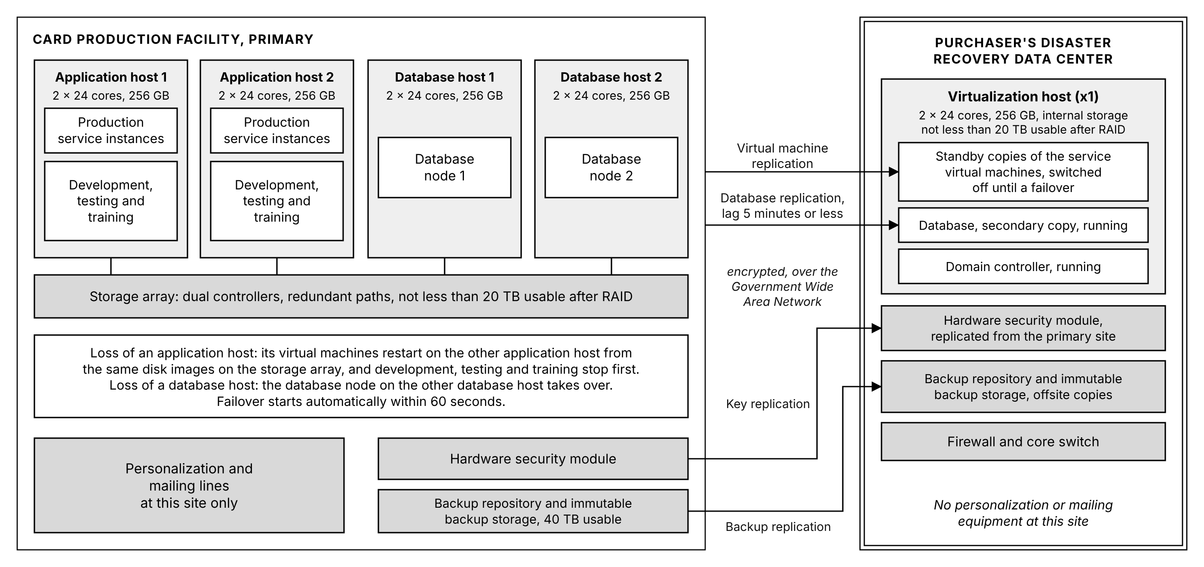
Figure 9.2: High availability and the secondary environment. Double borders are provided by the Purchaser; shaded boxes are hardware.
What the secondary environment does and does not cover. It carries the data and the application services, and its hardware security module holds the Document Signer key, so that production can resume after the loss of the primary site without waiting for a new certificate. It does not carry personalization or mailing equipment, or the machine control and signing services that drive them, which exist only at the Card Production Facility. A loss of the primary storage or of the primary site therefore preserves the record of every card produced and every card in progress and keeps those records available to NRIS and to reporting, and production resumes when the production platform, and after a site loss the equipment, is available again.
Testing. Disaster recovery is tested at least annually, by simulating full system failure, verifying data integrity after recovery, and recording the recovery point and recovery time achieved in a test report retained as audit documentation. The findings of each test are corrected in the recovery procedures before the next. Recovery procedures are documented for manual execution as well as automated, because the circumstances in which they are needed are the circumstances in which automation may also have failed.

Infrastructure scope of supply
The supporting ICT infrastructure, its software licenses and three years of support are within the scope of supply and appear in the System Inventory Tables.
Scope boundary. The items below are the ICT equipment. The facility infrastructure listed in Section 9.5, including the power, environmental, fire and physical security infrastructure, is delivered under the facility works.
Hardware.
Item | Quantity | Specification
Application hosts, primary site | 2 | Enterprise rack servers, two processors of 24 cores and 256 GB of memory each, redundant power, redundant paths to both controllers of the storage array with multipath, clustered with automated failover, each sized to run every production virtual machine of the application cluster alone, and carrying the non-production environments
Database hosts, primary site | 2 | Enterprise rack servers, two processors of 24 cores and 256 GB of memory each, redundant power, redundant paths to both controllers of the storage array with multipath, clustered, one database node on each
Storage array, primary site | 1 | Enterprise storage array, dual controllers with non-disruptive failover, redundant power, solid-state drives in a protected pool, RAID 6 or the manufacturer's equivalent, encryption at rest, not less than 20 TB usable after RAID
Backup repository, primary site | 1 | Encrypted, managed by Veeam Backup & Replication
Immutable backup storage, primary site | 1 | Not less than 40 TB usable, encrypted, with retention that no administrator can override
Virtualization host, secondary site | 1 | Standalone enterprise rack server, two processors of 24 cores and 256 GB of memory, redundant power, internal storage of not less than 20 TB usable after RAID, running the 7 virtual machines of the secondary environment at the Purchaser's disaster recovery data center
Backup repository, secondary site | 1 | Encrypted, receiving the backup copies replicated from the primary site
Immutable backup storage, secondary site | 1 | The offsite copy of the backups, not less than 40 TB usable, encrypted
Core switches, primary site | 2 | Layer 3, redundant pair, carrying the zone VLANs, including the Storage Zone
Edge switches, primary site | 3 | Managed, non-PoE, stacked, for the User Network, the Machine Control Zone and the Management Network
Next generation firewalls, primary site | 2 | High availability pair, with intrusion detection and prevention
Next generation firewall, secondary site | 1 | Standalone, with zone policy and intrusion prevention for the secondary environment
Core switch, secondary site | 1 | Layer 3, standalone, carrying the secondary environment's network
Hardware security modules | 2 | One at each site, the module at the secondary site replicated from the module at the primary site, FIPS 140-2 or FIPS 140-3 validated
Operator and administrative workstations | 10 | Client devices for the consoles listed in Section 9.1
Structured cabling and patching | As required by the approved room layout | Equipment room patching and connection of equipment to the network

Software.
Item | Coverage
Server operating system and hypervisor | All hosts, primary and secondary. One platform provides both, with failover clustering of the application hosts and of the database hosts
Virtual machine operating systems | All virtual machines
Windows Server client access licenses | Every person holding an account on the System
Workstation operating system | The operator and administrative workstations
Backup storage operating system | The backup repository and the immutable backup storage at each site
Database platform, SQL Server | The clustered database at the primary site and its secondary copy at the secondary site, with SQL Server Developer for the non-production environments
Backup and recovery platform, Veeam Backup & Replication | All protected systems at the primary site, with replication of the backups to the secondary site
Security information and event management | All sources across the estate
Endpoint detection and response | All servers, virtual machines and workstations
Privileged access management | All administrative and privileged accounts
Multi-factor authentication | All administrators and operators
Vulnerability scanning | All hosts, virtual machines, network devices and workstations
Next generation firewall security subscriptions | All three firewalls
Storage array and network device support and firmware | The storage array, all switches and all firewalls
Hardware security module client software and support | Both modules, and the Signing Service that reaches them
Monitoring and log aggregation | All infrastructure and application sources
SMS alert service | Subscription to a bulk SMS provider in Malawi for the delivery of alerts, for three years
Application software | The services described in Section 6

Licensing and support. Every license above is provided with three years of support and updates from Operational Acceptance, as described in Section 6.14.
General technical requirements. All active equipment complies with:
Requirement | Specification
Electrical supply | 220V plus or minus 20V, 50Hz plus or minus 2Hz
Power plugs | British Standard
Operating temperature | 18 to 27 degrees Celsius
Relative humidity | 40 to 60 percent
Dust | 0 to 40 grams per cubic meter
Noise | Not greater than 80 decibels
Electromagnetic emission | US FCC Class B, or EN 55022 and EN 50082-1, or equivalent
Language | English

Facility requirements
The Information System places the following requirements on the facility that houses it, and they are delivered under the facility works rather than as ICT equipment under Section 9.4. Apart from the Government Wide Area Network connection and NRB's perimeter firewall described in Section 9.2, the System is designed without reliance on any existing electrical, environmental, network or security infrastructure at the site.
Requirement | Provision
Power | Uninterruptible power supply sized for the production and server loads, generator support with automatic transfer, power distribution and grounding
Environment | Air conditioning, ventilation and humidity control holding the production area and the secure areas within the operating range in Section 9.4, precision cooling for the equipment room and the personalization room, air filtration to the dust limit in Section 9.4, and environmental monitoring of temperature, humidity and power
Physical security | Biometric access control to the server room and the production area, with every entry logged, including escorted visitors, closed circuit television with defined retention, and intrusion detection
Fire | Fire detection throughout, clean agent suppression in the equipment room, and suppression appropriate to a production area elsewhere
Racks | Equipment racks, rack power distribution units and console access for the ICT equipment in Section 9.4, to the approved room layout, and one rack at the secondary site
Secure areas | Separated areas for blank card storage, personalization equipment, data processing systems and secure destruction. The blank card store holds the full 2,000,000 cards, all of which are delivered before commissioning

The Purchaser supplies a dedicated electrical connection to the facility, provisioned against the final approved design, and coordinates the statutory approvals for the structural and electrical designs.
Environmental monitoring is linked to alerting, not only to record. Temperature, humidity, power and uninterruptible power supply status, reported by the sensors and the uninterruptible power supply installed under the facility works, feed the monitoring described in Section 12.2, and thresholds raise alerts before a condition reaches the point where production is affected. An environmental log that is only read after an outage explains the outage rather than preventing it.
Why the secure area separation matters to the system rather than only to the building. Stock control under Section 6.10 accounts for every blank card from receipt to issuance or destruction. That accounting is only meaningful if blanks are physically held where access is controlled and recorded, and if rejected cards are destroyed in a controlled area. The physical separation is the condition that makes the recorded reconciliation true.

Security Architecture

Security model
The security architecture is layered, so that no single control is the only thing standing between an attacker and a citizen's identity data.
Governing principles.
Principle | Application
Zero trust | No component is trusted because of where it sits on the network. Every request is authenticated and authorized on its own merits
Least privilege | Each account and each service holds the minimum rights required for its function, and no more
Segmentation | Zones are isolated by firewall policy, so reaching one does not yield the next. The zones are described in Section 9.2
Defense in depth | Transport, message, identity and storage are each protected independently, so the failure of one does not expose the data
Traceability | Every action is attributable to an identity and a time, under Section 10.6

What the architecture is protecting. Two million citizens' demographic records, photographs, signatures and fingerprint data pass through this system, and it produces the document by which a citizen proves who they are. The consequence of compromise is not data loss alone. It is the production of a genuine card for a person who is not entitled to one, which is why the controls on stock, on signing and on privileged access are treated as production controls rather than as administrative ones.
Trust boundaries. Three boundaries carry the weight of the model:
Boundary | Control
Between NRIS and the production system | Mutual certificate authentication and encrypted exchange, under Section 7.4
Between the application services and the equipment | The Machine Control Zone is isolated, and two defined interfaces cross into it: batches for the personalization lines through the Printer Control Service, and job data for the mailing lines from the Mailing and Dispatch Management System
Between any service and the signing key | Only the Signing Service holds credentials to the hardware security modules, under Section 10.4

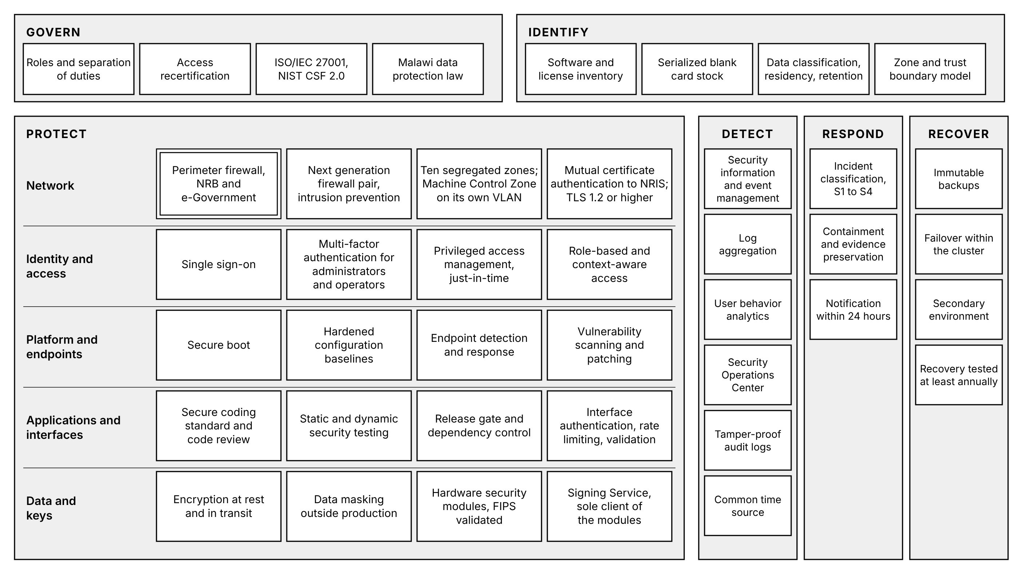
Figure 10.1: Cybersecurity architecture. Protective controls in depth from the network to the data and keys, with detection, response and recovery spanning every layer, arranged by the functions of the NIST Cybersecurity Framework 2.0. The double border is provided by the Purchaser.

Data protection and encryption
Control | Implementation
Data classification | Data is classified by sensitivity into citizen biometric and personal data, production and dispatch records, audit and security logs, and configuration and reference data, and each class carries its rules for storage, transfer, export, retention and destruction
Encryption at rest | AES-256 for all personally identifiable information, including the production database, its secondary copy and backups
Encryption in transit | TLS 1.2 or higher on every interface, internal and external. Plain-text transport is not offered
Data masking | Personal data is masked in development, training and user acceptance testing environments
Secure deletion | Defined sanitization procedures for media and for records reaching the end of their retention
Export control | Data leaves the System only through its defined interfaces and the export functions granted to specific roles, each export logged against the user who made it. Removable storage is disabled on the servers and workstations, outbound traffic from each zone is limited by firewall policy to the destinations it requires, and retrieval volumes inconsistent with production are detected under Section 10.7
Retention enforcement | Retention and archival policy applied by the platform rather than by operator action, under Section 11.4

Data minimization and purpose limitation. The production system is not a second national register. It retains production and audit data. Demographic data is retrieved with each request, and the photograph, signature and biometric data for the batch in preparation, and all of it is held only while production requires it, with NRIS remaining the system of record. Each data element is retrieved for card production and is used for no other purpose, and the interface requests only the elements the card and the mail piece require rather than the whole citizen record. This is both a data protection position and an architectural one: the smaller the standing copy of citizen data, the smaller the consequence of compromise.
Privacy by design. The system is built to the principles of the Data Protection Act 2024 and to the General Data Protection Regulation principles the Purchaser applies: lawful basis, purpose limitation, minimization, accuracy, storage limitation, integrity and confidentiality, and accountability. The system supports Privacy Impact Assessment by exposing what personal data it holds, where each element came from, which component processes it, how long it is retained and who has accessed it, so that an assessment can be evidenced from the system rather than reconstructed from documentation. A Privacy Impact Assessment is performed during design and repeated when a change alters what personal data is held or how it is processed.
Data residency. Citizen data is not stored or processed outside Malawi. Where any activity would otherwise require it, including factory testing and remote support, it is performed against synthetic or masked data. NRB is the data controller for citizen data held in the system.

Identity and access management
Directory. The System runs its own directory on three domain controllers: two in the Management and Monitoring Zone of the primary site, on different application hosts, and one at the secondary site. Each holds a full copy of the directory kept current by directory replication, so that identity and authentication depend on no NRB service. While one domain controller at the primary site is restarted or patched, the other serves authentication and name resolution without relying on the connection between the sites, and the one at the secondary site keeps the directory available if the primary site is lost. Every operator and administrator holds one identity in it, used by every interface through the single sign-on service described in Section 6.12, so an account disabled in the directory is disabled everywhere at once.
Control | Implementation
Role-based access control | Rights are granted to roles, and roles to people. No right is granted to an individual directly
Multi-factor authentication | Required for administrators and operators, and for all privileged access
Privileged access management | Privileged credentials are held under management, issued for a session and a purpose rather than held permanently
Just-in-time provisioning | Elevated access is granted for a defined window and withdrawn automatically
Session management | Session timeouts and concurrent session limits configurable per role
Context-aware access | Access conditioned on the device and the network location the request comes from, so that a privileged operation is refused from an unexpected origin even with valid credentials
Access logging | Every authentication, authorization and privileged action is logged, under Section 10.6
Access recertification | Periodic review of who holds what, with rights not reconfirmed being withdrawn

Separation of duties. The roles that matter are separated in the role model: the operator who runs a production job, the supervisor who releases it, the administrator who configures the system, and the auditor who reviews what happened. No single role can produce a card and remove the record of having done so.
Why recertification is included rather than assumed. Access accumulates. An operator who moves to another function keeps their rights unless something withdraws them, and in a facility producing national identity documents the accumulated rights of long-serving staff are a larger exposure than any external attacker. Periodic recertification is the control that removes what is no longer needed.

PKI, HSM and digital signature architecture
The certification authority is the Purchaser's. The Department of e-Government provides the Public Key Infrastructure for the Government of Malawi and provisions it for NRB. No new public key infrastructure and no certification authority is supplied under this Contract. The system uses the Government PKI for the Document Signer certificate behind the digitally signed QR code carried on the card, and for the certificates that authenticate its interfaces and services.
What is supplied. Two hardware security modules, one at the Card Production Facility and one in the secondary environment, both holding the Document Signer key used to sign each card's QR payload, and the Signing Service described in Section 6.5, which is the only component holding credentials to them.
Component | Provided by
Root and issuing certification authority | e-Government
Document Signer certificate | Issued by the Government PKI
Document Signer private key | Generated inside the hardware security modules supplied under this Contract, and never extracted from them
Hardware security modules | Two modules, one at each site, supplied, installed and configured under this Contract, the module at the secondary site replicated from the module at the primary site
Signing Service | Supplied under this Contract
Certificates for the interfaces and services, including the NRIS interface | Issued by the Government PKI

How the Document Signer key is established. The key pair is generated inside a hardware security module. The private key is created there and cannot be exported. A certificate signing request carrying only the public key is produced and submitted to the Government certification authority, which issues the Document Signer certificate. The certificate is loaded into the system. At no point does the private key exist outside the modules, so no procedure, no operator and no backup can move it.
Why a second module, and why at the secondary site. The key cannot leave the module that generated it. A spare module held on a shelf therefore holds no key, and bringing one into service would require a new key pair and a new Document Signer certificate from the certification authority, which is not an operation that completes within a production shift. A single module would make signing a single point of failure whose loss halts card production until a certificate is reissued.
The second module is therefore a replica holding the same key, and it is placed at the secondary site so that the key also survives the loss of the primary site. The module at the secondary site is enrolled into the same security domain under the same quorum of custodians, and the Document Signer key is replicated to it over the modules' own protected channel, carried inside the encrypted connection between the sites. The key exists in both modules and can be extracted from neither. The Signing Service signs through the module at the primary site. If that module fails, it signs through the module at the secondary site over the same connection, so the loss of one module does not interrupt production while the connection between the sites is available. After the loss of the primary site, production resumes with the replicated key, without waiting for a new certificate.
This also satisfies the spare parts obligation in Section 12.5, which requires a replacement unit for every critical component that would otherwise be a single point of failure. For a component whose key material cannot be copied onto a replacement, a synchronized second unit is the only form that obligation can take.
How a card is signed.
Step | Action
1 | The Data Preparation Service assembles the QR payload from the citizen record, encrypted where the Purchaser's QR specification requires it
2 | It calls the Signing Service, which submits the payload to the hardware security module at the primary site, or to the replicated module at the secondary site if that module is unavailable
3 | The module signs with the Document Signer private key and returns the signature
4 | The signature is incorporated into the payload structure and engraved into the card
5 | The operation is logged with the record it applied to and the certificate that signed it

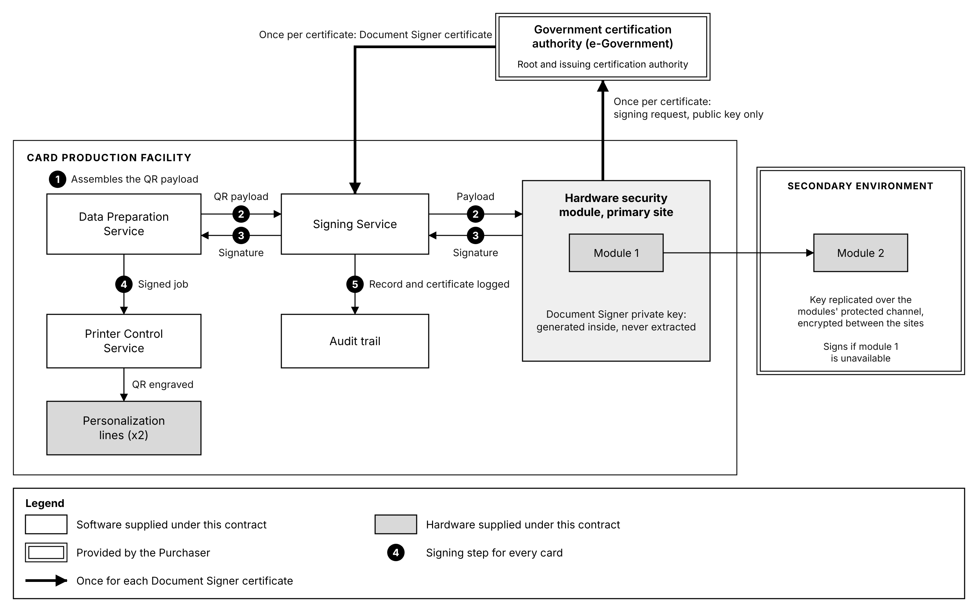
Figure 10.2: Card signing. The Document Signer key is generated inside the hardware security module at the primary site and replicated only to the module at the secondary site; it never leaves them, and only the signing request and the certificate pass to and from the certification authority. Numbers are the signing steps in the table above.
Certificate validity. A signature must remain verifiable for as long as the card it is on remains valid. The Document Signer certificate's validity period therefore has to cover the period during which it is used for signing plus the service life of the last card it signs, which is ten years. This is a constraint on the certificate the Purchaser issues rather than on the system, and it is recorded in Section 13.1 together with the renewal lead time, because production stops if the certificate lapses before a replacement is in place.
Key lifecycle. Generation, storage, rotation and revocation are defined procedures. Rotation produces a new key pair and a new certificate while the previous certificate remains valid for verification of cards already issued. Revocation is exercised by the certification authority, and the system holds the certificate reference on each card so that the cards signed under any certificate can be identified.
Standards. Both hardware security modules are FIPS 140-2 or FIPS 140-3 validated cryptographic modules. Certificates conform to X.509. Signature formats align with eIDAS digital signature standards.
Interface key material is separate. The keys used to authenticate the NRIS interface under Section 7.4 are distinct from the Document Signer key, held separately and managed under a different lifecycle. Compromise of an interface credential does not yield the ability to sign a card.
Reading the signed code. The QR payload is protected, and reading it requires verification software holding the keys the Purchaser issues for the purpose. The payload structure, the signing protocol and the data schema are specified by the Purchaser and provided to the Supplier, and are recorded in Section 13.1.

Application and interface security
Software written under this Contract is built under a secure development lifecycle, and the interfaces it exposes are treated as an attack surface rather than as internal plumbing.
Secure development lifecycle. Security requirements are defined alongside the functional requirements rather than added at the end, the design is threat modeled before it is built, and no release reaches production without passing the controls below.
Control | Application
Secure coding standard | Development against the OWASP Top 10, with the application assessed against it before each release
Code review | Every change reviewed by a second engineer, and security-relevant changes reviewed against a defined checklist
Static application security testing | Source code analyzed automatically on every build, with findings tracked to closure
Dynamic application security testing | The running application tested against the OWASP Top 10 before promotion to production
Dependency control | Third party and open source components inventoried under Section 6.14 and checked against published vulnerabilities
Release gate | A release carrying an unresolved high severity finding is not promoted to production

Interface security. Every interface enforces the same controls, whether it is consumed by NRIS, by the production equipment or by an operator console.
Control | Application
Authentication | Every call is authenticated. Mutual certificate authentication on the NRIS interface under Section 7.4, and service credentials elsewhere. No interface accepts an unauthenticated call
Authorization | Each call is authorized for the specific operation requested against the caller's role, not only for the connection
Encryption | TLS 1.2 or higher on every interface, under Section 10.2
Rate limiting | Call rates are bounded per caller, so that a faulty or abusive client degrades its own throughput rather than the production line
Input validation | Every field is validated against the interface contract before it reaches the application, and a rejection is recorded
Error handling | Failures return a defined error without disclosing internal structure, against the error conditions set out in the Interface Control Documents under Section 7.2

Why rate limiting is stated rather than assumed. The integration retrieves records from NRIS by polling and reports status back across the same interface. A retry loop on either side, whether from a defect or from a network fault, can generate enough load to starve the production path. Bounding the rate makes that a contained fault rather than a production stoppage.
Vulnerability management and patching. Vulnerability scanning runs against the application, the operating systems and the network components on a defined schedule and after any significant change, with quarterly assessment as the minimum, performed by the Supplier. Full penetration testing is performed by an independent third party before go-live and annually thereafter. Findings are risk rated, tracked to closure and reported.
Class | Patching position
Operating system, database and infrastructure software | Patched on a defined cycle, with operating system and database patches distributed automatically from the Management and Monitoring Zone and their installation reported for every host, and critical security patches applied out of cycle under the emergency change procedure in Section 12.1
Application software supplied under this Contract | Corrected and released under the same change control, throughout the warranty and post-warranty periods
Personalization and mailing control software | Patched to the equipment manufacturer's release schedule and only with releases the manufacturer has approved, which is why the Machine Control Zone is separated under Section 9.2

Operating system, database and application patches are applied first to the non-production environments described in Section 9.1 and promoted to production only after verification. Firmware for the network, storage and security devices is applied to one unit or controller at a time, and equipment software to one line at a time, each verified before the next is updated, so that no patch reaches the whole production estate untested.

Logging and audit
Log | Content
Audit trail | Every production action against the card and the record it affected
Security log | Authentication, authorization, certificate validation, and access grants and denials
User activity | Operator and administrator actions, attributable to a named identity, a time and the workstation or source address
Machine telemetry | Equipment state, calibration and fault events
Transaction log | Every exchange crossing the NRIS boundary, under Section 7.14

Tamper-proof audit trail. Audit records are written once to storage that does not permit a written record to be modified or deleted by any user, administrators included, and the integrity of the log is verifiable, so that an attempted alteration is both prevented and detected.
Time. All components synchronize to a common time source, so that events ordered by their recorded time are ordered as they occurred. Without this, correlation across components is guesswork.
Retention. Audit and security logs are retained for ten years, compressed and archived as described in Section 11.4, and remain searchable throughout. The storage for that volume is included in the sizing in Section 9.1.

Security monitoring and Security Operations Center
A Security Operations Center is established for the Card Production Facility from the components below, all supplied under this Contract. Its servers run in the Management and Monitoring Zone, its console is on the system administration workstations, and it is integrated with NRB's existing Security Operations Center.
Component | Function | Location
Security information and event management | Collects, correlates and stores security events from every source below, raises alerts, and provides the incident, compliance and posture dashboards | Security monitoring virtual machine, Section 9.1, with a standby copy at the secondary site
User behavior analytics | Compares user activity with the established pattern for each role | Within security information and event management
Endpoint detection and response | Detects and contains malware and malicious activity on every server, virtual machine and workstation | Section 9.4
Intrusion prevention | Inspects traffic between zones and at the perimeter | Next generation firewalls, Section 9.2
Vulnerability scanning | Scheduled and change-triggered scanning under Section 10.5 | Management and Monitoring Zone
Privileged access management | Records every privileged session under Section 10.3 | Management and Monitoring Zone
Security console | Alert queue, dashboards and investigation views | The system administration workstations in the control room

Event sources. The application services and the audit trail; operating systems, hypervisors and the database; the firewalls and intrusion prevention; endpoint detection and response; privileged access management and directory authentication; the hardware security modules and the Signing Service; the storage array and backup; configuration drift detection under Section 12.1; the traffic crossing into the Machine Control Zone; the secondary environment; and the physical access control, intrusion alarm and environmental monitoring events of the facility systems, so that a physical event and a system event can be correlated.
Security monitoring. Security information and event management collects from the application services, the infrastructure, the network and the security controls, and correlates across them. Detection rules cover the conditions that matter in this environment specifically: privileged access outside a maintenance window, signing volume inconsistent with production volume, stock reconciliation discrepancies, and access to the Machine Control Zone from outside the expected path.
User behavior analytics and anomaly detection. User activity is analyzed in real time against the established pattern for each role, and activity departing from it raises an alert for investigation. The conditions watched include a user working outside their normal hours or from an unusual location, a volume of record retrievals inconsistent with the batch in production, repeated authorization failures, and a sequence of actions no legitimate workflow produces. Rule-based detection finds the misuse that has been anticipated; behavior analytics is what surfaces the insider activity that is individually permitted and collectively abnormal, which in a card production facility is the harder and more consequential case.
Monitoring around the clock. Collection, correlation and alerting run continuously, 24 hours a day, independently of the two production shifts. An alert is raised on the security console and by dashboard notification, email and SMS, and alerts, with the events behind them, are forwarded to NRB's Security Operations Center, so that the facility is monitored within NRB's wider security operations at any hour. Until operation is transferred, the Supplier's on-call security engineer responds to S1 and S2 alerts at any hour under the support arrangements in Section 12.4.
Security incident classification and notification. Security incidents are classified separately from the equipment and production faults in Section 12.4, because the response differs: a production fault is restored, while a security incident is first contained and preserved for investigation.
Class | Condition | Containment | Notification to the Purchaser
S1, critical | Compromise or suspected compromise of the signing key or a hardware security module, unauthorized card production, or confirmed exfiltration of citizen data | Immediate, including suspension of signing or production where required | Immediately on detection, and in writing within 24 hours
S2, major | Unauthorized access to a production system or the Machine Control Zone, privileged account misuse, or malware on a production host | Isolate the affected component and preserve its state | Immediately on detection, and in writing within 24 hours
S3, moderate | Repeated authentication failure against a privileged account, an unexplained configuration change, or an anomaly raised by behavior analytics and not yet explained | Investigate under the Security Operations Center procedures | Within 24 hours of becoming aware of it
S4, minor | A security event or policy breach with no data or production exposure, such as a failed login or a single failed access attempt from an unexpected device | Logged and alerted on the security console, and reviewed in the periodic security report | In the periodic report

Escalation. S1 and S2 incidents are escalated immediately to the Supplier's security lead, NRB's security officer and the Purchaser's Project Manager; S3 incidents to the Supplier's security lead; S4 incidents through the periodic report. The escalation matrix, with names, contacts and response times, is part of the Incident Response Plan in the Cybersecurity Risk and Change Management Plan.
The 24 hour obligation is contractual. Cyber incidents are reported in writing to the Purchaser's Project Manager and designated security representatives within 24 hours of becoming aware of them, across the categories defined in the Contract, and the system supports it directly: detection is automated, the event record is complete enough to describe what occurred without waiting for an investigation to finish, and the initial notification is not delayed until the cause is known.
Forensic investigation. Evidence is preserved before recovery: containment isolates rather than rebuilds. Logs, memory state and disk images of an affected component are captured before it is restored, because restoring first destroys the evidence that establishes what was reached and whether any card was produced improperly. Captured evidence is hashed and held in the immutable backup storage described in Section 12.3, with a record of who captured it and when, so that its chain of custody is preserved, and it is examined against the security information and event management record and the audit trail described in Section 10.6 to establish what occurred and in what order. The Incident Response Plan governing the wider process is part of the Cybersecurity Risk and Change Management Plan.
Security reporting and policy enforcement. Incident reporting dashboards, compliance dashboards against ISO/IEC 27001 and the NIST Cybersecurity Framework, and security posture reports are produced from security information and event management. The system supports enforcement of the security policies set out in the Cybersecurity Risk and Change Management Plan, namely the information security, access control, acceptable use, cryptographic key management, vulnerability management, patch management, logging and monitoring, and incident response policies, through the controls that implement them: access control and acceptable use under Section 10.3, cryptographic key management under Section 10.4, vulnerability and patch management under Section 10.5, logging and monitoring under Section 10.6, and security monitoring and incident response through the Security Operations Center.
Handover of operation. NRB's security engineers are trained on the Security Operations Center, operate it under the Supplier's observation during operational acceptance testing, and take over its operation at handover, under the knowledge transfer described in the Training Sub-Plan.

Standards compliance
Standard or framework | Application
ISO/IEC 27001 | Information security management system
ISO/IEC 27002 | Security controls implementation
NIST Cybersecurity Framework 2.0 | Security architecture mapped to the six functions, below
CIS Controls | Configuration baselines and hardening
OWASP | Application security and secure development
FIPS 140-2 or FIPS 140-3 | Validated cryptographic modules
X.509 | Certificate formats
eIDAS | Digital signature standards alignment

Mapping to the NIST Cybersecurity Framework. The controls described in this section and in the infrastructure and operations sections map to the Framework's six functions as follows, so that the architecture can be read against the Framework rather than only against a list of technologies.
Function | Where it is implemented
Govern | Roles, separation of duties and access recertification under Section 10.3; the standards and legal obligations in this section; responsibility for operation after handover under Section 12.4
Identify | Software and license inventory under Section 6.14; blank card and consumable stock under Section 6.10; data classification, residency and retention under Section 10.2; the zone and trust boundary model under Section 10.1
Protect | Encryption under Section 10.2; identity and access control under Section 10.3; key protection under Section 10.4; application and interface controls under Section 10.5; network zoning and intrusion prevention under Section 9.2; endpoint detection and response under Section 9.4; physical access control and closed circuit television under Section 9.5; platform integrity under Section 9.1; hardened baselines and change control under Section 12.1
Detect | Logging under Section 10.6; security monitoring, behavior analytics and the Security Operations Center under Section 10.7; platform and equipment monitoring under Section 12.2; environmental monitoring linked to alerting under Section 9.5; in-line card verification under Section 6.8
Respond | Incident classification, escalation, containment, evidence preservation and notification under Section 10.7
Recover | Backup, immutable retention and restoration under Section 12.3; failover and the secondary environment under Section 9.3

Malawi legal and regulatory compliance. The system complies with the Data Protection Act 2024, the Communications Act 2016, the National Registration Act 2015, the Electronic Transactions and Cybersecurity Act 2016, and Malawi's National Digitalization Policy, and it is supplied, installed and operated in compliance with the Project Environmental and Social Management Plan.

Performance and Capacity

Production capacity
Measure | Performance
Combined personalization output | Not less than 2,000 cards per hour across two machines
Output per personalization line | Not less than 1,000 cards per hour
Combined mailing output | Not less than 2,000 completed mailers per hour across two machines, measured on single-card mailers
Output per mailing line | Not less than 1,000 completed mailers per hour
Operating window | Two shifts of seven hours, fourteen hours per day
Daily output | 28,000 cards and 28,000 envelopes
Batch size | 500 to 1,000 cards per batch
Sustained operation | Continuous 24/7 capability during peak issuance periods, with no degradation over sustained production cycles of at least 8 to 12 hours

Simultaneous multi-line operation. Both personalization lines and both mailing lines run concurrently on the same job or on different jobs. Capacity is the sum of the lines available rather than the capacity of a single line with a standby.
Rejection handling does not stop the flow. Rejected cards are detected, recorded and reproduced within the originating job without halting production, so the reject rate reduces neither the continuity of the run nor the completeness of the job.
Zero backlog under peak load. The mailing capacity matches the personalization capacity line for line, and buffer modules absorb short interruptions. Personalized cards therefore do not accumulate ahead of the mailing lines during a sustained run.
Capacity beyond the daily figure. The equipment is rated for continuous duty. The fourteen hour window produces the required daily volume, and the window can be extended during peak issuance without exceeding the equipment rating. Capacity is therefore bounded by operating hours rather than by the machines.

System response times
Operation | Target
User interface response, standard queries | 2 seconds or less
Transaction processing initiation | 3 seconds or less
Card personalization job submission | 5 seconds or less
Search and retrieval | 3 seconds or less
Standard report generation | 10 seconds or less
Complex report generation | 60 seconds or less
Batch job initiation | 30 seconds or less
Real-time validation of identity records | 2 to 5 seconds
Card encoding initiation | Near real time
Database transaction commit, normal load | 2 seconds or less
Failover initiation | 60 seconds or less, automatic
Full service recovery | 5 to 15 minutes
Data synchronization lag, primary to secondary | Near real time, not more than 5 minutes

These are targets under production load rather than on an idle system. Section 11.6 describes how each is verified.
Where response time matters operationally. An operator releasing a batch and a supervisor answering a query about one citizen are both waiting at a counter or a machine. A report that takes sixty seconds is read once; an interface that takes five seconds is used several hundred times a shift, and the difference compounds into production time.

Concurrent users
Measure | Capacity
Minimum concurrent users | 10 to 20
Scalable capacity without degradation | Up to 100 concurrent users

The following categories are supported concurrently:
Category | Typical activity
Card operators | Running production jobs at the lines
Supervisors | Releasing work, monitoring progress, handling exceptions
System administrators | Configuration, user administration, maintenance
Quality assurance personnel | Reviewing verification outcomes and reject trends
Security auditors | Reviewing audit trails and access records
Management | Reporting and analytics
External integration users | Programmatic consumers of the interfaces

Session handling. Concurrent sessions per role are configurable, session timeouts are configurable per role, and application traffic is load balanced across the two active application servers described in Section 9.1.
The platform is sized for a hundred concurrent users from Operational Acceptance, as set out in Section 9.1, and is stress tested to that figure under Section 11.6. Capacity beyond it is added to the cluster rather than by changing the architecture.

Data volumes, growth and retention
Measure | Capacity
Identity record scale supported | 10 million to 50 million records
Transaction volume | 1 million to 10 million transactions per month
Peak transaction volume | 100,000 or more transactions per day during issuance campaigns
Data retention | 10 to 15 years
Annual data growth | 15 percent, accommodated without redesign
Audit and log retention | 5 to 10 years
Log volume | Millions of entries per day, stored and queryable

Scale supported against data held. The platform is sized and licensed to operate at national register scale. What it retains is production and audit data, with NRIS remaining the system of record for citizen identity data. The distinction is deliberate: the system must perform at the scale of the national population it serves, without becoming a second standing copy of the register.
Growth. Capacity is added without replacing the platform: horizontally, by adding application server instances to the load balancing described in Section 9.1, and for the database by extending the processor, memory and storage allocated to the clustered database. A 15 percent annual growth rate compounds to roughly double the volume within five years, which a platform sized only for the volume at go-live would not absorb.
Transaction types. Each of the following is processed as a transaction recorded against the identity that initiated it and the record it affected, under Section 10.6, and is counted in the transaction volumes above. The card carries no chip or magnetic stripe, so card encoding is by laser engraving.
Type | Transactions
Card personalization | Card encoding by laser engraving, card printing, and re-issuance and reprint, under Sections 6.2 and 7.12
Mailing and dispatch | Envelope generation, card-to-envelope matching, dispatch confirmation, tracking reference generation and delivery status updates, under Sections 5.3, 5.4, 8.1, 8.3 and 8.6
Administrative | User creation and role assignment, configuration updates, audit log queries, report generation requests and security event handling, under Sections 6.11, 6.12, 10.6 and 10.7

Archival and compression. Audit and log data is compressed and archived on a defined schedule, and remains queryable after archival. Retention periods are enforced by policy in the platform rather than by operator action, and records reaching the end of their retention are deleted under the secure deletion procedures in Section 10.2.

Performance under peak and failover conditions
Performance is guaranteed under the following conditions rather than only under normal load:
Condition | Position
Peak load | The throughput and response targets hold at peak issuance volumes
Mixed workload | Concurrent production, reporting and administrative activity
Concurrent batch and real-time processing | Batch preparation runs alongside real-time status exchange without either being starved
Failover and disaster recovery mode | On the loss of a host, the other host of its cluster carries that cluster's production workload at full performance, as described in Section 9.1. On failover to the secondary environment, the data and application services continue within the recovery targets in Section 9.3, and card production resumes when the production platform at the Card Production Facility is restored
Maintenance windows | Minimal downtime: the paired hosts, application servers, database nodes, storage controllers, firewalls and core switches are maintained one at a time while the other of each pair carries the load, and maintenance is scheduled outside the production window where possible

Availability. Not less than 99 percent, measured as described in Section 9.3.
Concurrent batch and real-time work is the condition that usually breaks. Batch preparation is throughput-bound and status exchange is latency-bound, and a platform that treats them alike will serve one badly. They are separated by workload so that a large batch preparing does not delay a status update NRIS is waiting on.

Performance validation
Performance is demonstrated rather than asserted. Each figure above is verified before Operational Acceptance.
Test | Verifies
Throughput benchmark at factory and site acceptance testing | The production and mailing rates in Section 11.1
Load testing | The response time thresholds in Section 11.2, under production load
Stress testing | Concurrent user capacity in Section 11.3, to the scalable figure and beyond it to the point of degradation
Transaction integrity testing | That no transaction is lost or duplicated at peak volume
Sustained operation test | That no critical degradation occurs across a continuous production run
Failover test | The failover and recovery targets, by inducing failure rather than by inspection

Acceptance is conditional on these results. The system is accepted only if all throughput benchmarks are achieved, response thresholds are verified under load, concurrent user capacity is validated by stress testing, transaction integrity is maintained at peak, and no critical performance degradation is observed over sustained operation.
Monitoring continues after acceptance. Real-time performance dashboards, service level monitoring, throughput analytics, bottleneck detection, automated performance reporting and historical trend analysis are provided under Section 12.2, so that performance is a continuously observed property rather than a condition demonstrated once at handover.

Operations, Administration and Support

System administration and configuration management
Installation and configuration. Installation procedures are standardized and repeatable for every component, with guided installation for software components. Configuration is held centrally rather than on each host.
Capability | Provision
Centralized configuration management | One interface governs configuration across the estate
Secure baseline templates | Pre-configured hardened baselines for servers, databases, personalization machines and mailing systems
Version-controlled configuration | Every setting is versioned, so the configuration in force on any date can be established
Secure parameter management | Credentials and sensitive parameters held under protection rather than in configuration files
Multi-environment deployment | The same configuration is deployed across development, training, user acceptance testing and production

Change management. Changes to the system pass through a defined framework rather than being applied directly:
Control | Effect
Role-based approval workflow | Request, approve, implement and verify are separate steps held by separate roles
Separation of duties | Those who develop, those who administer and those who approve are different people
Change logging | Every change is recorded with what changed, when, by whom and under which approval
Version control | Software releases, configuration files, scripts and interface definitions are all versioned
Rollback | Every change has a defined path back to the previous state
Impact analysis | The components, interfaces and environments a proposed change affects are identified from the configuration repository, and the effect is assessed before approval
Scheduling | Changes are scheduled into maintenance windows against the production calendar
Emergency changes | An expedited path exists, with mandatory post-implementation review

Configuration governance. A central configuration repository holds the baselines, an audit trail records every configuration change, compliance against baseline is enforced, and automated drift detection identifies where a component's live configuration has diverged from its approved baseline, including changes made outside the approval workflow.

Operational monitoring, diagnostics and troubleshooting
Monitoring.
Monitored | Coverage
Production | Card personalization throughput, batch progress, printer and line status
Mailing | Mailing system performance, insertion and verification rates, reject rates
Platform | Server and database performance, storage utilization, network connectivity
Environment | Temperature, humidity, power and uninterruptible power supply status
Consumables | Blank card stock, carrier stock, envelopes and other consumables against thresholds

Monitoring runs 24/7. Alerting is by dashboard notification, email and SMS, on configurable thresholds with defined escalation rules.
Diagnostics. Built-in diagnostic tools cover every hardware component, with automated self-check routines for the personalization equipment, log analysis, fault detection and isolation, error code interpretation, and predictive failure analytics where the equipment exposes the necessary telemetry.
Troubleshooting.
Capability | Provision
Guided workflows | Step-by-step troubleshooting procedures for common faults
Centralized log aggregation | Logs from every component collected and searchable in one place
Event correlation | Related events across components associated rather than presented separately
Root cause analysis | Tools to trace a symptom back to its origin
Remote troubleshooting | Diagnosis and correction from the system administration workstations without attending the equipment, and Supplier access from outside the Facility over the remote access arranged with NRB and e-Government, as stated in Section 13.1
Simulation and test modes | Faults reproduced in a non-production environment for diagnosis
Automated ticket generation | Detected issues raise tickets without waiting for a person to notice

Performance monitoring. Real-time and historical dashboards, throughput monitoring in cards per hour and batch rates, bottleneck detection, service level monitoring and reporting, performance reports produced automatically on a defined schedule, capacity utilization tracking, and trend analysis and forecasting.

Backup, recovery and restoration
Requirement | Provision
Scheduled automated backup | Databases, configuration, application systems and audit logs
Backup types | Full, incremental and differential
Encryption | All backup storage encrypted: the backup repository and the immutable backup storage at each site
Validation | Backup integrity checked rather than assumed
Offsite replication | Replicated, encrypted, to the backup repository and the immutable backup storage of the secondary environment, at the Purchaser's disaster recovery data center
Immutable storage | Backup copies that cannot be altered or deleted within their retention period, on not less than 40 TB of immutable backup storage at each site

Backup management. Veeam Backup & Replication provides one console governing scheduling and policy at both sites. Routine restore points are held in the encrypted backup repository, and copies are kept on the immutable backup storage and replicated to the secondary site. Retention is enforced on daily, weekly, monthly and yearly cycles, and backup monitoring raises an alert and a notification for every failed or missed backup job.
Ransomware recovery. The backup copies at both sites are immutable, so an attacker holding administrative credentials can neither delete nor encrypt them within their retention period. The backup server, the backup repositories and the immutable backup storage are administered with credentials held apart from the production directory, so that administrative rights taken in production do not reach them. Recovery from a ransomware incident starts once the evidence has been preserved as described in Section 10.7: hosts are rebuilt from the secure baselines described in Section 12.1, data is restored from the most recent immutable copy verified as clean onto an isolated segment and checked before it returns to production, critical services are restored first, and the credentials in use at the time of the incident are replaced before service resumes.
Restoration.
Capability | Provision
Guided restoration | Documented, guided procedures rather than expert improvisation
Granular restoration | File, database and full system level recovery
Point-in-time recovery | Recovery to a chosen moment, not only to the last full backup
Prioritized recovery | Critical services restored first against a defined order
Verification | Recovery validated against defined checks before service resumes

Restoration procedures are tested, not only written. Disaster recovery drills are performed at least annually under Section 9.3, and they include verification of data integrity after recovery.

Support model, service levels and performance indicators
Warranty. Three years of warranty defect repair from Final Acceptance, covering all equipment, systems, components, software and services supplied, installed, configured or commissioned. The service includes diagnosis, repair, replacement, reconfiguration and restoration of defective items.
Post-warranty. Three years of post-warranty maintenance services, renewable, on the same response and resolution standards. The modes of service, preventive maintenance and service reporting are set out in the Warranty Defect Repair and Technical Support Service Sub-Plan of the Preliminary Project Plan.
Support desk. User support and hotline, 24 hours a day, seven days a week. Response time is counted from the moment an incident is logged through the service desk, hotline, email or other agreed channel.
Service levels.
Severity | Definition | Response | On-site attendance | Target resolution
1, Critical | Complete production stoppage, critical equipment or system unavailable, national ID production halted, or a major safety or security issue | 30 minutes, 24x7 | 2 hours | 4 hours temporary restoration, 8 hours permanent resolution where technically possible
2, High | Major degradation affecting production capacity, quality or a critical subsystem, with production continuing in a limited manner | 1 hour, 24x7 | 4 hours | 8 hours restoration
3, Medium | Non-critical fault with limited operational impact, workaround available | 4 business hours | 1 business day | 2 business days
4, Low | Minor defect, cosmetic issue, information request or configuration assistance with negligible production impact | 1 business day | As required | 5 business days

For Severity 1 and Severity 2 incidents, effort continues without interruption until service is restored. Where a permanent repair cannot be completed within the resolution period, a temporary replacement, workaround or alternative capable of restoring the affected production function is provided.
Support structure.
Level | Responsibility | Personnel | Typical issues
L1, first line | Initial logging, diagnosis and basic resolution | Facility operators, helpdesk, resident support staff | User issues, basic equipment faults, alarms, configuration checks, restart and recovery procedures
L2, technical | Detailed diagnosis, repair, replacement and restoration | Resident engineers and Supplier technical engineers | Hardware failures, electrical and electronic faults, software and configuration issues, production equipment faults
L3, specialist | Advanced diagnosis and specialist intervention | Equipment manufacturer product-line specialists and senior engineers | Complex equipment failures, recurring faults, firmware and software defects, controller issues, major integration problems
L4, engineering | Root cause resolution and product engineering | Manufacturer engineering and product development | Design defects, systemic failures, unresolved L3 issues, defects requiring engineering change

From Operational Acceptance, NRB operates the System and provides first-line support, and the Supplier provides Level 2 support and above.
Escalation.
Severity | L1 to L2 | L2 to L3 | L3 to L4
1, Critical | Immediate, within 30 minutes | 30 to 60 minutes | 2 hours
2, High | 1 hour | 2 hours | 4 hours
3, Medium | 4 business hours | 1 business day | As required
4, Low | 1 business day | As required | As required

Key performance indicators.
Indicator | Target
Overall Equipment Effectiveness | 85 percent, with a minimum acceptable monthly figure of 80 percent
Mean Time To Repair, Critical | 4 hours
Mean Time To Repair, High | 8 hours
Mean Time To Repair, Medium | 2 business days
Mean Time To Repair, Low | 5 business days
Mean Time Between Failures | Not less than 90 percent of the manufacturer's specified figure for each critical equipment category
Preventive Maintenance Compliance | 95 percent monthly, and 100 percent for safety-critical and mission-critical activities

No recurring failure of the same component more than twice in any rolling 90 day period is accepted without a formal root cause analysis and a corrective action plan. No scheduled preventive maintenance activity is deferred without written approval from the Purchaser.
Technical team. A technical team covers post-Operational Acceptance technical assistance, comprising the Card Production Facility Infrastructure Engineer, ID Card Security Specialist, Facilities and Electrical Engineer, Network Engineer, and Cybersecurity and PKI Specialist, each meeting the qualification and certification requirements set for the role.

Spare parts and consumables
On-site spare parts holding. An inventory of critical spare parts, components and maintenance materials is maintained at the Card Production Facility throughout the contract period. The minimum holding is:
Requirement | Provision
Single points of failure | At least one replacement unit or module for every critical component identified as a potential single point of failure
Wear and maintenance parts | Not less than three months of forecast consumption of commonly used maintenance and wear parts

Critical Spare Parts List. A list is submitted for the Purchaser's approval before commissioning, stating for each item the minimum and maximum stock levels, the lead time, the equipment it applies to, and the manufacturer's part number.
Replenishment.
Item | Replenishment
Critical spare part consumed in maintenance | Within 72 hours
Any spare part used from on-site inventory | Within 5 business days, or sooner where the component is critical
Critical components | 48 to 72 hours

Consumables. Adequate stock is maintained of lubricants, cleaning materials, filters, cleaning kits, fuses, belts, seals, gaskets, oils and greases, calibration materials and other maintenance consumables recommended by the equipment manufacturer.
Spare part and consumable levels are tracked by the stock control function described in Section 6.10, with low-stock alerting against defined thresholds, so that reordering is triggered by the system rather than discovered by an operator at a machine.

Basis of Offer
The Information System uses the items and services the Purchaser provides, listed in Section 13.1, and interfaces with the systems outside the scope of supply listed in Section 13.2. Each item and each system has a named owner.

Purchaser-provided items and services
Item | Basis
Public key infrastructure | The Department of e-Government provides the Public Key Infrastructure and the certification authority. No certification authority is supplied under this Contract. The hardware security modules and the Signing Service described in Section 10.4 use that infrastructure. It also issues the certificates that authenticate the System's interfaces and services, including the NRIS interface described in Section 7.4, and their renewals
Document Signer certificate | Issued by the Government certification authority against a certificate signing request produced by the hardware security modules. An agreed renewal lead time is required, because card production stops if the certificate lapses before a replacement is in place. The validity period must cover the signing period plus the ten year service life of the last card signed under it
QR code specification | The digital signing protocol, data format and structural schema of the QR code, including whether its payload is encrypted, are specified by the Purchaser and provided to the Supplier, together with the key material that encryption requires. The keys held by verification software are issued by the Purchaser. Final QR code dimensions follow the Purchaser's optimization
Card design | The Malawi National ID template is redesigned jointly with the Purchaser. Detailed layout data is issued to the Supplier following award. The position, symbology and dimensions of the card identifier described in Section 5.4 are settled in that design, and the card serial numbering scheme, format and range proposed by the Supplier are approved by the Purchaser during design, as described in Section 6.10
Eligibility determination | Entitlement to a card is decided in NRIS before a production request is released. The System validates each record for completeness and data quality, and retrieves approved citizen records
NRIS interface development | The Purchaser develops and provides the NRIS application programming interface. NRB developers build the NRIS side of each interface, working to the Interface Control Documents and in coordination with the Supplier
NRIS documentation | Interface specifications, including the NRIS recovery endpoints described in Section 7.15, data dictionary, message formats, authentication mechanisms and database platform details, provided at the point in the schedule where interface design begins
NRIS test environment | A test environment with representative data, against which integration testing and acceptance testing are performed
Wide area and internet connectivity | Provided over the Malawi Government Wide Area Network. The Supplier states the technical network requirements and the Purchaser provisions against them
Electrical connection | A separate dedicated electrical connection to the facility, provisioned against the Supplier's final approved design
Statutory approvals | NRB coordinates with the Buildings Department for approval of the structural and electrical designs
Site information | The ground floor plan for the designated area. Apart from the Government Wide Area Network connection and NRB's perimeter firewall, the design does not rely on any existing electrical, environmental, network or security infrastructure at the site
Disaster recovery facility | The Purchaser's existing disaster recovery data center, into which the secondary environment described in Section 9.3 is deployed. The Purchaser provides the space, power and cooling for its equipment, its connection to the Malawi Government Wide Area Network, and access for the Supplier to install and maintain it
Security Operations Center integration | NRB identifies the product its Security Operations Center runs, the endpoint to which alerts and security events are forwarded, and the events it requires, so that the facility's Security Operations Center is integrated with it as described in Section 10.7
Remote access | Supplier remote access for support is arranged with NRB and e-Government and is subject to their controls
Cards per carrier letter | The distribution of one to four cards per carrier is agreed with NRB for capacity planning

Interfaces to systems outside the scope of supply
System | Boundary
NRIS | The National Registration and Identification System is operated by NRB. The integration boundary is the interface described in Section 7.1. NRIS presently integrates with the existing card printers through a middleware application connected directly to its database. The System integrates with the NRIS application programming interface that the Purchaser develops and provides, as described in Section 7.2
Government public key infrastructure | Operated by e-Government. The System consumes certificates issued by it and does not administer it
NRIS document tracking system | Holds card status through printing, dispatching and ready for collection, and notifies the cardholder by SMS. The dispatch and delivery status described in Section 8.4 feeds it. Confirmation that a card has arrived at the registration office and is ready for collection is given by NRB, and the System records it as described in Section 8.3
Courier and postal services | No courier or postal operator is currently designated. The System generates tracking references and is ready for integration with a courier or postal service interface, as described in Section 8.6. The Supplier is responsible for engaging with the courier or postal operator through which cards are delivered, to agree with it on the data exchange and to connect the System to the operator's tracking service. Physical delivery of cards is outside the scope of supply and remains the responsibility of NRB, which today delivers to registration offices with its own fleet. The operator's own systems are also outside the scope of supply. The interface specification and address data standard are the operator's, and the System is configured to them
Malawi Government Wide Area Network | Provisioned and administered by NRB and e-Government. The perimeter firewall and the wide area service are outside the scope of supply
Purchaser disaster recovery site | Operated by NRB at its existing data center. The Supplier provisions the equipment of the secondary environment there
NRB mail service | Operated by NRB. The System's own mail relay delivers alert emails to the NRB staff addresses designated for each type of alert, and the System does not administer the mail service
SMS service provider | A bulk SMS provider in Malawi, under the subscription supplied with the System, delivers alert messages to the NRB staff designated for each type of alert
NRB Security Operations Center | Operated by NRB. The facility's Security Operations Center forwards alerts and security events to it, as described in Section 10.7, and is handed over to NRB

Matters for confirmation
Custody of the signing key after Operational Acceptance. The Document Signer private key is generated inside the hardware security modules supplied under this Contract and cannot be extracted from them. Which party holds custody of those modules, and which party is responsible for certificate renewal and revocation following Operational Acceptance, is confirmed with the Purchaser during design.

Annex A. Abbreviations
Abbreviation | Meaning
ACID | Atomicity, Consistency, Isolation, Durability
AES | Advanced Encryption Standard
API | Application Programming Interface
CIS | Center for Internet Security
CLI | Changeable Laser Image
DMZ | Demilitarized Zone
dpi | Dots per inch
eIDAS | Electronic Identification, Authentication and Trust Services
EN | European Norm
FCC | Federal Communications Commission
FIPS | Federal Information Processing Standard
gsm | Grams per square meter
HSM | Hardware Security Module
ICT | Information and Communication Technology
IEC | International Electrotechnical Commission
ISO | International Organization for Standardization
ITP | Instructions to Proposers
MRZ | Machine Readable Zone
NIST | National Institute of Standards and Technology
NRB | National Registration Bureau
NRIS | National Registration and Identification System
OVMI | Optically Variable Magnetic Ink
OWASP | Open Worldwide Application Security Project
PKI | Public Key Infrastructure
PoE | Power over Ethernet
QR | Quick Response code
RAID | Redundant Array of Independent Disks
REST | Representational State Transfer
SLA | Service Level Agreement
SMS | Short Message Service
SOAP | Simple Object Access Protocol
TLS | Transport Layer Security
UV | Ultraviolet
VLAN | Virtual Local Area Network
XML | Extensible Markup Language

