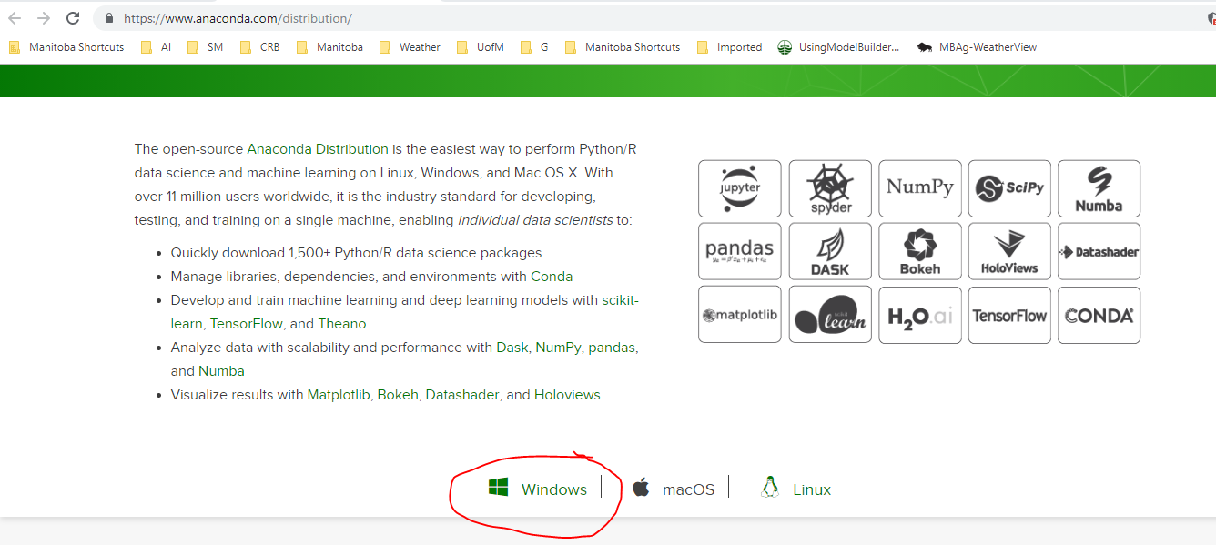

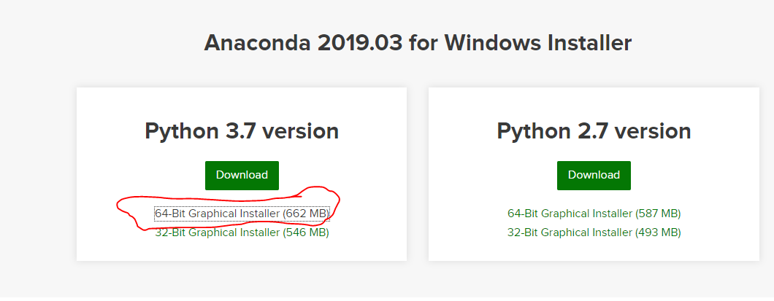

Go through the download process and install in default folder. Do not add to path variable. The installation could take up to 30 minutes.

Download pycharm free editor software. In the installation options, check the “Create Desktop Shortcut”, “Update context menu” and Create Associations. Leave other options as defaults.

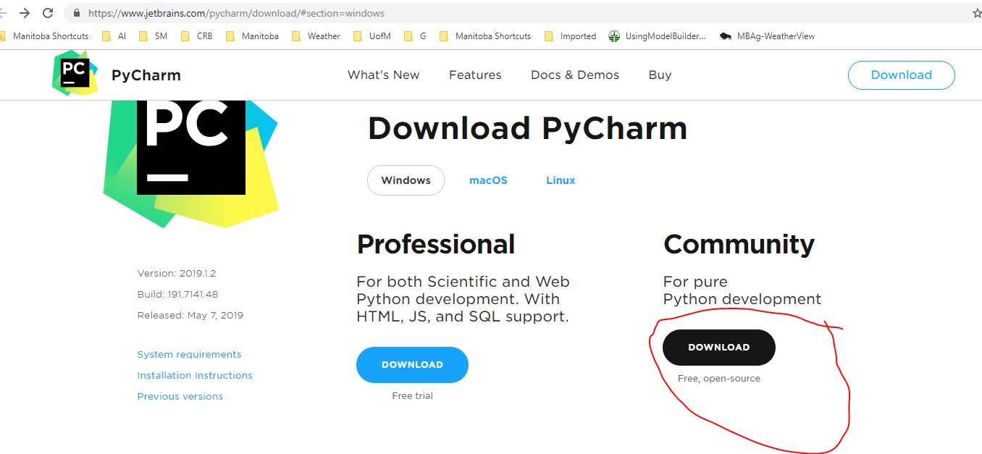

To download packages and work in another virtual environment e.g. 2.7 environment, open the anaconda prompt (go to search and type in anaconda prompt). When the command prompt opens, copy and *paste conda create -n py27 python=2.7 anaconda* (assuming you are interested in the 2.7 version. Replace the 27 and 2.7 with the version of interest).

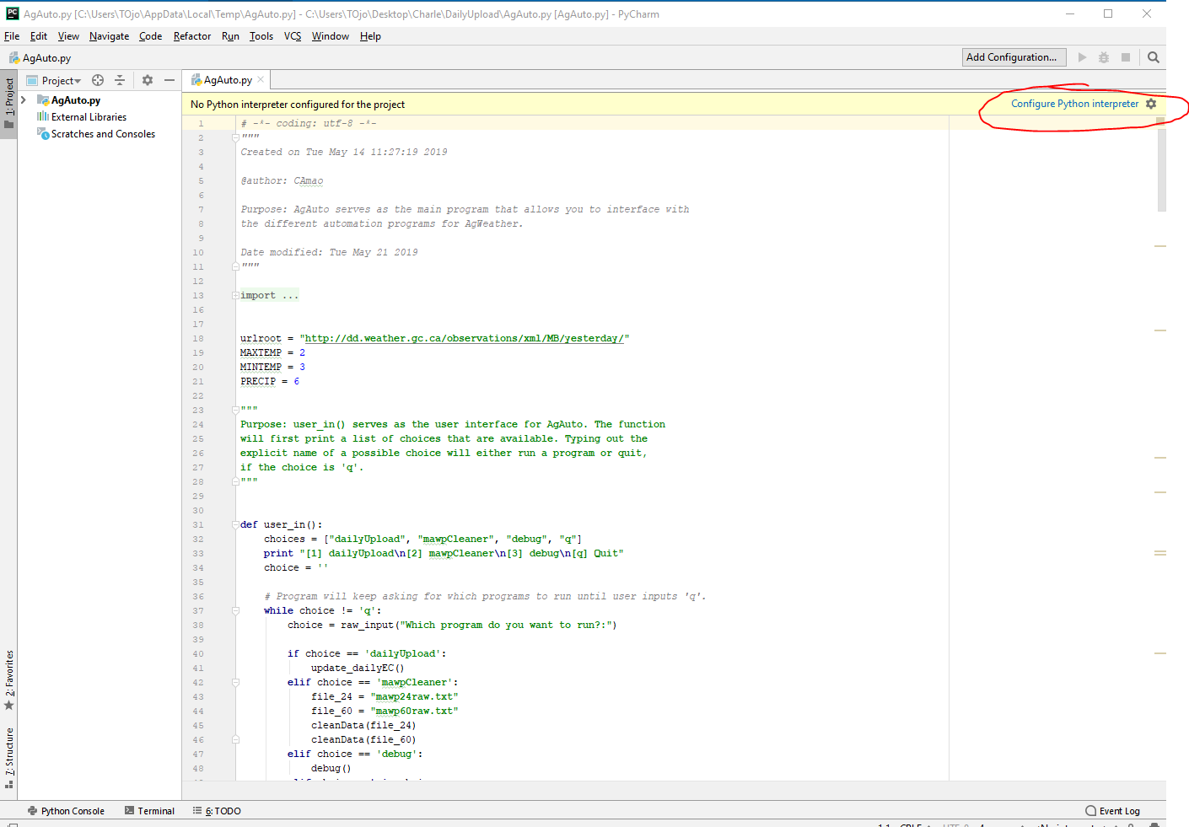

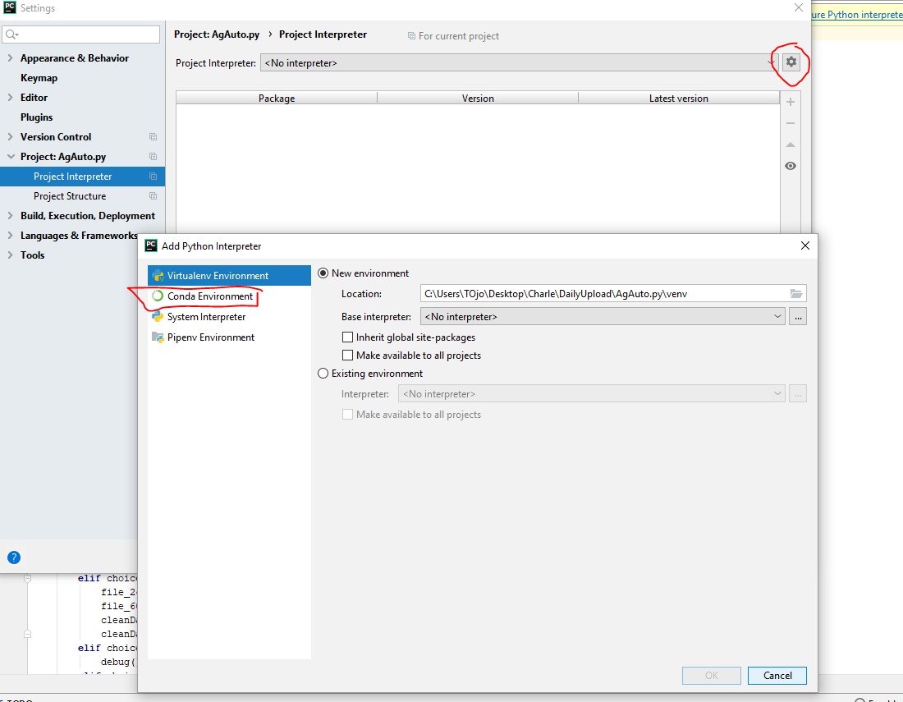

In the settings Icon, click Add. On the opened windows, click “Conda Environment” on the left hand panel.

