**Development of a Sub-system for an existing HRIS: Digitalized Personnel Assessment Tool**

A Capstone Presented to

The Faculty of Computer Studies Program

Father Saturnino Urios University

Butuan City, Philippines

In Partial Fulfillment

Of the Requirements for the Degree

BACHELOR OF SCIENCE IN INFORMATION TECHNOLOGY

By:

Alfaras, Ralph Vincent

Cubillan, Oscar Jan Levi Madrio

Palma-gil, Rodam Joshua

August 2021

Contents

Chapter 1 5

1.1 Introduction 5

1.2 Background of the Study 6

1.3 Statement of the Problem 7

1.4 Objectives of the Study 8

1.4.1 General Objectives 8

1.4.2 Specific Objectives 8

1.5 Scope and Limitation 9

1.5.1 Scope 9

1.5.2 Limitation 9

1.6 Significance of the Study 10

1.7 Review of Related Literature 10

1.7.1 Information Systems 10

1.7.2 Human Resource Information Systems 11

1.7.3 Decision Support Systems 13

1.7.4 Myers-Briggs Type Indicator 13

1.7.5 System Usability Scale 14

1.8 Theoretical Framework 14

1.9 Definition of terms 16

Chapter 2 17

2.1 Methodology 17

2.1.1 Agile Methodology with Scrum Adopted for Project 18

2.1.2 Requirements Analysis 19

2.1.3 Sprint Cycle 22

2.1.4 Final Deployment 23

2.2 Design of Software and System 23

2.2.1 Proposed System Design 23

2.2.2 Conceptual Framework 26

2.2.3 Use Case 27

2.3 Development and Testing 28

2.3.1 Proposal Phase 28

2.3.2 Development Phase 29

2.3.3 Testing Phase 29

2.3.4 Deployment Phase 29

Chapter 3 30

3.1 Results and Discussion 30

3.1.1 Results 30

3.1.2 Discussion 30

Chapter 4 31

4.1 Summary 31

4.2 Conclusions 32

4.3 Recommendations 32

Appendix A 34

Bibliography 36

# Chapter 1

## 1.1 Introduction

A Human Resource Information System (HRIS) is a type of software that is used in the management of an organization’s Human Resource Management. (Jahan, 2014) Earlier versions of HRI Systems were simply databases of employee information, but with more powerful hardware and the realization that the amount of data collected by these systems could be used for more, they have been integrated with other functionality such as a decision support system to name one.(Obeidat, 2012) This document contains the related information for the development and deployment of an HRIS system with an integrated IQ and Personality Exam contained within a web-service and app.

The current system of MotorTrade Butuan relies on manual methods of job applicant procurement. Their main HRIS is actually located at Davao City and no local system exists, therefore all job applicant transactions must go through the process of physically going to Davao City just to complete their job application.

We proposed to remove the need of going to Davao City just to take a few examinations and input their data into the HRIS implemented at that main branch. In its stead we will insert a sub-system that will act as a middle-man, handling transactions that would be needed by going physically to Davao City and instead just export data in bulk digitally.

## 1.2 Background of the Study

The study will mainly focus on the small enterprise businesses and as such will address issues within the given field and scope. One of our prospective deployment sites will be MotorTrade Butuan, located at Purok 3 Brgy. 16 Ong Yiu, North Montilla Boulevard, Butuan City.

Traditionally the act of procuring human resources was mainly done manually through one on one interviews with an HR representative and a potential employee, this was the traditional norm at that time. Due to increasing demand and bigger companies as we go forward into the future some improvements were needed to keep up with the influx of the demand of man power, that being the HRIS or Human Resource Information System.(Al-Dmour et al., 2017)

An HRIS’ main purpose was to facilitate and attempt to automate the procurement process of human resources, but eventually showed more potential with the development of more powerful computer hardware. As more and more data got stored and sorted through an HRIS the data could be further utilized outside of the initial employment phase of an employee, the data collected could be used in ways such as evaluation of an employee.(Jahan & Jahan, 2014)

## 1.3 Statement of the Problem

The proponents conducted a preliminary interview with the manager of MotorTrade Butuan and found the following issues within their current process of acquiring new personnel. Despite the growth of the economy and the advancements in technology most if not all of the companies residing within Butuan City still use a manual method of hiring personnel via sending of CVs or individual interviews including MotorTrade Butuan. The proponents listed the following underlying inefficiencies with their current manual method:

1. Prospect of personnel are manually sorted and filtered by an HR personnel and is then compiled into a CSV to be sent to their Davao City main branch where it will be further processed and added to their Human Resource Information System.
2. New applicants need to be sent to Davao City after the initial interview here in Butuan. Upon arrival in Davao City the applicants again face another interview and a proficiency exam. All of the monetary costs related to this process is shouldered by the applicant. The time needed to get results is not instant, there is a considerable gap of 7 working days at minimum before feedback if their CV even passed the initial filtering and sorting of the job applications.
3. Does not provide any updated information such as status updates for the job applicants.

## 1.4 Objectives of the Study

### 1.4.1 General Objectives

Develop a sub-system that is capable of replacing the current manual method of acquiring prospect of personnel by MotorTrade Butuan and improve the overall flow of job application to employment of applicants.

### 1.4.2 Specific Objectives

1. Provide a Decision Support System that will aid in speeding up the job hiring process through the use of automated filtering and sorting of job applications to reduce the required time for HR management intervention in the hiring process and provide the functionality to export the collected data in a CSV format that will be compatible with the main HRI System at Davao City.
2. Reduce the turn-around time of job applications giving instantaneous feedback upon submission of job applications to further reduce the time wasted waiting.
3. Create a data analytics system that will show relevant information such as:
   1. Display the available positions for job applicants.
   2. Accepted applicants by the DSS.
   3. Declined applicants by the DSS.
   4. Number of applicants.

## 1.5 Scope and Limitation

### 1.5.1 Scope

* This project proposal will only cover the job employment aspects of the HR management system and such is defined to be a sub-system meant to export data in the format that is used by the main HRI System at Davao City.

### 1.5.2 Limitation

* This system will not perform as a social media hub for employers and job applicants. Data access will only be limited to MotorTrade Butuan’s HR management and its applicants.
* This system will only handle aspects of the job employment process:
  + Handling of job applications such as the CVs.
  + Notification and feedback medium for accepted or rejected applicants.
  + Handle the evaluation forms that will be filled up by the HR personnel in-charge of the probational employees that have been accepted.
  + Export a file in CSV format that will be used to replace the manual inputting of data that will be sent to the main branch at Davao City.

## 1.6 Significance of the Study

**Job Applicant –** Will provide a more seamless transaction between the HR department and the Job Applicant. Will significantly reduce the transaction time between them due to having faster feedback.

**HR Department –** Provides a faster way of sorting through job applicants and significantly decrease the needed time in finding qualified personnel out of the job applicants through the help of the DSS.

**MotorTrade Butuan –** Reduced operational costs thanks to the reduction in the man power and time needed to be allocated for hiring new people.

## 1.7 Review of Related Literature

### 1.7.1 Information Systems

By definition an information system refers to any computer-based tool that people use to work with data and support an organization’s information and data processing needs. As IT wrapping its far-reaching effects on individuals and organizations the need for having support for an information system integrated into your business or organization has started to become more important. Information systems these days not only serving as a backbone but also giving a competitive edge for most modern companies taking advantage of the speed and efficiency of data processing provided by information systems that no manual method can compare to. (R. Kelly Rainer et al., n.d.)

### 1.7.2 Human Resource Information Systems

A Human Resource Information System (HRIS) can be defined as an integrated system to gather, store, and analyze information regarding an organization’s human resources. An HRIS is a type of system with the objective of sorting data of employees to aid in planning, decision making, and submitting reports to external agencies. (Jahan & Jahan, 2014) As HRI Systems slowly became more and more smarter they became useful in other aspects of a company outside of HR such as aiding in strategic decision making which later became known as decision support systems (DSS). Modern HRIS have expanded its focus from simply a support system for Human Resource Management to an integrated system of services which include advanced features such as a Decision Support System (DSS) as being part of its most basic functions within an organization. (Nagendra & Deshpande, 2014) The increasing importance of HRIS slowly became part of any corporate strategy. (Pyburn, 1983) These Information System strategies can be regarded as random, inspirational or unarticulated thoughts, some of them can even be the result of careful analysis and detailed planning. But as a strategy, an organization must align with not only the HR strategies but also other strategies. (Tansley et al., 2001) Automation of transactions and processing also started becoming more integrated with HRIS later becoming known as Transaction Processing Systems (TPS). With these extra features becoming more apparent on the advantages they provided, they were packaged into one system, that being the HRIS. Human Resource Strategy, HR techniques helps the organization to accomplish key objectives in the long run. The Success of an organization is hugely dependent on the performance on their HR. (Obeidat, 2012) Systems can be manual or computerized in their processes to carry out tasks within an organization. Human Resource information Systems aid in making those tasks more efficient and effective in the computerized HR Systems space. HR strategy plans should be executed in a way such that not only the corporate business plans are taken into account but must also coincide with the organization’s Information System’s strategic plans.

### 1.7.3 Decision Support Systems

A decision support system is an indispensable instrument for achieving competitive advantage. With the current advances in technology results have shown that without human intervention, that a DSS correctly and precisely summarized information into a format easily digestible by an HR personnel. (Nagendra & Deshpande, 2014)

### 1.7.4 Myers-Briggs Type Indicator

Myers-Briggs indicators provide interesting and instructive patterns that shed light on observations of individual differences in the way in which information is collected and decisions are made. With its well-known structural validity, the test has become a practical assessment tool. The purpose of this test is to describe preferences for thinking and feeling, decision and evaluation, and to help those who engage in personal counseling and those who work with groups. It has undergone extensive research and successfully met most of the challenges in its foundation, testing, procedures, and test results. (Murray, 1990) When personality conflicts, the efficiency of the team's operations will be reduced. Personality differences can affect face-to-face collaboration and reduce trust in virtual teams. For relatively short tasks, such as online crowdsourcing, personality matching can provide a simple and scalable strategy for effective team building. However, in this new environment where the workforce is more transient and diverse, it is unclear how personality differences affect teamwork. This study examines how personality compatibility in crowd groups affects individual performance and perception. (Lykourentzou et al., 2016) Finding a correlation between personality and intelligence has always been an area of interest for educators and employers. Many universities and companies have tried find a relationship between these two traits to find the most capable students or employees from thousands of applicants. (Ae et al., 2007)

### 1.7.5 System Usability Scale

The System Usability Scale (SUS) is the most widely used standardized questionnaire to assess perceived ease of use.(Lewis, 2018) The SUS developed by Brooke in 1996 reflected the strong need in the usability community for a tool that can quickly and easily capture a user's subjective rating on the usability of a product.(Bangor et al., 2008)

## 1.8 Theoretical Framework

In this project the developers opted in using the Agile methodology with Scrum. In the last few years, Agile methodologies appeared as a reaction to traditional ways of developing software and acknowledge the need for an alternative to documentation driven, heavyweight software development processes.(Ilieva et al., n.d., 2004) Reason being that in an Agile development rapid iterations of prototypes can be quickly churned out for client evaluation allowing the client and developer to be in the same picture when discussing features and additions to the product. (Qureshi, 2012) Scrum on the other hand allowed us to have a flexible working process. This was taken into account due to the various requirements required to be met by the client as well as having features and additions as the development went on. (Srivastava et al., n.d., 2017)

This methodology allowed for an open-ended type of development process befitting the needs of the project having variable requirements and additions that are needed to be met throughout the development and design phase. Having this incremental approach to development and constant feedback from the client, the development process would easily be able to adapt to the changes. (Sommerville, 2016)

The usage of the Scrum framework involves different processes that can be divided into four specific tasks that are contained in what are called as events. These include (1) The Sprint Planning, (2) Scrum or Sprint, (3) Sprint Review, and (4) Sprint Retrospective. (Schwaber & Sutherland, 2020)

## 1.9 Definition of terms

* **Bridging System -** Bridging describes systems that map the runtime behavior of different programming languages so they can share common resources. Translating data and state across the two sides of the different systems.
* **CSV Format -** A comma-separated values file is a delimited text file that uses a comma to separate values.
* **Decision Support System -** A computerized program used to support determinations, judgments, and courses of action in an organization or a business.
* **ICT-based -** Refers to any method of delivering data via information and communication technologies.
* **Information System -** An integrated set of components for collecting, storing, and processing data and for providing information, knowledge, and digital products.
* **MotorTrade Butuan –** The company chosen for the project proposal.
* **Myers-Briggs Type Indicator -** The Myers–Briggs Type Indicator is an introspective self-report questionnaire indicating differing psychological preferences in how people perceive the world and make decisions.
* **Crowdsourcing -** the practice of obtaining information or input into a task or project by enlisting the services of a large number of people, either paid or unpaid, typically via the internet.
* **Online-based -** used to describe activities that are done using the internet.
* **Open-ended –** Having no limit or boundary.
* **Parsing –** To package a collection of segmented data into a chuck that is easier to transport or export.
* **Scalable -** is an attribute of a tool or a system to increase its capacity and functionalities based on its users' demand.
* **Sub-system -** a self-contained system within a larger system.

# Chapter 2

## 2.1 Methodology

Before the project could begin, a suitable business was first researched that required IT solutions based on the approval of the instructor and panel members for the Capstone Research Project.

MotorTrade Butuan was selected as the prime candidate for a proposed system, requiring a bridging system for their Human Resource Information System. This bridging system would be focused on the human resource procurement and parsing of the data gathered for the Butuan branch that is to be sent to the main branch in Davao City.

### 2.1.1 Agile Methodology with Scrum Adopted for Project

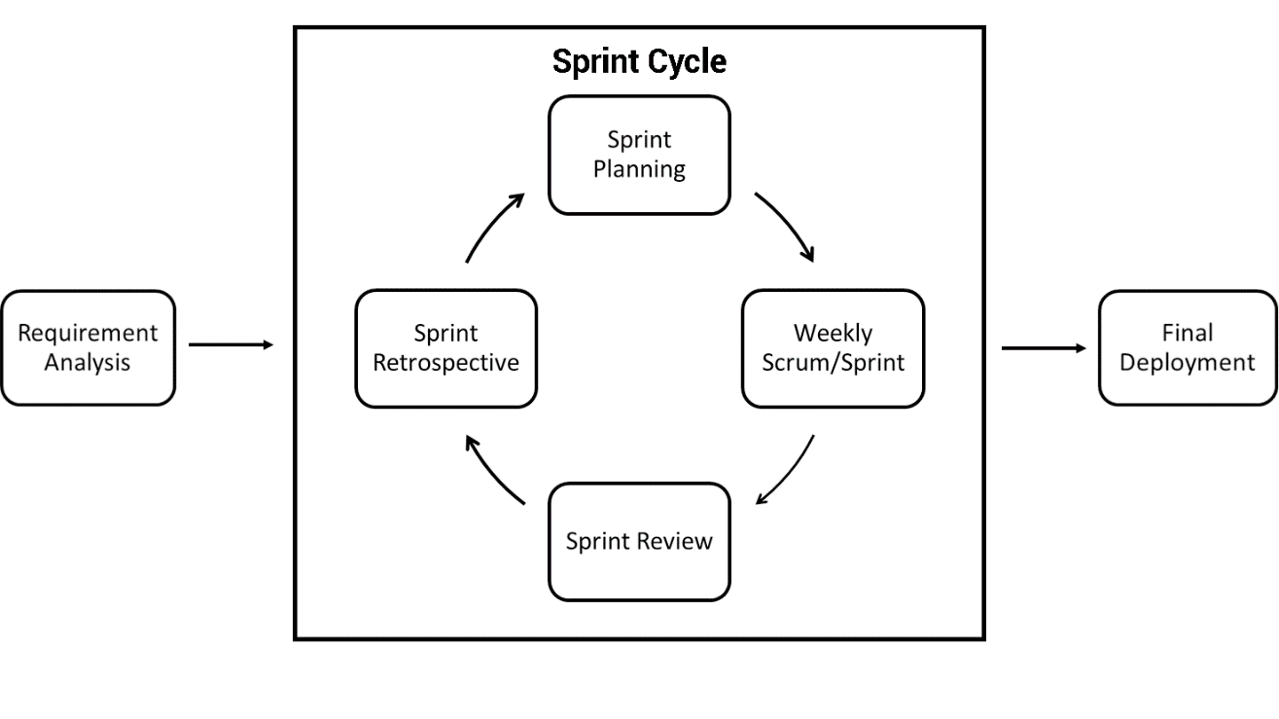

###### Figure 2.1: Adopted Agile Methodology with Scrum

The methodology was adopted to coincide with our development process and time constraints to finish the project proposal. The entire duration of the development is roughly seven months from the start of development at May till the final defense and thereafter deployment after December.

### 2.1.2 Requirements Analysis

A meeting was set up with the current manager of MotorTrade Butuan to facilitate the data gathering process for the proposed bridging system.

#### Existing System

###### Figure 2.2: Job Employment Procedure of MotorTrade Butuan

The current manual system implemented by the local business for procurement of personnel was by doing a manual method of accepting job applications and review of each application that is then parsed into a CSV format and is then sent to Davao for review. Any job application that passes through the review will then be sent to Davao to partake in an exam before they can even begin training here in Butuan and be accepted as probational employees. This manual process has proven to be slow and costly for both the company with the amount of human resources that must be dedicated to it and to the applicant who will shoulder the cost of the entire examination phase of the employment process. Feedback is also expected to be slow due to the communication lag between the Davao Branch and the Butuan Branch.

#### Proposed System

One of the main problems we have solved is the communication lag, by removing the need to have back and forth communication just to send some applicant data, it will instead be packaged in one go with all the necessary data that will be ingested by their HRIS at Davao City. The main issue is that there is allot of back-pedaling between the Butuan Branch and the Davao Branch, data-based transactions go back and forth updating applicant data such as personal information, scheduling, and examinations in an incremental manner.

The huge amount of man power needed to sort through the applicants which can be in the hundreds for a handful of job openings was a big issue. This has been resolved through the usage of the decision support system, thinning out the applicants so that only those who pass the application submission and meet the absolute minimum requirements. The few who do pass the bare minimum requirements are then the only applicants that the HR management will interact with through interviews and guiding them through the examination phase. This reduces the total amount of human interaction between the HR management and the applicants allowing them to reduce the man power required to man the HR management team.

We proposed to entirely cut out the need to take the examinations physically at Davao City. An examination can be taken locally through an online platform significantly reducing the burden of cost for the applicant.

#### Requirement Specification

##### Hardware Requirements

* An Intel Pentium 4 processor or later that's SSE3 capable
* Minimum 2GB of RAM
* Minimum of 300MB of available storage

##### Software Requirements

* Windows 7, Windows 8, Windows 8.1, Windows 10 or later
* Chrome or any chromium-based browser (Edge, Opera).

##### Network Requirements

* At least a 2Mbp/s internet broadband connection.

### 2.1.3 Sprint Cycle

Sprint planning starts the Sprint by defining the work to be done for the Sprint. This resulting plan is created through the joint work of the entire Scrum team. We set up the duration of the sprints to be between 20-30 days to coincide with our agreed schedule with the business management.

The proponents would hold weekly scrums/sprint however to review the progress and issues encountered during the development of each sprint and to align ourselves with the proposed final deployment schedule.

At the end of each sprint session a sprint review of the prototype is then presented to the management and gather their thoughts, suggestions, and possible feature additions to the current build.

A Sprint Retrospective is then conducted with the assigned adviser to solicit his/her thoughts on the current build, taking into account any tips or suggestions he/she may have for further improving the system.

At the end of the development process during the final stages of deployment and after the defense, the proponents then conducted a System Usability Scale test to assess the level of acceptance and usability of the produced system.

### 2.1.4 Final Deployment

The system is then deployed after the final Sprint Cycle where in the turn-over of documentation and the implementation of the system is conducted on MotorTrade Butuan’s preferred server choice.

## 2.2 Design of Software and System

### 2.2.1 Proposed System Design

It was deduced that the best course of action would be to implement a web-based service that could parse data gathered in a readable way by the Human Resource Information System used at the main branch in Davao City. We opted to suggest a feature of an online-based procurement method that would greatly streamline the process of human resource procurement, allowing them to use a decision support system to validate job applicants instead of needing to send them to Davao for testing. In this method the job application process would be fully done locally instead of needing the applicant to travel just to take an examination. The examination will be crafted by their own Human Resource Management in line with whatever requirements they may need for job applicants, thus a questionnaire module is also to be developed for this process.

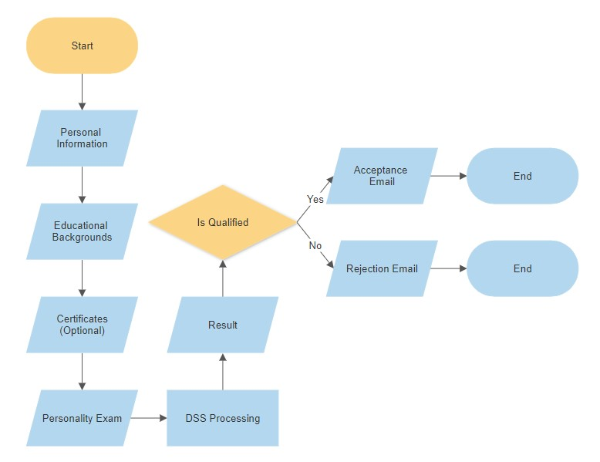

###### Figure 2.3: Proposed Job Application Procedure Flow Chart

The proposed new design completely negates the need for the physical appearance at Davao for a job application. A job applicant simply needs to fill up the required fields and is then given instant feedback of whether he/she should find other job opportunities or continue by replying the acceptance email with a preferred scheduled of interview. The interview can either be face to face or through online methods depending on the preferred method of the company at that time due to the currently on-going pandemic. It is up to the communication between the applicant and the HR personnel how they will do this interview.

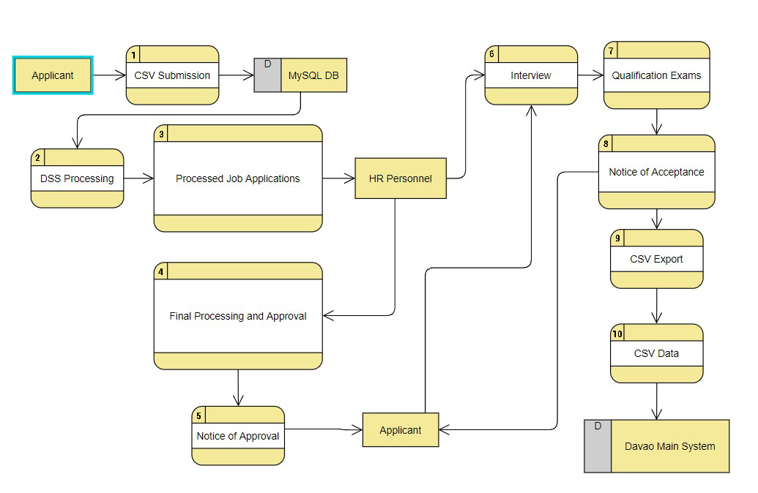

###### Figure 2.4: Data Flow Diagram

Upon the submission of the applicant’s details contained in the ‘CSV Submission’, the data is saved to the database where it will be processed by the DSS and filtered. Those who pass the initial job application process will be forwarded to an HR personnel’s inbox where they will be further evaluated and be given instructions on how to proceed with regards to their interview.

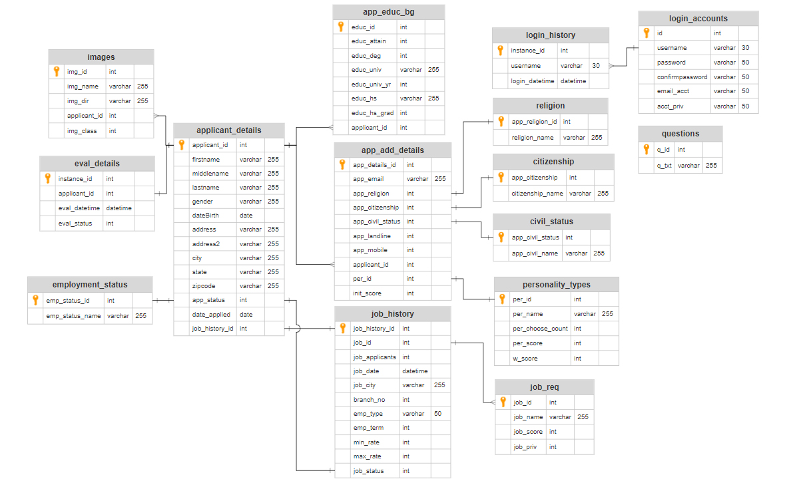

###### Figure 2.5: Entity Relationship Diagram

The entire Database system is based on several relationships between tables that correspond to storing Job Applicant Data. All applicants submit data such as pictures for their profile pictures and the optional certificates are stored on the images table where it is connected to the applicant_details with its applicant_id. Other data such as their additional details(app_add_details) and educational background(app_educ_bg) is also related in a similar manner in which they use the applicant_id as a foreign key to reference their relationship to the applicant_details table.

### 2.2.2 Conceptual Framework

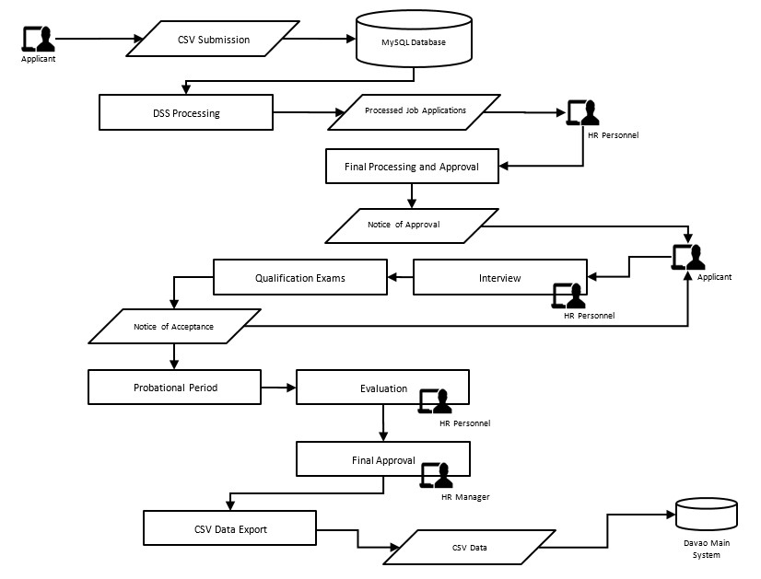

###### Figure 2.6: Conceptual Framework

The proposed Concept of the system to be implemented aimed to reduce the turn-around time of feedback between the company and the applicants. This automation process within the filtering and initial selection with the help of the DSS enables some automation in-between processes which allows the HR management to free up resources for other tasks. Menial tasks such as reviewing CVs for qualified personnel and checking exam results. This process also removes the need for applicants to go to Davao City’s main branch to initiate the examination phase of their job application process, instead it can be done online or within MotorTrade Butuan’s office where they can still be monitored while taking the same exam as if it were in Davao City’s main branch.

### 2.2.3 Use Case

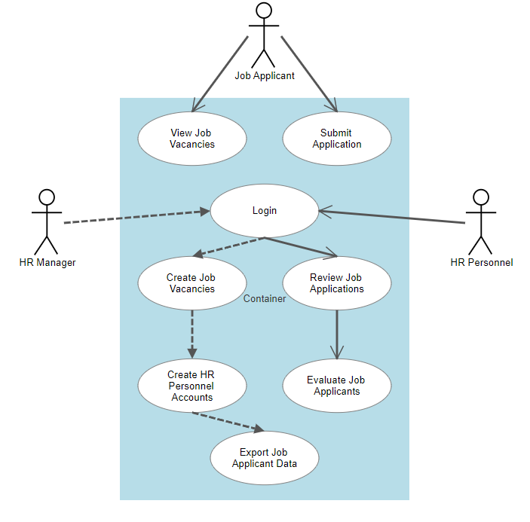

###### Figure 2.6: Use Case

Figure 2.6 shows the interaction between the sub-system and the HR management. The web portal will allow job applicants to view job vacancies and allow them to submit job applications. The HR management will have the ability to login into the web system allowing them access to the applicant management functions of the system such as reviewing applicants.

## 2.3 Development and Testing

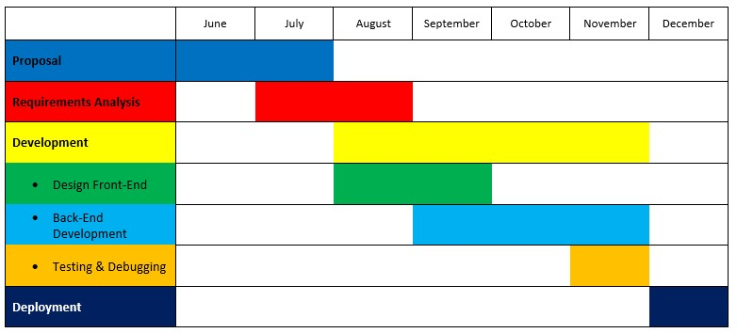

###### Figure 2.7: Gantt Chart

### 2.3.1 Proposal Phase

After the project was given the green light by the panel and faculty, the proponents proceeded to contact the establishment to perform reconnaissance and to formally begin the project proposal. During this time, initial requirements were set for the system as well as some feature suggestions by the proponents. A monthly meeting period was set up for the feedback and review of the sprint events with the clients. A monthly review was decided to lessen the potential risks of the currently ongoing pandemic and if possible, meetings would be held remotely to lessen the impact of having the manager be occupied with our inquiries during the working days.

### 2.3.2 Development Phase

The sprint cycle is then initiated for the development phase, using the aforementioned Agile with Sprint Methodlogy. Setting up meetings, scrums, reviews, and some prototype testing.

### 2.3.3 Testing Phase

We used the System Usability Scale due to its robust versatility.(Bangor et al., 2008) It can be easily modified to fit almost any need and proved to be the simplest and fastest way to evaluate the system’s performance judged by actual people who will be using the System. It has also been widely used and standardized for assessment of perceived usability.(Lewis, 2018)

### 2.3.4 Deployment Phase

1. The developed system will be deployed and given to the business in a test run scenario. If the business wants to adopt the system, then it will be migrated to their desired hosting servers along with the documentation containing the system’s inner workings.
2. A system admin will be assigned for a period of one week before defense of the system to assure that the system is working as it should be without errors in a real-world scenario.
3. A letter of agreement or memorandum of agreement will then be signed noting that the system’s update and maintenance will no longer be the responsibility of the proponents after the week testing period.

# Chapter 3

## 3.1 Results and Discussion

### 3.1.1 Results

The system performed well with regards to the requirements it needed to fulfill for the project. Those being to reduce the total net time for an applicant to get a job position if they were accepted and the total costs related to the job employment process. The need for traveling now has been removed from the job application process outside of a few cases where special training is required that can only be done at Davao City’s MotorTrade branch. A majority of job openings however can be trained locally through an evaluation phase of an applicant or through the probational employment program.

#### Designs

###### Figure 3.1: Landing Page

In the landing page some data regarding the job openings posted is visible as well as the total applicants that have sent in applications.

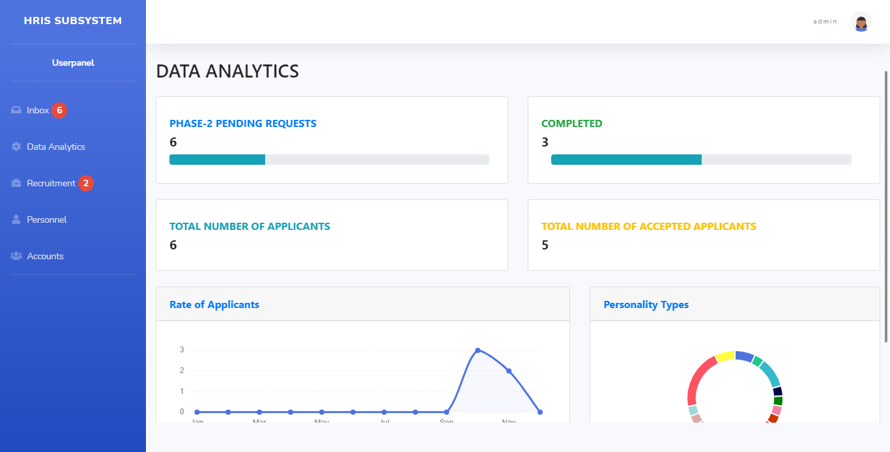

###### Figure 3.2: Dashboard

From the Dashboard, several statistical data can be viewed. Such as the total number of pending requests, completed, total number of applicants, accepted applicants, and the results of the personality tests taken.

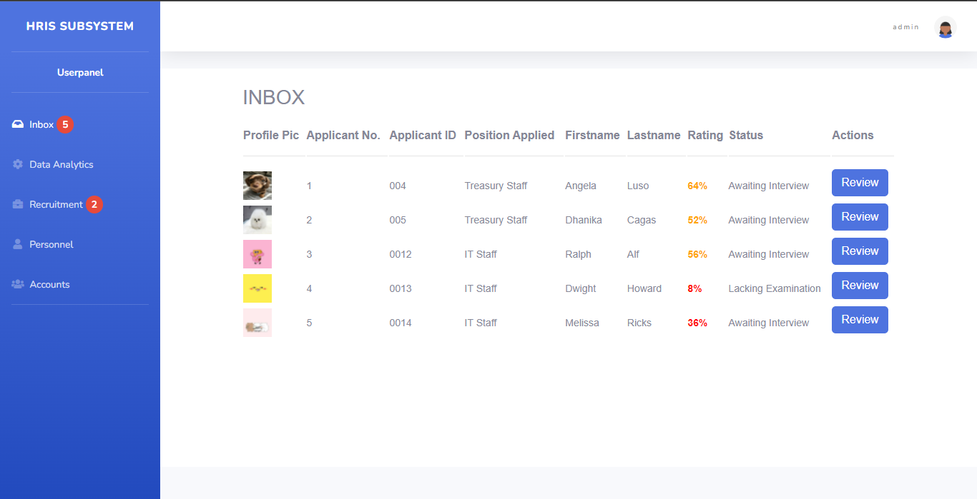

###### Figure 3.3: Inbox (Applicant’s Job Applications)

From the inbox the pending applicants can be viewed and reviewed by HR personnel.

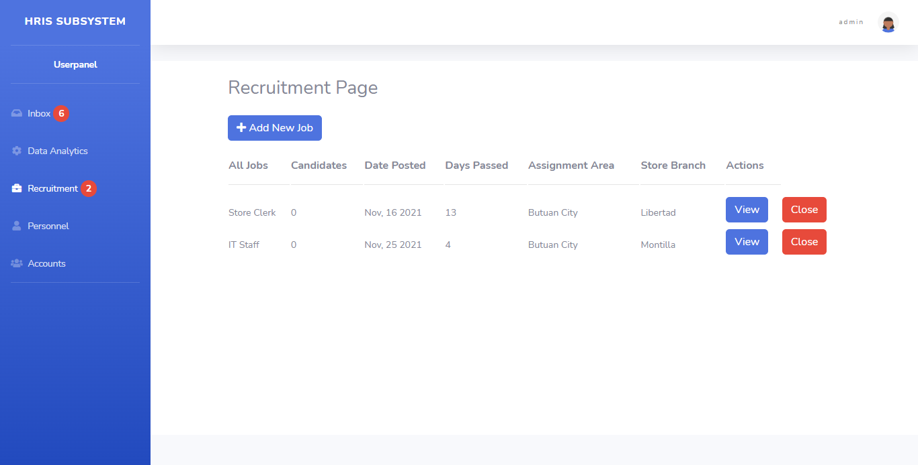

###### Figure 3.4: Recruitment Page

Job openings created through the recruitment page accessed by an account that has the privileges of an HR manager.

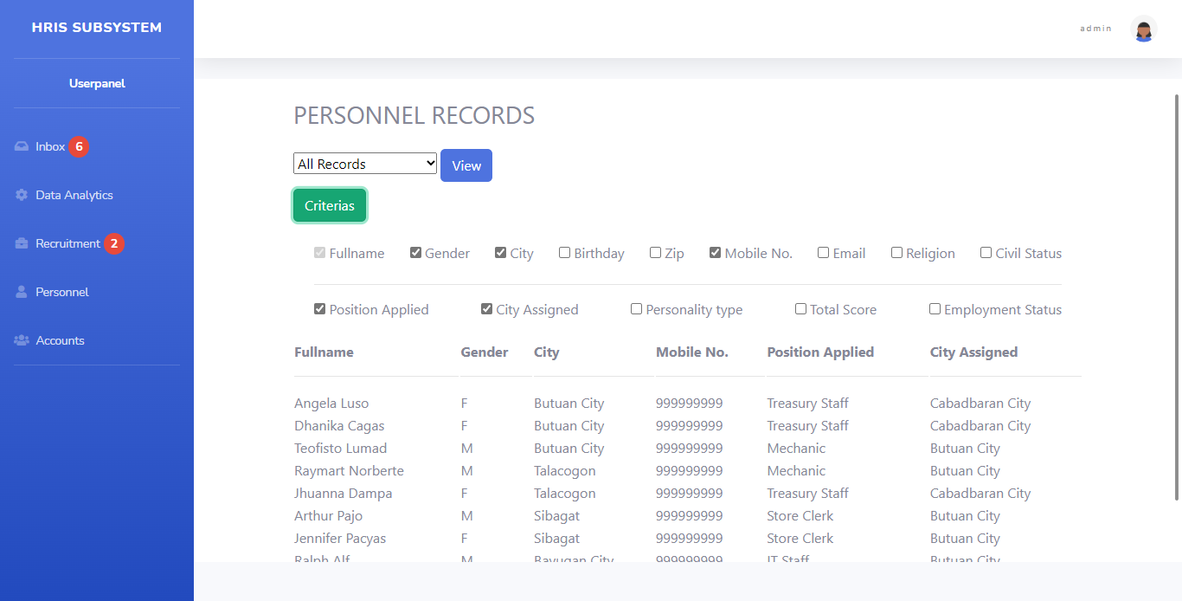

###### Figure 3.5: Personnel Records

A database of personnel records is kept and archived that is viewable through the personnel records page.

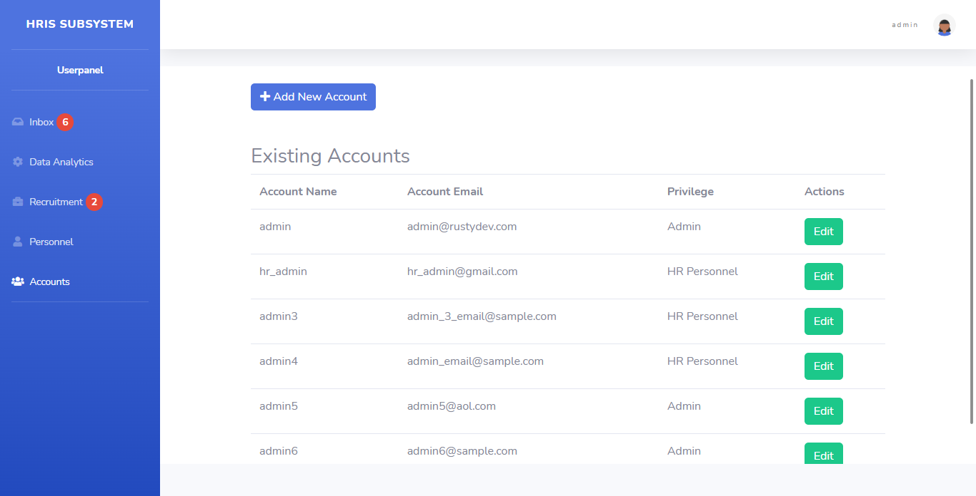

###### Figure 3.6: Account’s Management Page

Management of accounts are handled by accounts with privileges higher than HR Manager. Within this page an admin or manager can remove or add new personnel as needed.

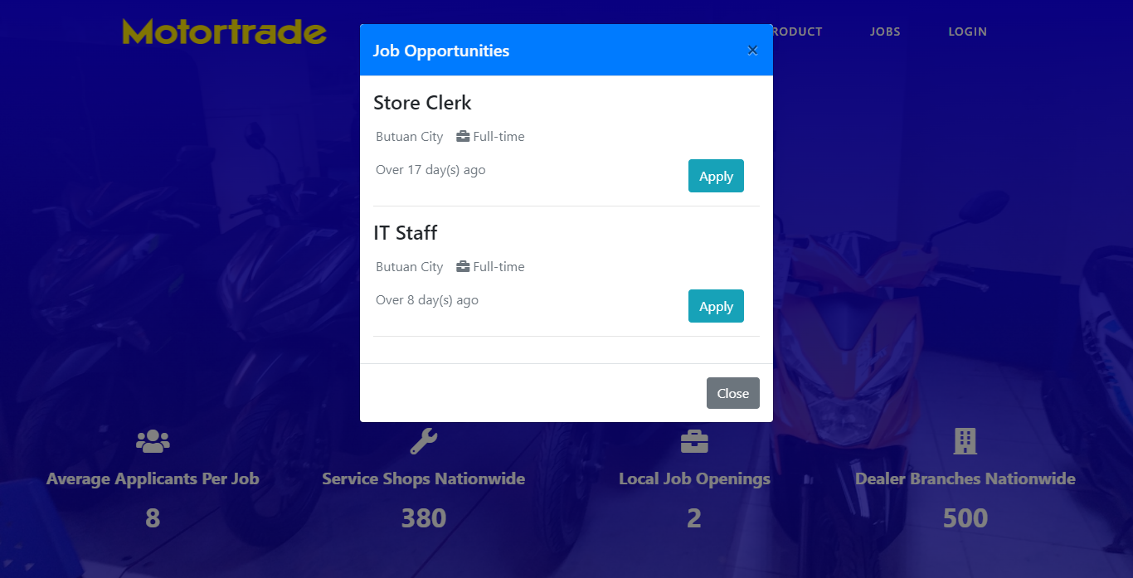

###### Figure 3.7: Job Application (start)

On the lading page upon clicking apply, a window pop’s up to show the available jobs posted.

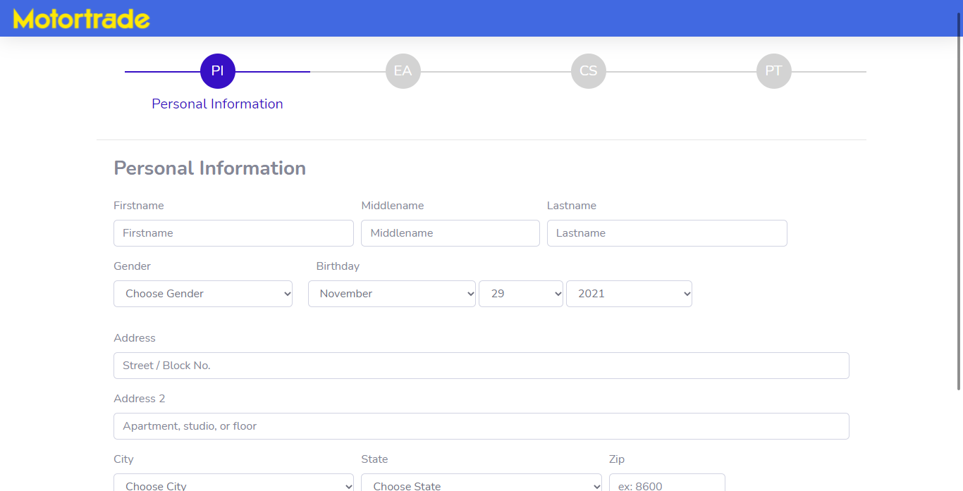

###### Figure 3.8: Job Application (Personal Information)

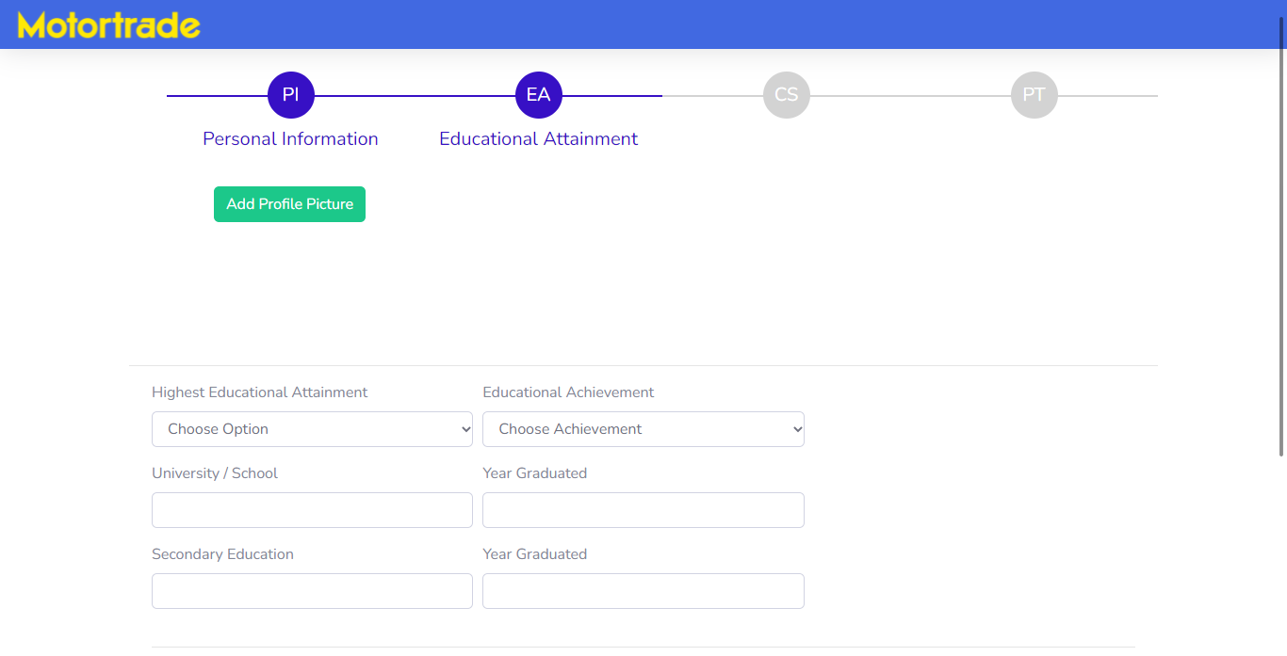

###### Figure 3.9: Job Application (Educational Attainments)

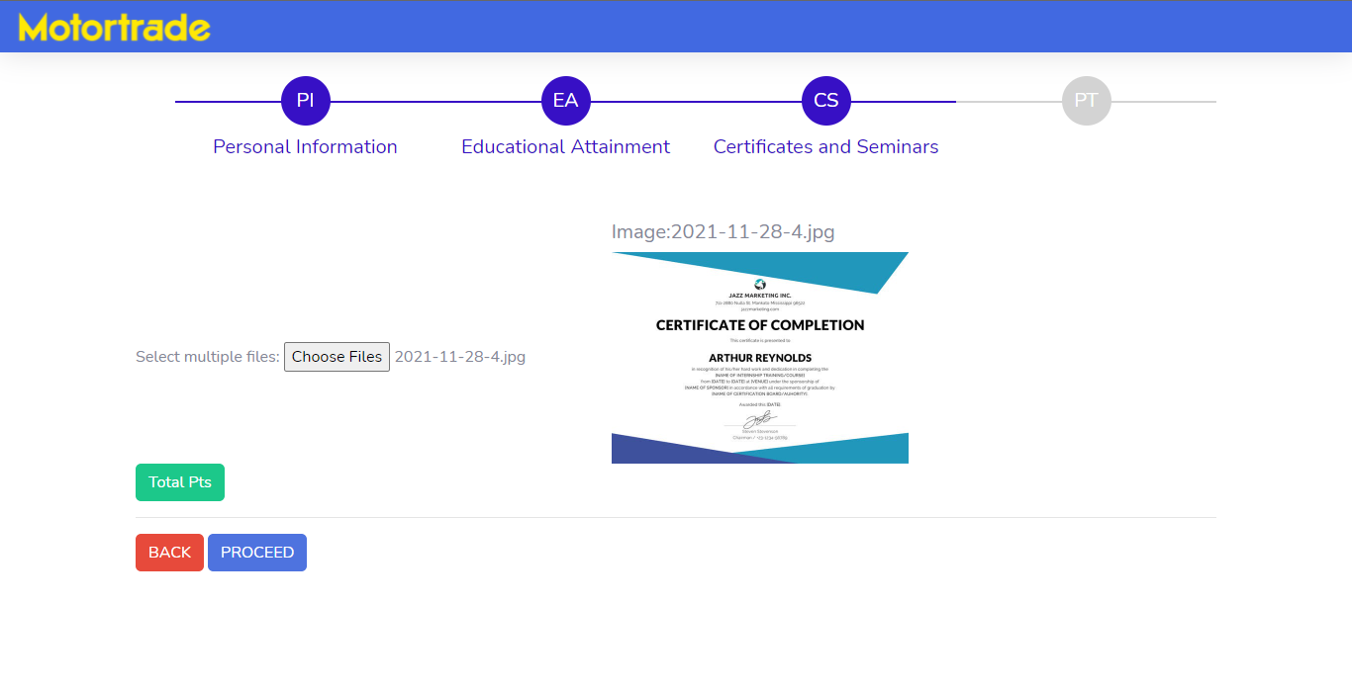

###### Figure 3.10: Job Application (Certificates)

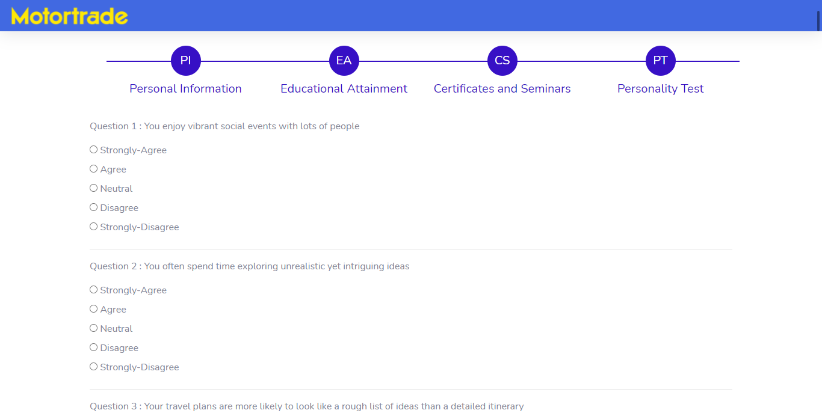

###### Figure 3.11: Job Application (Personality Test)

### 3.1.2 Discussion

Certain limitations were made clear with how the system was developed such as unable to directly interface with the main HRI System in the Davao Branch and instead opting to do import/export-type scenarios through CSVs to handle the data transfers. This limitation was mostly due to MotorTrade as a company not having a way to directly interact with the HRI system such as through APIs. All transactions still need to be done through a CSV import to the main database.

It was also noted that a good number of applicants do not actually have much certificates to show, such as those jobs that does not require any certifications or those that are usually for the fresh graduates.

# Chapter 4

## 4.1 Summary

The proposed system’s objective to reduce the overall man-power and time required to process job applicants of MotorTrade Butuan was met through the initial proposal of an HRIS system that would handle the entire human resource procurement procedure. This however was over-turned upon finding that an HRIS did exist for the company but was only used on the main branch at Davao City. This process of only having a centralized system made it difficult for new hires from local branches such as Butuan City’s MotorTrade to effectively and cost efficiently hire new personnel. A sub-system was proposed in its stead to handle only the procurement process of human resources in such a way that is compatible with the current HRIS at Davao City’s main branch.

## 4.2 Conclusions

The entire development process was met with allot of friction and struggles. These were partly through the stubbornness of older companies to adapt more modern methods to help in their company and failing to realize the growth they’ve had in comparison to the past. Having them adapt to this new system was not an easy task but was done through convincing the managers of the benefits of using this sub-system. Though it only partly fixes the issue of only having the main branch use the HRIS, it has at least helped in the entire procurement process just by making this one part substantially faster and more efficient.

A consideration was also made to accommodate such as those jobs that does not require any certifications, those that are usually for the fresh graduates or those who do not have any certificates to show as this gave clear bias towards people who did have certificates in terms of how the points would be distributed.

## 4.3 Recommendations

The proponents recommend that MotorTrade as a company should explore more technological ways that can help their company grow or adapt to its growing needs. Currently this Sub-system has only elevated a small portion of their overall system but with difficulty. We propose in the future, to have them deploy or develop a new HRIS that will incorporate the many local branches all over Mindanao instead of just using the main branch at Davao as a hub where all local branches must report to. This should effectively make their company more resilient.

We would also recommend that they shift their focus on the personality that is taken from the personality tests aspect of the personnel as currently this is their primary way of determining possible prospect of personnel. Adding maybe a basic IQ test or intelligence test would further increase their chances of getting reliable personnel for job openings within the company.

# Appendix A

Decision Support System

The process by which the selection of applicants is done is through a point system managed by a DSS. It consists of taking the applicants details processing it for points conversion.

The following is the criteria for which points are distributed for applicants:

1. For applicants who submit certificates or proof of their certification will be given an initial point of 1 for each upload they do.
2. Once those certificates have been verified by a HR personnel they will be allocated and additional 4 points for each of the uploads totaling 5 points.
3. The points given from the personality exam is reliant on the specific desirable personality types with the highest being 16 and lowest 1. (Ordered by most desirable to least desirable):

|  |  |
| --- | --- |
| **Personality Type** | **Description** |
| ESTP | Entrepreneur |
| ESFP | Entertainer |
| ESFJ | Consul |
| ESTJ | Executive |
| ENFP | Campaigner |
| ENFJ | Protagonist |
| ENTP | Debater |
| ENTJ | Commander |
| ISFP | Adventurer |
| ISTP | Virtuoso |
| ISFJ | Defender |
| ISTJ | Logistician |
| INFP | Mediator |
| INFJ | Advocate |
| INTP | Logician |
| INTJ | Architect |

Adding the total points accumulated by an applicant determines whether they pass or fail the application process. The maximum points that an applicant can obtain is 25 with the minimum passing at 12 points. Anything above the 25 points due to having allot of certificates will still cap it to 25. The main purpose of having the point system is to have the bear minimum as passing.

# Bibliography

Ae, A. F., Dissou, G., Peter, A. E., Ae, S., & Chamorro-Premuzic, T. (2007). *Personality and Intelligence in Business People: A Study of Two Personality and Two Intelligence Measures*. https://doi.org/10.1007/s10869-007-9051-z

Al-Dmour, R. H., Masa’deh, R., & Obeidat, B. Y. (2017). Factors influencing the adoption and implementation of HRIS applications: Are they similar? *International Journal of Business Innovation and Research*, *14*(2), 139–167. https://doi.org/10.1504/IJBIR.2017.086276

Bangor, A., Kortum, P. T., & Miller, J. T. (2008). An empirical evaluation of the system usability scale. *International Journal of Human-Computer Interaction*, *24*(6), 574–594. https://doi.org/10.1080/10447310802205776

Ilieva, S., Ivanov, P., & Stefanova, E. (n.d.). *Analyses of an agile methodology implementation*.

Jahan, S. S., & Jahan, S. S. (2014). Human Resources Information System (HRIS): A Theoretical Perspective. *Journal of Human Resource and Sustainability Studies*, *2*(2), 33–39. https://doi.org/10.4236/JHRSS.2014.22004

Lewis, J. R. (2018). The System Usability Scale: Past, Present, and Future. *International Journal of Human-Computer Interaction*, *34*(7), 577–590. https://doi.org/10.1080/10447318.2018.1455307

Lykourentzou, I., Antoniou, A., Naudet, Y., & Dow, S. P. (2016). Personality matters: Balancing for personality types leads to better outcomes for crowd teams. *Proceedings of the ACM Conference on Computer Supported Cooperative Work, CSCW*, *27*, 260–273. https://doi.org/10.1145/2818048.2819979

Murray, J. B. (1990). Review of research on the Myers-Briggs Type Indicator. *Perceptual and Motor Skills*, *70*(3 II), 1187–1202. https://doi.org/10.2466/pms.70.3.1187-1202

Nagendra, A., & Deshpande, M. (2014). Human Resource Information Systems (HRIS) in HR Planning and Development in Mid to Large Sized Organizations. *Procedia - Social and Behavioral Sciences*, *133*, 61–67. https://doi.org/10.1016/J.SBSPRO.2014.04.169

Obeidat, B. Y. (2012). The Relationship between Human Resource Information System (HRIS) Functions and Human Resource Management (HRM) Functionalities. *Journal of Management Research*, *4*(4). https://doi.org/10.5296/JMR.V4I4.2262

Pyburn, P. J. (1983). Linking the MIS plan with corporate strategy: An exploratory study. *MIS Quarterly: Management Information Systems*, *7*(2), 1–14. https://doi.org/10.2307/248909

Qureshi, M. R. J. (2012). Agile software development methodology for medium and large projects. *IET Software*, *6*(4), 358–363. https://doi.org/10.1049/iet-sen.2011.0110

R. Kelly Rainer, Brad Prince, Ingrid Splettstoesser-Hogeterp, Cristobal Sanchez-Rodriguez, & Sepideh Ebrahimi. (n.d.). *Introduction to Information Systems - R. Kelly Rainer, Brad Prince, Ingrid Splettstoesser-Hogeterp, Cristobal Sanchez-Rodriguez, Sepideh Ebrahimi - Google Books*. Retrieved July 24, 2021, from https://books.google.com.ph/books?hl=en&lr=&id=28T4DwAAQBAJ&oi=fnd&pg=PA1&dq=information+systems&ots=_fb9BVxEtp&sig=trwqy6ms5hSmV_pAL8e0BEZjpBI&redir_esc=y#v=onepage&q=information systems&f=false

Schwaber, K., & Sutherland, J. (2020). *The Scrum Guide The Definitive Guide to Scrum: The Rules of the Game*.

Sommerville, I. (2016). *GlobAl EdiTioN Software Engineering TENTH EdiTioN*. www.pearsonglobaleditions.com

Srivastava, A., Bhardwaj, S., & Saraswat, S. (n.d.). *SCRUM Model for Agile Methodology*.

Tansley, C., Newell, S., & Williams, H. (2001). Effecting HRM‐style practices through an integrated human resource information system: An e‐greenfield site? *Personnel Review*, *30*(3), 351–370. https://doi.org/10.1108/00483480110385870