Charlee Green
Sally Hayes
ECON 316
Dec 2025
Understanding Homelessness: The Role of Population, Income, Housing, and Climate
Introduction
Community wellness is the most important job of local governments. While national policies create broad frameworks, it is local governments that directly influence daily life—maintaining public safety, overseeing housing and development, providing social services, and shaping the conditions that determine whether residents can thrive. Because of this central role, understanding what makes a community “healthy” is essential. Yet community wellness is difficult to measure. Some indicators, like employment or school outcomes, receive attention, but others reveal deeper structural issues. One of the clearest signals of community wellbeing is the rate of homelessness.
Homelessness represents the intersection of multiple social and economic problems. Losing stable housing affects physical health, mental health, employment opportunities, safety, and long-term life outcomes. For local governments, high levels of homelessness may signal rising housing costs, inadequate social services, economic vulnerability, or insufficient support systems. From a policy perspective, homelessness is not only a humanitarian crisis but also a benchmark of how well a community supports its most vulnerable members.
However, homelessness does not occur uniformly across the United States. States vary widely in population demographics, labor markets, housing costs, income levels, available funding, and even climate—factors that create very different risks and pressures. For example, states with rapidly growing populations may experience shortages of affordable housing. States with high median rent values may see more residents pushed into unstable living situations. Lower-income communities, especially those with a large percentage of people living under the poverty line, may struggle to provide adequate social support. Even climate can play a role, as warmer regions may attract or retain individuals experiencing homelessness because survival outdoors is easier in mild weather.
To better understand these complexities, this project uses data to identify which state-level factors are most strongly associated with homelessness. The variables included in the analysis reflect a broad economic and social picture. Unemployment rate captures labor-market stability; population size (2024) reflects scale and demand for services; median rent value signals housing affordability; and disposable income per capita measures residents' financial capacity after taxes and essential costs. Additional variables capture structural and environmental conditions: percentage of the population living under the poverty line measures economic hardship, funding per capita represents governmental resource allocation, and a warm-climate dummy variable (1 if the average annual temperature exceeds 60°F) reflects environmental conditions that may influence homelessness trends.
Taken together, these indicators provide a comprehensive view of the pressures that shape homelessness across states. By analyzing these variables simultaneously through regression analysis, this project aims to determine which factors have the strongest statistical relationship with homelessness and what this implies for local governments attempting to reduce it. Understanding whether homelessness is driven more by economic conditions, housing markets, resource levels, or environmental factors can help policymakers design more effective and targeted interventions.
Problem Statement
This project seeks to answer the following question: Which measurable state characteristics—unemployment rate, population size, median rent, disposable income per capita, poverty levels, public funding per capita, and climate—best predict homelessness across U.S. states, and how can this information guide local governments in designing more effective strategies to reduce homelessness?
Theoretical Model
At its core, this model is designed to test how different economic, structural, and environmental conditions within a state influence the size of its homeless population. The intuition behind the model begins with the understanding that homelessness is not driven by a single cause; instead, it emerges from a complex interaction of pressures that vary widely across the country. People become homeless for many reasons and often remain homeless because the circumstances affecting them are difficult to escape. Because the United States is geographically large and culturally diverse—and because states differ dramatically in their political landscapes, economies, and social safety nets—it makes sense to examine homelessness at the state level rather than treating the nation as a uniform whole. Looking at the problem this way allows us to capture important differences in housing markets, labor markets, income levels, poverty rates, climate conditions, and government resource allocation.
In this model, I evaluate how these different state-level characteristics contribute to homelessness by analyzing their statistical impact. The idea is straightforward: if any of these factors meaningfully influence homelessness, then we should observe systematic relationships between the variables and the number of people experiencing homelessness in each state. Each variable included in the model is chosen to reflect a broad and realistic understanding of the forces shaping homelessness. This approach acknowledges that homelessness is both an economic issue and a social one, influenced by affordability, opportunity, public policy, and even geography.
The theoretical structure of the model assumes that homelessness can be expressed as a linear function of the selected explanatory variables. In other words, each variable contributes additively to the predicted number of homeless individuals in a state, holding all other factors constant. The functional form of the model is:
Homeless_{i} = β₀ + β₁(UnemploymentRate_{i}) + β₂(Population2024_{i}) + β₃(MedianRentValue_{i}) + β₄(DisposableIncomePerCapita_{i}) + β₅(PovertyRate_{i}) + β₆(FundingPerCapita_{i}) + β₇(WarmClimate_{i}) + ε_{i}
This linear structure is appropriate because it allows for a clear interpretation of the marginal effect of each variable on homelessness. For example, increases in economic strain—such as higher poverty rates or higher median rent—should logically correspond to higher levels of homelessness. Conversely, higher disposable income or greater state funding per capita might reduce homelessness by increasing access to resources. The warm-climate dummy variable accounts for structural differences that are not purely economic but still impact patterns of homelessness, such as the likelihood of individuals being able to survive outdoors year-round in certain states. Altogether, this model provides a structured way to test whether these theoretical expectations align with actual data.
Data
The dependent variable in this study is the total number of individuals experiencing homelessness in each U.S. state(plus District of Columbia) in 2023. This measure comes from the U.S. Department of Housing and Urban Development’s Annual Homeless Assessment Report (AHAR), which compiles Point-in-Time (PIT) estimates collected nationwide each January (HUD,2024). This variable reflects the absolute size of the homeless population and was chosen because it represents a clear and meaningful indicator of community well-being. Larger values indicate there is a greater number of individuals without stable housing in the given state. Using the raw count versus the percentage allows the model to capture real differences in scale across states and makes it possible to examine structural characteristics like population sizes and funding.
The model includes seven independent variables selected to represent economic, demographic, environmental, and policy-driven factors that theoretically contribute to homelessness. Unemployment Rate (mean= 3.9039%) measures labor market conditions and is expected to have a positive relationship, due to the idea that weaker job markets increase financial instability. This data is taken from the Bureau of Labor Statistics Local Area Unemployment Statistics program (BLS, 2024). Population 2024 (mean ≈ 6.67 million) captures the scale of each state; larger populations naturally create larger counts of at-risk individuals, creating a positive expected sign. The population data came from the U.S. Census Bureau’s Population Estimates Program (Census Bureau, 2024). Median Rent Value (mean ≈ $1,299.96) reflects housing costs, a key driver of homelessness. States with higher rents are expected to have more homelessness (positive sign). The values were drawn from the 2023 American Community Survey (Census Bureau, 2023a).
Disposable Income per Capita (mean ≈ $63,365.59) comes from the Bureau of Economic Analysis (BEA, 2024) and represents residents’ financial capacity after taxes, with higher disposable income expected to reduce homelessness (negative sign). Percent of Population Under Poverty ( mean = 10.5549%), from the 2023 ACS (Census Bureau, 2023b), measures economic hardship. Greater poverty is expected to increase homelessness, meaning a positive sign. Funding Per Capita ( mean ≈ $31,389.84) measures government investment in social services or homelessness support; higher funding should theoretically decrease homelessness (negative sign). The data comes from a compiled table of homeless-assistance funding reported through HUD Exchange and related programs (National Homeless Information Project, 2024) The final variable is Warm Climate, a dummy variable coded 1 if the state’s average annual temperature is greater than 60°F ( mean = 0.1961). and 0 otherwise. This variable reflects the idea that warmer states may have a higher unsheltered homelessness due to more survivable outdoor conditions, so the expected sign is positive. Such as someone being homeless in Florida versus Michigan. Michigan gets much colder in the winter and would be more uncomfortable to be homeless in than Florida. The warm-climate dummy was created manually using NOAA’s 1991-2020 average annual temperature normals(NOAA, 2024).
Before analysis, the datasets were combined in SPSS by state name to ensure consistency across data. All variables were kept in original units, with no transformations.
The descriptive statistics highlight significant variation among states. Homeless counts range from 501 to 187,084, with a mean of 15,055.65, showing large discrepancies in state experiences. Median rent varies from $850 to $1,992, while disposable income per capita ranges widely, $47,831 to $92,365. This reflects large differences in economic capacity. Poverty rates range from 6.1% to 21.5%, while funding per capita spans from %369 to %8,464, further illustrating state-level disparities in resources. These differences underscore the need for a multivariate model that looks at these type of factors simultaneously.
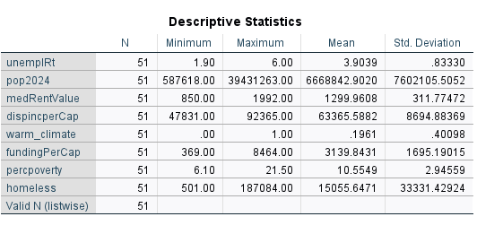
This dataset is appropriate because each source provides reliable, standardized, and annually updated state-level statistics. By combining federal housing data, labor statistics, demographic estimates, economic indicators, and climate measures, the model draws from credible sources to examine homelessness across America.
Empirical Model
In an ideal world, a model explaining homelessness would include every possible factor that contributes to someone become homeless. Including every possible variable would allow for narrowing down to the exact variables that truly effect homelessness. But for the span of this project, that is not feasible. A full picture of variables could include mental health access, substance abuse treatment availability, the number of affordable housing units, local zoning laws, and differences in how cities enforce homelessness policies. Because of limitations, the project uses several substitute variables that capture broader economic and social conditions related to homelessness.
Instead of directly measuring affordable housing availability, median rent value is used as a proxy for housing affordability. Disposable income per capita and poverty rate are included to reflect overall financial stability and economic hardship within a state. The unemployment rate represents the strength of the labor market, as job loss is often a major factor in housing insecurity. Funding per capita is used to represent how much support states provide for homelessness-related programs and services. Population size is included to account for the fact that larger states naturally have more people at risk of homelessness. Finally, a warm-climate dummy variable is used to capture environmental differences, since people experiencing homelessness may be more likely to remain unsheltered in states with milder weather.
Based on economic reasoning and prior research, several clear hypotheses are tested in this model. Staes with higher unemployment rates, higher poverty rates, higher median rent values, larger populations, and warmer climates are expected to have higher levels of homelessness. On the other hand, states with higher disposable income per capita and greater funding per capita are expected to have lower levels of homelessness. These hypotheses are tested using a linear regression model to see which factors have the strongest relationship with homelessness across states.
Empirical Results
The first regression model includes all proposed independent variables: unemployment rate, population (2024), median rent value, disposable income per capita, poverty rate, funding per capita, and the warm-climate dummy variable. Overall, this model performs well statistically. The F-statistic is 19.729 and is statistically significant at the 1% level (p < 0.001), indicating that the set of explanatory variables jointly explains a significant portion of the variation in homelessness across states. The model’s R² value is 0.632, meaning approximately 63.2% of the variation in state homelessness counts is explained by the included variables. The adjusted R² of 0.600 suggests the model remains strong even after accounting for the number of predictors.
Looking at individual coefficients, population size is the strongest and most statistically significant predictor of homelessness. Its coefficient is positive and significant at the 1% level, indicating that states with larger populations tend to have substantially higher homeless counts. Median rent value, funding per capita, and the warm-climate dummy variable all have the expected signs; however, they are not statistically significant at conventional levels in the full model. Unemployment rate, disposable income per capita, and poverty rate also fail to reach statistical significance, despite their theoretical relevance.
Collinearity diagnostics show no serious multicollinearity concerns, with all variance inflation factors (VIFs) well below commonly accepted thresholds. The Durbin–Watson statistic of approximately 2.05 suggests no evidence of autocorrelation in the residuals, which is expected given the cross-sectional nature of the data.
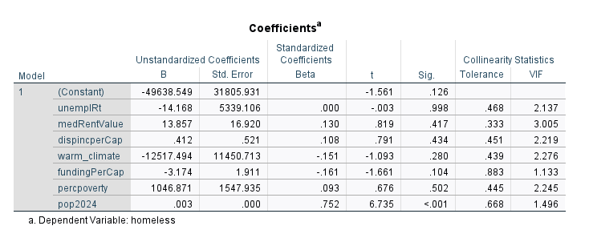
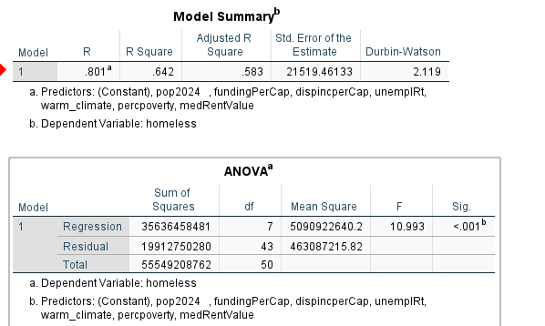
Although the full model performs well overall, several variables—specifically unemployment rate, disposable income per capita, and poverty rate—are statistically insignificant and contribute little additional explanatory power once other controls are included. These variables are also conceptually related to one another and may overlap in what they capture about economic conditions. To improve model simplicity and interpretability, these three variables are removed in the next specification.
The goal of refining the model is not to suggest that unemployment, income, or poverty are unimportant in explaining homelessness, but rather that their effects may already be captured indirectly through housing costs, population size, and funding levels at the state level.
The final model includes population (2024), median rent value, funding per capita, and the warm-climate dummy variable. This reduced model maintains strong explanatory power while improving clarity. Population remains the most influential predictor and is highly statistically significant, reinforcing the importance of scale effects when analyzing homelessness. Median rent value continues to have a positive relationship with homelessness, supporting the idea that housing affordability plays a key role in housing insecurity.
Funding per capita has a negative coefficient, suggesting that higher levels of state funding are associated with lower homelessness. Although its statistical significance increases in the reduced model, it remains marginal. The warm-climate dummy retains its expected sign, indicating that warmer states tend to have higher homelessness levels; however, this effect is not statistically significant (p = 0.146). Despite this, the warm-climate variable is kept in the model because theory suggests that individuals experiencing homelessness may be more likely to remain unsheltered in states with milder climates. While the estimated coefficient for warm climate is relatively large in magnitude, the lack of statistical significance means that this effect should be interpreted with caution.
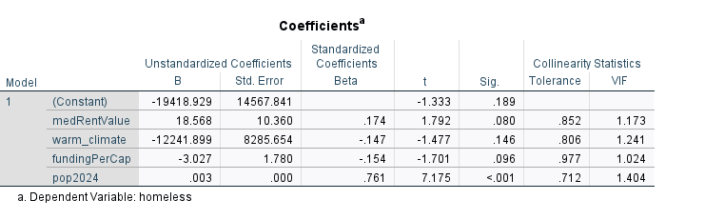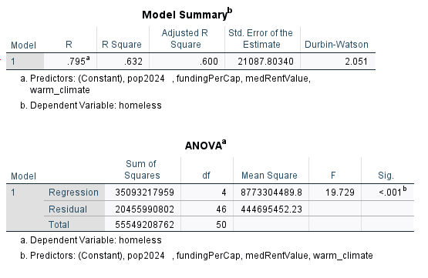

Given the large differences in population size across states, heteroskedasticity was formally tested using a Breusch–Pagan–type procedure. This was done by regressing the squared residuals from the original homelessness regression on the explanatory variables. The results show that population size is a statistically significant predictor of the squared residuals (p < 0.001), indicating that the variance of the error term increases with state population. This suggests the presence of heteroskedasticity related to scale effects, as larger states tend to exhibit greater variability in homelessness outcomes. The graph of the residuals with population further show signs of heteroskedasticity since there is a pattern. Despite the heteroskedasticity, population is kept in the model because it is the most statistically significant explanatory variable and is theoretically essential to capture the scale differences across states. The presence of heteroskedasticity is not unexpected given the nature of population data.
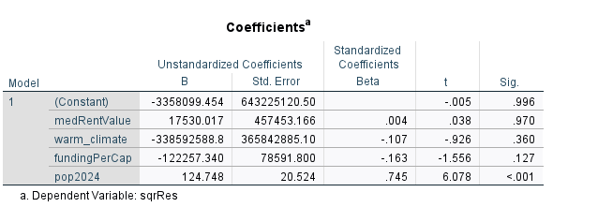
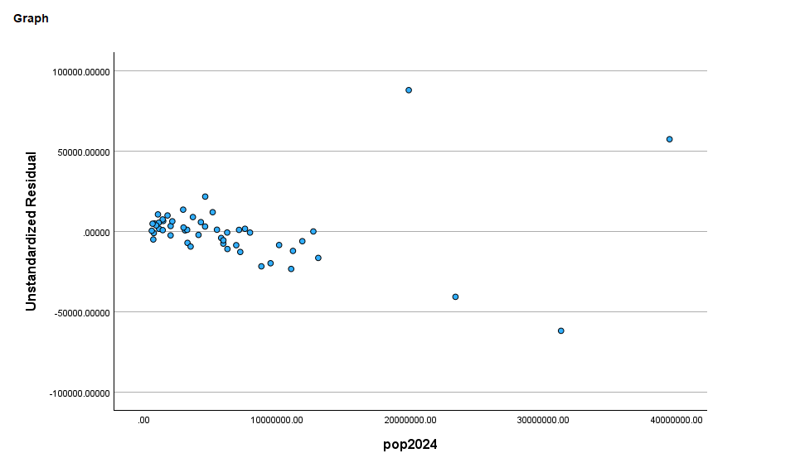
Conclusion
This project began with the idea that community wellness is one of the most important responsibilities of local governments and that homelessness serves as one of the clearest indicators of how well a community supports its most vulnerable residents. The results of this analysis help answer the central research question by showing that homelessness is strongly shaped by structural and economic conditions at the state level rather than by any single factor. In particular, population size emerges as the most consistent and statistically significant predictor of homelessness, reinforcing the idea that scale matters when communities attempt to address housing insecurity. Larger states face greater challenges simply due to the number of people who may be at risk, which places increased pressure on housing markets, public services, and local resources.
Beyond scale effects, the findings also highlight the importance of housing affordability and public investment. Median rent value is positively related to homelessness, supporting the view that rising housing costs are a key driver of housing instability. Funding per capita shows a negative relationship with homelessness, suggesting that government spending can help mitigate homelessness, even if its effect is not precisely estimated in all models. Climate also appears to play a role, as warmer states tend to experience higher homelessness levels, consistent with the idea that environmental conditions influence where unsheltered homelessness persists. Together, these results suggest that homelessness is not simply a consequence of individual circumstances but a reflection of broader community conditions.
From a policy perspective, these findings reinforce the argument that improving community wellness requires more than short-term or reactive responses. Local governments may be most effective when they focus on expanding affordable housing, especially in high-rent and rapidly growing states, and when they allocate sufficient funding toward homelessness prevention and support services. The strong role of population size also suggests that policies should be scaled appropriately to community size rather than applied uniformly across states. While factors like unemployment, income, and poverty are important, their effects may operate indirectly through housing markets and public resources, emphasizing the need for coordinated, structural solutions.
There are several ways this research could be improved in future work. Using homelessness rates rather than total counts could reduce heteroskedasticity and allow for clearer comparisons across states. Additionally, moving from state-level data to city- or county-level data would better capture local variation, particularly in urban areas where homelessness is concentrated. Future research could also incorporate variables related to housing supply, zoning laws, and access to mental health services to provide a more complete picture. Despite these limitations, this project demonstrates that homelessness is a meaningful measure of community wellness and that policies addressing housing affordability and resource allocation are central to reducing homelessness and improving overall community health.

Works Cited
Bureau of Economic Analysis. (2024). State Personal Income and Disposable Personal
Income. U.S. Department of Commerce.
Bureau of Labor Statistics. (2024). Local Area Unemployment Statistics (LAUS): State
Unemployment Rates. U.S. Department of Labor.
Census Bureau. (2023a). American Community Survey 1-Year Estimates: Median Gross
Rent. U.S. Department of Commerce.
Census Bureau. (2023b). American Community Survey 1-Year Estimates: Poverty Status in
the Past 12 Months. U.S. Department of Commerce.
Census Bureau. (2024). Population Estimates Program (PEP). U.S. Department of
Commerce.
HUD (U.S. Department of Housing and Urban Development). (2024). 2024 AHAR: Part 1 –
Point-in-Time Estimates of Homelessness in the U.S.
National Homeless Information Project. (2024). Homeless Assistance Funding by State.
(Funding per Capita Table provided by instructor/compiled dataset.)
National Oceanic and Atmospheric Administration. (2024). State Climate Normals (1991–
2020). U.S. Department of Commerce.

