Week 10: Live API Integration Evidence
HandyNear (Team 7) consuming MoneyMentor Kenya (Team 6)
Prepared by Kamau, Strathmore University (BICS). Work done 26 October 2026.

1. Summary
HandyNear now calls its upstream partner's live API and shows the result in its own app. The HandyNear dashboard displays a savings-goal progress box that comes from MoneyMentor Kenya's running API. We also tested what happens when the partner is unavailable: the dashboard shows a clear message and keeps working.
- Feature: "Savings goals (via MoneyMentor)" panel on the HandyNear dashboard.
- Partner endpoint used: GET /api/handymen/1/savings-goals on MoneyMentor's API (reached through their temporary tunnel URL).
- Live result: HTTP 200, "KES 450 of KES 1,000 (45%)" shown on the dashboard (Figures 1 and 2).
- Failure handling: HTTP 502 with a friendly message from our server, and a red message on the dashboard instead of a crash (Figures 3 to 5).

2. How the integration works
MoneyMentor's contract (openapi.yaml) requires a bearer token (JWT) on every provider route. To keep that token out of the browser, our own backend makes the call and the React page only talks to our server.
Browser (React dashboard)
-> GET http://localhost:5000/api/partner/savings-goals (no token)
HandyNear server (server/routes/partner.js)
-> GET {PARTNER_URL}/api/handymen/1/savings-goals
Authorization: Bearer <token from .env>
MoneyMentor API -> JSON -> HandyNear maps the fields -> dashboard
- The partner URL, token and handyman id come from environment variables (PARTNER_URL, PARTNER_API_KEY, PARTNER_HANDYMAN_ID) in server/.env. The file is not committed; server/.env.example lists the names with empty values.
- The server logs only the partner's status code or error code, never the token.
- Their response fields are snake_case. Our route maps them to the camelCase used across our own API:

MoneyMentor field | Our field | Shown on dashboard as
goal_amount | goalAmount | KES 1,000 (goal)
current_amount | currentAmount | KES 450 (saved)
progress_percentage | progressPercentage | 45%

3. Evidence

3.1 First call outside our app (Part B)
Before writing any code we called the partner from a terminal, without a token, to check the URL and the contract. Run on Monday 26 October 2026 at 11:42 EAT:
curl.exe -i https://00da2582d51ed3.lhr.life/api/handymen/1/savings-goals

HTTP/1.1 401 Unauthorized
content-type: application/json; charset=utf-8

{"error":"A valid bearer token is required."}
Compared with their contract: it matches. Their openapi.yaml documents a 401 with this exact message. It proved the tunnel and API were reachable and that a token was needed for real data.

3.2 Live data through our server (200 OK)
After MoneyMentor sent a bearer token and a new tunnel URL, we put both in server/.env, restarted the server and called our own route. Date header 09:16:54 GMT (12:16 EAT):
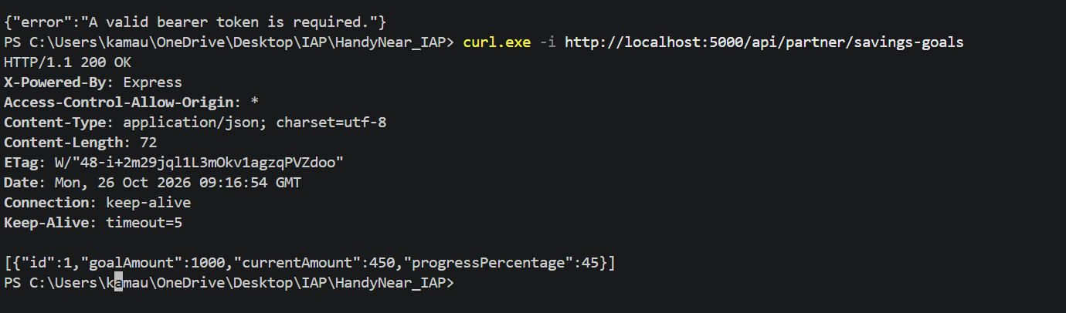
Figure 1: Our route returns 200 OK with the mapped savings goal. The 401 body above the command is the earlier token-less call.
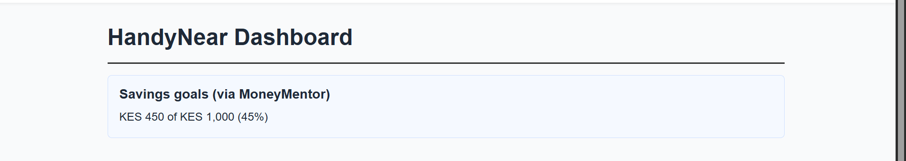
Figure 2: The HandyNear dashboard showing the live MoneyMentor data: KES 450 of KES 1,000 (45%).

3.3 Partner unavailable (Part D)
Our server must survive the partner being down. When the call fails it logs the reason, returns a 502 with a plain message, and the dashboard shows that message while the rest of the page keeps working.
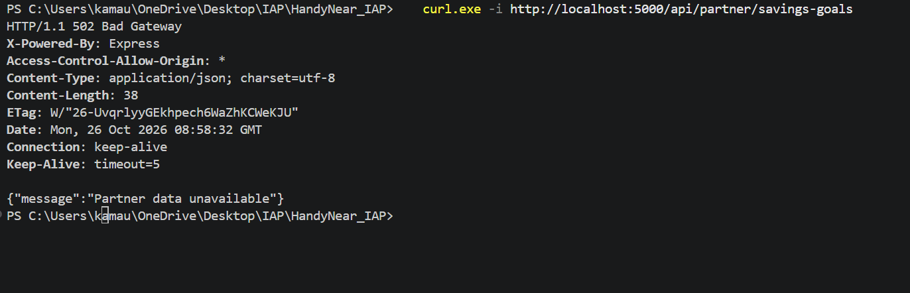
Figure 3: Our route returns 502 {"message":"Partner data unavailable"} (Date 08:58:32 GMT, 11:58 EAT). At this time MoneyMentor's tunnel had dropped; a direct call at 12:01 returned "502 Bad Gateway: no tunnel".
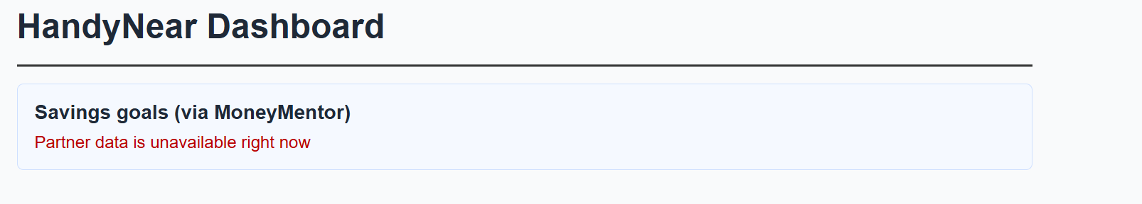
Figure 4: The dashboard when the partner call fails. The partner box shows "Partner data is unavailable right now" and the page does not crash.
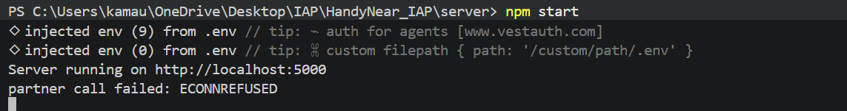
Figure 5: Server terminal during the failure test: "partner call failed: ECONNREFUSED". The log gives the reason (nothing listening at that address) without exposing the token.
Recovery: once MoneyMentor restarted their tunnel and sent a new URL, we changed only PARTNER_URL in .env and restarted. The data came back with no code change (Figures 1 and 2, 12:16 EAT).

4. Integration log (summary)
The full log is in INTEGRATION_LOG.md in the repository. Every bug or surprise is recorded, whoever's code it was.
# | What broke (symptom) | Root cause | Fix | Whose code / who fixed
1 | First call returned 502 "no tunnel" | Partner's tunnel was not running; the URL had expired | Partner restarted it and sent a new URL | Partner infrastructure, fixed by partner
2 | Calls without a token returned 401 | Their contract needs a bearer JWT on every route; we had assumed no key | Requested a token for provider 1 and sent it as Authorization: Bearer | Contract mismatch with our plan, fixed together
3 | Our route returned 502 and the dashboard showed "Partner data unavailable" | Partner tunnel dropped again (11:58 EAT) | Our code returned a friendly 502 and kept running; partner restarted the tunnel | Partner infrastructure; our handling worked as designed
4 | Partner URL changed several times during the lab | Free tunnel URLs expire when the tunnel restarts | URL is read from PARTNER_URL in .env, so only that line changed each time | Partner infrastructure, worked around by us
5 | Their tokens last one hour (issued 11:48, expiring 12:48) | Short-lived JWTs, as stated in their README | Used the token inside the window; will ask for a fresh one before any demo | Partner design, worked around together

5. Supporting our downstream partner (ShieldBox)
ShieldBox's repository contains a review of our contract with three questions. We checked our code and answered each one:
Their question | Our answer
Is serviceCategory restricted to certain values? What happens with an unknown one? | Free-text exact match, no enum. Current values are Plumbing, Electrical and Carpentry. An unknown category returns 200 with an empty array, not a 400.
Query parameter "available" vs response field "isAvailable" | Correct reading: the query parameter is "available", the response field is "isAvailable". available=true returns only available handymen, false returns only unavailable ones, omitted returns all. Other values return 400 INVALID_QUERY_PARAM.
What happens when a booking conflicts or the handyman is unavailable? | Not checked today. POST /api/bookings always returns 201 with status "pending" and there is no 409. This is documented as a known limitation in CONTRACT_DEVIATIONS.md.

Our API needs no key (our README says "None yet"), so ShieldBox can call the endpoints that match their needs list directly: GET /api/handymen/{id}, GET /api/bookings/{id} and GET /api/bookings?handymanId={id}&status=completed.

6. Open items
- Week 8 blind test: no outside team has completed a test of our README yet. The report will say so rather than claim a result.
- Week 7 partner exchange: no partner was assigned, so only Parts A and B (19 automated tests) apply.
- ShieldBox's current code does not yet call the HandyNear API; the endpoints and answers above are ready for when they do.

