TASK 1 – (P1.1)

Identify client requirements by listing the features required in the above scenario.

For the PC which is found in the Kiosk I will be doing a 2d Space Invaders game. The game will consists of;

* a spaceship which is controlled by the player (user).
* different levels, where in each the score will be reset
* 2d illustrations (images) which are the backgrounds, aliens, and spaceship.

The game will starts with a main menu with the logo and the name of the game and two buttons which are;

* + start button - which will ask the user to enter his/her name before starting the game.
  + exit button - will close the game.

The name entered will be visible on the screen for the whole game. The name can be changed whenever the user wish to start the game again.

The game starts with 2 rows and 5 columns of aliens which will be moving across the screen from right to left and left to right shooting downwards trying to hit the player (spaceship). Once the player is hit by the aliens the health 100 will be decreased by 10 within every hit. If the health becomes 0 the player will die and the game ends. The user will try to fire the laser and hit the aliens to get high score. When all the aliens are hit the user can proceed to the next level. To be more challenging, the aliens will be increasing in every level. (the number of rows will be increased). Once all the aliens are hit from all levels the player will win the game.

TASK 2 – (P1.2)

Identify the target group your game would interest. Explain your reasoning in a short paragraph.

Basically this type of game can be played by everyone since it is a simple one, which will be played by pressing just few buttons for the whole game. But if I had to mention the age gap on the game I will target children from 8 years to 12 years. The game has a cartoonish look and children will be more attracted to it rather than adults. Since it doesn't have lots of levels and no bosses to kill it is a very easy game.

TASK 3 – (P1.3)

Clarify your creative intentions by writing a short paragraph describing the overall look and feel of the game and how this game would cater for the target group you mentioned in Task 2

Overall the game is a short one with few levels to win. The user all he/she needs to do is to enter the name and proceed to that start screen where the player should hit the aliens by pressing the spacebar to shoot the laser and left and right key to move the spaceship across the screen. The target group I mentioned before will find it easy to play. And the illustrations of the spaceship and the aliens are cartoonish and funny which will attract more young aged group

TASK 4 – (P2.1)

List the areas of expertise required to implement this game.

To build this game all one have to learn the tools of Unity and understand the concept of the whole game. The game should have JavaScript pages filled with programming to make the game works. To make the game looks nicer and more fun the illustrations / mages should be well designed.

TASK 5 – (P2.2)

Rate your own expertise in each of these areas of expertise. Write a paragraph justifying your rating in the light of your experience and expertise.

I understood well the tools of unity and enjoyed working on it to build this simple game. But when it comes to programming I don't feel that comfortable working on it, if I had more knowledge skills on programming I could have done better. I could have made the user to choose from different types of spaceships rather than just click start and the game will start. But on the other side I enjoyed illustrate the images for the game since I am more focused on digital design.

TASK 6 – (P3.1)

Produce introduction concepts for an initial sample by creating a new project on http://www.github.com, and writing a full description of your intentions for the project. Include at least two screenshots of the project creation process and include a link to the Github project you have created.

this is the link:

https://github.com/charlenedelceppo/Assignment-2-space-invaders.git

(description in github)

This is a space invaders game which was created by Unity. The game consists of a spaceship (player) which needs to kill the aliens by shooting the laser upwards to hit them. The aliens will be moving across the screen from left to right and right to left. The player can move the spaceship across the screen too. The aliens will be shooting lasers too and if they hit the spaceship the player's health will start to decrease. The health will be set to 100 and if they hit the player enough to 0 the game ends "game over". When starting the game the user will entering the name and will be shown during the game-play.

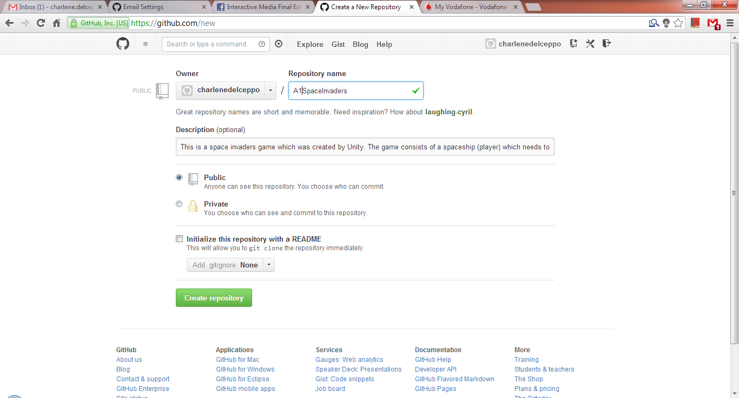

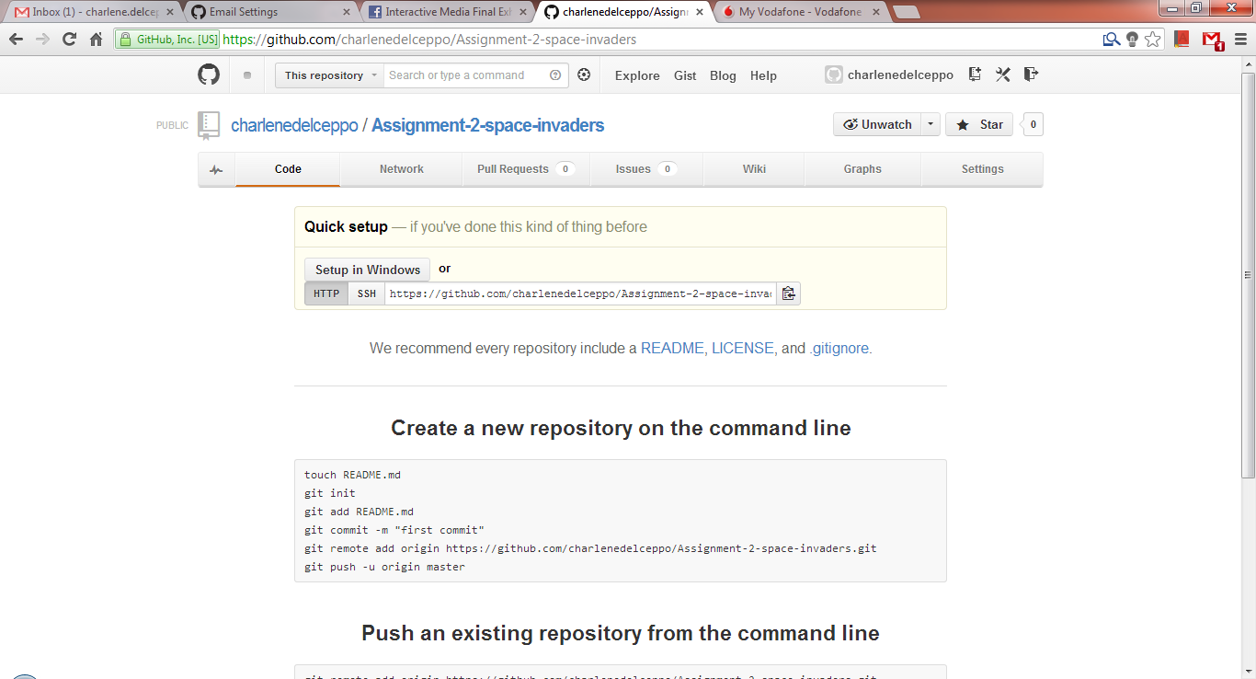

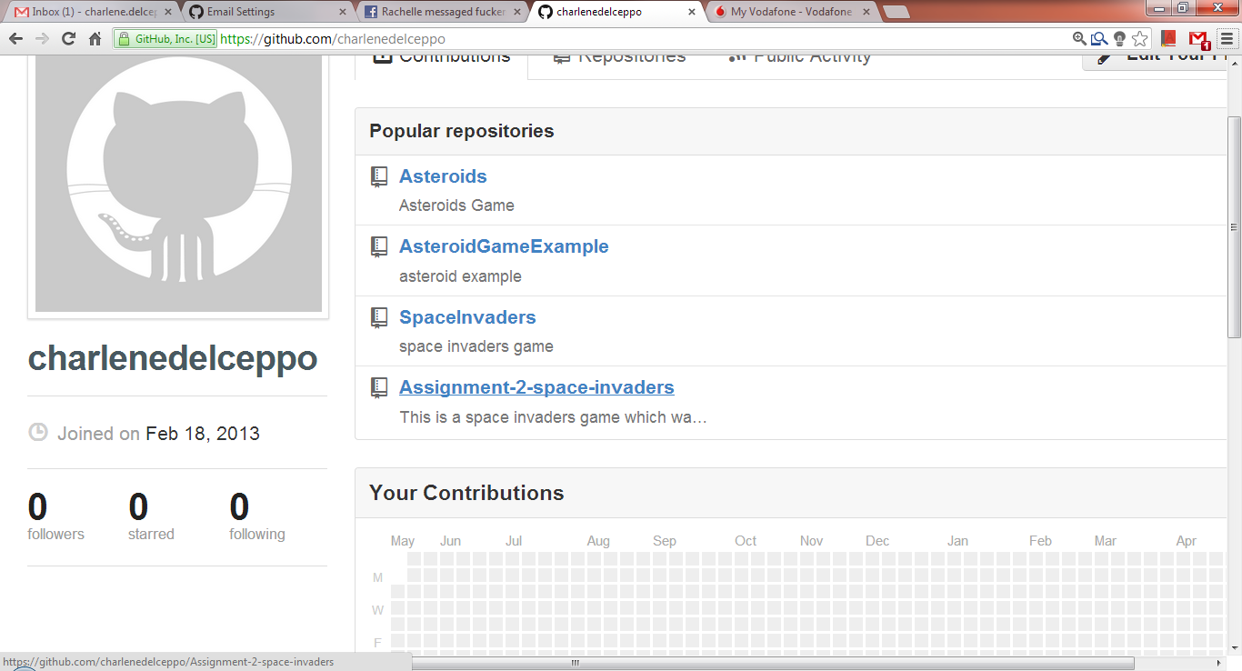

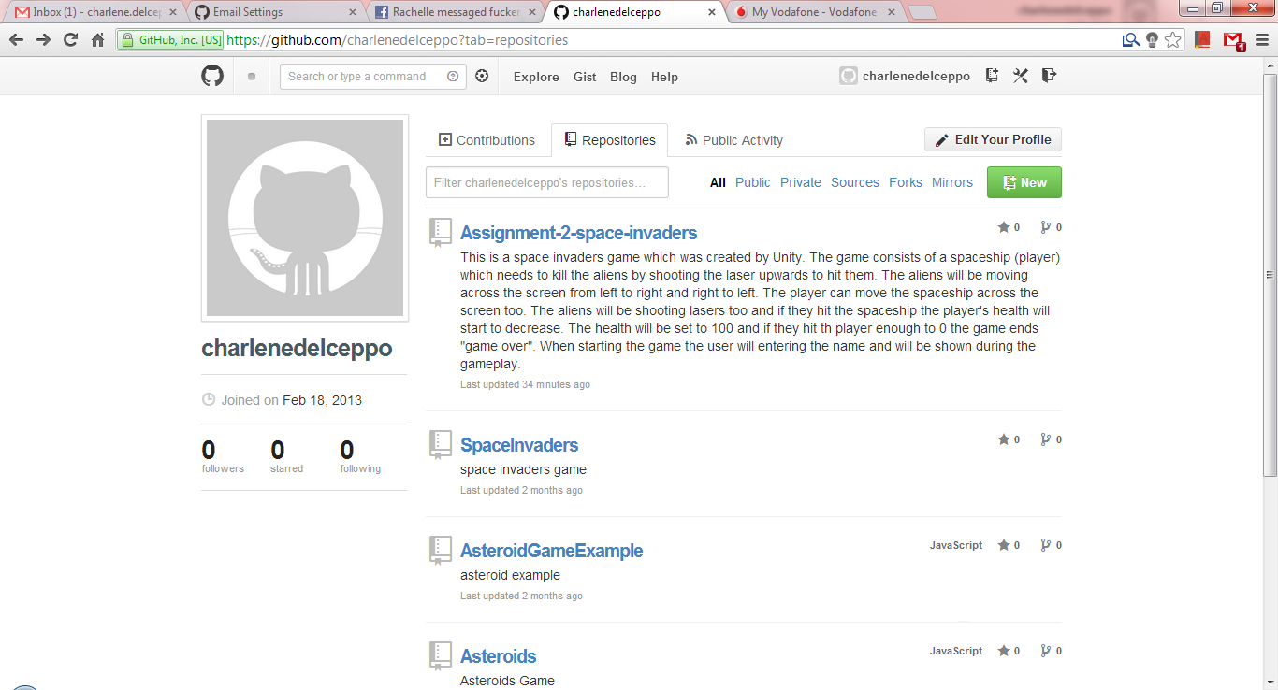

TASK 7 – (P3.2)

Evaluate and confirm the prototype in relation to constraints by posting the code of the asteroids/space invaders game project you created in Assignment 1 of CIDP to your Github project as a first commit. Describe the first commit in full and post a screenshot of the commit description.

By the github application I created the folder for the folders of my game. And added the repository.

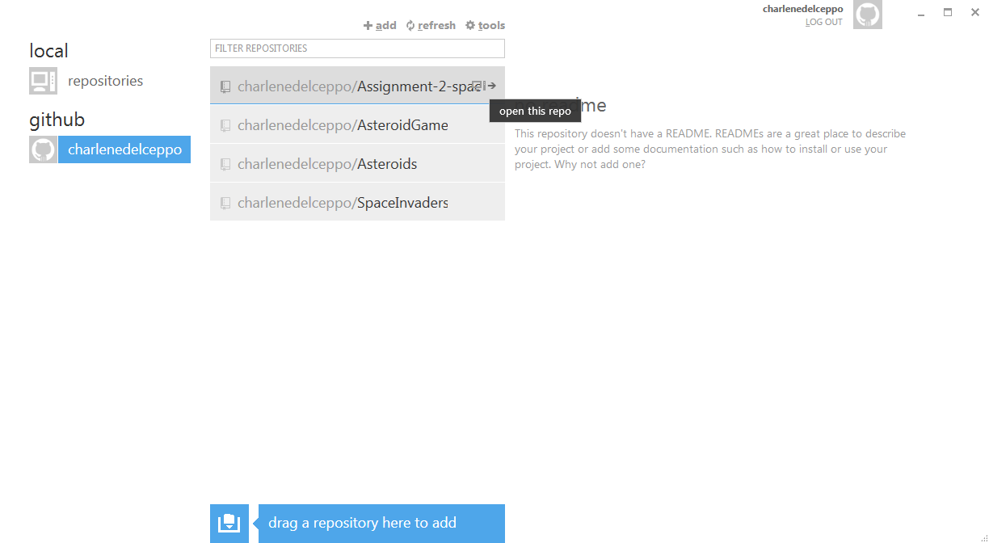

As you can see the repo is stil empty since I did not commit any files.

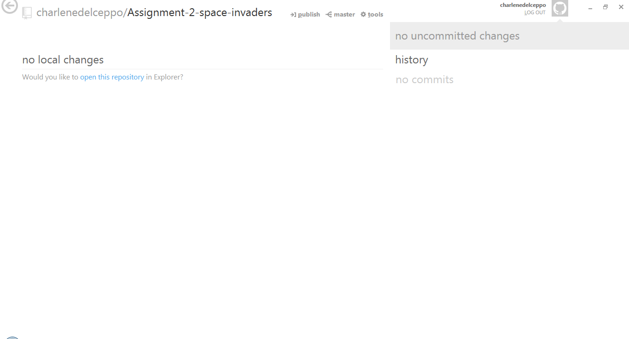

Once I put the game folder in the folder created by the Github application all files will appear to commit.

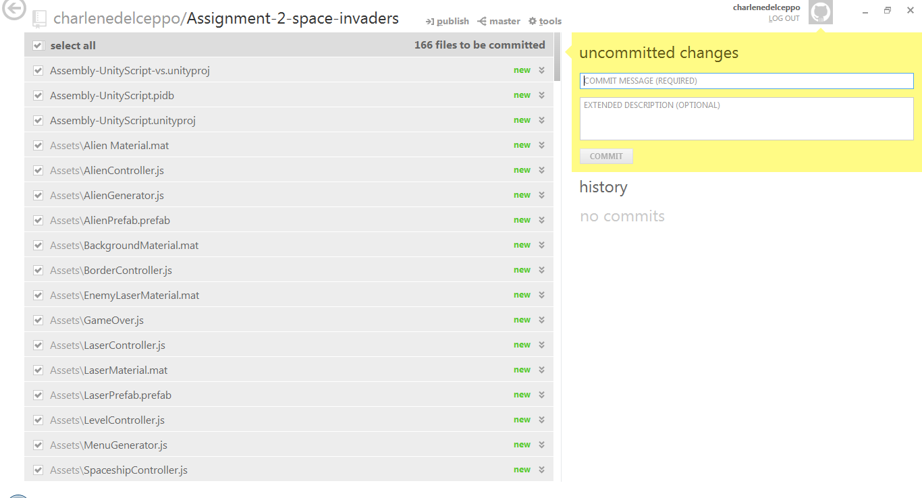

I filled the data needed and clicked commit.

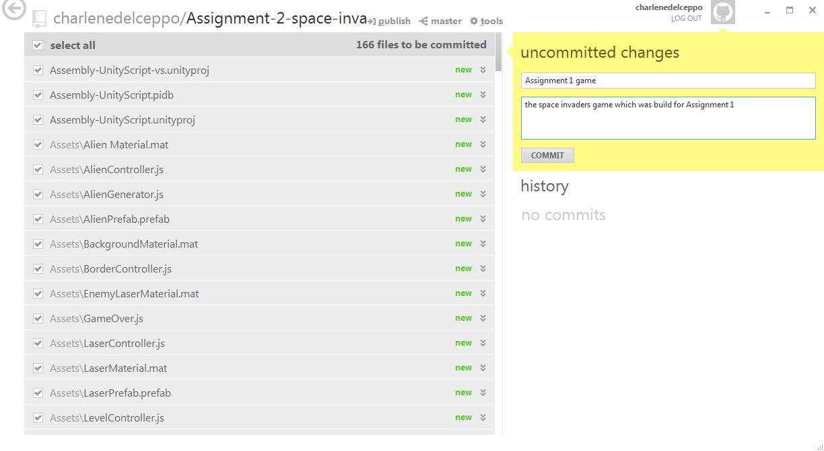

Clicked on publish to upload the file online (the link posted before)

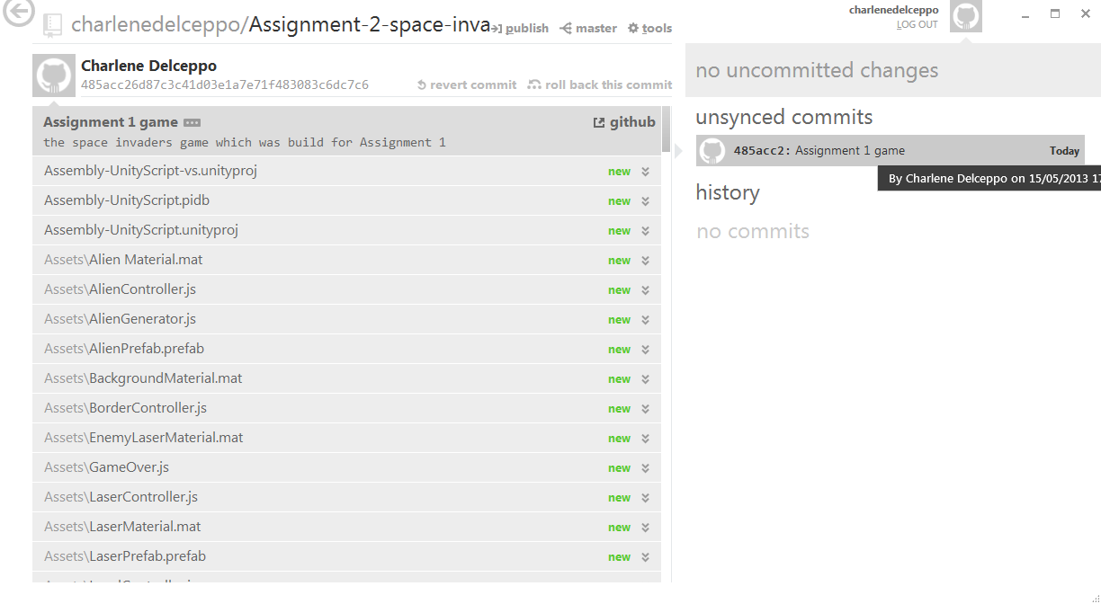

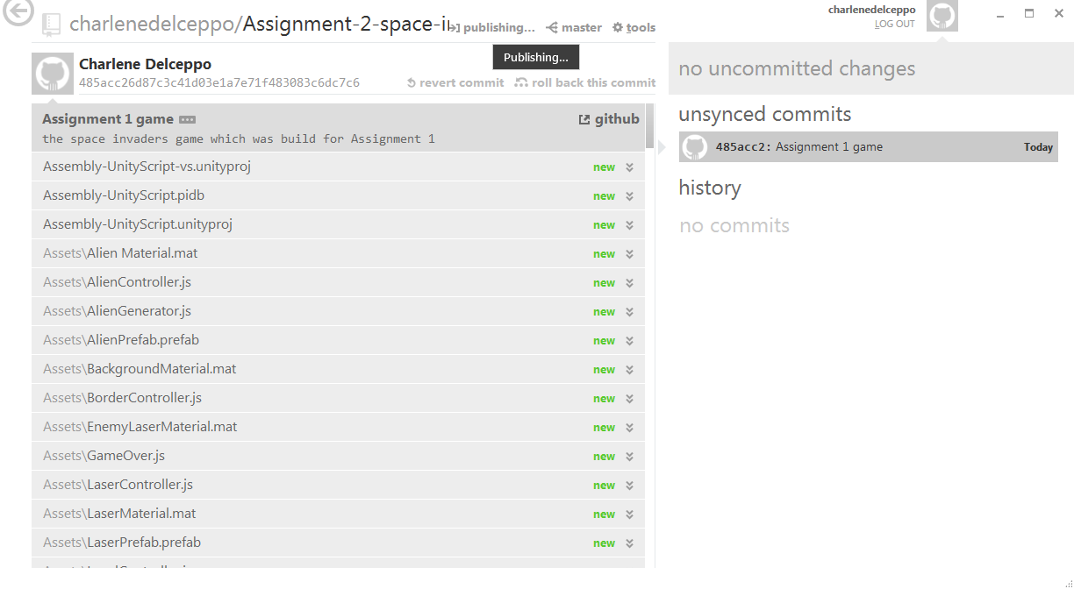

Once the file is published and go to the link all the files will be uploaded on the github website on the user's account.

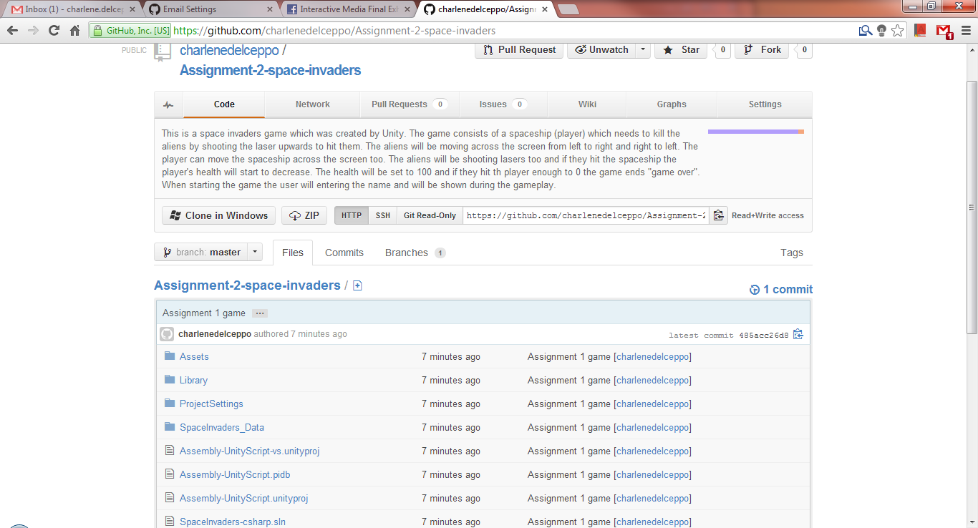

Now from the website one can download the file. Every change you do to the file you can commit and the changes will be saved once again on the same folder.

TASK 8 – (P3.3)

Reflect and record on feedback from prototype phases by explaining how the github issue tracker works, with screenshots. Post five issues (bugs) concerning your game to github and take screenshots, then reply to each issue describing what remedial actions were taken to close the issue, before posting another commit referring to this closed issue. MCAST HND-IM Interactive Media Teamwork Assignment 1 5/1

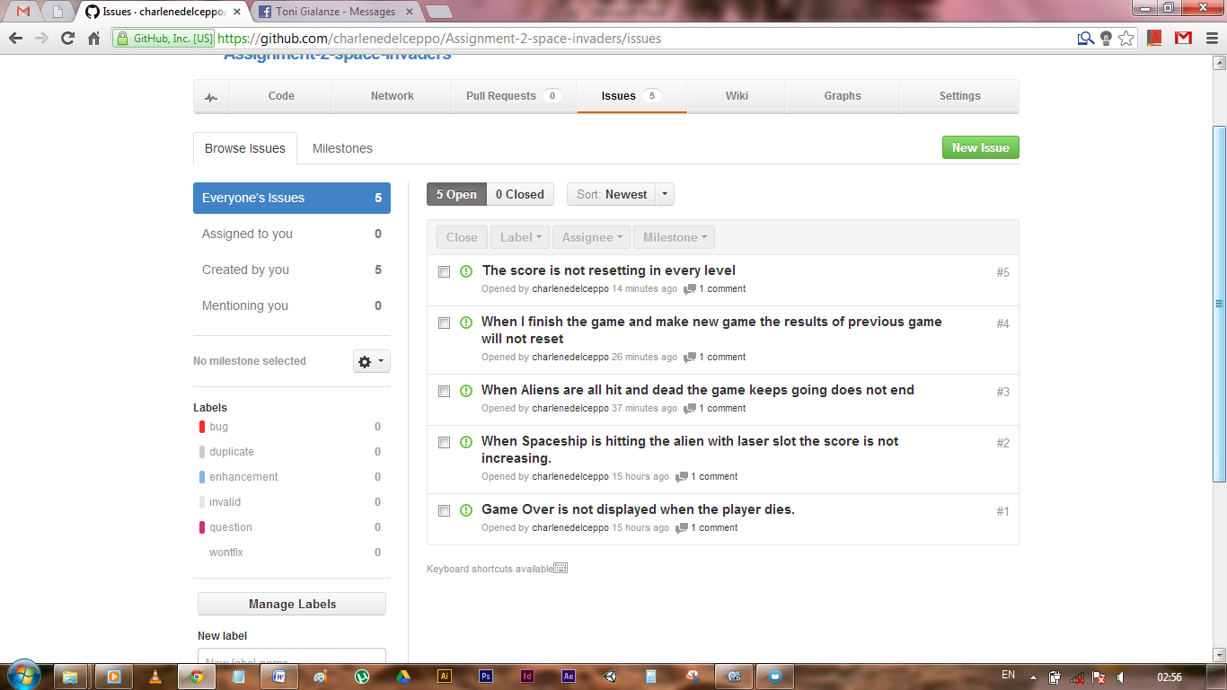

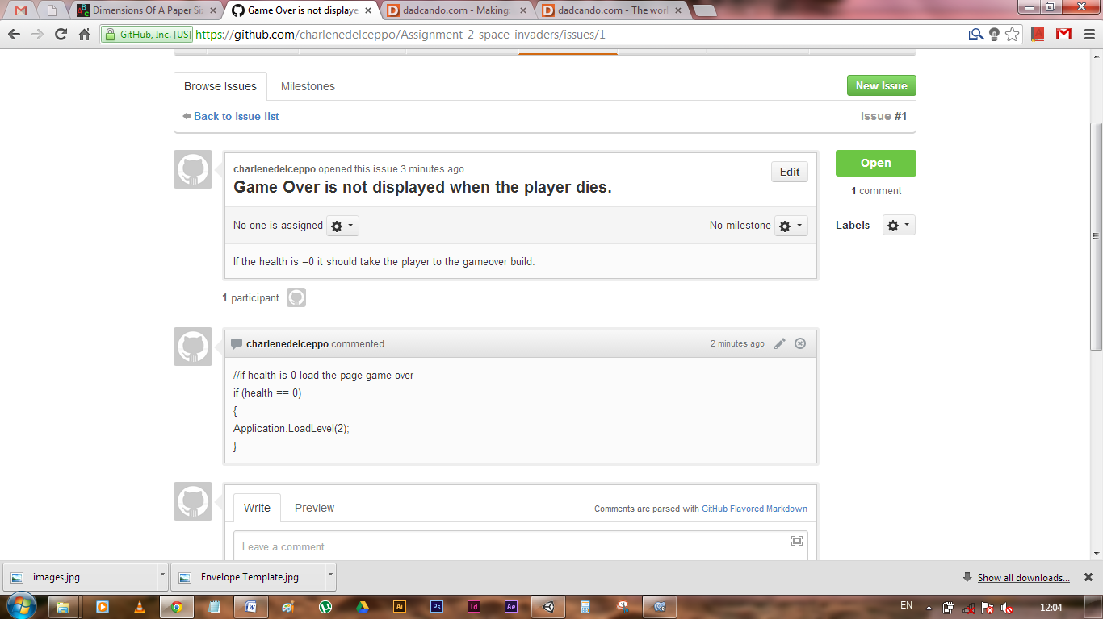

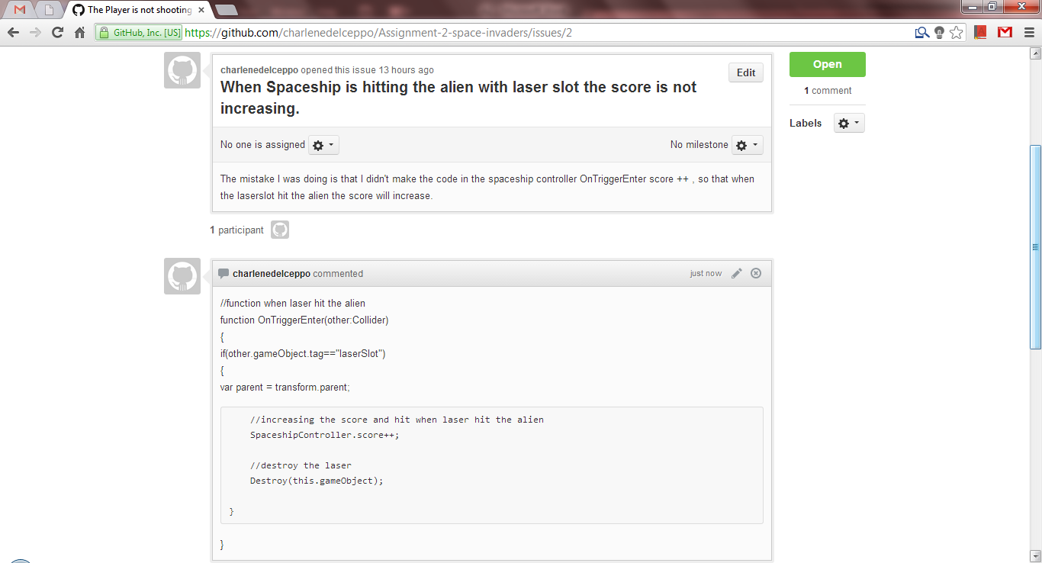

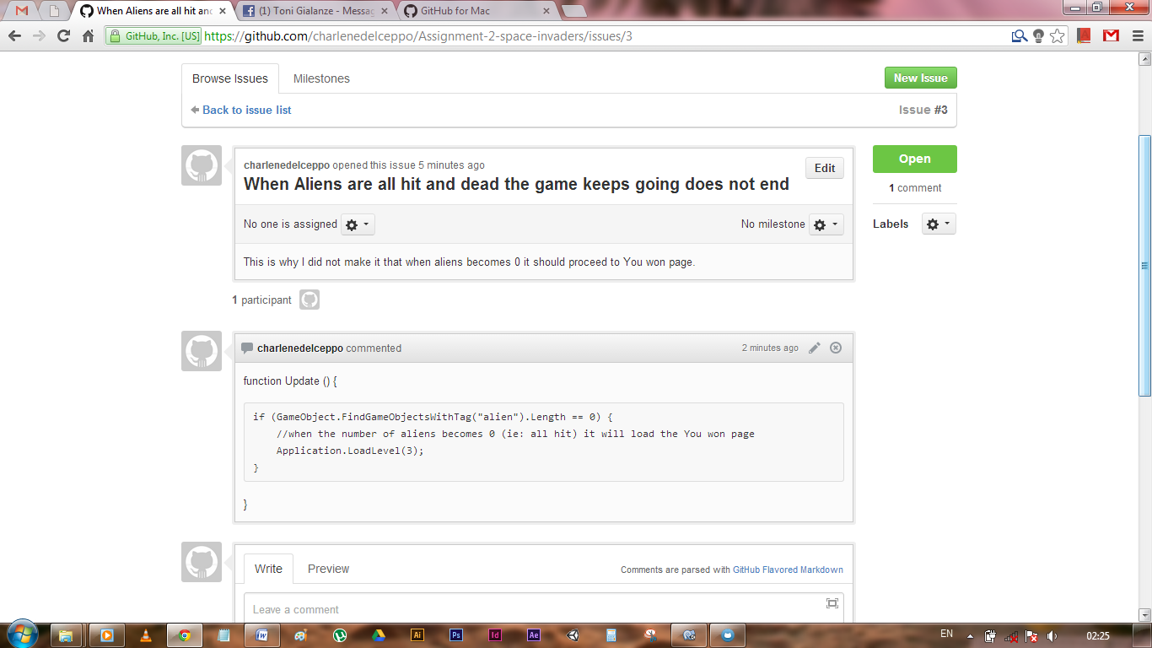

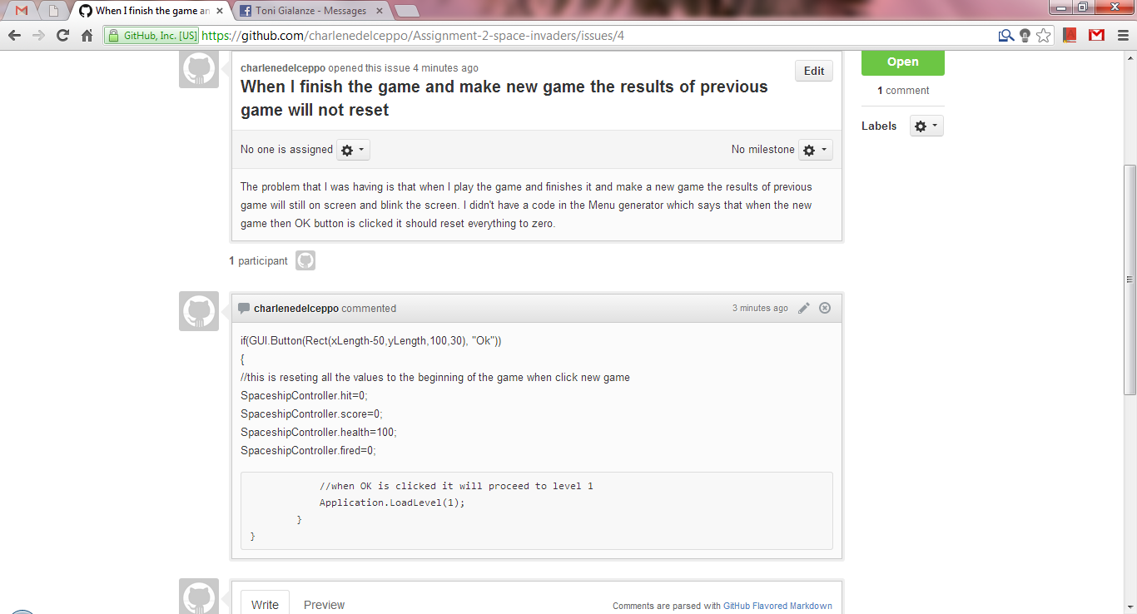

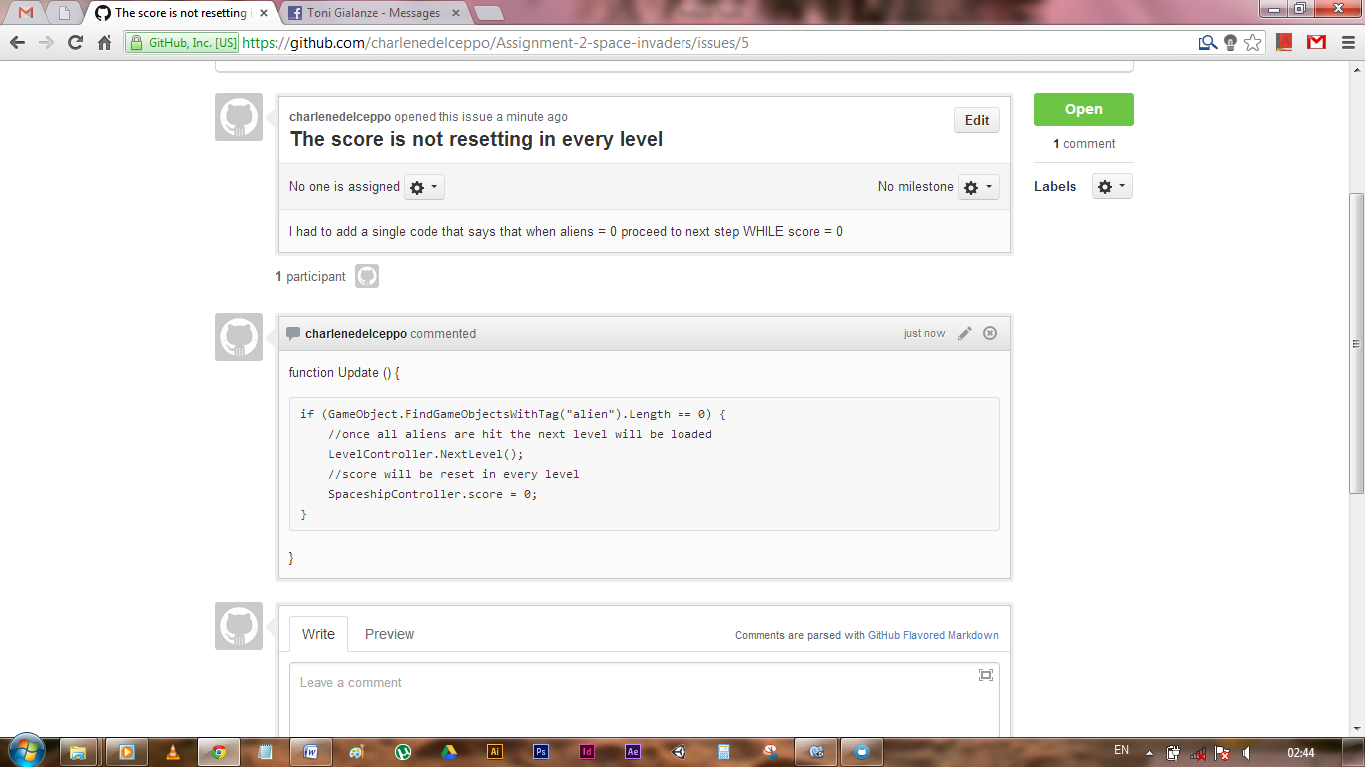

TASK 9 – (P4.1)

Develop a fully working interactive media product that meets client needs by showing three consecutive commits documenting the changes carried out to finalize the functionalities of the interactive application as defined in the case study.

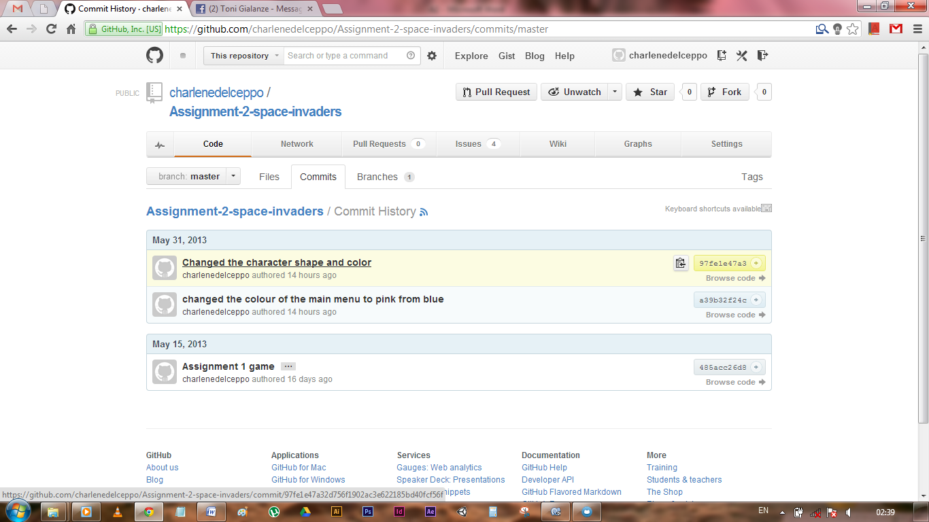

TASK 10 – (P4.2)

Evaluate and record interactive media outcomes against the constraints and requirements of the brief by writing a paragraph explaining how the use of Github issue tracking makes it easier for the client and the developer to communicate and share prototypes.

As a program it is a simple one once the user understand its concept. Practically it is very useful especially for those who need to back up while working on a project. This is because that once you upload the project on Github and commit it will be saved online. Example when I work on a 3d project I like to make a backup of my folder once every 10mins (approx. depends on what I'm doing) so that if I make a mistake and I cannot undo so far I will work on the saved data saved earlier time. This is a program which will help me by keep my data safe and backed up online, and every some time I can make a commit on Github.­­­­­­ Another thing is that once it is online you can share it easily online with others by giving them the link and download the ZIP

*