Aid and Education Outcomes: Mechanisms, Explanations, and Evidence

1. How Aid Improves Education Outcomes (Access Emphasis)

Mechanism 1: Fiscal Space and Public Investment
Aid → Fiscal Space → Fee Removal & Teacher Hiring → Lower PTR & New Schools → Higher Enrollment
Aid expands government budgets, enabling teacher recruitment and school construction.
Evidence: Duflo, Esther (2001). 'Schooling and Labor Market Consequences of School Construction in Indonesia: Evidence from an Unusual Policy Experiment.' American Economic Review, 91(4), 795–813.
Link: https://www.aeaweb.org/articles?id=10.1257/aer.91.4.795
Finding: School construction (partly aid-financed) raised years of schooling and enrollment rates, especially among low-income children.

Mechanism 2: Infrastructure Development
Aid → Infrastructure Development → Lower Travel Time & Safer Schools → Higher Attendance → Higher Enrollment
Road and electricity projects reduce travel costs and increase daily attendance.
Evidence: Asher, Sam & Novosad, Paul (2020). 'Rural Roads and Local Economic Development.' American Economic Review, 110(3), 797–823.
Link: https://www.aeaweb.org/articles?id=10.1257/aer.20180268
Finding: Improved road connectivity increased school attendance and secondary enrollment, particularly in remote districts.

Mechanism 3: Health and Nutrition Programs
Aid → Health & Nutrition Programs → Improved Readiness & Attendance → Better Learning → Higher Enrollment
Health and nutrition aid enhances physical and cognitive readiness for school.
Evidence: Miguel, Edward & Kremer, Michael (2004). 'Worms: Identifying Impacts on Education and Health in the Presence of Treatment Externalities.' Econometrica, 72(1), 159–217.
Link: https://www.aeaweb.org/articles?id=10.3982/ECTA1510
Finding: School deworming raised attendance by 7 percentage points and improved long-term educational attainment.

Mechanism 4: Governance and Institutional Strengthening
Aid → Governance & Institutional Strengthening → Payroll Integrity & Management → Reliable Service Delivery → Higher Enrollment
Institutional reforms supported by aid improve payroll accuracy and teacher deployment.
Evidence: Reinikka, Ritva & Svensson, Jakob (2004). 'Local Capture: Evidence from a Central Government Transfer Program in Uganda.' Quarterly Journal of Economics, 119(2), 679–705.
Link: https://academic.oup.com/qje/article/119/2/679/1924290
Finding: Transparency reforms increased the share of funds reaching schools, boosting enrollment.

Mechanism 5: Macro Stability and Household Income
Aid → Macro Stability → Household Income Stability → Reduced Dropout → Higher Enrollment
Aid stabilizes fiscal policy and household welfare during shocks, keeping children in school.
Evidence: Bazzi, Samuel & Clemens, Michael A. (2013). 'Blunt Instruments: On Establishing the Causes of Economic Growth.' American Economic Journal: Macroeconomics, 5(2), 152–187.
Link: https://www.aeaweb.org/articles?id=10.1257/mac.5.2.152
Finding: Aid inflows smooth macroeconomic volatility and sustain education spending in low-income countries.
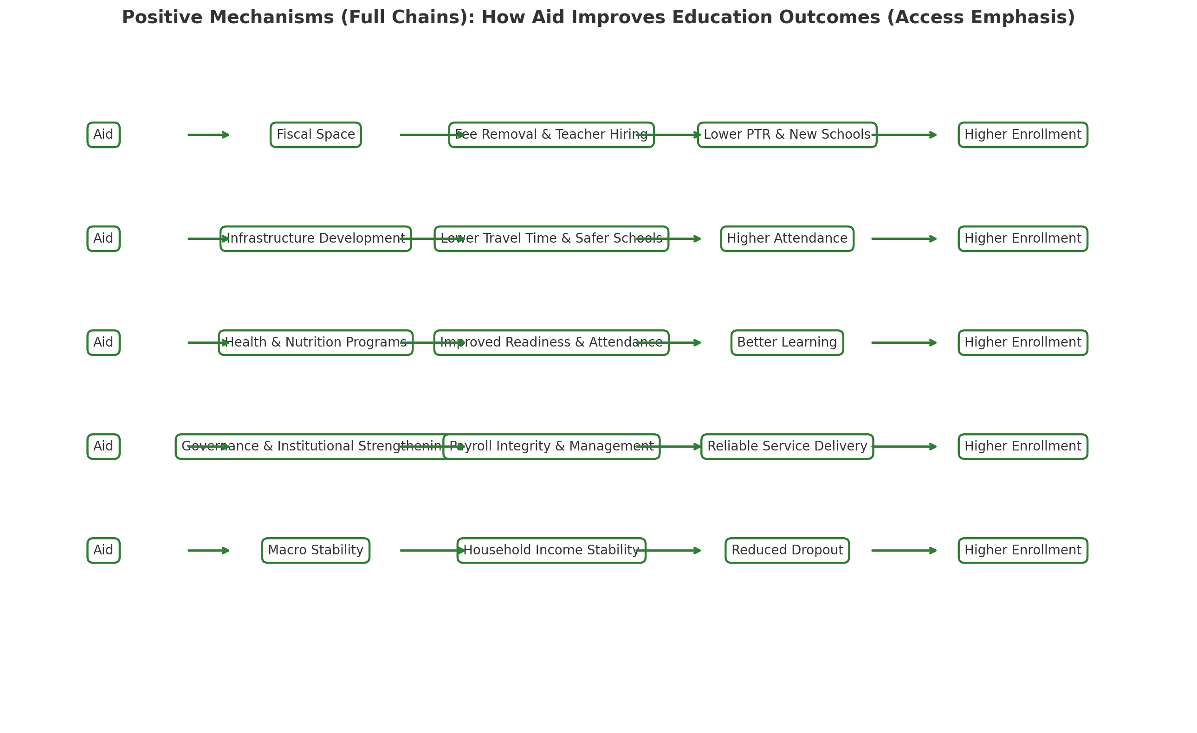

2. How Aid Harms Education Outcomes (Access Emphasis)

Mechanism 1: Fiscal Dependence and Volatility
Aid → Dependence & Volatility → Fiscal Instability → Interrupted Funding → Reduced Enrollment
When aid fluctuates, teacher salaries or construction projects halt mid-cycle, disrupting schooling.
Evidence: Celasun, Oya & Walliser, Jan (2008). 'Predictability of Aid: Do Fickle Donors Undermine Economic Development?' Economic Policy, 23(55), 545–594.
Link: https://academic.oup.com/economicpolicy/article/23/55/545/2916096
Finding: Volatile aid flows reduce investment and service continuity, leading to drops in education expenditure.

Mechanism 2: Misallocation and Fungibility
Aid → Misallocation & Fungibility → Weak Budget Discipline → Underfunded Core Inputs → Lower Quality → Lower Enrollment
Governments often divert domestic funds away from education once donors finance visible inputs.
Evidence: Van de Sijpe, Nicolas (2013). 'Is Foreign Aid Fungible? Evidence from the Education and Health Sectors.' World Bank Policy Research Working Paper 6346.
Link: https://ssrn.com/abstract=2209634
Finding: Earmarked education aid partly displaced domestic spending, weakening the impact on enrollment and quality.

Mechanism 3: Donor-Driven Priorities
Aid → Donor-Driven Priorities → Enrollment without Quality → Overcrowding & Low Learning → Net Lower Enrollment
Donors emphasize short-term enrollment targets rather than sustainable quality improvements.
Evidence: Hanushek, Eric A. & Woessmann, Ludger (2008). 'The Role of Cognitive Skills in Economic Development.' Journal of Economic Literature, 46(3), 607–668.
Link: https://www.aeaweb.org/articles?id=10.1257/jel.46.3.607
Finding: Education expansion without learning gains yields limited economic returns and weak long-term participation.

Mechanism 4: Governance Fragmentation
Aid → Governance Fragmentation → Parallel Systems & Bureaucracy → Policy Inconsistency → Access Inequities → Lower Enrollment
Multiple donors impose their own reporting and management systems, increasing transaction costs and weakening coordination.
Evidence: Gehring, K., Michaelowa, K., Dreher, A., & Spörri, F. (2017). 'Aid Fragmentation and Effectiveness: What Do We Really Know?' World Development, 95, 447–458.
Link: https://www.kai-gehring.net/files/articles/Dreher%2C%20Gehring%2C%20Michaelowa%2C%20Spoerri%20(2017%20WD).pdf
Finding: Fragmented donor portfolios are less effective in raising net primary enrollment.

Mechanism 5: Macroeconomic Distortions
Aid → Macroeconomic Distortions → Price & Wage Shocks → Household Affordability Falls → Inequitable Learning & Lower Enrollment
Large aid inflows can appreciate exchange rates and raise prices, reducing household affordability.
Evidence: Rajan, Raghuram G. & Subramanian, Arvind (2011). 'Aid, Dutch Disease, and Manufacturing Growth.' Journal of Development Economics, 94(1), 106–118.
Link: https://www.sciencedirect.com/science/article/pii/S0304387810000903
Finding: High aid inflows can distort domestic prices and employment, indirectly reducing school access for poor households.
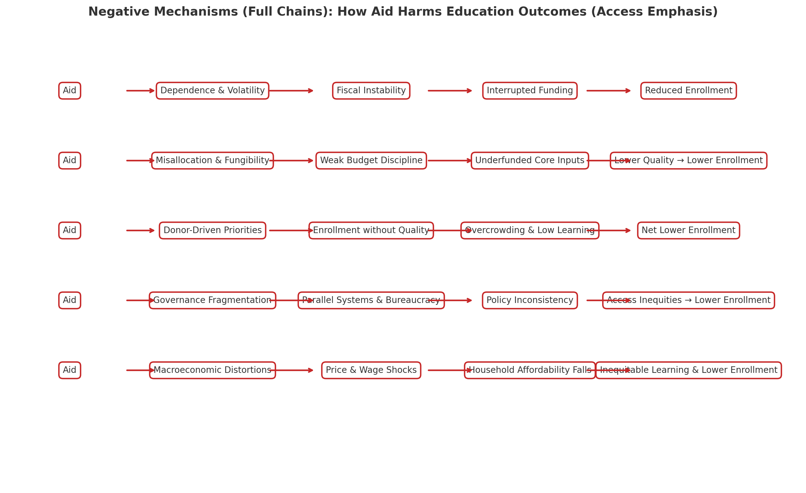

Data

Controls:
- growth in light density is a good proxy for growth in per capita consumption (Aid and Local Growth in Malawi ), proxy for economic growth we use nighttime light data. Chen and Nordhaus (2011) and Henderson, Storeygard, and Weil (2012) subsequently showed that light intensity at night is a good proxy for local economic activity. We can check our proxy for development using the World Bank Living Standards Measurement Study in the years 2010, 2011 and 2013.
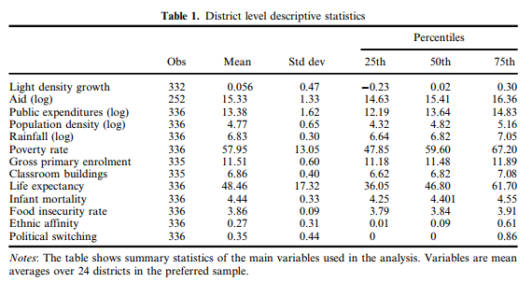
Source : showns here, https://www.tandfonline.com/doi/suppl/10.1080/00220388.2022.2032668?scroll=top

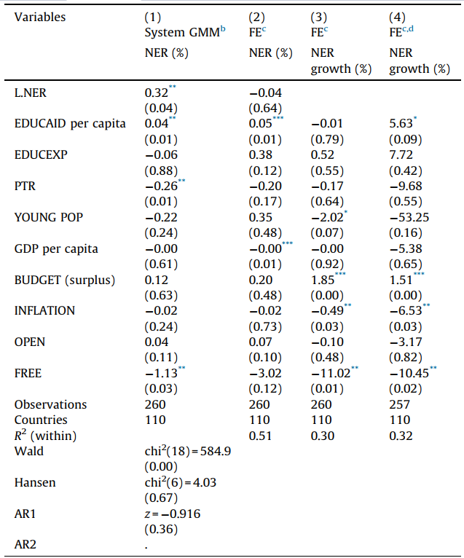
- lagged NER
- EDUCEXP: recipient governments’ own expenditure on education as a share of GNI
- structural characteristics of the education system: prevailing pupil–teacher ratio (PTR), and the share of the population under 15 years of age (YOUNG POP). Both indicate structural difficulties a country may have in increasing enrolment rates.
- economic and political governance using the budget surplus or deficit (BUDGET), INFLATION, openness to trade (OPEN), and the mean value of political freedom and civil liberties FREE. While good governance is generally correlated with development-oriented government preferences that can be expected to influence educational outcomes, it also affects donors’ propensity to grant development assistance.

Method | Regression Specification | Main Variables & Transformations | Interpretation / Notes
1. OLS / Fixed Effects (FE) | [ \text{NER}{it} = \alpha + \beta_1 \text{EDUCAID}{it-1} + \gamma' X_{it} + \mu_i + \lambda_t + \varepsilon_{it} ] | - Dependent variable: ( \text{NER}{it} ) = net primary enrolment rate (%) - Key independent: ( \text{EDUCAID}{it-1} ) = education aid disbursement per capita (in log or level) - Controls (X): education expenditure share of GNI, pupil–teacher ratio (PTR), % population under 15, GDP per capita, inflation, openness, governance indicators. - Fixed effects: ( \mu_i ) (country), ( \lambda_t ) (time period) | Tests whether higher aid disbursements are associated with higher enrolment, controlling for country/time fixed effects. Susceptible to reverse causality (aid responds to poor outcomes).
2. Dynamic Panel (System GMM) | [ \text{NER}{it} = \alpha + \rho, \text{NER}{i,t-1} + \beta_1 \text{EDUCAID}{it-1} + \gamma' X{it} + \varepsilon_{it} ] | - Dependent: ( \text{NER}{it} ) - Lagged dependent variable ( \text{NER}{i,t-1} ) included → introduces dynamic bias - Key independent: ( \text{EDUCAID}{it-1} ) (log of per capita education aid) - Endogenous variables: ( \text{NER}{i,t-1} ), ( \text{EDUCAID}_{it-1} ), sometimes education expenditure (( \text{EDUCEXP} ))  - Instruments: deeper lags of NER, EDUCAID, etc., in differences and levels | Estimated using Arellano–Bond (1991) or Blundell–Bond (1998) system GMM. Corrects bias from lagged dependent variable and simultaneity (aid ↔ enrolment). Interprets ( \beta_1 ) as short-run partial effect of aid on enrolment.
3. Instrumental Variables (2SLS / IV-FE) | First stage: [ \text{EDUCAID}{it-1} = \pi_0 + \pi_1 Z{it-1} + \delta' X_{it} + \mu_i + \lambda_t + u_{it} ] Second stage: [ \text{NER}{it} = \alpha + \beta_1 \widehat{\text{EDUCAID}}{it-1} + \gamma' X_{it} + \mu_i + \lambda_t + \varepsilon_{it} ] | - Dependent (2nd stage): NER (level or change)  - Endogenous variable: education aid per capita  - Instrument (Z): e.g., governance indicator, FTI endorsement year, child mortality, or donor-interest proxies (depends on paper) - Controls and fixed effects as above | Solves reverse causality bias by using exogenous predictors of aid. The coefficient ( \beta_1 ) reflects causal impact of predicted aid on enrolment. Results sensitive to instrument validity.
4. Growth-Rate (Change) Model | [ \Delta \text{NER}{it} = \alpha + \beta_1 \log(\text{EDUCAID}{it-1}) + \gamma' \log(X_{it}) + \mu_i + \lambda_t + \varepsilon_{it} ] | - Dependent variable: ( \Delta \text{NER}{it} = \text{NER}{it} - \text{NER}_{i,t-1} ), i.e. growth rate (percentage change)  - Aid variable: log of aid per capita (lagged)  - Other controls in logs (except categorical or negative values like budget balance, governance index) | This converts the outcome into growth in enrolment, reducing bias and emphasizing responsiveness. Birchler & Michaelowa (2016) find that doubling aid per capita over five years → ~5.6% increase in enrolment.
5. Qualitative Comparative Analysis (QCA) | Boolean logic, not regression. Examines patterns of combinations: [ \text{Outcome (success)} = f(\text{Equal Aid Shares},; \text{High/Low NER},; \text{High/Low Aid}) ] | - Dependent: improvement in (i) education quality or (ii) both quality & enrolment - Predictors (binary dummies): 1 = balanced aid between primary & higher education 1 = initial NER ≥ 80% 1 = high aid per capita - Uses Boolean simplification (Ragin, 1989) | Applied to SACMEQ 15-country dataset. Finds quality improvements when aid is balanced across sub-sectors, not necessarily when aid volume is high. Suitable for small N.

