**Revised Entity Relationship Diagram:**

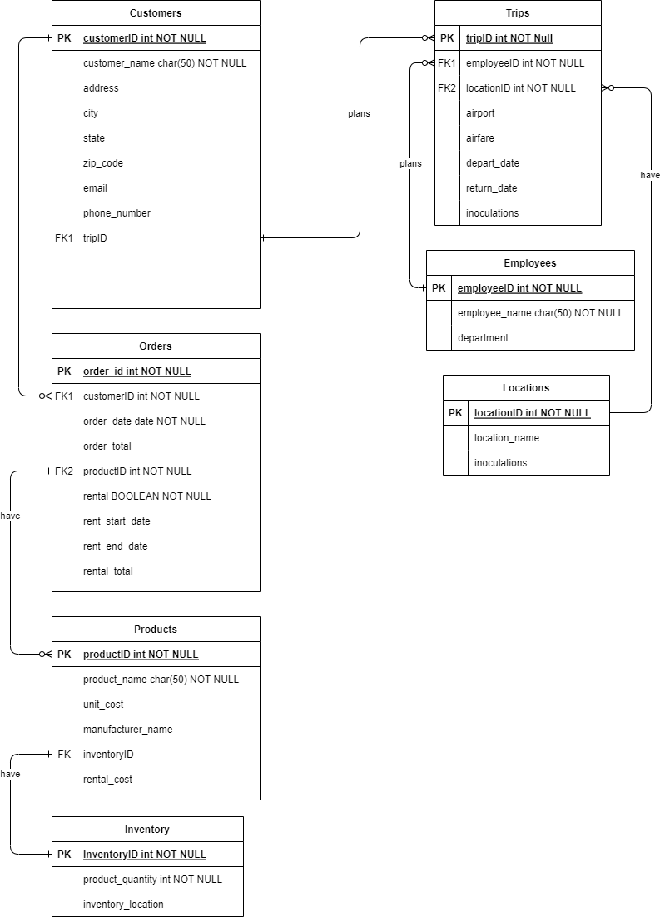

**Python Script Output (*DB_print_data.py*):**

