Charlene Centeno

CSD340

Module 1.2

GitHub Repository Setup

GitHub Link - <https://github.com/charleneyc1985/csd-340>

GitHub Repository

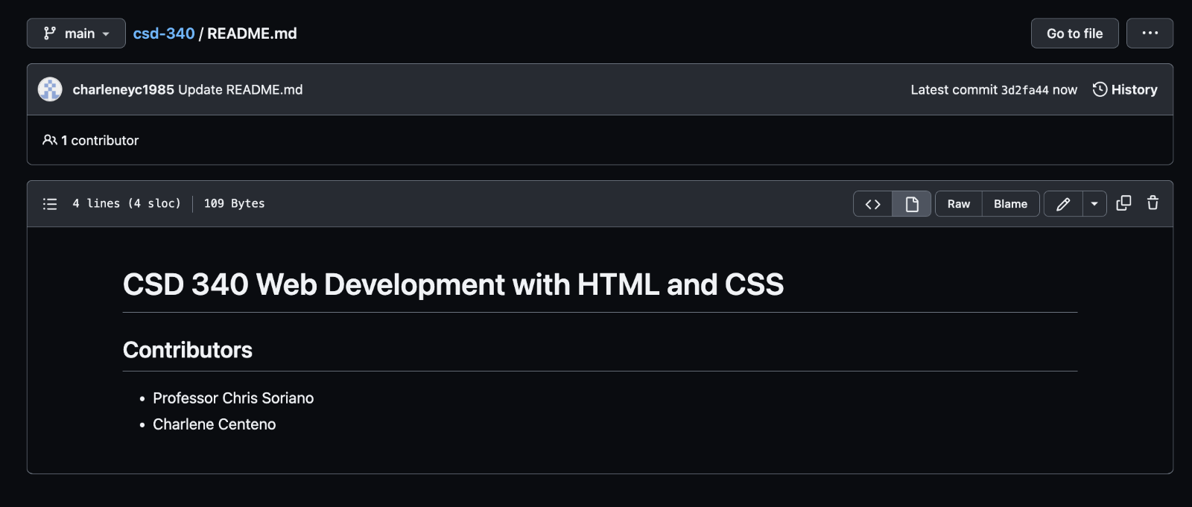

Local Directory

