MOBILE APPLICATION DEVELOPMENT PROJECT

Phase 1 Documentation
Project Proposal & Requirements Package
Ten Required Deliverables • Sections 1–10

BillAlert
Electricity billing, reminders and area collection records

Student Name(s): Charles Carcallas
Mary Tiffany Busalanan
Krisha Mae Basio
Cristell Obiso
Program / Section: BSCS – 3B
Instructor: Dr. Rey Anthony G. Godmalin
Date Submitted: ____________________

Current-project revision
Revised 24 October 2026 against the current working project, including local changes based on repository revision 7256f97. This document describes implemented source behavior and acceptance criteria. It does not certify that every backend update is deployed or that every workflow has passed a physical-device test.
This revision replaces the outdated descriptions throughout the original Phase 1 document. Existing functional identifiers are retained, new current-scope requirements use FR-38 onward, and the historical absence of FR-02 is preserved.

1. Project Title
Item | Current description
Application | BillAlert
Tagline | Electricity billing, reminders and area collection records
Primary setting | The project’s local area billing workflow in Tubod, using BOHECO statements and area staff roles.
Delivery target | Android application with a Supabase backend; a web build is retained for development preview.

Project overview
BillAlert connects the Area President, Meter Reader, Cashier and household Consumer through a shared billing record. The Meter Reader captures consumption, the President posts the amount from the cooperative statement, and the Cashier records eligible cash collections. Households can review bills, payment receipts and notices. The application also records reserve-fund activity, cooperative settlement evidence, staff changes and collection schedules.
The application records consumption but does not derive a peso charge from a kWh rate. The posted cooperative amount is retained, while the household amount rounds upward to the next whole peso. Local queues support selected field work, and SMS supplements app access for households with a registered mobile number.

Reading this revision
“Implemented” means the relevant behavior exists in the current source. User-story criteria state observable completion conditions. Performance, accessibility and device-delivery checks remain acceptance targets unless evidence is explicitly identified. The supporting change log records the source mapping and verification limits.

2. Problem Statement
The project’s original local workflow description identifies separate meter-reading records, cooperative paper statements and message-based sharing of bill information. The cooperative amount is available after reading capture, so a household’s reading and payable bill do not necessarily become available at the same time. Manual handoffs can make it difficult to know which record is current, whether a household has paid, and which staff member should follow up.
These observations motivate a shared area record rather than establish a measured prevalence of late payment in Tubod. The project has not supplied a local survey proving that missed messages cause most nonpayment or that every household owns a smartphone. Affordability, service arrangements and other factors can also affect payment. Published work on Philippine electric cooperatives associates collection outcomes with broader institutional conditions [1]; software alone cannot resolve those conditions.
A useful system must distinguish four situations: a reading awaiting its amount, a bill eligible for Cashier collection, an obligation temporarily covered by reserve funds, and a bill to be paid directly at BOHECO. Treating all four as the same payable balance can produce duplicate collection or misleading notices. Receipts, cooperative evidence and fund movements therefore need separate, traceable records.
Connectivity is another operating constraint. Readers and Presidents need selected work to survive temporary disconnection, while cash and account changes require current server checks. Households need clear saved-data indicators. Alerts must also respect practical limits: SMS depends on a correct number, a working gateway and network service; Android reminders depend on device permission and scheduling. Neither channel guarantees that the recipient has read or acted on the message.

Problem addressed
BillAlert addresses fragmented billing information and follow-up by linking readings, posted amounts, notifications, receipts, settlement evidence and staff accountability within one area-scoped workflow. It aims to improve the availability and traceability of information; any reduction in missed payments must be evaluated through a later field study.

3. Objectives
General objective: maintain an accessible and auditable record of area electricity billing, household communication, collection and cooperative follow-up using the current Android project.
Specific objective | Requirement coverage and evaluation
Provide appropriate access | FR-01, FR-03–08 and FR-31, 38–41, 51. Verify permitted household/work entry, temporary-password replacement, recovery and controlled staff handover.
Preserve field records | FR-09–12 and FR-19–22, 52. Test offline reading, amount and notice queues, owner separation, duplicates and reconnection.
Make obligations understandable | FR-23–27, 33, 36, 42. Check priced/unpriced states, current payment route, Philippine dates and exact receipt selection.
Communicate according to available channels | FR-13–18 and FR-50. Verify the channel matrix, permissions, unread state and distinct SMS dispatch outcomes; conduct delivery checks on devices.
Record cash and settlement without duplication | FR-28–30, 34–35 and FR-43–49. Exercise atomic receipts, QR references, cash reconciliation, reserve coverage, repayments and cooperative evidence.
Support evidence-based notice follow-up | FR-27, 32, 37. Check eligibility, service time, the configured interval and retained closure evidence.

The evaluation should report task completion, data integrity and observed delivery behavior. It must not describe load-test targets, field payment improvements or universal notification delivery as established results without measurements.

4. Scope and Limitations

In scope
Area | Included behavior
Access and accounts | Username sign-in, temporary password change, supported saved-session unlock, household linking, one-login household/work views, staff appointment, account controls and President succession.
Reading and billing | Assigned-area roster, previous reading, reading sheet, duplicate protection, unpriced bills, manually posted cooperative amounts and configurable Philippine-time schedules.
Consumer records | Current bills, bill history, payment-date filtering, itemized receipts with reference QR, Inbox and served notices, including available offline cache.
Collection and reserve | Online Cashier collection, one receipt per transaction, actual reserve cash, coverage allocation, covered-bill repayment, rounding credits and monthly Reader compensation.
Cooperative follow-up | Collection closure, physical handover records, confirmed BOHECO trip reporting, payment evidence, direct household settlement and separately recorded supply status.
Notice and oversight | Eligibility checks, service evidence, a configured 48-hour follow-up interval, notice outcomes, reserve reporting and justified corrections.
Communication and saved work | Bill-ready app and optional SMS alerts; local app pre-due reminders; enabled overdue alerts; notice SMS; household and staff Inbox; supported offline queues.

Operational boundaries
BOHECO statement amounts, payment receipts and field outcomes are entered or verified by authorized staff. There is no automatic BOHECO billing API, bank or e-wallet payment integration, remote meter reader, or control of electricity supply. A recorded notice is not proof that a cooperative has disconnected a household.
Cash recorded in the system must correspond to physical cash. Reserve balances, compensation and returned cash require reconciliation. Covered-bill repayments restore the fund and must not be counted as a second cooperative remittance. Direct BOHECO payments do not generate Cashier cash receipts.
The 48-hour interval is the project’s configured workflow boundary. This document does not certify legal notice sufficiency, service validity or a right to disconnect. Any operational adoption must use the cooperative’s applicable process rather than treating the screen timer as legal advice.

Connectivity, devices and deployment
Initial authentication and sensitive cash/account actions require connectivity. Saved data and scheduled reminders can remain stale until refresh. Remote account changes cannot instantly clear an unlocked offline phone; handovers require device and pending-work reconciliation.
Android is the current target; web is a development preview, and production iOS/Windows support is not established. Permissions, background restrictions, force-stop and gateway/network availability can delay alerts. A receipt QR alone does not prove authenticity. Local migrations and tests do not establish live deployment; device, cash and user-acceptance checks remain separate.

5. Target Users
User | Responsibilities and access
Consumer / household account holder | Review only the linked household’s bills, payment route, receipts, Inbox and notice information. Maintain the SMS mobile number and notification preferences. A household using a basic phone can receive enabled SMS but does not gain app screens through SMS alone.
Area President (Admin) | Manage accounts and staff within the assigned area; post cooperative amounts; maintain the billing schedule; record and review eligible notices; inspect reserve records and perform justified corrections. Prepare and complete a controlled President handover.
Meter Reader | Capture and check assigned-area readings, work through the saved queue, inspect the reading sheet, close collection when appropriate, record handovers and verify cooperative trip/payment evidence and confirmed supply outcomes.
Cashier | Find eligible households, perform online collection, issue and inspect receipts, record actual reserve cash, allocate eligible coverage, collect covered repayments and record monthly Reader compensation.
Supporting external services | Android presents local phone notifications and scheduled reminders; the SMS gateway dispatches texts and reports outcomes. Scheduled backend work enforces eligible routing and enabled alert rules when deployed and configured.

A staff member can also be a household account holder under the same login. Switching views changes the displayed purpose, not the permitted ownership or area. An incoming staff appointment requires the appropriate household link; ending work access is different from disabling the person’s login.
No age distribution, literacy level, device ownership rate or adoption percentage is asserted without a project survey. Interface validation should include representative Consumers and each staff role, including users with intermittent connectivity and accessibility needs.

6. Literature Review

Related studies
Study | Relevant finding and application
[1] Escresa and Glova (2024) | The study associates weaker political competition in Philippine electric-cooperative franchise areas with poorer collection efficiency and larger employee size. It supplies institutional context, not proof that a reminder app fixes collection problems. BillAlert therefore treats improved information traceability as its direct contribution.
[2] Wenceslao and Zaragosa (2022) | A web-based electricity billing prototype with SMS notification was evaluated positively for perceived usability and performance. It supports the feasibility of combining bill records with text messages. Those evaluations are not evidence of BillAlert performance or a measured causal reduction in late payments.
[3] Antinyan et al. (2021) | In a Chinese overdue-property-tax trial, weekly text reminders outperformed a one-off reminder, while more frequent reminders reduced effectiveness. The setting differs from electricity billing. BillAlert uses a limited reminder pattern, whose timing and effects require local evaluation.

Comparable applications
Application | Verified feature and comparison
My Meralco [4] | The official service page describes viewing and paying bills. BillAlert shares the bill-access purpose but concentrates on area staff, physical cash records, selected offline field work and manual cooperative evidence. It does not claim payment-channel integration or equivalent utility-scale capability.
MobileAP / Visayan Electric [5] | The utility describes monthly bill viewing, 12-month payment history, consumption charts, multiple accounts and payment options. BillAlert’s differentiating scope is its local role workflow and reserve/BOHECO recordkeeping. No claim is made that MobileAP lacks SMS, offline support or other features not established by the cited page.

Design implications
The literature supports investigating accessible billing records and restrained reminders while keeping evaluation claims narrow. It does not establish the best reminder frequency for Tubod, prove that all overdue accounts were uninformed, or justify replacing cooperative procedures. BillAlert’s field evaluation should measure usability, record consistency and notification reach separately from household payment outcomes.

References
[1] Escresa, L. C., & Glova, A. M. G. (2024). Politico-economic determinants of the performance of electric cooperatives in the Philippines. Utilities Policy, 91, 101815. DOI
[2] Wenceslao, J. L. B., & Zaragosa, A. R. A. (2022). Web-Based Electricity Billing System with SMS Notification. International Journal of Research in Engineering and Science, 10(6), 1087–1091. Publisher full text
[3] Antinyan, A., Asatryan, Z., Dai, Z., & Wang, K. (2021). Does the frequency of reminders matter for their effectiveness? A randomized controlled trial. Journal of Economic Behavior & Organization, 191, 752–764. DOI
[4] Meralco. (n.d.). My Meralco. Official service page, accessed 24 October 2026. Official page
[5] Visayan Electric. (n.d.). Payment and Refund Concerns. Official customer-service page, accessed 24 October 2026. Official page
Source-access note: the 2024 article’s bibliographic record and abstract were checked through its indexed record; an earlier author working paper is also available. The reminder study’s publisher/indexed abstract and author-institution record were checked. No unavailable full text is represented as having been reviewed.

7. Requirements Analysis

Functional requirement register
This register contains 51 active requirements. FR-02 was absent from the source document and remains unused; existing identifiers are not shifted. FR-38–52 formalize current features previously described as extensions. All entries describe source-implemented scope; deployment and device acceptance are tracked separately. The project’s older code comments sometimes use different FR numbering, so this register is the documentation reference.
ID / capability | Current requirement
FR-01  Sign in and authorize access | Authenticate by username and password and open only the household or work views permitted by the current account, role and area. Initial sign-in requires connectivity.
FR-03  Replace temporary password | Require a user issued temporary credentials to set a new password before entering protected work or household screens.
FR-04  Change password | Permit an authenticated user to change the password online. Require at least eight characters and matching confirmation. The current application does not require uppercase letters, digits or symbols. A failed request must not be presented as a completed change.
FR-05  Unlock a saved session | Offer supported device biometrics or the device PIN, pattern or password to reopen an eligible saved native session. Offline password verification is available after a successful online credential check; a fresh online sign-in remains distinct.
FR-06  Sign out safely | End the active session and remove its visible cached records and phone alerts. Retain unsent operations under their original owner for reconciliation; do not upload them as a different user. Sign-out is not a promise to erase another offline device.
FR-07  Control phone alerts | Request notification permission on supported Android devices and show permission and urgent-alert controls in Profile. Respect denied permissions and use the available Android presentation when full-screen alerts are unavailable.
FR-08  Maintain contact number | Allow the linked household to update its Philippine mobile number with validation and normalization. Store the number for subsequent SMS delivery; changing it does not establish that a previous message was delivered.
FR-09  Read cached records | Cache permitted household bills, history, receipts and Inbox records and applicable staff lists for offline viewing. Separate records by account and area, identify saved data and handle an empty cache explicitly.
FR-10  Save supported offline work | Persist supported reading, bill-amount and notice operations in an owner-scoped local queue. Cash collection, account management, schedule edits and reserve cash changes require an online confirmation path; they are not general offline writes.
FR-11  Synchronize safely | Retry queued work when a permitted active session and reachable connection are available, including foreground reconnection. Reuse operation identifiers, retain failed or uncertain work and surface conflicts; do not promise uploads while Android has stopped the app.
FR-12  Show pending and saved state | Display pending work and applicable last-saved or refresh information. Distinguish locally saved, synchronized, failed and uncertain results so users can tell whether the server has confirmed a change.
FR-13  Announce a priced bill | Queue the bill-ready alert when the Area President posts the cooperative amount and due date, not when a reading first creates an unpriced bill. Replaying the posting operation must not duplicate the bill or its channel-specific alert.
FR-14  Remind before the due date | Schedule an Android app reminder at 08:00 Philippine time, by default three days before an unsettled bill is due. Refresh the plan after synchronization, cancel reminders for newly confirmed settled bills and skip reminder times already past. No pre-due SMS is implemented.
FR-15  Queue enabled overdue alerts | Support overdue alert queuing for eligible priced unpaid or partial bills after the configured due-date offset. Respect the overdue enable setting, existing alerts and active-notice exclusion. The source default for overdue SMS is disabled; live enablement is not assumed.
FR-16  Deliver and track current alert channels | Use the current channel matrix: bill-ready app/Inbox plus an optional SMS copy enabled by default; pre-due local Android reminder only; overdue configured channel (SMS by default) only when enabled; disconnection SMS with its notification record visible in Inbox. App phone alerts use polling and local Android notifications, not a Firebase remote-push service. Record SMS failures and dispatch uncertainty; gateway acceptance, delivery confirmation and Inbox read state are separate facts.
FR-17  Open an alert destination | Open the related bill or notice from an available phone alert or Inbox item, rechecking the signed-in household and permitted target. Reject stale or foreign-account destinations.
FR-18  Maintain the household Inbox | List permitted household notifications with unread state and a badge; allow marking an owned item read. Exclude duplicate bill-ready SMS copies from the Inbox count and list. A local pre-due reminder need not create an Inbox row.
FR-19  Show the reading roster | Give the Meter Reader the assigned-area roster, current-cycle progress and not-yet-read households, including pending local work without attributing it to another Reader.
FR-20  Show the previous reading | Display the applicable previous meter reading and cycle or baseline before entry so the Reader can check the new value.
FR-21  Record a reading | Validate and save a new meter reading, its consumption difference and capture time, creating an unpriced bill for the cycle. Consumption is a recorded quantity, not a money calculation.
FR-22  Prevent duplicate readings | Reject duplicate household or meter readings for the same billing cycle through local checks and server constraints; replaying the original queued operation must not create another bill.
FR-23  Show current obligations | Show the linked household’s current bill, consumption, priced or awaiting-amount state, due date and balance. Distinguish Cashier collection, reserve-covered repayment and direct BOHECO payment, with applicable collection deadlines.
FR-24  Browse billing history | List available historical bills by cycle with amount, consumption and settlement state, supporting the screen’s search and ordering controls and cached access.
FR-25  Filter payment history | List one item per actual receipt and filter by an inclusive start/end payment-date range using Philippine calendar dates. Combine the range with text search and ordering, clear it independently, and open the exact selected receipt. Billing-history filters remain independent.
FR-26  Inspect a household receipt | Open a permitted receipt with its reference, payment date, collected amount and bill allocations. Show the existing verification reference and its QR when available. A direct BOHECO settlement must not invent a Cashier receipt.
FR-27  View a served notice | Show the household’s active notice, service evidence and the earliest follow-up time derived from the stored service time plus the configured 48-hour interval. This is an application workflow rule, not proof of actual disconnection or legal compliance.
FR-28  Record eligible cash collection | Allow an online Cashier to collect against eligible same-area bills after a current server check. Apply multi-bill payments atomically, reject unpriced or ineligible routes and show cash tendered and change. Reconcile uncertain results using the original operation.
FR-29  Issue a receipt with QR | Issue one itemized receipt per successful cash transaction and render its server-issued verification reference as a QR on the new receipt, Cashier detail and Consumer detail views. Retain readable text; a missing reference shows unavailable. The QR encodes a reference, not an authenticated verification service.
FR-30  Reopen permitted receipts | Allow the Cashier to reopen an exact permitted receipt and see its household, allocations, total, timestamp and verification reference without recording a second payment.
FR-31  Create linked accounts | Allow an online Area President to create a permitted account linked to a new or eligible existing household and issue temporary credentials. Use one current Reader and Cashier assignment per area; President succession uses its separate workflow. Review uncertain creation before another attempt.
FR-32  Close notice follow-up | Let the Area President review settlement evidence and close a notice as settled, cancelled or referred to BOHECO, subject to applicable evidence, explanation and time checks. Preserve the actor, outcome and history.
FR-33  Apply Philippine time | Use Philippine time (UTC+8) for cycle boundaries, payment dates, overdue status, collection cutoffs and notice deadlines; device timezone changes must not reinterpret stored obligations.
FR-34  Find collectible balances | Allow the Cashier to search permitted households by name or account number and display their eligible collectible balances and payment route within the assigned area.
FR-35  Browse recorded collections | List permitted Cashier receipts in recent-first order with household, reference and amount; distinguish the historical reporting period from an actual collection cutoff or handover deadline.
FR-36  Post cooperative amounts | Let the Area President enter the BOHECO statement amount and explicit due date for an unpriced bill. Preserve the exact cooperative amount and round the household payable amount upward to a whole peso. Do not calculate the charge from kWh.
FR-37  Record an eligible notice | Permit a new notice only for an overdue unpaid bill whose direct BOHECO referral has been confirmed. Exclude reserve-covered bills, retain service evidence and calculate the 48-hour follow-up boundary. Queue its SMS notification once; record field outcomes separately.
FR-38  Use household and work views | Allow a staff identity with a household link to switch between permitted work and personal-household views under one login, without broadening either view’s record access.
FR-39  Manage account and occupant changes | Distinguish ending work access from disabling login. Support reviewed same-household identity replacement and unrelated-occupant handover with a fresh household ledger and validated meter baseline; retain the former household’s history.
FR-40  Replace assigned staff | Allow the Area President to appoint or replace the area’s Reader or Cashier with a household-linked person. Reconcile pending work, remove outgoing work access and preserve identity and household history. Recheck versions and permissions online.
FR-41  Transfer President responsibility | Require successor preparation, acceptance and explicit completion before transferring President work access. Require the successor’s household link and retain historical attribution.
FR-42  Maintain the billing schedule | Let the online Area President save a default due day and collection closing day/time in Philippine time. Clamp short months, preserve posted due dates and closed trips, apply current/future revision rules and reject stale edits. Defaults are day 28 and noon.
FR-43  Record reserve cash | Record actual opening funds, contributions and permitted withdrawals with reasons and an audit trail. Protect unpaid Reader compensation; regular collections credit only rounding actually received, once. Reuse unresolved cash request identifiers across restarts and sign-out.
FR-44  Allocate reserve coverage and route bills | Allocate available reserve funds to eligible positive unpaid, not-overdue bills using exact cooperative amounts and record actual handover to the Reader. Uncovered and overdue eligible bills follow the direct BOHECO route; overdue bills are excluded from new reserve coverage.
FR-45  Close collection and record the trip | Allow the Reader to close collection early, otherwise enforce the saved cutoff, and record collection/remittance handovers. Complete a BOHECO trip by confirming accounts actually reported; closing collection alone is not cooperative payment or referral confirmation.
FR-46  Verify external settlement and supply | Record cooperative receipt reference, payment date and evidence for reserve remittance or a household’s direct BOHECO payment. Direct payment creates no Cashier receipt or reserve credit. Record disconnected or reconnected supply only from confirmed field information.
FR-47  Collect covered-bill repayments | Allow online collection of an eligible household’s full reserve-covered balance, issue a repayment receipt and restore the fund once. Exclude that repayment from money due for a second BOHECO remittance.
FR-48  Record Reader compensation | Protect PHP 500 per unpaid area-month from October 2026 (PHP 200 salary and PHP 300 transport). Debit the fund only on confirmed payout to the Reader. Prevent duplicate active payouts; require a reason and actual cash return or non-handover for reversal.
FR-49  Review and correct settlement records | Provide an Area President report of reserve cash and settlement activity. Require reasons, expected record versions and retry-safe identifiers for corrections; restore returned cash only once. Preserve evidence and distinguish legacy waivers from new normal Reader billing.
FR-50  Show staff work alerts | Deliver staff Inbox and phone alerts to the intended staff identity, role and area, with appropriate work destinations and unread state. Keep household and staff alerts distinct during account/view changes.
FR-51  Support password recovery | Provide recovery guidance and an authorized Area President reset flow for permitted accounts. Issue temporary credentials, require replacement at next sign-in and prevent an old saved session from bypassing a newly detected account reset.
FR-52  Review the reading sheet | Give the Reader an area/cycle reading sheet with recorded readings and consumption for checking completed field work, separate from monetary bill pricing.

FR-16 channel matrix
Event | Current route | Conditions and evidence
Bill ready | App / Inbox + optional SMS | Posting the amount creates the alert. The SMS copy defaults enabled and is omitted from the Inbox list/badge. Missing number is recorded as failed.
Pre-due | Local Android reminder | 08:00 Philippine time, normally three days before due date. No pre-due SMS. Requires a locally scheduled plan and applicable device permission.
Overdue | Configured channel; SMS by default | The overdue enable switch defaults false in source. Eligibility, due-date offset, existing alerts and active-notice exclusion apply.
Disconnection notice | SMS + notification record in Inbox | Created after eligible notice service. No additional remote push channel is promised.
Staff work item | Staff Inbox / local phone alert | Restricted to intended staff identity, work role and area; destination must remain permitted.

The legacy database channel name “push” denotes the project’s app-alert rows. The Android client polls and presents local notifications; Firebase remote push is not implemented. Approximate 15-minute background checks are best effort. “Shown”, “gateway accepted”, “delivered” and “read” are distinct states, and live channel settings were not queried for this revision.

Non-functional requirements
ID / quality | Current control or acceptance target
NFR-01  Performance targets | Acceptance targets: cold start within 3 seconds, cached navigation within 1 second, ordinary server reads within 3 seconds and confirmed writes within 5 seconds under a defined 50-concurrent-user test. Record device, network, dataset and percentile before accepting these targets. These are not measured guarantees in this revision.
NFR-02  Security and privacy | Current controls: passwords require at least eight characters and matching confirmation, without character-composition rules. Online credentials use Supabase Auth; app connections use HTTPS. Native session secrets and the SQLCipher database key use secure storage; the offline password verifier stores a salted PBKDF2-derived value rather than plaintext. Role, household and area checks exist in application and backend definitions. Web cache is not encrypted and web is a development preview. Acceptance must exercise unauthorized access, account resets, owner-separated queues and sign-out on a deployed Android build; source review is not a live security audit.
NFR-03  Usability | Use consistent role navigation, readable payment routes and explicit confirmation or pending states for cash and account changes. Acceptance target: representative users complete the core task for their role without assistance after onboarding; record completion rate and errors. The earlier two-action claim is not a blanket constraint on evidence and confirmation workflows.
NFR-04  Accessibility | Acceptance targets: support text scaling, semantic labels for interactive controls, visible focus and errors that do not rely only on color. Check 320-pixel layouts, both themes and Android screen-reader navigation. Some narrow-layout widget checks exist; a complete accessibility audit remains pending.
NFR-05  Reliability and integrity | Supported queued work and uncertain cash-request identifiers survive ordinary restart and remain tied to their original owner. Duplicate retries must not create repeated readings, receipts, alerts or ledger credits. Failures remain visible for reconciliation. App uninstall, storage clearing and loss of a device are outside local-cache durability.
NFR-06  Compatibility | Android is the supported application target. The checked build uses compile SDK 36 and Flutter’s minimum SDK, currently API 24 in the local toolchain. Actual supported device behavior must be tested on release builds. Web is a development preview; production iOS and Windows support is not established by this project.
NFR-07  Background operation | Refresh alerts on opening/resuming and through best-effort Android background work scheduled roughly every 15 minutes. Locally planned reminders depend on Android permission and scheduling behavior. Foreground reconnect resumes supported synchronization; do not guarantee immediate notification or upload from a force-stopped app. Validate idle, offline, permission-denied and battery-restricted cases on devices.

Verification status
The FR-25 payment-date filter and FR-29 QR rendering have focused local tests covering date boundaries, combined filtering, receipt selection, narrow layouts, cached data and both themes. Rendered QR images decoded to their expected reference. Installed-phone camera scanning and rebuilt-app behavior remain device checks. Existing project reports describe broader local tests, but this document does not relabel them as new end-to-end or production verification.
Acceptance still requires deployment alignment, configured scheduled work, SMS gateway outcomes, Android idle/permission behavior, account handover across phones, cash reconciliation, accessibility review and the measured NFR-01 performance test. These are verification gaps, not reasons to invent absent implementation or claim universal completion.

8. User Stories
GUIDANCE: Format: As a [user type], I want [functionality] so that [benefit]. Each user story must include at least 3 acceptance criteria defining when the story is complete. Add one row per user story until every functional requirement above is traceable to at least one story.
The following 36 stories cover every active functional requirement. Criteria are observable acceptance conditions; they do not imply that all device or deployment checks have been completed. Each story has at least three criteria.
Story / FR reference | User story | Acceptance criteria
US-01  FR-01 | As a registered user, I want to sign in with my username and password so that I can access my permitted household or work screens. | 1. Valid credentials open the home screen permitted by the stored account role and access status.  2. Invalid credentials show an error without opening protected records.  3. Staff access is restricted to the assigned area; household access is restricted to the linked household.
US-02  FR-03, FR-04 | As a registered user, I want to replace my temporary password and change it later so that I can protect my account. | 1. Temporary credentials require replacement before protected screens open.  2. A new password shorter than eight characters or a mismatched confirmation is rejected; the current app does not require particular character types.  3. A successful online change allows the new password at sign-in; an unsuccessful or offline request shows an error without claiming completion.
US-03  FR-05 | As a returning user, I want to unlock my saved session using supported device authentication so that I can resume work without repeatedly entering my password. | 1. Device unlock is offered only for an eligible saved session and supported device setup.  2. Successful device authentication unlocks the saved account; cancellation or failure leaves it locked.  3. A password-based recovery path remains available when device authentication cannot be used.
US-04  FR-06 | As a signed-in user, I want to sign out safely so that another person cannot access my session or household records. | 1. Sign-out clears the active session and account-specific display caches.  2. Protected screens require authentication again after sign-out.  3. Unsent operations retain their original owner and cannot be viewed or uploaded as another account; signing out does not discard unresolved work.
US-05  FR-07 | As an app user, I want to control phone notification permissions so that I can decide whether alerts appear on my device. | 1. On supported Android devices, the app requests notification permission and Profile shows its current state.  2. A user can open system settings and turn urgent reminders on or off.  3. Denied permissions do not mark an unshown app alert as shown; unavailable full-screen permission uses the supported Android fallback.
US-06  FR-08 | As a household account holder, I want to update my SMS contact number so that billing texts reach my current phone. | 1. The current saved number is displayed for review.  2. Invalid Philippine mobile numbers are rejected with a correction message.  3. A confirmed update is used for subsequent SMS delivery and does not alter another household’s contact number.
US-07  FR-09, FR-12 | As an app user, I want to view saved information and its freshness so that I can work with known limitations when offline. | 1. Previously loaded role and household information remains readable without a connection.  2. Saved-data timestamps and pending-action counts distinguish cached records from confirmed server data.  3. An uncached screen explains that data is unavailable rather than displaying invented or empty confirmed results.
US-08  FR-10, FR-11, FR-12 | As a field staff member, I want to retain and synchronize supported offline work so that recorded work survives connection loss without duplication. | 1. Readings, amount postings and notice captures are stored durably with their original account and operation identifier.  2. Connection recovery or foreground retry synchronizes eligible queued work without creating duplicate records.  3. Pending and rejected work remains visible with status and retry guidance; new cash payments and online-only account or fund actions are not presented as completed offline.
US-09  FR-13, FR-16 | As a consumer, I want to receive an alert when my bill amount is posted so that I know when the bill is ready to review. | 1. Recording a meter reading creates an unpriced bill and does not send a bill-ready alert.  2. Posting the cooperative amount queues the app/Inbox alert and an SMS copy when bill-ready SMS is enabled.  3. The Inbox omits the duplicate SMS copy; missing contact information produces an explicit SMS failure rather than a delivery claim.
US-10  FR-14, FR-15, FR-16 | As a consumer, I want to receive due-date and overdue alerts so that I can act on unpaid bills promptly. | 1. An unsettled bill is scheduled for an app reminder at 08:00 Philippine time, normally three days before its due date; no pre-due SMS is created.  2. A successful refresh cancels reminders for confirmed settled bills and does not schedule reminders whose time has already passed.  3. Overdue alerts are queued only when enabled, eligible and not already present; the source default disables overdue SMS.  4. Unavailable connectivity or Android permissions can delay alerts, and gateway acceptance is not presented as proof of delivery.
US-11  FR-17, FR-18 | As an app user, I want to review my alert Inbox and open linked records so that I can follow up on the right bill or notice. | 1. The Inbox displays alerts for the authenticated account with an unread count.  2. Opening an alert displays its relevant bill or notice and updates the read state.  3. Alert taps verify the recipient and permitted destination; an alert for another signed-in account cannot expose that account’s records.
US-12  FR-19, FR-20 | As a Meter Reader, I want to review my area’s reading roster and previous readings so that I can identify the next household to read. | 1. The roster includes active households in the assigned area and identifies those not yet read in the selected cycle.  2. Cycle progress and pending reading uploads are visible.  3. Opening a household displays its previous recorded reading or established opening baseline before entry.
US-13  FR-21, FR-22 | As a Meter Reader, I want to record and confirm each household’s meter reading so that consumption is recorded accurately for billing. | 1. The confirmation shows previous reading, present reading and their consumption difference; invalid readings are rejected.  2. Saving retains the household, billing cycle and capture time and creates an unpriced bill after successful synchronization.  3. A second reading for the same household and cycle is rejected, including duplicate submission attempts.  4. No peso amount is calculated from consumption.
US-14  FR-23 | As a consumer, I want to view my current bill and payment route so that I know what I owe and where to pay. | 1. A priced bill shows amount, due date, readings, consumption and current payment status.  2. An unpriced bill shows reading information and an awaiting-amount message without inventing an amount or due date.  3. The display distinguishes current Cashier collection, reserve-covered repayment and direct BOHECO payment when applicable, and shows the applicable collection deadline.
US-15  FR-24, FR-26 | As a consumer, I want to inspect my billing history and payment evidence so that I can verify past charges and settlements. | 1. Billing history shows available cycles, consumption, amount and settlement state.  2. Selecting a household payment opens the exact receipt with payment date, amount and bill allocations.  3. Cached history remains available during a network failure; direct BOHECO payment does not become a Cashier receipt.
US-16  FR-28, FR-34 | As a Cashier, I want to find eligible household bills and record cash received so that payments settle the correct balances. | 1. Search by name or account number returns permitted households in the Cashier’s area and shows their eligible balances.  2. An online eligibility check blocks unpriced, already settled or incorrectly routed bills and enforces earlier-debt restrictions.  3. Confirmed collection records all selected eligible bills in one atomic payment and shows tendered cash and change.  4. An uncertain response retains the same operation for reconciliation; it does not invite a second cash collection.
US-17  FR-29, FR-30, FR-35 | As a Cashier, I want to issue and reopen the receipt for each payment so that I can provide reliable evidence of cash received. | 1. Each confirmed cash transaction has one receipt reference and itemizes all bills paid.  2. The new receipt and both role-specific detail views show the same readable verification reference and QR.  3. A missing verification reference shows unavailable; a QR encodes only the reference, not an authenticated lookup or payment action.  4. Receipt history opens the exact selected item; replaying a transaction cannot create a second receipt.
US-18  FR-31 | As an Area President, I want to register households and issue staff or household logins so that authorized people can use the correct records. | 1. Creation requires an online active Area President and limits the account to the assigned area.  2. The new identity is linked to a new or eligible existing household and receives temporary credentials requiring replacement.  3. Current Reader and Cashier positions are managed through staff assignment; an uncertain creation is reviewed before another attempt.
US-19  FR-36 | As an Area President, I want to post the cooperative’s amount and due date against a recorded reading so that the household receives an accurate payable bill. | 1. Only an eligible unpriced bill in the President’s area can be selected.  2. The entered cooperative amount is retained and its centavos are rounded up to the next whole peso for the household bill; consumption is not converted into money.  3. The due date is checked explicitly, successful posting updates the bill and queues the bill-ready alert, and replay does not post it twice.
US-20  FR-27, FR-37, FR-16 | As an Area President, I want to record service of an eligible disconnection notice so that the household can review the notice and respond. | 1. A new notice requires an overdue unpaid bill with a confirmed direct BOHECO referral; reserve-covered bills are excluded.  2. The record preserves service date and time and displays the configured 48-hour notice deadline in Philippine time to the household.  3. The household Inbox and SMS workflow receive the notice, with upload and delivery status kept distinct.  4. The app records notice evidence and timing without claiming that it physically disconnects supply.
US-21  FR-32, FR-37 | As an Area President, I want to review notice evidence and record its outcome so that follow-up reflects the household’s verified situation. | 1. Notice review shows linked bills, payment or settlement evidence and the notice deadline.  2. A Settled outcome requires verified settlement evidence; cancellation and referral require explanatory notes and applicable timing checks.  3. Closed notices retain outcome, actor and timestamps in history rather than disappearing from the audit trail.
US-22  FR-33 | As an app user, I want to see consistent billing dates and deadlines so that device timezone changes do not change my obligations. | 1. Billing cycle and overdue classification use Philippine time.  2. Notice deadlines and collection cutoffs use the same Philippine-time basis.  3. Changing the device timezone does not move a bill into another cycle or alter its stored due date or notice deadline.
US-23  FR-38 | As a staff member, I want to access my linked household using the same login so that I can review personal bills alongside my permitted work. | 1. An eligible staff identity can switch between work and linked-household views.  2. The household view exposes only the linked household and does not grant additional staff permissions.  3. A missing household link offers the applicable setup guidance; ending work access does not erase household history.
US-24  FR-39 | As an Area President, I want to manage account changes and household handovers so that access can change without losing billing history. | 1. Ending work access and disabling login are separate actions with appropriate reasons and reconciliation checks.  2. Same-household identity replacement requires the previous login to be disabled before reviewed reassignment.  3. An unrelated occupant receives a fresh household ledger and validated meter baseline, while the former household retains its billing history.
US-25  FR-42, FR-33 | As an Area President, I want to maintain my area’s billing and collection schedule so that staff and households use consistent deadlines. | 1. An online President can save the default due day and collection cutoff with Philippine time shown.  2. The schedule pre-fills new bill forms while permitting an explicit statement date; it never rewrites posted due dates.  3. Short months clamp invalid day numbers, closed trips remain closed, and stale concurrent edits require a refresh.
US-26  FR-43, FR-44 | As a Cashier, I want to record reserve fund cash and allocate it to eligible bills so that the area can cover selected BOHECO obligations with traceable funds. | 1. Opening money, contributions and withdrawals represent actual cash with a retained reason or reference.  2. New reserve coverage selects eligible unpaid, not-overdue bills within available funds after protected compensation and records actual handover of cooperative amounts.  3. Regular receipt rounding credits only cash actually collected, once; covered repayments follow their separate full-restoration rule.  4. An uncertain cash entry retains the same request across restart or sign-out and blocks a replacement entry until reconciled.
US-27  FR-45, FR-46 | As a Meter Reader, I want to record collection handovers and verify BOHECO outcomes so that cash and external settlements remain distinguishable. | 1. Collection closes at the saved cutoff or explicit early closure without claiming payment has reached BOHECO.  2. Complete BOHECO trip confirms only accounts actually reported; unreported cases remain distinguishable.  3. Reserve remittance and direct BOHECO payment retain cooperative reference, date and evidence; a direct payment creates no Cashier receipt.  4. Supply disconnection or reconnection is recorded from confirmation rather than inferred from a payment.
US-28  FR-47, FR-28, FR-29 | As a Cashier, I want to collect eligible reserve-covered repayments so that the reserve fund is replenished accurately. | 1. Only an eligible household’s full covered balance can be collected after an online check.  2. Confirmation records cash, change and one matching repayment receipt and restores the reserve fund once.  3. Repayments are excluded from money to remit to BOHECO again, and direct-payment cases remain view-only for Cashier.
US-29  FR-48 | As a Cashier, I want to record the monthly Meter Reader payout so that salary and transportation payments are accountable. | 1. An unpaid area-month reserves PHP 500, comprising PHP 200 salary and PHP 300 transportation, beginning October 2026.  2. Online confirmation requires sufficient funds and identifies the receiving Reader; only one active payout is recorded per area-month.  3. An authorized correction requires a reason and confirmation that cash was not handed over or was returned; reversal restores funds once.
US-30  FR-49 | As an Area President, I want to review reserve fund transactions and corrections so that I can reconcile cash and investigate discrepancies. | 1. The report shows fund balances and recorded contributions, allocations, repayments, payouts and withdrawals.  2. Corrections retain the original evidence, actor and reason and do not duplicate or silently erase cash movements.  3. Legacy waived bills remain distinguishable from cash-paid bills; new Reader bills follow normal billing under the current compensation policy.
US-31  FR-50 | As a staff member, I want to receive alerts about work assigned to my role so that I can act on new readings, bills and follow-up tasks. | 1. Staff alerts are limited to the intended account, role and area.  2. An alert opens the relevant permitted work item and retains unread state in the staff Inbox.  3. Consumer alerts remain separate, and account changes prevent a previous account’s alert from exposing its records.
US-32  FR-25 | As a consumer, I want to filter receipts by payment date so that I can find when I actually paid. | 1. Both range endpoints include payments on those Philippine calendar dates, regardless of the billing month.  2. Date range, search and ordering combine; Clear dates removes only the date range and cancelling the picker leaves it unchanged.  3. One row represents one receipt, multiple receipts for a bill stay separate and selecting a row opens that exact receipt.  4. An empty result is explicit, the Bills tab is unaffected and a failed refresh retains previously loaded receipts with an error indication.
US-33  FR-40 | As an Area President, I want to replace my area’s Reader or Cashier so that the correct person can carry out the work. | 1. The incoming person has a valid household link and the selected position has one current holder.  2. The outgoing person loses the work assignment but retains their identity and linked household history.  3. Pending work and device reconciliation are checked before completion; stale online versions are rejected without silently replacing newer assignments.
US-34  FR-41 | As an Area President, I want to transfer responsibility to an accepted successor so that area administration can continue with a clear handover. | 1. A successor with a household is prepared without immediately gaining President work access.  2. The successor explicitly accepts the prepared handover.  3. Explicit completion transfers responsibility and preserves historical actors; incomplete handovers do not silently grant the position.
US-35  FR-51 | As a registered user, I want to recover access through the authorized reset process so that I can return to my account after forgetting my password. | 1. The sign-in screen supplies recovery guidance without revealing stored passwords.  2. A permitted Area President can reset an eligible account and provide temporary credentials.  3. The next sign-in requires a new password, and a detected reset blocks bypass through the old saved session.
US-36  FR-52, FR-20, FR-21 | As a Meter Reader, I want to inspect the cycle’s reading sheet so that I can check captured readings against field work. | 1. The sheet is limited to the assigned area and selected cycle.  2. Recorded values and consumption appear against the matching household or meter.  3. Reading quantities remain separate from the cooperative’s monetary amount; opening the sheet does not post or collect a bill.

Requirement traceability
The matrix below links each active requirement to at least one story and to the Section 9 diagram figures. A requirement may appear on several figures because shared constraints apply across roles.
Requirement | Story IDs | Diagram figure(s) 9.x
FR-01 | US-01 | 1, 2
FR-03 | US-02 | 1, 2
FR-04 | US-02 | 1, 2
FR-05 | US-03 | 1, 2
FR-06 | US-04 | 1, 2
FR-07 | US-05 | 1, 2
FR-08 | US-06 | 1, 2
FR-09 | US-07 | 1, 2, 3
FR-10 | US-08 | 1, 2, 4
FR-11 | US-08 | 1, 2, 4
FR-12 | US-07, US-08 | 1, 2, 4
FR-13 | US-09 | 1, 6, 7
FR-14 | US-10 | 1, 7
FR-15 | US-10 | 1, 7
FR-16 | US-09, US-10, US-20 | 1, 6, 7
FR-17 | US-11 | 1, 3, 7
FR-18 | US-11 | 1, 3, 7
FR-19 | US-12 | 1, 4
FR-20 | US-12, US-36 | 1, 4
FR-21 | US-13, US-36 | 1, 4
FR-22 | US-13 | 1, 4
FR-23 | US-14 | 1, 3
FR-24 | US-15 | 1, 3
FR-25 | US-32 | 1, 3
FR-26 | US-15 | 1, 3
FR-27 | US-20 | 1, 3
FR-28 | US-16, US-28 | 1, 5
FR-29 | US-17, US-28 | 1, 3, 5
FR-30 | US-17 | 1, 5
FR-31 | US-18 | 1, 6, 8
FR-32 | US-21 | 1, 6
FR-33 | US-22, US-25 | 1, 2
FR-34 | US-16 | 1, 5
FR-35 | US-17 | 1, 5
FR-36 | US-19 | 1, 6
FR-37 | US-20, US-21 | 1, 6, 7
FR-38 | US-23 | 1, 2, 8
FR-39 | US-24 | 1, 8
FR-40 | US-33 | 1, 8
FR-41 | US-34 | 1, 8
FR-42 | US-25 | 1, 6
FR-43 | US-26 | 1, 5, 9
FR-44 | US-26 | 1, 9
FR-45 | US-27 | 1, 9
FR-46 | US-27 | 1, 9
FR-47 | US-28 | 1, 5, 9
FR-48 | US-29 | 1, 5, 9
FR-49 | US-30 | 1, 6, 9
FR-50 | US-31 | 1, 4, 5, 6, 7
FR-51 | US-35 | 1, 2
FR-52 | US-36 | 1, 4

9. Use Case Diagram
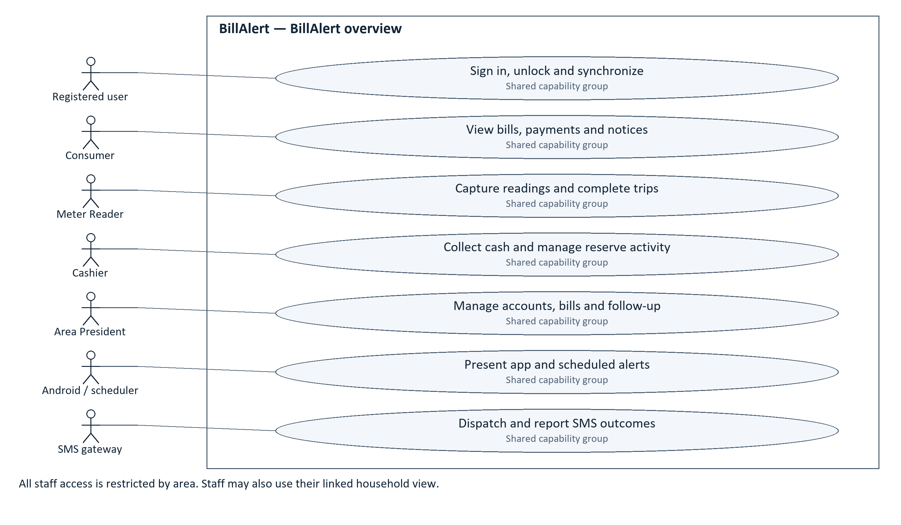
Figure 9.1. BillAlert overview. Solid lines show actor participation; they do not represent execution order.

9.2. Shared access and saved work
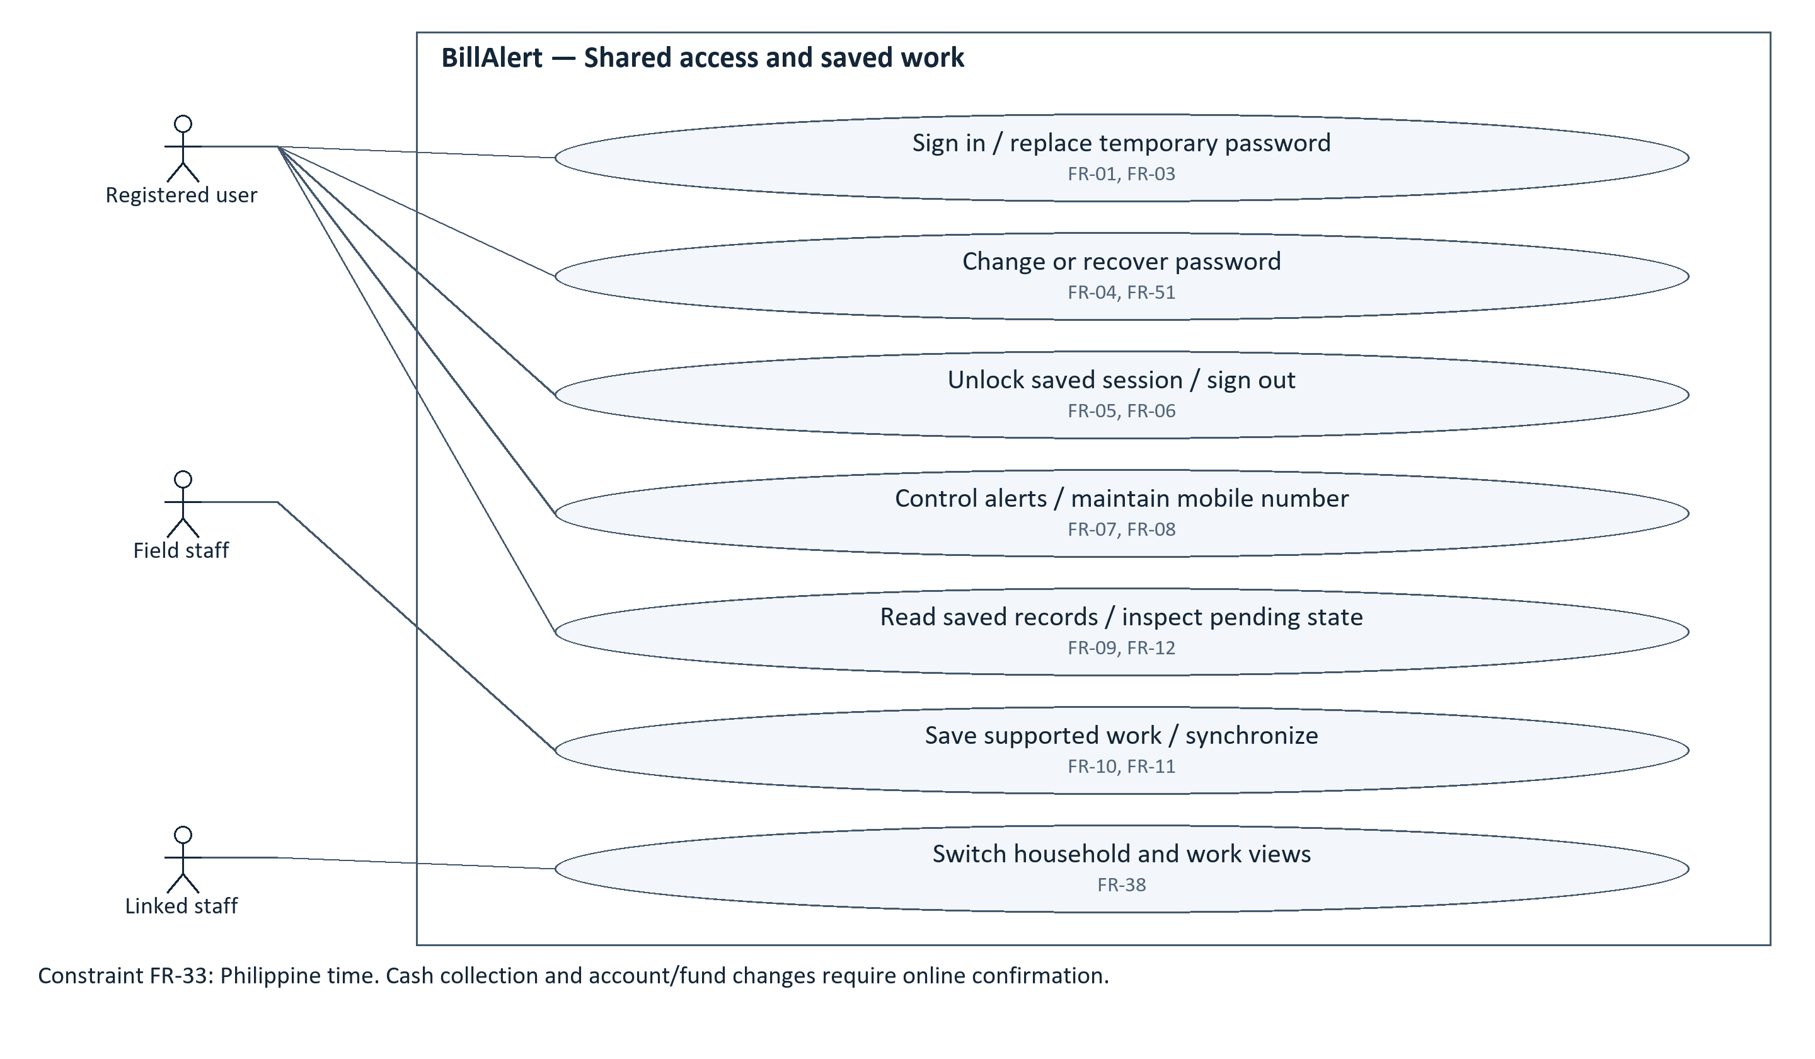
Figure 9.2. Shared access and saved work. Solid lines show actor participation; they do not represent execution order.

9.3. Consumer billing and payment evidence
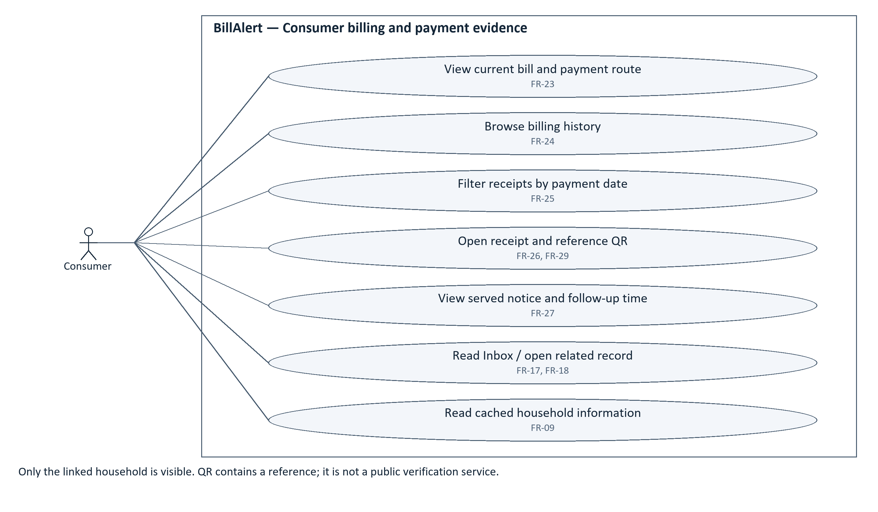
Figure 9.3. Consumer billing and payment evidence. Solid lines show actor participation; they do not represent execution order.

9.4. Meter Reader field work
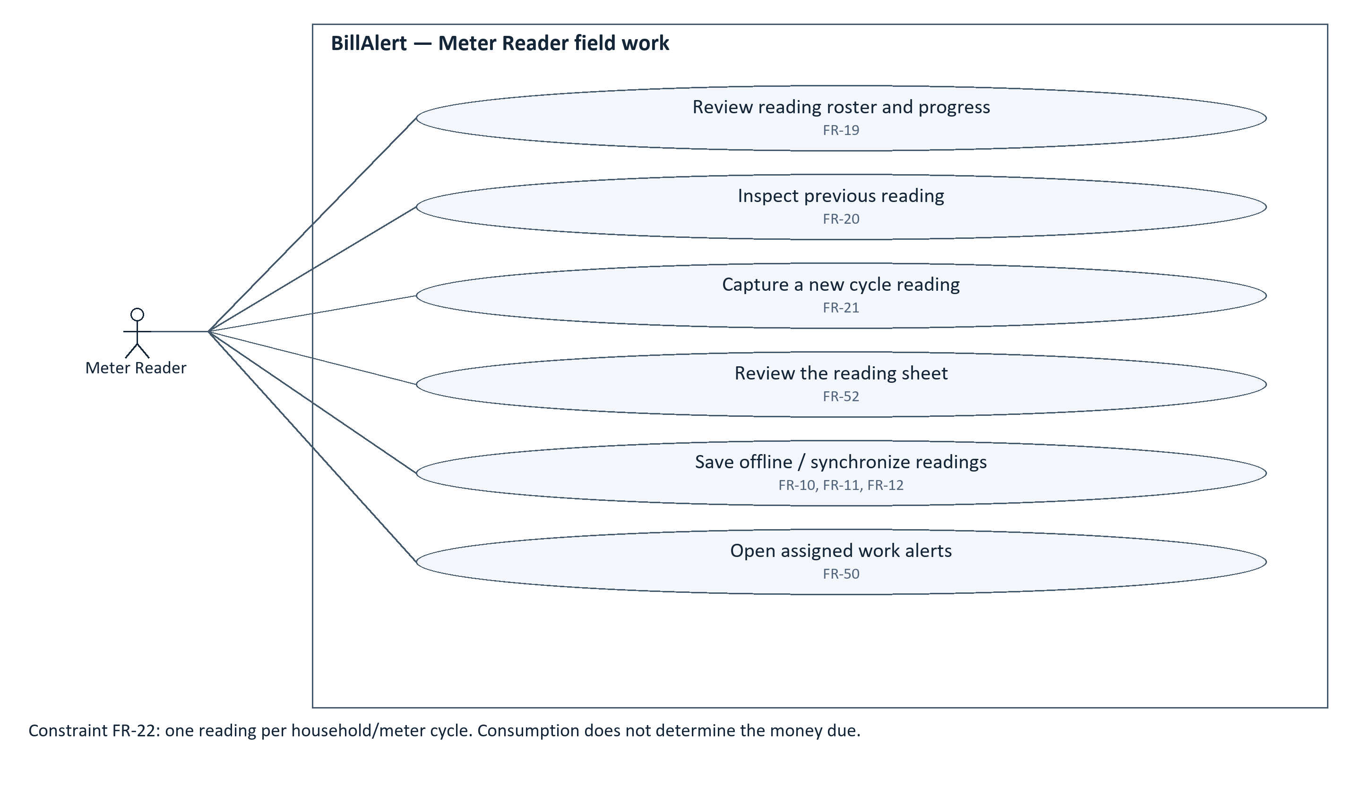
Figure 9.4. Meter Reader field work. Solid lines show actor participation; they do not represent execution order.

9.5. Cashier collection and receipts
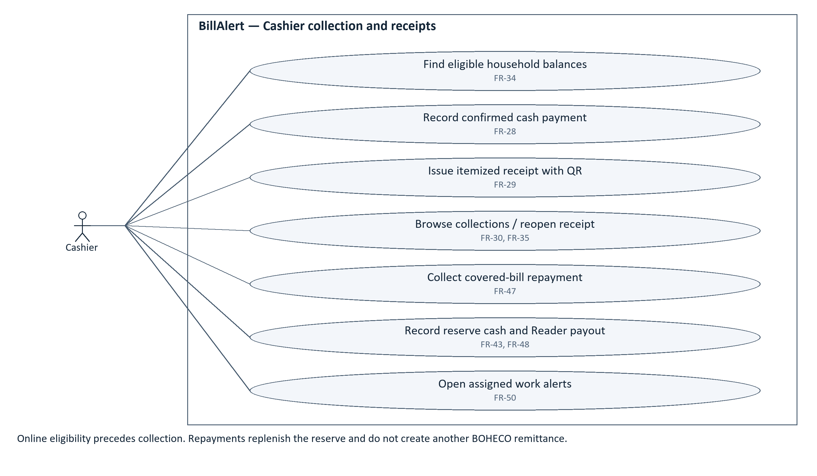
Figure 9.5. Cashier collection and receipts. Solid lines show actor participation; they do not represent execution order.

9.6. Area President billing and notices
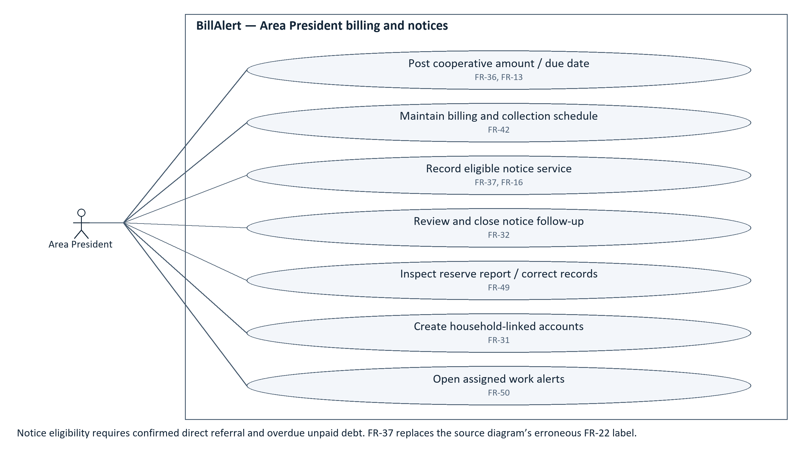
Figure 9.6. Area President billing and notices. Solid lines show actor participation; they do not represent execution order.

9.7. Notification channels and delivery
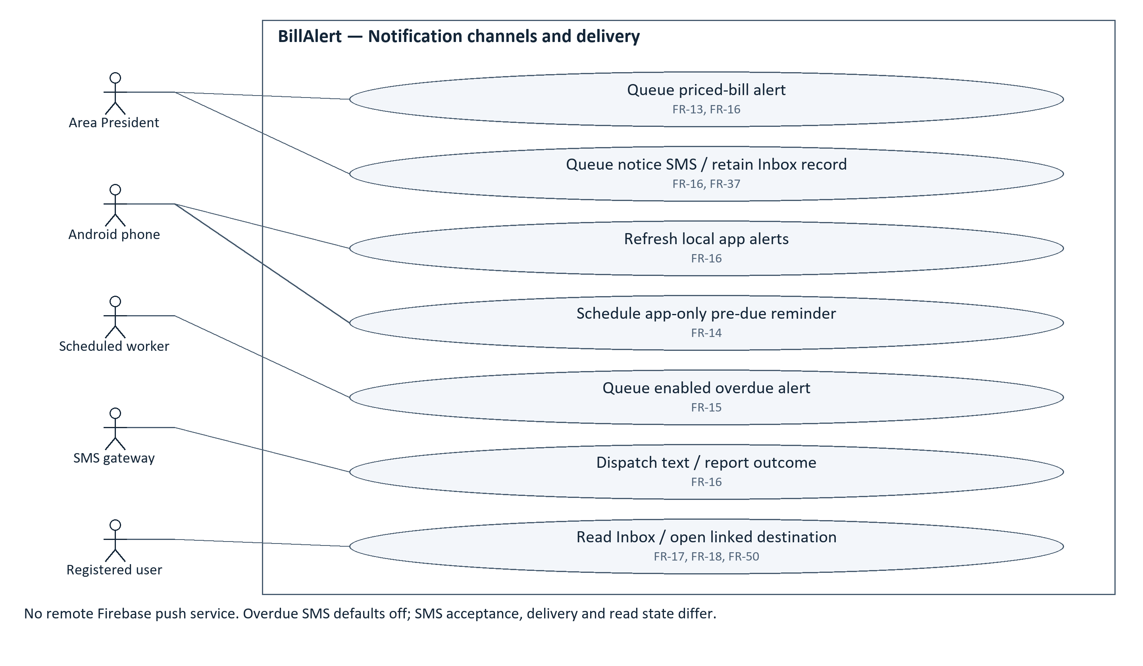
Figure 9.7. Notification channels and delivery. Solid lines show actor participation; they do not represent execution order.

9.8. Account, household and staff handovers
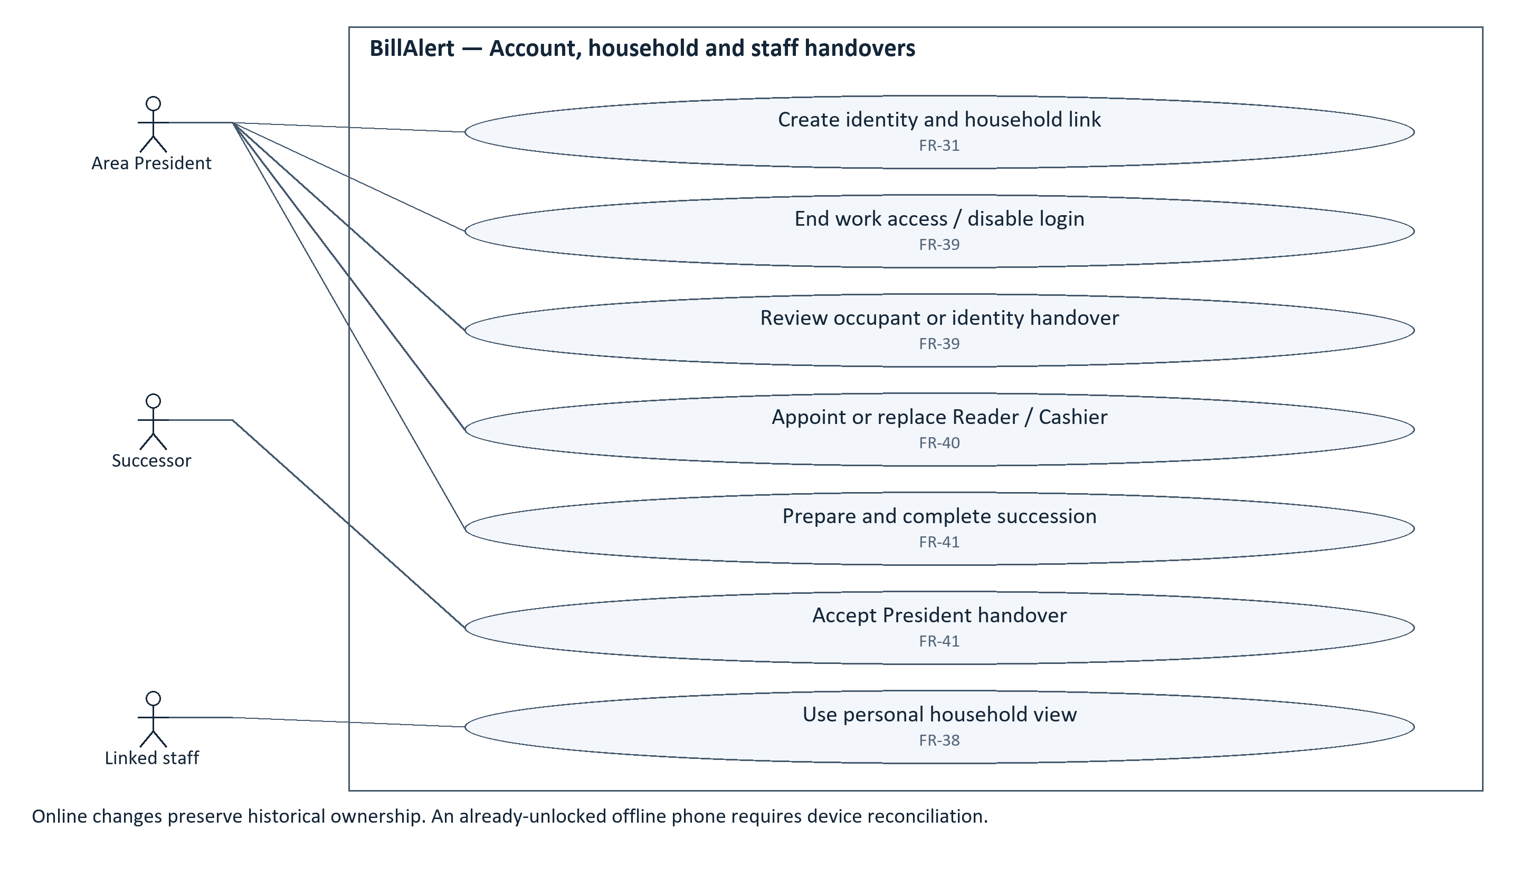
Figure 9.8. Account, household and staff handovers. Solid lines show actor participation; they do not represent execution order.

9.9. Reserve, cooperative trip and settlement
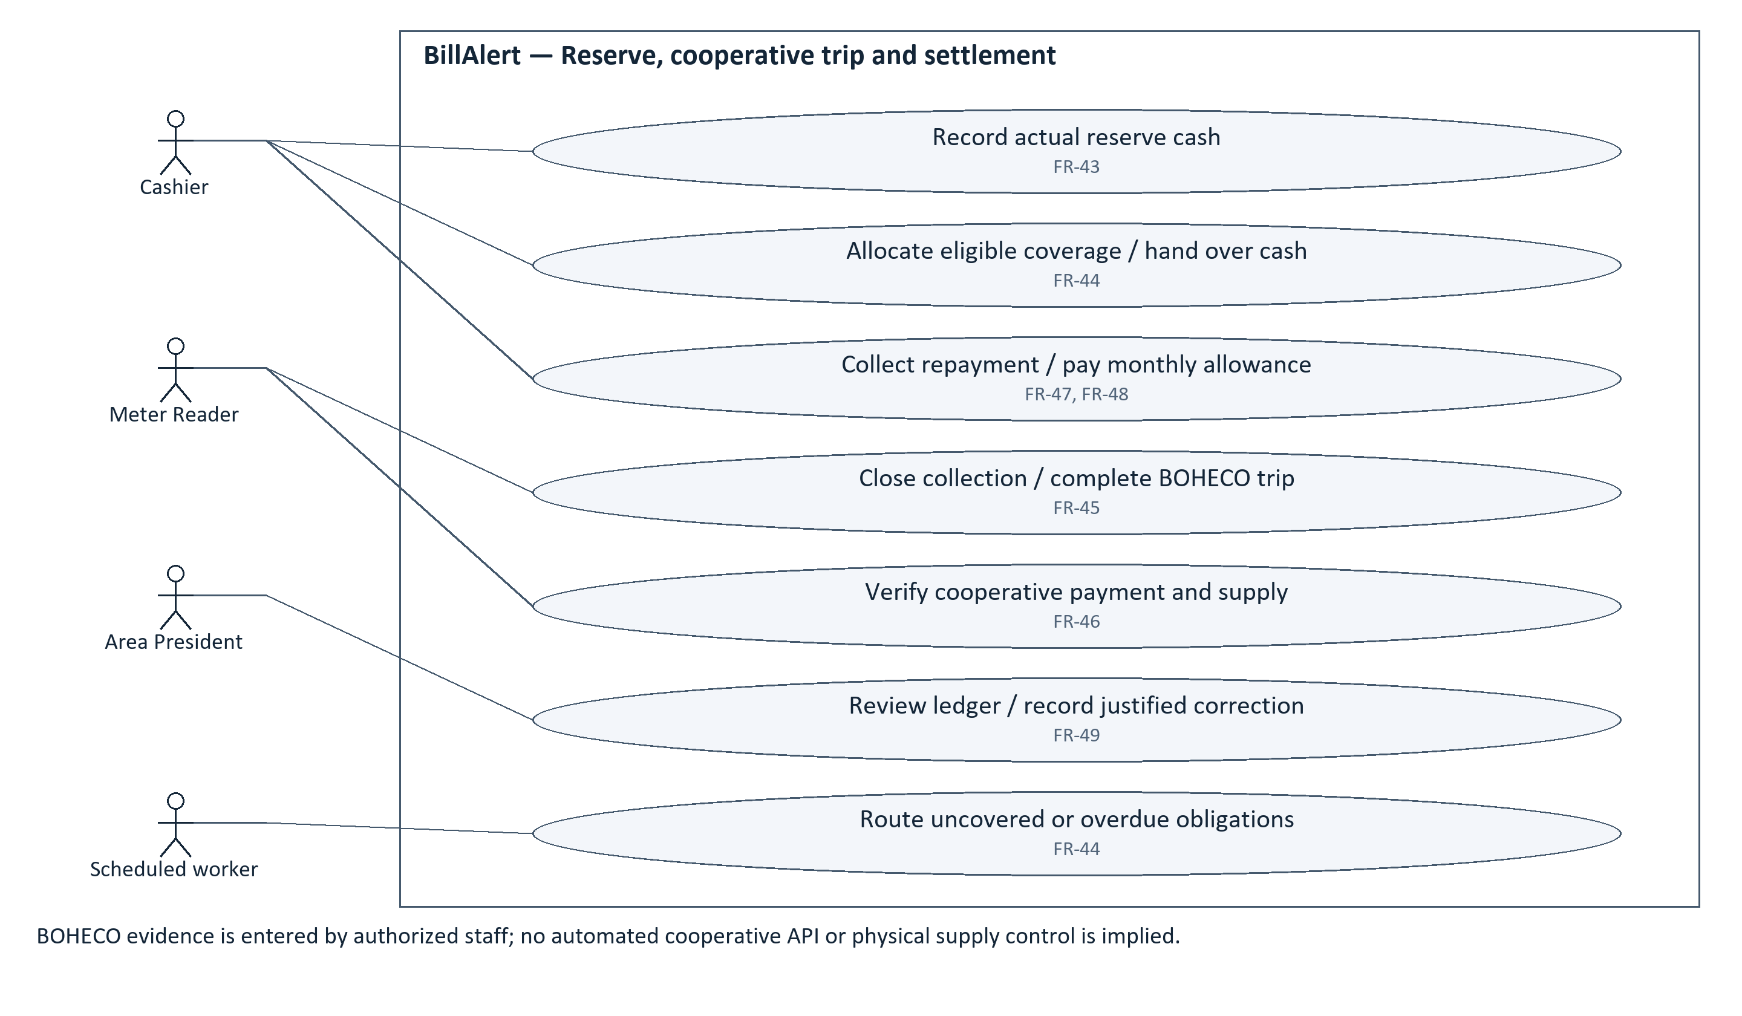
Figure 9.9. Reserve, cooperative trip and settlement. Solid lines show actor participation; they do not represent execution order.

9. Use Case Diagram — inventory
The supplied seven-page Draw.io diagram was reconciled and expanded with Account Lifecycle and Reserve/BOHECO detail pages. Original role groupings are preserved. The incorrect Admin notice reference is corrected to FR-37. Shared time and duplicate-reading rules appear as constraints, not separate actor goals. No “include” or “extend” dependency is asserted where the project only shows participation.
Figure / actor group | Use-case coverage
9.1 Context | Sign in, unlock and synchronize; View bills, payments and notices; Capture readings and complete trips; Collect cash and manage reserve activity; Manage accounts, bills and follow-up; Present app and scheduled alerts; Dispatch and report SMS outcomes
9.2 Shared – Authenticated User | Sign in / replace temporary password; Change or recover password; Unlock saved session / sign out; Control alerts / maintain mobile number; Read saved records / inspect pending state; Save supported work / synchronize; Switch household and work views
9.3 Consumer | View current bill and payment route; Browse billing history; Filter receipts by payment date; Open receipt and reference QR; View served notice and follow-up time; Read Inbox / open related record; Read cached household information
9.4 Meter Reader | Review reading roster and progress; Inspect previous reading; Capture a new cycle reading; Review the reading sheet; Save offline / synchronize readings; Open assigned work alerts
9.5 Cashier | Find eligible household balances; Record confirmed cash payment; Issue itemized receipt with QR; Browse collections / reopen receipt; Collect covered-bill repayment; Record reserve cash and Reader payout; Open assigned work alerts
9.6 Admin | Post cooperative amount / due date; Maintain billing and collection schedule; Record eligible notice service; Review and close notice follow-up; Inspect reserve report / correct records; Create household-linked accounts; Open assigned work alerts
9.7 Notification Engine | Queue priced-bill alert; Queue notice SMS / retain Inbox record; Refresh local app alerts; Schedule app-only pre-due reminder; Queue enabled overdue alert; Dispatch text / report outcome; Read Inbox / open linked destination
9.8 Account Lifecycle | Create identity and household link; End work access / disable login; Review occupant or identity handover; Appoint or replace Reader / Cashier; Prepare and complete succession; Accept President handover; Use personal household view
9.9 Reserve and BOHECO | Record actual reserve cash; Allocate eligible coverage / hand over cash; Collect repayment / pay monthly allowance; Close collection / complete BOHECO trip; Verify cooperative payment and supply; Review ledger / record justified correction; Route uncovered or overdue obligations

BOHECO is an external operational party whose evidence is recorded by authorized staff. The diagram deliberately shows those staff interactions rather than implying an automated cooperative service connection. Supporting Android and SMS actors are separate because their delivery paths and failure states differ.

10. Wireframes / Mockups
These updated schematic mockups summarize the current screen responsibilities using synthetic data. They are not screenshots of a deployed build and do not certify exact control placement. Their labels and example states are aligned with the current project; device-specific layout and interaction still require the installed-app checks.

10.1. Consumer bill and payment history
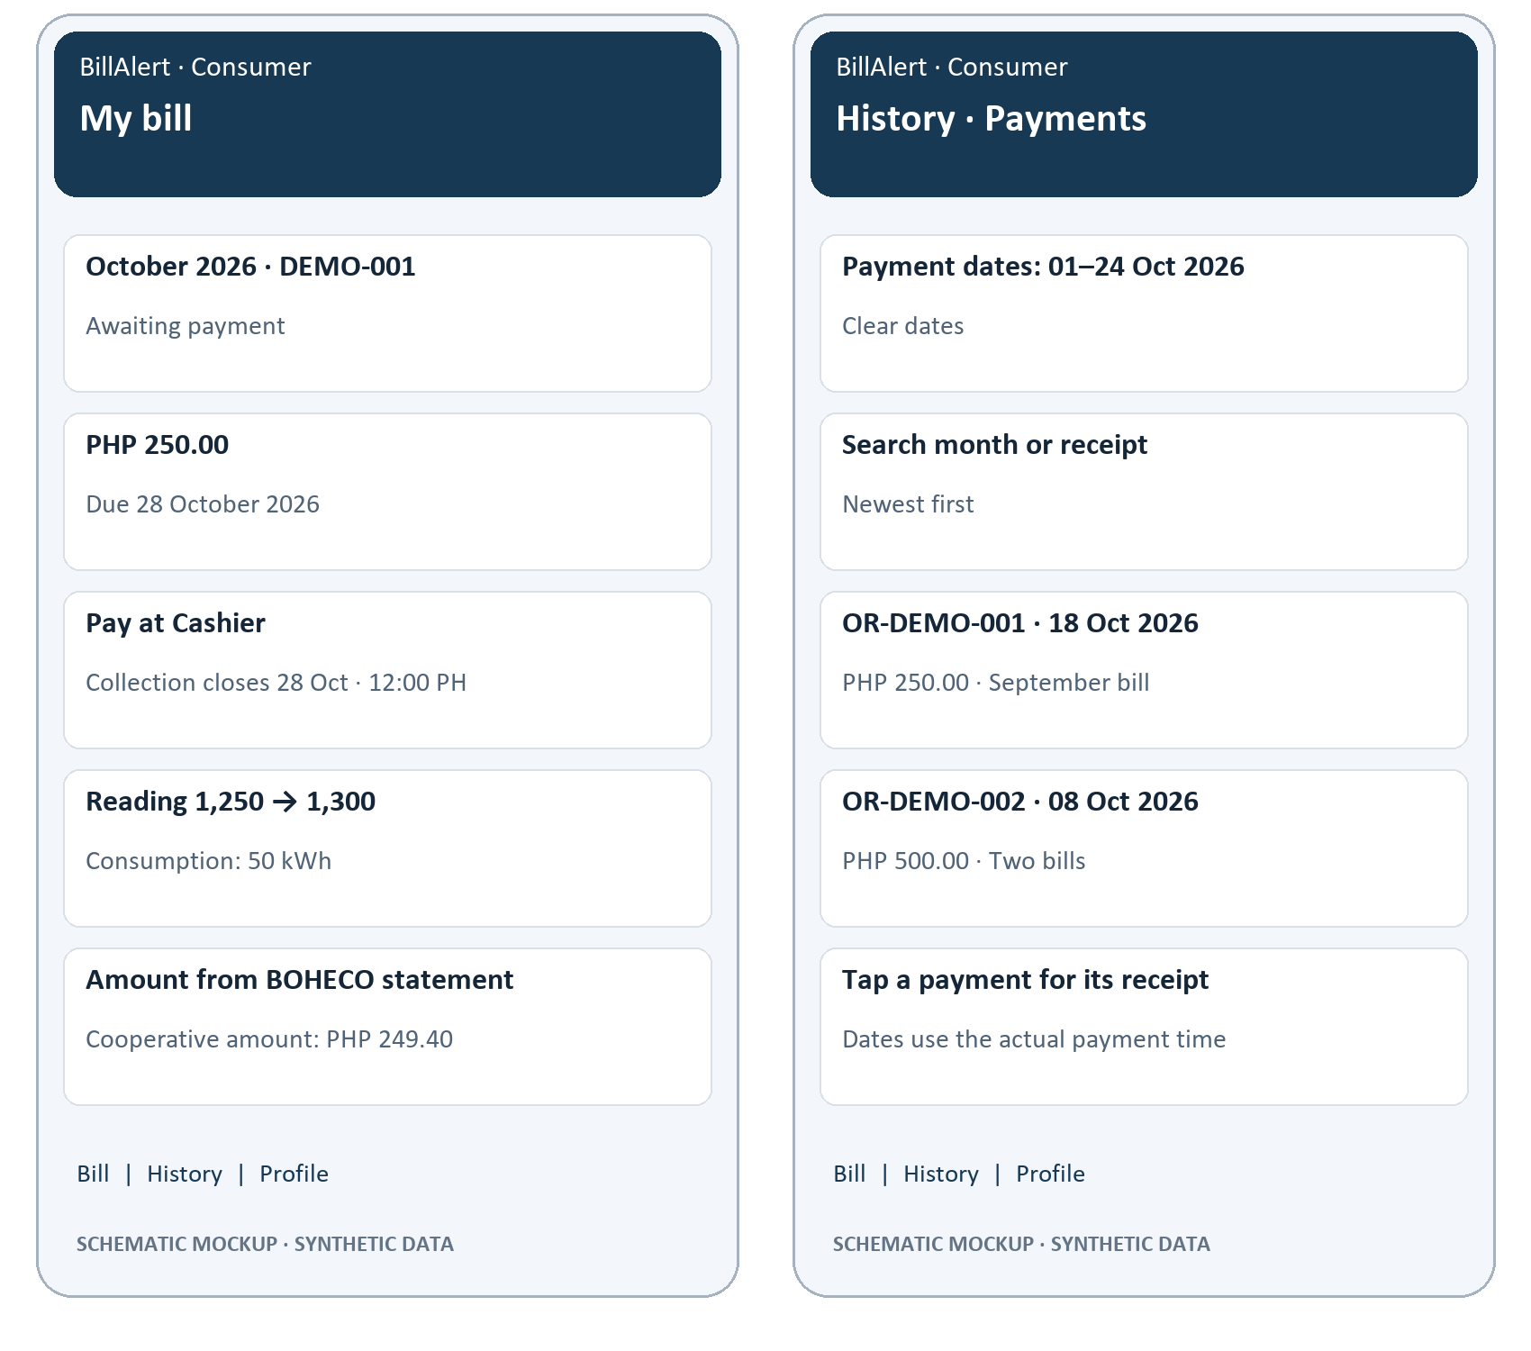
Figure 10.1. Consumer bill and payment history. Schematic mockups with synthetic examples.
The bill identifies the amount, due date and current collection route. Payments use actual receipt dates, combine range and text filters and open the selected receipt. A September bill paid in October appears in an October payment-date range.
Requirement links: FR-23–26, FR-29, FR-33.

10.2. Meter Reader capture and cooperative trip
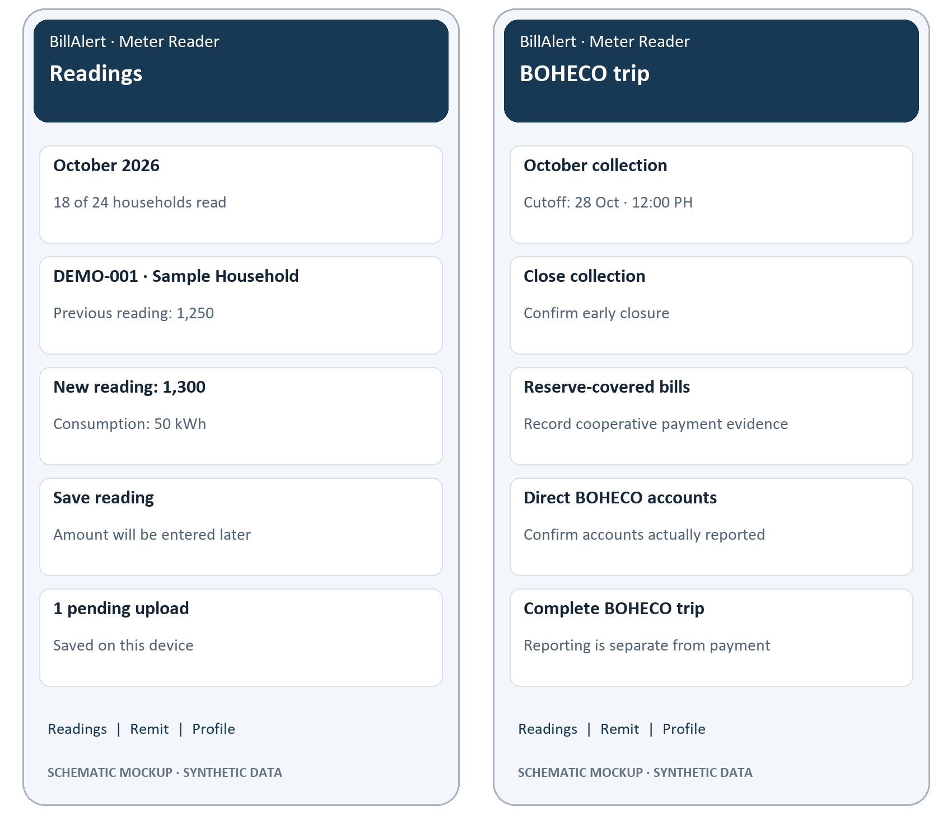
Figure 10.2. Meter Reader capture and cooperative trip. Schematic mockups with synthetic examples.
The Reader compares previous and new values and can retain a pending reading offline. The trip view separates collection closure, reporting accounts to BOHECO and verifying payment evidence. None of these actions computes a bill amount from consumption.
Requirement links: FR-19–22, FR-45–46, FR-52.

10.3. Cashier collection and reserve fund
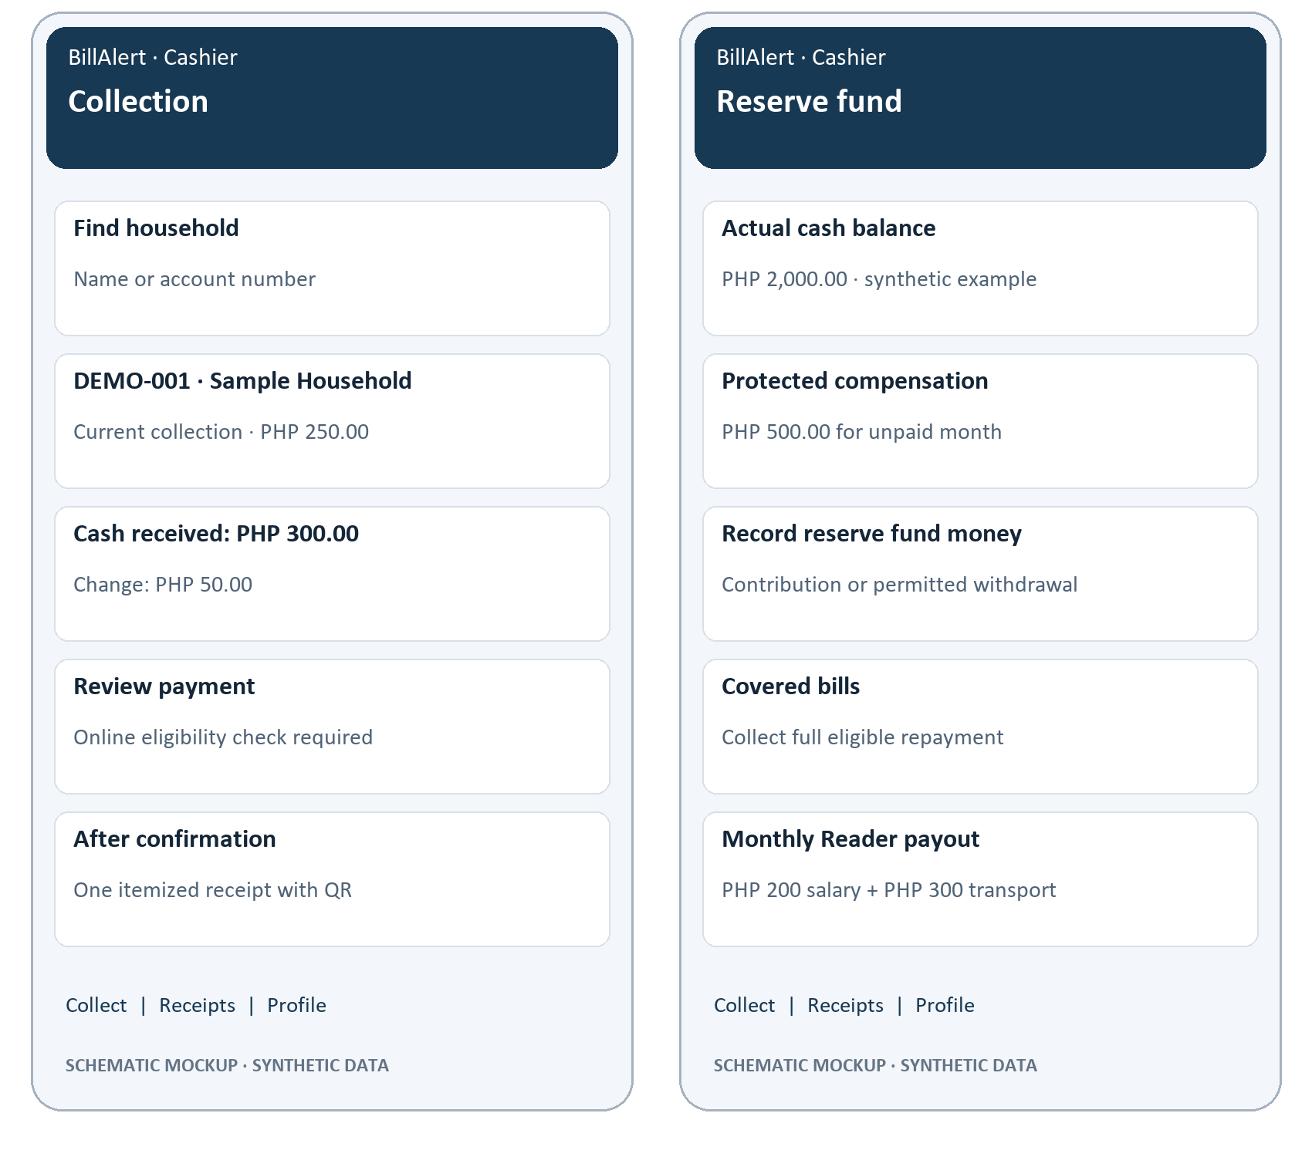
Figure 10.3. Cashier collection and reserve fund. Schematic mockups with synthetic examples.
Cash collection requires online eligibility and confirmation before a receipt is issued. Reserve actions reflect actual money, protect monthly compensation and distinguish full covered repayment from regular collection rounding.
Requirement links: FR-28–30, FR-34–35, FR-43–44, FR-47–48.

10.4. Area President accounts, schedule and notice review
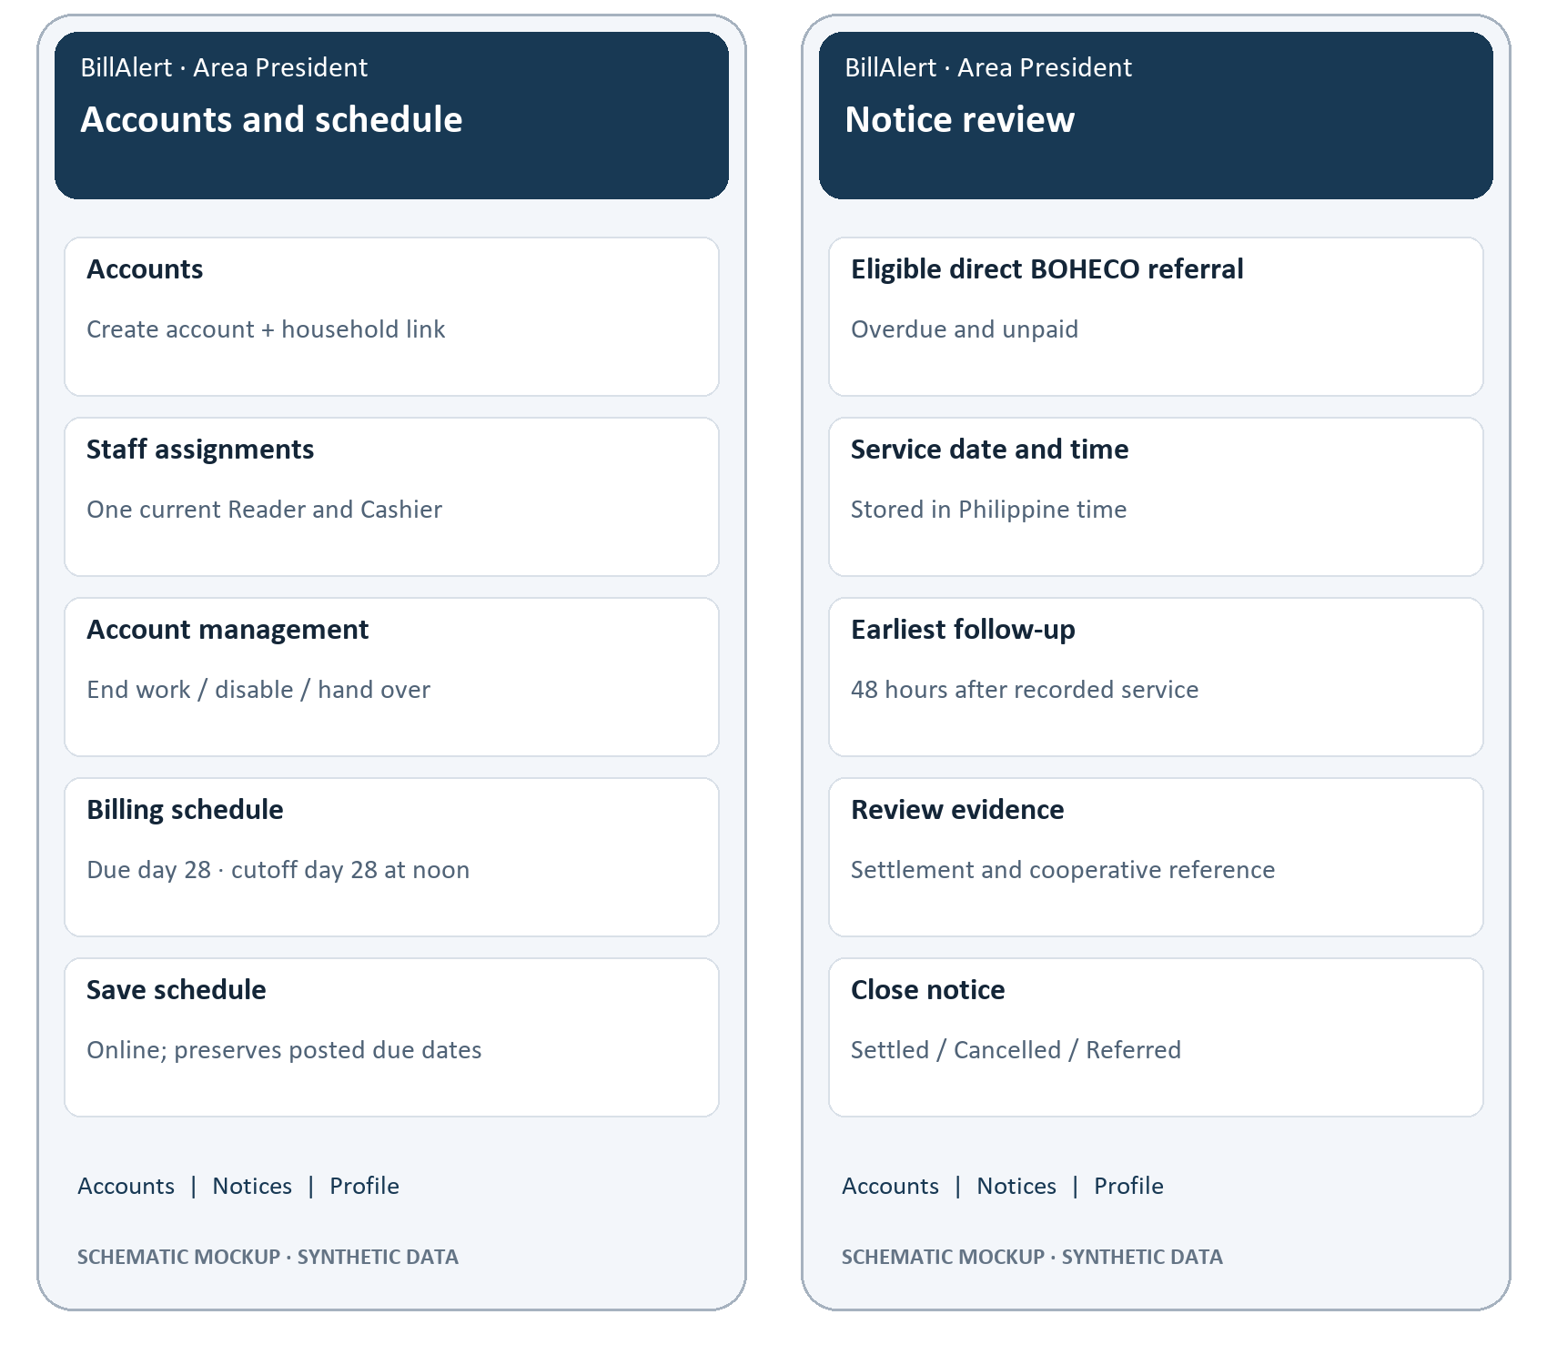
Figure 10.4. Area President accounts, schedule and notice review. Schematic mockups with synthetic examples.
Account management distinguishes work access, login and household ownership. Schedule edits preserve posted dates. Notice service is limited to eligible referred debt; closure requires the relevant evidence and checks.
Requirement links: FR-31–32, FR-37, FR-39–42, FR-49.

Receipt QR behavior
The Consumer receipt, Cashier detail and newly issued receipt all render the same server-issued verification reference as readable text and a QR. Light and dark themes keep a white QR background. Scanning returns that reference; the current project does not include a new public verification page or camera-scanning workflow. Missing references are shown as unavailable.

