MOBILE APPLICATION DEVELOPMENT PROJECT
Phase 1 Documentation
Project Proposal & Requirements Package
Ten Required Deliverables -Sections 1 through 10
Application Name: BillAlert
Student Name(s): Charles Carcallas
Mary Tiffany Busalanan
Krisha Mae Basio
Cristell Obiso
Program / Section: BSCS - 3B
Instructor: Dr. Rey Anthony G. Godmalin
Date Submitted:

1. Project Title
Field | Your Entry
Application Name | BillAlert
Tagline | Automated SMS Electricity Billing Notifications for Timely Payments
Full Title | BillAlert: Automated SMS Electricity Billing Notifications for Timely Payments

2. Problem Statement
Small local cooperatives, like the one that serves Barangay Tubod in Clarin, Bohol, do not carry out anything near fully automated electricity billing. Meter readers go out to specific areas and take meter readings, which they write down on forms. The bill issued by the BOHECO is printed, and consumers usually become aware of their billing amount when they personally visit the cashier to make a payment. In some cases, consumers only find out how much they need to pay when someone else happens to go to the cashier to pay their own bill and ask the cashier to check their bill as well. This means that consumers do not have a convenient way to regularly monitor their monthly billing amount without personally visiting the cashier. Customers have to deal with the uncertainty of knowing when a bill has been posted, checking what their balance may be, and the lack of reminders of when their bill is due. Cooperative staff, such as meter readers and cashiers, spend a lot of time chasing up payments. Poor collection is not just a Tubod concern. A Philippine electric cooperative study states that it is well known in the industry that collection efficiency varies greatly between franchises and is a recognised and measured weakness in the sector (Escresa & Glova, 2024).
Current coping methods have predictable failures. The Cashier receives their electricity billing paper from BOHECO. Once the billing paper arrives, the cashier takes a picture of the bill and sends it through the consumers’ group chat in Messenger. However, this method depends on internet access, which may not be available to all consumers. The bill picture may also be difficult to read because the text is small and the image may become blurred or reduced in quality when sent through Messenger. None of the issues are attributable to nonpayment or insolvency. Rather, they are attributed to a failure to provide timely information. A single reminder to pay sent the week before payment is due has been proven to be more effective than sending multiple reminders. In fact, doubling the number of reminders, while still sending them the week before payment is due, eliminated the positive effect of the reminder. (Antinyan, Asatryan, Dai, & Wang, 2021)
A mobile app is better than a website or a printed process in this case and for three reasons specific to mobile. The first reason is reach. In the service area, almost everyone has a mobile phone. Pairing push notifications within an app with an SMS gateway means that one workflow can reach both smart and not smart phone users. The second reason is cost and speed. Sending a push notification is free and instant, whereas printing a notification is costly and takes days. The third reason, and the most important, is field conditions. Meter readers have to go out into fields which have limited connectivity. That means the capture device must store data and sync when it has a connection again, something a browser-based system cannot do. For these reasons, BillAlert was created with Flutter as a replacement for an error-prone process that is done manually.

3. Objectives
# | Objective Statement
1 | Build a notification module in Flutter that sends an in-app push emergency alert for an available bill within 24 hours of the amount due being entered and validated by the system.
2 | Develop a cross-platform bill record management system, which allows consumers to check current and past billing status. The application must enable offline viewing of the bill that was cached last.
3 | Develop a server-side, automated and cost-effective reminder system which sends a free push notification when a new bill becomes available, and delivers the 3-day due-date reminder to every consumer by SMS as well as by push, with SMS also used for overdue notifications and disconnection notices, requiring no manual dispatch by staff.
4 | Create a secure mobile authentication system and implement role-based access control both on the application and server for all four of the roles (Admin, Meter Reader, Cashier, Consumer), where Admin will be able to create staff and consumer accounts.
5 | To provide the Administrator with a disconnection workflow that issues a statutory notice to an overdue consumer, records the date and time it was served, and enforces the 48-hour grace period before any field action, so that every disconnection is documented and no account is referred for field action earlier than the notice period allows.

4. Scope and Limitations

In Scope / Out of Scope
In Scope (16-Week Feasible) | Out of Scope
Manage consumer records for billing data (account info, readings, bill amount, due date, payment status) | Actual payment processing - no payment gateway or e-wallet integration
Push emergency notifications configured for bill posting and due date (3 days prior to due date, overdue) delivered through server-side scheduled API calls. | Integration with a live electric cooperative’s production billing system
Dual-channel delivery:sent through SMS and push emergency notifications within the application. Delivery records are maintained. | Printed physical receipts and printed bill statements
A consumer dashboard will include current bill, billing history, payment history, notification inbox, and a record of payments made. | Multi-cooperative or multi-utility tenancy
Field Meter Reader Module: a capture list of area readings, offline reading capture, queuing and syncing, notification of on-site disconnection. | Automated meter reading via hardware or IoT integration
Cashier Module: lookup of account or name, cash payment application, multiple bills with cash payment, digital receipts with scannable reference, digital Cashier payment history, ability for Cashier or Consumer to view a Cashier receipt. | Consumer initiated online bill dispute or case ticketing system
Admin Module: account and staff creation, logging of payment amount due posted by the cooperative, review of disconnection notices, notice outcome logging. | Multiple languages other than English
Consumer Module: Current bill, billing history, payment history, receipts, notification history, an offline cached bill. | Analytic, foresee, or predictive consumption features. Recording an outcome does not disconnect anyone field action is carried out by cooperative personnel.
A single editable Unified Profile section for all four roles will be accessible for contacts configured to receive SMS. | Web or desktop client - the output is mobile application only; and authorizing, scheduling, or performing a disconnection which remains a field operation of a cooperative outside this application

Known Limitations
- Role breadth. The system maintains all four roles (Admin, Meter Reader, Cashier, Customer). This is broad for a 16 week mobile project; however, it is manageable with a four person team (one person per role).
- No live payment processing. Cash is received by a Cashier and payments are recorded in the application; the application never processes cash.
- Mock data only. There will be no integration with a live, cooperative mining, utility or billing database, and sample data representing the Tubod, Clarin service area will be used.
- Digital receipts only. Cashier outputs are either in-app or PDF, and are never printed.
- Limited SMS service. SMS is sent via httpSMS, which sends a command to an Android device controlled by the project team; the team member's Android device sends the message. It is unclear when the member's Android device will be powered on and when it will be connected to a working service. This would not be an acceptable service for a cooperative; however, it is an acceptable service for this project, since the goal of this project is to develop a proof of concept and a simulated device SMS channel is used when the handset is unavailable. Every consumer now receives at least one SMS per billing cycle at the reminder stage, so the whole barangay's message traffic passes through that single handset each month.
- Single Language.ENGLISH ONLY. Interface strings will be stored in a resource file which allows other languages to be added later, but no translation is in scope.
- Synchronization happens offline and occurs one record at a time. Field-captured data will sync to the server in the order they were captured. If there are competing edits, the application will not try to resolve them.
- Platform Floor. iOS 13.0 and Android 8.0 API 26 and newer only; all other devices are unsupported.
- The application does not compute bills. Amounts due are produced by the cooperative's central billing office, approximately 7 days after readings are submitted, and are entered into BillAlert as opposed to being computed by the application. BillAlert will derive consumption from meter readings but will never derive a peso amount. No tariff, rate tables or ERC unbundled rate structures are implemented.
- Single-barangay deployment. The meter reader, cashier and admin role for Barangay Tubod in Clarin, Bohol are deployed across 4 Service Areas. The application is scoped to these 4 areas. Building out the application to other barangays in the Bohol I Electric Cooperative franchise is outside the scope of Phase I.
- Configuration is fixed. SMS Configurations, notifications, and reminders are created as configuration as opposed to being inserted into the application. Administration of these values will be moved to Phase 2.

5. Target Users
Four user groups, not four individuals. Barangay Tubod has four service areas, each with an area President, Meter Reader, and Cashier. Each of the four service areas serves its respective consumers. Because each staff role will have four holders working to the same brief, the profiles that follow describe the staff group as a whole rather than a single individual. The numbers are affirmed for Barangay Tubod; the age, literacy, aspirations and frustrations are reflective of the staff group as a whole and are a reflection of each individual staff member’s perception of the Barangay. The Admin role in this document is the Area President - the role is called Admin throughout Sections 7 to 10, and the President is the individual who holds that role.

User Group A - Electricity Consumers of Barangay Tubod

This user group covers all residents and small-business electricity consumers across the four service areas of Barangay Tubod, Clarin, Bohol. They are all adults, with the account owner typically being the head of the household or in the case of small businesses, the business owner. Their occupations are varied, ranging from mixed-farming, fishing, small retail, and services to salaried work and remittance-supported households. Their technical literacy is low to moderate; while nearly everyone owns a mobile phone, smartphone ownership and mobile data use still lag behind, with many phones used mainly for calls and texts and few users installing applications. Their main goal is simply to know how much their bill is and when it is due, so they never miss a deadline or face disconnection. Their key frustration is that they never know how much they owe when the paper bill arrives, leaving them with no way to know a new bill has been posted, and the billed amount remains a mystery for about a week. The app helps by sending a push emergency notification for each posted amount and a reminder three days before the deadline, with SMS used for disconnection notices for overdue so that all potential recipients are reached. Bills also remain readable and stored on the device, ensuring that no week is ever left blank or unaccounted for.

User Group B - Area Presidents (the Admin role)

This group consists of the four Area Presidents of Barangay Tubod, one for each service area. They are adults serving as elected or appointed representatives, holding the position of Barangay Tubod Electricity Services Community Officer, which corresponds to the Admin role within BillAlert. Their technical literacy is moderate-they are comfortable using a smartphone and keeping written records, though not necessarily experienced with office software. Their main goal is to get the amounts recorded by BOHECO matched quickly to the right readings, so that consumers in their area know their bill and the cashier can proceed with collection, while also keeping their area's staff and consumer accounts accurate. Their biggest frustration is the roughly seven-day delay before amounts come back after readings are submitted; until the data is transcribed, no one in the area knows what is owed, there is no record of which readings remain pending, and following up with overdue consumers is entirely manual. The app addresses this by providing a single screen showing all readings in their area. Posting an amount automatically notifies the consumer record, account creation enforces exactly one Meter Reader, one Cashier, and one Admin per area, and disconnection notice outcomes are recorded in one central location.

User Group C - Meter Readers

This group is made up of the four Meter Readers of Barangay Tubod, each assigned to one service area. They are working-age adults employed as field staff of the barangay electricity association, responsible for reading meters in their assigned area. Their technical literacy is moderate-they are confident using a smartphone in the field. Their main goal is to visit all the meters in their area, read them correctly, and input the readings into the app so that a record exists even if the physical form is lost or misplaced. Their main frustration stems from the current process of writing readings by hand on a form provided by BOHECO, which creates a real risk that the form could be lost or misplaced. The app helps by reminding consumers about upcoming bills, eliminating the risk of misplaced or lost paperwork, and ultimately improving customer service.

User Group D - Cashiers

This group includes the four Cashiers of Barangay Tubod, one assigned to each service area. They are working-age adults serving as collection staff for the barangay electricity association, responsible for accepting cash payments within their area. Their technical literacy is moderate, as they are accustomed to cash handling and operating registers for transactions. Their main goal is to transact with consumers and issue receipts efficiently, without creating long queues. Their main frustration lies in having to manually determine a consumer's balance and total up unpaid amounts, so that whenever a consumer approaches the counter, staff must search for the recorded payment themselves. The app helps by allowing cashiers to look up a consumer by account number or name, settle multiple bills in a single transaction, and access a history of their own recorded payments so that an earlier receipt can be reopened right at the counter.

6. Literature Review

Academic References
# | Citation (APA format) | Key Finding / Relevance
1 | Escresa, L. C., & Glova, A. M. G. (2024). Politico-economic determinants of the performance of electric cooperatives in the Philippines. Utilities Policy, 91, Article 101815. https://doi.org/10.1016/j.jup.2024.101815 | Identifies collection efficiency as a measured and uneven performance problem for Philippine electric cooperatives. Related to this problem, assumes that weaker collections are attributed to the governance of the franchise area rather than the consumers' ability to pay. The problem statement is situated correctly by country and the type of institution. Bohol I Electric Cooperative is a cooperative which falls squarely within the scope of this study. As the analysis is at the cooperative level, not the consumer level, it demonstrates that the collection problem exists and is recognized, it does not explain why a specific consumer pays his or her bill late.
2 | Wenceslao, J. L. B., & Zaragosa, A. R. A. (2022). Web-based electricity billing system with SMS notification. International Journal of Research in Engineering and Science, 10(6), 1087–1091. | Developed a web-based billing system (PHP/MySQL using the Waterfall SDLC) to enable an electric cooperative in the Philippines to distribute bills electronically and notify customers via SMS. Assessed as "Very Good" by both household and expert evaluators concerning usability and performance. This evaluation methodology (using the ISO/IEC 25010 usability/performance criteria) makes this case relevant and novel in the context of a real-world cooperative at this scale.
3 | Antinyan, A., Asatryan, Z., Dai, Z., & Wang, K. (2021). Does the frequency of reminders matter for their effectiveness? A randomized controlled trial. Journal of Economic Behavior & Organization, 191, 752–764. https://doi.org/10.1016/j.jebo.2021.09.023 (accepted manuscript freely available at https://orca.cardiff.ac.uk/id/eprint/146926/) | A randomized control trial to test the optimal frequency for reminder messages. One reminder message per week caused more accounts to be settled as compared to the control, while two reminder messages per week resulted in a reduction in the effect. Reminders restore the attention to an obligation that the individual intended on fulfilling. This is the reasoning behind BillAlert. The finding that additional messages stop helping is the basis of the single pre-due reminder for FR-14 and the rationale behind FR-16 for no reminder escalation to SMS. The context of this study is an overdue property tax in China compared to a utility bill. The behavioral mechanism remains, but the context of the bill is different.
4 | Batican, A. C., Pleños, M. C. F., Cavero, J. A., Sabanal, R. N., & Seriño, M. N. V. (2024). Assessing the adoption of cashless payment system for household utilities: A case among selected barangays in Albuera, Leyte, Philippines. Review of Socio-Economic Research and Development Studies, 8(1), 126–165. https://doi.org/10.5281/zenodo.15788938 | A study on 246 households in selected barangays of Albuera, Leyte, on the adoption of cashless payment for household utilities. The predictors found to be significant were effort expectancy, performance expectancy, social influence, and perceived risk, while age, sex, education, income, internet access, and prior experience were insignificant. The nearest published study fits the setting of the bill payment service offered to households in rural Visayan barangays. The finding that demographics and connectivity were of no consequence in adoption also led to the decision to present BillAlert as a mobile app to the entire cooperative as opposed to a self-selected subset. Perceived risk being significant supports the decision to retain the mobile app cooperative branded and without any facility for electronic payments.
5 | Kolpyak, K. N., & Patil, J. A. (2025). Monthly electricity billing display with SMS feature. International Journal of Innovative Research in Electrical, Electronics, Instrumentation and Control Engineering, 13(6), 292–296. https://doi.org/10.17148/IJIREEICE.2025.13650 | Presents a microcontroller (MCU)-based system with a digital energy meter, LCD display, and GSM module for monitoring and reporting consumption/billing locally and sending monthly SMS reminders. Also discusses integration with photovoltaic "nano leaves." It is notable for its low-cost hardware setup and discussion of the advantages and disadvantages of SMS-based billing (cost, system security), as well as billing system extensions (prepaid billing) and integration with the IoT and/or mobile applications.

Existing Application Analysis
App Name | Strengths | Gaps / Weaknesses | How BillAlert Improves
My Meralco | Consumers can view current and past bills, pay online, enrol in paperless billing, and receive email, SMS, and push notification when a new bill is available or a payment is confirmed. | Users have complained of a lengthy, complex registration process, bugs (app crashes) and failed logins, as well as notifications that are limited to the app and are not sent to the user. | BillAlert makes the pre-due date reminder the core behaviour rather than an afterthought, and is designed for small electric cooperatives that have no billing app at all. It also gives cooperative staff a field-capable operational tool, not only a consumer-facing view.
MobileAP (AboitizPower) -Visayan Electric | Provides users with the ability to view past and present bills, check payment history and total consumption, pay bills, manage bills, and opt to receive notifications about their utility and service. | Prioritizes bill viewing and payment as well as reminder notifications for utility updates. It does not emphasize a dedicated proactive due-date reminder system with customizable reminders before the dead-line. Users are still responsible for monitoring their due dates. | BillAlert has bill management as its primary focus, and it sends reminders before a due date via SMS or push notification (ex. 7, 3, or 1 day before).

7. Requirements Analysis

Functional Requirements
ID | Requirement Description | Priority
A. Authentication and access
FR-01 | The system shall authenticate a registered user using his/her username and password and navigate the user to the respective home screen of the corresponding role. | Must
FR-03 | At least on the first login, the system shall prompt the user to change the password assigned on the user's behalf. | Must
FR-04 | The system shall allow the user to change the password based on the minimum strength policy. | Must
FR-05 | The system shall allow the user to log back into the application using the device biometric or the device passcode, instead of entering back the password. | Must
FR-06 | The system shall allow the user to log out the application and remove the session token and delete all locally stored role data. | Must
B. Notification setup and contact
FR-07 | Upon opening the Notification Inbox for the first time, the system shall request the permission to access operating system notifications and shall inform the user regarding the permission status in the profile for re-request in case the permission was not granted. | Must
FR-08 | The system shall allow the user to change his/her contact number for SMS delivery and shall verify the number as a valid Philippine mobile number. | Must
C. Offline operation and synchronisation
FR-09 | The system shall cache the role-related information for the authenticated user on the device. | Must
FR-10 | The system shall hold the action performed offline on the device to be synchronized at a later time. | Must
FR-11 | The system will automatically sync queued actions to the server once a connection is established, without the need for user intervention to sync. | Must
FR-12 | The system shall display the number of actions pending synchronisation and the time the cached data was last refreshed. | Must
D. Notification engine
FR-13 | The system shall dispatch a bill-ready notification automatically when the amount due is recorded against a bill. | Must
FR-14 | The system shall dispatch a pre-due-date reminder automatically at the configured lead time (default 3 days), excluding bills already settled. | Must
FR-15 | The system shall dispatch an overdue notification automatically after the due date has passed. | Must
FR-16 | The system shall deliver the bill-ready notification by push, and shall deliver the pre-due-date reminder, the overdue notification and the disconnection notice to every consumer by SMS as well as by push where the application is installed, and shall record the outcome of each dispatch. | Must
FR-17 | The system shall open the app at the related bill or notice when a push notification is selected, after verifying the notification belongs to the authenticated account. | Must
FR-18 | The system shall display an in-app inbox of every alert generated for the account, with an unread badge count. | Should
E. Meter Reader field module
FR-19 | The system shall display to a Meter Reader an area-scoped list of active consumers not yet read in the current cycle, together with progress through the cycle and the count of readings still pending synchronisation. | Must
FR-20 | The system shall retrieve and display a consumer's previous meter reading before a new reading is entered. | Must
FR-21 | The system shall record a meter reading for a consumer, capturing the present reading, the consumption against the previous reading, and the capture timestamp, creating a bill in an unpriced state. | Must
FR-22 | The system shall reject a second reading for the same consumer within one billing cycle. | Must
F. Consumer
FR-23 | The system shall display a Consumer's current bill summary. Where the bill is payable, this shows the amount due, due date, meter reading, consumption and payment status. Where the bill is unpriced, it shows the meter reading, the consumption, the date read, and that the amount is awaiting the cooperative's computation. | Must
FR-24 | The system shall display a Consumer's billing history. | Must
FR-25 | The system shall display a Consumer's payment history, searchable by date range. | Must
FR-26 | The system shall display the full detail of a digital receipt selected from payment history. | Must
FR-27 | The system shall display an active disconnection notice to the Consumer, showing the date and time the notice was served and the earliest date and time disconnection may lawfully occur. | Must
G. Cashier
FR-28 | The system shall record a cash payment against one or more of a consumer's payable bills within a single atomic transaction. Unpriced bills cannot be settled, and a Cashier may settle bills only for consumers in their assigned service area. | Must
FR-29 | The system shall generate one digital receipt for each recorded payment, itemising every bill that payment settles and carrying a single scannable reference code. | Must
FR-30 | The system shall allow a Cashier to open and view in full any receipt they have issued, reached from their receipt history. | Must
FR-34 | The system shall allow a Cashier to search for a consumer by name or account number and open their outstanding bills, returning only consumers in the Cashier's assigned service area who have at least one payable bill. | Must
FR-35 | The system shall display to a Cashier a history of the payments they have recorded, most recent first, showing the consumer, the amount and the receipt reference. | Must
H. Admin
FR-31 | The system shall allow an Admin to create a staff or consumer account, enforcing one active Meter Reader, one active Cashier and one active Admin per service area. | Must
FR-32 | The system shall allow the Admin to review a pending disconnection notice and record its outcome as settled, cancelled, or referred for field action. | Must
FR-36 | The system shall record, against a recorded reading, the amount due and due date issued by the cooperative's central billing office, moving that bill from unpriced to payable. | Must
FR-37 | The system shall allow an Administrator to issue a statutory disconnection notice to a consumer with an overdue bill, recording the date and time of service, and to record the outcome of each issued notice as settled, cancelled, or referred for field action once the 48-hour notice period has elapsed. | Must
I. System-wide
FR-33 | The system shall evaluate all date-dependent logic cycle boundaries, due dates, overdue classification, the 48-hour notice period, and the lawful disconnection window against Philippine Standard Time rather than device local time. | Must

Non-Functional Requirements
ID | Category | Requirement Description
NFR-01 | Performance | The application shall reach an interactive authenticated screen within 3 seconds on a mid-range Android device. Cached screens shall render within 1 second and network-backed screens within 3 seconds. Recording a meter reading, recording an amount due, and recording a payment shall each complete within 5 seconds excluding SMS round-trip. The backend shall support at least 50 concurrent users without noticeable degradation.
NFR-02 | Security | Passwords shall be hashed before storage and require a minimum of 8 characters including uppercase letters, numbers, and symbols. All network traffic shall use TLS. Session tokens and cached data shall be held in platform-secure storage (Android Keystore / iOS Keychain) with the local cache encrypted at rest. Role-based access shall be enforced server-side on every request so it cannot be bypassed from the client.
NFR-03 | Usability | Navigation should implement a bottom footer or drawer that is geared for a mobile, one-handed interface design. Each role in the app should have its own home screen, and the main functionality that is required for the Consumer, Meter Reader, Cashier, and Admin should take no more than two interactions to perform (the Congressional Bill for the Consumer, the list of meters that have yet to be read for the Meter Reader, the search for the Consumer for the Cashier, and the readings for the Admin that are waiting to be input the amount). In a list that is wider than one screen, we should use scrollable cards. Error messages should describe the issue and how to resolve it.
NFR-04 | Accessibility | The app should respect the operating system’s. Text in the Meter Reader field screens should be designed for readability in direct sunlight. Every control should have a semantic label in order for assistive technologies to operate properly.
NFR-05 | Reliability | Any work done on the application should not be lost if the application is closed or if the device is powered off. Actions should be idempotent which means an action that is performed more than once should have no impact on the bill, reading, or payment. An action that is performed and is rejected by the server should not be discarded. Each of the following actions should be done as a single transaction reading, an amount due, and a payment.
NFR-06 | Compatibility | The application will be built using Flutter for use on Android 8.0 and above, and iOS 13.0 and up. It will be fully functional on devices with 320 to 480 dp screen widths in portrait and on tablet devices.
NFR-07 | Usability | Background synchronization and notification polling will be set to use the platform managed scheduling feature of background task management, rather than continuous background execution, and will only sync the modified records since the last successful sync. This will minimize the battery impact on a regular work day.

8. User Stories
GUIDANCE: Format: As a [user type], I want [functionality] so that [benefit]. Each user story must include at least 3 acceptance criteria defining when the story is complete. Add one row per user story until every functional requirement above is traceable to at least one story.
Revision scope — 24 October 2026. The stories below trace all 36 requirements listed in Section 7 (FR-02 is absent from that section). Acceptance criteria define completion targets, not a claim that deployment or testing is complete. “Extension” and “Current scope addition” identify newer project behavior without inventing approved FR identifiers.
Requirements to reconcile: Section 7 retains older wording on logout data deletion, offline cash collection, notification timing/channels, staff assignment limits and notice eligibility. Current stories preserve unsent work by owner, require online cash collection, use an app-only pre-due reminder, and restrict new notices to confirmed BOHECO referrals. Password complexity beyond eight characters, payment date-range search and scannable receipt codes remain requirements gaps to verify. Sections outside User Stories are unchanged.
ID | Requirement reference | User story | Acceptance criteria
US-01 | FR-01 | As a registered user, I want to sign in with my username and password so that I can access my permitted household or work screens. | 1. Valid credentials open the home screen permitted by the stored account role and access status.  2. Invalid credentials show an error without opening protected records.  3. Staff access is restricted to the assigned area; household access is restricted to the linked household.
US-02 | FR-03, FR-04 | As a registered user, I want to replace my temporary password and change it later so that I can protect my account. | 1. An issued temporary password requires a change before protected screens can be used.  2. The new password must contain at least eight characters and match its confirmation.  3. A successful online change permits subsequent sign-in with the new password; an offline attempt reports that nothing changed.
US-03 | FR-05 | As a returning user, I want to unlock my saved session using supported device authentication so that I can resume work without repeatedly entering my password. | 1. Device unlock is offered only for an eligible saved session and supported device setup.  2. Successful device authentication unlocks the saved account; cancellation or failure leaves it locked.  3. A password-based recovery path remains available when device authentication cannot be used.
US-04 | FR-06 | As a signed-in user, I want to sign out safely so that another person cannot access my session or household records. | 1. Sign-out clears the active session and account-specific display caches.  2. Protected screens require authentication again after sign-out.  3. Unsent operations retain their original owner and cannot be viewed or uploaded as another account; signing out does not discard unresolved work.
US-05 | FR-07 | As a app user, I want to control phone notification permissions so that I can decide whether alerts appear on my device. | 1. The app requests operating-system notification permission when enabling phone alerts.  2. Profile shows whether phone alerts are permitted and provides the supported settings or permission action.  3. Denied permission does not prevent access to bills or the in-app Inbox.
US-06 | FR-08 | As a household account holder, I want to update my SMS contact number so that billing texts reach my current phone. | 1. The current saved number is displayed for review.  2. Invalid Philippine mobile numbers are rejected with a correction message.  3. A confirmed update is used for subsequent SMS delivery and does not alter another household’s contact number.
US-07 | FR-09, FR-12 | As a app user, I want to view saved information and its freshness so that I can work with known limitations when offline. | 1. Previously loaded role and household information remains readable without a connection.  2. Saved-data timestamps and pending-action counts distinguish cached records from confirmed server data.  3. An uncached screen explains that data is unavailable rather than displaying invented or empty confirmed results.
US-08 | FR-10, FR-11, FR-12 | As a field staff member, I want to retain and synchronize supported offline work so that recorded work survives connection loss without duplication. | 1. Readings, amount postings and notice captures are stored durably with their original account and operation identifier.  2. Connection recovery or foreground retry synchronizes eligible queued work without creating duplicate records.  3. Pending and rejected work remains visible with status and retry guidance; new cash payments and online-only account or fund actions are not presented as completed offline.
US-09 | FR-13, FR-16 | As a consumer, I want to receive an alert when my bill amount is posted so that I know when the bill is ready to review. | 1. Successful amount posting creates a bill-ready alert for the correct household.  2. The current delivery workflow queues its SMS copy and makes the alert available to the app.  3. Dispatch status distinguishes queued, sent, delivered and failed outcomes when available; provider acceptance is not treated as proof of handset delivery.
US-10 | FR-14, FR-15, FR-16 | As a consumer, I want to receive due-date and overdue alerts so that I can act on unpaid bills promptly. | 1. The pre-due app reminder uses the configured lead time, initially three days, and excludes settled bills.  2. An unpaid bill becomes eligible for an overdue alert only after its due date in Philippine time.  3. Urgent reminders respect device permissions and the user’s alert setting; the current app-only pre-due reminder is not described as guaranteed SMS delivery.
US-11 | FR-17, FR-18 | As a app user, I want to review my alert Inbox and open linked records so that I can follow up on the right bill or notice. | 1. The Inbox displays alerts for the authenticated account with an unread count.  2. Opening an alert displays its relevant bill or notice and updates the read state.  3. Alert taps verify the recipient and permitted destination; an alert for another signed-in account cannot expose that account’s records.
US-12 | FR-19, FR-20 | As a Meter Reader, I want to review my area’s reading roster and previous readings so that I can identify the next household to read. | 1. The roster includes active households in the assigned area and identifies those not yet read in the selected cycle.  2. Cycle progress and pending reading uploads are visible.  3. Opening a household displays its previous recorded reading or established opening baseline before entry.
US-13 | FR-21, FR-22 | As a Meter Reader, I want to record and confirm each household’s meter reading so that consumption is recorded accurately for billing. | 1. The confirmation shows previous reading, present reading and their consumption difference; invalid readings are rejected.  2. Saving retains the household, billing cycle and capture time and creates an unpriced bill after successful synchronization.  3. A second reading for the same household and cycle is rejected, including duplicate submission attempts.  4. No peso amount is calculated from consumption.
US-14 | FR-23 | As a consumer, I want to view my current bill and payment route so that I know what I owe and where to pay. | 1. A priced bill shows amount, due date, readings, consumption and current payment status.  2. An unpriced bill shows reading information and an awaiting-amount message without inventing an amount or due date.  3. The display distinguishes current Cashier collection, reserve-covered repayment and direct BOHECO payment when applicable, and shows the applicable collection deadline.
US-15 | FR-24, FR-25, FR-26 | As a consumer, I want to inspect my billing history and payment evidence so that I can verify past charges and settlements. | 1. Billing history identifies the cycle, reading or consumption, amount and status for each available bill.  2. Payment history identifies payment date, amount and receipt reference; date-range search remains an acceptance target from FR-25.  3. Selecting a payment opens its matching receipt and bill allocations; a direct BOHECO settlement is not represented as a Cashier cash receipt.
US-16 | FR-28, FR-34 | As a Cashier, I want to find eligible household bills and record cash received so that payments settle the correct balances. | 1. Search by name or account number returns permitted households in the Cashier’s area and shows their eligible balances.  2. An online eligibility check blocks unpriced, already settled or incorrectly routed bills and enforces earlier-debt restrictions.  3. Confirmed collection records all selected eligible bills in one atomic payment and shows tendered cash and change.  4. An uncertain response retains the same operation for reconciliation; it does not invite a second cash collection.
US-17 | FR-29, FR-30, FR-35 | As a Cashier, I want to issue and reopen the receipt for each payment so that I can provide reliable evidence of cash received. | 1. Each successful payment has one receipt reference and itemizes every bill paid in that transaction.  2. Receipt history lists permitted recorded payments most recent first with household, amount and reference.  3. Opening a history item retrieves that exact receipt; retrying a payment cannot create a second receipt.  4. A scannable receipt reference remains an acceptance target from FR-29 and must not be claimed complete from a text reference alone.
US-18 | FR-31 | As a Area President, I want to register households and issue staff or household logins so that authorized people can use the correct records. | 1. Creation requires an online active Area President and is limited to the assigned area.  2. Required identity, household and staff-assignment fields are validated before creation.  3. A created login receives temporary credentials requiring a password change; uncertain creation prompts review before retrying.  4. Staff-slot limits follow the current assignment policy; the older one-holder-per-role rule requires reconciliation before being used as a completion claim.
US-19 | FR-36 | As a Area President, I want to post the cooperative’s amount and due date against a recorded reading so that the household receives an accurate payable bill. | 1. Only an eligible unpriced bill in the President’s area can be selected.  2. The entered cooperative amount is retained and its centavos are rounded up to the next whole peso for the household bill; consumption is not converted into money.  3. The due date is checked explicitly, successful posting updates the bill and queues the bill-ready alert, and replay does not post it twice.
US-20 | FR-27, FR-37, FR-16 | As a Area President, I want to record service of an eligible disconnection notice so that the household can review the notice and respond. | 1. A new notice requires an overdue unpaid bill with a confirmed direct BOHECO referral; reserve-covered bills are excluded.  2. The record preserves service date and time and displays the configured 48-hour notice deadline in Philippine time to the household.  3. The household Inbox and SMS workflow receive the notice, with upload and delivery status kept distinct.  4. The app records notice evidence and timing without claiming that it physically disconnects supply.
US-21 | FR-32, FR-37 | As a Area President, I want to review notice evidence and record its outcome so that follow-up reflects the household’s verified situation. | 1. Notice review shows linked bills, payment or settlement evidence and the notice deadline.  2. A Settled outcome requires verified settlement evidence; cancellation and referral require explanatory notes and applicable timing checks.  3. Closed notices retain outcome, actor and timestamps in history rather than disappearing from the audit trail.
US-22 | FR-33 | As a app user, I want to see consistent billing dates and deadlines so that device timezone changes do not change my obligations. | 1. Billing cycle and overdue classification use Philippine time.  2. Notice deadlines and collection cutoffs use the same Philippine-time basis.  3. Changing the device timezone does not move a bill into another cycle or alter its stored due date or notice deadline.
US-23 | Extension of FR-31 | As a staff member, I want to access my linked household using the same login so that I can review personal bills alongside my permitted work. | 1. An eligible staff identity can switch between work and linked-household views.  2. The household view exposes only the linked household and does not grant additional staff permissions.  3. A missing household link offers the applicable setup guidance; ending work access does not erase household history.
US-24 | Extension of FR-31 | As a Area President, I want to manage account changes and household handovers so that access can change without losing billing history. | 1. Online management distinguishes ending work access from disabling login and requires the appropriate reason and reconciliation confirmation.  2. An unrelated occupant handover preserves the old household history, validates the last reading and transfers the meter to a fresh household record.  3. President succession requires a prepared successor, acceptance and explicit completion; historical records remain available to their rightful household.
US-25 | Extension of FR-36, FR-33 | As a Area President, I want to maintain my area’s billing and collection schedule so that staff and households use consistent deadlines. | 1. An online President can save the default due day and collection cutoff with Philippine time shown.  2. The schedule pre-fills new bill forms while permitting an explicit statement date; it never rewrites posted due dates.  3. Short months clamp invalid day numbers, closed trips remain closed, and stale concurrent edits require a refresh.
US-26 | Current scope addition | As a Cashier, I want to record reserve fund cash and allocate it to eligible bills so that the area can cover selected BOHECO obligations with traceable funds. | 1. Opening funds, contributions and withdrawals represent actual cash and retain an audit reason or reference.  2. Allocation is limited to available funds after protected compensation reserves and identifies the selected bills and receiving Reader.  3. Confirmation records the actual handover and debits cooperative amounts once; unselected bills follow the BOHECO referral route.
US-27 | Current scope addition | As a Meter Reader, I want to record collection handovers and verify BOHECO outcomes so that cash and external settlements remain distinguishable. | 1. Collection closes at the saved cutoff or by explicit early closure, without claiming payment has already reached BOHECO.  2. Reserve-funded BOHECO payment confirmation records receipt reference, date and evidence.  3. Confirmed referrals and verified direct BOHECO payments retain evidence; direct payment creates no Cashier cash receipt.  4. Supply disconnection or reconnection is recorded only from BOHECO confirmation and is not inferred from payment alone.
US-28 | Extension of FR-28, FR-29 | As a Cashier, I want to collect eligible reserve-covered repayments so that the reserve fund is replenished accurately. | 1. Only an eligible household’s full covered balance can be collected after an online check.  2. Confirmation records cash, change and one matching repayment receipt and restores the reserve fund once.  3. Repayments are excluded from money to remit to BOHECO again, and direct-payment cases remain view-only for Cashier.
US-29 | Current scope addition | As a Cashier, I want to record the monthly Meter Reader payout so that salary and transportation payments are accountable. | 1. An unpaid area-month reserves PHP 500, comprising PHP 200 salary and PHP 300 transportation, beginning October 2026.  2. Online confirmation requires sufficient funds and identifies the receiving Reader; only one active payout is recorded per area-month.  3. An authorized correction requires a reason and confirmation that cash was not handed over or was returned; reversal restores funds once.
US-30 | Current scope addition | As a Area President, I want to review reserve fund transactions and corrections so that I can reconcile cash and investigate discrepancies. | 1. The report shows fund balances and recorded contributions, allocations, repayments, payouts and withdrawals.  2. Corrections retain the original evidence, actor and reason and do not duplicate or silently erase cash movements.  3. Legacy waived bills remain distinguishable from cash-paid bills; new Reader bills follow normal billing under the current compensation policy.
US-31 | Extension of FR-18 | As a staff member, I want to receive alerts about work assigned to my role so that I can act on new readings, bills and follow-up tasks. | 1. Staff alerts are limited to the intended account, role and area.  2. An alert opens the relevant permitted work item and retains unread state in the staff Inbox.  3. Consumer alerts remain separate, and account changes prevent a previous account’s alert from exposing its records.

9. Use Case Diagram

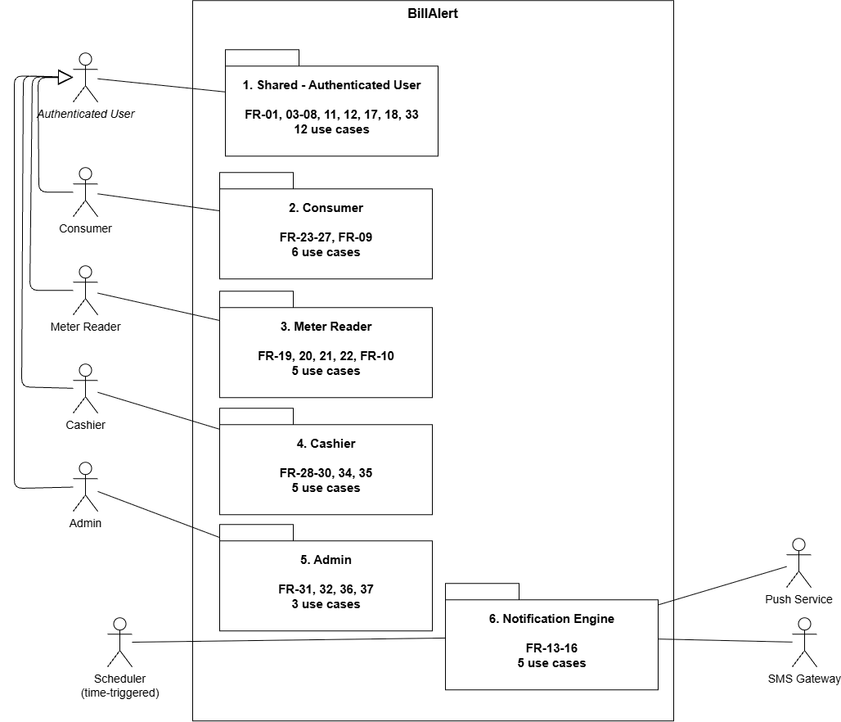
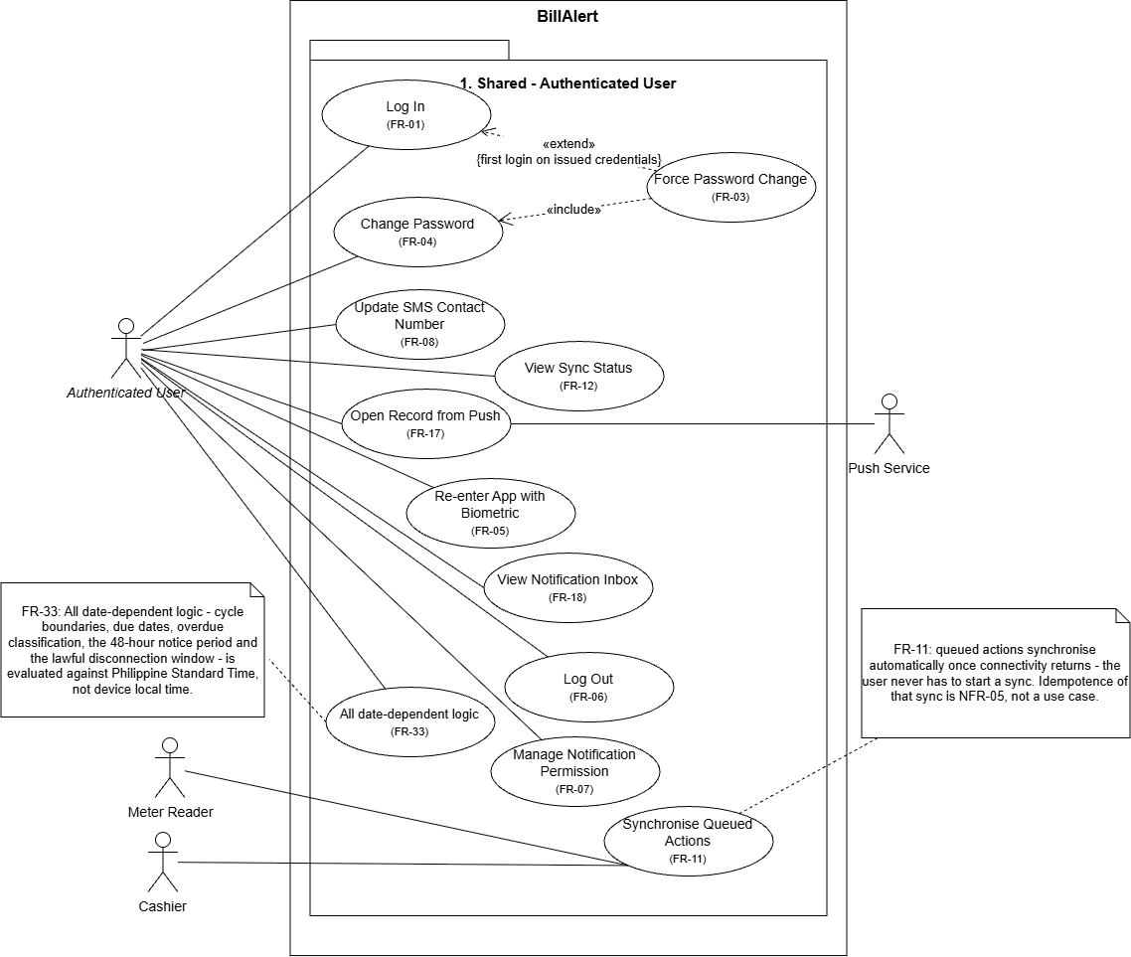

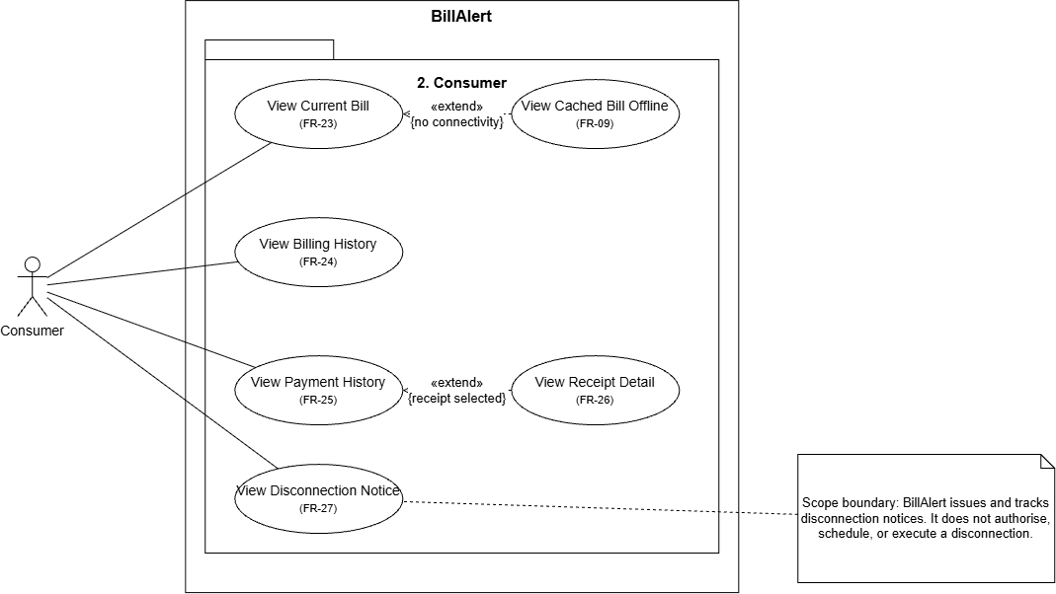

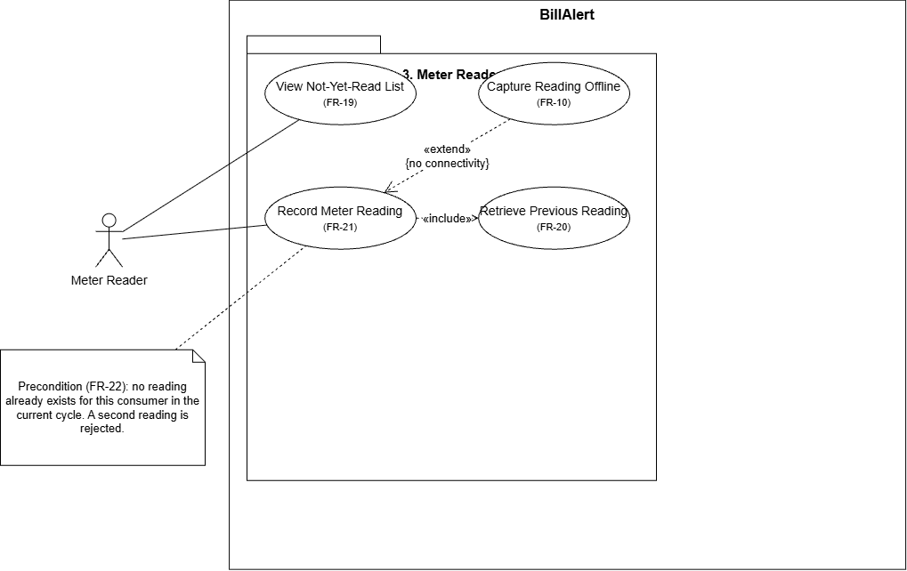
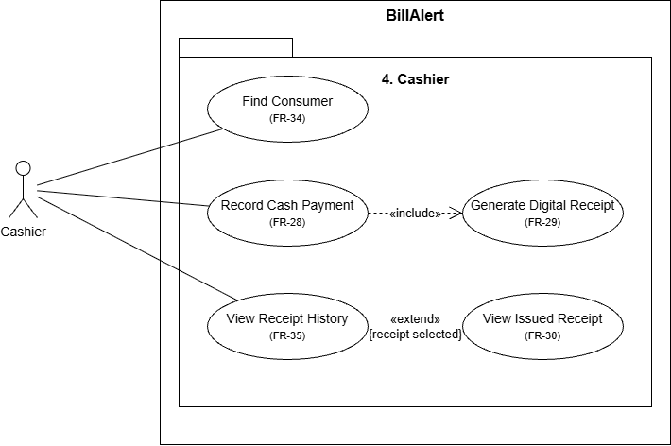
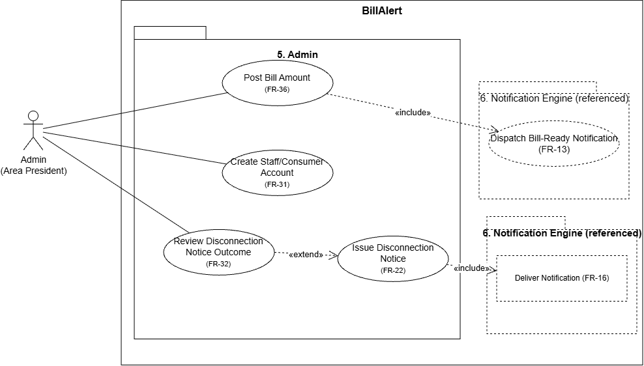

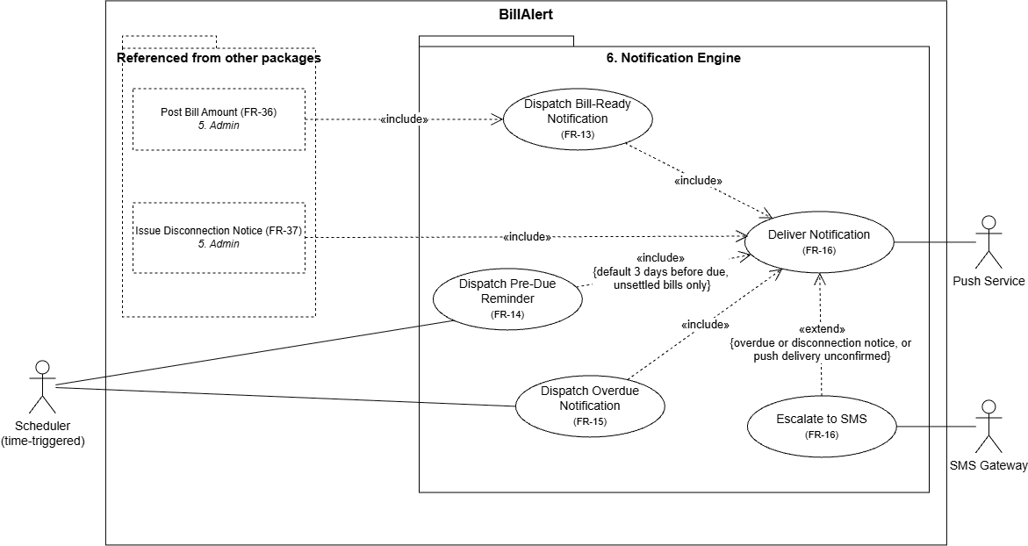

Actor & Use Case Inventory
Actor | Use Cases | Relationship (include / extend)
Authenticated User | Log In, Force Password Change, Change Password, Re-enter App with Biometric, Log Out, Manage Notification Permission, Update SMS Contact Number, View Sync Status, Open Record from Push, View Notification Inbox, Synchronise Queued Actions | Consumer, Meter Reader, Cashier and Admin all generalise from Authenticated User. Force Password Change extends Log In {first login on issued credentials} and includes Change Password. Synchronise Queued Actions attached to Meter Reader and Cashier only. Consumers and Admin queue no offline writes. Log In is a precondition of the role use cases, not an «include» of them.
Consumer | View Current Bill, View Cached Bill Offline, View Billing History, View Payment History, View Receipt Detail, View Disconnection Notice | View Cached Bill Offline extends View Current Bill {no connectivity}. View Receipt Detail extends View Payment History {receipt selected}. View Current Bill covers both the payable and unpriced states of a bill.
Meter Reader | View Not-Yet-Read List, Retrieve Previous Reading, Record Meter Reading, Capture Reading Offline | Record Meter Reading includes Retrieve Previous Reading. Capture Reading Offline {no connectivity} extends Record Meter Reading.
Cashier | Find Consumer, Record Cash Payment, Generate Digital Receipt, View Receipt History, View Issued Receipt | Record Cash Payment includes Generate Digital Receipt -one receipt per transaction, itemising every bill it settles. View Issued Receipt extends View Receipt History {receipt selected}. Find Consumer is the Cashier's entry point and a precondition of Record Cash Payment -a precondition, not an «include». Preconditions on Record Cash Payment: the consumer has at least one payable bill, unpriced bills cannot be settled , and the consumer is in the Cashier's assigned service area .
Admin | Create Staff/Consumer Account, Post Bill Amount, Review Disconnection Notice Outcome, Issue Disconnection Notice | Post Bill Amount includes Dispatch Bill-Ready Notification . Note on Post Bill Amount: amounts are issued by the cooperative's central billing office roughly seven days after readings are submitted, and are transcribed rather than computed. The Admin role is held by an Area President, one per service area, so every Admin use case is scoped to that Admin's own area. Constraint note on Create Staff/Consumer Account: one active Meter Reader, one active Cashier and one active Admin per service area.
Scheduler (time-triggered), Push Service and SMS Gateway (supporting) | Dispatch Bill-Ready Notification, Dispatch Pre-Due Reminder, Dispatch Overdue Notification, Deliver Notification, Escalate to SMS | Scheduler initiates the pre-due and overdue dispatches. Dispatch Bill-Ready Notification has no initiating actor -it is included by Post Bill Amount. All three dispatches include Deliver Notification. Escalate to SMS extends and deliver Notification {overdue or disconnection notice, or push delivery unconfirmed}. Push Service supports Deliver Notification; SMS Gateway supports Escalate to SMS.

10. Wireframes / Mockups

Consumer
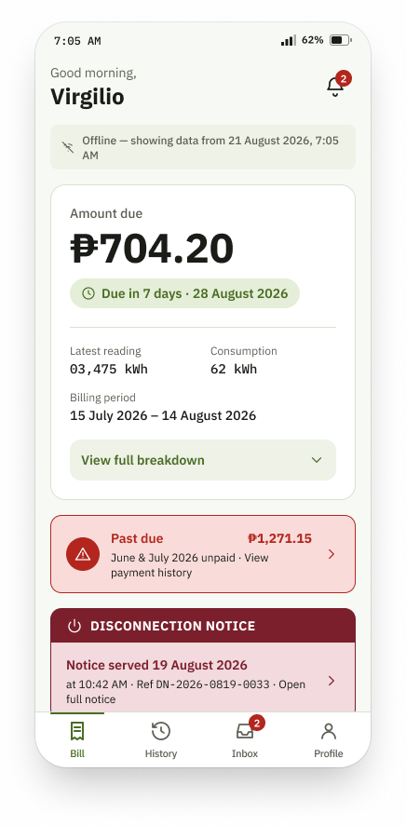  3 · Consumer - Current Bill  The amount due and its date are the visual anchor, because knowing them is the whole reason the app exists. The offline strip names the moment the data was cached, so nothing stale is ever shown as live. | 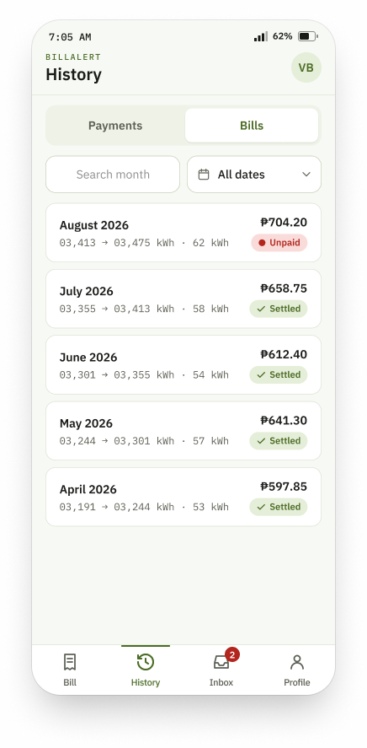  4 · Consumer - History (Bills tab)  Bills and payments are tabs on one screen rather than two destinations, because a consumer thinks in months, not in record types. Each row carries its meter movement, so a disputed amount can be traced to a reading.
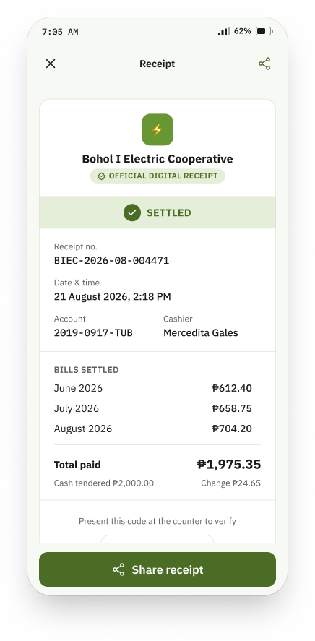  5 · Consumer - Receipt Detail  The consumer's copy of a receipt the cashier issued, reached from payment history. One receipt covers all three bills settled in the transaction, which is why every line here shares a single OR number. | 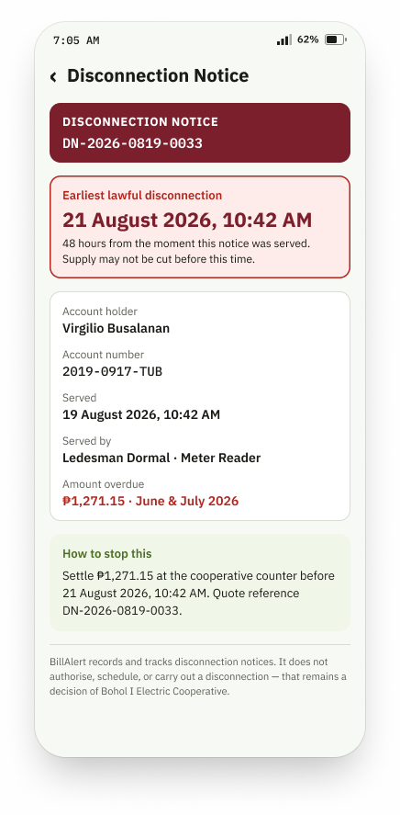  7 · Consumer - Disconnection Notice  The statutory 48-hour deadline leads, because that is the fact the consumer must act on. The footnote states that BillAlert records notices but does not authorise or carry out a disconnection.
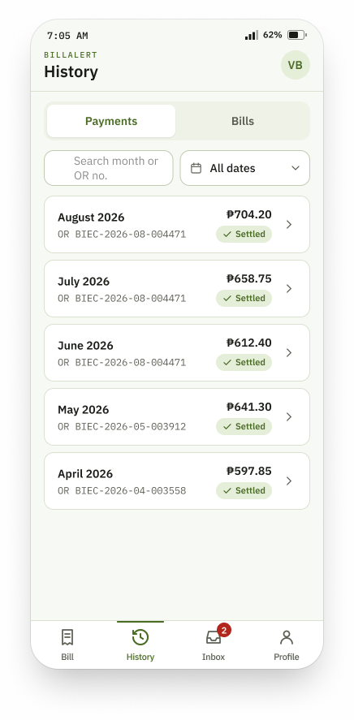  4 · Consumer - History (Payments tab)  The same screen as the Bills tab, showing settled transactions rather than billed months. Three months share one OR number, which is what a single counter payment across several bills actually produces. | 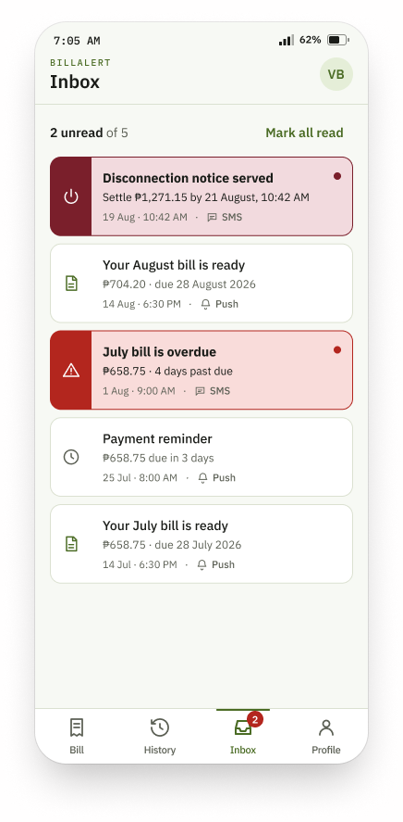  6 · Consumer - Notification Inbox  Every alert the system generated for this account, so a consumer who missed a push can still find it. Push and SMS entries are distinguished, since the two channels carry different delivery guarantees.
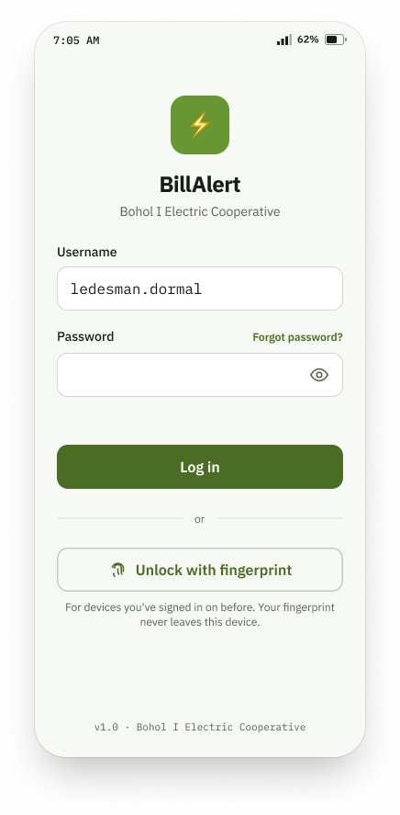  1 · Login  Minimal fields, with the forced first-login password change made unavoidable without reading as an error state. Credentials are issued by an Admin, so nobody self-registers. | 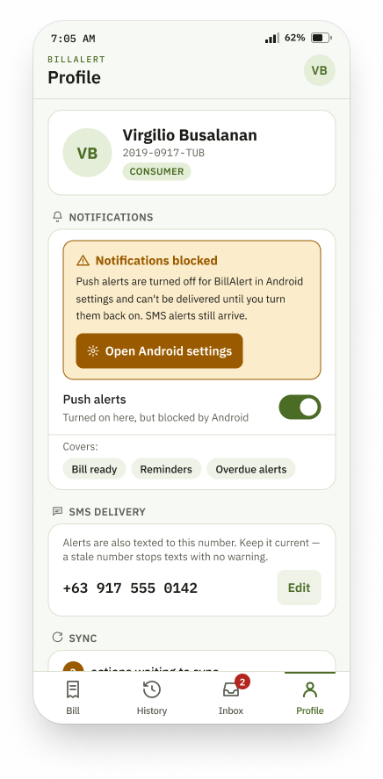  2 · Profile & Notification Settings (Consumer)  One screen reused by all four roles, rendering with the bar of whoever is logged in -which is why Section 10 counts it once and shows it four times. The SMS number sits under Notifications because that is the only thing it governs.

Meter Reader
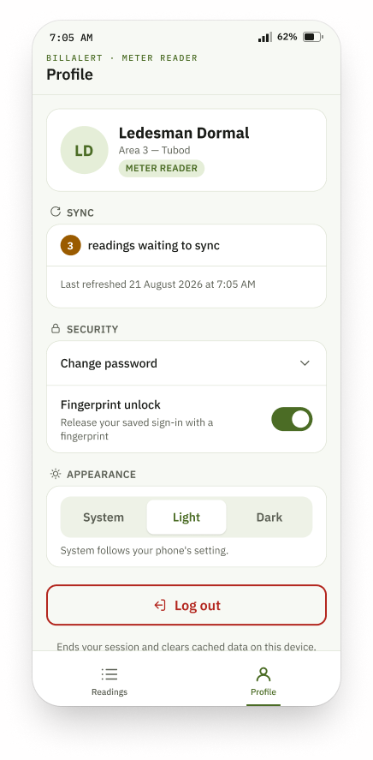  2 · Profile & Notification Settings (Meter Reader)  The same Profile screen carrying the Meter Reader's two-tab bar. Sync status is surfaced here because a reader must know work is still queued on the device before leaving the area. | 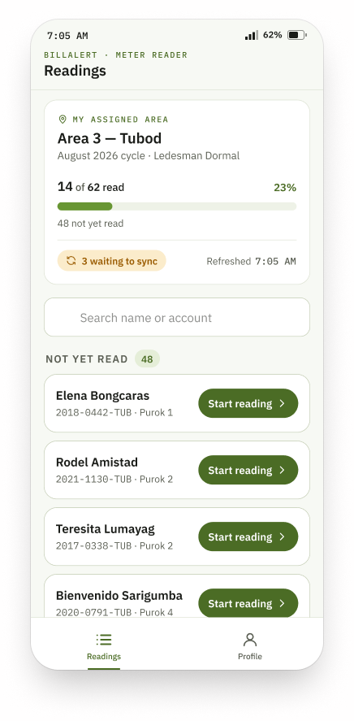  8 · Meter Reader - Not-Yet-Read List  Scoped to the reader's own service area, with cycle progress and the pending-sync count visible without leaving the screen. Large targets and high contrast are deliberate: this screen is used outdoors, one-handed.
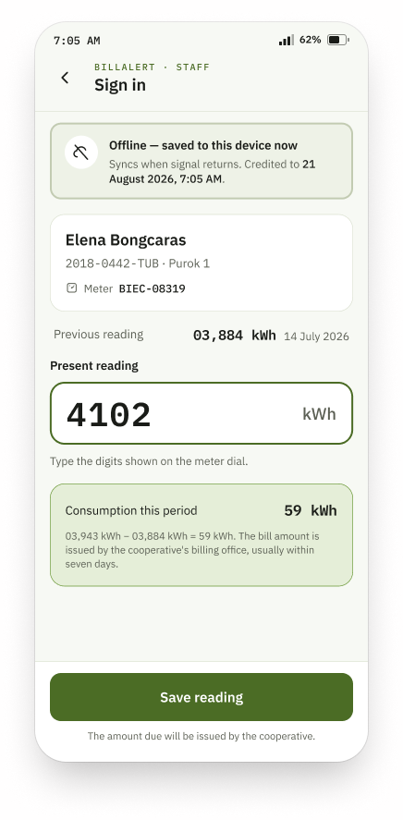
9 · Meter Reader - Record Reading
The previous reading sits beside the entry field so a mistyped digit is caught at the meter rather than at sync. No peso amount appears anywhere: the reader has no tariff, and the cooperative returns the amount about seven days later.

Cashier
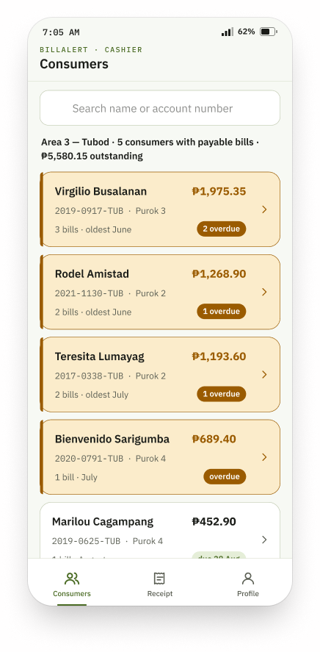  10 · Cashier - Consumer Lookup  The counter's front door: find the person, then settle. Only consumers in this cashier's own area with at least one payable bill are listed, so a reading still awaiting the cooperative's amount never appears as collectable. | 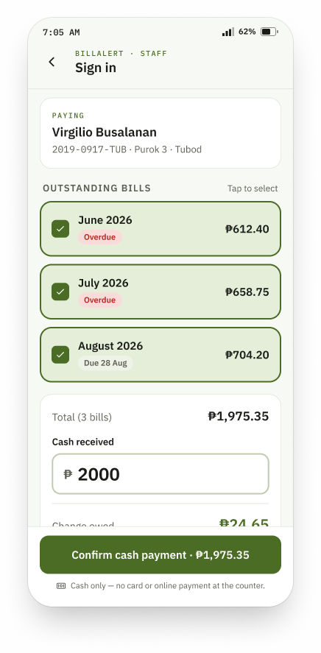  11 · Cashier - Record Payment (multi-bill)  Several months are settled in one transaction, with the running total and change shown before confirmation. Unpriced bills cannot be selected, because there is no amount to collect against.
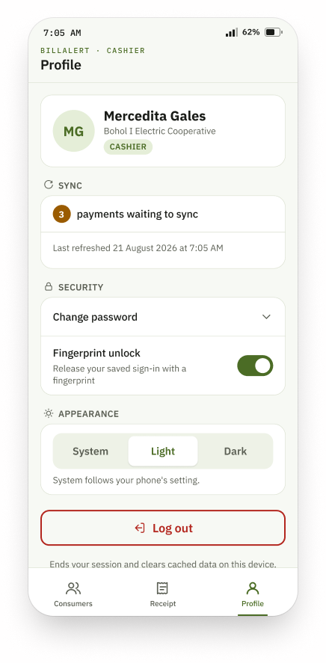  2 · Profile & Notification Settings (Cashier)  The same Profile screen carrying the Cashier's three-tab bar. Identical content across roles, different navigation -the clearest illustration of why this is one screen in four states. | 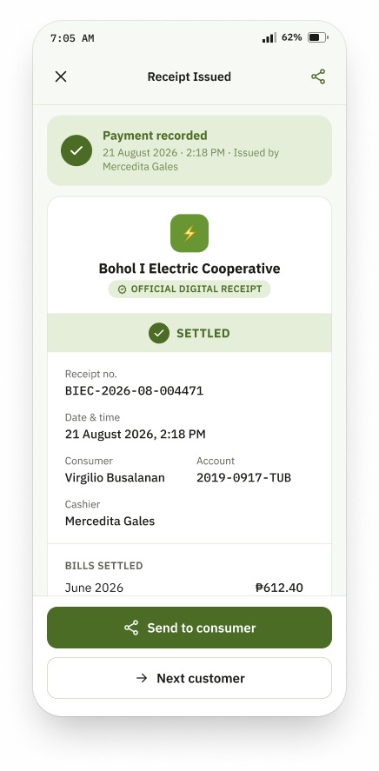  12 · Cashier - Digital Receipt  The cashier-side confirmation of a completed transaction, itemising every bill it settles under one reference code. It is issued in place of a printed receipt, which is why the scannable code carries the verification burden.
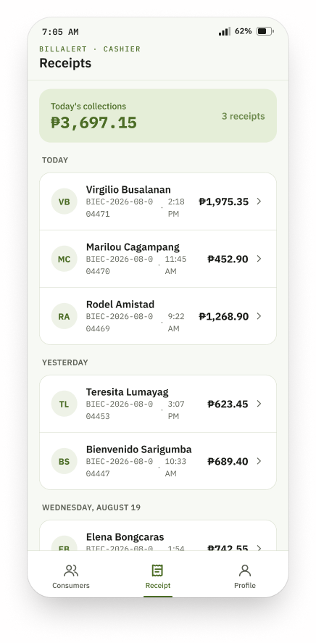
13 · Cashier - Receipt History
A log of this cashier's own recorded payments, so an earlier receipt can be reopened at the counter without searching for the consumer again. It lists payments, never unpaid bills.

Admin
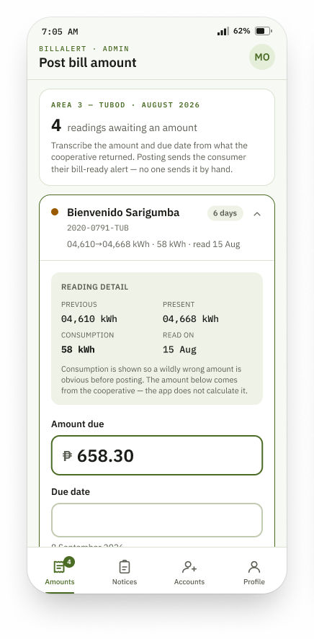  14 · Admin - Post Bill Amount  Where the cooperative's returned figures are transcribed against readings already captured, ending the seven-day gap. Consumption is shown only so a wildly wrong amount is obvious before posting; nothing here calculates money. | 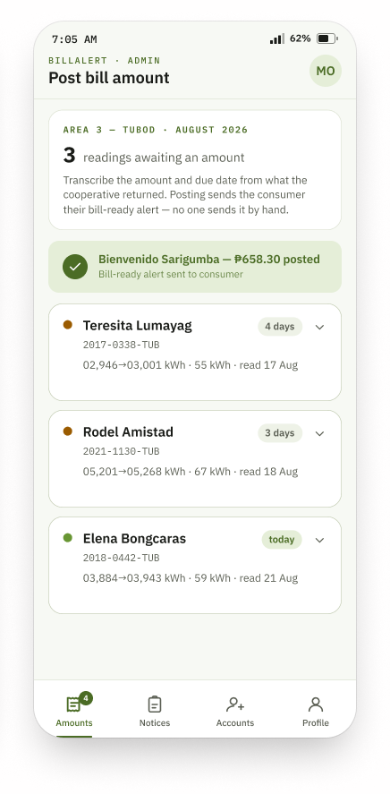  14 · Admin - Post Bill Amount (after posting)  The same screen once an amount is posted: the bill moves from unpriced to payable, leaves the queue, and the consumer's bill-ready alert is dispatched automatically rather than by a staff member.
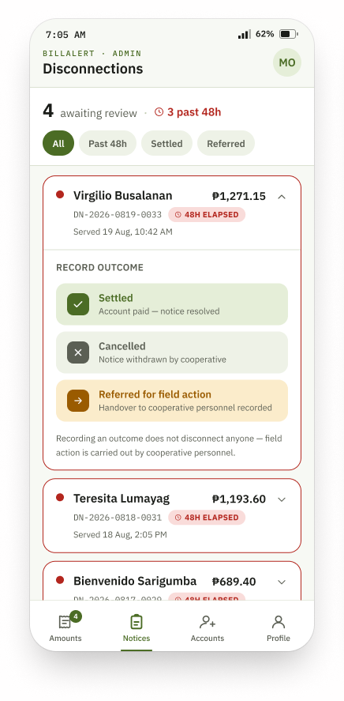  15 · Admin - Pending Disconnections  Notices awaiting an outcome, each shown against the 48-hour clock. Recording an outcome carries confirmation friction appropriate to an irreversible act, and the footnote repeats that the application does not disconnect anyone. | 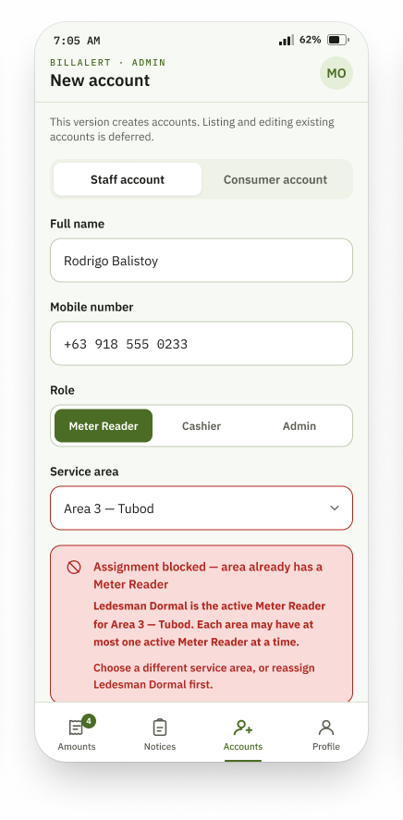  16 · Admin - New Staff Account  Submission is blocked when the chosen area already has an active holder of that role, and the block names the holder rather than failing silently. The line stating that listing and editing accounts is deferred marks a scope boundary, not a gap.
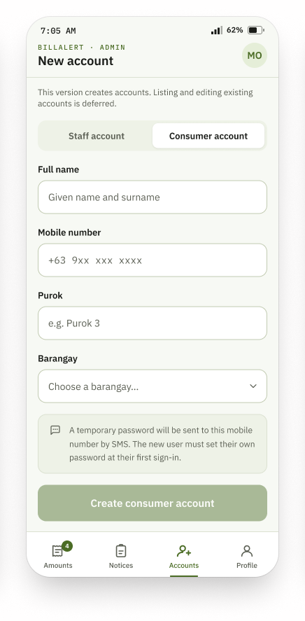  17 · Admin -New Consumer Account  The same form in its consumer variant: a service area and account number instead of a role, since a consumer holds no assignment that could conflict. | 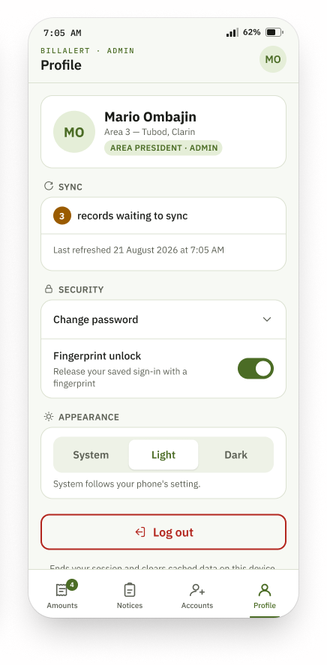  2 · Profile & Notification Settings (Admin)  The same Profile screens carry the Admin's four-tab bar, identifying the holder as an Area President rather than a cooperative employee - the role is called Admin throughout Sections 7 to 10.

