Music Genie – overview and user guide
Charles Fox (cwf22@cam.ac.uk)

What is Music Genie?

Music Genie is a music system based on hierarchical structures (also known as Generative Grammars or L-Systems). It has two functions: firstly, it can be used purely for composition. Secondly, it can genetically splice and mutate compositions, allowing users to selectively breed music that appeals to them.

The two functions overlap somewhat; the genetic methods can also be used as part of the composition process, to provide inspiration in museless moments; and the music editing functions can be used to tinker with evolving pieces if the user wishes.

The genome language

A composition is represented by a genome, which is a list of hierarchical definitions or genes. A simple gene for the top-level structure of a pop song might be

POP-SONG => { VERSE, (&2)CHORUS, (^5)VERSE, (&2)CHORUS, MIDDLE8, (&2)CHORUS }

The curly brackets mean that the elements inside them are to be played in series (as opposed to square brackets, for playing at the same time). The transform (&2) means ‘play in the key a second above the current key’. The transform (^5) means ‘transpose up by a fifth of the current scale’ (staying in the same key).

A genome for a short tune could be:

POP-SONG => { VERSE, (&2)CHORUS, (^5)VERSE, (&2)CHORUS, MIDDLE8, (&2)CHORUS }
VERSE => [VOCAL, HARMONY, BASSLINE]
CHORUS => {(R)VERSE}
MIDDLE8 => {(@1/2)(^5)(&2)VOCAL}
HARMONY => {(^3)VOCAL}
BASS => {(^-8)VOCAL}
VOCAL => {NOTE, (^2)NOTE, (^3)NOTE, (~2)(^3)NOTE, (^3)(~2)NOTE }

( The symbols @ and ~ mean ‘multiply amplitude by’ and ‘timestretch by’)

The gene NOTE is a special predefined gene, which represents a single middle C crotchet, in the key of C major. Using NOTE is the only way to produce sounds – all other genes are ultimately made up only of NOTEs.

Keys and Scales

An important feature of Music Genie is that the notions of key and scale are built into the system. So you can define the VOCAL gene as above only in terms of degrees of a scale. By default, VOCAL will be played in C Major, but the key and scale patterns can be changed with the following transforms:

VOCAL-IN-G-MAJOR => { (&5)VOCAL } (Key shifted up by 5 degrees)
VOCAL-IN-C-MINOR => { ($6)VOCAL } (Mode shifted to that of 6th degree of old scale)

(More advanced transforms allow the scale pattern to be completely redefined, to allow, for example, ragas and pentatonics)

Composing with Music Genie

Composing is done in the Edit Window:

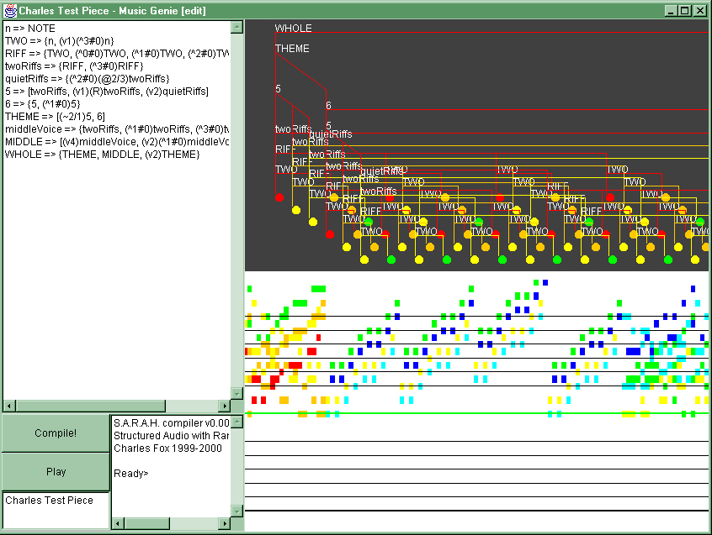
Here, the user is creating a piece by typing in genes in the panel on the top left. When the user clicks ‘Compile’, Music Genie uses the genome to create the composition, which is displayed both as a piano-roll score and as the hierarchical structure which underlies the score. Clicking ‘Play’ will play a MIDI rendition of the piece (which can be exported as a MIDI file to score setting programs, for example).

(The different colors represent different instruments, which are accessed with the ‘shift voice’ transform, (v). The tree is 3 dimensional - it represents time on the horizontal, and uses depth to show two or more structures which play at the same time.)

The following are examples of each of the supported transforms:

(^5) transpose by a fifth (~3/2) timestretch by 3/2 (@4/5) multiply amplitude by 4/5
(v3) shift 3 instruments up (&4) raise key by a fourth ($3) change to 3rd mode of scale
(R) retrograde (play backwards)

(when sharpened intervals are required, the syntax is (^5#), (^3##), (^3bb) for single and double sharps flats etc. Downwards intervals use minus signs, eg. (^-5) )

Evolution

Two forms of evolution are supported: cross-over and mutation.

Mutation acts on single genomes by making small random (but legal) mutations to them. Typical mutations may alter the transforms within genes, add or remove structures from genes, or add and remove genes from the whole genome.

Cross-over acts on two or more genomes by combining randomly-chosen genes from each one to form a new genome. (Note that the names of the genes may be changed to allow this to work.)

Breeding music with Music Genie

The Breeding window allow the user to work with the sounds of several genomes, without having to worry about their internal details:

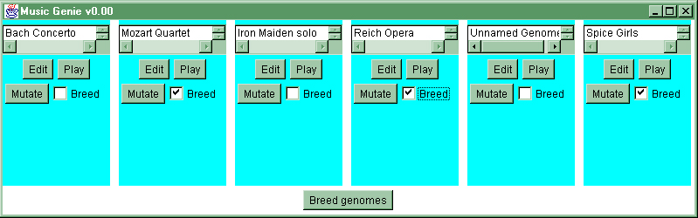
Here, the user can listen to each genome, and select it for breeding if he likes the sound. Clicking ‘Breed Genomes’ will produce a new generation of genomes from the selected parents (with a few random mutations performed on each). This process can be repeated indefinitely to allow the user to breed successively better pieces.

Music Genie will eventually have a web-based interface to the Breeding window, so that millions of users around the world can contribute to the evolution process.

Summary
- Music Genie is both a composition tool and a facility for evolving computer-produced pieces.
- It uses the principal of Hierarchical structures
- Keys and Scales are hardwired into its design, to encourage aesthetically pleasing results
- It two functions overlap; composers can use random mutations for inspiration, and breeders can access the editing controls to fine-tune their crops of compositions.

