Database Systems: Coursework 1

C1646151- Charles Read

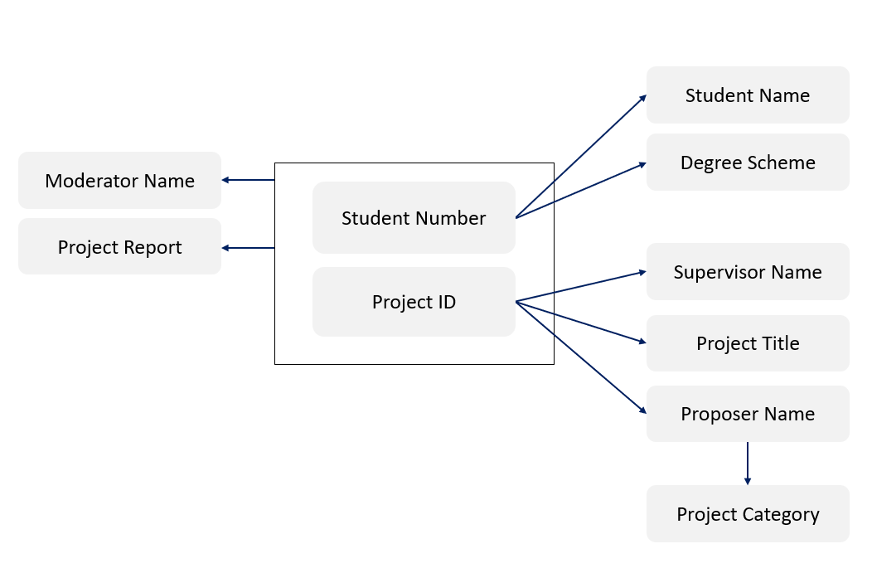**Q1)**

Assumptions:

* Each student is doing a single Degree Scheme.
* Each student is doing a single project.
* Project report is determined by both Project ID and Student Number.
* Each project report can have only one moderator.
* One person can propose only one project.
* Project category is dependent on Proposer Name.
* Each proposer can propose only one project but for multiple students.
* Each supervisor can supervise only one project but for multiple students.

**Q2)**

Student (Student Number, Student Name, Degree Scheme)

R2 (Project ID, Project Title, Supervisor Name, Proposer Name, Project Category)

Results (Student Number, Project ID, Moderator Name, Project Report)

Project (Project ID, Project Title, Project Category, Proposer Name)

Supervisor (Project ID, Supervisor Name)