Large-Scale Databases – PartA

Charles Read | C1646151 | CM3104 CW

# Task 1:

C:/mongodb/bin/mongod --nojournal --dbpath C:/Users/charl/Desktop/cw/db

C:/mongodb/bin/mongoimport –db services –collection zipcodes –file zips.json

C:/mongodb/bin/mongoimport –db services –collection restaurants –file restaurants.json

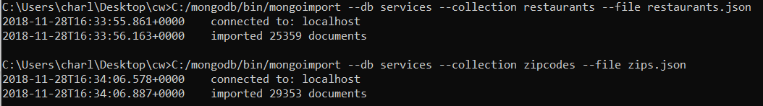

> C:/mongodb/bin/mongo

> use services

> show collections

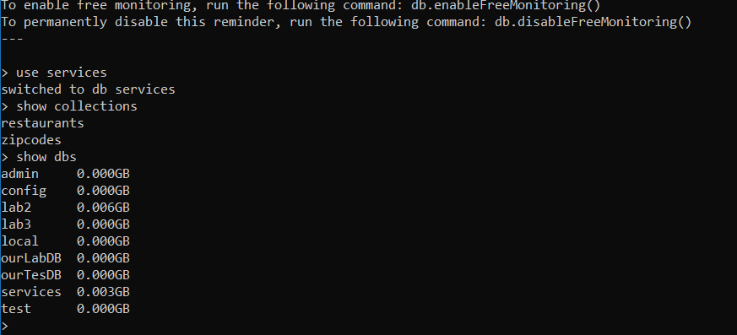

Task 2:

## Question 1:

var pizzaRestaurant = db.restaurants.find({"name" : /.*Pizza.*/})

pizzaRestaurant.count()

pizzaRestaurant

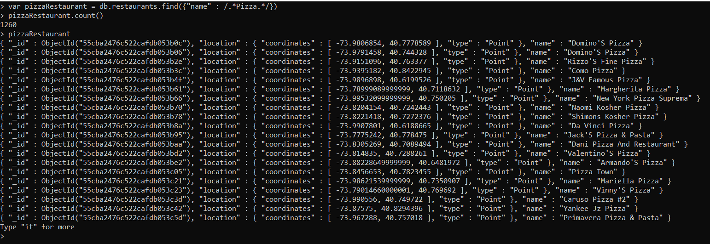

## Question 2:

db.zipcodes.createIndex({"loc" : "2dsphere"});

db.restaurants.createIndex({"location" : "2dsphere"});

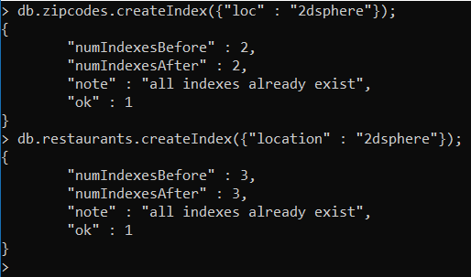

var pizzaRestaurant = db.restaurants.find({"name" : /.*Pizza.*/})

pizzaRestaurant.forEach(function(pizzaRestaurant){

var zip = db.zipcodes.findOne({loc : {$near: pizzaRestaurant.location}});

print("Pizza Restaurant:"); printjson(pizzaRestaurant.name);

print("Nearest City:"); printjson(zip.city);

});

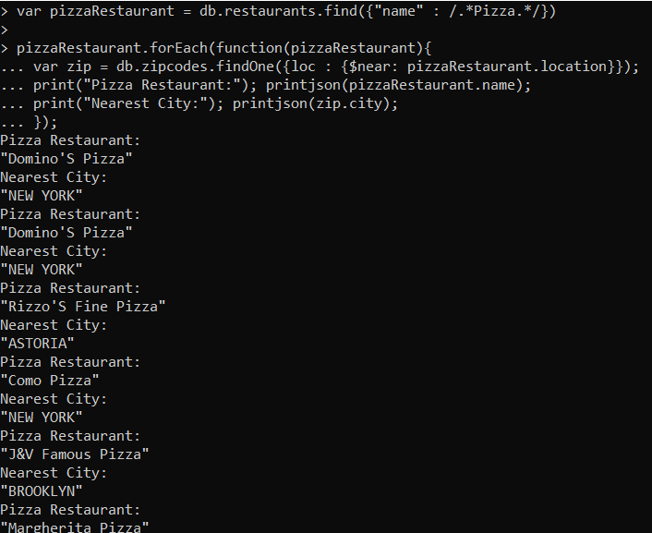

## Question 3:

db.restaurants.aggregate([{ $out: "geodb" } ])

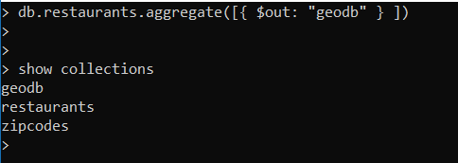

var pizzaRestaurant = db.geodb.find();

pizzaRestaurant.forEach(function(pizzaLocation){

var zip = db.zipcodes.findOne({loc : {$near: pizzaLocation.location}});

db.geodb.update({"_id" : pizzaLocation._id}, {$set: {city : zip.city}});

});

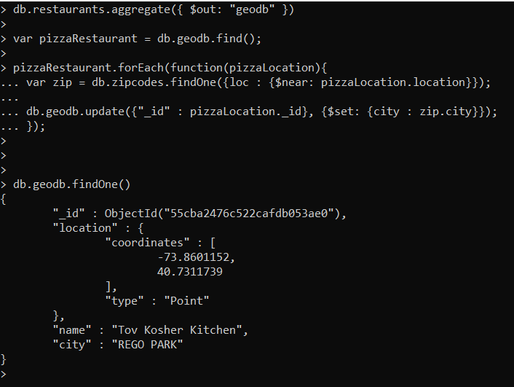

## Question 4:

db.geodb.aggregate(

[

{$group: {

_id: "$city",

"restaurantsA" : { $push: "$name"},

}

},

{$project: {

_id : 0,

"City" :"$_id",

"No of Restaurants" : { $size : "$restaurantsA"},

"Restaurants": "$restaurantsA",

}

}]).pretty();

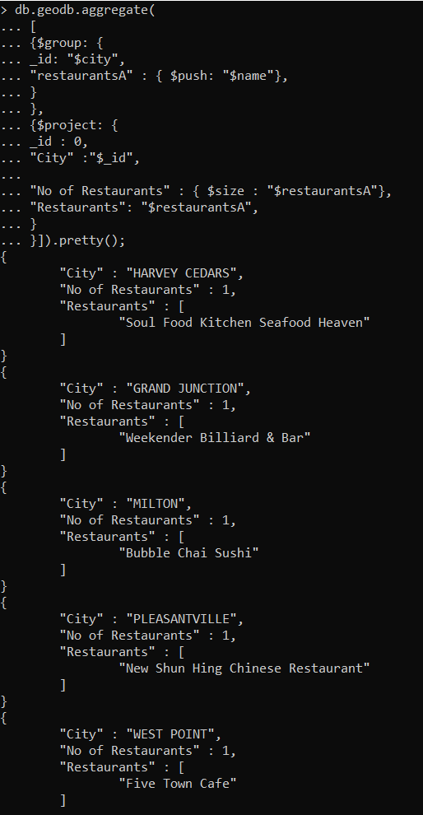

## Question 5:

This is not a sensible model for storing the information of restaurants with their associated cities. The problem with this method would be the clashing of restaurants with the same name, for example, a city may have multiple PizzaHuts which would cause issues especially with runtime as extra steps would have to be used to identify the correct restaurant. If two restaurants within the same city had the same name, there would be a clash and most likely, only one restaurant would be displayed within the query for that specific city, regardless of how many exist.