**Supplemental Information**

**Supplemental Methods**

*Participants*

The total longitudinal sample consisted of 220 scans from 135 participants (6–23 years of age; n= 65 22qDel baseline, 63.1% female; n= 69 TD controls baseline, 49.3% female), recruited from an ongoing longitudinal study at the University of California, Los Angeles (UCLA). A prior cross-sectional study of whole-thalamus FC in 22qDel included a single time point from 79 individuals included in the current longitudinal sample (1). The 22qDel participants all had a molecularly confirmed 22q11.2 deletion. 22qDel and TD participants were statistically matched based on baseline age, sex, handedness, and fMRI motion (percent frames flagged based on displacement/intensity thresholds recommended by Power et al. 2012 (2)), as well as mean number of longitudinal visits and interval between visits, using appropriate tests (ANOVA, or chi-squared). Exclusion criteria for all study participants were as follows: significant neurological or medical conditions (unrelated to 22q11.2 deletion) that might affect brain structure, history of head injury with loss of consciousness, insufficient fluency in English, and/or substance or alcohol use disorder within the past 6 months. As we aimed to include a representative cohort of CNV carriers, patients with cardiac-related issues were not excluded, as this is a hallmark of 22qDel. Healthy controls were free from significant intellectual disability and did not meet criteria for any psychiatric disorder, with the exception of attention deficit-hyperactivity disorder or a past episode of depression, due to their prevalence in childhood and adolescence (3–5). After study procedures had been fully explained, adult participants provided written consent, while participants under the age of 18 years provided written assent with the written consent of their parent or guardian. The UCLA Institutional Review Board approved all study procedures and informed consent documents.

*Clinical assessment*

At each study time point, demographic information and clinical measures were collected for each participant by trained Master's-level clinicians, supervised by a clinical psychologist. Psychiatric diagnoses were established with the Structured Clinical Interview for DSM-IV (SCID) (6). Verbal IQ was assessed via the Wechsler Abbreviated Scale of Intelligence (WASI) Vocabulary subtest, and nonverbal IQ was assessed via the WASI Matrix Reasoning subtest. Psychiatric and dimensional psychotic-like symptoms were assessed via the Structured Interview for Psychosis-Risk Syndromes (SIPS) (7). For more details on study ascertainment and recruitment procedures, see Jalbrzikowski et al. 2012 and 2013 (8,9)

*Neuroimaging acquisition*

All subjects were imaged at the UCLA Center for Cognitive Neuroscience on either a Siemens TimTrio or Prisma scanner. The Prisma data were collected with Human Connectome Project (HCP)-style sequences. 420 volumes (5.6 min) of resting BOLD data were acquired in 72 interleaved slices with multiband-8 acceleration (voxel size = 2 × 2 × 2 mm, TR = 800 ms, TE = 37 ms, flip angle = 52°, FOV = 208 × 208 mm), along with single-band reference images and a pair of spin-echo field maps with phase encoding in the anterior-posterior (AP) and posterior-anterior (PA) directions. T1w MP-RAGE and T2w SPC images were collected in 208 sagittal slices (voxel size = 0.8 × 0.8 × 0.8 mm, FOV = 256 × 256 mm) with (T1w TR = 2400 ms, TE = 2.22 ms) and (T2w TR = 3200 ms, TE = 563 ms). The TimTrio resting BOLD data were acquired in 34 interleaved axial slices using a fast gradient-echo, echo-planar sequence (voxel size = 3 × 3 × 4 mm, TR = 2000 ms, TE = 30 ms, flip angle = 90°, FOV = 192 × 192 mm). Acquisition lasted 5.1 min and produced 152 volumes. High-resolution T1w MP-RAGE images were collected in 160 sagittal slices (voxel size = 1 × 1 × 1 mm, TR = 2300 ms, TE = 2.91 ms, flip angle = 90°, FOV = 240 × 256 mm).

*Neuroimaging preprocessing*

Structural and functional MRI data were processed using the Quantitative Neuroimaging Environment & Toolbox (10) which includes an extension of the Human Connectome Project (HCP) minimal preprocessing pipeline (11) compatible with multi-band and single-band fMRI. Additional processing of the fMRI time series included bandpass filtering, motion scrubbing for frames exceeding either a framewise displacement threshold of 0.5 mm or signal change threshold of 3 (normalized root mean square difference) proposed by Power et al. (2), and spatial smoothing (4mm Gaussian full width half maximum). Scans with >50% frames flagged for motion were excluded. To correct for spatially pervasive sources of noise including latent physiological factors and unaddressed movement, final analyses were performed on the residuals of the time series after regression of movement, mean signal from the ventricles and deep white matter, and the mean global gray matter signal (12). For a detailed description of preprocessing methods, see previous work in a subset of these data (1).

*Functional connectivity*

rs-fMRI analyses were performed using the ciftiTools package in R version 4.2.2 (13). Network thalamocortical functional connectivity (TCC) was calculated based on the Cole-Anticevic Brain-Wide Network Partition (CAB-NP) (14) which provides a whole brain cortical-subcortical extension of the HCP multimodal surface parcellation (15) derived from healthy adult resting-state fMRI. For each network, TCC was computed as the Fisher z-transformed Pearson correlation between the mean BOLD time series in the cortical portion of the network and the thalamic portion of the same network. Nine networks were investigated (frontoparietal, somatomotor, cingulo-opercular, default mode, dorsal attention, auditory, posterior multimodal, primary visual, and secondary visual), and three were excluded for lack of representation in the thalamus (orbito-affective, ventral multimodal, and language).

*Data harmonization*

To harmonize data acquired on two different scanner platforms, we applied a longitudinal implementation of the ComBat algorithm using the longComBat package in R (16,17). ComBat uses empirical Bayes methods to estimate and remove site/batch effects with increased robustness to outliers in small samples compared to general linear model approaches. ComBat was initially developed for genomics data (17), and has been subsequently adapted for neuroimaging and shown to preserve biological associations while effectively removing unwanted non-biological variation associated with site/scanner (18). The longitudinal adaptation, which uses random effects to account for within-subject repeated measures, has been shown to further increase statistical power in longitudinal neuroimaging analyses (16). LongComBat has been used to harmonize structural MRI features in a longitudinal analysis of cortical thickness and volume in a largely overlapping cohort of individuals 22qDel and controls (19).

*Modeling age trajectories*

Nonlinear relationships between age and thalamocortical connectivity in 22qDel and TD youth were assessed with general additive mixed models (GAMMs) as in Jalbrzikowski et al., 2022 (19) using the mgcv package in R. Like linear mixed effects models, GAMMs can account for repeated within-subject measures with random effects. Non-linear curves are estimated with basis functions, with overfitting prevented by penalization of polynomials and restricted estimation of maximum likelihood (20–22). We examined the smoothed effects of age on TCC separately in 22qDel and TD cohorts because GAMMs allow the shape of the relationship between the smoothed predictor and dependent variable to differ between groups. For each network, a GAMM was fitted predicting TCC from the smoothed effect of age and group, controlling for sex, scanner, and with a random intercept for subject ID. Test statistics were collected for the smoothed effect of age in each group, and *p*-values were corrected for multiple comparisons with False Discovery Rate (23). To identify age ranges of significant TCC change in each group, the first derivative of the age curve was taken, and ages in which the 95% confidence interval (CI) did not include zero for the first derivative were considered to represent significant age-associated change. Similarly, age ranges with significant group differences in TCC were determined where the 95% CI for the group difference in age smooths did not include zero.

*Secondary analyses*

To test the robustness of our models to various assumptions we performed a range of additional analyses. In our primary analyses, movement was corrected by scrubbing and by regression of motion traces from the BOLD time series, but as a supplementary analysis we repeated the main GAMMs with motion (percent frames flagged) as an additional covariate. Similarly, additional separate models were tested with antipsychotic medication status or congenital cardiac diagnosis. To test robustness to outliers, 90% Winsorization was performed, restricting extreme values to the 5th and 95th percentiles, and the main GAMM analysis was repeated on this modified input. Additionally, we repeated the main analyses with inputs that had not been subjected to global signal regression (GSR) as a preprocessing step. To quantify the relationship between movement and FC with and without GSR, we performed QC-FC analysis, an approach developed by Power et al. (24). To test the impact of using data from two scanners, the main GAMM analysis was repeated with only the Trio data (Prisma scans excluded). The Prisma cohort alone did not have enough scans to test an equivalent model.

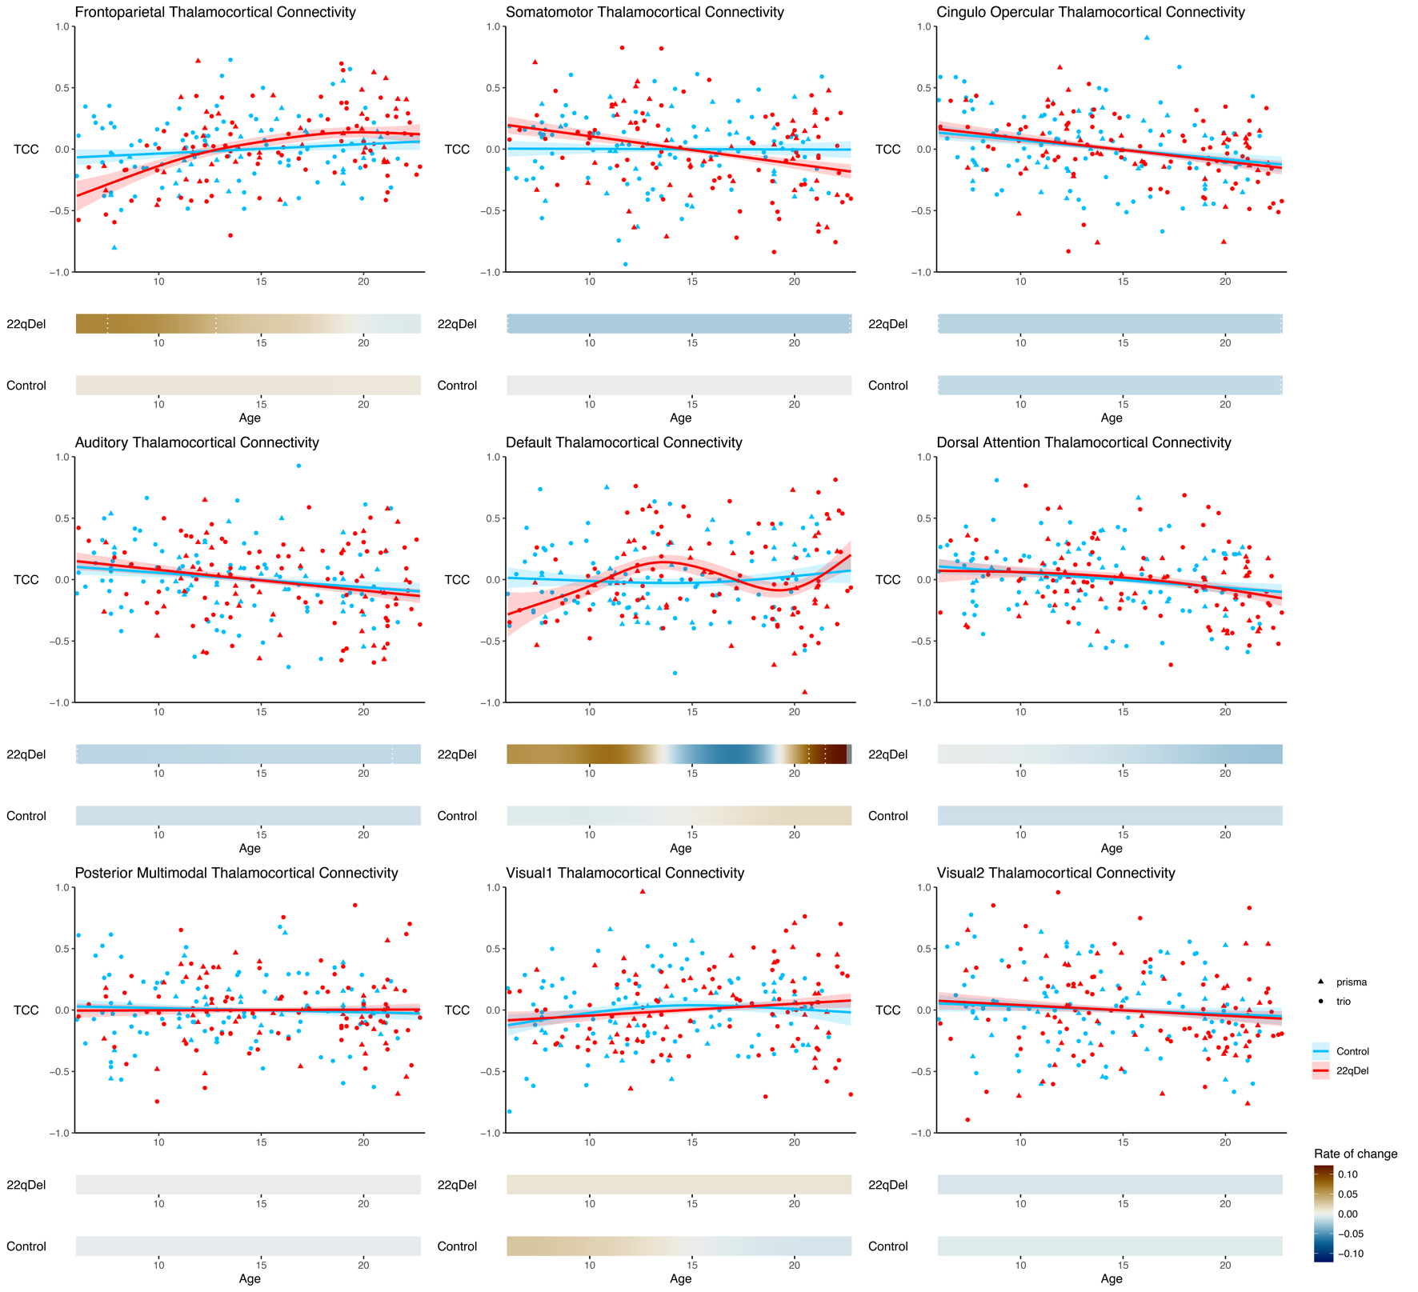 **Supplemental Results**

**Figure S1. Age trajectories for all networks.** Visualization ofGAMM curves and partial residuals *(above)* and first derivatives *(below*) for all nine networks from the primary analysis.

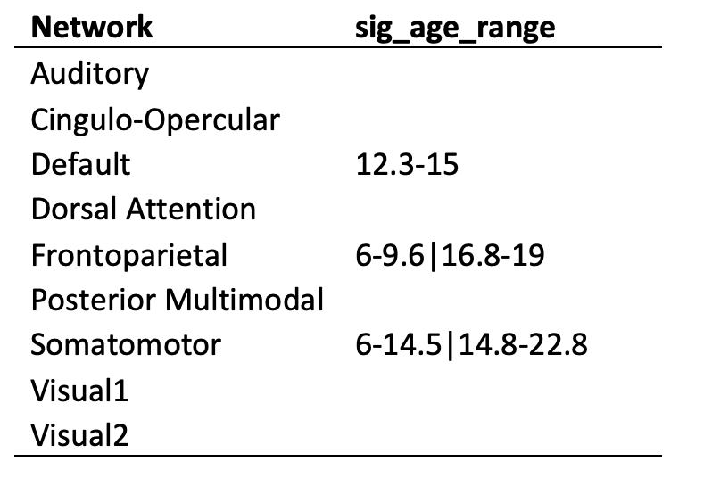

**Table S1. Periods of significant group difference in TCC developmental trajectory.** For each network**,** sig_age_range describes age ranges during which 22qDel and TD curves were significantly different (i.e. 95% confidence interval for the difference in age smooths does not include zero). If multiple discontinuous age periods of significant difference are found for a network (e.g., frontoparietal or somatomotor), they are separated by “|”.

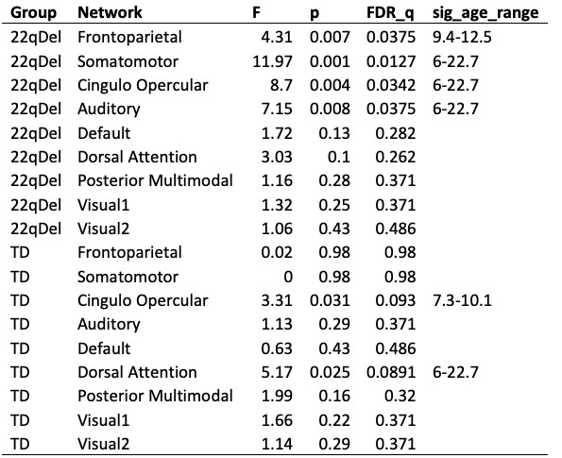

**Table S2. Excluding Prisma data.** GAMM age coefficients, *p*-values, FDR corrected *q*-values, and periods of significant change, tested using only data from the Siemens Trio scanner.

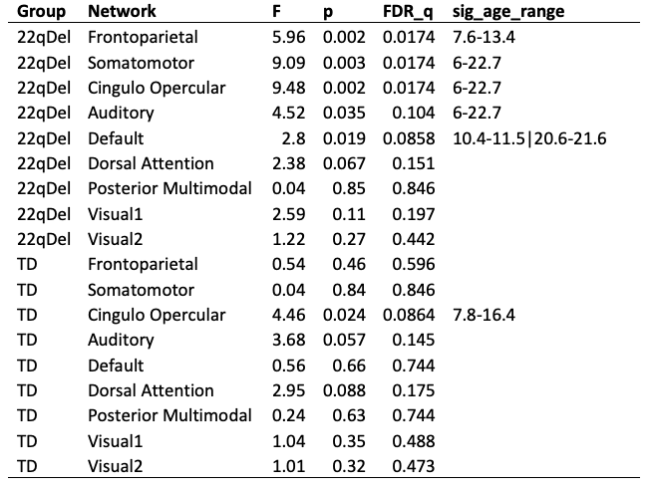

**Table S3. Winsorization for outliers.** Repeat of main analyses (with full trio+prisma dataset) with the additional step of 90% Winsorization, which transforms all outliers above the 95th percentile to the 95th percentile, and all below the 5th percentile to the 5th percentile.

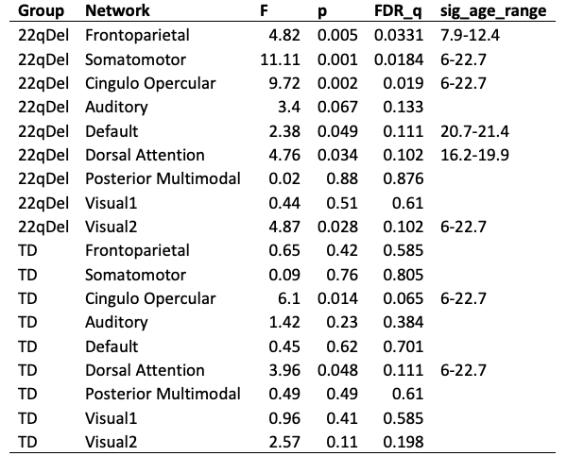

**Table S4. Controlling for movement.** Repeat of main analyses with movement (percent of frames scrubbed) as an additional fixed effect in the GAMM.

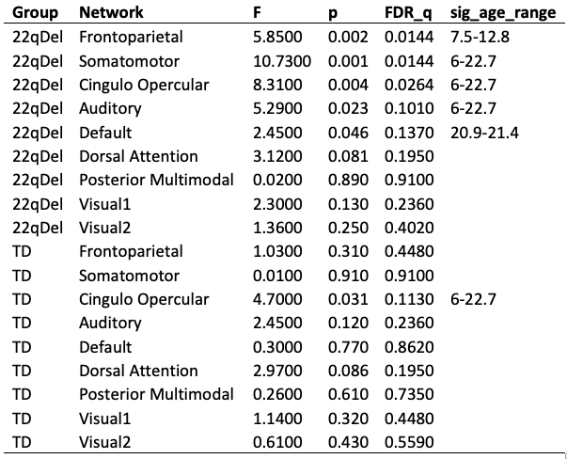

**Table S5. Controlling for antipsychotic medication.** Repeat of main analyses with current antipsychotic medication status (true/false) as an additional fixed effect in the GAMM.

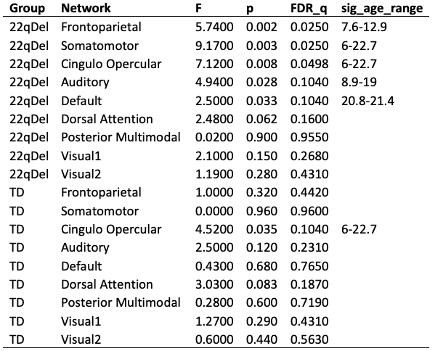

**Table S6. Controlling for cardiac diagnosis.** Repeat of main analyses with an additional covariate for lifetime congenital cardiac diagnosis including ventral/atrial septal defect, valvular anomalies, and conotruncal anomalies.

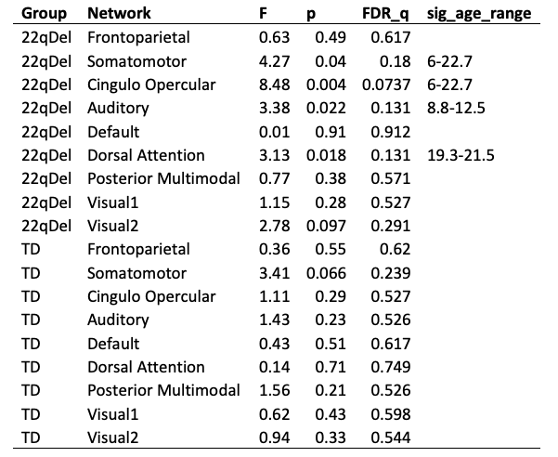

**Table S7. Omission of global signal regression (GSR).** Repeat of main analyses without GSR as a preprocessing step.

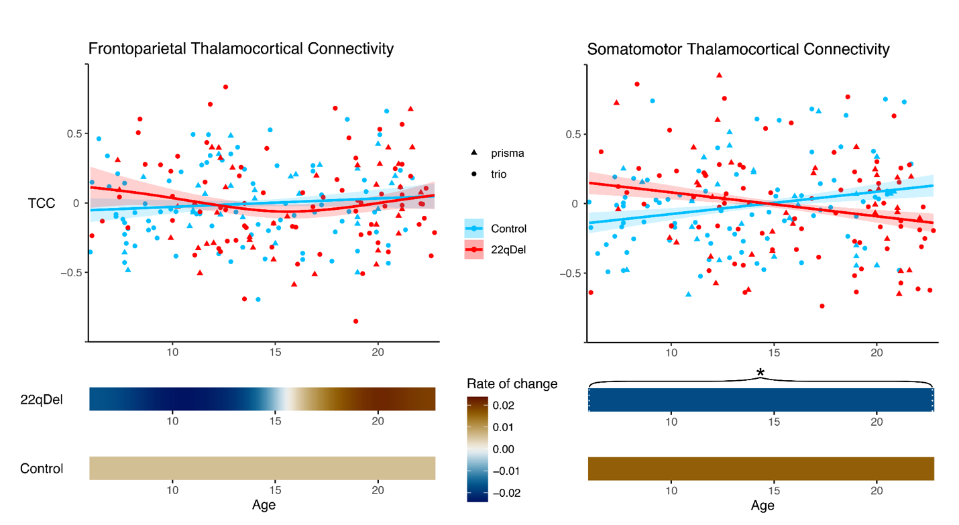**Figure S2. Age trajectories of frontoparietal and somatomotor thalamocortical connectivity without GSR.** Visualization ofGAMM curves and partial residuals *(above)* and first derivatives *(below*) for frontoparietal *(left)* and somatomotor *(right)* networks.

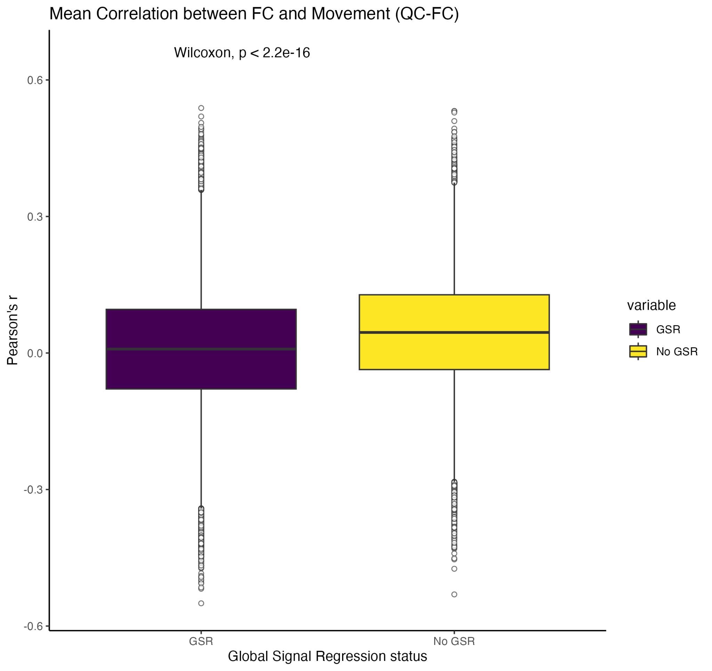

**Figure S3. QC-FC relationships with and without GSR.** For each pair of regions in the n=718 region CAB-NP parcellation, QC-FC was calculated as the Pearson correlation between functional connectivity and movement across all baseline 22qDel and TD scans (24). QC-FC values were compared for data with and without GSR using a Wilcoxon signed rank test indicating a significantly decreased relationship between movement and functional connectivity in the global signal regressed data (purple) compared to the data without GSR (yellow).

**Supplemental References**

1. Schleifer C, Lin A, Kushan L, Ji JL, Yang G, Bearden CE, Anticevic A (2019): Dissociable Disruptions in Thalamic and Hippocampal Resting-State Functional Connectivity in Youth with 22q11.2 Deletions. *J Neurosci Off J Soc Neurosci* 39: 1301–1319.

2. Power JD, Barnes KA, Snyder AZ, Schlaggar BL, Petersen SE (2012): Spurious but systematic correlations in functional connectivity MRI networks arise from subject motion. *Neuroimage* 59: 2142–2154.

3. Ghandour RM, Sherman LJ, Vladutiu CJ, Ali MM, Lynch SE, Bitsko RH, Blumberg SJ (2019): Prevalence and Treatment of Depression, Anxiety, and Conduct Problems in US Children. *J Pediatr* 206: 256-267.e3.

4. Sayal K, Prasad V, Daley D, Ford T, Coghill D (2018): ADHD in children and young people: prevalence, care pathways, and service provision. *Lancet Psychiatry* 5: 175–186.

5. Thapar A, Collishaw S, Pine DS, Thapar AK (2012): Depression in adolescence. *The Lancet* 379: 1056–1067.

6. First MB, Gibbon M (2004): The Structured Clinical Interview for DSM-IV Axis I Disorders (SCID-I) and the Structured Clinical Interview for DSM-IV Axis II Disorders (SCID-II). *Comprehensive Handbook of Psychological Assessment, Vol. 2: Personality Assessment*. Hoboken, NJ, US: John Wiley & Sons, Inc., pp 134–143.

7. Miller TJ, McGlashan TH, Rosen JL, Somjee L, Markovich PJ, Stein K, Woods SW (2002): Prospective diagnosis of the initial prodrome for schizophrenia based on the Structured Interview for Prodromal Syndromes: preliminary evidence of interrater reliability and predictive validity. *Am J Psychiatry* 159: 863–865.

8. Jalbrzikowski M, Carter C, Senturk D, Chow C, Hopkins JM, Green MF, *et al.* (2012): Social Cognition in 22q11.2 Microdeletion Syndrome: Relevance to Psychosis. *Schizophr Res* 142: 99–107.

9. Jalbrzikowski M, Jonas R, Senturk D, Patel A, Chow C, Green MF, Bearden CE (2013): Structural abnormalities in cortical volume, thickness, and surface area in 22q11.2 microdeletion syndrome: Relationship with psychotic symptoms. *NeuroImage Clin* 3: 405–415.

10. Ji JL, Demšar J, Fonteneau C, Tamayo Z, Pan L, Kraljič A, *et al.* (2022, October 2): QuNex – An Integrative Platform for Reproducible Neuroimaging Analytics. bioRxiv, p 2022.06.03.494750.

11. Glasser MF, Sotiropoulos SN, Wilson JA, Coalson TS, Fischl B, Andersson JL, *et al.* (2013): The Minimal Preprocessing Pipelines for the Human Connectome Project. *NeuroImage* 80: 105–124.

12. Power JD, Plitt M, Laumann TO, Martin A (2017): Sources and implications of whole-brain fMRI signals in humans. *NeuroImage* 146: 609–625.

13. Pham DD, Muschelli J, Mejia AF (2022): ciftiTools: A package for reading, writing, visualizing, and manipulating CIFTI files in R. *NeuroImage* 250: 118877.

14. Ji JL, Spronk M, Kulkarni K, Repovš G, Anticevic A, Cole MW (2019): Mapping the human brain’s cortical-subcortical functional network organization. *NeuroImage* 185: 35–57.

15. Glasser MF, Coalson TS, Robinson EC, Hacker CD, Harwell J, Yacoub E, *et al.* (2016): A multi-modal parcellation of human cerebral cortex. *Nature* 536: 171–178.

16. Beer JC, Tustison NJ, Cook PA, Davatzikos C, Sheline YI, Shinohara RT, Linn KA (2020): Longitudinal ComBat: A method for harmonizing longitudinal multi-scanner imaging data. *NeuroImage* 220: 117129.

17. Johnson WE, Li C, Rabinovic A (2007): Adjusting batch effects in microarray expression data using empirical Bayes methods. *Biostatistics* 8: 118–127.

18. Fortin J-P, Cullen N, Sheline YI, Taylor WD, Aselcioglu I, Cook PA, *et al.* (2018): Harmonization of cortical thickness measurements across scanners and sites. *NeuroImage* 167: 104–120.

19. Jalbrzikowski M, Lin A, Vajdi A, Grigoryan V, Kushan L, Ching CRK, *et al.* (2022): Longitudinal trajectories of cortical development in 22q11.2 copy number variants and typically developing controls. *Mol Psychiatry* 27: 4181–4190.

20. Hastie TJ (1992): Generalized Additive Models. *Statistical Models in S*. Routledge.

21. Wood SN (2004): Stable and Efficient Multiple Smoothing Parameter Estimation for Generalized Additive Models. *J Am Stat Assoc* 99: 673–686.

22. Wood SN (2011): Fast stable restricted maximum likelihood and marginal likelihood estimation of semiparametric generalized linear models. *J R Stat Soc Ser B Stat Methodol* 73: 3–36.

23. Benjamini Y, Hochberg Y (1995): Controlling the False Discovery Rate: A Practical and Powerful Approach to Multiple Testing. *J R Stat Soc Ser B Methodol* 57: 289–300.

24. Power JD, Schlaggar BL, Petersen SE (2015): Recent progress and outstanding issues in motion correction in resting state fMRI. *NeuroImage* 0: 536–551.