Robert Call

Linux Admin

12/11/21

**Installing Docker on Ubuntu Server**

First step is to update existing list of packages with this command: sudo apt update

You get the following output:

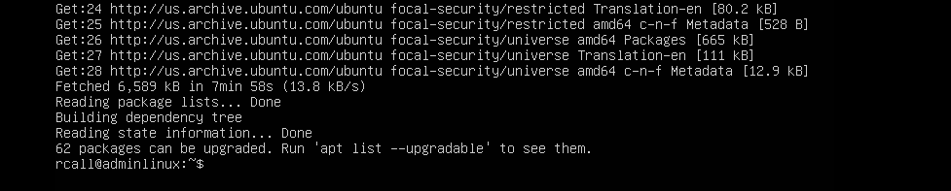

We then will install needed packages with this code: sudo apt install apt-transport-https ca-certificates curl software-properties-common



We click Y for yes and we get the following output to show we installed successfully.

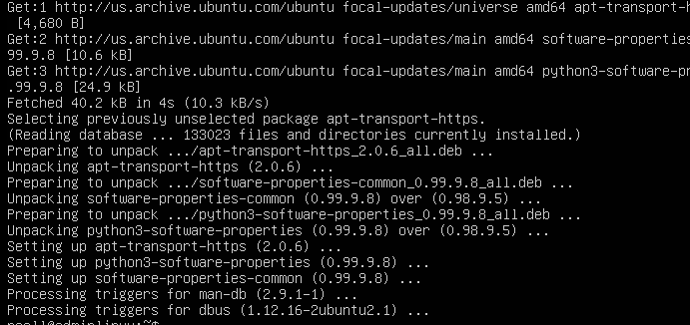

We then need to add a GPG key for the official Docker repository to your system with this command:

Then add the GPG key for the official Docker repository to your system:

Command 1: curl -fsSL https://download.docker.com/linux/ubuntu/gpg | sudo apt-key add –

Command 2: sudo add-apt-repository "deb [arch=amd64] https://download.docker.com/linux/ubuntu focal stable”

These commands will retrieve and add a key from the https address and then add the docker repository to apt sources.

We have to make sure we are installing from the docker repo not the default ubuntu repo to do that we use the following command: apt-cache policy docker-ce

Output should look like this:

Now we should be able to install docker using this command: sudo apt install docker-ce

You should see output like this:

Lastly we want to check the status and make sure its running so we use the following command:

sudo systemctl status docker

We now have Docker installed!