Robert Call

Linux Admin

12/8/21

**Containers Lab Centos 8 Server Installing Docker**

To install Docker use the following command: sudo dnf config-manager --add-repo=https://download.docker.com/linux/centos/docker-ce.repo after hitting enter you should see following out put that tells you retrieved repository.



You can then use the following command to check what docker packages we can install

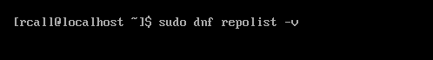

This produces the following details.

We then use the command sudo dnf install docker-ce –allowerasing this will allow docker to install after replacing certain programs allowing a successful install.

Once the installer runs you will see the following output.

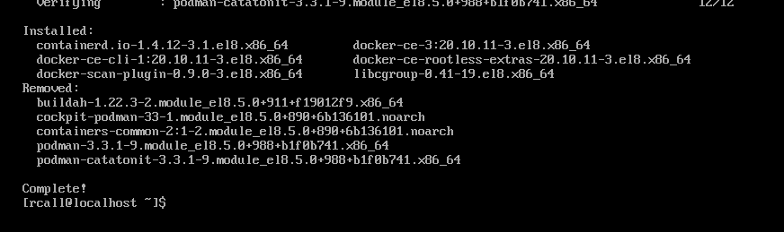

Now to enable and start docker then we will test it.

We enable it with: sudo systemctl enable --now docker you get the following output

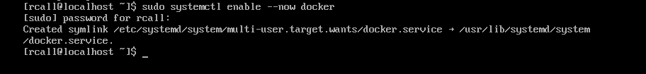

Then use the following command to check the status of docker and if it is enabled: systemctl status docker

We can see its active and running!

Next we will want to add a user with the following command: sudo usermod -aG docker $rcall (put the name of a user you want to add to this group)

Then we use: id $rcall

We get the following output:

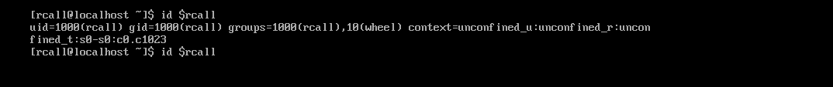

Before testing Docker we need to disable firewalld we can do this with one command:

sudo systemctl disable firewalld

To test Docker we will use the command: sudo docker pull alpine. we get the following output.

We use the command: sudo docker images. To see if the image is available.

We then us two commands to run the alpine and check if docker is working.

Command 1: docker run -it --rm alpine /bin/sh

Then in the blank space fill in this command: /# apk update

You should get the following output which means you are successful!

