Robert Call

Linux Admin

12/8/21

**Containers Lab Centos 8 Server installing Kubernetes**

First we need to have Docker installed which we do. Next we will add a repository for Kubernetes to do that we need to use the following command: sudo nano /etc/yum.repos.d/kubernetes.repo



In the file put the following information:

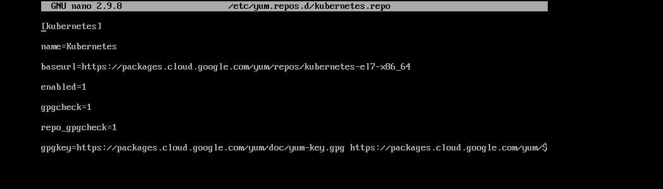

Save and close the file with ctrl X

We will then install the needed packages with the command: sudo dnf install -y kubelet kubeadm kubectl --disableexcludes=Kubernetes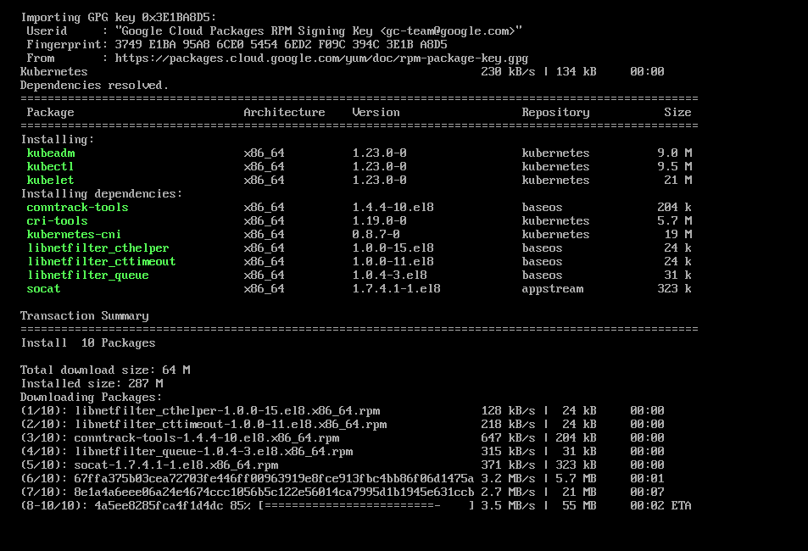

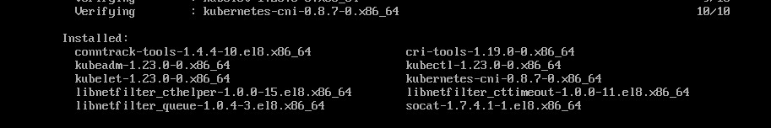

The next command will enable Kubelet daemon: sudo systemctl enable --now kubelet



We then use the next command to write another file with nano: Sudo nano /etc/sysctl.d/k8s.conf

We then add the following two lines to the file.

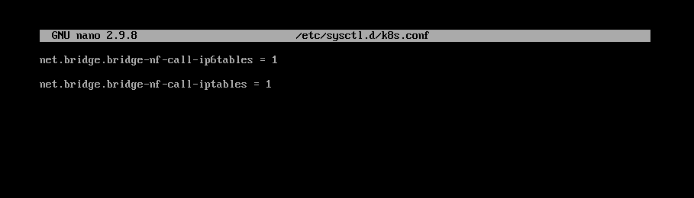

Last part is we need to use ther following command to reload the system configuration: sysctl –system

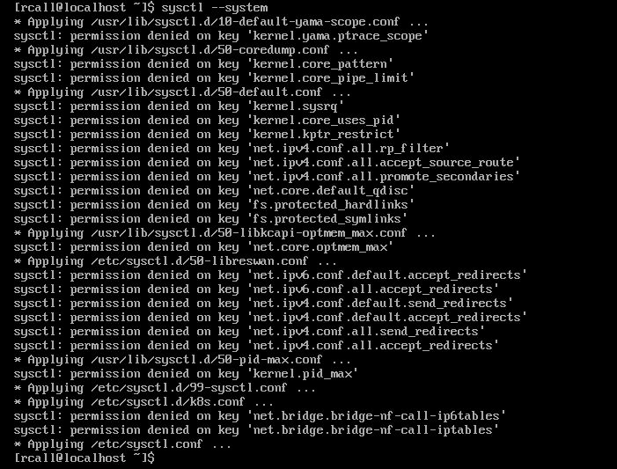

We then turn off swap before running Kubernetes cluster by disabling swap with his command: sudo swapoff -a

We want to make this permanent with his command: sudo nano /etc/fstab

We do this by adding a # in front of the line /dev/mapper/cl-swap so it looks like this #/dev/mapper/cl-swap

We can now use our Kubernetes cluster and add nodes.