Robert Call

Linux Admin

9/18/21

**Lab 2 Grep Family**

1.Print all lines containing the string Street.

Code: grep ‘Street’ datebook

Explanation: I use the grep command and specify im looking for Street (capital s) in the file datebook.

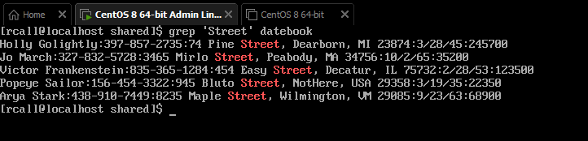

2.Print all lines where the person's first name starts with M.

Code: grep ‘^M’ datebook

Explanation: This specifies in the file datebook which we know starts with names so by using the ^ symbol which will find M at the beginning of each line and print those lines.

3.Print all lines ending in 000.

Code: grep ‘000$’ datebook

Explanation: This command will search the file datebook for any lines containing 000 in the line but with the $ this only prints lines with 000 at the end of the line

4.Print all lines that don't contain 408.

Code: grep -v ‘408’ datebook

Explanation: The command using grep with -v which means only print lines that don’t contain 408

5.Print all lines where birthdays are in the year 1923.

Code: grep “./../23” datebook

Explanation: using grep we with “ instead of ‘ because it will look for exactly what we want in this case the format used in the file to show the date and specify that the year is 23.

6.Print all lines where the phone number is in an area code that starts with an 8

Code: ‘[8]..-…-….’ datebook

Explanation: The command looks for a 8 followed by spaces and dashes we set the format up to find that particular string.

7.Print all lines containing an uppercase letter, followed by 5 lowercase letters, a comma, and one uppercase letter.

Code: grep “[A-Z][a-z]\{5\}, [A-Z]\{1\}” datebook

Explanation: The command looks for a capital letter [A-Z] first followed by 5 {5\} lower case letters [a-z] then followed by a comma a space and then a capital letter.

8.Print lines where the address begins with a two or three digit number (so this would be 12 main st or 123 main street but not 1234 main street).

Code: grep ‘:[0-9]\{2,3} ‘ datebook

Explanation: The command looks for : followed by a number with no more then two or three digits which is why we use {2,3} specifying we only want up to two or three digits between 0-9 and we don’t get any more than that.

9.Print lines preceded by a line number where the person is from Massachusetts (or MA)

Code: grep -n “MA” datebook

Explanation: we use the grep -n to precede the line with a number and use “ and MA to specify if the line has MA to print it.

10.Print lines containing an address that doesn't include Street or St

Code: grep -v ‘Street\|St’ datebook

Explanation: Using the grep -v command to print all lines but what we specify which is Street and using \ slash then a pipe symbol | we ask it to search for Street or St in datebook also be careful on capitals as searches are case sensitive.

Citations:

I used our class chapter : <https://flylib.com/books/en/4.356.1.25/1/>

Adrianna's video on how to use grep: <https://youtu.be/Iif-DjWYoWY>

This was a site I googled to help understand a little more: [How to Grep for Multiple Strings and Patterns | Linuxize](https://linuxize.com/post/grep-multiple-patterns/)