Robert Call

Linux Admin

10/23/21

**Awk Lab**

1. Print all the First Names.

A. Awk ‘{print $1}’ awklab

B. Explanation: Using awk we use the print command and using the dollar sign and one ($1) this will designated the first part of each line separated by the delimiter which is a space so we get the first name of each line.

1. Print phone numbers for Tom and Frodo

A. awk -F: ‘/Tom/{print $2} /Frodo/{print $2}’ awklab

B. Explanation: using awk -F: and specifying : as our delimiter we can split each line into a way we can specify the $2 (second part) will give us just the phone number. We have to do this for Tom and Frodo because if you try and have them in the same command it will print all phone numbers from Tom to Frodo.

1. Print Peregrin's name and phone number area code.

A. awk ‘/Peregrin/{print $1 $2}’ awklab

B. Explanation: we use Peregrin to pick the line we want to extract from and we user the default space with awk so it splits the line up by each space. We then use print $1 $2 with no “/t” so we don’t have a space and this will yield the name and the $2 will yield the area code only.



1. Print all phone numbers in the 408 area code.

A. awk -F: ‘/(408)/{print $2}’ awklab

B. Explanation: we use awk -F: to change from a space to a : delimiter this lets us print only the phone number. Using (408) to find lines with 408 area code. We then print the second part of the line with print $2 which because of the delimiter it is just the phone number.

1. Print all Last names beginning with either a B or D

A. awk ‘/ B/{print $2}/ D/{print $3}’ awklab | awk -F: ‘{print$1)’

B. Explanation: using awk we use a space and B to specify we want all capital b names. We use print $2 so that using awk default which is space delimiter we split the line up do the same for D. see below:

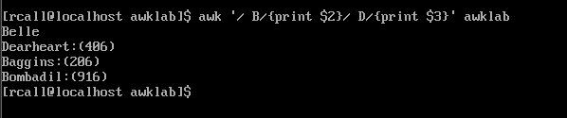

Next we pipe in the same command this output into the next awk command which use the -F function to specify we want to make : the delimiter for this output. This allows us to refine the line further and specify with print $1 that we only want the name not the : or numbers.

1. Print all first names containing four or less characters.

A. awk ‘length($1) == 4{print $1}’ awklab

B. Explanation: using awk default which uses spaces to split up the line we specify and use length with $1 to say we only want part 1 of the line which is the first names but only ones that have a length up to 4 with (== 4) then we use print $1 to print out the names.

1. Print the first names of all those in the 916 area code.

A. awk ‘/(916)/{print $1}’ awklab

B. Explanation: using the default awk space to split up the line and we specify with the /(916)/ to look for any line with the area code 916 in it then using print $1 we print the first name

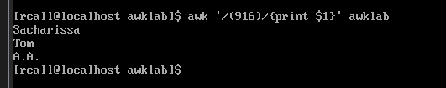

1. Print Sacharissa's campaign contributions. Each value should be printed with a leading dollar sign; e.g., $250 $100 $175.

A. awk -F: ‘/Sacharissa/{print $3 “\t” $4 ‘\t” $5 }’ awklab | awk ‘{print “$” $1, “$” $2, “$” $3}’

B. Explanation: using awk -F: we change our field separator to : then with ‘/Sacharissa/ we search for a line with this name then we print out fields 3, 4, and 5 we use the \t field in between to make it neater. We then pipe this into a awk command that using “$” $1 for each field so it prints each field with a dollar sign in front of it as seen below?

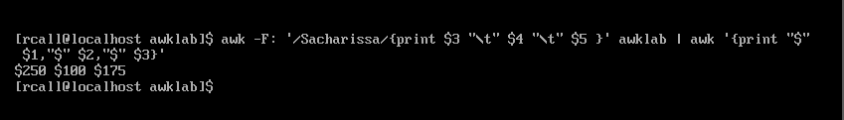

1. Print last names followed by a comma and the phone number. Be careful of the last names's format.

A. awk ‘{print $2, $3, $4}’ awklab | awk -F: ‘{print $1”:”,$2}’

B. Explanation: using awk to print sections of the line with default spaces. We use $2 $3 $4 and print out everything we need but the first name. we then pipe this into another awk command using -F to change the field separator to : which we can then using the print function and $1 $2 fields to show the last name and we also add “:” in front of $2 which is field two this is before the phone number. Which produces the output below.

1. Write an awk script called facts to do the following (MUST be an awk script not just a bash script or commands on the commandline)

Prints first name of the Tooks followed by their total campaign contributions .

Prints "Bullroarer"'s contributions.

Prints all those who contributed over $175 for their last contribution

A. The Script and Explanantion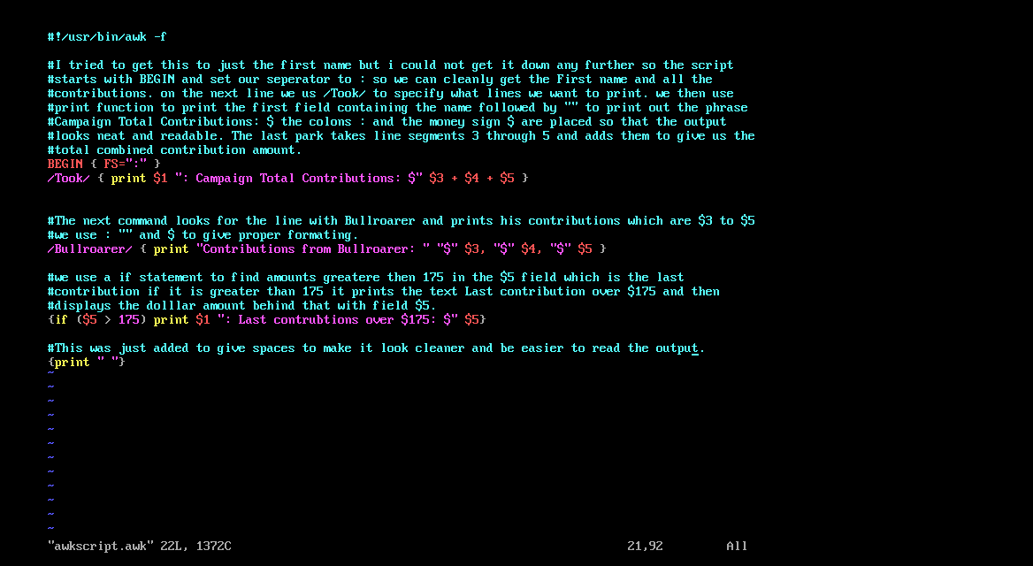

B. Example: 

Part 2: Awk assignment

1. Print the first and last names of those who contributed more than $110 in the last month.

1. Print the last names and phone numbers of those who contributed less than $75 in the first month.

1. Print the first names of those who contributed between $75 and $150 in the first month.

A. Script and explanation: This will print any contributions between 75 and 150 but we did not have any first month contriubutions between those amounts so it prints nothing as seen below.

The code uses BEGIN { FS=”:” } this will sdet the field seperator to : in the program then we use the following code that also has a description below.

1. Print the first and last names of those who contributed less than $700 over the three-month period.

A. script and explanation:

B. 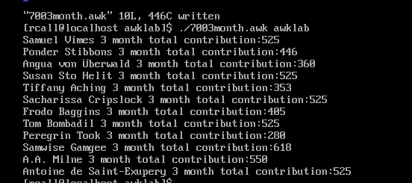

1. Print the first names and first letter of the last name of those with an average monthly contribution greater than $100 .

A. Script: 

B. Explanation: The first awk uses [ ] to set the field separator to colon and a space. Letting us break the line into needed sections we then use a if statement to find the average of all contributions by adding up each section and divide it by 3 if It is greater then 100 it would print the $1 and $2 sections that contained the first and last name. we then use another awk script to print the first name which is $1 and then using a substring we only print first letter of the second field which is the last name.

1. Print the last name of those not in the 916 area code.

A. awk -F: ‘!/(916)/{print $1} ‘ awklab | awk ‘{print $NF}’

B. Explanation: this code uses field separator colon and using the !/(916)/{print $1} we look for all lines that don’t have (916) in them and print those then we use the next awk statement to print just the last field of the first field which was first and last names so we only print the last name.

1. Print each record preceded by the number of the record.

A. awk ‘{print NR,$0}’ awklab

B. using awk we print using the NR which will put a number record in front of each line and we use $0 to print the whole line of each line.

1. Print the name and total contribution of each person.

A. Script

B. Explanation: we use awk to separate by colon to print the first field containing first and last name. Then will print total contributions and by adding the total of all three columns 3, 4 , and 5 we get the total contribution.

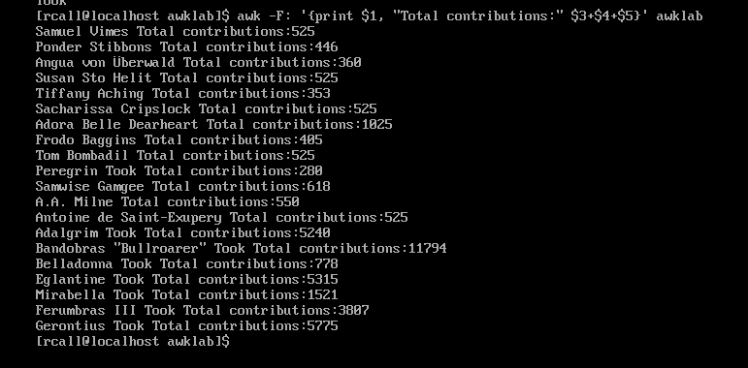

1. Add $10 to Tiffany Aching's first contribution.

A. Script: 

B. Explanation: we use awk to find the line that has tiffany`s name and specifying we want that line with /Tiffany/ we then print the third column which is the first contribution and we add ten to it giving use 25 instead of 15.

1. Change Samwise Gamgee's name to Sean Astin

A. Script:

B. Explanation: we use awk to find the line with Samwise gamgee using /Samwise Gamgee/ we then print the whole line but we use the command $1= “Sean Astin” this will change the first field which is Samwise gamgee to Sean Astin and then print the line again with $0.

Citation:

<https://flylib.com/books/en/4.356.1.72/1>

<https://www.tecmint.com/write-shell-scripts-in-awk-programming/amp/>

<http://tuxgraphics.org/~guido/scripts/awk-one-liner.html>

https://www.grymoire.com/Unix/Awk.html#uh-15