Robert Call

Linux Admin

12/11/21

**Installing Kubernetes on Ubuntu Server**

We will be installing Microk8s to install and run Kubernetes on. We use the first command to install microk8s: sudo snap install microk8s –classic

This will install Snap first a tool we are using with this command.

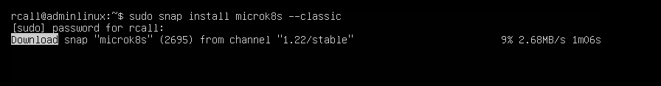

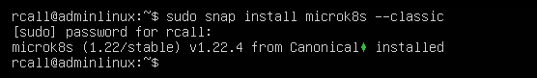

Next we want to add a user to microk8s admin group I will use rcall

Use the following commands to do so:

sudo usermod -a -G microk8s rcall

sudo usermod -a -G microk8s rcall

output should be as follows:



Next we will check the status of Kubernetes:

microk8s status --wait-ready

Turn on the services you want:

microk8s enable dashboard dns ingress

Try microk8s enable --help for a list of available services and optional features. microk8s disable ‹name› turns off a service.

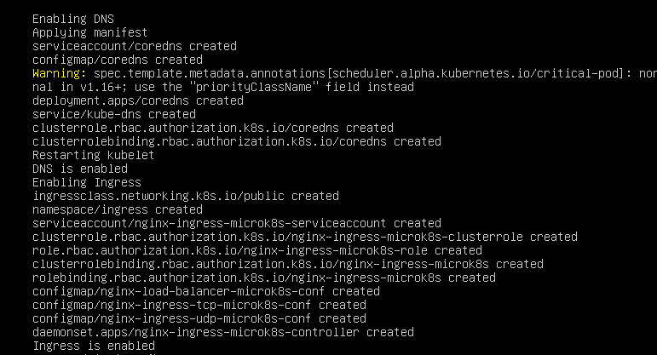

Now to start using Kubernetes :

microk8s kubectl get all --all-namespaces

To Access the Kubernetes dashboard with this command: microk8s dashboard-proxy

It produces a token to login with and a address for the dashboard.

If you need to stop or start Kubernetes, use the following commands:

1. microk8s start

2. microk8s stop

You now have a node cluster created and Kubernetes is working.