Data Visualisation Stand Up Project

1. Time and day of regular meeting  
   - 15/03/2022: 12:00 AM – 1:30 PM  
   - 19/03/2022: 3:00 PM – 7:00 PM
2. Summary of tasks we have done.  
   - Researching and finding data for the project.  
   - Decide what types of chart we will use in the project   
   - Finish the first chart that including the option to show chart for each sectors as well as the stacked bar chart of all sectors.  
   - Start writing process book.

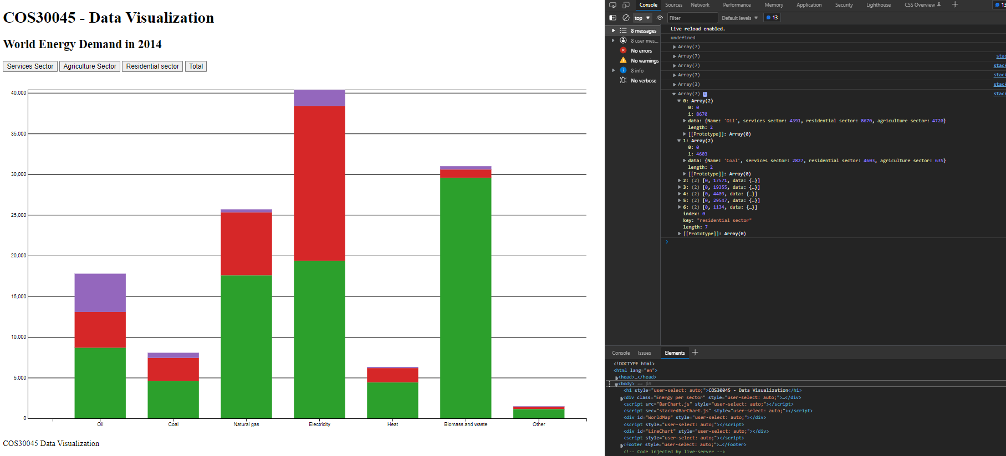

***Demo of what we have done***

1. Summary of to-dos before next meeting  
   - Finish the community energy use part.  
   - Adding axis name to the bar charts.  
   - Reorganise the script files.  
   - Continue writing process book.  
   - Upload code on Github.  
   - Debugging code together.
2. Screenshot of Github repository and Communication Channel and other materials
   1. Screenshot of Github repository

* 1. Screenshot of Communication Channel.

Below is the screenshot of booking receipt and the discord channel the we use to discuss about the project.

* 1. Screenshot of shared Drive

