Executive summary

# Introduction

## Background and Motivation

This visualization aims to provide information about global energy production and consumption for the general public as well as the energy domain experts. The reason for our choice of energy topic is due to the fact that although energy has brought a wide range of benefits to our daily social lives, its manufacture and consumption has led to a catastrophic environmental crisis. According to the International Energy Agency (IEA), the power sector accounted for nearly two-thirds of global emissions growth in 2018.

In order to assist society in moving towards a more sustainable future, my team will be creating visualizations about the energy use profile around the world. The infographics not only enable individuals to understand the energy consumption profile, but it also helps them to recognize the severe environmental consequences caused by power use. This in turn makes way for appropriate actions to be undertaken to reduce the amount of energy consumption.

## Project Objectives

The primary objective of this report is to demonstrate the following energy data to the audiences:

- The amount of global energy used in different sectors in the community including services, residential and agriculture sectors in 2014.

- The total energy consumption by different regions around the world in the 10-year period from 2010 to 2019.

- The amount of CO2 emissions generated from different types of energy use (e.g. coal, oil and gas combustion) in the 5-year period from 1960 to 2020.

These visualizations are beneficial for the scientists as well as people interested in energy domains and its impact on the environment. As a result, they could answer the following questions respectively to the above topics:

- How is the energy used in the community?

- How different countries around the world make use of the energy?

- What is the environmental impact of different types of energy ?

## Project Schedule

To finish this project which includes the interactive website and Process Book, both of us have agreed on the schedule below:  
Week 3-6:

Decide what kind of graph should appear on the website and start to sketch the design idea.

Week 6-7:

Collecting Data from different sources

Deciding which datasets are appropriate for the visualization.

Start writing the Process Book.

Week 8:

Finishing the Data part in process book

# Data

## Data source

### Energy demand per sector

For the visualization of energy demand by sector, we use the dataset from IEA (International Energy Agency)(Figure 1.). This dataset is made up of various tables that contain data on the analytic information of energy demand for each sector from 2014 to 2060. It is an analysis of information and trade-offs of different technology and policy choices, thereby providing quantitative data of energy demand for different sectors.

Figure 1. Dataset from IEA

As previously stated, This is an excel file consisting of various tables about energy demand in different sectors and each will have those attributes that will be listed below:

|  |  |  |
| --- | --- | --- |
| Attributes | Note | Type |
| Type of energy | This attribute will let us know what type of energy we will consider in the data (Oil, Coal, Heat, etc.) | Nominal |
| Year | The year included in the study of energy demand | Interval |
| Energy demand | Energy demand measured in Pj | Ratio |

We have reorganized the tables to create the visualization. Because we are interested in the energy demand in three sectors in 2014, including residential, services, and agriculture, we must integrate three tables from the aforementioned sectors to obtain the necessary data.

### Primary energy consumption around the world

### In order to provide the infographics about the primary energy consumption in different countries around the world, the following dataset is going to be examined:

### - Primary energy consumption, 2020, Our World in Data:

### <https://ourworldindata.org/explorers/energy?facet=none&country=USA~GBR~CHN~OWID_WRL~IND~BRA~ZAF&Total+or+Breakdown=Total&Energy+or+Electricity=Primary+energy&Metric=Annual+consumption>

### 

### Figure 2. A part of dataset of primary energy consumption in different countries around the world

### This dataset is the table displaying the total amount of primary energy consumption (Twh) in each country in each single year. It consists of the following attributes:

|  |  |  |
| --- | --- | --- |
| Attributes | Description | Type |
| Entity | This attribute refers to different countries around the world | Nominal |
| Code | Each country is encoded by a code | Nominal |
| Year | The financial years that are reported and examined in the dataset | Interval |
| Primary energy consumption | The total amount of energy used in each country in the specified year. The unit measured is in terawatt-hour | Ratio |

### 

### - GeoJSON file for the location of all nations on the world:

### <https://github.com/johan/world.geo.json/blob/master/countries.geo.json>

### This json file will enable us to create the choropleth for the visualization of primary energy consumption in different countries.

### 

### Co2 emissions from different types of energy

For the visualization of the amount of Co2 emissions from different types of energy, we have decided to use 3 datasets from Statista. Those three were published by the same project which is Global Carbon Project (Global Carbon Atlas) and it contain data about CO2 emission from different types of energy (Coal, Gas Combustion and Oil) from 1960 to 2020:

* <https://www.statista.com/statistics/1198050/carbon-dioxide-emissions-from-coal-use-in-select-countries/> (CO2 emissions from coal)

Figure 2. Dataset about CO2 emissions from Coal.

* <https://www.statista.com/statistics/1198084/carbon-dioxide-emissions-from-gas-combustion-in-select-countries/> (CO2 emissions from gas combustion)

Figure 3. Dataset about CO2 emissions from Gas Combustion.

* <https://www.statista.com/statistics/1198124/carbon-dioxide-emissions-from-oil-use-in-select-countries/> (CO2 emissions from oil use)

Figure 4. Dataset about CO2 emissions from Oil use.

Those three excel files provide us with tables of CO2 emissions from various types of energy in different countries such as Japan and the United States. Besides, the CO2 emissions were measured in million metric tons. And the attributes included in those two tables are shown in the table below:

|  |  |  |
| --- | --- | --- |
| Attributes | Note | Type |
| Year | The year included in the study of CO2 emissions from the mentioned type of energy | Interval |
| Country’s name | The CO2 emissions of that country measured in million tons | Ratio |

To obtain the correct data, we have to combine the information from those three tables, as we did in the first visualization. Then we need to remove some countries that do not appear in all three datasets.

## Data processing

### Energy demand per sector

Despite the fact that the dataset comprises more than three sectors, we have agreed to only provide visualization for three of them in this chart which include: residential, services, and agricultural. The reason for this is because numerous industries do not offer data of energy demand for certain energy kinds. Consequently, we selected three areas that shared the most data for various forms of energy.

As previously mentioned, the purpose of this chart is to provide visualization of energy demand for each sector in 2014. Therefore, we must filter the columns of the other year (which contain forecasting information that are not in need). As a result, the expected table will include attributes that will be listed below.

|  |  |  |
| --- | --- | --- |
| Attributes | Note | Type |
| Name | This attribute will let us know what type of energy we will consider in the data (Oil, Coal, Heat, etc.) | Nominal |
| services sector | Energy demand for services sector measured in Pj | Ratio |
| agriculture sector | Energy demand for agriculture sector measured in Pj | Ratio |
| residential sector | Energy demand for residential sector measured in Pj | Ratio |

In addition, because the Excel files provided by IEA were not organized in logical form that D3 could process, therefore we have to copy the data of each sector and paste to a new file (Figure).

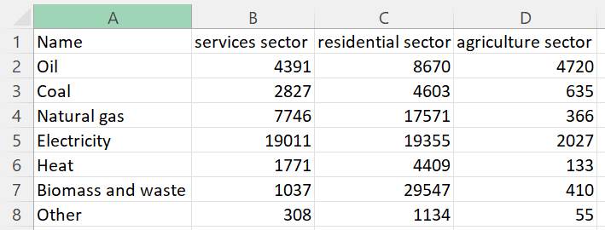

Figure. the excel file would be used in this visualization

In the last state, we have to pass the data from the csv file to an array that contains elements about the names of energy kinds, the sectors and the amount of energy demand recorded in Pj.

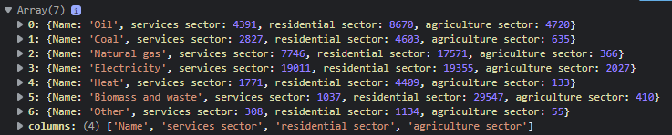

Figure. Final data for visualization of energy demand for different sectors.

### Primary energy consumption around the world

For reducing the data size when loaded into D3, the “Code” attribute which does not contribute to the data semantics, is deleted. Besides, the “Entity” column is renamed to “Country” to make it more interpretable for audiences. Below is the resulting dataset after applying those filters:

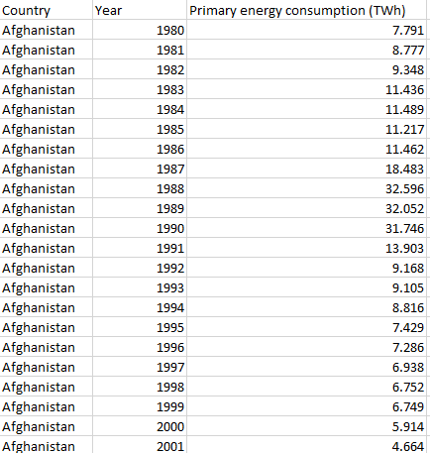

Figure 5: Primary energy consumption dataset after filtering

Furthermore, some “country” records are not actually a country. For example, there are records for “Africa” and “Asia Pacific”, which should be treated as a continent or region rather than a country.





Figure 6: Some “not-country” records in the dataset

Those records are then removed out of the dataset because it does not match with the chosen Geojson file as well as provide unnecessary information. Besides, some countries in the dataset do not match with the properties’ names in the Geojson file. For instance, the US is marked as “United States” in the dataset, whilst the json file marks it as “United States of America”. Thus, we have to change the property’s name of the US in json file to make it properly corresponds to its record in the dataset.

The dataset is intended to be visualized as a choropleth map based on different year choices. To be specific, the primary energy consumption in all countries (with available data) will be displayed in a choropleth according to the selected year. Thus, we have to group the data by year in D3 in order to make the processed data more organized.

var groupByYear = d3.group(data, function(d) {

return d.Year;

});

Figure 7: Code to group the dataset by year

### Co2 emissions from different types of energy

To extract the data needed for this visualization, we must integrate the three files about different energy kinds (Coal, Gas Combustion and Oil). To do this we have to use functions offered by both Excel and D3.

Except the datasets for Coal and Gas Combustion that contain the data of 5-year period from 1960 to 2020, the other one (dataset for Oil use) has data for each year from 1960 to 2020. Therefore, we have to filter unnecessary years in the dataset of Oil. To filter the rows related to unnecessary years, we can use the filter function in excel and choose appropriate years (Figure ).

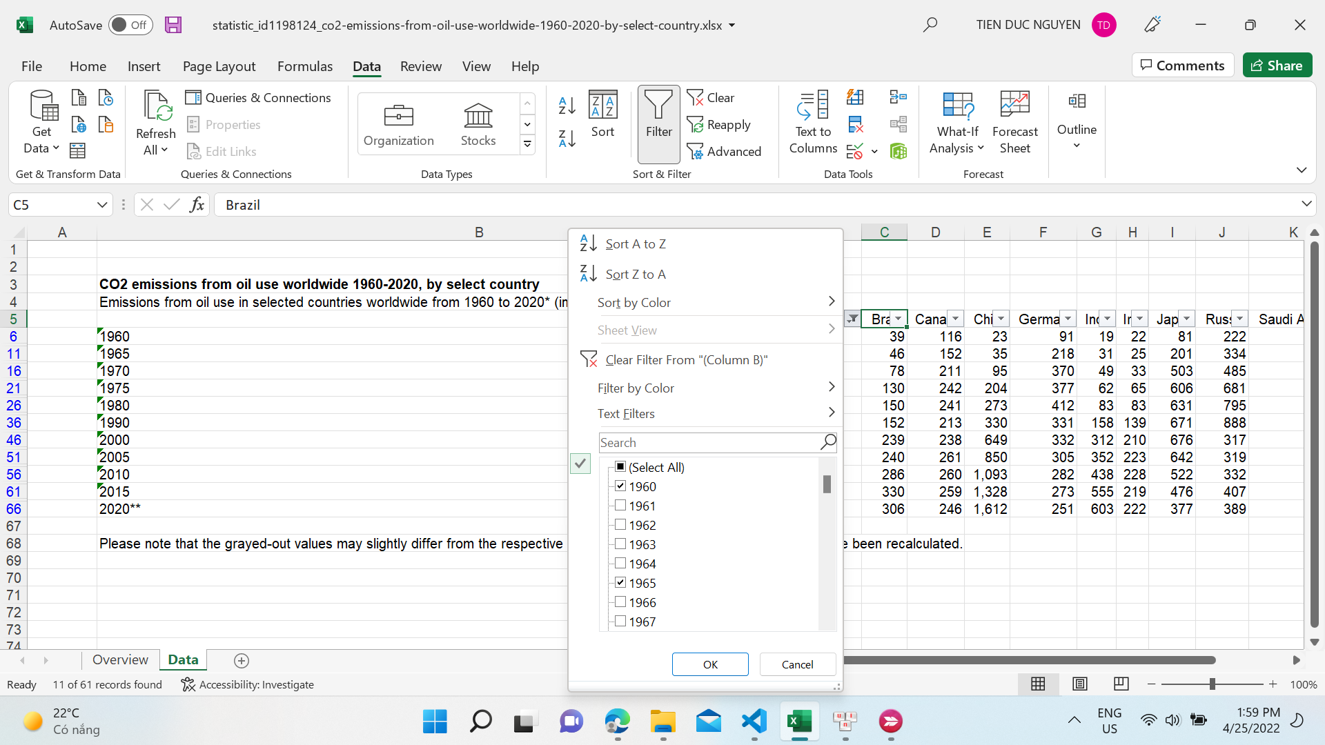

Figure.

However, not all of the countries will be represented on the graph. Because a number of countries did not have data in all three datasets, we must select countries that appear in all datasets, which include Japan, Germany, the United States, and China. After that, we can combine the datasets, and the result is a csv file like the one below:

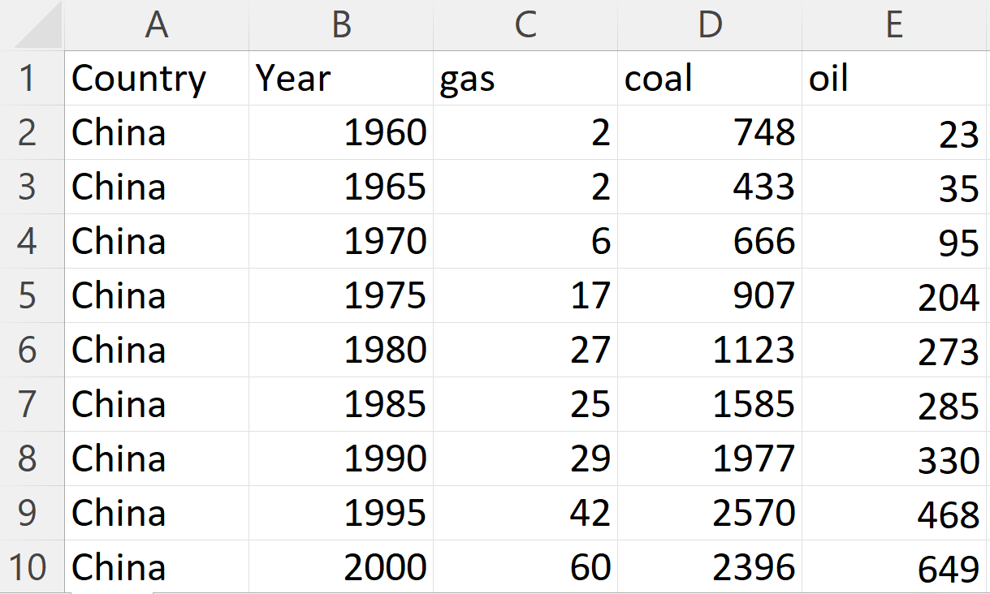

Figure CSV file for the third Visualization.

The primary objective of this chart is to generate a line chart with each line representing the variance of CO2 emissions in each country over a 5-year period. Thus, we need to use the “Group” function in D3 to generate an organized array with the key element being the name of a country.

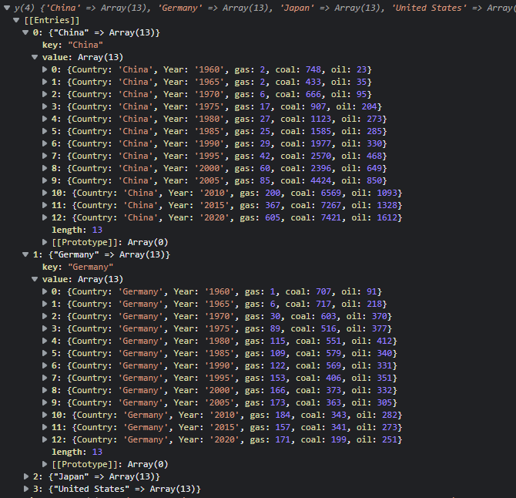

Figure. Data after grouping

# Requirement

## Must-have Features

## Optional features

# Visualization Design

## Energy demand per sector

### Initial Idea

Our initial idea is to make a Pie Chart that shows the energy demand for a sort of energy in each sector (Services Sector, Agriculture Sector and Residential Sector). To make the chart more interactive, we allow users to select the type of energy they want by clicking buttons above the chart.

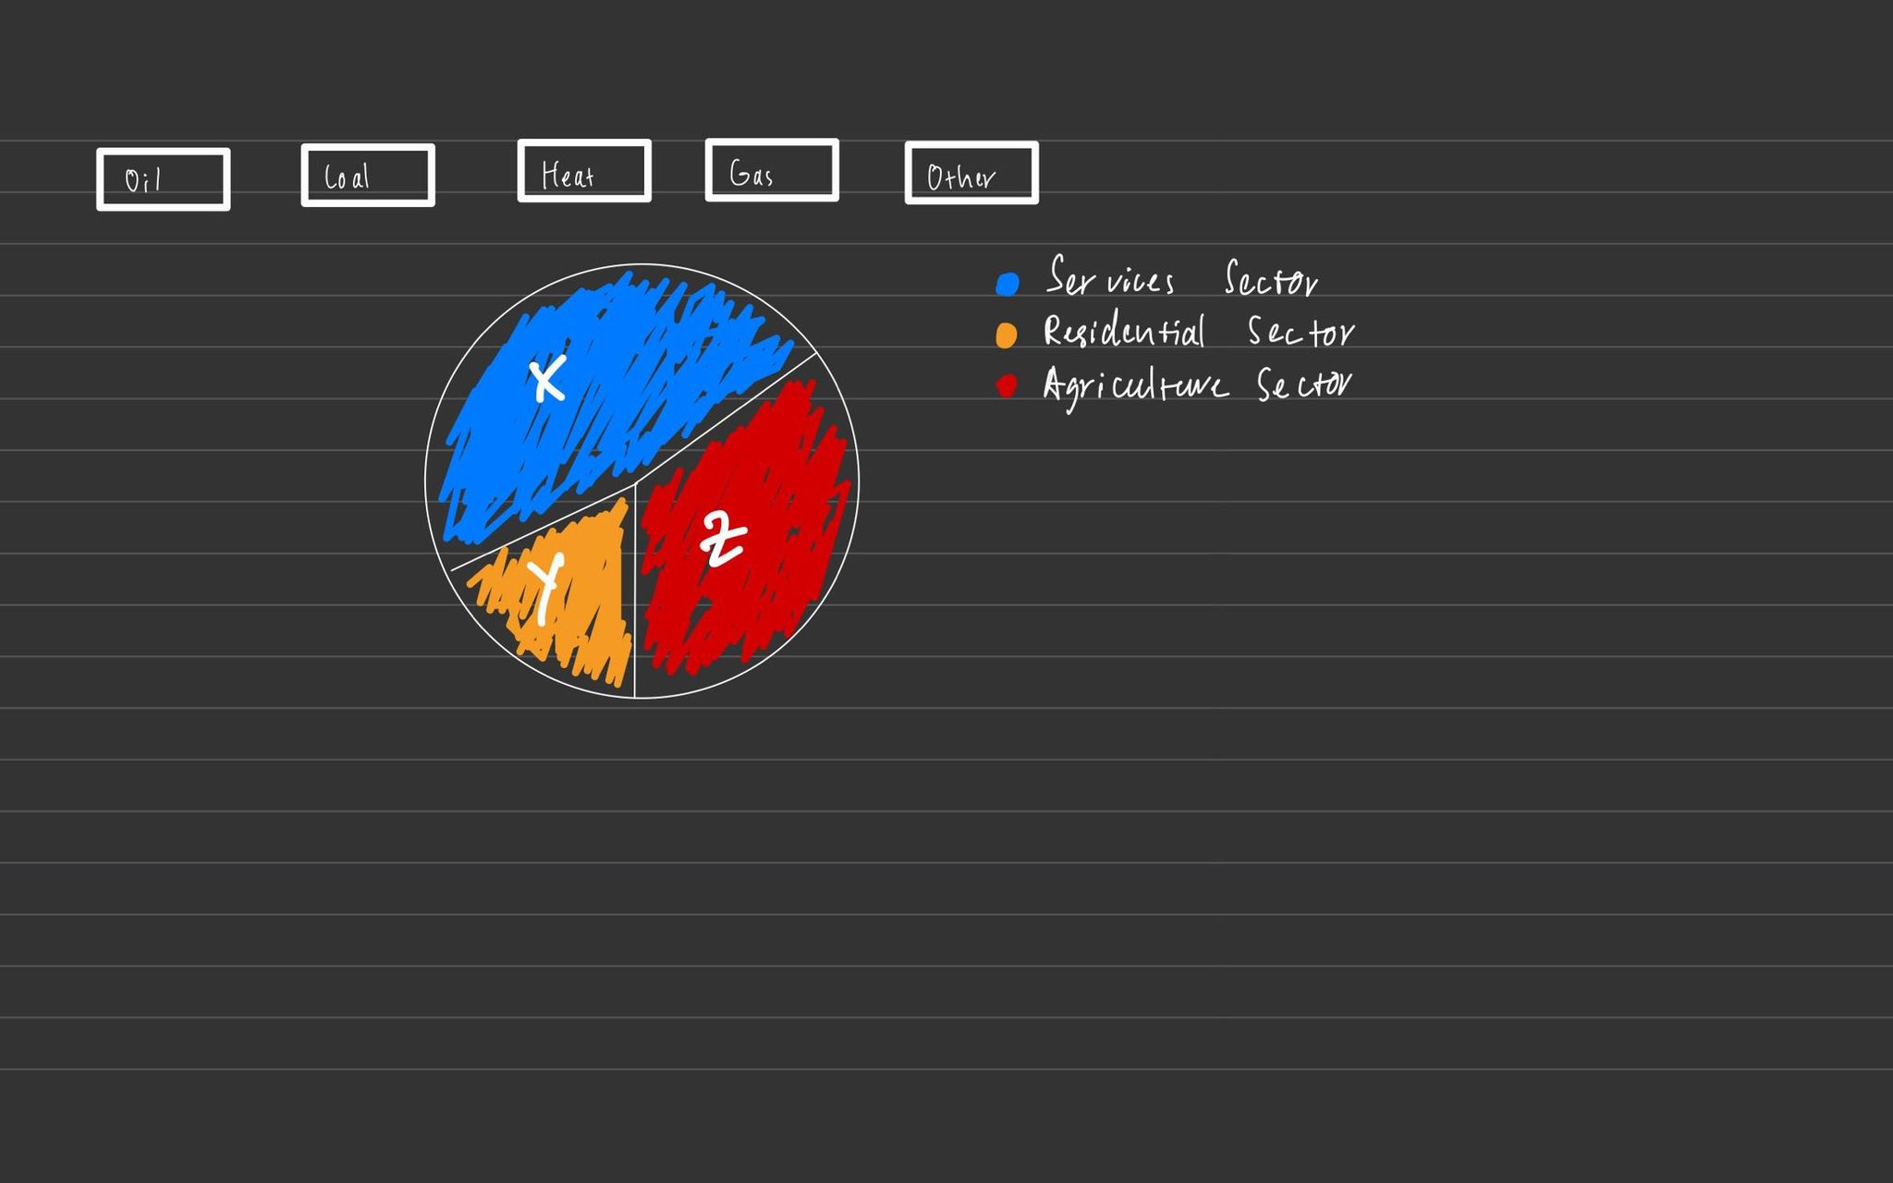

* Pie chart
* Hard for comparison

### Final

## Energy consumption per region

### Initial Idea

### Final

## Co2 emissions from different types of energy

### Initial Idea

### Final

# Conclusion

References

[world.geo.json/countries.geo.json at master · johan/world.geo.json (github.com)](https://github.com/johan/world.geo.json/blob/master/countries.geo.json) (GeoJson)

[Energy Technology Perspectives 2017 - Data product - IEA](https://www.iea.org/data-and-statistics/data-product/energy-technology-perspectives-2017-2) (First Chart)

Appendix