Assignment 4 Buisness Class

Charles-Étienne Gauthier

Assignment 4 Report

2021-04-29

Table of Contents

Charles-Etienne Gauthier 1

K10G-20 1

Report on Shopify 1

2021-04-21 1

Overview of the company I chose: 1

Privacy or Conflict of Interest 2

*Purpose of a privacy statement:* 2

*Meaning of informed consent:* 2

*Company’s regulations on User Information:* 2

*My opinion on their Policy:* 2

Canadian Bank Note Company: 2

*Conflict of interest:* 2

*Purpose of a conflict of interest policy:* 2

*Summary of the regulations on the conflict of Interest:* 2

*Opinion on policy:* 3

Shopify on Hiring: 3

Job Postings: 3

*Names and Purposes of the positions:* 3

*Technical Skills:* 4

*Interpersonal Skills:* 5

*Excel Graph:* 6

*Comparing Roles to the ones we’ve learned in class:* 6

My Service: 6

*Name:* 6

*Purpose of the Service:* 6

*Description of the Service:* 6

*How the technology assists businesses or people:* 7

*The future of the Service:* 7

*Visio Diagram:* 7

## Executive Summary

This report is a review on one company’s policies on information privacy, their way of employing new people to their team, two job positions that they offer, their description and a service that would help the company grow. In this Case Shopify.   
  
For their policy on privacy, they say that the only information they take is to keep count of the of the transaction with their clients and they share it with connections all over the world.   
  
They employ new people with an interview called “Life story interview”. They ask the person interested in the job to share his life story with him and the employer judges his character and skills by listening to the person talking about their life.  
  
As for the IT and Software Developer, they are very similar to the ones we’ve learned in class and the skills required are also very similar to the ones in class  
  
The service provided would be a platform where people could interact with each other and give advice on their company and even make business decisions in groups/partnership.

# Overview of the company I chose:

I took Shopify as a company. Shopify as for mission to enable people to create a platform where they can sell their products. They a space to host sites and their target people are entrepreneurs, people who want to make businesses. For the technology, they use a very interesting platform to share the products.

# Privacy or Conflict of Interest

## Purpose of a privacy statement:

It discloses to the customers some or all of the ways a website collects, uses the data.

## Meaning of informed consent:

Informed consent means to make the user agree to things but also explaining what the user has to agree to and what are the

## Company’s regulations on User Information:

They use the user’s information to process subscription payments and to provide with a service. This is mostly personal information (your name, or something like your credit card). They also use it to: prevent risk and fraud, answer questions or providing other types of support help merchants find and use apps through our app store provide and improving our products and services provide reporting and analytics test out features or additional services. They process their data to other shopify locations and companies that make business with them all across the world. They only send it to countries that have good laws for that.

## My opinion on their Policy:

I do not believe this is clear enough to allow the person to give their data. The company does not state specifically what sort of data that they will use and do not state what company do they give their information to. They just say “individuals across the world”. You can’t know if these individuals are really trustworthy or not.

# Shopify on Hiring:

To employ someone, they give this “Life story” style interview. So, Firstly, you would have a short conversation with the hiring manager in which the future employee will learn about his role. Then, you would have a hour long interview where you will tell the employer about the story of your life, both professionnaly and personally. With this conversation, they will be able to figure out if you are a trustworthy person, judge your self-awareness, your engagement in the things you do and your skills/professional capabilities. After that, you will meet the team and the hiring manager will give you his decision.

# Job Postings:

## Names and Purposes of the positions:

IT: The purpose of both is to employees of the merchants if they have any problem with the features of the shopify platform. You will solve problems, make new contacts and learn new things along the way.

Software Developper: The purpose of this job is to build and maintain the platform that delivers accessible data to power decision-making at Shopify. In all, there are four teams:

The Engine group which organizes all the data into the data pool and maintains security for it.

There’s the analyitics group takes the engine primitives to build upon it a make useful products which can be used in machine learning and batch.

There is the data experiences group which builds end-user experiences so that we can analyse the data to make better business decisions.

There is also the reliability group which they build tools for the other tools to ease their experiences with the data collected.

## Technical Skills:

IT: Knowing hardware, software and computers in general. Be bilingual, find solutions for problems fast. Also, have a understanding of the shopify platform.

(Shopify, 2021)Reference: [Bilingual Customer Service Specialist - Fluent in French (Remote, Eastern Canada) (shopify.ca)](https://www.shopify.ca/careers/bilingual-customer-service-specialist-fluent-in-french-remote-eastern-canada-fbaa0b13)

Software Developper:

Experience with the internals of a distributed compute engine (Spark, Presto, DBT, or Flink/Beam)

Experience in query optimization, resource allocation and management, and data lake performance (Presto, SQL)

Experience with cloud infrastructure (Google Cloud, Kubernetes, Terraform)

Experience with security products and methods (Apache Ranger, Apache Knox, OAuth, IAM, Kerberos)

Experience deploying and scaling ML solutions using open-source frameworks (MLFlow, TFX, H2O, etc.)

Experience building full-stack applications (Ruby/Rails, React, TypeScript)

Background and practical experience in statistics and/or computational

mathematics (Bayesian and Frequentist approaches, NumPy, PyMC3, etc.)

Modern Big-Data storage technologies (Iceberg, Hudi, Delta)

(Shopify, 2021)Reference: [Staff Software Developer - Data Platform (Americas - Remote) (shopify.ca)](https://www.shopify.ca/careers/staff-software-developer-data-platform-americas-remote-c62b63b5)

## Interpersonal Skills:

IT:

Have strong reading, writing and communication skills.

Willingness to learn all about entrepreneurship, care deeply about supporting people and enjoy having genuine human conversations.

Possess a high level of understanding, patience and empathy. Able to navigate more difficult conversations/interactions with professionalism.

(Shopify, 2021)Reference: [Bilingual Customer Service Specialist - Fluent in French (Remote, Eastern Canada) (shopify.ca)](https://www.shopify.ca/careers/bilingual-customer-service-specialist-fluent-in-french-remote-eastern-canada-fbaa0b13)

Software Developper:

An experienced technical leader with a proven track record of delivering impactful results.

Technical engineering background in one or more areas in the next section.

Experience with technical mentoring, coaching, and improving the technical output of the people around you.

Exceptional communication skills and ability to translate technical concepts into easy to understand language for our stakeholders.

Excitement for working with a remote team; you value collaborating on problems, asking questions, delivering feedback, and supporting others in their goals whether they are in your vicinity or entire cities apart.

Capable of diffusing conflicts and interact with other people.

(Shopify, 2021)Reference: [Staff Software Developer - Data Platform (Americas - Remote) (shopify.ca)](https://www.shopify.ca/careers/staff-software-developer-data-platform-americas-remote-c62b63b5)

## Excel Graph:

Interpersonnal skills vs technical skills

## Comparing Roles to the ones we’ve learned in class:

The IT portion of the job is very much like we learned in class, where you help people that have problem either with their software or hardware (in this case software) in which you have to have good communication and social skills.

The software developper is similar to what we discussed. They create separate teams to work on one aspect of software engineering (ex: one team for maintenance and the other that creates the software). Still, these aspects are very much alike what we’ve learned during the business course.

(Shopify, 2021)Reference: [Staff Software Developer - Data Platform (Americas - Remote) (shopify.ca)](https://www.shopify.ca/careers/staff-software-developer-data-platform-americas-remote-c62b63b5)

# My Service:

## Name:

Business online Courses/teaching/platform for new business ideas(like [Entrepreneurs' Organization (eonetwork.org)](https://hub.eonetwork.org/))

## Purpose of the Service:

Platform to teach young entrepreneurs how to start their business by people with more experience and for senior businessmen to share their platform and create new partnerships.

## Description of the Service:

A platform where entrepreneurs can discuss their ideas and experiences with other businessmen or businesswomen. Young entrepreneurs will be able to learn new things from older entrepreneurs. They will be able to share their ideas and maybe even start partnerships for new brands. A bit like a social network. Would ressemble Entrepreneurs Organization.com

## How the technology assists businesses or people:

Young entrepreneurs will be able to learn new things from people with more experience and these people will also maybe get to know new ideas for new buinsesses.

## The future of the Service:

Make the platform more user-friendly, make it easier to use, reach a wider audience to expand the platform and shopify itself. Search for new technologies that would make the site more efficient and cheaper to maintain.

## Visio Diagram:

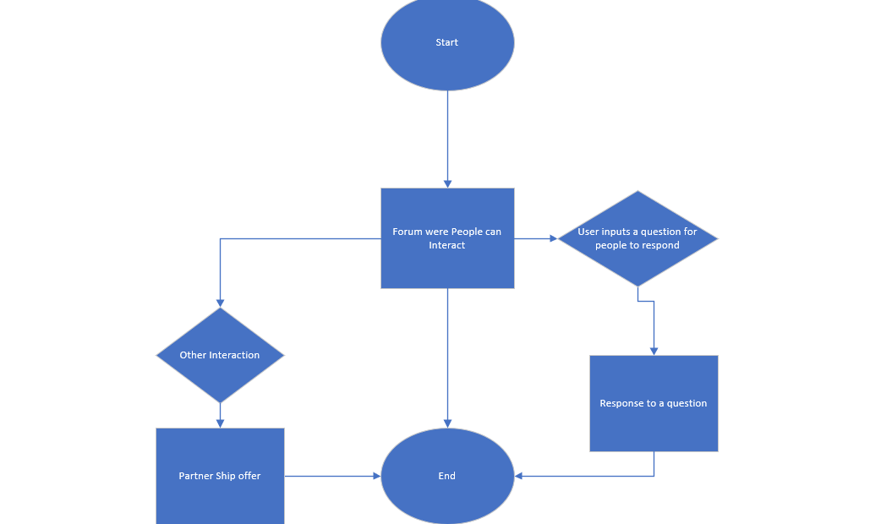

# Conclusion

In conclusion, Shopify is a website that offers entrepreneurs the chance to advertise their company and keep track of their businesses. Their policy on information consists of only using personal information to keep track of their numbers. They share this information to contacts all over the world.

The two jobs listed (IT and software developper) are very similar to the ones we have seen in class and are also very similar to the skillsets we have seen in class.

Has for the service that would be useful to their company, a platform were businessmen could interact with each other, offer advice or even start a partnership.

Thank you for reading.

# Bibliography

# Works Cited

Organization, E. (2021). *eonetwork.org*. Retrieved from eonetwork.org.

Shopify. (2021). *Shopify.com*. Retrieved from Shopify.

(Shopify, 2021)Reference: [Bilingual Customer Service Specialist - Fluent in French (Remote, Eastern Canada) (shopify.ca)](https://www.shopify.ca/careers/bilingual-customer-service-specialist-fluent-in-french-remote-eastern-canada-fbaa0b13)

(Shopify, 2021)Reference: [Staff Software Developer - Data Platform (Americas - Remote) (shopify.ca)](https://www.shopify.ca/careers/staff-software-developer-data-platform-americas-remote-c62b63b5)