SALESFORCE COURIER MANAGEMENT SYSTEM
OBJECT CREATION

1. Project Overview
This document records the Salesforce custom objects required for the Courier Management System. The objects are designed to manage customers, shipments, delivery agents, branches, delivery updates, and invoices.

2. Combined Salesforce Objects
Object | Purpose | Suggested Key Fields
Customer | Stores customer information such as name, contact details, and address. | Customer Name, Phone, Email, Address, City
Shipment | Stores parcel booking and shipment information. | Shipment Number, Customer, Booking Date, Source, Destination, Weight, Status
Delivery Agent | Stores details of delivery personnel assigned to shipments. | Agent Name, Phone, Email, Employee ID, Branch, Agent Status
Branch | Stores courier branch information. | Branch Name, Branch Code, Phone, Address, City
Delivery Update | Records shipment delivery and tracking updates. | Update Number, Shipment, Update Date/Time, Location, Status, Remarks
Invoice | Stores billing and invoice information for shipments. | Invoice Number, Shipment, Invoice Date, Amount, Payment Status, Payment Method

3.1 Customer Object
Stores customer information such as name, contact details, and address.
Field Name | Data Type | Requirement
Customer Name | Text | Required
Phone | Phone | Required
Email | Email | Optional
Address | Long Text Area | Required
City | Text | Optional
Salesforce Creation Steps:
- Open Salesforce Setup.
- Go to Object Manager.
- Select Create → Custom Object.
- Enter the object name: Customer.
- Configure the required fields and settings.
- Save the object.
- Create the suggested fields under Fields & Relationships.
- Add the object/tab to the required application and verify access.
Verification: ☐ Object created ☐ Fields created ☐ Tab/app access verified ☐ Screenshot added

3.2 Shipment Object
Stores parcel booking and shipment information.
Field Name | Data Type | Requirement
Shipment Number | Auto Number | Required
Customer | Lookup/Master-Detail | Required
Booking Date | Date | Required
Source | Text | Required
Destination | Text | Required
Weight | Number | Optional
Status | Picklist | Required
Salesforce Creation Steps:
- Open Salesforce Setup.
- Go to Object Manager.
- Select Create → Custom Object.
- Enter the object name: Shipment.
- Configure the required fields and settings.
- Save the object.
- Create the suggested fields under Fields & Relationships.
- Add the object/tab to the required application and verify access.
Verification: ☐ Object created ☐ Fields created ☐ Tab/app access verified ☐ Screenshot added

3.3 Delivery Agent Object
Stores details of delivery personnel assigned to shipments.
Field Name | Data Type | Requirement
Agent Name | Text | Required
Phone | Phone | Required
Email | Email | Optional
Employee ID | Text | Required
Branch | Lookup | Required
Agent Status | Picklist | Required
Salesforce Creation Steps:
- Open Salesforce Setup.
- Go to Object Manager.
- Select Create → Custom Object.
- Enter the object name: Delivery Agent.
- Configure the required fields and settings.
- Save the object.
- Create the suggested fields under Fields & Relationships.
- Add the object/tab to the required application and verify access.
Verification: ☐ Object created ☐ Fields created ☐ Tab/app access verified ☐ Screenshot added

3.4 Branch Object
Stores courier branch information.
Field Name | Data Type | Requirement
Branch Name | Text | Required
Branch Code | Text | Required
Phone | Phone | Optional
Address | Long Text Area | Required
City | Text | Required
Salesforce Creation Steps:
- Open Salesforce Setup.
- Go to Object Manager.
- Select Create → Custom Object.
- Enter the object name: Branch.
- Configure the required fields and settings.
- Save the object.
- Create the suggested fields under Fields & Relationships.
- Add the object/tab to the required application and verify access.
Verification: ☐ Object created ☐ Fields created ☐ Tab/app access verified ☐ Screenshot added

3.5 Delivery Update Object
Records shipment delivery and tracking updates.
Field Name | Data Type | Requirement
Update Number | Auto Number | Required
Shipment | Lookup | Required
Update Date/Time | Date/Time | Required
Location | Text | Optional
Status | Picklist | Required
Remarks | Long Text Area | Optional
Salesforce Creation Steps:
- Open Salesforce Setup.
- Go to Object Manager.
- Select Create → Custom Object.
- Enter the object name: Delivery Update.
- Configure the required fields and settings.
- Save the object.
- Create the suggested fields under Fields & Relationships.
- Add the object/tab to the required application and verify access.
Verification: ☐ Object created ☐ Fields created ☐ Tab/app access verified ☐ Screenshot added

3.6 Invoice Object
Stores billing and invoice information for shipments.
Field Name | Data Type | Requirement
Invoice Number | Auto Number | Required
Shipment | Lookup | Required
Invoice Date | Date | Required
Amount | Currency | Required
Payment Status | Picklist | Required
Payment Method | Picklist | Optional
Salesforce Creation Steps:
- Open Salesforce Setup.
- Go to Object Manager.
- Select Create → Custom Object.
- Enter the object name: Invoice.
- Configure the required fields and settings.
- Save the object.
- Create the suggested fields under Fields & Relationships.
- Add the object/tab to the required application and verify access.
Verification: ☐ Object created ☐ Fields created ☐ Tab/app access verified ☐ Screenshot added

4. Object Relationships
Object 1 | Object 2 | Relationship
Customer | Shipment | A customer can have multiple shipments.
Shipment | Delivery Update | A shipment can have multiple delivery updates.
Shipment | Delivery Agent | A shipment can be assigned to a delivery agent.
Delivery Agent | Branch | A delivery agent belongs to a branch.
Shipment | Branch | A shipment can be associated with source/destination branches as required.
Shipment | Invoice | A shipment can have an associated invoice.

5. Screenshot Checklist
- Customer Object Manager page / object details screenshot: ____________________
- Customer Fields & Relationships screenshot: ____________________
- Shipment Object Manager page / object details screenshot: ____________________
- Shipment Fields & Relationships screenshot: ____________________
- Delivery Agent Object Manager page / object details screenshot: ____________________
- Delivery Agent Fields & Relationships screenshot: ____________________
- Branch Object Manager page / object details screenshot: ____________________
- Branch Fields & Relationships screenshot: ____________________
- Delivery Update Object Manager page / object details screenshot: ____________________
- Delivery Update Fields & Relationships screenshot: ____________________
- Invoice Object Manager page / object details screenshot: ____________________
- Invoice Fields & Relationships screenshot: ____________________

6. Final Verification
☐ All six custom objects are created.
☐ Required fields are created for each object.
☐ Lookup/master-detail relationships are configured as required.
☐ Tabs and application navigation are configured.
☐ Object access and permissions are verified.
☐ Screenshots are added to the project documentation.
☐ Documentation is ready to upload to the GitHub repository.

7. GitHub Upload
Suggested filename: COURIER_MANAGEMENT_SALESFORCE_OBJECTS.docx
Upload this Word document to the courier-management-system repository using Add file → Upload files → Commit changes.

8. Consolidated Screenshot Evidence
Use the spaces below for final screenshots showing the completed Salesforce configuration.

Customer – Final Evidence
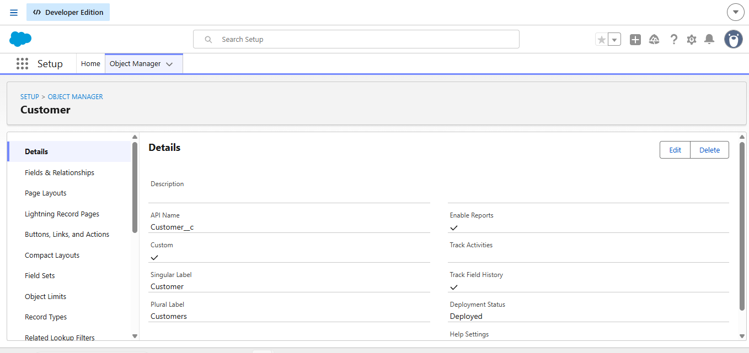

Shipment – Final Evidence
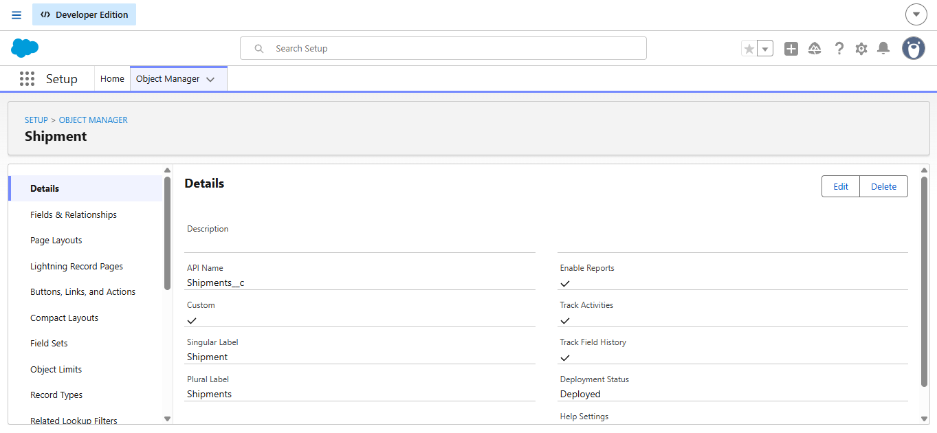

Delivery Agent – Final Evidence

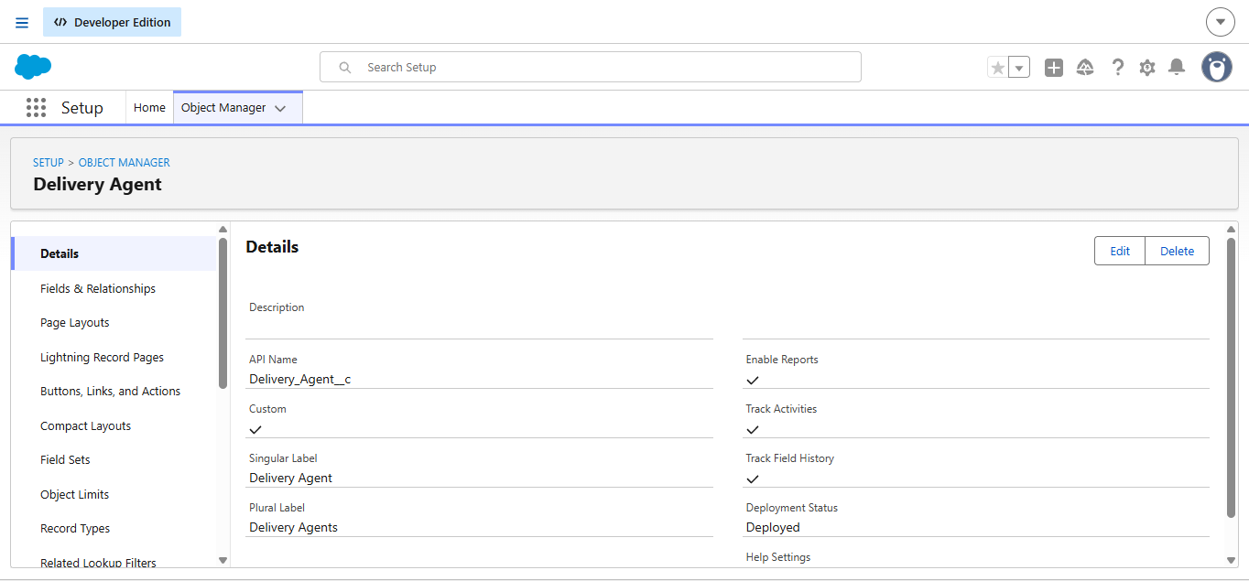

Branch – Final Evidence

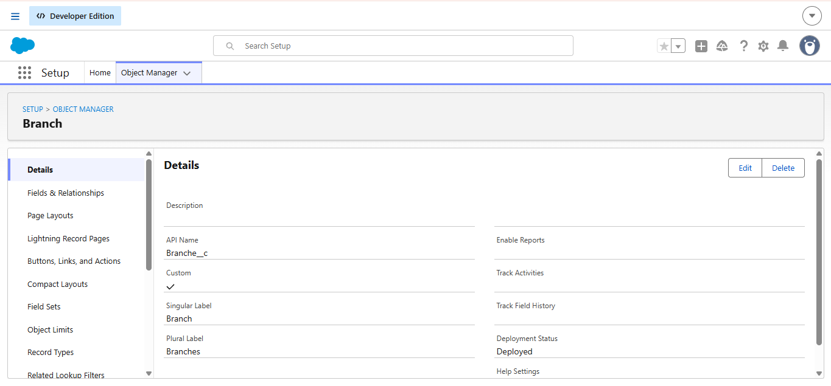

Delivery Update – Final Evidence

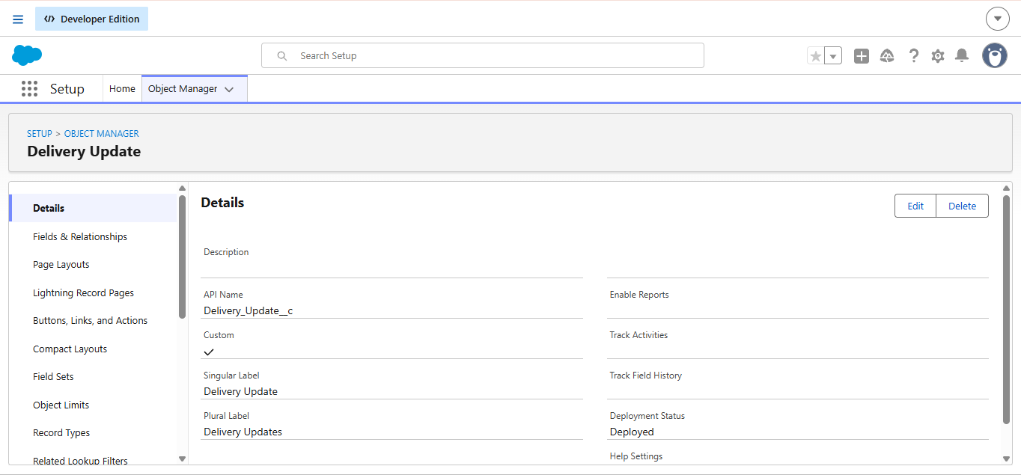

Invoice – Final Evidence
