SALESFORCE VALIDATION RULES DOCUMENTATION
Courier Management System
This document contains recommended Salesforce validation rules for the Courier Management System. The rules are designed to prevent invalid or incomplete data from being saved in the Customer, Shipment, Delivery Agent, Branch, Delivery Update, and Invoice objects.

1. How to Create a Validation Rule
1. Open Salesforce Setup.
2. Open Object Manager.
3. Select the required object.
4. Select Validation Rules.
5. Click New.
6. Enter a Rule Name.
7. Enter the Error Condition Formula.
8. Click Check Syntax to confirm the formula is valid.
9. Enter a clear Error Message.
10. Choose the Error Location.
11. Click Save.
12. Test the rule by entering invalid data and confirm that Salesforce blocks the record.

2. Recommended Validation Rules

2.1 Customer Validation Rules
Object API Name: Customer__c
Rule Name | Formula | Error Message | Error Location | Purpose
Customer_Phone_Format | AND(NOT(ISBLANK(Phone__c)), NOT(REGEX(Phone__c, "^[0-9+() -]{7,20}$"))) | Enter a valid phone number using digits and standard phone symbols only. | Phone | Prevents invalid phone number formats.
Customer_Postal_Code | AND(NOT(ISBLANK(Postal_Code__c)), NOT(REGEX(Postal_Code__c, "^[0-9]{6}$"))) | Postal Code must contain exactly 6 digits. | Postal Code | Ensures a valid six-digit postal/PIN code.

Evidence / Screenshot - Customer Validation Rules
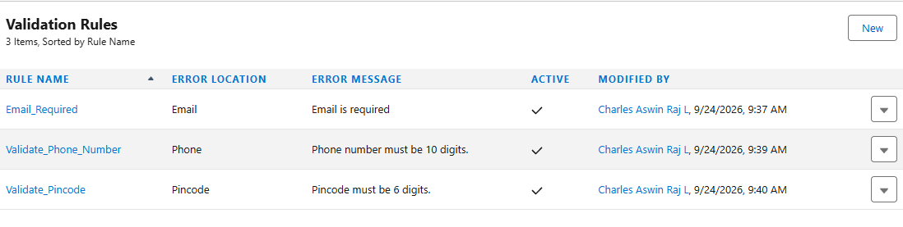

2.2 Shipment Validation Rules
Object API Name: Shipment__c
Rule Name | Formula | Error Message | Error Location | Purpose
Shipment_Weight_Must_Be_Positive | Weight_kg__c <= 0 | Shipment weight must be greater than 0 kg. | Weight (kg) | Prevents zero or negative parcel weight.
Shipment_Charge_Cannot_Be_Negative | Shipping_Charge__c < 0 | Shipping charge cannot be negative. | Shipping Charge | Prevents invalid negative charges.
Expected_Date_After_Shipment_Date | AND(NOT(ISBLANK(Expected_Delivery_Date__c)), Expected_Delivery_Date__c < Shipment_Date__c) | Expected Delivery Date cannot be earlier than Shipment Date. | Expected Delivery Date | Keeps shipment dates logically correct.
Delivered_Shipment_Needs_Agent | AND(ISPICKVAL(Status__c, "Delivered"), ISBLANK(Assigned_Delivery_Agent__c)) | Assign a Delivery Agent before marking the shipment as Delivered. | Assigned Delivery Agent | Ensures delivered shipments have an assigned delivery agent.

Evidence / Screenshot - Shipment Validation Rules
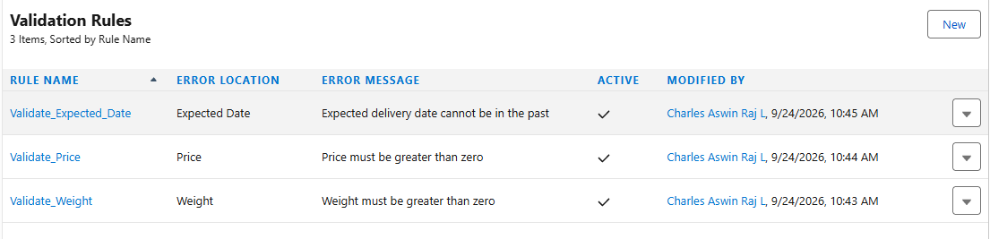

2.3 Delivery Agent Validation Rules
Object API Name: Delivery_Agent__c
Rule Name | Formula | Error Message | Error Location | Purpose
Agent_Phone_Format | AND(NOT(ISBLANK(Phone__c)), NOT(REGEX(Phone__c, "^[0-9+() -]{7,20}$"))) | Enter a valid delivery agent phone number. | Phone | Prevents invalid phone formats.
Assigned_Agent_Requires_Vehicle | AND(ISPICKVAL(Availability_Status__c, "Assigned"), ISBLANK(Vehicle_Number__c)) | Vehicle Number is required when the agent status is Assigned. | Vehicle Number | Ensures an assigned agent has vehicle information.

Evidence / Screenshot - Delivery Agent Validation Rules
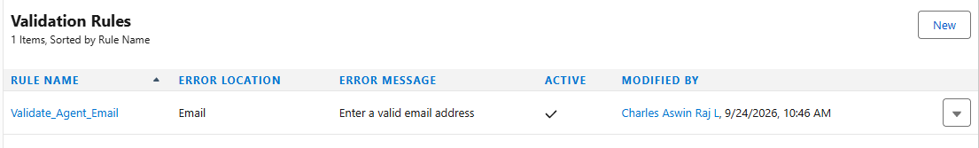

2.4 Branch Validation Rules
Object API Name: Branch__c
Rule Name | Formula | Error Message | Error Location | Purpose
Branch_Code_Format | AND(NOT(ISBLANK(Branch_Code__c)), NOT(REGEX(Branch_Code__c, "^[A-Z0-9-]{3,20}$"))) | Branch Code must use 3-20 uppercase letters, numbers, or hyphens. | Branch Code | Keeps branch codes consistent.
Branch_Postal_Code | AND(NOT(ISBLANK(Postal_Code__c)), NOT(REGEX(Postal_Code__c, "^[0-9]{6}$"))) | Postal Code must contain exactly 6 digits. | Postal Code | Validates the branch postal/PIN code.

Evidence / Screenshot - Branch Validation Rules
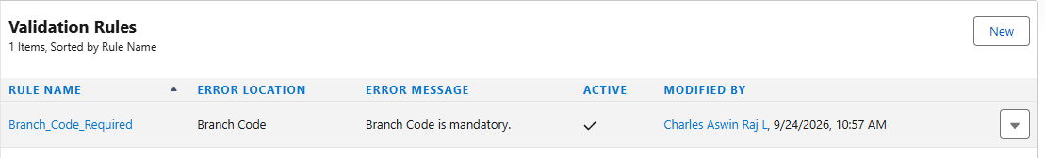

2.5 Delivery Update Validation Rules
Object API Name: Delivery_Update__c
Rule Name | Formula | Error Message | Error Location | Purpose
Update_Time_Not_In_Future | Update_Date_Time__c > NOW() | Delivery Update Date/Time cannot be in the future. | Update Date/Time | Prevents future-dated tracking updates.
Failed_Delivery_Requires_Remarks | AND(ISPICKVAL(Status__c, "Failed Delivery"), ISBLANK(Remarks__c)) | Remarks are required when delivery status is Failed Delivery. | Remarks | Captures the reason or notes for failed delivery.
Active_Update_Requires_Location | AND(NOT(ISPICKVAL(Status__c, "Booked")), ISBLANK(Location__c)) | Location is required for delivery progress updates. | Location | Ensures shipment movement updates contain a location.

2.6 Invoice Validation Rules
Object API Name: Invoice__c
Rule Name | Formula | Error Message | Error Location | Purpose
Invoice_Amount_Cannot_Be_Negative | Amount__c < 0 | Invoice amount cannot be negative. | Amount | Prevents invalid invoice amounts.
Invoice_Tax_Cannot_Be_Negative | Tax__c < 0 | Tax amount cannot be negative. | Tax | Prevents invalid tax values.
Paid_Invoice_Requires_Payment_Method | AND(ISPICKVAL(Payment_Status__c, "Paid"), ISBLANK(TEXT(Payment_Method__c))) | Select a Payment Method before marking the invoice as Paid. | Payment Method | Ensures paid invoices contain payment method information.

Evidence / Screenshot - Invoice Validation Rules
Paste Salesforce validation rule screenshot here

3. Validation Rule Testing
- Try to save a Customer with an invalid phone or postal code.
- Try to save a Shipment with zero or negative weight.
- Try to set Expected Delivery Date earlier than Shipment Date.
- Try to mark a Shipment as Delivered without assigning a Delivery Agent.
- Try to mark a Delivery Agent as Assigned without entering a Vehicle Number.
- Try to enter an invalid Branch Code or postal code.
- Try to create a Delivery Update with a future date/time.
- Try to save Failed Delivery status without Remarks.
- Try to save an Invoice with a negative amount or tax.
- Try to mark an Invoice as Paid without selecting a Payment Method.
Evidence / Screenshot - Validation Rule Testing
Paste Salesforce validation rule screenshot here

4. Final Verification Checklist
☐ Customer validation rules created and tested.
☐ Shipment validation rules created and tested.
☐ Delivery Agent validation rules created and tested.
☐ Branch validation rules created and tested.
☐ Delivery Update validation rules created and tested.
☐ Invoice validation rules created and tested.
☐ Each validation formula passes Salesforce Check Syntax.
☐ Error messages are displayed on the correct fields.
☐ Valid records can still be saved successfully.
☐ Invalid records are blocked as expected.
☐ Screenshot evidence has been added to this document.

5. Important Notes
- The field API names in this document match the recommended fields used in the earlier Courier Management System documentation.
- If your Salesforce org uses different API names, replace the field names in the formulas before saving the rules.
- The six-digit postal code rules are suitable for Indian PIN codes. Change the formula if your project must support other postal code formats.
- Salesforce Email fields already perform basic email-format validation, so a separate email validation rule is usually unnecessary.
- Keep a validation rule Active only after testing it with both valid and invalid records.

