SALESFORCE ROLE DOCUMENTATION
Courier Management System
This document defines the recommended Salesforce roles and role hierarchy for the Courier Management System. Roles control record visibility through the hierarchy and help ensure that managers can access records owned by users below them.

1. Purpose of Roles
- Organize users according to their job responsibilities.
- Control record visibility through the Salesforce role hierarchy.
- Allow higher-level users to access records owned by users below them.
- Support branch-level and delivery-agent-level access in the Courier Management System.

2. Recommended Role Hierarchy
Recommended hierarchy:
Courier Administrator
↓
Branch Manager
↓
Courier Staff
↓
Delivery Agent
This hierarchy is recommended for documentation purposes. Actual visibility also depends on organization-wide defaults, sharing rules, profiles, permission sets, and object settings.

3. Recommended Roles
Role | Hierarchy Position | Responsibility | Access Purpose
Courier Administrator | Top-level role | System-level administration and overall monitoring. | Can supervise the complete Courier Management System and users below this role.
Branch Manager | Reports to Courier Administrator | Manages operations for a courier branch. | Can supervise Courier Staff and Delivery Agents below the role, subject to Salesforce sharing settings.
Courier Staff | Reports to Branch Manager | Handles customer, shipment, invoice, and delivery processing. | Works with operational records assigned or shared with the staff user.
Delivery Agent | Reports to Courier Staff or Branch Manager | Handles assigned deliveries and delivery status updates. | Works primarily with assigned shipment and delivery update records.

4. Role Responsibilities

4.1 Courier Administrator
- Oversees all courier operations.
- Manages users, roles, profiles, and permissions.
- Reviews customer, shipment, branch, agent, delivery update, and invoice data.
- Monitors overall system operation.

4.2 Branch Manager
- Supervises branch operations.
- Monitors shipments handled by the branch.
- Coordinates courier staff and delivery agents.
- Reviews delivery progress and branch performance.

4.3 Courier Staff
- Creates and updates customer records.
- Creates and manages shipment records.
- Assigns delivery agents when permitted.
- Maintains invoice and delivery information.

4.4 Delivery Agent
- Views assigned shipment information.
- Updates delivery progress.
- Records location and delivery remarks.
- Confirms delivered or failed delivery status.

5. How to Create Roles in Salesforce
1. Open Salesforce Setup.
2. In Quick Find, search for Roles.
3. Open Roles.
4. Click Set Up Roles if required.
5. Choose the parent role where the new role should be placed.
6. Click Add Role.
7. Enter the Role Label and Role Name.
8. Select the parent role.
9. Enter a role description if required.
10. Click Save.
11. Repeat the process for Branch Manager, Courier Staff, and Delivery Agent.
12. Verify the hierarchy visually in the Roles page.

6. Assign a Role to a User
1. Open Setup.
2. Search for Users.
3. Open Users.
4. Select the required user.
5. Click Edit.
6. Find the Role field.
7. Select the correct role.
8. Click Save.
9. Repeat for each Courier Management System user.
Evidence / Screenshot
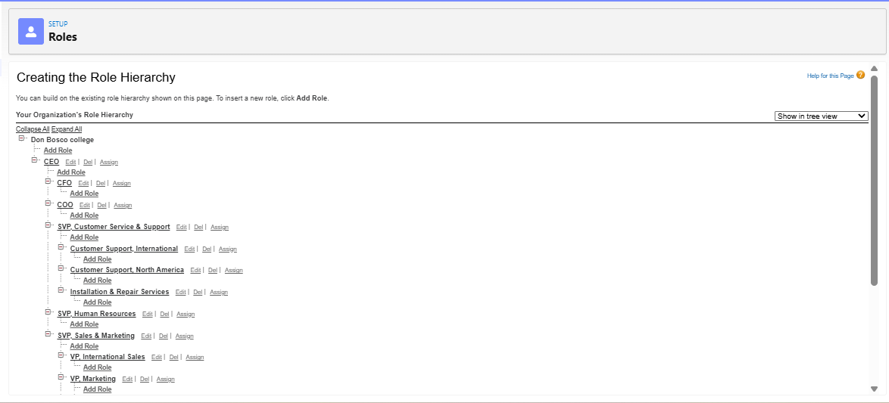

7. Suggested User-to-Role Mapping
User Type | Recommended Role | Purpose
System/Admin User | Courier Administrator | Overall system supervision.
Branch Supervisor | Branch Manager | Branch-level supervision.
Office/Courier Staff | Courier Staff | Operational data entry and processing.
Delivery Person | Delivery Agent | Delivery execution and status updates.

8. Role vs Profile
Feature | Role | Profile
Main Purpose | Controls record visibility through hierarchy. | Controls what a user can do.
Object Permission | Does not directly grant CRUD permission. | Controls Create, Read, Edit, Delete permissions.
Field Access | Does not control field-level security. | Controls field-level security.
Tab/App Access | Does not control tab visibility. | Can control tab and application access.
Hierarchy | Yes | No

9. Verification Checklist
☐ Courier Administrator role created.
☐ Branch Manager role created.
☐ Courier Staff role created.
☐ Delivery Agent role created.
☐ Roles are arranged in the correct hierarchy.
☐ Users are assigned to the correct roles.
☐ Higher roles can access appropriate subordinate records according to sharing configuration.
☐ Role settings do not replace profile permissions.
☐ Screenshot evidence has been added to the document.

10. Important Notes
- Roles primarily affect record visibility, while Profiles and Permission Sets control functional permissions.
- Role hierarchy access depends on the object's sharing model and Salesforce sharing settings.
- Do not assign unnecessary high-level roles to ordinary users.
- Use the actual role names created in your Salesforce org when submitting final documentation.
- Only mark role configuration as completed after verifying user assignments and record visibility.

