SALESFORCE PROFILE DOCUMENTATION
Courier Management System
This document describes the recommended Salesforce profile configuration for the Courier Management System. It covers object permissions, tab visibility, field-level security, application access, user assignment, testing, and screenshot evidence areas.

1. Purpose of Profiles
- Control what users can view and perform in Salesforce.
- Grant access to the Courier Management System application and its custom objects.
- Control Create, Read, Edit, and Delete permissions for each object.
- Control tab visibility and field-level security.
- Ensure users receive only the access needed for their role.

2. Recommended Profiles
Profile | Intended User | Access Level
Courier Administrator | System administrator / project administrator | Full access to all courier objects and configuration.
Courier Staff User | Branch or operations staff | Operational access to customers, shipments, updates, invoices, branches, and agents as required.
Delivery Agent User | Delivery personnel | Limited access focused on assigned shipments and delivery updates.

3. How to Create or Configure a Profile
1. Open Salesforce Setup.
2. In Quick Find, search for Profiles.
3. Open Profiles.
4. Select an existing profile to review, or clone a suitable standard profile when a custom profile is required.
5. Enter the new profile name if cloning.
6. Configure object permissions under Object Settings.
7. Configure field-level security for the custom objects.
8. Configure tab visibility.
9. Grant access to the Courier Management System application where applicable.
10. Save the profile.
11. Assign the profile to a test user.
12. Log in as the test user or use the appropriate Salesforce testing method to verify access.

4. Object Permissions

4.1 Courier Administrator
Object | Create | Read | Edit | Delete
Customer | Yes | Yes | Yes | Yes
Shipment | Yes | Yes | Yes | Yes
Delivery Agent | Yes | Yes | Yes | Yes
Branch | Yes | Yes | Yes | Yes
Delivery Update | Yes | Yes | Yes | Yes
Invoice | Yes | Yes | Yes | Yes

4.2 Courier Staff User
Object | Create | Read | Edit | Delete
Customer | Yes | Yes | Yes | No
Shipment | Yes | Yes | Yes | No
Delivery Agent | Yes | Yes | Yes | No
Branch | No | Yes | No | No
Delivery Update | Yes | Yes | Yes | No
Invoice | Yes | Yes | Yes | No

4.3 Delivery Agent User
Object | Create | Read | Edit | Delete
Customer | No | No | No | No
Shipment | No | Yes | Limited | No
Delivery Agent | No | Yes | Limited | No
Branch | No | Yes | No | No
Delivery Update | Yes | Yes | Yes | No
Invoice | No | No | No | No

5. Tab Visibility
Tab | Courier Administrator | Courier Staff User | Delivery Agent User
Customer | Default On | Default On | Tab Hidden
Shipment | Default On | Default On | Default On
Delivery Agent | Default On | Default On | Default On
Branch | Default On | Default On | Default On
Delivery Update | Default On | Default On | Default On
Invoice | Default On | Default On | Tab Hidden

6. Field-Level Security
Recommended field-level security should match the user role. Sensitive or administrative fields should be read-only or hidden for users who do not need to change them.
Object | Important Fields | Recommended Access
Customer | Contact and address fields | Administrator/Staff: Editable; Delivery Agent: Hidden or Read-Only if exposed through related records.
Shipment | Status, Branches, Assigned Agent, Charges | Administrator: Editable; Staff: Editable; Delivery Agent: Read-Only except fields explicitly needed by your process.
Delivery Agent | Availability Status, Vehicle Number, Branch | Administrator/Staff: Editable; Delivery Agent: Read-Only or limited according to project requirements.
Branch | Branch Code, Address, Contact | Administrator: Editable; Staff/Delivery Agent: Read-Only.
Delivery Update | Status, Location, Remarks, Date/Time | Administrator/Staff/Delivery Agent: Editable when their job requires creating updates.
Invoice | Amount, Tax, Total Amount, Payment Status | Administrator/Staff: Editable where appropriate; Delivery Agent: Hidden.

7. Application Access
- Ensure the Courier Management System application is visible to the intended profiles.
- Courier Administrator should have full application access.
- Courier Staff User should have access to the operational application and tabs required for daily work.
- Delivery Agent User should have access only if the application is intended for delivery personnel.
- Verify that hidden objects or tabs do not appear unexpectedly in the user navigation.

8. Assign a Profile to a User
1. Open Setup.
2. Search for Users.
3. Open Users.
4. Select the required user.
5. Click Edit.
6. Choose the required Profile.
7. Save the user record.
8. Verify that the user receives the expected object, tab, and application access.
Evidence / Screenshot
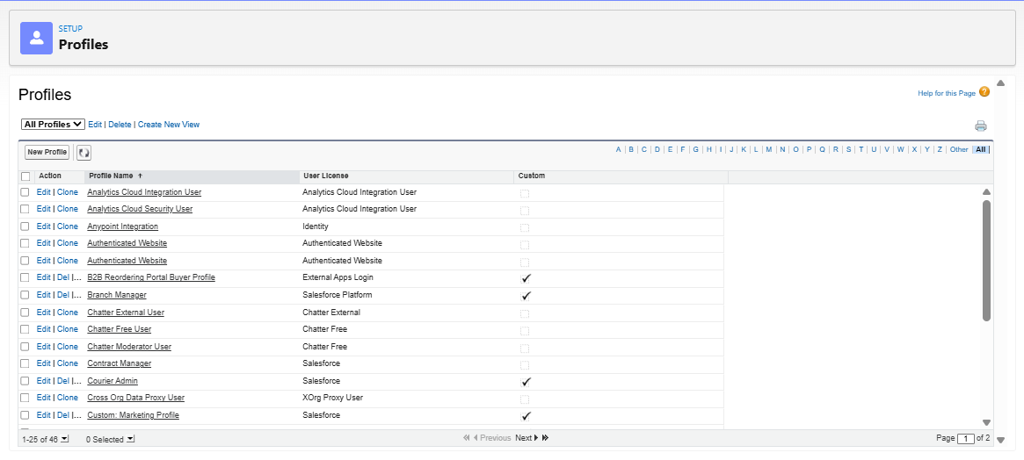

9. Verification Checklist
☐ Courier Administrator profile permissions reviewed.
☐ Courier Staff User profile permissions reviewed.
☐ Delivery Agent User profile permissions reviewed.
☐ Object permissions match the intended role.
☐ Tab visibility is configured correctly.
☐ Field-level security is configured correctly.
☐ Courier Management System application access is available to intended profiles.
☐ A test user has been assigned the appropriate profile.
☐ Create, Read, Edit, and Delete behavior has been tested.
☐ Restricted users cannot access unauthorized objects or fields.
☐ Screenshot evidence has been inserted into this document.

10. Important Notes
- The permission matrix in this document is a recommended project configuration. Adjust it to match your actual Salesforce implementation and course requirements.
- Do not grant Modify All Data or similarly broad administrative permissions to normal operational users.
- Use the principle of least privilege: give each profile only the access necessary for its role.
- If your Salesforce edition or environment limits custom profile creation, you can document equivalent permissions using an existing profile plus permission sets.
- Do not mark the profile configuration as completed until it has been tested with an actual user.

