SALESFORCE USER DOCUMENTATION
Courier Management System
This document describes the recommended Salesforce users for the Courier Management System, including user creation, profile and role assignment, user activation, access verification, and screenshot evidence sections.

1. Purpose of Salesforce Users
- Provide individual login access to the Courier Management System.
- Assign each person the correct Profile and Role.
- Control application, object, field, tab, and record access.
- Support accountability because records show which Salesforce user created or modified them.

2. Recommended Users
User Type | Recommended Profile | Recommended Role | Purpose
Courier Administrator | Courier Administrator Profile | Courier Administrator | Full project administration and supervision.
Branch Manager | Courier Staff User Profile | Branch Manager | Supervises branch operations and staff.
Courier Staff User | Courier Staff User Profile | Courier Staff | Handles customers, shipments, invoices, and operational data.
Delivery Agent User | Delivery Agent User Profile | Delivery Agent | Updates assigned shipment and delivery information.

3. How to Create a User in Salesforce
1. Open Salesforce Setup.
2. In Quick Find, search for Users.
3. Open Users.
4. Click New User.
5. Enter the user's First Name and Last Name.
6. Enter a unique Email address.
7. Enter a unique Username. Salesforce usernames must be unique across Salesforce organizations.
8. Set the Alias and Nickname if required.
9. Select the required User License.
10. Select the appropriate Profile.
11. Select the appropriate Role.
12. Select the correct Locale, Language, and Time Zone.
13. Keep Active selected when the user should be able to log in.
14. Choose whether Salesforce should generate and send the password notification, depending on your project environment.
15. Click Save.

4. Suggested User Configuration
User | License | Profile | Role | Status
Courier Administrator | Appropriate available Salesforce user license | Courier Administrator Profile | Courier Administrator | Active
Branch Manager | Appropriate available Salesforce user license | Courier Staff User Profile | Branch Manager | Active
Courier Staff User | Appropriate available Salesforce user license | Courier Staff User Profile | Courier Staff | Active
Delivery Agent User | Appropriate available Salesforce user license | Delivery Agent User Profile | Delivery Agent | Active
Use the actual user licenses available in your Salesforce organization. License availability varies by Salesforce edition and environment.

5. User Access Responsibilities

5.1 Courier Administrator User
- Accesses all major project setup and administration areas as permitted.
- Manages users, profiles, roles, objects, fields, layouts, flows, and validation rules.
- Monitors project records and configuration.

5.2 Branch Manager User
- Supervises branch-related operations.
- Reviews shipments, staff, delivery agents, and related branch records.
- Uses access granted through the assigned profile, role hierarchy, and sharing settings.

5.3 Courier Staff User
- Creates and edits Customer records.
- Creates and updates Shipment records.
- Works with Invoice and Delivery Update records when permitted.
- Assigns delivery agents when permitted by the profile and sharing model.

5.4 Delivery Agent User
- Views records made available to the delivery agent.
- Updates delivery status, location, and remarks.
- Works only with the access granted by the assigned profile, role, and sharing configuration.

6. Assign Profile and Role to an Existing User
1. Open Setup → Users → Users.
2. Select the required user.
3. Click Edit.
4. Select the required Profile.
5. Select the required Role.
6. Verify that Active is selected if the user should have login access.
7. Click Save.
8. Test access using the appropriate Salesforce login or user-access testing method available in your environment.

7. User Activation and Deactivation
- Active users can log in when their license, authentication, and organization settings allow it.
- Deactivate a user when access is no longer required instead of deleting the user.
- Before deactivation, review record ownership and reassign records if necessary.
- A deactivated user no longer consumes an active user license in cases where Salesforce permits license reuse.

8. User Verification Procedure
1. Confirm that the user appears in Setup → Users.
2. Confirm that the correct Profile is assigned.
3. Confirm that the correct Role is assigned.
4. Confirm that the user is Active.
5. Verify that the Courier Management System app is accessible if intended.
6. Verify that required object tabs are visible.
7. Verify that permitted records can be created, read, edited, or deleted according to the assigned permissions.
8. Verify that restricted objects, fields, or records are not accessible when access should be limited.
9. Record screenshot evidence after verification.
Evidence / Screenshot
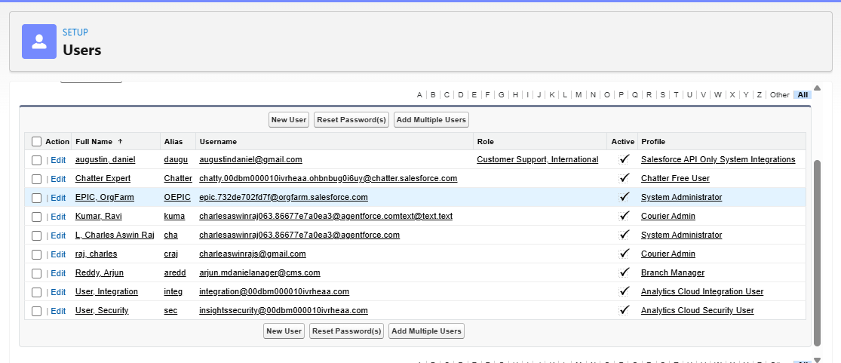

9. User, Profile, and Role Relationship
Component | Main Purpose | Example
User | Represents an individual Salesforce account. | Delivery Agent User
Profile | Controls permissions and access capabilities. | Delivery Agent User Profile
Role | Helps control record visibility through hierarchy. | Delivery Agent

10. Final Verification Checklist
☐ Courier Administrator user created or identified.
☐ Branch Manager user created if required.
☐ Courier Staff user created if required.
☐ Delivery Agent user created if required.
☐ Correct Salesforce license assigned to each user.
☐ Correct profile assigned to each user.
☐ Correct role assigned to each user.
☐ Required users are Active.
☐ Application and tab access verified.
☐ Object and record permissions verified.
☐ Screenshot evidence added to this document.

11. Important Notes
- Do not include passwords, security tokens, verification codes, or other sensitive login information in project documentation or screenshots.
- Use actual usernames and email addresses only when your institution requires them; otherwise screenshots may be cropped or redacted for privacy.
- A Profile controls what a user can do, while a Role primarily contributes to which records the user can see through the hierarchy.
- Exact Salesforce license names depend on the organization and edition, so select from the licenses available in your own Salesforce org.
- Do not mark user setup as completed until the user, profile, role, activation status, and access have been verified.

