SALESFORCE TABS DOCUMENTATION
Courier Management System
This document describes the creation of custom tabs for the main Salesforce objects used in the Courier Management System. The tabs provide direct access to object records from the Salesforce navigation interface.

1. Purpose of Tabs
- Provide quick access to each custom object.
- Allow users to view, create, edit, and manage object records.
- Make the Courier Management System easier to navigate.
- Prepare the objects for inclusion in a Salesforce custom application.

2. Tabs Required
Object | API Name | Tab Name | Purpose
Customer | Customer__c | Customer Tab | Stores and manages customer details.
Shipment | Shipment__c | Shipment Tab | Provides access to shipment and parcel records.
Delivery Agent | Delivery_Agent__c | Delivery Agent Tab | Provides access to delivery agent information.
Branch | Branch__c | Branch Tab | Provides access to courier branch records.
Delivery Update | Delivery_Update__c | Delivery Update Tab | Provides access to shipment status and delivery update records.
Invoice | Invoice__c | Invoice Tab | Provides access to invoice and payment-related records.

3. General Procedure to Create a Custom Object Tab
1. Log in to Salesforce.
2. Click the Setup gear icon and select Setup.
3. In Quick Find, search for Tabs.
4. Open Tabs under User Interface.
5. Go to the Custom Object Tabs section.
6. Click New.
7. Select the required custom object.
8. Choose an appropriate tab style/icon.
9. Click Next.
10. Keep the tab visible for the required profiles, unless your course instructions specify otherwise.
11. Click Next and choose the applications in which the tab should be available.
12. Click Save.

4. Individual Tab Configuration

4.1 Customer Tab
Custom Object | Customer
API Name | Customer__c
Tab Label | Customer
Suggested Tab Style | Choose any suitable icon/style representing customer data.
Visibility | Default On for required user profiles.
Application Availability | Enable for the Courier Management System app.
Implementation Status | Not confirmed - update after creating and testing the tab in Salesforce.
Verification:
- The Customer tab appears in the Salesforce navigation bar.
- Clicking the tab opens the Customer object list view.
- A new Customer record can be created from the tab.
- The tab is visible to the intended user profile.
Screenshot placeholder:
[Insert screenshot of the Customer tab here]

4.2 Shipment Tab
Custom Object | Shipment
API Name | Shipment__c
Tab Label | Shipment
Suggested Tab Style | Choose any suitable icon/style representing shipment data.
Visibility | Default On for required user profiles.
Application Availability | Enable for the Courier Management System app.
Implementation Status | Not confirmed - update after creating and testing the tab in Salesforce.
Verification:
- The Shipment tab appears in the Salesforce navigation bar.
- Clicking the tab opens the Shipment object list view.
- A new Shipment record can be created from the tab.
- The tab is visible to the intended user profile.
Screenshot placeholder:
[Insert screenshot of the Shipment tab here]

4.3 Delivery Agent Tab
Custom Object | Delivery Agent
API Name | Delivery_Agent__c
Tab Label | Delivery Agent
Suggested Tab Style | Choose any suitable icon/style representing delivery agent data.
Visibility | Default On for required user profiles.
Application Availability | Enable for the Courier Management System app.
Implementation Status | Not confirmed - update after creating and testing the tab in Salesforce.
Verification:
- The Delivery Agent tab appears in the Salesforce navigation bar.
- Clicking the tab opens the Delivery Agent object list view.
- A new Delivery Agent record can be created from the tab.
- The tab is visible to the intended user profile.
Screenshot placeholder:
[Insert screenshot of the Delivery Agent tab here]

4.4 Branch Tab
Custom Object | Branch
API Name | Branch__c
Tab Label | Branch
Suggested Tab Style | Choose any suitable icon/style representing branch data.
Visibility | Default On for required user profiles.
Application Availability | Enable for the Courier Management System app.
Implementation Status | Not confirmed - update after creating and testing the tab in Salesforce.
Verification:
- The Branch tab appears in the Salesforce navigation bar.
- Clicking the tab opens the Branch object list view.
- A new Branch record can be created from the tab.
- The tab is visible to the intended user profile.
Screenshot placeholder:
[Insert screenshot of the Branch tab here]

4.5 Delivery Update Tab
Custom Object | Delivery Update
API Name | Delivery_Update__c
Tab Label | Delivery Update
Suggested Tab Style | Choose any suitable icon/style representing delivery update data.
Visibility | Default On for required user profiles.
Application Availability | Enable for the Courier Management System app.
Implementation Status | Not confirmed - update after creating and testing the tab in Salesforce.
Verification:
- The Delivery Update tab appears in the Salesforce navigation bar.
- Clicking the tab opens the Delivery Update object list view.
- A new Delivery Update record can be created from the tab.
- The tab is visible to the intended user profile.
Screenshot placeholder:
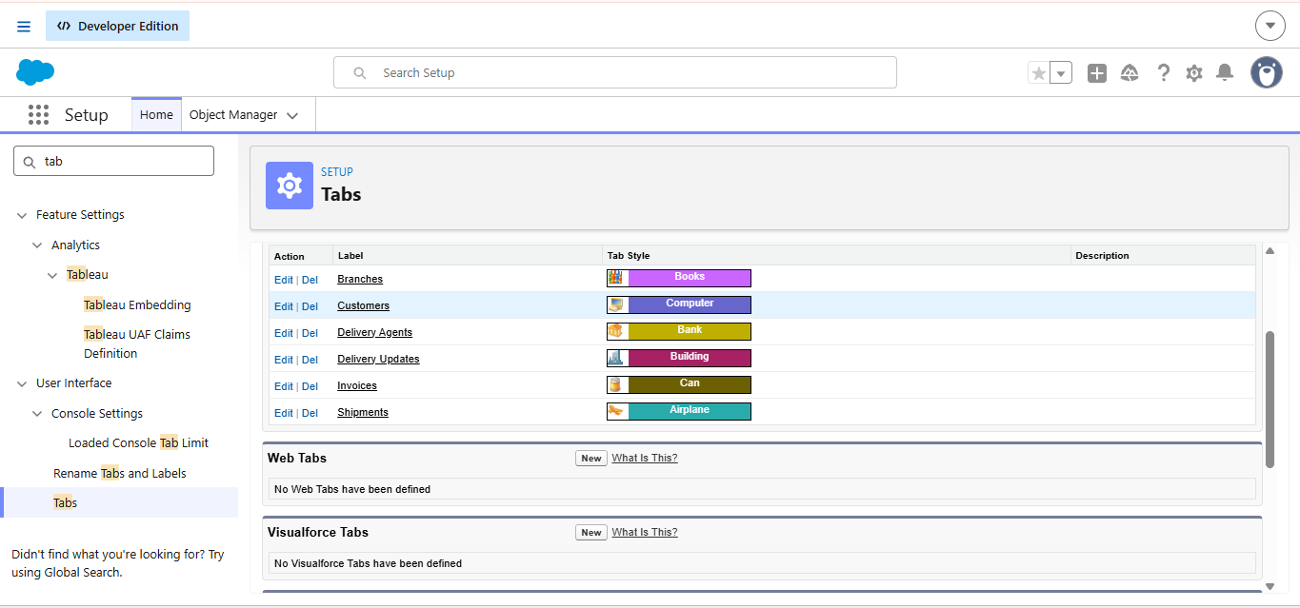

4.6 Invoice Tab
Custom Object | Invoice
API Name | Invoice__c
Tab Label | Invoice
Suggested Tab Style | Choose any suitable icon/style representing invoice data.
Visibility | Default On for required user profiles.
Application Availability | Enable for the Courier Management System app.
Implementation Status | Not confirmed - update after creating and testing the tab in Salesforce.
Verification:
- The Invoice tab appears in the Salesforce navigation bar.
- Clicking the tab opens the Invoice object list view.
- A new Invoice record can be created from the tab.
- The tab is visible to the intended user profile.
Screenshot placeholder:
[Insert screenshot of the Invoice tab here]

5. Add Tabs to the Courier Management System App
1. Open Setup.
2. Search for App Manager.
3. Locate the Courier Management System application.
4. Click the drop-down menu and select Edit.
5. Open Navigation Items.
6. Move Customer, Shipment, Delivery Agent, Branch, Delivery Update, and Invoice into Selected Items.
7. Arrange the tabs in the preferred navigation order.
8. Click Save.
9. Open the application from the App Launcher and verify that all six tabs are displayed.
Recommended navigation order:
Customer → Shipment → Delivery Agent → Branch → Delivery Update → Invoice

6. Final Verification Checklist
☐ Customer tab created and visible.
☐ Shipment tab created and visible.
☐ Delivery Agent tab created and visible.
☐ Branch tab created and visible.
☐ Delivery Update tab created and visible.
☐ Invoice tab created and visible.
☐ All tabs added to the Courier Management System app.
☐ Tabs open the correct object list views.
☐ Required user profiles can access the tabs.
☐ Screenshots added to this document before final submission.

7. Submission Note
Replace every screenshot placeholder with your actual Salesforce screenshots after the tabs are created. Update each Implementation Status from 'Not confirmed' to 'Completed and verified' only after checking the tab directly in Salesforce.

