SALESFORCE FLOWS DOCUMENTATION
Courier Management System
This document defines recommended Salesforce Flows for automating key processes in the Courier Management System. Each flow includes the flow type, trigger, logic, configuration steps, testing procedure, and a large evidence area for inserting Salesforce screenshots.

1. How to Create a Flow in Salesforce
1. Open Salesforce Setup.
2. In Quick Find, search for Flows.
3. Open Flows under Process Automation.
4. Click New Flow.
5. Select the required flow type. For this project, Record-Triggered Flow is mainly used.
6. Select the object that will trigger the flow.
7. Configure the trigger condition and decide whether the flow runs when a record is created, updated, or both.
8. Add the required elements such as Decision, Get Records, Update Records, Create Records, or Assignment.
9. Connect the elements in the required sequence.
10. Click Save.
11. Enter a clear Flow Label and Flow API Name.
12. Click Debug and test the flow with sample records.
13. After successful testing, click Activate.

2. Recommended Flows
Flow Name | Flow Type | Object | Trigger | Purpose
Update Shipment Status from Delivery Update | Record-Triggered Flow | Delivery Update | When a Delivery Update is created | Copies the latest delivery update status to the related Shipment.
Create Invoice When Shipment Is Delivered | Record-Triggered Flow | Shipment | When Status changes to Delivered | Automatically creates an Invoice for a delivered shipment.
Set Shipment Expected Delivery Date | Record-Triggered Flow | Shipment | When a Shipment is created | Sets an expected delivery date automatically when it is blank.
Update Agent Availability | Record-Triggered Flow | Shipment | When a Delivery Agent is assigned | Changes the assigned agent's availability status to Assigned.
Mark Agent Available After Delivery | Record-Triggered Flow | Shipment | When Shipment Status changes to Delivered | Changes the assigned delivery agent back to Available.

2.1 Update Shipment Status from Delivery Update
Flow Type: Record-Triggered Flow
Trigger Object: Delivery_Update__c
Trigger: A record is created
Entry Condition: Shipment__c Is Null = False
Run: After the record is saved
Main Action: Update related Shipment.Status__c with the Delivery Update Status__c
Flow Logic:
- Start when a new Delivery Update record is created.
- Confirm that the Delivery Update is linked to a Shipment.
- Use Update Records on the related Shipment.
- Set Shipment.Status__c equal to Delivery_Update__c.Status__c.
- Save and activate the flow.
Testing:
- Open a Shipment record.
- Create a Delivery Update with a status such as In Transit.
- Save the Delivery Update.
- Confirm that the related Shipment Status changes to the same value.

2.2 Create Invoice When Shipment Is Delivered
Flow Type: Record-Triggered Flow
Trigger Object: Shipment__c
Trigger: A record is updated
Entry Condition: Status__c Equals Delivered
Run: After the record is saved
Main Action: Create an Invoice record linked to the Shipment
Recommended Create Records values:
Invoice Field | Value
Shipment__c | $Record.Id
Invoice_Date__c | $Flow.CurrentDate
Amount__c | $Record.Shipping_Charge__c
Tax__c | 0
Payment_Status__c | Pending
Important configuration:
- Configure the flow to run only when the record is updated to meet the condition requirements.
- This prevents a new invoice from being created every time an already-delivered Shipment is edited.
- If your project allows only one Invoice per Shipment, verify that no invoice already exists before creating another one.
Testing:
- Open a Shipment whose Status is not Delivered.
- Change Status to Delivered and save.
- Open the related Invoice list.
- Confirm that an Invoice was created and linked to the Shipment.

2.3 Set Shipment Expected Delivery Date
Flow Type: Record-Triggered Flow
Trigger Object: Shipment__c
Trigger: A record is created
Entry Condition: Expected_Delivery_Date__c Is Null = True
Run: Before the record is saved
Main Action: Set Expected_Delivery_Date__c automatically
Example logic: set Expected_Delivery_Date__c to Shipment_Date__c + 3 days. You may change the number of days based on your project requirement.
Flow Logic:
- Start when a Shipment is created.
- Check whether Expected Delivery Date is blank.
- Use an Assignment element or before-save field update.
- Set Expected_Delivery_Date__c = Shipment_Date__c + 3.
- Save and activate the flow.
Testing:
- Create a Shipment with Shipment Date entered.
- Leave Expected Delivery Date blank.
- Save the Shipment.
- Confirm that Salesforce fills the Expected Delivery Date automatically.

2.4 Update Agent Availability When Assigned
Flow Type: Record-Triggered Flow
Trigger Object: Shipment__c
Trigger: A record is created or updated
Entry Condition: Assigned_Delivery_Agent__c Is Null = False
Run: After the record is saved
Main Action: Update Delivery Agent Availability_Status__c to Assigned
Flow Logic:
- Start when a Shipment has an assigned Delivery Agent.
- Use Update Records for the related Delivery Agent.
- Set Availability_Status__c to Assigned.
- Save and activate the flow.
Testing:
- Open or create a Shipment.
- Select a Delivery Agent in Assigned Delivery Agent.
- Save the Shipment.
- Open the Delivery Agent record.
- Confirm that Availability Status is Assigned.

2.5 Mark Agent Available After Delivery
Flow Type: Record-Triggered Flow
Trigger Object: Shipment__c
Trigger: A record is updated
Entry Condition: Status__c Equals Delivered AND Assigned_Delivery_Agent__c Is Null = False
Run: After the record is saved
Main Action: Update Delivery Agent Availability_Status__c to Available
Flow Logic:
- Start when Shipment Status changes to Delivered.
- Confirm that a Delivery Agent is assigned.
- Use Update Records for the related Delivery Agent.
- Set Availability_Status__c to Available.
- Save and activate the flow.
Testing:
- Use a Shipment with an assigned Delivery Agent.
- Change Shipment Status to Delivered.
- Save the Shipment.
- Open the Delivery Agent record.
- Confirm that Availability Status is Available.

3. Recommended Flow Order
- Shipment created -> Expected Delivery Date is set.
- Delivery Agent assigned -> Agent Status becomes Assigned.
- Delivery Update created -> Shipment Status is updated.
- Shipment reaches Delivered -> Invoice is created.
- Shipment reaches Delivered -> Delivery Agent Status becomes Available.

4. Flow Testing and Debugging
1. Open the Flow in Flow Builder.
2. Click Debug.
3. Select or create a suitable test record.
4. Run the debug test.
5. Review each executed element.
6. Confirm that the expected records were created or updated.
7. Correct any field API names or conditions if an error appears.
8. Repeat the test until the flow completes successfully.
9. Activate the flow only after successful testing.
Evidence / Screenshot
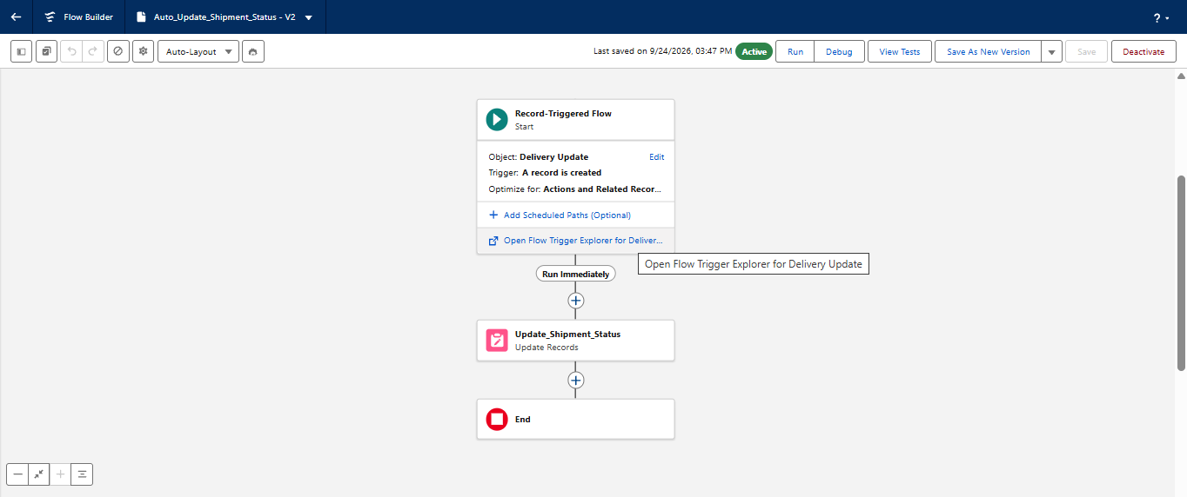

5. Final Verification Checklist
☐ Flow 1 updates Shipment Status from Delivery Update.
☐ Flow 2 creates an Invoice when a Shipment becomes Delivered.
☐ Flow 3 sets Expected Delivery Date automatically.
☐ Flow 4 changes an assigned Delivery Agent to Assigned status.
☐ Flow 5 changes the Delivery Agent back to Available after delivery.
☐ All Flow API field names match the actual Salesforce fields.
☐ All flows pass Debug testing.
☐ No duplicate invoices are created.
☐ Valid records continue to save successfully.
☐ All required flows are Activated.
☐ Screenshot evidence has been inserted into this document.

6. Important Notes
- Use the exact API names from your Salesforce org. If your API names differ from this document, update the flow configuration accordingly.
- Test flows in a safe development or Trailhead environment before using them with important data.
- For record-triggered flows that create records, use condition settings that prevent duplicate automation on repeated edits.
- If a flow and a validation rule affect the same field, test both together to ensure they do not conflict.
- Do not mark a flow as completed until it has been debugged, activated, and tested with an actual record.

