eFORGE analysis tool

The eFORGE (experimentally-derived Functional element Overlap analysis of ReGions from EWAS) tool performs a Functional Overlap analysis to identify tissue specific signal for a given set of EWAS DMPs.

Sections
- Resources
- Overview
- Inputs
- Options
- Outputs
- Output Examples
- Methods
- Source Code
- Citation
- Contact/Acknowledgements
Other Resources
- Source code on GitHub

Overview

The eFORGE tool provides a method to view the tissue specific regulatory component of a set of EWAS DMPs. eFORGE analysis takes a set of DMPs, such as those hits above genome-wide significance threshold in an EWAS study, and analyses whether there is enrichment for overlap of putative functional elements compared to matched background DMPs. It assesses enrichment on a per cell type basis, since functional elements are differentially active in different cell types, and hence can expose tissue-specific signals of enrichment for the given test DMP set. This can reveal the sites of action underlying the EWAS signal, and provide confirmation of the validity of the EWAS where a tissue-specific mechanism is known or expected for the phenotype. Conversely unknown tissue involvements can also be revealed.

In the initial implementation, the functional elements considered are DNase I hotspots from either the ENCODE or Roadmap Epigenomics projects generated by the Hotspot method. The hotspots are regions of general DNase I sensitivity (rather than peaks which are more similar to DNase hypersensitive sites).

For each set of test DMPs, an overlap analysis is performed against the functional elements from either data source for each cell sample separately (125 samples for ENCODE, 299 for Roadmap), and the number of overlaps is counted. A background distribution of the expected overlap counts for this DMP set is obtained by picking sets of the same number of DMPs as the test DMP set, matched for gene relationship and CpG island relationship annotation. The matched background sets are then overlapped with the functional elements and the background distribution of overlaps determined. By default 1000 matched sets are used. The enrichment value for the test DMP set is expressed as the -log10 (binomial p value). Enrichments outside the nominal 99th and 99.9th percentile of the binomial distribution (i.e. -log10 (binomial p values) of >=2.68 and >= 3.38, respectively) are considered significant. A schematic of the analysis is shown below.
eFORGE Analysis Strategy
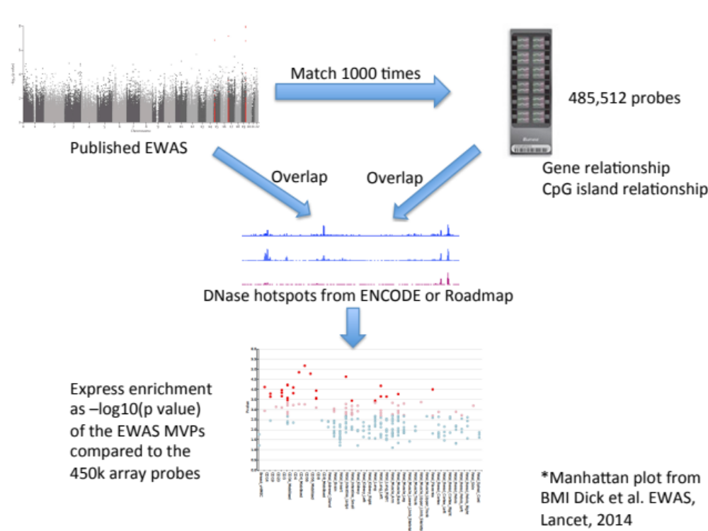
The results are presented by cell sample in either graphic (interactive Dimple chart or static pdf) or tabular (interactive DataTables table or tab separated file) forms. Typical results may show an enrichment of overlap (red or pink points) for the EWAS DMP set in a tissue of mechanistic relevance to the phenotype under analysis, for instance blood cell subtypes for Rheumatoid Arthritis DMPs.
Alternatively there may be no enrichment and all points will be blue below the -log10 (binomial p value) thresholds. This could be because there is no regulatory component underlying the EWAS association, or because the relevant tissue is not present in the available functional element datasets, or for other technical reasons (e.g. too few overlaps).
A list of probes from a tDMR study by Jaffe and Irizarry (Genome Biology, 2014) is available as default data in the web tool and more example datasets are being considered for a catalogue of eFORGE analysis results.
Inputs
You can supply a list of DMPs by their Illumina probeid, one DMP per line in the Paste data: box. For example, you can run the DMPs already in the paste box which are a set of blood cell type tDMPs obtained from filtering data from the tDMP study by Jaffe and Irizarry (Genome Biology, 2014).
Alternatively you can upload a file from disk or via a URL. The file should contain
- a list of DMPs by Illumina probeid, one per line as above,
DMPs have to be present on the 450k array to work in the analysis. Any DMPs provided not in this set will be excluded from the analysis and this is reported to you. Also note that at least 5 input DMPs are required in the set for the web based analysis. There is no maximum, but very large sets will be slower to analyse. See below for false discovery rate analysis.
Options
Name for this data
Give an optional name for your DMP set. This name will be used in the title of the pdf output image.
Analysis data from
The data set to analyse your DMP set against. Currently this is DNase I hotspots from either the ENCODE (Thurman et al, 2012) or Roadmap Epigenomics projects generated by the Hotspot method. The hotspots are regions of general DNase I sensitivity (rather than peaks which are more similar to DNase hypersensitive sites).
Depletion

Activating depletion analysis will look for depletion of input DMP set in DNase I hotspots (otherwise eFORGE will analyse enrichment, which is the default option).

Background repetitions

Define the number of matching background DMP sets to analyse for the background overlap distribution. By default this is set to 1000 background DMP sets.

Significance thresholds

These are the -log10 (binomial p value) thresholds used to colour the points red (by default >= 3.38) or pink (>=2.68). Experiments with randomly selected input DMPs (n≥20) showed that the significance thresholds were reasonably well calibrated to false positive levels of around 12.5% for -log10(binomial p value)≥2.68 and <2.5% for -log10(binomial p value)≥3.38.
Outputs
Several outputs are produced and provided from the results page.
- An interactive table of the overlaps by cell is given by default on the results page, and can also be accessed through the Interactive table link.
- The PDF link provides a base R graphics pdf chart of the eFORGE analysis useful for printing, presentations and publications.
- The Interactive chart link provides an interactive chart to explore the data.
- The TSV link provides the eFORGE analysis results in tab separated format.
- The R code for regenerating these files (PDF, chart and table).
- The original Input data in raw text format.
Each of the graphics presents the -log10 (binomial p values) by cell sample. Cells are grouped alphabetically by tissue and then organised alphabetically by cell name. In each of the graphics the colouring is consistent, blue (-log10(binomial p value) < 2.68), pink (2.68 =< -log10(binomial p value) < 3.38), and red (-log10(binomial p value) >= 3.38).
Example Outputs
See the following graphics/links for examples of the output for the default CD14 tDMPs:
Interactive Chart
The interactive chart presents the -log10 (binomial p values) by tissue. Each point is a -log10 (binomial p value) for a cell type with the different cells organised alphabetically within the tissues. Where the same cell type is assayed (either the same cell line, or the same sample type from different individuals) the results are stacked at the same x axis position which provides useful validation of results where there are replicate or equivalent cell samples. Passing the mouse cursor over the individual points will show a tooltip giving the information from the results table. The fields called Class and Number are for plotting purposes only and should be ignored.
PDF
The pdf output presents the -log10 (binomial p values) in a similar way organised alphabetically by Tissue and Cell, but without stacking duplicate samples. For guidance the Tissues are divided by the brown vertical lines. Horizontal pink lines show the -log10 (binomial p value) thresholds. An example is shown below. Threshold lines are not necessarily plotted if the results are all below threshold.
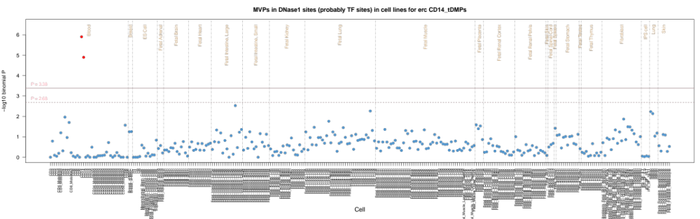
TSV file
The results are also available as a tab separated value file (TSV) with columns as follows:
- Zscore - The Z score of the test data enrichment count versus the background
- Pvalue - The P value of the test data enrichment count versus the background
- Cell - The cell for which the enrichment is calculated
- Tissue - The tissue of the Cell according to either ENCODE or BioSamples
- File - Filename of the functional annotation analysed
- Probe - The probes that overlap features in that file
- Number - An irrelevant number used to help plotting.
- Accession - The GEO accession number of the data set.
We are planning on making more example analyses in pdf format available.
Methods
Data
ENCODE consortium hotspots were obtained from ftp://ftp.ebi.ac.uk:pub/databases/ensembl/encode/integration_data_jan2011/byDataType/openchrom/jan2011/combined_hotspots/
Roadmap Epigenome DNase I sequencing tag alignments were obtained from http://www.genboree.org/EdaccData/Current-Release/experiment-sample/Chromatin_Accessibility/. These were processed by the Hotspot method to give hotspot files using the default parameters.
Cell and Tissue assignments were obtained by custom perl scripts using data from ENCODE Data Coordination Center tables or BioSamples
Overlaps
DNase I hotspot data in bed/wig format was formatted for overlap analysis using Tabix. The standard Illumina annotation file for all the probes on the 450k array was obtained and overlaps with the DNase I elements by cell type for every probe were calculated using Tabix in a distributed approach on the EBI compute farm. Overlaps were stored as a binary string for each data set (ENCODE or Roadmap) for each 450k probe in an indexed sqlite database, eforge.db.
eFORGE analysis
For a given set of DMPs eFORGE queries the sqlite database and retrieves all overlap bit strings. It then unpacks the bitstrings for each DMP and counts the overlaps per cell type. It next identifies matching probes for the DMPs based on gene relationship and CpG Island relationship, and repeats the overlap analysis for each background set. The final step is a simple calculation of the -log10 (binomial p value) of the test overlap count versus the background distribution.
Outputs
The TSV output is generated by eFORGE during processing. The graphic and tabular outputs are all generated via R code embedded in eFORGE. The pdf output is generated with base R graphics. The interactive table is produced using the Datatables plug-in for the jQuery Javascript library accessed through the rCharts package. The interactive graphic is a dimple d3 interactive graphic again using the rCharts package.
Estimating False Positive Rates by DMP count in the Test DMP Set
To estimate false positive rates, 1000 randomly chosen DMP sets for each of a series of DMP counts between 10 and 300 DMPs were analysed using eFORGE on the Roadmap and ENCODE data. The false positive rate was calculated as the number of cell enrichments greater than the two standard thresholds used by eFORGE expressed as the proportion of the total number of cell overlap tests performed.
False Positive Rate by DMP set Count

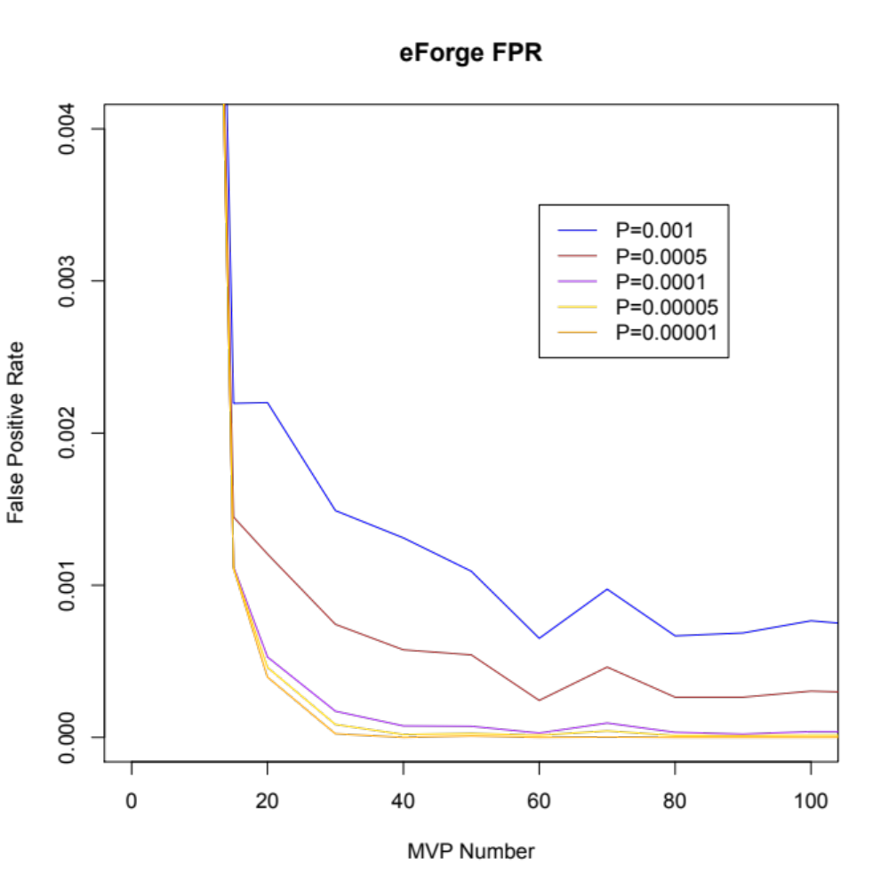
This plot suggests that for a DMP set of >= 20, a threshold of -log10 (binomial p value) >= 3.38 (equivalent to 0.001 in corrected p value) maintains the false positive rate below around 0.0025 (0.25%).
Source Code
The source code for eFORGE is available on Github at https://github.com/charlesbreeze/eFORGE. It has been installed and run on Mac OSX 10.8.4, 10.10.1 and Red Hat Linux. To run you also need to download the eforge.db database and the background selection hash table from
http://eforge.cs.ucl.ac.uk/?download.
Citation
If you find the tool useful, please cite the website at http://eforge.cs.ucl.ac.uk/. For use in publications cite the website and Breeze CE, Paul DS, Butcher LM, Herrero J, Birney E, Dunham I, Beck S. eFORGE: A tool for identifying tissue-specific signal in epigenomic data. Manuscript in preparation.
Contact
Charles Breeze (c.breeze@ucl.ac.uk)

