Assembly Survey Report Compiler Documentation

Author: Charles Cheng

Contact: [charlescheng2024@u.northwestern.edu](mailto:charlescheng2024@u.northwestern.edu)

**Installation**

Before running the program, you will need to install the required software and Python modules. If you haven’t already, install Anaconda. For Windows, refer to the webpage, <https://docs.anaconda.com/anaconda/install/windows/>, for step-by-step instructions.

If you already have Anaconda installed, ensure that it is the latest version. If not, follow these instructions to update to the newest version: <https://docs.anaconda.com/anaconda/install/update-version/>.

Once Anaconda is installed, you have the option of creating a new environment to run the program in. Instructions on how to do that are provided here, <https://conda.io/projects/conda/en/latest/user-guide/tasks/manage-environments.html#activating-an-environment>.

Next, activate your environment:

1. Open Anaconda Prompt
2. Execute command conda activate my_env where “my_env” is the name of your created environment
   1. If you did not create a new environment, you can use the default one by typing conda activate base
3. Keep Anaconda Prompt open

Check that your numpy and pandas module are the most recent version. To update these modules,

1. Execute command conda update numpy (in Anaconda Prompt)
2. Execute command conda update pandas

You will need to install the following Python modules: openpyxl, xls2xlsx, xlwings. Perform the following:

1. Execute command conda install openpyxl (in Anaconda Prompt)
2. Execute command pip install xls2xlsx
3. Execute command conda install xlwings

Lastly, download the Assembly Survey Report folder from the following Github link: <https://github.com/charlescheng091703/Assembly-Survey-Report>. Unzip the folder and save it to the desired location in your local file system.

You should be good to go once you’ve completed these steps without any errors.

**Program Use**

To use the program, you will first need to create a folder with name “DLM#-1###”, where “#”s are placeholders for variable characters, in the Assembly Survey Report folder. For example, if you want to create a report for module DLMB-1040, you will need to create a file named DLMB-1040.

Then, you will need to import the necessary files into the folder which you have just created. Those files should be named:

1. CENTERS.csv
2. FIDUCIALS.xls
3. INFO.csv
4. SA Report.xls
5. USMN - Unified Spatial Metrology Network.xls

Once you the module’s folder created and the necessary files inside that folder, you need to

1. Open Anaconda Navigator
2. Launch Jupyter Notebooks
3. Navigate to the file, Report Complier.ipynb, and open it
4. Press the Run button or select the first cell and press “Shift” + “Enter” on your keyboard
5. Modify the module name text box to be the desire module to create a report for
6. Press the “Create assembly survey report” button
7. Wait roughly 30 seconds to a minute for the program to run
   1. In this time, you should be seeing progress statements appear
   2. The program will open and close the Excel application in the background. There is no need to interact with these windows unless permission to a file is requested (this should not occur if file permissions are set to read and write for all files within the module folder).
   3. Important: do not press the button again before “Done!” is printed or an error is thrown
   4. If an error is thrown, please contact me by email and include a screenshot of the error.
8. Repeat steps 5-7 for other desired modules

**Version 1**

Version 1 of the program reads the magnet list from an Excel file rather than pulling this information directly from the CDB. The CDB Magnet List.xlsx file should look like the following.

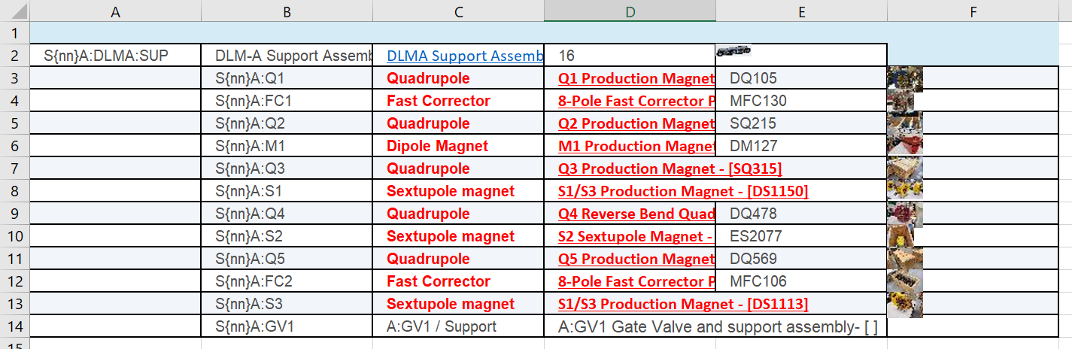

The program will copy cells C3 to D13 into the Alignment Summary Tab. It is important that the magnet list information to be placed exactly in those cells. If there are less than 11 magnets in the module, simply leave the extra rows blank (ie. if there are 12 magnets, leave C13 and D13 blank). In future versions, this manual process will be automized, but for now, ensure each magnet list Excel file abides to the format described above.

**Version 2**

Version 2 of the program reads the magnet list directly from the CDB.

Potential error: the order of the magnets may be out of order.