Cornerstone of Engineering
Fall 2020
Northeastern University
College of Engineering
Programming Lab 2
(Due: October 9, 2020)
Non-Programming Homework
- Develop flowcharts for programming homework problem 1.

Programming Homework
1. Write a program to generate a table of conversion from Fahrenheit to kelvin for values from 0 degrees F to 200 degrees F. allow the user to enter the increment in degrees Fahrenheit between lines. Use a do/while loop in your solution.

2. Twin primes are two primes that differ by 2 (e.g., 3 and 5, 101 and 103). Write a program that outputs all twin primes less than 1000 and the total count.

3. Write a program that uses for loops to prints the following patterns separately, side by side by making clever use of nested for loops. All asterisks (*) should be printed by a single statement of the form cout <<”*”;
(Hint: The last two patterns require that each line begin with an appropriate number of blanks)
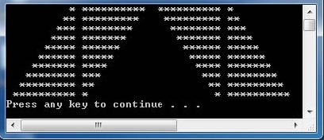

4. (Optional: extra credit - 10%) Write a C++ program to produce the following square pattern, you may use if statements, but you may not simply output the pattern using cout statement.
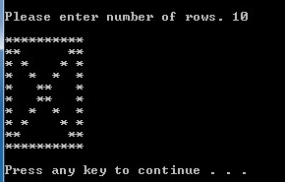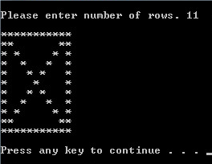
To Turn In via Blackboard:
- Word file with Cover page, Answer non-programming homework / questions, Screen Capture of outputs, and Results and Discussion
- Source code e-file (upload to the blackboard, the source code should be saved as phw21_xxx.cpp, phw22_xxx.cpp, …etc., where xxx is your initial)

