

Report for Programming Lab #2

Charles Daigle
Bala Maheswaran

Non-Programming Questions
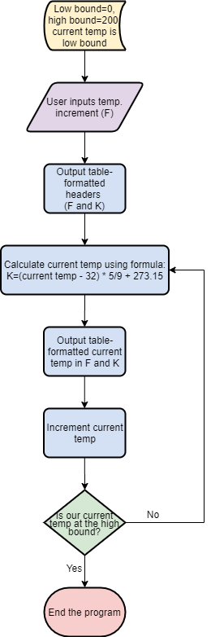
- Below is the flowchart corresponding to the first program (temperature conversion):
Code Outputs
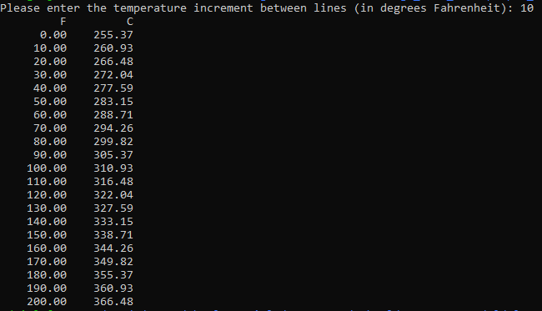

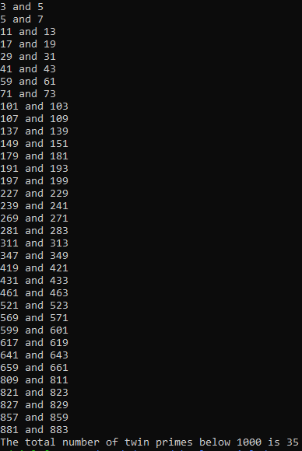
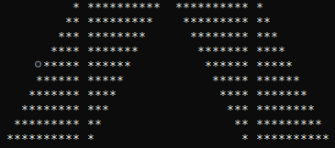

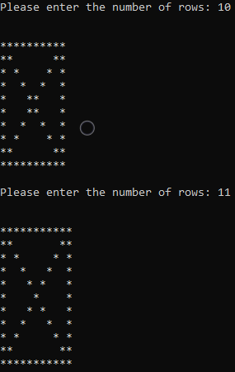

Results/Discussion
In this lab, problems were solved by applying the concept of looping. I used both fixed looping (“for”) and post-condition looping (“do-while”). For the problems where a predetermined output was necessary, for looping was useful to produce the same output each time the program was run. In the other problems, for looping and do-while looping was used with user-defined variables so that the program can be reactive to any user input.
The extra credit problem was solved by printing asterisks only at the beginning or end of a line, or if the row number was equal to the column number (first diagonal) or the complementing diagonal.

