

**Report for Programming Lab #1**

Charles Daigle

**Bala Maheswaran**

**Non-Programming Questions**

1. A picture containing object, clock

   Description automatically generatedBelow is the flowchart corresponding to the first program (slope of a line):

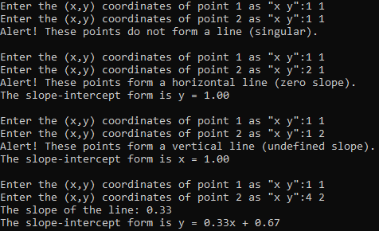**Code Outputs**

2. 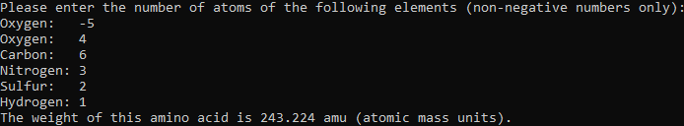
3. 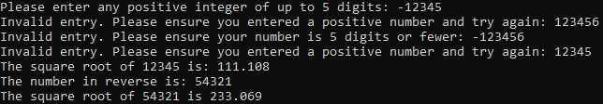
4. 1. 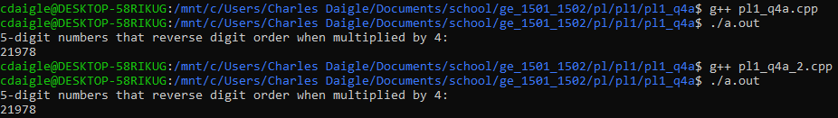

*Note: I solved problem 4a in 2 ways, see discussion at the end*

* 1. 

**Results/Discussion**

In this lab, several disparate introductory programming problems were solved. The raw concepts contained in these problems will soon be applied to engineering problems.

After experiencing issues with “cout” introducing unwanted line breaks when I used CLion, I switched to using a command line (WSL) and editing in “vi.” The programs were compiled using g++ and run by opening the output file.

Most of the problems I found relatively normal, other than the occasional bug. However, I found 2 solutions to problem 4a. Both are guess-and-check, but my solution pl1_q4a_2.cpp checks the number*4 against the reverse of the number, and the other solution pl1_q4a.cpp uses a formula that arises from the following algebraic expansion of the initial problem statement:

$$\begin{aligned}4\overline{abcde}=\overline{edcba}\#\left(1\right)\end{aligned}$$

Using place value, the following is true:

$$\begin{aligned}4\left({10}^{4}a+{10}^{3}b+{10}^{2}c+{10}^{1}d+{10}^{0}e\right)={10}^{4}e+{10}^{3}d+{10}^{2}c+{10}^{1}b+{10}^{0}a\#\left(2\right)\end{aligned}$$

Solving the following for a linear equation of 5 variables:

$$\begin{aligned}39,999a+3990b+300c-960d-9996e=0\#\left(3\right)\end{aligned}$$

This property can then be checked for all 5 digit numbers.