Cornerstone of Engineering

Fall 2020

Northeastern University

College of Engineering

Programming Lab 2

(Due: October 9, 2020)

**Non-Programming Homework**

1. Develop flowcharts for programming homework problem 1.

**Programming Homework**

1. Write a program to generate a table of conversion from Fahrenheit to kelvin for values from 0 degrees F to 200 degrees F. allow the user to enter the increment in degrees Fahrenheit between lines. Use a *do/while* loop in your solution.

2. Twin primes are two primes that differ by 2 (e.g., 3 and 5, 101 and 103). Write a program that outputs all twin primes less than 1000 and the total count.

3. Write a program that uses ***for*** loops to prints the following patterns separately, side by side by making clever use of nested **for** loops. All asterisks (*) should be printed by a single statement of the form ***cout <<”*”;***

(Hint: The last two patterns require that each line begin with an appropriate number of blanks)

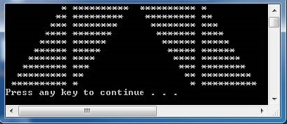

4.(Optional: extra credit - 10%) Write a C++ program to produce the following square pattern, you may use if statements, but you may not simply output the pattern using **cout** statement.

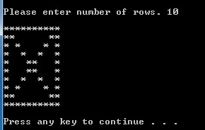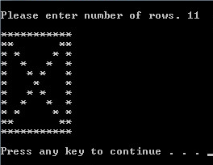

**To Turn In via Blackboard:**

1. Word file with Cover page, Answer non-programming homework / questions, Screen Capture of outputs, and Results and Discussion
2. Source code e-file (upload to the blackboard, the source code should be saved as phw21_xxx.cpp, phw22_xxx.cpp, …etc., where xxx is your initial)