

**Report for Programming Lab #2**

Charles Daigle

**Bala Maheswaran**

**Non-Programming Questions**

1. 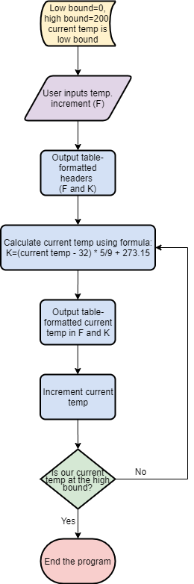Below is the flowchart corresponding to the first program (temperature conversion):

**Code Outputs**

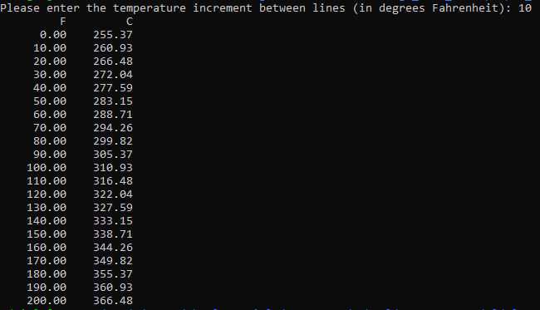

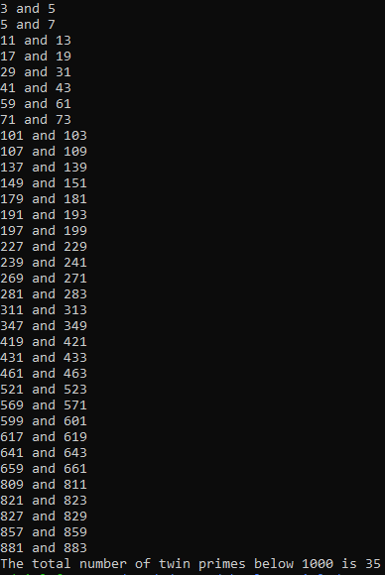

1. 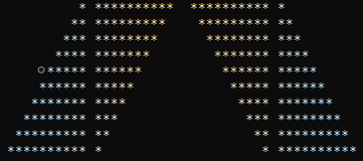
2. 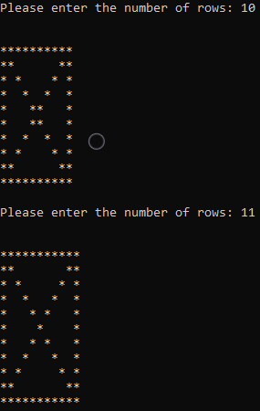

**Results/Discussion**

In this lab, problems were solved by applying the concept of looping. I used both fixed looping (“for”) and post-condition looping (“do-while”). For the problems where a predetermined output was necessary, for looping was useful to produce the same output each time the program was run. In the other problems, for looping and do-while looping was used with user-defined variables so that the program can be reactive to any user input.

The extra credit problem was solved by printing asterisks only at the beginning or end of a line, or if the row number was equal to the column number (first diagonal) or the complementing diagonal.