

**Report for Programming Lab #4**

Charles Daigle

**Bala Maheswaran**

**Code Outputs**

1. 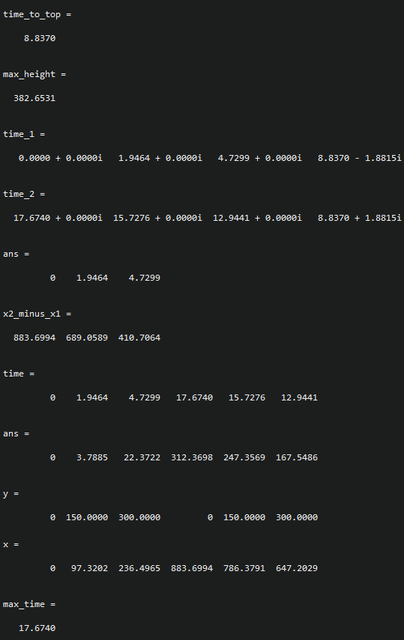

1. 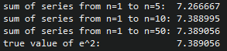
2. 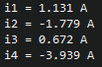
3. 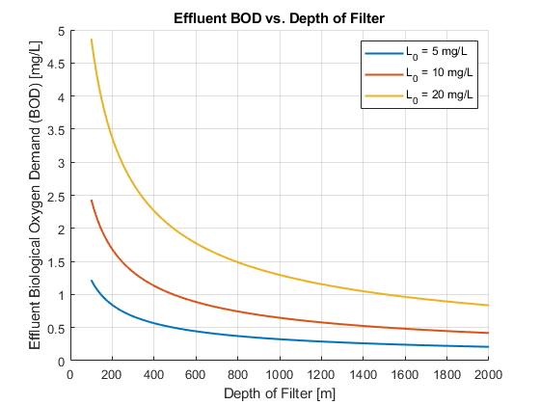

Given the above graph, we decide that water is drinkable at the first depth of filter where the effluent BOD (effBOD) is “flat” ; that is, where the effBOD decreases by a maximum of 0.15 mg/L by the time the depth reaches 2000m.

* 5 mg/L : **850 m**
* 10 mg/L : **1235 m**
* 20 mg/L : **1545 m**

1. Chart, line chart

   Description automatically generated

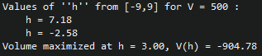

**Results/Discussion**

In this lab, MATLAB was introduced. The new concept of plotting was explored, and there was a greater emphasis on computation and numerical analysis. When I was plotting, I found it much better looking to use a ‘LineWidth’ of 1.5 instead of the default – the thicker line shows up better when the graph is downsized. I read quite a bit of the MATLAB documentation, and found a few very useful tools; firstly, symbols and symbolic expressions. This allows you to use placeholder variables that don’t have a value. This is especially useful when combined with an anonymous function that can be stored in a variable – I used this to define quick expression variables that didn’t need a full formal declaration. I also used ‘arrayfun’ to apply a function across an array – very useful.