

**Report for Programming Lab #5**

Charles Daigle

**Bala Maheswaran**

**Code Outputs**

1. 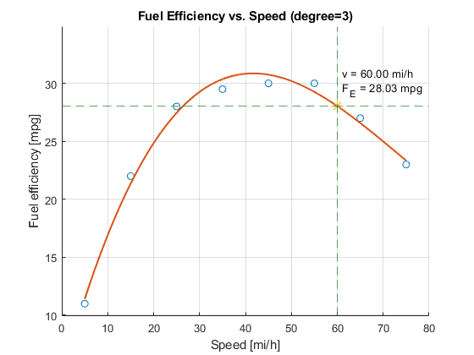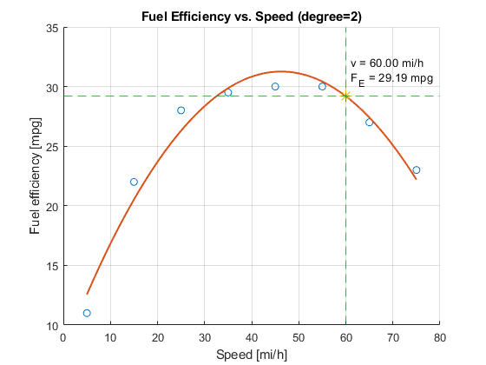
2. 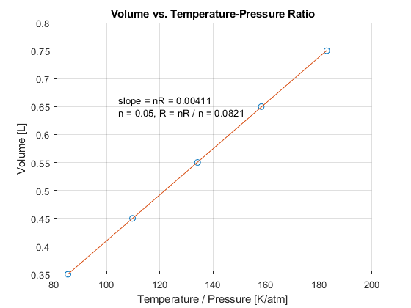
3. 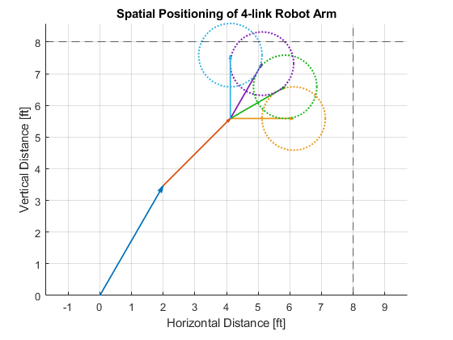
4. 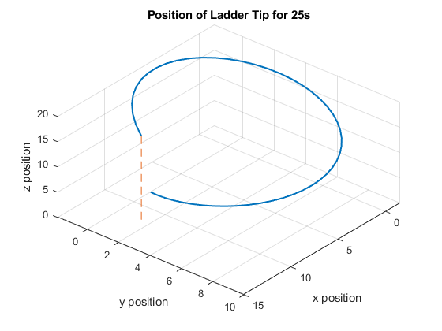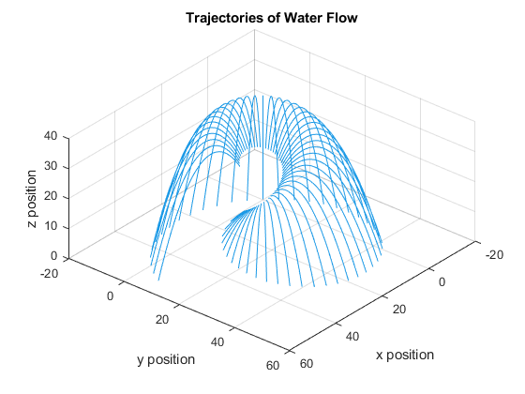

**Results/Discussion**

In this lab, we used MATLAB to generate a bunch of different graphs. I used the “line” commands to create straight lines along axes to clarify some of my graphs. I also used the “quiver” command to draw each arm in the robot arm problem. I chose not to use the “axis” command to set the limits, because I wanted the overlap to be clearly shown. When I did the last problem, I messed up the spherical coordinates a bunch of times and had to restart it from scratch.